ANNEX IV
Indicative maps of the trans-European transport network extended to specific third countries

 | Map Finder Chart for Neighbouring Countries
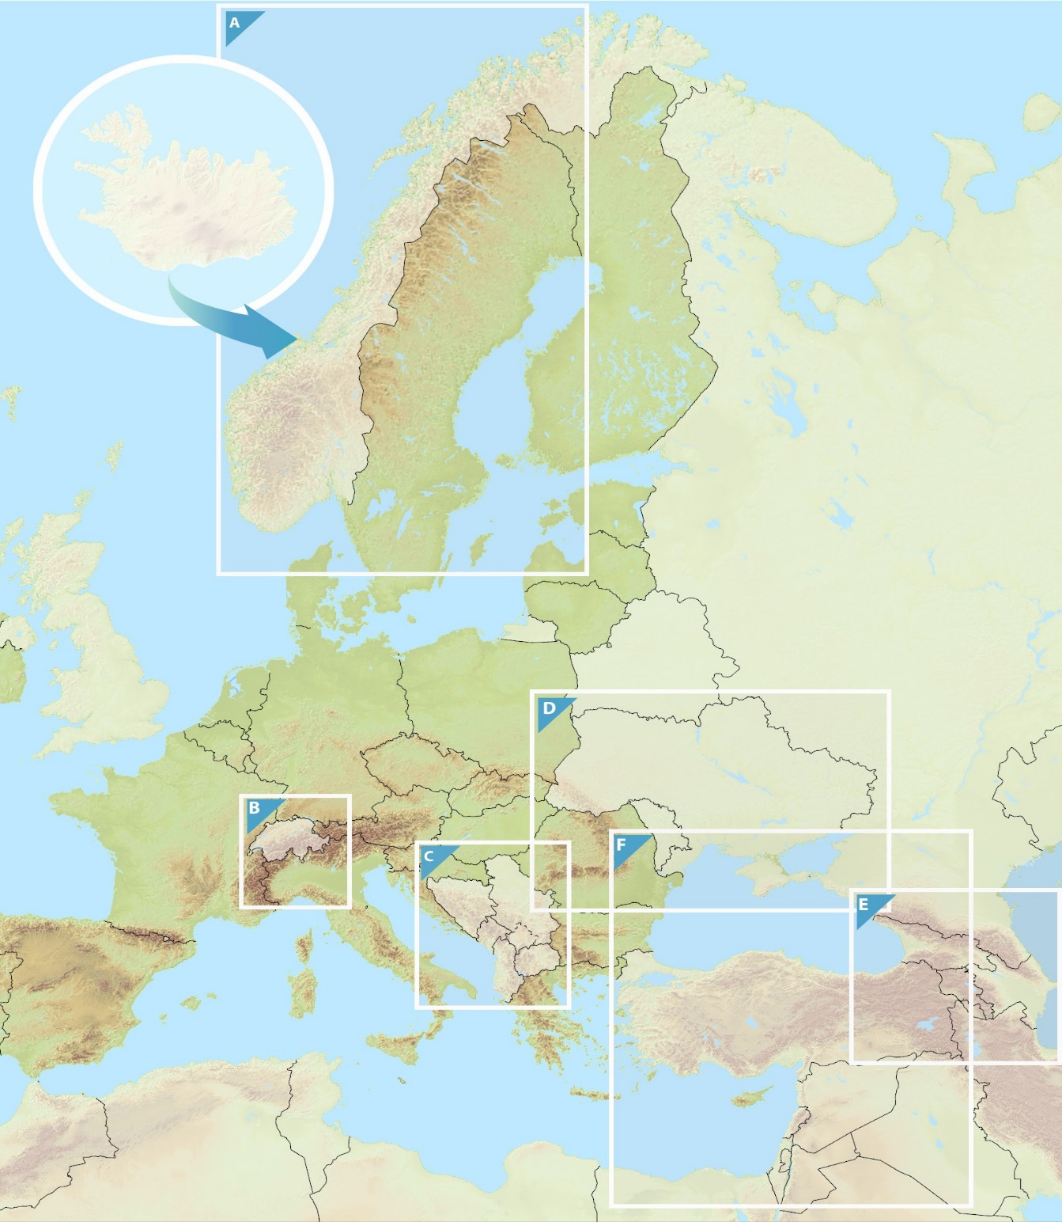

Indicative Extension to Neighbouring Countries
Core & Comprehensive Networks: Rail, ports and rail-road terminals (RRT)
Eastern Partnership Transport Network: Moldova / Ukraine
D
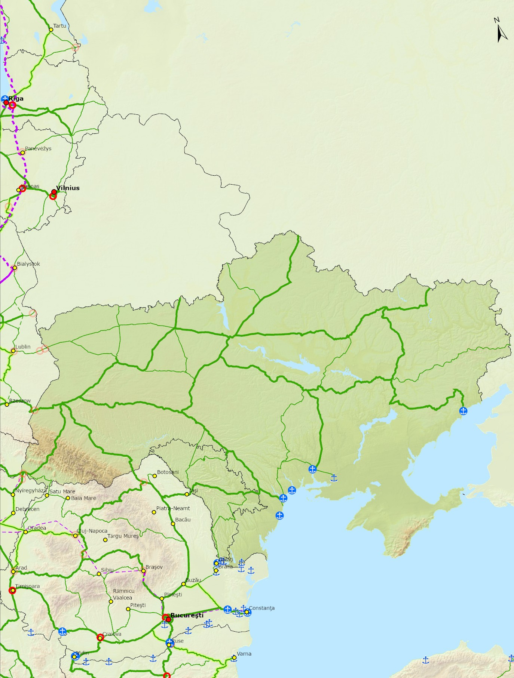
Railways Core |  | Railways Extended Core |  | Railways Comprehensive |  | Compr Core |  | Urban Nodes
 | Conventional |  | Conventional |  | Conventional |  | Ports |  | Capitals
 | Conventional / New Constr. |  | Conventional / New Constr. |  | Conventional / New Constr.
 | ≥ 200 km/h |  | ≥ 200 km/h |  | ≥ 200 km/h |  | RRT |  | Urban Nodes
 | ≥ 200 km/h / New Constr |  | ≥ 200 km/h / New Constr. |  | ≥ 200 km/h / New Constr
 |  |  |  |  | Projected

