Procedural information
Lead DG, Decide Planning/CWP references
DG ENER, PLAN/2020/6834, Commission work programme 2021 (COM(2020) 690 final) Annex I. 1.e.
Organisation and timing
The review of the EED was announced in the European Green Deal Communication in December 2019.
An Inter Service Steering Group was established which involved the following DGs: SG, AGRI, BUDG, CLIMA, COMP, CNECT, EASME, ECFIN, ENV, ESTAT, FISMA, GROW, JRC, JUST, LS, MOVE, REGIO, RTD, TAXUD, TRADE.
Five meetings were held, which took place on 17 June 2020, 7 October 2020, 10 December 2020, 19 February 2021 and 2 March 2021.
Consultation of the RSB
A meeting with the RSB took place on 14 April 2021.
On 19 April 2021, the RSB issued a negative opinion. An improved Impact Assessment has been submitted on 29 April, fully addressing the recommendations provided by the Board in its first opinion. Table 1 shows the RSB recommendations and the changes made to respond to them.
Table 1: How RSB recommendations of 19 April 2021 have been addressed
RSB recommendation | How the IA report has been amended
(1) The report should clearly define the scope of the initiative.  It should specify how it aligns with the greenhouse gas reduction targets of the Climate Law, and how it follows or differs from the CTP modelling scenarios.  On this basis, the report should make clear what are the open policy choices that this impact assessment aims to inform.  The report should explain how the other ‘Fit for 55’ initiatives may affect the scope, choices or impacts of this initiative. | As a result of the Board’s important recommendation, Section 1.5 on the revision of the EED as part of the ‘Fit for 55’ package has been enhanced to make clear that the overall target (and consequently the level of the obligations, including Article 7) is taken from the CTP modelling.  Moreover, the contribution to the 55% GHG target and the link with the CTP IA has been clarified still in section 1.5, but also in sections 5.1 on what the baseline from which options are assessed is, 5.3 from options to scenarios that build on the Climate Target Plan, 6.1 on how the assessment is carried out, 6.2 on the summary of quantitative results and in a new Annex D on key findings of CTP and how they are fine-tuned in the “Fit for 55” IAs.  The report now explains that the open policy choices mainly relate to the package of measures necessary for energy efficiency to contribute optimally to the achievement of the 55% GHG reduction target.  The possible effect of other ‘Fit for 55’ initiatives has been further elaborated in sections 1.3 on the role of the EED and interlinkages with key related legislation, 1.5 on the revision of the EED as part of the ‘Fit for 55’ package and 8 on the preferred option, in particular as regards the interaction with an extended ETS for buildings and transport.
(2) The report should better explain the framework character of the EED and provide a clearer picture (especially in the options description) of where it supports separate pieces of (EU and national) sectoral legislation and how, and where it adds additional elements. | Section 1.3 on the role of the EED and interlinkages with key related legislation has been modified to address the comment made by the Board to better explain the role of the EED in view of other policy instruments, with further details provided in Annex F on the main elements of the EED, Annex J on the energy saving obligation and Annex M on the interaction with other policy areas and legislation.  Following the recommendation of the Board and in light of the under-developed elements in the in the first submission, the Impact Assessment now clarifies that the EED aims to enhance energy efficiency by using various mechanisms, through the action of the Member States, to deliver increased energy savings and energy efficiency above what would be achieved through minimum performance standards and pricing measures alone.
(3) The intervention logic of the initiative needs significant improvement. | The intervention logic has been significantly improved by restructuring the problem definition and underlying drivers, updating and simplifying the objectives and better linking it with the policy options (sections 2 on the problem definition, 4 on the objectives and 5 on what the available policy options are).  Section 2 now explains in a detailed way that, if no action is taken, a large share of energy efficiency and energy saving potential would remain unexploited, largely due to market and regulatory failures, which prevent cost-effective energy efficiency investments and actions from taking place.  As a result, unless higher levels of energy efficiency are achieved, GHG emissions would be higher for a given unit of output, important co-benefits would not be realised and the EU would not meet its 55% GHG emission reduction target in a cost-effective manner as shown by the CTP IA.  Section 4 has been modified to clarify what the general objective of this initiative is, namely the need to revise the EED to further promote energy efficiency and energy savings to contribute optimally to the cost-effective achievement of the EU 55% GHG reduction ambition for 2030, by achieving a 36-37% energy efficiency target as shown in the Climate Target Plan. Moreover, it also streamlines the specific objectives, which are currently three.  Section 5 has been substantially revised and restructured to address better and in a clearer way the problems and drivers outlined in section 2, with the aim to further substantiate the need to improve the EED across many areas.  The broad set of potential measures identified based on the evaluation outcomes, the assessment of the final NECPs, the support study, and the results of stakeholder meetings and the open public consultation, have been further developed and better described.
(4) The report should clarify the precise content of the considered options.  It should better link the measures listed under particular options to the identified problems.  The various proposed choices, for example for target levels, should be better justified on the basis of modelling, expert opinions, stakeholder suggestions or any available evidence underpinning the feasibility of the proposals and ambition levels. | Section 5.2 on the description of the policy options has been completely rewritten to address the Board’s concerns and to strengthen the link to the problem definition, taking better account of available evidence, the evaluation, workshops and public consultation responses.  The description of the policy measures has been expanded, e.g. to justify the levels chosen, and some more detailed policy measures have been deleted.
(5) On the basis of better defined options, the report should improve substantially the qualitative or quantitative assessment of the considered individual measures and better link these to the high-level results of the modelling. This should also help to identify the more critical measures from the less important ones. | Section 6 on the impacts of scenarios and policy options, and in particular section 6.3 on the assessment of policy options, has been substantially modified in particular to improve the assessment and to identify the more important options from less important ones.  Based on this, section 7 on how the options compare has been substantially changed to improve the comparison of policy options.
(6) Options regulating heating and cooling, should be better justified from a subsidiarity and proportionality perspective. As most actions in this area are to be conducted locally, with little or no spill-over effects, the report should clarify the value added of harmonisation at EU level, especially when going beyond setting overall targets but also imposing specific measures. | The description of the heating and cooling options has been greatly expanded and the underlying reasons for addressing this sector has been more detailed in section 5.2 on the description of policy options.  The assessment of these options in section 6.3.7 on the assessment of heating and cooling has been modified to better reflect subsidiarity and proportionality impacts.
(7) Given that one of the objectives of the initiative relates to energy poverty, the report should strengthen the impact analysis of the proposed measures in this respect.  It should reflect diverse levels of income and energy prices across Member States. While measures to eliminate energy poverty are by virtue of subsidiarity in the hands of Member States, the report should clearly present the impacts of increased energy efficiency targets on energy poverty levels. | To address the Board’s important recommendation, energy poverty has been addressed as part of the possible policy options under Article 7 in section 5.2 on the description of policy options, providing evidence for the link between energy efficiency (and the EED) and energy poverty (Annex L specifically on the impacts of energy poverty) and assessment of the proposed measures (section 6.3). An important basis for actions at EU level is the fact that 61% of respondents in the Public Consultation voiced to a high degree of importance the request for a specific share of EU measures to address energy poverty.
(8) The report should better reflect the views of different stakeholder groups, including dissenting and minority views throughout the report, including on the problem definition, construction of options and the choice of the preferred option(s). | Views of stakeholder have been better reflected in the problem definition, policy options and assessment of options. This has been done throughout sections 2 on the problem definition, 5.2 on the description of policy options, 6.3 on the assessment of policy options, 7 on how the options compare and 8 on the preferred option.
(9) The report should improve the presentation of the estimated costs and benefits of the preferred option(s) and include a more comprehensive overview in Annex 3. As far as possible, the report should quantify the expected increase in administrative burden. | The report has been up-dated to include further quantification of impacts and cater for the recommendation of the Board suggesting that an improved presentation is needed. This is why efforts have been made to increase and improve the qualitative assessment of the various measures.  As regards the administrative burden, the comments have been addressed based on the available data, which allowed for a qualitative rather than a quantitative assessment.
(10) The methodological section (in the annex), including methods, key assumptions, and baseline, should be harmonised as much as possible across all ‘Fit for 55’ initiatives. Key methodological elements and assumptions should be included concisely in the main report under the baseline section and the introduction to the options. The report should refer explicitly to uncertainties linked to the modelling. Where relevant, the methodological presentation should be adapted to this specific initiative. | Sections 5.1 on the baseline from which options are assessed and 6.2 on the summary of quantitative results have been revised to improve how the key methodological elements and assumptions are addressed.  A harmonised Annex D on key findings of CTP and how they are fine-tuned in the “Fit for 55” IAs has been added also to this report, as well as to the other IAs part of the package.

On 28 May 2021, the RSB issued a positive opinion with reservations on the resubmitted Impact Assessment. The recommendations provided by the Board have been fully addressed in the current Impact Asssessment. Table 2 shows the RSB recommendations and the changes made to respond to them.
Table 2 How RSB recommendations of 28 May 2021 have been addressed
RSB recommendation | How the IA report has been amended
(1) The report does not sufficiently justify the need for specific sectoral energy savings obligations. Their added-value to the global savings obligation and other Fit for 55 initiatives is unclear. | For both transport and vulnerable consumers, extra text has been added to point 2 of section 5.2 describing why specific sectoral action is desirable and reasonable. This also provides explanation of why this provides added value and discusses the possible level.
(2) The report does not sufficiently justify the introduction of further measures at the EU level for heating and cooling. | Clarifications have been made to the text in section 5.2 describing the options, in particular HEAT.2, to provide greater clarity on the measures.  The text assessing subsidiarity of the options in section 6.3.7.4 has been expanded and strengthened.
(3) The report does not provide clear evidence of the need for and added-value of the transport options. It is unclear how mandatory mobility planning for certain urban areas would be in line with the subsidiarity principle. | Part 9 of section 5.2 has been further elaborated to provide a more detailed explanation of the merits of the measure and the energy saving potential.
(4) The choice and feasibility of the preferred options for buildings needs further clarification. The subsidiarity assessment of the two public procurement options is deficient. | Text has been added to point 4 of section 5.2 to better explain the minimum EPBD requirements and clarify that the NZEB standards is already de-facto the standard for renovations and is achievable  The scoring for PROCURE.2 has been reassessed. This led to an increase in the coherence score and a decrease in the sustainability and proportionality score.
(5) The interplay between the measures included in the preferred options is unclear. Administrative burdens, compliance costs and circular economy impacts remain insufficiently assessed. | A new Annex N has been inserted which contains a thorough assessment of the possible change in net administrative burden as a result of the simplification of certain elements and the additional impacts of other elements for all measures of the preferred option. This is based upon the Better Regulation assessment tool.  Extra text has been included in section 8 describing the measures of the preferred option and how they work as a package. This also explains the interplay with the EE1st principle and the flexibility available to Member States when choosing how to achieve the overall target.  Extra text has been included in Annex M explaining the interactions between Energy Efficiency measures and the circular economy and illustrating how accelerating energy saving replacement may impact this.
General | Stakeholder views have been better disaggregated on the basis of 4 categories (public authorities, business, civil society and citizens) for a number of key public consultation questions.  The baseline has been reintroduced to each element of section 5.2 and 6.3 as well as in all the tables of section 6.3.

Evidence, sources and quality
The aim of this Impact Assessment is to support a legislative proposal amending the EED to address any remaining ambition gap to the EU energy efficiency target of 32.5% for 2030 and in view of a higher climate ambition for 2030, which would require more efforts in energy efficiency.
It builds on the impact assessment carried out for the comprehensive plan to increase the EU 2030 climate target to at least 50% and towards 55% in a responsible way. That impact assessment indicated how climate and energy policies would interact to achieve an increased greenhouse gas emissions reduction target. It provided information on a coherent set of changes required for the existing 2030 climate and energy framework - the ETS Directive, the Effort Sharing Regulation and the Land Use, Land Use Change and Forestry Regulation, the Renewable Energy Directive and the Energy Efficiency Directive.
In addition, findings of the evaluation of the EED have helped to identify the measures needed to address the objectives.
Other central sources are the Member States’ NECPs and the Commission’s assessment, the 2020 Progress Report and the work of the Task Force on Mobilising Efforts to Reach the EU Energy Efficiency Targets for 2020. Reports from the Joint Research Centre have also been of importance.
A large amount of external expertise has fed into the preparation of this impact assessment. A specific expert group meeting was held in November 2019 at which outlain ideas of the available options were presented and expert’s opinions invited.
Many dedicated reports have been produced assessing specific aspects of the legislation and its effects. Some key ones are referenced in this document and a wider set are referenced in the support study carried out in its preparation. Other relevant reports and research is cited.
That support study provided the bulk of the evidence used to support the identification and choice of measures, their organisation into options packages and assessing their likely impacts.

Stakeholder consultation
- Synthesis of consultation activities
This Annex provides a synopsis of the stakeholder consultation carried out as part of the back-to-back ex-post evaluation and impact assessment of the Energy Efficiency Directive (EED).
- Consultation strategy and objectives
The stakeholder consultation followed the strategy, objectives and steps laid out in the consultation strategy for the review and revision of the Energy Efficiency Directive.
The overall objective of the consultation was to identify the shortcomings associated with the current provisions of the EED and ways to strengthen, if necessary, elements of the EED to deliver on the Commission proposal to increase the EU’s greenhouse gas emission reduction target for 2030 to at least 55%.
In order to achieve this objective, the consultation strategy laid out that the EED Review needed to cover the following elements:
(1) An ex-post evaluation of those elements of the EED that were not revised in 2018; and
(2) An impact assessment for the revision of the EED.
The consultation strategy underscored the need for a comprehensive consultation, as the EED had not been evaluated since its adoption in 2012, except for the articles revised in 2018 in the context of the Clean Energy for All Europeans package.
“Flexible” elements of the consultation strategy such as direct interviews and calls for ad-hoc contributions were used throughout the process to corroborate findings and address upcoming issues identified during the more formal consultation stages such as the feedback to the Roadmap/Inception Impact Assessment.
- Consultation activities
  - Stakeholder groups and consultation tools
The consultation strategy identified the following stakeholder groups and assessed their level of interest:
- European public actors: European Parliament, Committee of the Regions, Economic and Social Committee (high interest);
- National authorities responsible for the implementation of the EED in Member States (e.g. ministries of energy or economy and other competent authorities, including potentially at regional and local level) (high interest);
- Interest groups affected by the implementation of the EED such as companies, including small and medium-sized enterprises, regional and local public bodies, private organisations and industry associations, several of the European social partners, NGOs (high interest);
- Wider interest groups who may have an interest in implementation of the EED including civil society and academia (moderate interest).
Several tools for engaging stakeholders were used to ensure a successful consultation on both ex-post evaluation and identification of further policy options for the Impact Assessment. They included:
- The Consultation on the evaluation roadmap/inception impact assessment;
- Nine stakeholder workshops on specific topics and articles and one EED Expert group meeting;
- Targeted stakeholder consultations including evaluation questionnaires and interviews; and
- The Open Public Consultation (OPC).
Table 3: Alignment of tools and stakeholders
 | European public actors | National authorities | Core interest groups | European social partners | Wider interest groups
Roadmap consultation | ✓ | ✓ | ✓ | ✓ | ✓
Stakeholder workshops |  | ✓ | ✓ | ✓
Evaluation questionnaires & interviews | ✓ | ✓ | ✓ | ✓
Open public consultation |  | ✓ | ✓ | ✓ | ✓

Due to the comprehensive communication strategy, all stakeholder groups could be reached. Consultation activities were tailored to deliver analytically separate insights into the evaluation of the existing acquis and the impact assessment.
The received feedback was analysed based on a mixed-method design, applying qualitative and quantitative analysis. This comprised qualitative content analysis, delivering read-outs of stakeholder positions. Computer-aided text analysis (CATA) based on MaxQda software allowed for an additional coding of feedback to track salience of the topics. Quantitative data gathered in the consultations on the Roadmap/Inception Impact Assessment and the Open Public Consultation were analysed with MS Excel and IBM SPSS statistical software.
The following section presents a detailed description of these consultation activities and their return.
  - Consultation feedback
    - Roadmap/Inception Impact Assessment
The evaluation roadmap (Roadmap) was published on 3 August 2020 and was available for feedback until 21 September 2020. It received 189 replies. 99 stakeholders annexed supplementary statements and information to their replies. The largest number of replies (67) were received from Belgium, followed by France (20 replies) and Germany (19 replies). 15 replies were anonymous, which did not allow tracking the geographic location of contributors. The group of Business Associations was the largest to reply (80 replies), followed by Companies (36 replies) and NGOs (26 replies). Section II presents the detailed read-out of the consultation results.
    - Stakeholder Workshops and EED Expert Group
Nine dedicated stakeholder meetings were organised virtually in the period from September to October 2020 with targeted stakeholder groups on specific topics to ensure focussed discussion (Table 4). The outcome of discussions contributed to both processes – evaluation and the impact assessment for revising the EED.
Table 4: Overview of EED stakeholder workshops
No. | Topic | Number of participants | Date
1 | Heating and Cooling and Article 14 | 97 | 10.09.2020
2 | Energy Efficiency in Networks and Article 15 | 78 | 16.09.2020
3 | Financing and Article 20 | 61 | 17.09.2020
4 | Energy Efficiency in the Public Sector and Articles 5, 6 and 18 | 61 | 06.10.2020
5 | General Issues and Energy Efficiency Targets | 71 | 07.10.2020
6 | Energy Audits and Article 8 | 59 | 08.10.2020
7 | Energy Efficiency in Specific Sectors | 65 | 19.10.2020
8 | Energy Consumers and Articles 12 and 19 | 44 | 21.10.2020
9 | Energy Services and Skills Articles 16 and 18 | 50 | 22.10.2020

Workshops were split in two parts to cover ex-post evaluation aspects and possible solutions for improvements of the EED and were guided by questions sent in advance to participants.
A dedicated EED expert group meeting was held on 10 November 2020. The meeting aimed to seek feedback on the preliminary findings of the evaluation of the EED framework and to discuss identified policy options for amending the EED. Over 100 participants attended the expert group.
    - Evaluation questionnaires and direct interviews
Targeted questionnaires on relevant topics of the EED were sent to national authorities and other stakeholders in advance of dedicated workshops to seek more detailed feedback. In total 14 questionnaires were prepared covering the various EED articles, general issues and four sector specific sectors - agriculture, water, ICT, transport. Table 5 below presents an overview of the number of responses and feedback received from stakeholders.
Table 5: Feedback response overview to evaluation questionnaires
Article /topic | Questionnaire responses | Additional feedback*
Targeted articles of the EED
Article 1&3 | 21 | -
Article 5 | 19 | -
Article 6 | 15 | -
Article 8 | 25 | 4
Article 12 | 11 | 2
Article 14 | 12 | 16
Article 15 | 5 | 2
Article 16 | 9 | 1
Article 18 | 21 | -
Article 19 | 10 | 2
Sector-specific issues
General issues | 30 | 8
Agriculture and water | 5 | 1
ICT | 5 | -
Transport | 8 | -
* This includes position papers and other notes received via email from stakeholders that were not presented in the questionnaire format.
The consultation activities included direct interviews as a follow up on dedicated issues.
Stakeholders were proposed to decide whether they would like to participate in interviews to illustrate their contributions through the questionnaire and the workshops. In total eight interviews were conducted. The purpose of the interviews was to validate and clarify matters, and to gather additional information and details where necessary. Summary of the interviews were prepared for the reporting exercise.
    - Public consultation
An internet based public consultation targeted a broad stakeholder audience. The consultation was launched on 17 November 2020 and lasted until 9 February 2021. The questions of the consultation addressed aspects concerning the ex-post evaluation and option for the revision of the EED and specific modification of individual articles. The questions were formulated on basis of the Commission Better Regulation guidelines.
To ensure that the results of this consultation informed the two parallel processes of ex-post evaluation and impact assessment at both general and expert level, the survey contained two parts:
- Part I with questions of a general nature covering both the evaluation and impact assessment. The first sub-section contained questions assessing whether the EED framework and relevant provisions are efficient, effective, and coherent with the broader EU legislative framework covering energy efficiency policy. The second sub-section investigated the most appropriate policy options to be considered for the EED revision as part of the impact assessment, which could allow addressing the insufficient level of ambition in the National Energy and Climate Plans and also delivering on the higher energy efficiency contribution for 2030 to reach the GHG emissions reductions target of at least 55%.
- Part II was of a technical nature on specific articles dedicated to experts.
The consultation received 344 replies, often accompanied by additional position papers. Replies came from 26 Member States and three non-EU countries (Norway, Switzerland, and the UK). Replies were submitted in 17 languages. The largest group of respondents covered business associations (132 replies), individual businesses and companies (92 replies), followed by NGOs (34 submissions). 21 respondents submitted replies as individual citizen. 24 public authorities replied, including 13 national authorities from 12 Member States (Cyprus, Czech Republic, Estonia, Finland, France, Italy, Lithuania, Luxembourg, Netherlands, Norway, Spain, and Sweden).
  - Stakeholder input concerning the Impact Assessment
    - Roadmap/Inception Impact Assessment
The feedback retrieved in the consultation on the Roadmap/Inception Impact Assessment overall aligns with the feedback on the evaluation of the existing EED provisions: The present EED is overall regarded to be a workable policy instrument, which however is not deploying its full potential. Along this line, many stakeholders argued for an increased level of ambition regarding energy efficiency targets and asking for a stronger role of binding measures in their feedback to the consultation on the Roadmap/Inception Impact Assessment. Besides commenting on energy efficiency targets (69 mentions), heating and cooling (37 mentions) and buildings (31 mentions) received the broadest attention.
Further to these overall comments, respondents provided detailed suggestions for revising dedicated articles of the EED. This concerned the topics and articles shown in Table 6.
Table 6: Stakeholder recommendations for changing EED provisions
Articles | Number of contributions with revision suggestions
1 &3 (objectives and targets): | 10
5 (exemplary role of public bodies’ buildings): | 24
6 (public procurement): | 5
7 (energy efficiency obligations): | 23
8 (energy audits): | 14
9-11 (metering and billing): | 6
14 & 15 (energy transformation, heating and cooling): | 31
16 & 17 (qualifications and training): | 4
18 (energy services): | 4
20 (financing): | 7

Stakeholders strongly focussed their comments and suggestions for improvement on the aspects of heating and cooling as well as on energy efficiency action in the public sector (buildings and procurement). The main results of the Roadmap/Inception Impact Assessment feedback are:
- Stakeholders were largely positive about stepping up the ambition on energy efficiency to match the higher climate target. Many stakeholders acknowledged the need for updating and aligning the 2030 energy efficiency targets to reflect the more ambitious GHG emissions reduction objective.
- Regarding the formulation of targets, some replies cautioned against fixing absolute targets for fear of curbing economic growth or limiting flexibility of the energy markets.
- Some stakeholders stressed the need to strengthen governance arrangements through a clearer alignment of the EU objectives for GHG, renewable energy and energy efficiency as well as further sectorial regulation as announced in the European Green Deal. The alignment with other policies is a recurring topic in many stakeholder replies. Many stakeholders pointed out that energy efficiency should be looked at from the perspective of the energy system.
- A majority of stakeholders supported the revision of the EED. Support for policy option 3 (Revision of the EED) was more widespread among respondents than support for policy option 2 (Non-regulatory measures). However, many stakeholders noted that both options were not mutually exclusive. Regarding the policy options laid out in the Roadmap, a large share of stakeholders implicitly or explicitly supported a revision of the EED, including proposing regulatory measures.
- The overall view was that a future revision of the EED should comprise regulatory and non-regulatory measures. Heating & cooling, buildings, as well as system efficiency and renewable energies, have been widely raised as key issues. In addition, the provisions concerning the public sector (Articles 5 and 6) received a large number of feedback.
  - Stakeholder Workshops and EED Expert Group
    - Stakeholder workshops
The second half of each stakeholder workshop addressed forward-looking elements to gather input for the revision of the EED. Table 7 and Table 8 sum up the key findings of the workshops.
Table 7: Summary of key workshop findings on specific EED provisions (forward-looking)
Article/ Workshop topic | Stakeholder input for impact assessment
14 (heating and cooling) | - Many participants consider that the EED is not capturing the existing heating and cooling potential to the fullest.  - Several participants argued for more ambitious measures to capture heat integration into the energy system, address waste heat (data centres and supermarkets), consider system efficiency and renewable district heating, the latter potentially through dedicated targets.  - Energy efficiency first as a principle should be further strengthened.  - The CBA has been lacking on the implementation side, a follow-up is needed.  - Municipalities need support in designing and implementing heating and cooling networks.  - Further linking to financing, Article 7 EED and to the EPBD/building efficiency should be considered.
15 (energy transformation) | - Participants suggested strengthening the energy efficiency first-principle to incentivise further local optimisation of grids.
20 (financing) | - Participants suggested that national energy efficiency funds should base their agreements on performance guarantees (either energy performance contracts or other contracts).  - Art. 18 and 19 EED could be used to follow up on barriers relating to energy efficiency finance and be used to back up art. 20 EED.
5, 6, 18 (Public sector) | - Participants suggested to not only considering the rate of renovation but also its depth and follow-up in terms of energy management and monitoring.  - Reinforcing the link between Article 5 and 18 might be important. Furthermore, participants argued that there is a need to provide assistance to local authorities to increase their capacity to enter in procurement with ESCOs and to support them with project aggregation.  - Several national good practice measures exist that deserve looking into.  - Another issue to consider is extending the scope to other public sector levels. In such a case, there would be a need for more guidance and support through TA or one-stop-shops.
12, 19 (empowering consumers) | - Participants suggested providing incentives for energy efficiency renovation while at the same time addressing the criterion of cost neutrality.  - Several national good practices were highlighted that deserve further looking into.
16, 18 (energy services and qualification) | - There is a need to strengthen the focus on technical competences and further capacity development in the future. Some attention should be given to a possible value added through more uniform competences and schemes across the EU  - There is a need for awareness raising and in relation to Article 18 EED. There is a need for the right skills and the right skills of technical competencies. Still issues to be solved in relation to state aid.
8 (audits) | - Some participants argued that the EED provisions should be enlarged to encourage up-take of energy audit recommendations.  - Participants agreed that mechanisms have to be established, which guarantee the implementation of the audits’ findings.  - Participants were split in their opinion whether obligatory audits or follow-up incentives deliver stronger impacts in terms of energy savings.  - Illustrating non-energy benefits to companies that should be identified in audits might lead to additional up-take of audits.

Table 8: Summary of key workshop findings on overall EED framework and specific sectors (forward-looking)
Article/ Workshop topic | Findings regarding impact assessment
1&3 (targets) | - Many participants argued for higher energy efficiency targets to align with the overall GHG ambition of the European Green Deal.  - Several participants argued that strengthening and more clearly spelling out the “Energy efficiency first principle” could be helpful to trigger energy savings across the whole chain of energy provision.  - In an updated EED, the links to renewable energies (via addressing primary energy consumption), EPBD and environmental aspects (e.g. water use) could be further deepened.
Sectors (transport, ICT, agriculture and waste) | - Many participants argued that the sector-specific legislation should be kept with the sectors. However, there might be a need for an over-spanning energy efficiency intake, such as introducing the “energy efficiency first” principle across the sectors.  - Concerning ICT, the discussion among stakeholders showed that the inclusion of ICT is more comprehensive than addressing only data centres and requires further looking into.  - Regarding agriculture and water, options for further addressing these sectors were seen in e.g. in waste water treatment facilities and heat recovery. Participants overall agreed on the need to further look into how synergies in water sector and the energy efficiency area could be improved and mutually reinforce each other.

The stakeholder workshops led to the identification of further options to enhance the individual articles of the EED. The main findings of the stakeholder workshops were:
- Participants supported a higher ambition and overall update of the EED provisions;
- In line with the results of the evaluation, the workshops allowed to identify further options for updating the EED’s provisions;
- Regarding heating and cooling as well as supply side efficiency, applying the “energy efficiency first-principle” could be a good way forward to address the existing untapped potential; introducing this principle into further sectorial legislation might help to address sectors such as agriculture, water and ICT.
- Public sector renovation was confirmed to be of central importance. Extending the scope of EED provisions to other levels of government (local and regional), considering renovation depth and linking to energy service providers seem promising;
- Renovation incentives and provision of finance is key to backing up many requirements of the EED, thereby leading to an approach combining obligations and supporting financial incentives;
- Training and qualifications remain important and need to be stepped up. This would support further development of energy service markets in all Member States;
- Energy audits are important, but a follow-up on their findings is not sufficiently addressed in the present EED.
- Good practice examples exist throughout the Member States, which deserve further looking into. This highlights the need to promote further exchange between governments and actors at national level.
    - EED Expert group
A dedicated EED expert group meeting was held on 10 November 2020 attended by over 100 participants. The meeting aimed to seek feedback on the preliminary findings of the evaluation of the EED framework and to discuss identified policy options for amending the EED. The main findings of the expert group were:
- The importance of a higher ambition and the binding nature of the energy efficiency targets;
- The need to consider the costs and benefits of energy efficiency measures;
- The need to consider interlinkages with other legislation;
- The importance to contribute to the Green Deal initiatives, notably the Renovation Wave and the Strategy for Energy System Integration;
- The importance of heating and cooling – notably by a stronger implementation follow-up with policies based on the comprehensive assessments;
- The importance of increasing energy performance contracting and facilitating; and
- The need for wider use of energy management systems.
    - Evaluation questionnaires and direct interviews
The 14 evaluation questionnaires and direct interviews covered Articles 1&3, 5, 6, 8, 12, 14, 15, 16, 18, 19 and 20 EED. They gave not only insights on the evaluation of the present Directive but also delivered valuable insights for further improving the EED. The feedback received strongly aligns with the feedback obtained in the workshops and the EED expert group.
Main findings regarding the further development of the EED:
- Respondents assessed the EED to be relevant and clearly creating EU added value. However, while the Directive was effective, they confirmed views voiced in the other consultation channels that the EED’s potential is not exploited to the fullest and that further ambition is needed in view of more ambitious GHG targets.
- Regarding public sector buildings, an additional focus on the local level, notably regarding schools and hospitals might address large untapped saving potentials.
- Article 8 on energy audits could be strengthened by requesting follow-up activities to implement the findings of the audits. Linking to overall schemes (energy management systems) and financial incentives might be interesting.
- Provisions on consumer empowerment (Article 12 EED) might need follow-up in terms of guidelines on transposition and further sharing of good practices at Member State level.
- An update of the provisions on heating and cooling as well as supply-side efficiency should address synergies and overlaps with other EU legislation, notably on renewable energies and building efficiency. Addressing waste heat and cooling is seen as high remaining potential in this field.
- The increased technical complexity of deep renovations asks for an update of qualification and accreditation. Likewise, existing barriers that limit the impact of energy service markets should be addressed by turning provisions of Article 18 EED legally binding. Issues addressed relate to public procurement rules, clear provisions for minimum qualifications of service providers, further reinforcement in relation to quality assurance and accreditation systems, data collection, reporting, monitoring and quality checks.
- Regarding Article 19 EED, the questionnaires returned several suggestions, comprising the empowerment of tenants, minimum energy performance standards for renovation, and the empowerment of local public authorities.
  - Public consultation
An internet based public consultation (PC) targeted a broad stakeholder audience. The consultation was launched on 17 November 2020 and lasted until 9 February 2021. The questions of the consultation addressed aspects concerning the ex-post evaluation and forward looking options for modification of the EED. A comprehensive read-out of the 344 replies to the PC is published separately.
Regarding the feedback on the revision and update of the EED, the following points can be pointed out:
- A clear majority of stakeholders (86% of respondents, n=332) agreed that energy efficiency should play a key role in delivering a higher climate ambition for 2030 and in view of the EU achieving carbon neutrality by 2050.
- Regarding the instruments to be considered to underpin an increased effort in energy efficiency, participants stressed a stronger focus on life-cycle efficiency and circularity, a stronger focus on consumer empowerment (awareness-raising and behavioural change) and making the “Energy Efficiency First” principle a compulsory test in relevant legislative and investment planning decisions. Equally strong was the support for a stronger focus on implementation and enforcement of the existing legislation. 190 out of 285 respondents agreed that the EED should be strengthened by introducing new measures and stricter requirements.
- Regarding targets, stakeholders assessed the level of the 2020 objective as appropriate, but advocate a higher target for 2030 (115 of 200 replies). The largest group (53%) favours binding targets, including at national level (47%).
- Stakeholders see additional energy efficiency efforts needed most in following sectors: Buildings (76%), heating & cooling (63%) as well as transport (62%), followed by industry (52%) and ICT (40%).
- Feedback suggests that there is a need to address the public sector in a more comprehensive and stringent manner. 67% of replies take the view that it is too easy to evade the public purchasing requirements (total of 49 respondents). 73% out of 165 respondents support expanding scope of Article 6 EED to include all levels of public administration.
- Regarding Article 7 EED and its contribution to higher energy efficiency efforts, the current level of ambition of Article 7(1) on energy savings is considered too low by 100 out of 194 replies. Further 72 see the level as adequate. In turn, 104 stakeholders assess the increase of the energy saving obligation for 2021-2030 to be “very important”, 42 as “important” and 14 as “somewhat important” (n=202).
- Regarding Article 8 EED 123 respondents (61%) supported changing the rules, which oblige enterprises that are not small or medium-sized to carry out an energy audit every four years to learn about their energy consumption profile and identify energy saving opportunities. The consultation feedback showed strong support for relating the audits to depend on the energy consumption rather than the size or ownership and the obligation to implement certain measures identified in the audits. Participants showed strong support for including recommendations for renewable energies and resource efficiency in the audits.
- Stakeholders were asked to assess additional options to make Article 14 and its related Annexes more effective. The option “Planning and permitting of infrastructure generating waste heat or cold should take into consideration geographical proximity of a potential demand (heat sink) for this energy” received the highest number of positive scores (69 strongly agreeing, 53 agreeing, 27 somewhat agreeing out of n=168 respondents). This is followed up by the option to oblige Member States to better ensure that cost and benefits of more efficient heating and cooling are taken into account.
- Regarding the functioning of energy service markets, 58% of the 147 respondents favoured strengthening requirements on independent market intermediaries as a means to increase trust and facilitate the use of energy services.
  - Summary regarding findings for a further revision of the EED
All categories of stakeholders identified in the stakeholder mapping participated in various consultation activities, therefore the outcomes of the consultation process were of substantial help in the analysis and the formulation of the policy proposal. As with the evaluation of the EED, the staged approach of consultation helped to cross-validate and deepen points raised by stakeholders in various rounds of consultation.
Stakeholders’ opinions regarding a potential strengthening of several provisions of the Energy Efficiency Directive can be summarised as follows:
- Stakeholders largely agree that a strengthening of the EED is possible and adequate to align to the increased ambition of the European greenhouse gas objectives.
- The increased level of ambition can be implemented by updating and revising the provisions of the EED under review, notably energy efficiency in public buildings, support for building renovation as well as heating and cooling.
- Stakeholders contributed many suggestions for improving the present provisions of the EED, often based on existing experiences and good practices.
- Stakeholder input delivered many suggestions for further fields of action (e.g. waste heat, data centres, synchronisation with EU acquis on renewable energies and energy efficiency in buildings).
- A large group of stakeholders voiced support for expanding the update of the EED by revising energy efficiency targets (Articles 1 & 3 EED) and energy efficiency obligation schemes (Article 7 EED).

Who is affected and how?
- Summary of costs and benefits

I. Overview of Benefits (total for all provisions) – Preferred Option
Description | Amount | Comments
Direct benefits
Energy savings | Compared to REF: €23.09 billion €’15/year  Compared to MIX: €7.65 billion €’15/year | Average annual energy savings comparing MIX-MAX and REF scenarios. Of which: €5.42 billion/year in industry, €7.48 billion/year in Households, €6.64 billion/year in the Tertiary sector, €3.56 billion/year in Transport.  Average annual energy savings comparing MIX-MAX and MIX scenarios. Of which: €0.32 billion/year in industry, €2.08 billion/year in Households, €2.38 billion/year in the Tertiary sector, €0.03 billion/year in Transport.
Disutility costs | Compared to MIX: €6.35 billion €’15/year | Average annual Disutility costs (e.g., cost of foregone energy services due to higher prices) lower in MIX-MAX than in MIX.
Compliance cost reductions from Article 8 simplification | €225 million per year | Mainly business is the beneficiary as a result of avoided energy audits for small energy consuming businesses. There is a small reduction in public administration costs due to there being less audits to monitor.
Indirect benefits
Overall co-benefits for society | Based upon the COMBI project analysis these are expected to amount to around 50% of the value of the energy savings | The project assesses the co-benefits of energy savings on: human health; eco-systems: acidification, eutrophication, ozone exposure, crop loss; air pollution emissions; avoided GHG emissions; material footprint/resource impacts; energy cost savings/available income effect; productivity; gross employment/GDP; public budget; energy security.  To the degree possible it aims to quantify them, but this is only feasible for a subset of the impacts.
Reduced air pollution emissions and other environmental impacts | Estimated 9% reduction | Extrapolated on the basis of overall level of energy savings using the modelling results for MIX compared to REF (8.4% reduction) as the starting point.

II. Overview of costs – Preferred option
 |  | Citizens/Consumers |  | Businesses |  | Administrations
 |  | One-off | Recurrent | One-off | Recurrent | One-off | Recurrent
Overall targets | Direct costs | Household investments  €63.3 billion €’15  (Average annual investments comparing MIX-MAX and REF) | N/A | Industry investments €6.52 billion €’15  Tertiary investments €13.8 billion €’15  (Average annual investments comparing MIX-MAX and REF) | N/A | Setting up schemes | Monitoring and reporting
Overall targets | Indirect costs | N/A | Disutility costs compared to REF: 12.02 billion €’15/year | N/A | N/A | N/A | N/A
Public buildings | Direct costs | N/A | N/A | N/A | N/A | Estimated at €8.8 billion per year through bottom up calculations.  Includes all renovation costs, not only costs related to energy efficiency. Most of the renovation cost relate to keeping a building at use at a certain standard.
Public buildings | Indirect costs | N/A | N/A | N/A | N/A |  | N/A
Public procurement | Direct costs | N/A | N/A | N/A | N/A | N/A | Additional effort for drafting tender documents
Public procurement | Indirect costs | N/A | N/A | N/A | N/A | N/A | N/A

Key CTP findings input to the “fit for 55” IAs
Key findings of CTP
The Climate Target Plan and its underpinning impact assessment are the starting point for the initiatives under Fit for 55 package.
The plan concluded on the feasibility - from a technical, economic and societal point of view - of increasing the EU climate target to 55% net reductions by 2030. It also concluded that all sectors need to contribute to this target.
In particular, with energy supply and use responsible for 75% of emissions, the plan put forward ambition ranges for renewables and energy efficiency which in a cost-efficient manner correspond to the increased climate target. The climate target plan also established that this raise in climate and energy ambition will require a full update of the current climate and energy policy framework in a coherent manner.
As under the current policy framework, the optimal policy mix should combine, at the EU and national levels, strengthened economic incentives (carbon pricing) with updated regulatory policies, notably in the field of renewables, energy efficiency and sectoral policies such as CO2 car standards. It should also include the enabling framework (R&D policies, financial support, etc.).
While sometimes working in the same sectors, the policy tools vary in the way they enable the achievement of the increased climate target. The economic incentives provided by strengthened and expanded emissions trading would contribute to the cost-effective delivery of emissions reductions. The regulatory policies, such as RED, EED, and CO2 standards for vehicles aim at addressing market failures and other barriers to decarbonisation, but also create an enabling framework for investment, which supports cost-effective achievement of climate target by reducing perceived risks, increasing the efficient use of public funding and helping to mobilise and leverage private capital. The regulatory policies also pave the way for the future transition needed to achieve the EU objective of the climate-neutrality. Such a sequential approach from the CTP to the Fit for 55 initiatives was necessary in order to ensure coherence among all initiatives and a collective delivery of the increased climate target.
The final calibration between the different instruments is to be made depending, inter alia on the decision on the extension of ETS beyond the maritime sector and its terms.
Table 9 below shows the summary of all key CTP findings:
Table 9: Key CTP findings.
POLICY CONCLUSIONS IN THE CTP
GHG emissions reduction | - 55% reduction (w.r.t. 1990)  - Agreed by the European Council in December 2020  - Agreed by the legislator in the Climate Law
ETS | - Corresponding targets need to be set in the EU ETS and the Effort Sharing Regulation to ensure that in total, the economy wide 2030 greenhouse gas emissions reduction target of at least 55% will be met.  - Increased climate target requires strengthened cap of the existing EU ETS and revisiting the linear reduction factor.  - Further expansion of scope is a possible policy option.  - EU should continue to regulate at least intra-EU aviation emissions in the EU ETS and include at least intra-EU maritime transport in the EU ETS.  - For aviation, the Commission will propose to reduce the free allocation of allowances, increasing the effectiveness of the carbon price signal in this sector, while taking into account other policy measures.
ESR | - Corresponding targets need to be set in the Effort Sharing Regulation and under the EU ETS, to ensure that in total, the economy wide 2030 greenhouse gas emissions reduction target of at least 55% will be met.
LULUCF | - Sink needs to be enhanced.  - Agriculture forestry and land use together have the potential to become rapidly climate-neutral by around 2035 and subsequently generate removals consistent with trajectory to become climate neutral by 2050.
CO₂ standards for cars | - Transport policies and standards will be revised and, where needed, new policies will be introduced.  - The Commission will revisit and strengthen the CO₂ standards for cars and vans for 2030.  - The Commission will assess what would be required in practice for this sector to contribute to achieving climate neutrality by 2050 and at what point in time internal combustion engines in cars should stop coming to the market.
Non-CO₂ emissions | - The energy sector has reduction potential by avoiding fugitive methane emissions. The waste sector is expected to strongly reduce its emissions already under existing policies. Turning waste into a resource is an essential part of a circular economy. Under existing technology and management options, agriculture emissions cannot be eliminated but significantly reduced while ensuring food security is maintained in the EU. Policy initiative have been included in the Methane Strategy.
Renewables | - 38-40% share needed to achieve increased climate target cost-effectively.  - Renewable energy policies and standards will be revised and, where needed, new policies will be introduced.  - Relevant legislation will be reinforced and supported by the forthcoming Commission initiatives on a Renovation Wave, an Offshore Energy strategy, alternative fuels for aviation and maritime as well as a Sustainable and Smart Mobility Strategy.  - EU action to focus on cost-effective planning and development of renewable energy technologies, eliminating market barriers and providing sufficient incentives for demand for renewable energy, particularly for end-use sectors such as heating and cooling or transport either through electrification or via the use of renewable and low-carbon fuels such as advanced biofuels or other sustainable alternative fuels.  - The Commission to assess the nature and the level of the existing, indicative heating and cooling target, including the target for district heating and cooling, as well as the necessary measures and calculation framework to mainstream further renewable and low carbon based solutions, including electricity, in buildings and industry.  - An updated methodology to promote, in accordance with their greenhouse gas performance, the use of renewable and low-carbon fuels in the transport sector set out in the Renewable Energy Directive.  - A comprehensive terminology for all renewable and low-carbon fuels and a European system of certification of such fuels, based notably on full life cycle greenhouse gas emissions savings and sustainability criteria, and existing provisions for instance in the Renewable Energy Directive.  - Increase the use of sustainably produced biomass and minimise the use of whole trees and food and feed-based crops to produce energy through inter alia reviewing and revisiting, as appropriate, the biomass sustainability criteria in the Renewable Energy Directive,
Energy Efficiency | - Energy efficiency policies and standards will be revised and, where needed, new policies will be introduced.  - Energy efficiency improvements will need to be significantly stepped up to around 36% in terms of final energy consumption.  - Achievement of a more ambitious energy efficiency target and closure of the collective ambition gap of the national energy efficiency contributions in the NECPs will require actions on a variety of fronts.  - Renovation Wave will launch a set of actions to increase the depth and the rate of renovations at single building and at district level, switch fuels towards renewable heating solutions, diffuse the most efficient products and appliances, uptake smart systems and building-related infrastructure for charging e-vehicles, and improve the building envelope (insulation and windows).  - Action will be taken not only to better enforce the Energy Performance of Buildings Directive, but also to identify any need for targeted revisions.  - Establishing mandatory requirements for the worst performing buildings and gradually tightening the minimum energy performance requirements will also considered.

The modelling work in CTP
In the CTP, the increase of efforts needed for the GHG 55% target was illustrated by policy scenarios (developed with model PRIMES) showing increased ambition (or stringency) of climate, energy and transport policies and, consequently, leading to a significant investment challenge.
The first key lesson from the CTP exercise was that while the tools are numerous and have a number of interactions (or even sometimes trade-offs) a complete toolbox of climate, energy and transport policies is needed for the increased climate target as all sectors would need to contribute effectively towards the GHG 55% target.
The second key lesson was that even though policy tools chosen in the CTP scenarios were different - illustrating in particular the fundamental interplay between the strength of the carbon pricing and intensity of regulatory measures - the results achieved were convergent. All CTP policy scenarios that achieved a 55% GHG target showed very similar levels of ambition for energy efficiency, renewables (overall and on sectoral level) and GHG reductions across the sectors indicating also the cost-effective pathways.
The third lesson was that carbon pricing working hand in hand with regulatory measures helps avoid “extreme” scenarios of either:
- A very high carbon price (in absence of regulatory measures), which will translate into energy prices for all consumers as illustrated by the MIX-CP scenario;
- Very ambitious policies that might be rejected by Member States (e.g. very high energy savings or renewables obligations) because they would be too costly for economic operators as illustrated by the REG scenario.
Figure 1: interactions between different policy tools
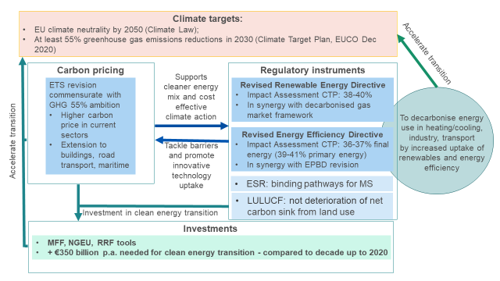
From CTP scenario to “Fit for 55” core scenarios
With the 55% GHG target confirmed by EU leaders in the December 2020 EUCO Conclusions and the 2021 Commission Work Programme (CWP 2021) that puts forward the complete toolbox to achieve the increased climate target (so-called “Fit for 55” proposals), the fundamental set-up of the CTP analysis was confirmed. This set-up is still about the interplay between carbon pricing and regulatory measures as illustrated above, and the extension of the ETS is the central policy issue.
Some slight updates were needed:
- In terms of the Baseline to reflect the most recent statistical data available, notably in terms of COVID impacts, fuller extent of NECPs; and
- Scenario design in order to align better with policy options as put forward in the CWP 2021.
As described above, the CTP policy scenarios are cost-effective pathways that capture all policies needed to achieve the increased climate target of 55% GHG reductions. This fundamental design remains robust and the CTP scenarios thus become “Fit for 55” policy scenarios.
Some of the CTP scenarios can, however, be discarded:
- CPRICE assuming no intensification of energy policies and relying primarily on carbon price is no longer relevant as the REDII and the EED revisions are part of the 2021 CWP;
- 50% GHG scenario (MIX-50) is no longer relevant since the proposal of the increased climate target is for 55% GHG.
This leaves the following CTP scenarios still relevant as “Fit for 55” core scenarios ensuring the achievement of the overall 55% GHG reduction ambition with similar levels of renewable energy and energy efficiency deployment as in CTP:
- REG (relying only on intensification of energy and transport policies in absence of carbon pricing beyond the current ETS sectors);
- MIX (relying on both carbon price signal extension to road transport and buildings) and intensification of energy and transport policies;
In addition, one more “Fit for 55” core scenario was added:
- MIX-CP illustrates a lower ambition revision of energy policies (and CO2 standards for vehicles), with a strong role for carbon price signals (as in MIX also extended to road transport and buildings). MIX-CP scenario is in some ways similar to CPRICE scenario of CTP, but reflects a revision to the EED and RED.
Finally, the ALLBNK scenario is not part of core scenarios for this IA. The ambition level of the ALLBNK scenario, which represents the widest scope of GHG emissions is being assessed in the context of the impact assessments on aviation and maritime emissions.
Changes in the scenario results
These elements of revision described above lead to only a few changes in scenario results compared to CTP scenarios – with the most relevant one for this impact assessment being the increase of RES ambition in the transport sector as illustrated by the RES-T share. The cost-effective pathways in terms of renewables deployment and necessary energy savings remain the same. This is the result of very ambitious national policies on advanced biofuels specifically or RES-T in general (as explained above) put forward in the NECPs as well as the final ambition of the REfuel initiatives adopted in XX. Table below shows the comparison of key scenario results.
Table 10 Comparison of key scenario results; Source PRIMES
Results for 2030 | CTP 55GHG scenarios range  (REG, MIX, CPRICE, ALLBNK) | Fit for 55 core scenarios range  (REG, MIX, MIX-CP)
Overall net GHG reduction (w.r.t. 1990) | 55% | 55%
Overall RES share | 38-40% | 38-39 [upper end currently being fine-tuned to 40]%
RES-E | 64-67% | 62-63%
RES-H&C | 39-42% | 38-41%
RES-T | 22-26% | 26-27%
FEC EE | 36-37% | 35-37%
PEC EE | 39-41% | 38-39%
GHG reduction on the supply side (w.r.t. 2015) | 67-73% | 57-59%
GHG reduction in residential sector (w.r.t. 2015) | 61-65% | 56-58%
GHG reduction in services sector (w.r.t. 2015) | 54-61% | 52-54%
GHG reduction in industry (w.r.t. 2015) | 21-25% | 33-34%
GHG reduction in transport (w.r.t. 2015) | 16-18% | 19-22%
Investments magnitude, excluding transport | €401-438 billion /year | €393-422 billion /per year
Energy system costs (excluding auction payments and disutilities) as % of GDP | 10.9-11.1% | 11.0-11.3%

Analytical methods
Methodological chapter on common analytical framework for revision of ESR, ETS, LULUCF, RED and EED Impact Assessments

Introduction
Aiming at covering the entire GHG emissions from the EU economy, and combining horizontal and sectoral instruments, the various pieces of legislation under the “Fit for 55” package strongly interlink, either because they cover common economic sectors (e.g. buildings sector is currently addressed by energy efficiency and renewables polices but would be also falling in the scope of extended ETS) or by the direct and indirect interactions between these sectors (e.g. electricity supply sector and final demand sectors using electricity).
As a consequence, it is crucial to ensure consistency of the analysis across all initiatives. For this purpose, the impact assessments underpinning the “Fit for 55” policy package are using a collection of integrated modelling tools covering the entire GHG emissions of the EU economy.
These tools are used to produce a common Baseline and a set of core scenarios reflecting internally coherent policy packages aligned with the revised 2030 climate target, key policy findings of the CTP (see Annex D) and building on the Reference Scenario 2020, a projection of the evolution of EU and national energy systems and GHG emissions under the current policy framework [xxx cross reference to the REF2020 publication xxx]. These core scenarios serve as a common analytical basis for use across different “Fit for 55” policy initiatives, and are complemented by specific variants as well as additional tools and analyses relevant for the different initiatives.
This Annex describes the tools used to produce the common baseline (the Reference Scenario 2020) and the core policy scenarios, the key assumptions underpinning the analysis, and the policy packages reflected in the core policy scenarios.

Modelling tools for assessments of policies

Main modelling suite
The main model suite used to produce the scenarios presented in this impact assessment has a successful record of use in the Commission's energy, transport and climate policy assessments. In particular, it has been used for the Commission’s proposals for the Climate Target Plan to analyse the increased 2030 mitigation target, the Sustainable and Smart Mobility Strategy, the Long Term Strategy as well as for the 2020 and 2030 EU’s climate and energy policy framework.
The PRIMES and PRIMES-TREMOVE models are the core elements of the modelling framework for energy, transport and CO₂ emission projections. The GAINS model is used for non-CO₂ greenhouse gas emission projections, the GLOBIOM-G4M models for projections of LULUCF emissions and removals and the CAPRI model is used for agricultural activity projections.
The model suite thus covers:
- The entire energy system (energy demand, supply, prices and investments to the future) and all GHG emissions and removals from the EU economy.
- Time horizon: 1990 to 2070 (5-year time steps).
- Geography: individually all EU Member States, EU candidate countries and, where relevant the United Kingdom, Norway, Switzerland and Bosnia and Herzegovina.
- Impacts: energy system (PRIMES and its satellite model on biomass), transport (PRIMES-TREMOVE), agriculture, waste and other non-CO2 emissions (GAINS), forestry and land use (GLOBIOM-G4M), atmospheric dispersion, health and ecosystems (acidification, eutrophication) (GAINS).
The modelling suite has been continuously updated over the past decade. Updates include the addition of a new buildings module in PRIMES, improved representation of the electricity sector, more granular representation of hydrogen (including cross-border trade) and other innovative fuels, improved representation of the maritime transport sector, as well updated interlinkages of the models to improve land use and non-CO₂ modelling. Most recently a major update was done of the policy assumptions, technology costs and macro-economic assumptions in the context of the Reference scenario 2020 update.
Figure 2 shows how the models are linked with each other in such a way to ensure consistency in the building of scenarios. These inter-linkages are necessary to provide the core of the analysis, which are interdependent energy, transport and GHG emissions trends.
Figure 2 Interlinkages between models
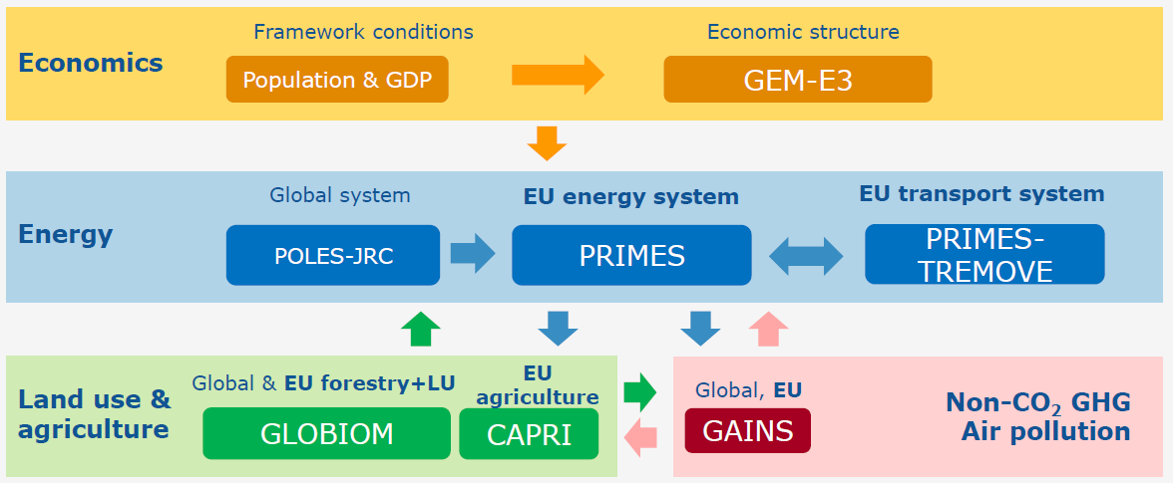

Energy: the PRIMES model
The PRIMES model (Price-Induced Market Equilibrium System) is a large scale applied energy system model that provides detailed projections of energy demand, supply, prices and investment to the future, covering the entire energy system including emissions. The distinctive feature of PRIMES is the combination of behavioural modelling (following a micro-economic foundation) with engineering aspects, covering all energy sectors and markets. Figure 3 shows a schematic representation of the PRIMES model.
The model has a detailed representation of policy instruments related to energy markets and climate, including market drivers, standards, and targets by sector or overall. It simulates the EU Emissions Trading System. It handles multiple policy objectives, such as GHG emissions reductions, energy efficiency, and renewable energy targets, and provides pan-European simulation of internal markets for electricity and gas.
The model covers the horizon up to 2070 in 5-year interval periods and includes all Member States of the EU individually, as well as neighbouring and candidate countries.
PRIMES offer the possibility of handling market distortions, barriers to rational decisions, behaviours and market coordination issues and it has full accounting of costs (CAPEX and OPEX) and investment on infrastructure needs.
Figure 3: Schematic representation of the PRIMES model
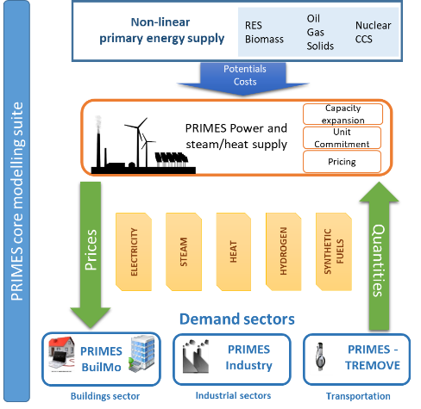
PRIMES is designed to analyse complex interactions within the energy system in a multiple agent – multiple markets framework. Decisions by agents are formulated based on microeconomic foundation (utility maximization, cost minimization and market equilibrium) embedding engineering constraints and explicit representation of technologies and vintages, thus allowing for foresight for the modelling of investment in all sectors.
PRIMES allows simulating long-term transformations/transitions and includes non-linear formulation of potentials by type (resources, sites, acceptability etc.) and technology learning.
It includes a detailed numerical model on biomass supply, namely PRIMES-Biomass, which simulates the economics of current and future supply of biomass and waste for energy purposes. The model calculates the inputs in terms of primary feedstock of biomass and waste to satisfy a given demand for bio-energy and provides quantification of the required capacity to transform feedstock into bioenergy commodities. The resulting production costs and prices are quantified. The PRIMES-Biomass model is a key link of communication between the energy system projections obtained by the core PRIMES energy system model and the projections on agriculture, forestry and non-CO₂ emissions provided by other modelling tools participating in the scenario modelling suite (CAPRI, GLOBIOM/G4M, GAINS).
It also includes a simple module which projects industrial process GHG emissions.
PRIMES is a private model maintained by E3Modelling, originally developed in the context of a series of research programmes co-financed by the European Commission. The model has been successfully peer-reviewed, last in 2011; team members regularly participate in international conferences and publish in scientific peer-reviewed journals.
Sources for data inputs
A summary of database sources, in the current version of PRIMES, is provided below:
- Eurostat and EEA: Energy Balance sheets, Energy prices (complemented by other sources, such IEA), macroeconomic and sectoral activity data (PRIMES sectors correspond to NACE 3-digit classification), population data and projections, physical activity data (complemented by other sources), CHP surveys, CO₂ emission factors (sectoral and reference approaches) and EU ETS registry for allocating emissions between ETS and non ETS
- Technology databases: ODYSSEE-MURE, ICARUS, Eco-design, VGB (power technology costs), TECHPOL – supply sector technologies, NEMS model database, IPPC BAT Technologies
- Power Plant Inventory: ESAP SA and PLATTS
- RES capacities, potential and availability: JRC ENSPRESO, JRC EMHIRES, RES ninja, ECN, DLR and Observer, IRENA
- Network infrastructure: ENTSOE, GIE, other operators
- Other databases: EU GHG inventories, district heating surveys (e.g. from COGEN), buildings and houses statistics and surveys (various sources, including ENTRANZE project, INSPIRE archive, BPIE), JRC-IDEES, update to the EU Building stock Observatory

Transport: the PRIMES-TREMOVE model
The PRIMES-TREMOVE transport model projects the evolution of demand for passengers and freight transport, by transport mode, and transport vehicle/technology, following a formulation based on microeconomic foundation of decisions of multiple actors. Operation, investment and emission costs, various policy measures, utility factors and congestion are among the drivers that influence the projections of the model. The projections of activity, equipment (fleet), usage of equipment, energy consumption and emissions (and other externalities) constitute the set of model outputs.
The PRIMES-TREMOVE transport model can therefore provide the quantitative analysis for the transport sector in the EU, candidate and neighbouring countries covering activity, equipment, energy and emissions. The model accounts for each country separately which means that the detailed long-term outlooks are available both for each country and in aggregate forms (e.g. EU level).
In the transport field, PRIMES-TREMOVE is suitable for modelling soft measures (e.g. eco-driving, labelling); economic measures (e.g. subsidies and taxes on fuels, vehicles, emissions; ETS for transport when linked with PRIMES; pricing of congestion and other externalities such as air pollution, accidents and noise; measures supporting R&D); regulatory measures (e.g. CO₂ emission performance standards for new light duty vehicles and heavy duty vehicles; EURO standards on road transport vehicles; technology standards for non-road transport technologies, deployment of Intelligent Transport Systems) and infrastructure policies for alternative fuels (e.g. deployment of refuelling/recharging infrastructure for electricity, hydrogen, LNG, CNG). Used as a module that contributes to the PRIMES model energy system model, PRIMES-TREMOVE can show how policies and trends in the field of transport contribute to economy-wide trends in energy use and emissions. Using data disaggregated per Member State, the model can show differentiated trends across Member States.
The PRIMES-TREMOVE has been developed and is maintained by E3Modelling, based on, but extending features of, the open source TREMOVE model developed by the TREMOVE modelling community. Part of the model (e.g. the utility nested tree) was built following the TREMOVE model. Other parts, like the component on fuel consumption and emissions, follow the COPERT model.
Data inputs
The main data sources for inputs to the PRIMES-TREMOVE model, such as for activity and energy consumption, comes from EUROSTAT database and from the Statistical Pocketbook "EU transport in figures. Excise taxes are derived from DG TAXUD excise duty tables. Other data comes from different sources such as research projects (e.g. TRACCS project) and reports.
In the context of this exercise, the PRIMES-TREMOVE transport model is calibrated to 2005, 2010 and 2015 historical data. Available data on 2020 market shares of different powertrain types have also been taken into account.

Maritime transport: PRIMES-maritime model
The maritime transport model is a specific sub-module of the PRIMES and PRIMES-TREMOVE models aiming to enhance the representation of the maritime sector within the energy-economy-environment modelling nexus. The model, which can run in stand-alone and/or linked mode with PRIMES and PRIMES-TREMOVE, produces long-term energy and emission projections, until 2070, separately for each EU Member-State.
The coverage of the model includes the European intra-EU maritime sector as well as the extra-EU maritime shipping. The model covers both freight and passenger international maritime. PRIMES-maritime focuses only on the EU Member State, therefore trade activity between non-EU countries is outside the scope of the model. The model considers the transactions (bilateral trade by product type) of the EU-Member States with non-EU countries and aggregates these countries in regions. Several types and sizes of vessels are considered.
PRIMES-maritime features a modular approach based on the demand and the supply modules. The demand module projects maritime activity for each EU Member State by type of cargo and by corresponding partner. Econometric functions correlate demand for maritime transport services with economic indicators considered as demand drivers, including GDP, trade of energy commodities (oil, coal, LNG), trade of non-energy commodities, international fuel prices, etc. The supply module simulates a representative operator controlling the EU fleet, who offers the requested maritime transport services. The operator of the fleet decides the allocation of the vessels activity to the various markets (representing the different EU MS) where different regulatory regimes may apply (e.g. environmental zones). The fleet of vessels disaggregated into several categories is specific to cargo types. PRIMES maritime utilises a stock-flow relationship to simulate the evolution of the fleet of vessels throughout the projection period and the purchasing of new vessels.
PRIMES-maritime solves a virtual market equilibrium problem, where demand and supply interact dynamically in each consecutive time period, influenced by a variety of exogenous policy variables, notably fuel standards, pricing signals (e.g. ETS), environmental and efficiency/operational regulations and others. The PRIMES maritime model projects energy consumption by fuel type and purpose as well as CO₂, methane and N₂O and other pollutant emissions. The model includes projections of costs, such as capital, fuel, operation costs, projections of investment expenditures in new vessels and negative externalities from air pollution.
The model serves to quantify policy scenarios supporting the transition towards carbon neutrality. It considers the handling of a variety of fuels such as fossil fuels, biofuels (bioheavy, biodiesel, bio-LNG), synthetic fuels (synthetic diesel, fuel oil and gas, e-ammonia and e-methanol) produced from renewable electricity, hydrogen produced from renewable electricity (for direct use and for use in fuel cell vessels) and electricity for electric vessels. Well-to-Wake emissions are calculated thanks to the linkage with the PRIMES energy systems model which derives ways of producing such fuels. The model also allows to explore synergies with Onshore Power Supply systems. Environmental regulation, fuel blending mandates, GHG emission reduction targets, pricing signals and policies increasing the availability of fuel supply and supporting the alternative fuel infrastructure are identified as drivers, along fuel costs, for the penetration of new fuels. As the model is dynamic and handles vessel vintages, capital turnover is explicit in the model influencing the pace of fuel and vessel substitution.
Data inputs
The main data sources for inputs to the PRIMES-maritime model, such as for activity and energy consumption, comes from EUROSTAT database and from the Statistical Pocketbook "EU transport in figures. Other data comes from different sources such as research projects (e.g. TRACCS project) and reports. PRIMES-maritime being part of the overall PRIMES model is it calibrated to the EUROSTAT energy balances and transport activity; hence the associated CO₂ emissions are assumed to derive from the combustion of these fuel quantities. The model has been adapted to reflect allocation of CO₂ emissions into intra-EU, extra-EU and berth, in line with data from the MRV database. For air pollutants, the model draws on the EEA database.
In the context of this exercise, the PRIMES-maritime model is calibrated to 2005, 2010 and 2015 historical data.

Non-CO₂ GHG emissions and air pollution: GAINS
The GAINS (Greenhouse gas and Air Pollution Information and Simulation) model is an integrated assessment model of air pollutant and greenhouse gas emissions and their interactions. GAINS brings together data on economic development, the structure, control potential and costs of emission sources and the formation and dispersion of pollutants in the atmosphere.
In addition to the projection and mitigation of non-CO greenhouse gas emissions at detailed sub-sectorial level, GAINS assesses air pollution impacts on human health from fine particulate matter and ground-level ozone, vegetation damage caused by ground-level ozone, the acidification of terrestrial and aquatic ecosystems and excess nitrogen deposition of soils.
Model uses include the projection of non-CO₂ GHG emissions and air pollutant emissions for the EU Reference scenario and policy scenarios, calibrated to UNFCCC emission data as historical data source. This allows for an assessment, per Member State, of the (technical) options and emission potential for non-CO₂ emissions. Health and environmental co-benefits of climate and energy policies such as energy efficiency can also be assessed.
The GAINS model is accessible for expert users through a model interface and has been developed and is maintained by the International Institute of Applied Systems Analysis. The underlying algorithms are described in publicly available literature. GAINS and its predecessor RAINS have been peer reviewed multiple times, in 2004, 2009 and 2011.
Sources for data inputs
The GAINS model assesses emissions to air for given externally produced activity data scenarios. For Europe, GAINS uses macroeconomic and energy sector scenarios from the PRIMES model, for agricultural sector activity data GAINS adopts historical data from EUROSTAT and aligns these with future projections from the CAPRI model. Projections for waste generation, organic content of wastewater and consumption of F-gases are projected in GAINS in consistency with macroeconomic and population scenarios from PRIMES. For global scenarios, GAINS uses macroeconomic and energy sector projections from IEA World Energy Outlook scenarios and agricultural sector projections from FAO. All other input data to GAINS, i.e., sector- and technology- specific emission factors and cost parameters, are taken from literature and referenced in the documentation.

Forestry and land-use: GLOBIOM-G4M
The Global Biosphere Management Model (GLOBIOM) is a global recursive dynamic partial equilibrium model integrating the agricultural, bioenergy and forestry sectors with the aim to provide policy analysis on global issues concerning land use competition between the major land-based production sectors. Agricultural and forestry production as well as bioenergy production are modelled in a detailed way accounting for about 20 globally most important crops, a range of livestock production activities, forestry commodities as well as different energy transformation pathways.
GLOBIOM covers 50 world regions / countries, including the EU27 Member States.
Model uses include the projection of emissions from land use, land use change and forestry (LULUCF) for EU Reference scenario and policy scenarios. For the forestry sector, emissions and removals are projected by the Global Forestry Model (G4M), a geographically explicit agent-based model that assesses afforestation, deforestation and forest management decisions. GLOBIOM-G4M is also used in the LULUCF impact assessment to assess the options (afforestation, deforestation, forest management, and cropland and grassland management) and costs of enhancing the LULUCF sink for each Member State.
The GLOBIOM-G4M has been developed and is maintained by the International Institute of Applied Systems Analysis.
Sources for data inputs
The main market data sources for GLOBIOM-EU are EUROSTAT and FAOSTAT, which provide data at the national level and which are spatially allocated using data from the SPAM model. Crop management systems are parameterised based on simulations from the biophysical process-based crop model EPIC. The livestock production system parameterization relies on the dataset by Herrero et al. Further datasets are incorporated, coming from the scientific literature and other research projects.
GLOBIOM is calibrated to FAOSTAT data for the year 2000 (average 1998 - 2002) and runs recursively dynamic in 10-year time-steps. In the context of this exercise, baseline trends of agricultural commodities are aligned with FAOSTAT data for 2010/2020 and broadly with AGLINK-COSIMO trends for main agricultural commodities in the EU until 2030.
The main data sources for G4M are CORINE, Forest Europe (MCPFE, 2015), countries’ submissions to UNFCCC and KP, FAO Forest Resource Assessments, and national forest inventory reports. Afforestation and deforestation trends in G4M are calibrated to historical data for the period 2000-2013.

Agriculture: CAPRI
CAPRI is a global multi-country agricultural sector model, supporting decision making related to the Common Agricultural Policy and environmental policy and therefore with far greater detail for Europe than for other world regions. It is maintained and developed in a network of public and private agencies including the European Commission (JRC), Universities (Bonn University, Swedish University of Agricultural Sciences, Universidad Politécnica de Madrid), research agencies (Thünen Institute), and private agencies (EuroCARE), in charge for use in this modelling cluster). The model takes inputs from GEM-E3, PRIMES and PRIMES Biomass model, provides outputs to GAINS, and exchanges information with GLOBIOM on livestock, crops, and forestry as well as LULUCF effects.
The CAPRI model provides the agricultural outlook for the Reference Scenario, in particular on livestock and fertilisers use, further it provides the impacts on the agricultural sector from changed biofuel demand. It takes into account recent data and builds on the 2020 EU Agricultural Outlook. Depending on the need it may also be used to run climate mitigation scenarios, diet shift scenarios or CAP scenarios.
Cross checks are undertaken ex-ante and ex-post to ensure consistency with GLOBIOM on overlapping variables, in particular for the crop sector.
Sources for data inputs
The main data source for CAPRI is EUROSTAT. This concerns data on production, market balances, land use, animal herds, prices, and sectoral income. EUROSTAT data are complemented with sources for specific topics (like CAP payments or biofuel production). For Western Balkan regions a database matching with the EUROSTAT inputs for CAPRI has been compiled based on national data. For non-European regions the key data source is FAOSTAT, which also serves as a fall back option in case of missing EUROSTAT data. The database compilation is a modelling exercise on its own because usually several sources are available for the same or related items and their reconciliation involves the optimisation to reproduce the hard data as good as possible while maintaining all technical constraints like adding up conditions.
In the context of this exercise, the CAPRI model uses historical data series at least up to 2017, and the first simulation years (2010 and 2015) are calibrated on historical data.

Assumptions on technology, economics and energy prices
In order to reflect the fundamental socio-economic, technological and policy developments, the Commission prepares periodically an EU Reference Scenario on energy, transport and GHG emissions. The scenarios assessment used for the “Fit for 55” policy package builds on the latest “EU Reference 2020 scenario” (REF2020). [xxx link to publication xxx]
The main assumptions related to economic development, international energy prices and technologies are described below.

Economic assumptions
The modelling work is based on socio-economic assumptions describing the expected evolution of the European society. Long-term projections on population dynamics and economic activity form part of the input to the energy model and are used to estimate final energy demand.
Population projections from Eurostat are used to estimate the evolution of the European population, which is expected to change little in total number in the coming decades. The GDP growth projections are from the Ageing Report 2021 by the Directorate General for Economic and Financial Affairs, which are based on the same population growth assumptions.
Table 11. Projected population and GDP growth per MS
 | Population |  |  | GDP growth
 | 2020 | 2025 | 2030 | 2020-‘25 | 2026-‘30
EU27 | 447.7 | 449.3 | 449.1 | 0.9% | 1.1%
Austria | 8.90 | 9.03 | 9.15 | 0.9% | 1.2%
Belgium | 11.51 | 11.66 | 11.76 | 0.8% | 0.8%
Bulgaria | 6.95 | 6.69 | 6.45 | 0.7% | 1.3%
Croatia | 4.06 | 3.94 | 3.83 | 0.2% | 0.6%
Cyprus | 0.89 | 0.93 | 0.96 | 0.7% | 1.7%
Czechia | 10.69 | 10.79 | 10.76 | 1.6% | 2.0%
Denmark | 5.81 | 5.88 | 5.96 | 2.0% | 1.7%
Estonia | 1.33 | 1.32 | 1.31 | 2.2% | 2.6%
Finland | 5.53 | 5.54 | 5.52 | 0.6% | 1.2%
France | 67.20 | 68.04 | 68.75 | 0.7% | 1.0%
Germany | 83.14 | 83.48 | 83.45 | 0.8% | 0.7%
Greece | 10.70 | 10.51 | 10.30 | 0.7% | 0.6%
Hungary | 9.77 | 9.70 | 9.62 | 1.8% | 2.6%
Ireland | 4.97 | 5.27 | 5.50 | 2.0% | 1.7%
Italy | 60.29 | 60.09 | 59.94 | 0.3% | 0.3%
Latvia | 1.91 | 1.82 | 1.71 | 1.4% | 1.9%
Lithuania | 2.79 | 2.71 | 2.58 | 1.7% | 1.5%
Luxembourg | 0.63 | 0.66 | 0.69 | 1.7% | 2.0%
Malta | 0.51 | 0.56 | 0.59 | 2.7% | 4.1%
Netherlands | 17.40 | 17.75 | 17.97 | 0.7% | 0.7%
Poland | 37.94 | 37.57 | 37.02 | 2.1% | 2.4%
Portugal | 10.29 | 10.22 | 10.09 | 0.8% | 0.8%
Romania | 19.28 | 18.51 | 17.81 | 2.7% | 3.0%
Slovakia | 5.46 | 5.47 | 5.44 | 1.1% | 1.7%
Slovenia | 2.10 | 2.11 | 2.11 | 2.1% | 2.4%
Spain | 47.32 | 48.31 | 48.75 | 0.9% | 1.6%
Sweden | 10.32 | 10.75 | 11.10 | 1.4% | 2.2%

Beyond the update of the population and growth assumptions, an update of the projections on the sectoral composition of GDP was also carried out using the GEM-E3 computable general equilibrium model. These projections take into account the potential medium- to long-term impacts of the COVID-19 crisis on the structure of the economy, even though there are inherent uncertainties related to its eventual impacts. Overall, conservative assumptions were made regarding the medium-term impacts of the pandemic on the re-localisation of global value chains, teleworking and teleconferencing and global tourism.

International energy prices assumptions
Alongside socio-economic projections, EU energy modelling requires projections of international fuel prices. The 2020 values are estimated from information available by mid-2020. The projections of the POLES-JRC model – elaborated by the Joint Research Centre and derived from the Global Energy and Climate Outlook (GECO) – are used to obtain long-term estimates of the international fuel prices.
The COVID crisis has had a major impact on international fuel prices. The lost demand cause an oversupply leading to decreasing prices. The effect on prices compared to pre-COVID estimates is expected to be still felt up to 2030. Actual development will depend on the recovery of global oil demand as well as supply side policies.
Table 12 shows the international fuel prices assumptions of the REF2020 and of the different scenarios and variants used in the “Fit for 55” policy package impact assessments.
Table 12: International fuel prices assumptions
in $'15 per boe | 2000 | ‘05 | ‘10 | ‘15 | ‘20 | ‘25 | ‘30 | ‘35 | ‘40 | ‘45 | ‘50
Oil | 38.4 | 65.4 | 86.7 | 52.3 | 39.8 | 59.9 | 80.1 | 90.4 | 97.4 | 105.6 | 117.9
Gas (NCV) | 26.5 | 35.8 | 45.8 | 43.7 | 20.1 | 30.5 | 40.9 | 44.9 | 52.6 | 57.0 | 57.8
Coal | 11.2 | 16.9 | 23.2 | 13.1 | 9.5 | 13.6 | 17.6 | 19.1 | 20.3 | 21.3 | 22.3
in €'15 per boe | 2000 | 2005 | ‘10 | ‘15 | ‘20 | ‘25 | ‘30 | ‘35 | ‘40 | ‘45 | ‘50
Oil | 34.6 | 58.9 | 78.2 | 47.2 | 35.8 | 54.0 | 72.2 | 81.5 | 87.8 | 95.2 | 106.3
Gas (NCV) | 23.4 | 31.7 | 40.6 | 38.7 | 17.8 | 27.0 | 36.2 | 39.7 | 46.6 | 50.5 | 51.2
Coal | 9.9 | 15.0 | 20.6 | 11.6 | 8.4 | 12.0 | 15.6 | 16.9 | 18.0 | 18.9 | 19.7
Source: Derived from JRC, POLES-JRC model, Global Energy and Climate Outlook (GECO)

Technology assumptions
Modelling scenarios on the evolution of the energy system is highly dependent on the assumptions on the development of technologies - both in terms of performance and costs. For the purpose of the impact assessments related to the “Climate Target Plan” and the “Fit for 55” policy package, these assumptions have been updated based on a rigorous literature review carried out by external consultants in collaboration with the JRC.
Continuing the approach adopted in the long-term strategy in 2018, the Commission consulted on the technology assumption with stakeholders in 2019. In particular, the technology database of the main model suite (PRIMES, PRIMES-TREMOVE, GAINS, GLOBIOM, and CAPRI) benefited from a dedicated consultation workshop held on 11th November 2019. EU Member States representatives also had the opportunity to comment on the costs elements during a workshop held on 25th November 2019. The updated technology assumptions are published together with the EU Reference Scenario 2020.

The existing 2030 framework: the EU Reference Scenario 2020

The EU Reference Scenario 2020 as the common baseline
The EU Reference Scenario 2020 (REF2020) provides projections for energy demand and supply, as well as greenhouse gas emissions in all sectors of the European economy under the current EU and national policy framework. It embeds in particular the EU legislation in place to reach the 2030 climate target of at least 40% compared to 1990, as well as national contributions to reaching the EU 2030 energy targets on Energy efficiency and Renewables under the Governance of the Energy Union. It thus gives a detailed picture of where the EU economy and energy system in particular would stand in terms of GHG emission if the policy framework were not updated to enable reaching the revised 2030 climate target to at least -55% compared to 1990 proposed under the Climate Target Plan.
The Reference Scenario serves as the common baseline shared by all the initiatives of the “Fit for 55” policy package to assess options in their impact assessments:
- updating the Effort Sharing Regulation,
- updating the Emission Trading System,
- revision of the Renewables Energy Directive,
- revision of the Energy Efficiency Directive,
- revision of the Regulation setting CO2 emission performance standards for cars and light commercial vehicles,
- review of the LULUCF EU rules.

Difference with the CTP “BSL” scenario
The REF2020 embeds some differences compared to the baseline used for the CTP impact assessment. While the technology assumptions (consulted in a workshop held on 11th November 2019) were not changed, the time between CTP publication and the publication of the “Fit for 55” package allowed updating some other important assumptions:
- GDP projections, population projections and fossil fuel prices were updated, in particular to take into account the impact of the COVID crisis through an alignment with the 2021 Ageing Report and an update of international fossil fuel prices notably on the short run.
- While the CTP baseline aimed at reaching the current EU 2030 energy targets (on energy efficiency and renewable energy), the Reference Scenario 2020, used as the baseline for the “Fit for 55” package, further improved the representation of the National Energy Climate Plans (NECP). In particular it aims at reaching the national contributions to the EU energy targets, and not at respecting these EU targets themselves.

Reference scenario process
The REF2020 scenario has been prepared by the European Commission services and consultants from E3Modelling, IIASA and EuroCare, in coordination with Member States experts through the Reference Scenario Experts Group.
It benefitted from a stakeholders consultation (on technologies) and is aligned with other outlooks from Commission services, notably DG ECFIN’s Ageing Report 2021 (see section a), as well as, to the extent possible, the 2020 edition of the EU Agricultural Outlook 2020-2030 published by DG AGRI in December 2020.

Policies in the Reference scenario
The REF2020 also takes into account the still-unfolding effects of the COVID-19 pandemic, to the extent possible at the time of the analysis. According to the GDP assumptions of the Ageing Report 2021, the pandemic is followed by an economic recovery resulting in moderately lower economic output in 2030 than pre-COVID estimates.
The scenario is based on existing policies adopted at national and EU level at the beginning of 2020. In particular, at EU level, the REF2020 takes into account the legislation adopted in the Clean Energy for All European Package. At national level, the scenario takes into account the policies and specific targets, in particular in relation with renewable energy and energy efficiency, described in the final National Energy and Climate Plans (NECPs) submitted by Member States at the end of 2019/beginning of 2020.
The REF2020 models the policies already adopted, but not the target of net-zero emissions by 2050. As a result, there are no additional policies introduced driving decarbonisation after 2030. However, climate and energy policies are not rolled back after 2030 and several of the measures in place today continue to deliver emissions reduction in the long term. This is the case, for example, for products standards and building codes and the ETS Directive (progressive reduction of ETS allowances is set to continue after 2030).
Details on policies and measures represented in the REF2020 can be found in the dedicated publication [xxx reference to EU Reference 2020 scenario xxx].

Reference Scenario 2020 key outputs
For 2030, the REF2020 scenario mirrors the main targets and projections submitted by Member States in their final NECPs. In particular, aggregated at the EU level, the REF2020 projects a 33.2% share of renewable energy in Gross Final Energy Consumption. Final energy consumption is 823 Mtoe, which is 29.6% below the 2007 PRIMES Baseline.
In the REF2020, GHG emissions from the EU in 2030 (including all domestic emissions & intra EU aviation and maritime) are 43.8% below the 1990 level. A carbon price of 30 EUR/tCO₂eq. in 2030 drives emissions reduction in the ETS sector. Table 13 shows a summary of the projections for 2030. A detailed description of the REF2020 can be found in a separate report published by the Commission.
Table 13: REF2020 summary energy and climate indicators.
EU 2030 | REF2020
GHG reductions (incl. Domestic emissions & intra EU aviation and maritime) vs 1990 | -43.8%
RES share | 33.2%
PEC energy savings | -32.7%
FEC energy savings | -29.6%
Environmental impacts
GHG emissions reduction in current ETS sectors vs 2005 | -48.2%
GHG emissions reduction in current non-ETS sectors vs 2005 | -30.7%
Energy system impacts
GIC (Mtoe) | 1224.2
- Solid fossil fuels | 9.3%
- Oil | 31.9%
- Natural gas | 22%
- Nuclear | 11%
- Renewables | 25.8%
Final Energy Demand (Mtoe) | 822.6
RES share in heating & cooling | 32.8%
RES share in electricity | 58.5%
RES share in transport | 21.2%
Economic and social impacts
System costs (excl. auction payment) (average 2021-30) as % of GDP | 10.9%
Investment expenditures (incl. transport) average annual (2021-30) vs (2011-20) (bn€) | 285
EU ETS carbon price (€/ton, 2030) | 30
Energy- expenditures (excl. transport) of households as % of total consumption | 7.0%
Source: PRIMES model
The system costs (excluding ETS carbon-related payments) reaches close to 11% of the EU’s GDP on average over 2021-2030. This cost is calculated ex-post with a private sector perspective applying a flat 10% discount rate over the simulation period up to 2050 to compute investment-related annualized expenditures.
By 2050, final energy consumption is projected at around 790 Mtoe and approximately 74% of the European electricity is generated by renewable energy sources. GHG emissions in the EU are projected to be about 60% lower than in 1990: the REF2020 thus falls short of the European goal of climate neutrality by 2050.
Focusing on the energy system, REF2020 shows that in 2030 fuel mix would still be dominated by fossil fuels. While the renewables grow and fossil fuels decline by 2050, the substitution is not sufficient for carbon neutrality. It also has to be noted that there is no deployment of e-fuels that are crucial for achievement of carbon neutrality as analysed in the Long Term Strategy and in the CTP.
Figure 4: Fuel mix evolution of the Reference Scenario 2020
Source: Eurostat, PRIMES model
Figure 5: Share of energy carriers in final energy consumption in the Reference Scenario 2020
Note: * includes peat and oil shale; ** includes manufactured gases, *** includes waste
Source: Eurostat, PRIMES model
Coal use in power generation decrease by 62% by 2030 and almost completely disappear by 2050. Also demand for oil sees a significant decrease of 54% over the entire period – the most important in absolute terms. Electricity generation grows by 24% by 2050.
Figure 6: Final energy demand by sector in the Reference Scenario 2020
Source: Eurostat, PRIMES model
Despite continued economic growth, final energy demand decreases by 18% between 2015 and 2050 (already by 2030 it decreases by more than 8%).

Scenarios for the “Fit for 55” policy analysis

From the CTP scenarios to “Fit for 55” core scenarios
In the Climate Target Plan (CTP) impact assessment, the increase of efforts needed for the GHG 55% target was illustrated by policy scenarios (developed with the same modelling suite as the scenarios done for the “Fit for 55” package) showing increased ambition (or stringency) of climate, energy and transport policies and, consequently, leading to a significant investment challenge.
The first key lesson from the CTP exercise was that while the tools are numerous and have a number of interactions (or even sometimes trade-offs) a complete toolbox of climate, energy and transport policies is needed for the increased climate target as all sectors would need to contribute effectively towards the GHG 55% target.
The second key lesson was that even though policy tools chosen in the CTP scenarios were different - illustrating in particular the fundamental interplay between the strength of the carbon pricing and intensity of regulatory measures - the results achieved were convergent. All CTP policy scenarios that achieved a 55% GHG target showed very similar levels of ambition for energy efficiency, renewables (overall and on sectoral level) and GHG reductions across the sectors indicating also the cost-effective pathways.
The third lesson was that carbon pricing working hand in hand with regulatory measures helps avoid “extreme” scenarios of either:
- a very high carbon price (in absence of regulatory measures) that will translate into increased energy prices for all consumers,
- very ambitious policies that might be difficult to be implemented (e.g. very high energy savings or renewables obligations) because they would be costly for economic operators or represent very significant investment challenge.
Figure 7 below illustrates the interactions between different policy tools relevant to reach the EU’s climate objectives.
Figure 7: Interactions between different policy tools
With the 55% GHG target confirmed by EU leaders in the December 2020 EUCO Conclusions and the 2021 Commission Work Programme (CWP 2021) that puts forward the complete toolbox to achieve the increased climate target (so-called “Fit for 55” proposals), the fundamental set-up of the CTP analysis was confirmed. This set-up is still about the interplay between carbon pricing and regulatory measures as illustrated above, and the extension of the ETS is the central policy question.
As described above, the policy scenarios of the CTP assessment are cost-effective pathways that capture all policies needed to achieve the increased climate target of 55% GHG reductions. This fundamental design remains robust and the CTP scenarios were thus used as the basis to define the “Fit for 55” policy scenarios.
In the context of the agreed increased climate target of a net reduction of 55% GHG compared to 1990, the 50% GHG scenario (CTP MIX-50) explored in the CTP has been discarded since no longer relevant. The contribution of extra EU aviation and maritime emissions in the CTP ALLBNK scenario was assessed in the respective sector specific impact assessments and was not retained as a core scenario. This leaves the following CTP scenarios in need of further revisions and updates in the context of preparing input in a coherent manner for the set of IAs supporting the “Fit for 55” package, ensuring the achievement of the overall net 55% GHG reduction ambition with similar levels of renewable energy and energy efficiency deployment as in CTP:
- CTP REG (relying only on intensification of energy and transport policies in absence of carbon pricing beyond the current ETS sectors);
- CTP MIX (relying on both carbon price signal extension to road transport and buildings and intensification of energy and transport policies);
- CTP CPRICE (relying chiefly on carbon price signal extension, and more limited additional sectoral policies).

Scenarios for the “Fit for 55”package
Based on the Climate Target Plan analysis, some updates were needed though for the purpose of the “Fit for 55” assessment, in terms of:
- Baseline:
  - to reflect the most recent statistical data available, notably in terms of COVID impacts,
  - to capture the objectives and policies put forward by Member States in the NECPs, which were not all available at the time of the CTP analysis,
The baseline used in the Fit for 55 package is thus the “Reference Scenario 2020”, as described in section 4.
- Scenario design in order to align better with policy options as put forward in the CWP 2021 and respective Inception Impact Assessments.
As a consequence, the three following core policy scenarios were defined to serve as common policy package analysis across the various initiatives of the “Fit for 55” policy assessments:
- REG: an update of the CTP REG case (relying only on very strong intensification of energy and transport policies in absence of carbon pricing beyond the current ETS sectors).
- MIX: reflecting an update of the CTP MIX case (relying on both carbon price signal extension to road transport and buildings and strong intensification of energy and transport policies). With its uniform carbon price (as of 2025), it reflects either an extended and fully integrated EU ETS or an existing EU ETS and new ETS established for road transport and buildings with emission caps set in line with cost-effective contributions of the respective sectors.
- MIX-CP: representing a more carbon price driven policy mix, combining thus the general philosophy of the CTP CPRICE scenario with key drivers of the MIX scenario albeit at a lower intensity. It illustrates a revision of the EED and RED but limited to a lower intensification of current policies in addition to the carbon price signal applied to new sectors.
Unlike MIX, this scenario allows to separate carbon price signals of “current” and “new” ETS. The relative split of ambition in GHG reductions between “current” ETS and “new ETS” remains, however, close in MIX-CP to the MIX scenario leading to differentiated carbon prices between “current” ETS and “new” ETS.
These three “Fit for 55” core policy scenarios have been produced starting from the Reference Scenario 2020 and thus use the same updated assumptions on post-COVID economics and international fuel prices.
Table 14 provides an overview of the policy assumptions retained in the three core policy scenarios. It refers in particular to different scopes of emissions trading system (“ETS”):
- “current+”: refers to the current ETS extended to cover also national and international intra-EU maritime emissions: this scope applies to all scenarios,
- “new”: refers to the new ETS for buildings and road transport emissions: this scope applies in MIX and MIX-CP up to 2030,
- “large”: refers to the use of emissions trading systems covering the “current” scope ETS, intra-EU maritime, buildings and road transport (equivalent to “current+” + “new”): this scope applies in MIX and MIX-CP after 2030.
The scenarios included focus on emissions within the EU, including intra-EU navigation and intra-EU aviation emissions. The inclusion or not of extra-EU navigation and extra-EU maritime emissions is assessed in the relevant sector specific Impact Assessments.

Table 14: Scenario assumptions description (scenarios produced with the PRIMES-GAINS-GLOBIOM modelling suite)
Scenario | REG | MIX | MIX-CP
Brief description: ETS | Extension of “current” ETS to also cover intra-EU maritime navigation  Strengthening of “current+” ETS in line with -55% ambition | By 2030: 2 ETS systems:  - one “current+” ETS (current extended to intra-EU maritime)  - one “new” ETS applied to buildings and road transport  After 2030: both systems are integrated into one “large” ETS
Brief description: ETS |  | Relevant up to 2030: the 2 ETSs are designed so that they have the same carbon price, in line with -55% ambition | Relevant up to 2030: “current+” ETS reduces emissions comparably to MIX
Brief description: ETS |  |  | Lower regulatory intervention resulting in higher carbon price than in MIX, notably in the “new” ETS
Brief description: sectoral policies | High intensity increase of EE, RES, transport policies versus Reference | Medium intensity increase of EE, RES and transport policies versus Reference | Lower intensity increase of EE and RES policies versus Reference.  Transport policies as in MIX (except related to CO2 standards)
Target scope | EU27
Aviation | Intra-EU aviation included, extra-EU excluded
Maritime navigation | Intra-EU maritime included, extra-EU excluded
Achieved GHG reduction of the target scope
Including LULUCF | Around 55% reductions
Excluding LULUCF | Around 53% reductions
Assumed Policies
Carbon pricing (stylised, for small industry, international aviation and maritime navigation may represent also other instruments than EU ETS such as taxation or CORSIA for aviation)
Stationary ETS | Yes
Aviation-Intra EU ETS | Yes
Aviation - Extra EU ETS | Yes: mixture 50/50 carbon pricing (reflecting inclusion in the “current+” / “large” ETS, or taxation, or CORSIA) and carbon value (reflecting operational and technical measures); total equal to the carbon price of the “current+” (up to 2030) / “large” ETS
Maritime-Intra EU ETS | Yes, carbon pricing equal to the price of the “current+” (up to 2030) / “large” EU ETS
Maritime-Extra EU ETS | As in MIX (but applied to the “current+” ETS) | Up to 2030: no carbon pricing.  After 2030: 50% of extra-EU MRV sees the “large” ETS price, while the remaining 50% sees a carbon value equal to the “large” ETS carbon price.
Buildings and road transport ETS | No | Yes (in the “new” ETS up to 2030, and in the “large” ETS after 2030)
CO₂ standards for LDVs and HDVs | CO₂ standards for LDVs and HDVs + Charging and refuelling infrastructure development (review of the Directive on alternative fuels infrastructure and TEN-T Regulation & funding), including strengthened role of buildings
CO₂ standards for LDVs and HDVs | High ambition increase | Medium ambition increase | Lower ambition increase
EE policies overall ambition | High ambition increase | Medium ambition increase | Lower ambition increase
EE policies in buildings | High intensity increase (more than doubling of renovation rates assumed) | Medium intensity increase (at least doubling of renovation rates assumed) | Lower intensity increase, no assumptions on renovation rates increases
EE policies in transport | High ambition increase | Medium intensity increase | As in MIX
RES policies overall ambition | High ambition increase | Medium intensity increase | Lower ambition increase except for transport (see below)
RES policies in buildings + industry | Incentives for uptake of RES in heating and cooling | Incentives for uptake of RES in heating and cooling | No increase of intensity of policy (compared to Reference)
RES policies in transport and  policies impacting transport fuels | Increase of intensity of policies to decarbonise the fuel mix (reflecting ReFuelEU aviation and FuelEU maritime initiatives).  Origin of electricity for “e-fuels” under the aviation and shipping mandates:  up to 2035 (inclusive) “e-fuels” (e-liquids, e-gas, hydrogen) are produced from renewable electricity, applying additionality principle.  from 2040 onwards “e-fuels” are produced from “low carbon” electricity (i.e. nuclear and renewable origin). No application of additionality principle.  CO₂ from biogenic sources or air capture.
Taxation policies | Central option on energy content taxation of the ETD revision
Additional non-CO₂ policies (represented by a carbon value) | Medium ambition increase

Quantitative elements and key modelling drivers
Policies and measures are captured in the modelling analysis in different manners. Some are explicitely represented such as for instance improved product energy performance standards, fuel mandates or carbon pricing in an emission trading system. Others are represented by modelling drivers (“shadow values”) used to achieve policy objectives.
The overall need for investment in new or retrofitted equipment depends on expected future demand and expected scrapping of installed equipment. The economic modelling of the competition among available investment options is based on:
- the investment cost, to which a “private” discount rate is applied to represent risk adverseness of the economic agents in the various sectors,
- fuel prices (including their carbon price component),
- maintenance costs as well as performance of installations over the potential lifetime of the installation,
- the relevant shadow values representing energy efficiency or renewable energy policies.
In particular, carbon pricing instruments impact economic decisions related to operation of existing equipment and to investment, in the different sectors where they apply. Table 15 shows the evolution of the ETS prices by 2030 in the Reference and core scenarios.
Table 15: ETS prices by 2030 in the difference scenarios (€2015/tCO2)
Scenarios | Carbon price “current” ETS sectors |  | Carbon price “new” ETS sectors
Scenarios | 2025 | 2030 | 2025 | 2030
REF2020 | 27 | 30 | 0 | 0
REG | 31 | 42 | 0 | 0
MIX | 35 | 48 | 35 | 48
MIX-CP | 35 | 52 | 53 | 80

The investment decisions are also taken considering foresight of the future development of fuel prices, including future carbon values post 2030. Investment decisions take into account expectations about climate and energy policy developments, and this carbon value achieves in 2050 levels between €360/tCO2 (in REG, where energy policy drivers play comparatively a larger role) and €430/tCO2 (MIX-CP).

In complement to carbon pricing drivers, the modelling uses “shadow values” as drivers to reach energy policy objectives of policies and measures that represent yet to be defined policies in the respective fields: the so-called “energy efficiency value” and “renewable energy value”, which impact investment decision-making in the model. These values are thus introduced to achieve a certain ambition on energy efficiency, for instance related to national energy efficiency targets and renewable energy targets in the NECPs as represented in the Reference Scenario 2020, or increased renovation rates in buildings and increased sector specific renewable energy ambition related to heating and cooling in the policy scenarios.
Table 16 shows average 2025-2035 values for the different scenarios. The values in REF2020 reflect the existing policy framework, to meet notably the national energy targets (both energy efficiency and renewable energy) as per the NECPs. They are typically higher in policy scenarios that are based on regulatory approaches than in scenarios that are more based on carbon pricing. The “energy efficiency value” and “renewable energy value” also interact with each other through incentivising investment in options which are both reducing energy demand and increasing the contribution of renewables, like heat pumps. This is for instance the case in the REG scenario, where the comparatively higher “energy efficiency value” complements the “renewable energy value” in contributing to the renewable energy performance of the scenario, notably through the highest heat pump penetration of all scenarios.
Table 16: Energy efficiency value and renewable energy value (averaged 2025-2035)
Scenarios | Average renewables shadow value | Average energy efficiency shadow value
Scenarios | (€'15/ MWh) | (€'15/ toe)
REF2020 | 62 | 330
REG | 121 | 1449
MIX | 61 | 1052
MIX-CP | 26 | 350

Specific measures for the transport system
Policies that aim at improving the efficiency of the transport system (corresponding to row “EE in Transport” in the Table 14), and thus reduce energy consumption and CO₂ emissions, are phased-in in scenarios that are differentiated in terms of level of ambition (low, medium, high ambition increase). All scenarios assume an intensification of such policies relative to the baseline. Among these policies, the CO₂ emission standards for vehicles are of particular importance. The existing standards, applicable from 2025 and from 2030, set binding targets for automotive manufacturers to reduce emissions and thus fuel consumption and are included in the Reference Scenario.
Medium ambition increase
In this case, the following policy measures are considered that drive improvements in transport system efficiency and support a shift towards more sustainable transport modes, and lead to energy savings and emissions reductions:
- Initiatives to increase and better manage the capacity of railways, inland waterways and short sea shipping, supported by the TEN-T infrastructure and CEF funding;
- Gradual internalisation of external costs (“smart” pricing);
- Incentives to improve the performance of air navigation service providers in terms of efficiency and to improve the utilisation of air traffic management capacity;
- Incentives to improve the functioning of the transport system: support to multimodal mobility and intermodal freight transport by rail, inland waterways and short sea shipping;
- Deployment of the necessary infrastructure, smart traffic management systems, transport digitalisation and fostering connected and automated mobility;
- Further actions on clean airports and ports to drive reductions in energy use and emissions;
- Measures to reduce emissions and air pollution in urban areas;
- Pricing measures such as in relation to energy taxation and infrastructure charging;
- Revision of roadworthiness checks;
- Other measures incentivising behavioural change;
- Medium intensification of the CO₂ emission standards for cars, vans, trucks and buses (as of 2030), supported by large scale roll-out of recharging and refuelling infrastructure. This corresponds to a reduction in 2030 compared to the 2021 target of around 50% for cars and around 40% for vans.
Low ambition increase
In this case, the same policy measures as in the Medium ambition increase are included. However, limited increase in ambition for CO₂ emission standards for vehicles (passenger cars, vans, trucks and buses) as of 2030 is assumed, supported by the roll-out of recharging and refuelling infrastructure. This corresponds to a reduction in 2030 compared to the 2021 target of around 40% for cars and around 35% for vans.
High ambition increase
Beyond measures foreseen in the medium ambition increase case, the high ambition increase case includes:
- Further measures related to intelligent transport systems, digitalisation, connectivity and automation of transport - supported by the TEN-T infrastructure;
- Additional measures to improve the efficiency of road freight transport;
- Incentives for low and zero emissions vehicles in vehicle taxation;
- Increasing the accepted load/length for road in case of zero-emission High Capacity Vehicles;
- Additional measures in urban areas to address climate change and air pollution;
- Higher intensification of the CO₂ emission standards for cars, vans, trucks and buses (as of 2030) as compared to the medium ambition increase case, leading to lower CO₂ emissions and fuel consumption and further incentivising the deployment of zero- and low-emission vehicles, supported by the large scale roll-out of recharging and refuelling infrastructure. This corresponds to a reduction in 2030 compared to the 2021 target of around 60% for cars and around 50% for vans.

Drivers of reduction in non-CO₂ GHG emissions
Non-CO₂ GHG emission reductions are driven by both the changes taking place in the energy system due to the energy and carbon pricing instruments, and further by the application of a carbon value that triggers further cost efficient mitigation potential (based on the GAINS modelling tool) in specific sectors such as waste, agriculture or industry.
Table 17: Carbon value applied to non-CO₂ emissions in the GAINS model (€2015/tCO₂)
Scenarios | Non-CO₂ carbon values
Scenarios | 2025 | 2030
REF2020 | 0 | 0
REG | 4 | 4
MIX | 4 | 4
MIX-CP | 5 | 10

Key results and comparison with Climate Target Plan scenarios
Table 18: Key results of the FF55 core scenarios analysis
2030 unless otherwise stated |  | REF | REG | MIX | MIX-CP
EU27 | metric | 2030 | 2030 | 2030 | 2030
Key results
GHG emissions* reductions (incl. intra EU aviation and maritime, incl. LULUCF) | % reduction from 1990 | 45% | 55% | 55% | 55%
GHG emissions* reductions (incl. intra EU aviation and maritime, excl. LULUCF) | % reduction from 1990 | 43.4% | 53.0% | 52.9% | 52.9%
Overall RES share | % | 33% | 40% | 38% | 38%
RES-E share | % | 59% | 65% | 65% | 65%
RES-H&C share | % | 33% | 41% | 38% | 36%
RES-T share | % | 21% | 29% | 28% | 27%
PEC energy savings | % reduction from 2007 Baseline | 33% | 39% | 39% | 38%
FEC energy savings | % reduction from 2007 Baseline | 30% | 37% | 36% | 35%
Environmental impacts
CO2 emissions reductions (intra-EU scope, excl. LULUCF), of which | (% change from 2015) | -30% | -43% | -42% | -42%
Supply side (incl. power generation, energy branch, refineries and district heating) | (% change from 2015) | -49% | -62% | -63% | -64%
Power generation | (% change from 2015) | -51% | -64% | -65% | -67%
Industry (incl. process emissions) | (% change from 2015) | -10% | -23% | -23% | -23%
Residential | (% change from 2015) | -32% | -56% | -54% | -50%
Services | (% change from 2015) | -36% | -53% | -52% | -48%
Agriculture energy | (% change from 2015) | -23% | -36% | -36% | -35%
Transport (incl. domestic and intra EU aviation and navigation) | (% change from 2015) | -17% | -22% | -21% | -21%
Non-CO2 GHG emissions reductions (excl. LULUCF) | (% change from 2015) | -22% | -32% | -32% | -33%
Reduced air pollution compared to REF | (% change) |  |  | -10%
Reduced health damages and air pollution control cost compared to REF - Low estimate | (€ billion/year) |  |  | 24.8
Reduced health damages and air pollution control cost compared to REF - High estimate | (€ billion/year) |  |  | 42.7
Energy system impacts
Gross Available Energy (GAE) | Mtoe | 1,289 | 1,194 | 1,198 | 1,205
Primary Energy Intensity | toe/M€'13 | 83 | 75 | 76 | 76
Share of fuels in GAE
- Solids share | % | 9% | 6% | 5% | 5%
- Oil share | % | 34% | 33% | 33% | 33%
- Natural gas share | % | 21% | 20% | 20% | 21%
- Nuclear share | % | 10% | 11% | 11% | 11%
- Renewables share | % | 26% | 31% | 30% | 30%
- Bioenergy share | % | 13% | 13% | 12% | 12%
- Other Renewables than bioenergy share | % | 13% | 18% | 18% | 18%
Gross Electricity Generation (TWh) | TWh | 2,996 | 3,152 | 3,154 | 3,151
- Gas share | % | 14% | 12% | 13% | 14%
- Nuclear share | % | 17% | 16% | 16% | 16%
- Renewables share | % | 59% | 65% | 65% | 65%
Economic impacts
Investment expenditures (excl. transport) (2021-30) | bn €'15/year | 297 | 417 | 402 | 379
Investment expenditures (excl. transport) (2021-30) | % GDP | 2.1% | 3.0% | 2.9% | 2.7%
Additional investments to REF | bn €'15/year |  | 120 | 105 | 83
Investment expenditures (incl. transport) (2021-30) | bn €'15/year | 944 | 1068 | 1051 | 1028
Investment expenditures (incl. transport) (2021-30) | % GDP | 6.8% | 7.7% | 7.6% | 7.4%
Additional investments to REF | bn €'15/year |  | 124 | 107 | 84
Additional investments to 2011-20 | bn €'15/year | 285 | 408 | 392 | 368
Energy system costs excl. carbon pricing and disutility (2021-30) | bn €'15/year | 1518 | 1555 | 1550 | 1541
Energy system costs excl. carbon pricing and disutility (2021-30) | % GDP | 10.9% | 11.2% | 11.2% | 11.1%
Energy system costs incl. carbon pricing and disutility (2021-30) | bn €'15/year | 1535 | 1598 | 1630 | 1647
Energy system costs incl. carbon pricing and disutility (2021-30) | % GDP | 11.0% | 11.5% | 11.7% | 11.8%
ETS price in current sectors (and maritime) | €/tCO2 | 30 | 42 | 48 | 52
ETS price in new sectors (buildings and road transport) | €/tCO2 | 0 | 0 | 48 | 80
Average Price of Electricity | €/MWh | 158 | 156 | 156 | 157
Import dependency | % | 54% | 52% | 53% | 53%
Fossil fuels imports bill savings compared to REF for the period 2021-30 | bn €'15 |  | 136 | 115 | 99
Energy-related expenditures related to buildings (excl. disutility) | % of private consumption | 6.9% | 7.5% | 7.5% | 7.4%
Energy-related expenditures related to transport (excl. disutility) | % of private consumption | 18.1% | 18.1% | 18.3% | 18.5%
GDP impacts |  | GEM-E3 range: -0.2% (with crowding out) to 0.52% (without crowding out) increase in 2030 compared to Reference
Employment impacts |  | GEM-E3 range: -0.3% (with crowding out) to 0.36% (without crowding out) increase in 2030 compared to Reference
Note: *All scenarios achieve 55% net reductions in 2030 compared to 1990 for domestic EU emissions, assuming net LULUCF contributions of 255 Mt CO₂-eq. in 1990 and 225 Mt CO₂-eq. in 2030 and including national, intra-EU maritime and intra-EU aviation emissions.
Source: PRIMES model, GAINS model
Table 19: Comparison with the CTP analysis
Results for 2030 | CTP 55% GHG reductions scenarios range  (REG, MIX, CPRICE, ALLBNK) | “Fit for 55” core scenarios range  (REG, MIX, MIX-CP)
Overall net GHG reduction (w.r.t. 1990)* | 55% | 55%
Overall RES share | 38-40% | 38-40%
RES-E | 64-67% | 65%
RES-H&C | 39-42% | 36-41%
RES-T | 22-26% | 27-29%
FEC EE | 36-37% | 35-37%
PEC EE | 39-41% | 38-39%
CO₂ reduction on the supply side (w.r.t. 2015) | 67-73% | 62-64%
CO₂ reduction in residential sector (w.r.t. 2015) | 61-65% | 50-56%
CO₂ reduction in services sector (w.r.t. 2015) | 54-61% | 48-53%
CO₂ reduction in industry (w.r.t. 2015) | 21-25% | 23%
CO₂ reduction in intra-EU transport (w.r.t. 2015) | 16-18% | 21-22%
CO₂ reduction in road transport (w.r.t. 2015) | 19-21% | 24-26%
Non-CO₂ GHG reductions (w.r.t. 2015) | 31-35% | 32-33%
Investments magnitude, excluding transport (in bn€/per year) | 401-438 bn/year | 379-417 bn/per year
Energy system costs (excl. auction payments and disutilities) as share of GDP (%, 2021-2030) | 10.9-11.1% | 11.1-11.2%
Note: *All scenarios achieve 55% net reductions in 2030 compared to 1990 for domestic EU emissions, assuming net LULUCF contributions of 255 Mt CO2-eq. in 1990 and 225 Mt CO2-eq. in 2030 and including national, intra-EU maritime and intra-EU aviation emissions ( except the CTP ALLBNK that achieves 55% net reductions including also emissions from extra-EU maritime and aviation).
Source: PRIMES model, GAINS model
Regarding results for Member States, this Annex is complemented by detailed modelling results at EU and MS level for the different core policy scenarios:
- Energy, transport and overall GHG (PRIMES model)
- Detailed on non-CO₂ emissions (GAINS model)
- LULUCF emissions (GLOBIOM model)
- Air pollution (GAINS model)

Policy scenarios variants for this impact assessment
The additional scenarios conceived for the impact assessment of energy efficiency policies are variants of the core scenarios. All the variants aim at achieving at least the 55% GHG emission reduction target by 2030 and reach climate neutrality by 2050.
The MIX-FLEX scenario variant builds on the MIX scenario, but energy efficiency effort are re-allocated across Member States as a result of mandatory targets per Member State.
MIX-MAX scenario builds on MIX scenario, but assumes the obligations to implement energy audits. This induces slightly higher energy savings in the industrial sectors compared to the MIX. The results shows that increased waste heat recovery in industry in MIX-MAX compared to MIX.
The REG-MAX scenario has the same assumptions about energy audits as MIX-MAX, but builds on REG, which by assumption assumed higher energy savings from waste heat recovery than MIX. This results in even higher levels of heat recovery than in MIX-MAX.
The REG-Cert scenario build on the REG scenario, but the price of the White Certificates (modelled as the shadow price of the energy efficiency improvement) is the same for all countries and all sectors. However, the cost of energy efficiency investments is lower in households compared to other sectors where White Certificates apply. This results in more investments for energy efficiency in households (i.e. renovation of the building envelope) compared to the standard REG. Similarly, to MIX-FLEX, REG-Cert has mandatory national targets for energy efficiency.
All scenarios assume increased energy savings. The design of the core policy scenarios MIX and REG has applied a simple proportionality rule for increasing energy efficiency policies relative to the Reference scenario. As these scenarios reflected the NECP’s plans on energy efficiency, a simple proportional rule is used to increase energy efficiency effort in the core scenarios. The intensity of energy efficiency policies (in particular in the buildings sector) so that the marginal cost of increasing energy savings is a fixed proportion of the marginal cost of energy savings per Member State (as calculated by the PRIMES model) for the Reference scenario projection. In this manner, the core scenarios have preserved the points of view of the national plans about the volume of savings. However, the proportionality rule does not ensure cost-efficiency of the allocation of the overall energy efficiency effort across the Member States.
Using a model-based analysis, it is possible to calculate two distinct indicators useful to evaluate cost-efficiency of the effort allocation across the Member States. The first indicator is average costs of energy savings in the building sectors calculated by dividing total energy sector costs cumulatively over the period 2020-2030 in the core scenarios by the cumulative energy savings relative to the Reference scenario projection. The cost indicator measures two effects, namely the distance from savings’ potential, given that marginal costs of savings increase when the volume of savings approaches the potential, and the unit costs of insulation and renovation works and services, which depend on economic conditions in the supply of renovation services. The second indicator measures total energy saving costs including renovation costs as a share of total income of households. The indicator differs across the Member States due to different income levels and to different energy consumption levels per unit of income. The income-related indicator is a measurement of equity regarding the effort of energy efficiency. One should combine the two indicators to evaluate cost-efficiency of the energy efficiency effort. The cost indicator measures economic performance and the income-related one measures social and economic feasibility. The aggregation of the two indicators into a single one uses a Cobb-Douglas aggregation function with fixed elasticities, with higher elasticity value attributed to the cost indicator.
These criteria were used to increase energy efficiency costs in the scenario. Table 20 summarises the main specifications of the variant scenario.
Table 20 Short description of the variant scenario (core policy scenarios are reported for comparison).
Scenario name | REF  (option 1) | MIX-CP  (option 3) | MIX  (option 4) | MIX-Flex (option 5) | MIX-MAX (option 6) | REG  (option 7) | REG-MAX (option 8) | REG-Cert (option 9)
Core scenario as basis | Reference scenario | Core scenario | Core scenario | MIX | MIX | Core scenario | REG | REG
Targets and governance
FEC Target (A) -Articles 1 and 3 | -29.6% | -34.6% | -35.7% | -35.8% | -36.1% | -37% | -37.2% | -36.7%
Governance rule for FEC targets at national level | NECP and governance procedure as in current legislation | Indicative | Target at EU level and governance procedure to monitor MS performance | Binding by MS and enhanced governance procedure | Target at EU level and governance procedure to monitor MS performance | Target at EU level and governance procedure to monitor MS performance | Binding by MS and enhanced governance procedure | Binding by MS and enhanced governance procedure
Article 7 (B) | 0.9% | 1.4% | 1.5% | 1.5% | 1.5% | 1.6% | 1.6% | 1.6%
Building renovation rates(B) | Not applicable | Not applicable | Doubling renovation rates and increased depth (+15%) | Doubling renovation rates and increased depth (+15%) | More than doubling renovation rates and increased depth (+15%) | 2.5 times higher renovation rates and increased depth (+20%) | More than 2.5 times higher renovation rates and increased depth (+20%) | 2.5 times higher renovation rates and increased depth (+20%)
Novel policy instruments | NO | NO | NO | NO | NO | NO | NO | White certificates (C)
Changes in Articles of the EED
Energy Efficiency First (D) | Not applicable | Moderate | Moderate | Moderate | High | Moderate | High | Moderate
Article 5 | As currently legislated | Low increase in ambition | Moderate increase in ambition | Moderate increase in ambition | High increase in ambition | High increase in ambition | High increase in ambition | High increase in ambition
Article 6 (E) | As currently legislated | Moderate | Moderate | Moderate | High | Moderate | High | Moderate
Article 8 (F) | As currently legislated | Low increase in ambition | Moderate increase in ambition | Moderate increase in ambition | High increase in ambition | High increase in ambition | High increase in ambition and above REG for industry | High increase in ambition
New transport article | Not applicable | Included in transport sector policies | Included in transport sector policies | Included in transport sector policies | Included in transport sector policies | Included in transport sector policies | Included in transport sector policies | Included in transport sector policies
Article 14 (G) | NECP policies | Low increase above REF | Medium ambition of dedicated RES policies | Medium ambition of dedicated RES policies | Medium ambition of dedicated RES policies | High ambition of dedicated RES policies | High ambition of dedicated RES policies | High ambition of dedicated RES policies
Article 15 | As currently legislated | Low efficiency gains in grid infrastructure | Efficiency gains in grid infrastructure | Efficiency gains in grid infrastructure | Efficiency gains in grid infrastructure | Efficiency gains in grid infrastructure | Efficiency gains in grid infrastructure | Efficiency gains in grid infrastructure
Article 18 (H) | As currently legislated | Enhanced | Enhanced | Enhanced | Enhanced | Enhanced | Enhanced | Enhanced
Articles 12, 16, 20 and 24 (I) | As currently legislated | Enhanced | Enhanced | Enhanced | Enhanced | Enhanced | Enhanced | Enhanced
Policies under other legislation affecting energy efficiency directly or indirectly
Price policies affecting energy efficiency indirectly | EU ETS carbon prices (ETS sectors only) | Extension of ETS to buildings and road transport | Extension of ETS to buildings and road transport | Extension of ETS to buildings and road transport | Extension of ETS to buildings and road transport | EU ETS carbon prices (ETS sectors only) | EU ETS carbon prices (ETS sectors only) | EU ETS carbon prices (ETS sectors only)
RES policies affecting energy efficiency indirectly | As in NECPs | Modest increase in ambition | Moderate ambition, incl. for heat pumps | Moderate ambition, incl. for heat pumps | Moderate ambition, incl. for heat pumps | High ambition, incl. for heat pumps | High ambition, incl. for heat pumps | High ambition, incl. for heat pumps
RES fuels mandates in transport | As currently legislated | No new obligation | Added RES fuel obligation | Added RES fuel obligation | Added RES fuel obligation | Added more ambitious RES fuel obligation | Added more ambitious RES fuel obligation | Added more ambitious RES fuel obligation
CO₂ standards in transport | As currently legislated | Low ambition increase | Medium ambition increase | Medium ambition increase | Medium ambition increase | High ambition increase | High ambition increase | High ambition increase
Ecodesign Directive | As currently legislated | Enhanced | Enhanced | Enhanced | Enhanced | Enhanced | Enhanced | Enhanced
Industrial Emissions Directive | As currently legislated | As currently legislated | Better enforcement | Better enforcement | Better enforcement | Maximum enforcement | Maximum enforcement | Maximum enforcement
Efficiency standards for data centres |  |  | YES | YES | YES | YES | YES | YES
EPBD | As currently legislated | As currently legislated | Better enforcement | Better enforcement | Better enforcement | Maximum enforcement | Maximum enforcement | Maximum enforcement
Energy performance of new buildings | As currently legislated | As currently legislated | Tightening of standards | Tightening of standards | Tightening of standards | Tightening of standards | Tightening of standards | Tightening of standards
Notes:
(A): Final energy consumption target in 2030 for the metric Europe 2020-2030, as % change of energy consumption from the projection of PRIMES 2007 for the respective year. A target on primary energy consumption is also considered but generally it is exceeded in the scenarios due to the increase in RES in the power sector and the extended coal phase-out in most Member States.
(B): The targets under Article 7 are calculated per scenario following an iterative approach; the intensity of drivers of energy efficiency improvement, notably bottom-up and economic measures, are adjusted to achieve the targets of the scenario and the Article 7 targets derives ex-post. The target of Article 7 is a metric of annual energy savings due to measures, eligible under Article 7, relative to average final energy consumption in 2016-2018 calculated as average and levelized energy savings in the period 2021-2030. Explicit targets for renovation of buildings are included in scenarios, where applicable, as illustration of increased efforts in buildings resulting also from Article 7 measures. When included as explicit targets they are meant to trigger application of specific measures supporting an increase in renovation to reach the target, otherwise such additional measures do not apply. The metrics applied to renovation targets refer to the rate of building stock to renovate in a period and a threshold defining minimum deepness of renovation measured as % of energy savings.
(C): The White Certificate mechanism is a cap-and-trade system. The cap on energy consumptions are defined administratively and by assumption the certificates act as allowances to consume energy. The consumers purchase the certificates from auctions organised at a pan-European scale. The certificates are tradable among the Member States and the sectors subject to the regulation, which include houses, buildings and industry. Free allocation of allowances has not been considered in the analysis. The tradability of certificates is assumed to operate within perfect markets and thus the exchanges lead to a single price of White Certificates.
(D): The "Energy Efficiency First" policy measure is part of non-regulatory policy. By assumption, all MIX and REG scenarios include the corresponding institutional arrangements as conditions enabling faster uptake of energy efficiency options by consumers. This corresponds to the moderate ambition option. In scenarios assuming "high" intensity option, consumers slightly accelerate the replacement of old combustion equipment.
(E): Enforcing energy efficiency in public procurement is part of the non-regulatory policy included in all MIX and REG scenarios as enabling conditions, however without explicit identification regarding the impacts on energy efficiency in consumption.
(F): The measures under Article 8, such as audits, energy management systems, etc., are obligations which act as drivers towards high exploitation of waste heat recovery potential in industry and buildings and rational use of energy.
(G): Regarding district heating, both MIX and REG scenarios include a considerable increase in RES and heat pumps for district heating, also an expansion of DH coverage
(H): Measures improving services by ESCOs and their perception by consumers are of non-regulatory nature and are assumed to be present in the MIX and REG scenarios as conditions facilitating acceleration of renovation pace and increase in renovation deepness.
(I): The measures in Articles 12, 16, 20 and 24 are non-regulatory policies included in REG and MIX scenarios as enabling and facilitation drivers

Analysis of energy modelling results
  - Introduction
All the policy scenarios meet the target of 55% GHG emissions reduction in 2030, compared to 1990. The metric for the GHG target is the amount of emissions that includes domestic and intra-EU maritime and aviation and excludes LULUCF. As the latter is likely to reduce emissions by roughly 2%, a 53% GHG emissions reduction is an accepted threshold for the GHG target. All the policy scenarios reach climate neutrality by 2050, which corresponds to a reduction of net GHG emissions by 93%, as LULUCF emissions reduction cover the remaining part.
Figure 8 GHG total (Domestic & Intra-EU Maritime and Aviation) (% change to 1990).

Table 21: Percentage change of GHG emissions from 2005 by sector.
 | 2030 vs 2005
 | REF | MIX-CP | MIX | MIX-FLEX | MIX-MAX | REG | REG-  MAX | REG-  CERT
Non-CO₂ | -29% | -39% | -38% | -38% | -38% | -38% | -38% | -37%
Non-energy related CO₂ | -22% | -35% | -33% | -33% | -34% | -31% | -31% | -32%
Residential | -48% | -61% | -65% | -66% | -65% | -66% | -66% | -68%
Tertiary | -44% | -54% | -56% | -56% | -56% | -56% | -57% | -57%
Industry | -38% | -46% | -47% | -47% | -48% | -49% | -49% | -51%
Transport | -19% | -23% | -23% | -24% | -23% | -24% | -24% | -23%
Energy Supply | -58% | -71% | -69% | -69% | -70% | -69% | -69% | -68%
Total | -40% | -50% | -50% | -50% | -50% | -50% | -50% | -50%
 | 2050 vs 2005
 | REF | MIX-CP | MIX | MIX-Flex | MIX-MAX | REG | REG-  MAX | REG-  CERT
Non-CO₂ | -39% | -63% | -63% | -63% | -63% | -63% | -63% | -60%
Non-energy related CO₂ | -44% | -108% | -107% | -108% | -107% | -106% | -106% | -98%
Residential | -62% | -100% | -100% | -100% | -100% | -99% | -99% | -99%
Tertiary | -55% | -91% | -91% | -91% | -92% | -91% | -91% | -92%
Industry | -58% | -98% | -98% | -98% | -98% | -98% | -98% | -98%
Transport | -39% | -93% | -94% | -94% | -94% | -94% | -94% | -94%
Energy Supply | -79% | -99% | -103% | -102% | -103% | -101% | -103% | -103%
Total | -57% | -92% | -93% | -93% | -94% | -93% | -93% | -92%

In all policy scenarios, the Green Deal strategy puts emphasis on performing emissions reduction in power generation to allow electrification of transport and heating reducing emissions. In fact, power and heat supply sectors achieve in 2030 the largest emissions reduction among all sectors. Until 2030, energy efficiency improvement in stationary energy uses (i.e. buildings and industry) is an important contributor to reduction of emissions with a larger effect than electrification in these sectors. However, in the long-term, emissions reduction from electrification is more effective and allows for deeper emissions abatement. By 2030, the emissions reduction is higher in buildings compared to industry (as expected given that industrial restructuring is probably more difficult than energy savings in buildings).
Regarding GHG emission reductions, the policy scenarios present small differences between them. The REG scenarios decrease emissions of the buildings sectors in 2030 slightly more than the MIX scenarios due to more ambitious energy efficiency policies. Industry and transport sectors behave similarly in the REG scenarios, whereas the power and heat supply sectors reduce emissions slightly less in the REG and MIX scenarios than in MIX-CP , due to a weaker ETS price signal.
  - Impacts on the Article 7 target
The target of Article 7 is a metric of annual energy savings due to measures, eligible under Article 7, calculated in the model as the percentage of average and levelized annual energy savings relative to 2020 in the period 2021-2030 over the average final energy consumption in 2016-2018. The ambition of the targets under Article 7 increases in all scenarios relative to the current legislation mirroring the increased ambition of the bottom-up and economic measures in the scenario design. The measures eligible under Article 7 include mainly measures to support investments on the renovation of the building envelope and the replacement of the heating and cooling equipment in the buildings sector, measures to trigger the modal shift (from private to public means) in the transport sector and measures to promote the uptake of direct energy management systems in the industrial sectors.
The model meets the targets under Article 7 by varying the associated shadow price (i.e., the dual variable). Therefore, the target under Article 7 is calculated per scenario following an iterative approach. The dual variable associated with the energy efficiency target, representing the drivers of energy efficiency improvement (notably bottom-up and economic measures) is adjusted in each model iteration to achieve the target of the scenario. The dual variable associated with the target of Article 7 represent a variety of concrete policy measures, including subsidy to energy efficiency investment, penalties applying to enforce energy efficiency performance (for example on utilities having an obligation to carry out energy efficiency at the premises of their clients), and others. Therefore, it is a price signal affecting the energy efficiency decisions.
A long-list of policies and measures that induce energy efficiency improvement are considered in the iterative process, to ensure that only the energy savings from measures eligible under Article 7 are included for the calculation of the target. The list includes all the measures that are associated with other legislations (than the EED) and which in most cases are represented in the model in the form of standards. The scenarios take into account both the provisions of the Eco-design Directive regarding minimum energy performance standards and the building codes set out in the Energy Performance of Building Directive (EPBD).
The model calculates the amount of new energy savings in the 5-yr periods that are due to Article 7 and extrapolates the annual averages. Figure 9 shows the average annual savings from Article 7 in Mtoe and in percentage.
Figure 9: Article 7 ambition in Mtoe annual energy savings and %.

The Article 7 ambition in the REF scenario roughly represents the current legislation, and corresponds to 0.9% of annual energy savings relative to average final energy consumption in 2016-2018. MIX scenarios almost double the ambition (1.5%), while the highest is the ambition in the REG scenarios (1.6%).
  - Impacts on final and primary energy consumption
In every scenario final energy consumption is significantly below the Reference scenario (i.e., the projection based on the NECPs). The energy conservation effort has to increase significantly compared to the plans included in the NECPs. The REG scenarios include more intense energy efficiency policies than in MIX and thus final energy consumption is lower; the difference is, however, only 1.3% in 2030. The MIX_CP has the highest final energy consumption among the policy scenarios as it includes a weaker energy efficiency ambition and the higher carbon prices incite lower energy efficiency improvement compared to the rest of scenarios. The scenarios performing high energy efficiency ambition decrease final energy consumption slightly compared to the corresponding core scenario. The difference of MIX-MAX from MIX is less than half percentage point, and the difference of REG-MAX from REG is even lower.
In the long term, low final energy consumption plays a fundamental role for reaching climate neutrality. The green gases deploying in the longer term, as needed to reach climate neutrality, are particularly inefficient and electricity-intensive and thus energy efficiency succeed to keep the green gas amounts as low as possible.
Figure 10: Final energy consumption outlook
The following graphic shows final energy consumption in the different scenarios. The MIX scenarios achieve -35.7% in 2030 down from PRIMES 2007 projection and the REG scenarios achieve -37%. The MIX-CP stays at -34.6%.
Figure 11: Final energy consumption (wrt PRIMES 2007 baseline)
The impacts on primary energy demand combines the effects on final energy consumption with the changes in energy intensity of the energy transformation sectors. The power and heat production sectors are by far the largest energy transformation sectors and the renewables are increasingly dominating the technology mix. At the same time, coal-based production declines and nuclear energy stagnates. As renewables have by definition a primary energy factor of one, while the other technologies have an energy conversion coefficient above one, the deployment of renewables implies a significant decrease in primary energy requirements of the energy transformation system. But, at the same time, the climate neutrality strategy calls upon deployment of hydrogen and synthetic hydrocarbons, which to be compatible with climate neutrality need to rely on electricity produced mainly from renewables (and other carbon free sources) and carbon capture from the air and biogenic sources. Hydrogen and green hydrocarbons produced as e-fuels have a low energy efficiency performance over their production chain. Consequently, primary energy requirements of the entire energy transformation system tend to increase considerably in the longer term. The policy scenarios project primary energy requirements to lay below the Reference projection roughly at 10% below in 2030. In 2050, most of the scenarios based on MIX project higher primary energy consumption compared to Reference due to low energy performance compared to other policy scenarios. This implies higher use of synthetic fuels and hydrogen and hence higher use of electricity.
Figure 12: primary energy demand.
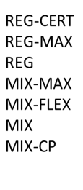
The projections show that the policy scenarios achieve primary energy savings between -38.3% and -39.6% in 2030, below the PRIMES 2007 projection.
Figure 13: Primary energy savings (wrt to PRIMES 2007 baseline)
  - Impact on renewables
The deployment of renewables is, with energy efficiency, one of the most important pillars of the energy transition. The policy scenarios involve explicit policies supporting the renewables in all sectors. As renewable technologies costs decrease over time as a result of the learning-by-doing process, the deployment is also a consequence of market forces as they gain in competitiveness over conventional technologies.
In the power sector, the support of renewables focus on technologies that have not yet exploited the learning potential, but also include horizontal measures for all renewables regarding infrastructure development, licensing, support of electricity storage as an essential complement of renewables, and market integration over all stages of the power markets, including balancing and ancillary services. The renewables in the power sector exceed 60% on average in the EU by 2030, which is higher than in the Reference scenario. In the longer term, the renewables exceed 80% in total electricity generation. Development of storage technologies, including the contribution of chemical storage based on hydrogen and e-fuels, is of critical importance to ensure reliability of power system operation, together with the expansion and full operation of the interconnected system over the broadest possible areas.
Figure 14: Projection of RES-E shares.
In the buildings sector, there are synergies between strong energy efficiency improvement and higher use of renewables, as heat pumps are likely to be the most cost-efficient choice for deeply renovated buildings. The policy scenarios include, in addition, specific policies promoting heat pumps in all sectors. The increase in the use of biomass for heating purposes is modest, due to environmental concerns and supply limitations. However, the modelling assumes that increasing the use of biomass is still possible in industry and district heating to a certain extent.
Compared to the Reference scenario, the policy scenarios project a significant increase in the RES H&C shares. They range between 36% to 42% in the policy scenarios in 2030, which is 3-9 percentage points higher than in Reference in 2030. The REG scenarios achieve 3-4 percentage points higher RES H&C shares compared to the MIX scenarios, as they include more intense renewable supporting policies.
Figure 15: Projection of RES H&C shares.
In the transport sector, the development of renewables relies on the blending of biofuels in the transport fuels supported by mandates which also promote advanced biofuels. However, the long term potential of biofuels is limited (due to biomass feedstock limitations and sustainability concerns). Apart from biofuels, source of renewable energy in transport are electricity, hydrogen and synthetic hydrocarbons of renewable energy origin. As a result of multipliers increasing the weight of their contribution, the projections show an impressive increase in the RES-T shares. For 2030, the projection for the policy scenarios shows RES-T targets reaching a range of 27% to 29%, which is 6-8 percentage points above the Reference scenario projection.
The role of ambient heat used in heat pumps within the RES H&C target is very significant in the medium term. In the longer-term, hydrogen and other RNFBOs, have an increasing contribution in the increase in the RES H&C shares. Compared to the Reference scenario, ambient heat from heat pumps increases considerably until 2030 and constitutes a decisive factor for meeting the RES H&C targets. As mentioned, the market penetration of heat pumps associates with energy efficiency improvement of buildings and in particular links to renovation undertaking. By 2030, the amount of RES from ambient heat is more than double compared to the Reference. The ambient heat amounts follow a much slower pace after 2030 compared to the period before 2030. The costs of the RFNBO are high in the medium term preventing them from getting a significant share in heat markets until 2030, in contrast with the longer-term period. As biomass is also stagnating, the RFNBOs exhibit a fast growth pace within the RES H&C in the longer-term.
Figure 16: Outlook of ambient heat used in heat pumps.
The calculation of the overall RES shares, according to the EUROSTAT calculator, divides the sum of renewables by gross final energy consumption. The overall RES-shares range between 38% to 40% by 2030 in the policy scenarios, which is 5-7 percentage points above the Reference scenario levels.
Figure 17: Projection of overall RES-shares.
  - Impact on the residential sector
Income growth drives an increase in useful energy services but thanks to energy efficiency improvement final energy consumption in all energy uses in houses is decreasing steadily over time. Measured by the ratio of final energy consumption per unit of income of households, energy intensity improves continuously and much above the performance under Reference scenario conditions. The decoupling of final energy consumption from income growth, observed already in the Reference scenario projection, is further pronounced in the policy scenarios. The decoupling is higher in the REG scenarios than in the MIX as a result of higher ambition of energy efficiency policies in the former. The ratio of energy over income decreases continuously also in the longer term and reaches a value more than three times lower than its level in the recent past.
Figure 18: Specific energy consumption relative to households’' income (toe/M€ '15).

The improvement of energy performance in houses is a result of three types of energy efficiency improvement, namely in the building envelope, the energy equipment and the electric appliances. Accelerated renovation of the building envelope is the primary driver of energy savings in terms of both share of stock renovated and the depth of energy savings. Renovation of the building envelope counts for roughly more than half of total savings. Energy efficiency improvement takes place also for new buildings as a result of enforced application of stringent building codes. The choice of energy equipment considerably shifts in favour of advanced efficient technologies, among which advanced heat pumps with high coefficient of performance values emerge as a preferred choice for well-renovated houses. The assumed further stringency of eco-design standards enables choice of highly efficient appliances and lighting. The energy efficiency improvements for all three types are in the policy scenarios significantly higher than in the Reference already until 2030. They are also considerably above Reference scenario trends in the longer-term.
The acceleration in renovation of houses and the increase in the depth of energy savings is the primary energy efficiency measure in the residential sector. The potential to tap on in the policy scenarios is significantly higher than the renovation plans included in the NECPs and mirrored in the Reference scenario projection. The ensuing supporting policies will evidently have to considerably accentuate compared to the NECP. The renovation rates of the building envelope increase in the policy scenarios by more than one percentage point annually until 2030, relative to the Reference scenario. The pace of renovation continuous after 2030 until the end of the projection horizon, while it decelerates under the Reference scenario conditions. The annual rate of building envelope renovation is roughly 0.5 percentage point higher in the REG scenarios than in the MIX.
The following figures show the projections for renovation rates in houses.

Figure 19: Projection of renovation rates in houses.

Figure 20: Energy savings from renovation of houses.

Figure 21: Energy consumption in houses for heating and cooling, on average per household (in toe/household).

Figure 22: Number of houses by heating equipment (Million).
Figure 23: Final Energy Demand in houses (Mtoe).

  - Impact on the services sector
Thanks to energy efficiency improvement, final energy consumption in the services sector steadily decreases over time although value added growth drives an increase in useful energy demand. Decoupling of growth and energy consumption is already in the Reference scenario. The delinking is further pronounced in the policy scenarios; it is higher in the REG scenarios than in the MIX as a result of higher ambition of energy efficiency policies.
The energy savings stemming from the renovation of the building envelope in the services sector account for roughly more than 20% of total energy savings in the sector. The energy efficiency improvement due to renovation is significantly higher in all scenarios compared to the Reference, and particularly for public services buildings.
Nonetheless, renovation of office buildings plays a relatively smaller role than in the residential sector, given that the office building usually have a faster capital turnover than houses. To this respect, enforcement of stringent building standards is of great importance for energy efficiency.
Figure 24 Specific energy consumption in services sectors relative to value added (toe/M€)
The shift of heating and cooling equipment choice towards advanced and highly efficient technologies (with a strong contribution of heat pumps) allow very significant energy efficiency progress in office buildings. The contribution of equipment to overall efficiency gains is much higher than that of renovation of the building shell.
The specific electricity uses increase in all services sectors much above total energy demand. This increase includes electricity used in data centres, which account for an increasing share of total energy consumption in the services sector. All policy scenario variants include specific electricity efficiency performance standards for data centres.
In the Reference scenario, there is a significant increase in the share of stock undertaking renovation, mirroring the renovation plans included in the NECPs. However, there is significant potential still untapped of building renovation in the services sectors, which is assumed to be exploited in the policy scenarios thanks to the inclusion of high ambition energy efficiency policies. The renovation rates of the building envelope in the services sector roughly double in the policy scenarios until 2030, relative to the Reference scenario. Renovation rates are particularly high in the scenario MIX-MAX, which includes additional measure of higher ambition for Article 5.
Figure 25 Renovation rates in services sector.

As already mentioned, the policy scenarios assume both higher stringency and better enforcement of eco-design standards as well as energy performance standards for data centres. Consequently, the projections show a significant improvement in specific energy consumption of the appliances and lighting, reaching in the policy scenarios 5-10 percentage points above the Reference scenario in 2030.
The electrification trend in the services sector is evident in the Reference scenario projection and its pace accelerates in the policy scenarios. Already in the Reference scenario, electricity represents more than half of the total consumption in the services sector in 2030, 5 percentage points above its market share in 2015. The policy scenarios need to increase further electricity’s market share between 7 and 9 percentage points in 2030, above the Reference.
As a result of electrification, all fossil fuels see diminishing market shares. Solids and liquids are shown to vanish, whereas the use of gas also declines to a certain extent, due to electrification but also to cost of decarbonising gas distribution. However, the use of more expensive gas fuels, such as biogas, hydrogen and synthetic methane is by assumption modest until 2030.
The volume of renewables slightly increases in the policy scenario compared to past years but remain lower than in the Reference due to higher electrification included in policy scenarios. The substitution away from renewables concern in particular biomass due to air pollution impacts and does not concern solar and geothermal applications.
The district heating expansion plans are part of the Reference scenario, similarly to the assumptions for the residential sector. The network expansion coverage implies an increase in distributed heat volumes in the services sector, compared to past years.
Figure 26 Fuel mix in services sectors - Final Energy Demand in services sectors (Mtoe)

  - Impacts on the Industrial sector
Several policy drivers influence the restructuring of energy consumption in industry but the most important factor of technology change and investment in competitiveness. The energy efficiency improvement is to a large extent embedded in the turnover of productive capital vintages, which in general is slow (in particular in energy and capital-intensive industries).
A policy instrument of major importance in industry is the EU ETS carbon pricing, which is a sufficient incitation for the industry to internalise carbon costs in the calculation of industrial production costs. The energy-intensive industries are subject to EU ETS obligations and are modelled to adjust their cost-benefit evaluations accordingly. Positive anticipation of future carbon costs is among the relevant policy drivers to promote the choice of advanced and highly energy efficient or low carbon technologies. However, enabling conditions and facilitating legislation are also important, as well as policies favouring recycling and circular economy patterns.
All these multifaceted enabling policies are assumed to be deploying successfully in the policy scenarios and to a significant extent to also part of the Reference scenario projection. The policy scenarios include additional effort regarding material recycling in the economies and the emergence of circular economy features. Regarding recycling, the policy scenarios assume an extensive exploitation of potentials, for the metals, cement, paper and glass.
Direct energy saving investment is a meaningful intervention, to a certain extent independently of the replacement of the productive capital vintage. The potential of improving energy efficiency via direct saving measures is significant and relatively untapped, according to several recent studies which identify untapped energy savings, in particular for heat, as of 10-12% of total energy consumption in the European industry.
Energy savings is also enabled in the policy scenarios via auditing and other obligations acting in addition to Reference scenario conditions. In the maximum effort scenario variants, the included assumption envisages stronger enforcement and scope extension of auditing and control policies.
The overall impacts of the changes in industry indicate that energy efficiency, measured by the ratio of total final energy consumption (including blast furnaces) over total value added in industry, decreases in the Reference by approximately 20% in 2030 compared to 2015 and further decreases in the policy scenarios by roughly 10% in 2030 compared to the Reference. The policy scenario project this energy efficiency indicator to become in 2050 approximately 50% lower than in 2015.
Figure 27 Final energy demand in industry by fuel

The fuel in industry changes smoothly over time in the policy scenarios. The inertia of restructuring is higher compared to the buildings sector. The use of solid fuels until 2030 slightly decreases in the policy scenarios compared to the Reference, but in the long-term abolishment of solids is possible thanks to the use of hydrogen and other sustainable fuels in high enthalpy heat uses. The projections show a persisting electrification tendency, which is slow until 2030 and accelerates only in the long-term. The gaseous fuels see small reduction in market shares in industry until 2030. The gaseous blend becomes climate neutral in the long-term including hydrogen. The direct use of renewables increases only slightly in the future; the use of waste energy feedstocks in industry faces limitations due to absence of support and carbon taxation of non-renewable waste.
  - Impact on the Transport sector
The evolution of transport activity, measured by passenger-km and tons-km has been closely related to GDP growth, since many years. The decoupling of mobility from economic growth is very slow for passenger travelling and almost inexistent for freight transport. The high values of the income elasticity of long-distance travelling of passengers has sustained the increase in aviation and fast rail, which partly substituted other modes without effecting any decrease in total mobility. The freight transport mobility is remarkably linked with GDP growth.
A possible source of energy efficiency improvement are structural changes in modal shifts, such as soft transport modes, public transport, vehicle sharing and freight transport logistics. All such changes imply a reduction in energy consumption per unit of passenger and transport mobility. However, such changes are difficult and slow due to several causes including inflexible habits, infrastructure limitations, economic structures. The policy scenarios include assumptions about structural changes in transport modes that allow for energy efficiency gains. The assumptions about such changes are however prudent and mainly take place in the long-term.
In parallel, the scenarios foresee a considerable change in the technology paradigm of car mobility, based on the electric powertrains, which embed high energy efficiency gains compared to conventional technologies. The carbon emission standards, considered as a major policy tool, induces energy efficiency improvement also for conventional technologies.
The gains are somehow limited in the horizon of 2030 and take place to a large extent in the Reference scenario, which by 2030 decreases specific energy consumption per unit of mobility by roughly 25% relative to 2015 for both passenger and freight transport. The policy scenarios achieve modest additional energy efficiency gains above Reference scenario levels, in 2030. However, in the long-term, the policy scenarios succeed to drop specific energy consumption by 68% for passengers and 55% for freight, down from 2015 levels.
The specific energy consumption performance of car technologies evolves in the future, as expected, also for conventional technologies. However, the impressive improvement of energy efficiency of car mobility achieved in the policy scenarios is due to change in the vehicle mix in favour of the electric cars, which need much less energy than conventional technologies and also significantly below energy consumption of fuel cells. Figure 28 shows the improvement in specific energy efficiency for cars and Light Duty Vehicles (measured in energy consumed per millions of passenger kilometre).
Figure 28 Specific energy consumption of cars and LDV (toe/Mpkm)
The fuel mix in the transport sector changes significantly but only in the long-term. Achieving climate neutrality in transport is an endeavour of particular difficulty. All options are necessary to deploy, including biofuels that cover the most inflexible transport market segments, such as aviation and maritime, hydrogen and synthetic clean hydrocarbons and electricity-driven vehicles. In the long-term, the shares of fuels are different in the various transport market segments to accommodate technical constraints and resource limitations.
Figure 29 Final energy demand in transport by fuel (Mtoe)
  - Distributional impact for households
The decisions to renovate depend on the income of households. Low-income households have poor access to capital that implies high discount rates influencing renovation decisions negatively. Moreover, uncertainty and lack of information factors are particularly important for low-income households and affect renovation decisions negatively. The age and type of building also affect the decision to undertake renovations. PRIMES model represents mathematically decision making of different types of consumers. Based on this approach, noticeable differences emerge among the categories of consumers and houses regarding both the rate and the energy performance of buildings after renovation.
Renovation rates of the building envelope increase in all building classes in the policy scenarios in the period 2021-2030, compared to the Reference, as a result of the ambitious energy efficiency policies. In the Reference scenario includes the policies and measures of the NECPs and aims at achieving the renovation targets set out in the submissions.
In the policy scenarios, the policy context allows the reduction of risk factors which prevailed in the Reference and the MIX_CP scenario; there are enabling conditions that together with the ambitious energy efficiency policies incite also low-income classes to undertake energy efficiency investments. In the scenarios derived from MIX, carbon price also drives more low-income households to invest in energy efficiency of the building envelope as the effect of this additional cost is lower for high-income households. Figure 30 shows the average annual renovation rate for the 2026-2030 period for different income classes and building types.
Figure 30 Annual renovation of the building envelope (% of stock)
The energy efficiency policies in the policy scenarios enabling an increase in renovation, improve the affordability of energy expenses by reducing the energy consumption significantly and particularly for low and medium-income consumers. However, the differences in energy bills as a percentage of income that existed in the recent past continue to prevail even if in magnitude. Figure 31 shows the energy bill as a share of private income per income class.
Figure 31 Energy bill as a share of private income per income class (%)
Under the current assumptions about enabling conditions, the policy context of the Reference and the MIX_CP scenario suffices for inciting high-income consumers to undertake fairly deep renovation, but not for low-income consumers who require ambitious energy efficiency policies in addition to institutional measures to shift to deeper renovation. It should be noted that the level of energy savings shown in Figure 31 are generally not enough to repay house renovation, so other policies would are needed to trigger investments, especially for low-income households (energy savings alone, however, do not capture all the benefits of energy efficiency – e.g., reduced air pollution).
  - Impacts on GDP and investments of core policy scenarios
Energy efficiency policies are argued to bring important benefits both at employment and the economy. While reducing energy consumption and emissions, energy efficiency investment also lower energy bills for households and firms. Moreover, energy efficiency investments have the potential to boost employment and the activity of several industrial and services sectors. Energy efficiency investment has a high activity multiplier effect, and affects sectors which have relatively low exposure to foreign competition.
However, the financing of energy efficiency investment has been identified as of critical importance for the positive economic impacts. Poor financing conditions in the economy may cancel the expected positive impacts as a result of crowding-out effects of energy efficiency investment. In other words, lack of funding resources implies that other productive investment and expenditures reduce to allow for energy efficiency investment to be implemented. It is of particular importance for households to ensure that energy investment funding does not exert crowding-out effects, because in addition to negative net effects there is also risk of welfare losses. Table 22 shows investments in equipment and buildings.
Table 22 Building energy efficiency investments in REG and MIX scenarios
REG (additional to Reference / billion € 2015 per year) | 2025 | 2030 | 2035 | 2040 | 2045 | 2050
Equipment | 25 | 44 | 23 | 5 | 6 | 8
Buildings | 29 | 39 | 66 | 61 | 62 | 71
Total | 53 | 83 | 89 | 65 | 68 | 78
MIX (additional to Reference / billion € 2015 per year) | 2025 | 2030 | 2035 | 2040 | 2045 | 2050
Equipment | 28 | 5 | 1 | 6 | 0 | 0
Buildings | 19 | 34 | 46 | 42 | 39 | 39
Total | 47 | 39 | 47 | 48 | 39 | 39

The results show evidence of a positive role of energy efficiency investment for activity and employment, as building and materials sectors have a high Leontief multiplier compared to other investment and maintenance and services for energy efficiency are labour intensive.
To estimate the impact on GDP and employment of energy efficiency investments, the modelling framework based on the macroeconomic General equilibrium model GEM-E3 The version of the GEM-E3 model used for this analysis includes a fully-fledged representation of the banking and financial system. Modelling was carried out for the MIX and REG scenarios. As changes in macroeconomic aggregates are generally close for comparable scenarios, modelling was not carried out for other variants.
A sensitivity analysis has been carried out to analyse the dependence on financing conditions of the impacts of energy efficiency investment on GDP and employment. Two extreme stylised conditions were modelled: a “full-financing” case and a “self-financing” case. The latter implies adverse effects on the economy and employment as the funding of energy efficiency investment requires a reduction of other expenditures; this happens already in the early stages of policy implementation. The full financing case allows deferring the repayment in the longer-term and also assumes reduced costs of capital borrowing. These assumptions minimise crowding-out effects allowing Leontief multiplier effects and inducing positive growth and job creation. However, the model does close the financing accounts inter-temporally and thus debt raised to finance investment in energy and efficiency and renewables is fully repaid by the investors in the long-run. Figure 32 summarises the results of the GEM-E3 model for the MIX and REG core scenarios. Under the assumptions of the full-financing cases, the abundance and long-term horizon of funding implies minimum crowding out effects, whereas as in the self-financing case equity and cash flow of investors is the main source of funding. The self-financing case is not a realistic situation and is simulated in this study to illustrate the importance of easing financial conditions for funding energy efficiency investment. The full-financing case is more plausible in reality provided that appropriate policy supports applies.
Figure 32 GDP and employment impacts of the REF and MIX scenarios
The full-financing scenario conditions lead to positive, but small impacts on GDP and employment. The changes in GDP, in volume, is close to 0.6% in 2030 and for employment the increase is 0.4% in 2030.
The model-based analysis finds that the REG scenario has higher positive impacts on GDP and employment than the MIX scenario in the short and medium-term and lower negative impacts in the long-term. The REG scenario includes more ambitious energy efficiency and renewable supporting policies than the MIX and at the same time involves lower carbon taxation. The higher energy efficiency and renewables investment included in the REG, compared to the MIX, are beneficial for domestic activity and employment, while at the same time the budget impacts caused are lower in REG compared to the MIX that includes high carbon taxation. The results show that the recycling of auction revenues in the economy, which are higher in MIX than in REG, are not able to fully offset the negative economic effects of the budget impacts of the carbon tax. However, it should be noted that results are small (a fraction of GDP percentage point over many years) and critically depend on the assumptions about the effects of investment crowding out.

Main elements of the EED
Figure 33 Intervention logic of the existing EED
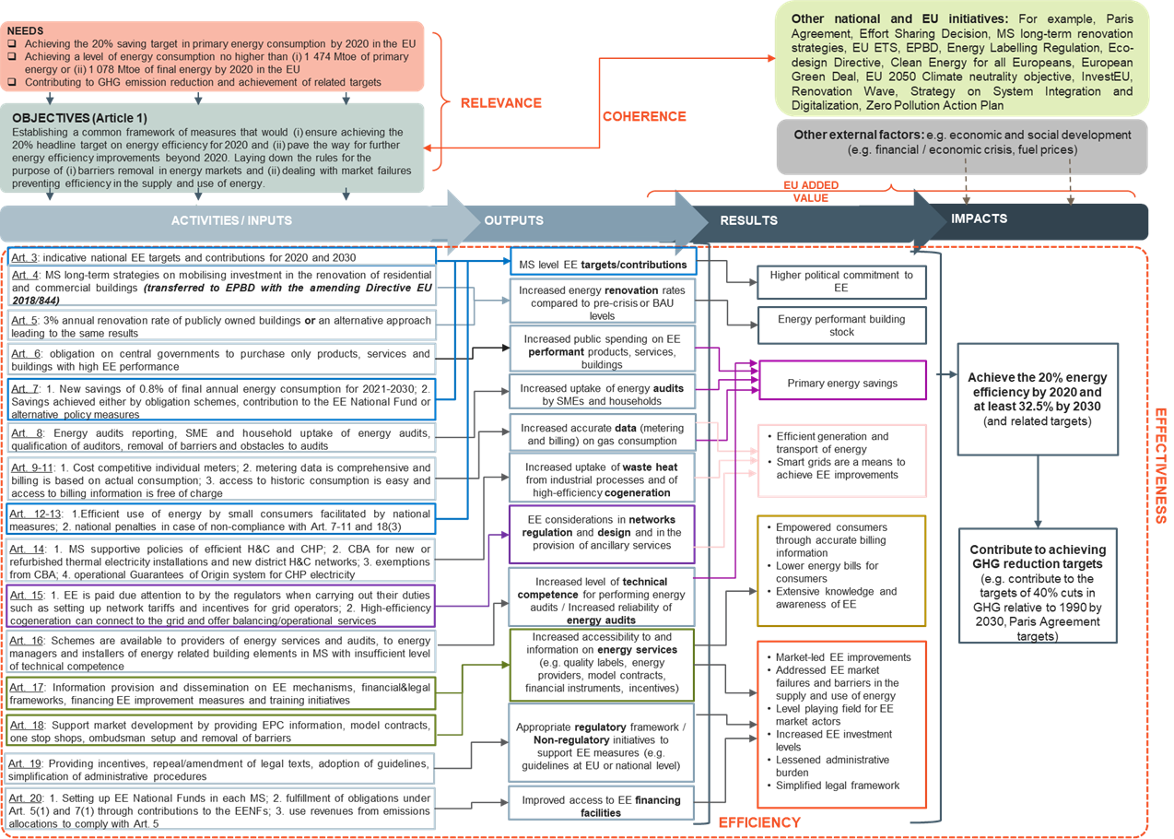
The overall energy efficiency target
This target sets out the envelope of energy efficiency that the Member States need to achieve. Some of this efficiency will result from normal market behaviour, but this is not sufficient, and this is why EU actions are needed. As there is an underlying rate of upgrading and replacement (e.g. cars have an average life of 14 years), there will be a slow improvement in overall energy efficiency and gradual energy saving (to the degree the efficiency improvements are not offset by increased activity). The level of these background efficiency will depend on how far end users are willing to invest in the most energy efficient processes, actions and devices. Member States will primarily need to intervene in the market to ensure that energy savings above this underlying rate are achieved to meet their overall target.
Energy Savings Obligation
Normal operation of markets will lead to a background level of energy efficiency improvements and a large share of this will be driven by EU level energy performance standards. The energy savings obligation, established in the EED require Member State to put in place energy efficiency obligation schemes and alternative policy measures, that means specific programmes, which will achieve a large proportion of the expected shortfall between the savings needed and the baseline savings due to natural replacement and upgrading.
Exemplary role of public buildings
In view of the essential role that improving the energy performance of buildings has, it is essential for the public sector to play an exemplary role. Public buildings may also be iconic and be visited by large numbers of people meaning that their improved energy performance may provide inspiration for others to upgrade the energy performance of their own buildings. Public buildings are estimated to consumer around 2% of final energy consumption in the EU.
Supporting markets
Through its requirements to better take account of energy efficiency in public procurement, the EED ensures a demand for more energy efficient products and sends a signal to market operators. The EED also requires Member States to carry out certain activities in specific important areas (e.g. district heating and cogeneration) to help identify the potential for energy savings and the economic attractiveness of it.
Enabling framework
There are many barriers to implementing energy efficient improvements, like, for example, an imperfect access to capital, the lack of proper information, split incentives, the disproportionate perception of hidden costs. Because of these, the rate of action is lower than desirable. To reduce those barriers, the EED requires Member States to carry out actions to create an enabling framework for the promotion of energy efficiency. These include provisions on qualification, accreditation and certification ensuring that there are appropriately qualified personnel available and that for example energy audits are robust and reliable.
Provision of information
Lack of knowledge about the potential for energy efficiency improvements and the economic benefits from it is an important obstacle. While it is addressed in certain areas through – for example – the requirements on energy labelling of products and cars, this is obviously too limited. There are, in fact, more fundamental needs, such as ensuring consumers have good information over their own energy consumption and that they are able to control it. They also need independent advice on actions that they can take to reduce their energy consumption, which may be beyond individual end users knowledge. More information on financial means to increase energy efficiency is also necessary. The EED therefore creates obligations for Member States to ensure that these sorts of information are provided to the end users in need of it.
Finance
A key barrier to undertaking energy efficiency investments is to finance them since there will always be an up-front cost that has to be repaid over time through the energy savings. The EED therefore requires Member States to ensure that appropriate actions are taken to assist in financing these investments.

Underachievement of targets
- The energy efficiency ‘ambition gap’
EU Member States agreed in 2018 to reach at least 32.5% of energy efficiency by 2030. However, the 2020 assessment of the final NECP shows that the energy efficiency aggregated ambition would amount to a reduction of 29.7% for primary energy consumption and 29.4% for final energy consumption, reaching 1176 Mtoe and 885 Mtoe respectively in 2030.
This means that national policies and measures as planned by Member States create a gap compared to the Union’s existing 2030 target of at least 32.5%. This gap still stands at 2.8 percentage points for primary energy consumption and at 3.1 percentage points for final energy consumption.
Of course, this ‘ambition gap’ in the NECPs does not necessarily mean that a higher energy efficiency target could not be achieved. It needs to be underlined that the ‘ambition’ gap identified in the NECPs does not reflect a “gap” de facto, but simply indicates that current Member States’ plans fall short of the required level (currently 32.5% by 2030). This is linked to the following factors:
- The general political situation is very different in 2021 than it was in 2016-2017 in relation to climate change and to the need to ensure a clean energy transition that does not leave anyone behind. As Member States have all endorsed the 55% climate target and as energy efficiency is a precondition of all decarbonisation scenarios, there is no reason to think that Member States would not adopt stronger policy measures with a higher energy efficiency target, also considering their positive effects on social issues, energy poverty and on addressing distributional effects;
- The measures in the existing legislation were adopted to allow reaching the 32.5% energy efficiency target. Member States were working, therefore, on the basis of these measures and of the 32.5% target when preparing the NECPs.

- Energy consumption trends
When it was clear that the EU was not going to meet its energy efficiency targets for 2020, the Commission set up a dedicated Member States’ Task Force to look into what efforts could be made to achieve the targets. The Member States broadly recognised the fact that the EU is currently not on track towards achieving the 2020 target for energy efficiency and that it is important to guarantee that the target is met. The Task Force presented an analysis on the reasons for the growth in energy consumption as well as possible pathways forward.
Although the trend between 2005 and 2020 is of decreasing energy consumption, in the years 2015, 2016 and 2017, final energy consumption rose. This increase follows five years of decrease (2010-2014). Possible and at least partial explanations are good economic performance, low oil prices, and cold winter and warm summers during some years. The main increase in energy consumption was observed in buildings followed by transport.
Between 2014 and 2016 energy use increased by 7.4% in the residential sector, which was explained mainly by colder winters. The Task Force report highlights that further analysis is needed to understand whether the increase in demand can also be attributed to life-style changes, such as an increased use of ICT. Comfort is stated as one of the explanations for increased energy consumption in public buildings. Following three years’ increase in primary energy consumption, in 2018 there was a decrease. This is again partly explained by weather conditions, as the weather was warmer in 2018. By 2018, primary energy consumption decreased in many Member States. The decline was thanks to decrease in the residential sector and in the services sector, whereas transport and industry saw an increase. In 2014, the demand for final energy actually decreased due to an exceptionally warm winter. Final energy consumption increased in 2018 compared to 2014.
Rising energy consumption in transport and industry were the main causes of the slowing progress towards the target in 2015-2017 at the end-use level. Energy use in the transport sector increased by 4.2% between 2014 and 2016. This is partly explained by increased passenger and freight transport due to good economic conditions and the trend towards large vehicles (SUVs). The industry sector saw a very small increase during the same period in spite of an increase in industrial production, which is partly explained by the fact that many energy-intensive companies already having introduced cost- and energy-efficiency measures following the financial crisis.
The 2020 Progress Report indicates that Member States saw economic and activity growth as plausible explanations to the increase in energy consumption in 2017. Other factors identified were increase in the population or the number of households, increase in households’ disposable incomes, and weather conditions.
- Shortfall to meeting 2020 targets
Final energy consumption in the EU28 fell by 5.8%, from 1194 Mtoe in 2005 to 1124 Mtoe in 2018. This is 3.5 percentage points above the 2020 final energy consumption target of 1086 Mtoe. Primary energy consumption in the EU28 decreased from 1721 Mtoe in 2005 to 1552 Mtoe in 2018 – a 9.8% drop. This is 4.65 percentage points above the 2020 target of 1483 Mtoe.
In 2019 primary energy consumption decreased for the second consecutive year. It was 1.7% lower than in 2018 but still 1.9% above the linear trajectory and 2.9% above the 2020 target level. Final energy consumption declined for the first time in six years. The yearly decline of 0.6% in 2019 was in line with the pace of linear trajectory to reach the 2020 target. However, given the accumulated gap the pace was not sufficient to bring the EU28 on track to reach the target: the actual consumption was 2.3% above the linear trajectory and 2.9% above the 2020 target level.
Based on the progress up to 2019 it could be assumed that the 20% energy efficiency target for 2020 would not be reached. However, because of the impact on the COVID-19 crisis, it is expected that energy consumption fell substantially in 2020 and the targets would be met. At present official data for 2020 are not available.
- Shortfall of measures in NECPs
EED Article 3 requires Member States to set an indicative energy saving target. The NECPs were developed by Member States to collectively achieve the agreed EU targets for 2030 (at least 32% renewable energy share, 32.5% energy efficiency improvement, and 40% greenhouse gas reductions ). The assessment of the draft plans in 2019 indicated a substantial ambition gap in the collective contributions of energy efficiency.
In 2018 and 2019, the Commission launched infringement proceedings against all Member States, for failing to comply with obligations under the EED. Most issues were clarified by the Member States and the infringements closed, but some remain open. Several Member States will most likely not meet their national energy savings obligations by December 2020, as required by Article 7 of the EED, but many introduced new measures and policies during 2019.
Member States have highlighted the need to fully implement existing legislation, to better mobilise EU structural and cohesion funding, and to undertake additional measures that would deliver quick savings, during meetings with the Task Force in 2019. In addition, for the 2030 targets, the need to put a stronger focus on ensuring that buildings undergoing major renovations achieve minimum energy performance standards was also emphasised.
The Commission’s assessment of the final Member States NECPs has concluded that the sum of the Member State commitments to reduce final energy consumption is not sufficient to achieve the EU target of 32.5% savings for 2030. The sum of commitments reached 29.4% leaving a shortfall of 3.1% to the existing target.
The absence of any overall binding obligation for each Member State in the current legal framework for energy saving reduces certainty over the energy savings that will be achieved. The persistent ambition gap indicates a need for additional EU-wide measures in line with the Governance Regulation, including through a possible revision of the EED.

Energy savings potentials
There is extensive material published on both technical and economically cost effective energy saving potentials. This annex provides a short overview of some of this material. It provides in the first section an overview of actually implemented energy efficiency investments and the payback times and cost-effective of these.
- The DEEP platform
The Energy Efficiency Financial Institutions Group (EEFIG) was established in 2013 by the European Commission and the United Nations Environment Programme Finance Initiative (UNEP FI). EEFIG is composed of over 300 representatives from more than 200 organisations - spanning public and private financial institutions, industry representatives and sector experts and aims to accelerate private finance to energy efficiency.
EEFIG aims to develop practical tools to facilitate the energy efficiency market. AS one of these, EEFIG has developed the De-risking Energy Efficiency Platform (DEEP). The DEEP Database is intended to support financial institutions in energy efficiency investment decisions. It is an open-source database for sharing and transparent analysis of energy efficiency investments, performance monitoring and benchmarking. The data comes from actual projects carried out with the costs and energy savings identified.It provides an improved understanding of the real risks and benefits of energy efficiency investments by providing market evidence and investment track records.
It includes more than 15,000 energy efficiency projects (7,767 in buildings and 9,421 in industry) from 30 data providers. Overall these show that the investments in buildings have a median payback time of 5 years and an avoidance cost of 3.1 cents/kWh. For industry the projects have a median payback time of 3.4 years and an avoidance cost of 2.7 cents/kWh.
Table 23 and Table 24 below provides aggregated figures from these projects on the payback times for different types of measures and company sizes.
Table 23 Observed payback time for energy efficiency investments in businesses
Payback time per measure (investment in EUR / energy saving in EUR per year)
EE measure type | median
Motors | 1.9
Metering, Monitoring and Energy Management | 2.3
Cooling | 2.4
Heating | 2.4
Power Systems | 3.0
ICT | 3.1
Pumps | 3.3
Compressed Air | 3.8
Other | 4.0
Refrigeration | 4.0
Waste heat (without power generation) | 5.2
Street Lighting | 5.6
Payback time per enterprise size (investment in EUR / energy saving in EUR per year)
Enterprise size | median
Large enterprises(250+ employees) | 2.6
Small enterprises(10-49 employees) | 2.8
Micro enterprises(<10 employees) | 3.1
Medium enterprises(50-249 employees) | 4.1

Table 24 Observed payback time for energy efficiency investments in buildings
Payback time per measure (investment in EUR / energy saving in EUR per year)
EE measure type | median
Lighting | 3.0
HVAC Plant | 3.3
Building Fabric Measures | 11.1
Integrated Renovation | 13.5
Payback time per building type (investment in EUR / energy saving in EUR per year)
Building type | median
Wholesale and retail trade | 3.0
Other single family dwellings | 3.0
Office buildings | 3.1
Hotels & restaurants | 3.2
Industry | 3.2
Not Specified | 3.3
Health care | 4.5
Educational buildings | 5.8
Public buildings | 8.3
Multi-family buildings 1-4 storeys | 11.9
Multi-family buildings 5+ storeys | 14.1
Unit energy saving per measure type (EUR/m²/year)
EE measure type | median
Lighting | 1.98
Building Fabric Measures | 4.86
Integrated Renovation | 8.79
HVAC Plant | 22.20

- Studies on the energy efficiency potential at national and sectoral level
There are very many assessments of the potential available for energy savings from the further deployment of currently available energy efficient techniques. These differ from other assessments exploring the further potential to improve the energy performance of appliances and products that are by their nature more speculative.
DG ENER currently has a report under preparation by ICF consulting to estimate the technical and economic energy savings potential by sector and Member State. The tables below are taken from the draft report and compare the technical and economic reduction potential to the projected energy consumption in 2030 from the 2016 EU reference scenario.
Figure 34 Estimated sectoral technical and economic energy savings potential by 2030
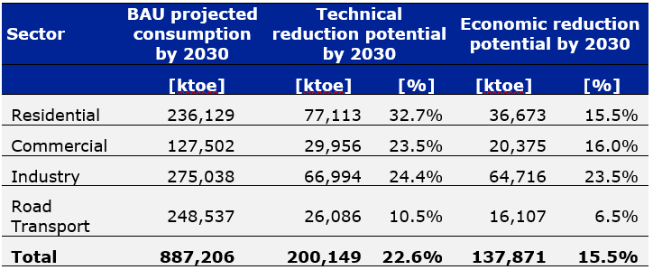
Figure 35: Estimated technical and economic energy savings potential by 2030 by Member State
It should be noted that these assessments are based on existing technology. They do not assume new technology or future cost reductions.
Another recent research paper reviews a significant number of energy efficiency potential studies. While it shows that comprehensive national energy efficiency potentials studies are rare and difficult to compare, it concludes that the existing studies agree that significant energy efficiency potential exists in the EU.
Assuming low policy intensity, energy savings between 10 and 28% could be realised by 2030 compared to a baseline development. However, in order to achieve higher savings of up to 44%, high policy intensity is necessary. Technical energy efficiency potentials in the different EU Member States range from 14 to 52%, as presented in the table below.
Figure 36: Energy efficiency potentials in the EU Member States until 2030 according to different energy and climate scenario studies, in per cent of final energy demand reduction versus the respective baseline
- Energy saving potential in business
It is often speculated that because business in general and industry in particular are economically driven sectors where energy is often an important cost, that it should be expected that there will not be unexploited cost-effective potential. These sectors have also been subject to emissions trading which provides a further economic incentive to implement available energy efficiency measures. While the energy use trends show the most improvement in the industry sector compared to others, the evidence identified in DEEP and also presented below show that there is still substantial available cost-effective potential.
- Industrial heat
A large share (around 2/3) of energy use in industry is for heat. Energy saving potential exists for reusing waste heat for other purposes and for avoiding the loss of useful heat. Waste heat may be reused for example through district heating, industrial symbiosis or even the use of heat exchangers within an installation to recycle heat.
With regard to avoiding heat losses, the European Industrial Insulation Foundation supports the performance of industrial insulation audits and estimates a potential 14 Mtoe of cost effective savings from heat insulation (about 6% of all industrial energy use).
- Electric motors
Electric motors are another important energy using area using around 70% of manufacturing electricity consumption globally. In view of this considerable effort has been made in defining energy performance standards for new motors.
Figure 37 below shows the market share of new motors by efficiency class as a result of eco-design legislation.
Figure 37 New motor sales share by efficiency class
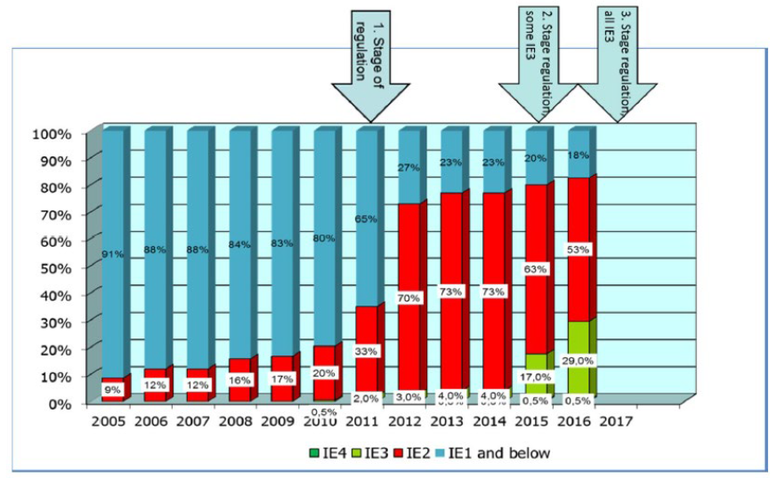
Motors meeting higher energy classes are significantly more efficient, especially at part load as illustrated in Figure 38 below.
Figure 38 Efficiency of electric motors by efficiency class
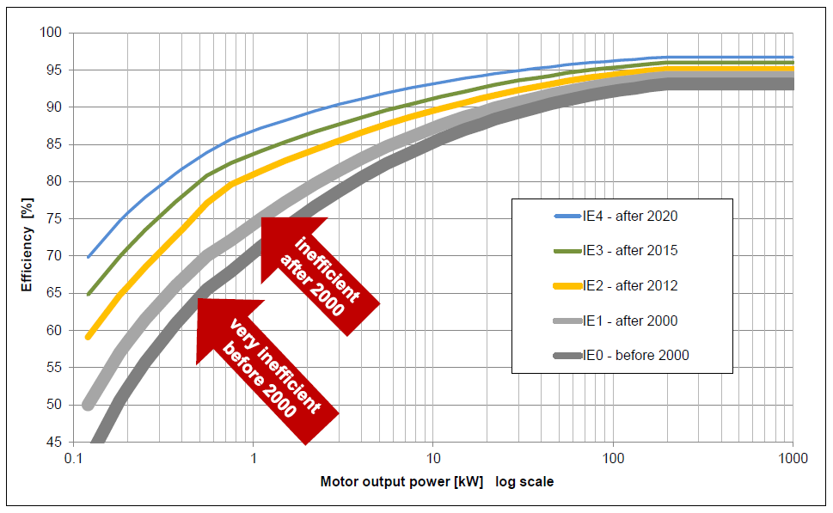
However, because of lengthy motor lifetimes (shown in Figure 39 below) it will take a long time for the full potential energy savings to be realised without incentives to speed up replacement. In Sweden it is estimated that old motor replacement could save 4 TWh/year.
Figure 39 Observed age of electric motors in use
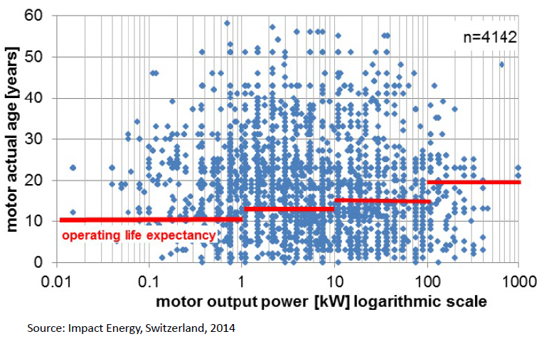
Another example of the potential for motor replacement is in ventilation and air conditioning systems. These account for a significant share of building energy use and outdated fans are one of the main causes of excessive energy consumption in existing air conditioning and ventilation systems. Replacing old fans with modern, energy-efficient fans can save up to 50% energy. In a German example, more than 50% of air conditioning system inspections pointed to the desirability of fan replacement and the cost savings lead to short payback times.

Mechanism to reduce energy consumption
In view of the high importance of reducing energy consumption for the EU as explained in section 1.2, a number of pieces of EU legislation along with the EED and measures also taken at Member State level aim at this general objective. Annex M contains a short description of these main relevant other EU instruments and policies.
In simple terms, the total EU energy use is the result of the energy efficiency (the desired service per unit of energy used) of the energy using devices in the EU multiplied by the amount they are used. This is illustrated in Figure 40 below.
Figure 40 Schematic representation of mechanisms to reduce the consumption of energy-using devices
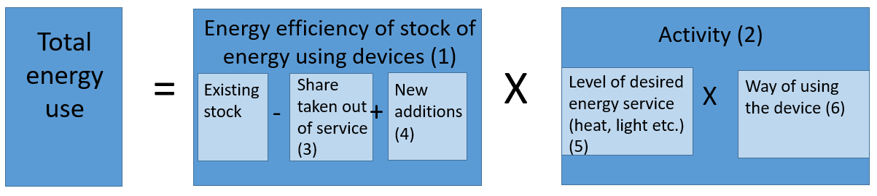
Energy using devices range from the massive (industrial steam boilers or combustion plants) to the tiny (mobile phones or bulbs).
To reduce energy consumption, it is possible to address many different elements of this equation. For example, the energy efficiency of devices in service (1) may be affected by measures that increase the rate at which existing devices are taken out of service (3) for example through scrapping schemes. They can be influenced by the rate of new additions to the stock (4) and their efficiency. The overall energy consumption can also be reduced by decreasing the overall activity (2). This may be a result of changes in the cost of carrying out the activity or by other changes that alter the desired level of service (5). Finally, the way in which devices are used may be influenced (6), for example through the provision of information.
The majority of relevant EU legislation affects the energy efficiency of the new energy using devices. The key mechanisms are illustrated in Figure 41 below. The main mechanism is through the setting of minimum energy performance standards (1). This is done for example through Eco-design for appliances, while road vehicle CO₂ legislation for cars and commercial vehicles addresses the new fleet average efficiency.
A second key mechanism is through the provision of energy consumption information (2). Examples of EU requirements for this are the car labelling Directive, the Energy and Tyre labelling Regulations and energy performance certificates for buildings (EPBD). Finally, energy prices will influence choices over energy efficiency and are partly the result of market forces and partly the result of taxation both at EU level (ETD), national level and the cost of ETS allowances.
Figure 41 Mechanisms to affect the energy efficiency of new energy-using devices
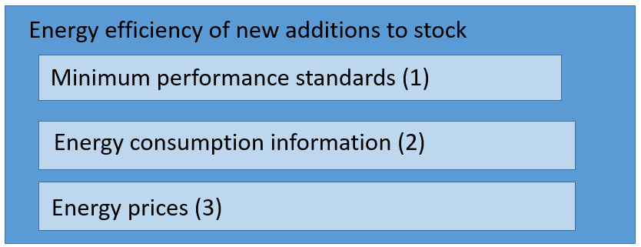
However, it is important to note that none of these instruments creates any obligation to either accelerate the rate at which energy using devices are replaced or to exceed minimum performance standards if they are replaced, nor they are foreseeing an energy efficient development of processes. If the rate of retirement of older higher energy consuming devices is accelerated then their replacement with more efficient ones will lead to lower energy use. But, since there will be a range of performance available for new devices (such as the A to G energy label range), it is also possible to accelerate the rate of reduction of energy use by encouraging the replacement devices to be better energy performing. Both mechanisms can be used simultaneously.
The level of desired or needed energy service (5) is more exogenous. However, it too can be influenced. For example, measures to promote the integration of data centres in urban planning and their contribution to district heating systems reduces the need for heat in buildings. Other measures such as urban planning and mobility measures can reduce the need for motorised mobility.
The way of using energy using devices (6) is also a relevant factor. A lack of knowledge may mean that driving is carried out inefficiently or there is a poor understanding of how to achieve desired temperatures in a building without wasting surplus heat. These are not types of activity carried out at EU level since they require communicating with end users but are typically organised at Member State level or more locally.

Energy savings obligation
- Scope of the energy savings obligation
In view of the climate and energy framework for 2030, the EED has extended the energy savings obligation beyond 2020. While the rate of new annual energy savings in the first obligation period (2014-2020) is the same for all Member States (i.e. 1.5%), this is not the case in the second period (2021-2030). Member States are required to achieve cumulative end-use energy savings for the entire obligation period 2021 to 2030, equivalent to new annual savings of at least 0,8% of final energy consumption. Malta and Cyprus have a lower yearly energy savings obligation.
That requirement could be met by new policy measures that are adopted during the new obligation period from 1 January 2021 to 31 December 2030 or by new individual actions as a result of policy measures adopted during or before the previous period, provided that the individual actions that trigger energy savings are introduced during the new period. To that end, Member States should be able to make use of an energy efficiency obligation scheme, alternative policy measures, or both. Whether a Member State decides to use an energy efficiency obligation scheme or adopt alternative policy measures, it must ensure that the policy measures are eligible to achieve the required cumulative end-use energy savings by 31 December 2030. Member States have the flexibility to target one or more specific sector(s) in order to meet the energy savings obligation.
For the purpose of the integrated NECPs, Member States must assess the number of households in energy poverty in accordance with Article 3(3)(d) of the Governance Regulation. Under Article 7(11) EED, when designing policy measures to meet their energy savings obligations, Member States are to take account of the need to alleviate energy poverty by requiring, as far as appropriate, that a proportion of policy measures be implemented as a priority among vulnerable households, including those affected by energy poverty and, where appropriate, in social housing.
Article 7(9) EED requires Member States to ensure that energy savings resulting from policy measures referred to in Articles 7a, 7b and 20(6) EED are calculated in accordance with Annex V EED. The additionality requirement needs to be taken into account when determining energy savings for all kinds of policy measures. The basic principles are set out in Annex V(2)(a) and (b) EED.
In addition to the additionality principle, Member States need to satisfy the ‘materiality’ criterion. Annex V, part 1 EED sets out methods for calculating energy savings other than those arising from taxation measures for the purposes of Articles 7, 7a, 7b and 20(6) EED. For determining the energy savings from tax related policy measures introduced under Article 7b EED , the principles in Annex V(4) EED apply. Annex V(2), point (i) EED provides that Member States need to take into account the lifetime of the measures and the rate at which the savings decline over time in their the calculation of energy savings.
Following the amendment of the EED in December 2018, Member States were obliged to transpose new rules on energy efficiency obligation schemes (i.e. the new Articles 7, 7(a) and 7(b) by 25 June 2020.
Since the beginning, Article 7 has been a pivotal provision of the EED as was estimated in the impact assessment of the EED that this provision would be responsible for more than a half (85 Mtoe of primary energy consumption in 2020) of the energy savings the Member States should achieve under the EED. The energy savings obligation can be fulfilled by delivering energy savings from all sectors of the economy, with a wide range of policy instruments, across all technologies and non-technological efficiency interventions. The wide-ranging nature of Article 7 EED, the way in which it interacts with other efficiency policies, the requirements for monitoring and verification of energy savings and the additionality requirement make the energy savings obligation the most important component of the EED in terms of its contribution. Article 7 EED encourages Member States to implement policy measures which go beyond the requirements provided in EU law. Article 7 EED provides flexibility to Member States for choosing the type of policy measure which fits best to national characteristics, and is one of the key policies with a great outreach to the end-consumers, e.g. via information campaigns or behavioural measures which are eligible under Article 7 EED.
- Member States´ progress towards fulfilling the energy savings obligation (period 2014-2020)

- Cumulative energy savings required by 31 December 2020
For the period 2014 to 2020, Member States notified the following cumulative amounts of energy savings to be achieved under Article 7 EED by 31 December 2020.
Figure 42 Cumulative energy savings to be achieved under Article 7 EED
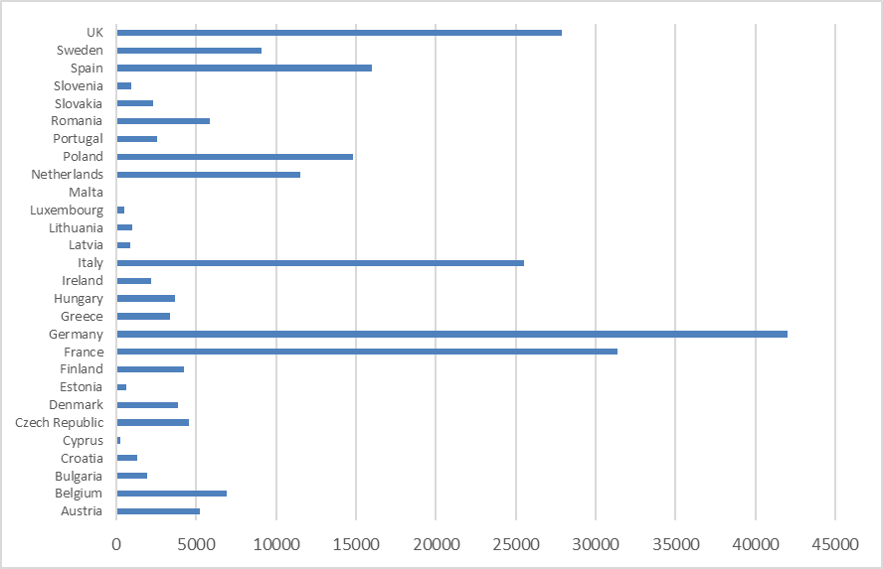
Source: DG ENER´s assessment; national cumulative savings requirements by 2020 in ktoe
Based on the assessment of the energy savings notifies by Member States to the Commission in their annual reports, Member States achieved by the end of 2018 about 55% (126.44 Mtoe) of the sum of the cumulative end-use energy savings obligations for 2014-2020 (230.17 Mtoe) aggregated at EU-level.
Table 25 Progress by Member States towards their cumulative energy savings targets
Country | Progress towards the cumulative savings requirement
 | National cumulative savings requirements by 2020 (target) | Progress towards total cumulative savings requirement by 2020 (taking into account actions implement-ted over 2014–2018) | Required cumulative savings for 2018 on the basis of average yearly delivery (benchmark = constant rate of new annual savings; lifetime > 7 years) | Reported savings compared to estimated cumulative savings for 2018 on the basis of average yearly delivery (progress vs. benchmark) | Required cumulative savings for 2018 on the basis of average yearly delivery (benchmark = constant rate of new annual savings; lifetime = 1 year) | Reported savings compared to estimated cumulative savings for 2018 on the basis of average yearly delivery (progress vs. benchmark)
Austria | 5 200 | 80% | 2 786 | 149% | 3 714 | 112%
Belgium | 6 911 | 56% | 3 702 | 105% | 4 936 | 79%
Bulgaria | 1 942 | 26% | 1 040 | 48% | 1 387 | 36%
Croatia | 1 296 | 45% | 694 | 85% | 926 | 64%
Cyprus | 242 | 67% | 130 | 125% | 173 | 94%
Czech Republic | 4 565 | 37% | 2 446 | 69% | 3 261 | 52%
Denmark | 3 841 | 83% | 2 058 | 155% | 2 744 | 116%
Estonia | 610 | 61% | 327 | 113% | 436 | 85%
Finland | 4 213 | 112% | 2 257 | 208% | 3 009 | 156%
France | 31 384 | 56% | 16 813 | 104% | 22 417 | 78%
Germany | 41 989 | 51% | 22 494 | 96% | 29 992 | 72%
Greece | 3 333 | 41% | 1 786 | 76% | 2 381 | 57%
Hungary | 3 680 | 47% | 1 971 | 88% | 2 629 | 66%
Ireland | 2 164 | 65% | 1 159 | 121% | 1 546 | 91%
Italy | 25 502 | 50% | 13 662 | 93% | 18 216 | 70%
Latvia | 851 | 65% | 456 | 121% | 608 | 91%
Lithuania | 1 004 | 54% | 538 | 100% | 717 | 75%
Luxembourg | 515 | 22% | 276 | 41% | 368 | 31%
Malta | 67 | 71% | 36 | 132% | 48 | 99%
Netherlands | 11 512 | 68% | 6 167 | 126% | 8 223 | 95%
Poland | 14 818 | 60% | 7 938 | 112% | 10 584 | 84%
Portugal | 2 532 | 20% | 1 356 | 37% | 1 809 | 28%
Romania | 5 817 | 23% | 3 116 | 43% | 4 155 | 32%
Slovakia | 2 284 | 62% | 1 224 | 116% | 1 631 | 87%
Slovenia | 945 | 47% | 506 | 88% | 675 | 66%
Spain | 15 979 | 44% | 8 560 | 81% | 11 414 | 61%
Sweden | 9 114 | 51% | 4 883 | 95% | 6 510 | 71%
Total (EU) | 202 310 | 54% | 108 380 | 100% | 144 507 | 75%
United Kingdom | 27 859 | 66% | 14 924 | 124% | 19 899 | 93%
Total (EU and United Kingdom) | 230 169 | 55% | 123 305 | 103% | 164 406 | 77%
Source: DG ENER´s assessment (November 2020), progress towards the cumulative savings requirement in the Member States
Based on the assessment of the last annual reports Member States submitted in 2020, it appears that five Member States are very unlikely to meet their energy savings target in 2020 if no additional actions are taken. Another nine are unlikely to fulfil the energy savings obligation by the end of 2020. On the other side, four Member States and UK are likely and nine Member States are very likely to meet their energy savings target. In total, 14 countries will likely or very likely meet their energy savings target. According to Article 27 of the Governance Regulation, each Member State shall report to the Commission on the achievement of its required amount of energy saving (obligation period 2014-2020) by 30 April 2022.
- Policy measures implemented by Member States in the period 2014 to 2020
Five Member States (Denmark, France, Luxembourg, Poland, and Sweden) notified only one policy measure, all of them but one (Sweden implemented energy and carbon taxes) implemented energy efficiency obligation schemes (EEOS). Six countries reported more than 25 policy measures. All countries with more than 10 policy measures reported a mix of at least five different instrument types.
Member States implemented 463 (total number) policy measures by 2018. The majority of the reported policy measures (50%) are financing schemes/instruments. The other half of notified policy measures refers to other instrument types. EEOS count for 4% of the number of policy measures implemented. Energy labelling schemes have been rarely chosen as an instrument.
While EEOS represent only 4% of the number of policy measures implemented, the assessment of energy savings achieved by the different types of policy measure show that EEOS contribute to around 35% of energy savings. The share of energy savings achieved by financing schemes is around 12%, and energy and CO₂ taxes result in 16%.

Figure 43 Breakdown of the number of reported measures by type
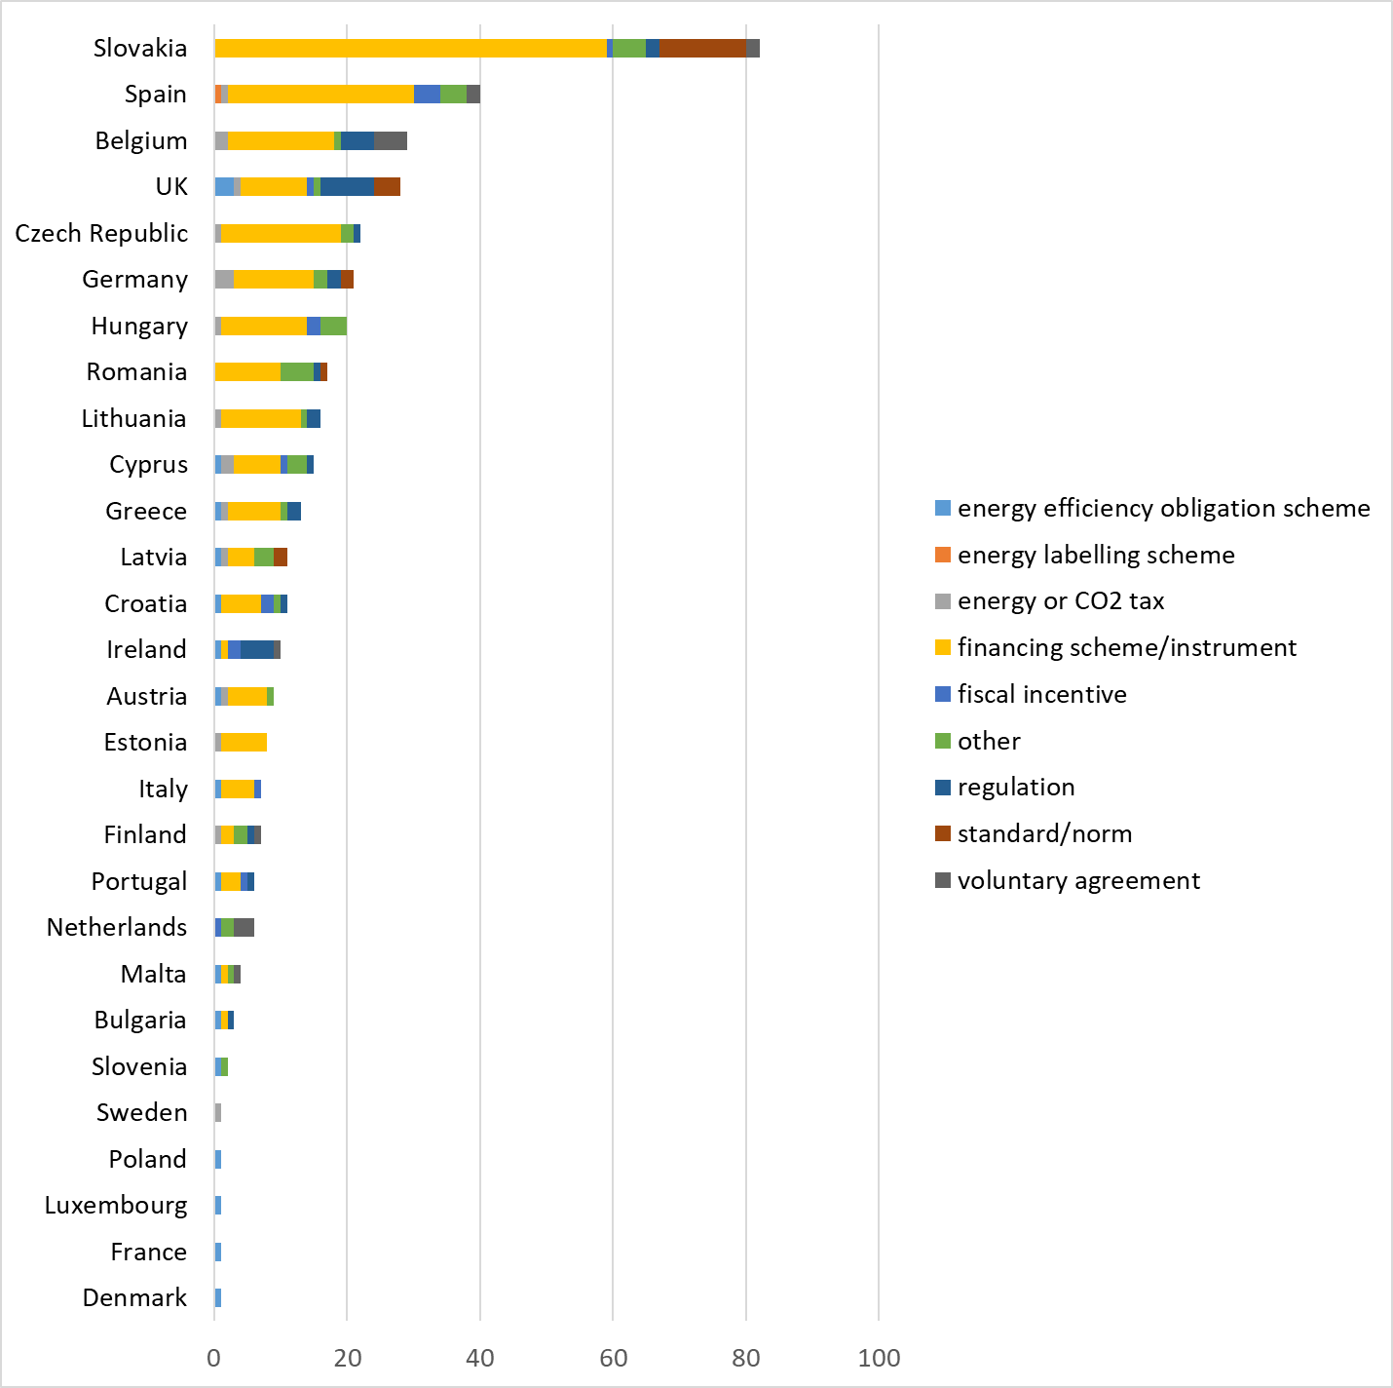
Source: DG ENER assessment (November 2020), number of reported policy measures by Member State
Figure 44 Breakdown of all reported measures by instrument type
Source: DG ENER assessment (November 2020), number of reported policy measures by instrument type aggregated at EU level
Figure 45 Share of reported energy saving by type of measure
Source: DG ENER assessment (November 2020); share of reported energy savings by type of policy measure aggregated at EU level
On the sectors targeted by the implemented policy measures, the largest share of energy savings reported by Member States by 2018 results from cross-cutting measures, which cannot be attributed to a single sector. Most measures (by count of reported measures) target services and industry, which cover most companies (except for transport companies) and the public sector (except for housing owned by public bodies, which is included in the private households sector). The two main instrument types in terms of energy savings, EEOS and taxation measures, are exclusively cross-cutting. The majority of measures (by count) is targeting services/industry, reflecting the heterogeneity of this sector.
Figure 46 Share of EU level reported energy savings by sector
Source: DG ENER assessment (November 2020); share of reported energy savings by sector aggregated at EU level
Figure 47 Number of policy measures by instrument type for targeted sectors at EU level
Source: DG ENER assessment (November 2020); number of policy measures by instrument type for targeted sector at EU level
Taxation measures are implemented in 15 Member States and the United Kingdom in the first period 2014–2020. These taxation measures target various fuels and energy carriers and have delivered a substantial amount of energy savings. More specifically, Cyprus, Estonia and Sweden report a high proportion of cumulative savings (over 75%) from taxation measures. Four more countries have a share of cumulative savings from taxation measures higher than 25%: Finland (28%), Latvia (39%) and Germany and Lithuania (both around 43%). For the majority of countries, this share remains between 5 and 19%. It is also important to note that 13 Member States and the United Kingdom have reported their taxation measures as a separate policy measure (see table below), while two Member States (Malta and the Netherlands) include them in a broader policy package. For the obligation period of 2021 to 2030, only in eight Member States notified taxation measures for the purpose of Article 7 EED. The majority of these Member States will continue to apply the existing ones.
Figure 48 Overview of reporting of taxation measures in the first obligation period 2014–2020
Country | Year of notification | Sectoral coverage | Cumulative Savings over 2014–2018 (ktoe) | % in the total cumulative savings (2014–2018)* | % in the new annual savings of 2018*
Austria | 2014 | Cross cutting | 595 | 14.8% | 48.7%
Belgium | 2017 | Cross cutting | 230 | 5.9% | 39.3%
Cyprus | 2017 | Cross cutting | 146 | 90.1% | 95.3%
Czech Republic | 2019 | Cross cutting | 183 | 10.9% | 18.7%
Germany | 2014 | Cross cutting | 9 267 | 43.0% | 62.5%
Estonia | 2014 | Cross cutting | 341 | 92.1% | 98.2%
Greece | 2019 | Transport sector and buildings | 252 | 18.6% | 61.3%
Spain | 2013 | Cross cutting | 470 | 6.8% | 9.1%
Finland | 2013 | Transport | 1 321 | 28.1% | 47.7%
Hungary | 2018 | Cross-cutting | 269 | 15.5% | 13.1%
Lithuania | 2017 | Transport | 230 | 42.6% | 66.3%
Latvia | 2018 | Cross cutting | 213 | 38.5% | 50.3%
Malta | 2019 | Transport | Reported as part of a policy package
Netherlands | 2013 | Cross cutting | Reported as part of a policy package
Sweden | 2014 | Cross cutting | 4 654 | 100% | 100%
United Kingdom | 2013 | Cross cutting | 860 | 4.7% | 15.8%
* The percentages in the table above represent the share of savings from taxation measures in the sum of savings from all the measures for each country, respectively for cumulative savings and new annual savings
Source: DG ENER assessment (November 2020); overview of the reporting of taxation measures in the first obligation period 2014–2020
As buildings represent a major share of the EU’s energy consumption, a broad variety of policy measures targets them exclusively or at least partially. Among the measures targeting buildings exclusively, financing schemes are the dominant policy measures implemented as shown in Figure 49.
The current EED encourages Member States to implement, to the extent appropriate, policy measures alleviating energy poverty, increasing energy efficiency in social housing or protecting vulnerable households. The type of policy measures targeting energy poverty, social housing or vulnerable households differs between these three groups as shown in Figure 50. Whereas six countries have an EEOS including a special focus on energy poverty (Austria, Croatia, France, Greece, Ireland, UK), EEOS are not specifically used to target social housing or vulnerable households. For these groups, financing schemes are the preferred instrument type.

Figure 49 Number of policy measures targeting buildings and including buildings by instrument type at EU level
Source: DG ENER assessment (November 2020); number of policy measures only targeting buildings and measures including buildings by instrument type at EU level
Figure 50 Number of policy measures targeting energy poverty, social housing or vulnerable households by instrument type at EU level
Source: DG ENER assessment (November 2020); number of policy measures targeting energy poverty/social housing/vulnerable households by instrument type at EU level
Member States must address the additionality requirement when calculating energy savings from policy measures as set out in Annex V(2)(a) and (b) EED. Energy savings need to be additional to those that would have occurred in any event without the activity of the obligated, participating or entrusted parties, or implementing public authorities. To determine the savings that can be claimed as additional, Member States have to show how energy use and demand would evolve in the absence of the policy measure in question by taking into account energy consumption trends, changes in consumer behaviour, technological progress and changes caused by other measures implemented at Union and national level. Energy savings resulting from the implementation of mandatory Union law are considered to be savings that would have occurred in any event.
Figure 51 shows that in the obligation period 2014 to 2020, 63% of cumulative energy savings (2014–2018) derive from policy measures with no concerns regarding the additionality requirement, 18% of cumulative energy savings from policy measures raised concerns, 11% of cumulative energy savings raised serious concerns, and 8% of cumulative energy savings were claimed without providing details on additionality.
Figure 51 Share of concern over additionality requirement by energy savings
Source: DG ENER assessment (November 2020); Cumulative energy savings (period 2014–2018) by type of concern regarding compliance with additionality requirement
Figure 52 Cumulative energy savings (in ktoe in period 2014–2018) by type of concern regarding compliance with additionality requirement and type of policy measure
Source: DG ENER assessment (November 2020); Cumulative energy savings (in ktoe in period 2014–2018) by type of concern regarding compliance with additionality requirement and type of policy measure
- Member States´ notifications to fulfil the energy savings obligation covering the obligation period 2021 to 2030

- Cumulative energy savings required by 31 December 2030
In their first final National Energy and Climate Plans, Member States notified the following cumulative amounts of energy savings to be achieved by 31 December 2030.
Figure 53 Cumulative savings target for the period 2021–2030 by Member State
Source: DG ENER assessment; cumulative savings target for the period 2021–2030 by Member State
The comparison of the amounts of cumulative energy savings notified by the Member States in their final NECPs with the minimum energy savings obligations calculated in line with Article 7(1)(b) EED and using Eurostat data (FEC2020–2030 indicator) resulted in a difference of less than 1%.
Figure 54 Comparison of cumulative energy savings required by 2030 notified by Member States in their final NECPs with the minimum energy savings obligation according to Article 7 EED(1)(b)
 | Required amount of cumulative energy savings over 2021–2030 (in ktoe)
Country | As notified by the Member States | Minimum energy savings obligation according to Article 7 EED(1) | difference (notified vs. minimum)
Austria | 11 878 | 12 414 | -4.3%
Belgium | 15 907 | 15 967 | -0.4%
Bulgaria | 4 358 | 4 320 | 0.9%
Croatia | 1 290 | 2 994 | -56.9%
Cyprus | 243 | 242 | 0.6%
Czech Republic | 11 035 | 11 094 | -0.5%
Denmark | 6 414 | 6 483 | -1.1%
Estonia | 1 261 | 1 270 | -0.7%
Finland | 9 028 | 11 187 | -19.3%
France | 65 179 | 65 180 | 0.0%
Germany | 95 460 | 95 442 | 0.0%
Greece | 7 299 | 7 203 | 1.3%
Hungary | 7 911 | 8 055 | -1.8%
Ireland | 5 180 | 5 221 | -0.8%
Italy | 50 977 | 50 977 | 0.0%
Latvia | 1 760 | 1 762 | -0.1%
Lithuania | 2 346 | 2 345 | 0.0%
Luxembourg | Target not notified in the NECP | 1 843 | n.a.
Malta | 82 | 82 | 0.1%
Netherlands | 22 093 | 22 052 | 0.2%
Poland | 30 635 | 30 727 | -0.3%
Portugal | 6 740 | 7 287 | -7.5%
Romania | 10 120 | 10 143 | -0.2%
Slovakia | 4 117 | 4 788 | -14.0%
Slovenia | 2 169 | 2 171 | -0.1%
Spain | 36 809 | 37 289 | -1.3%
Sweden | 14 016 | 14 145 | -0.9%
TOTAL for EU27 | 424 305 | 432 682 | -1.9%
Source: DG ENER assessment; comparison of the cumulative amounts of energy savings required by 2030 notified by the Member States in their final NECPs with the minimum energy savings obligation according to Article 7 EED(1)(b) by using Eurostat dataset
- Policy measures implemented by Member States in the period 2021 to 2030
Around 50% of the policy measures notified by the Member States in the first final National Energy and Climate Plans are financial programmes. But again, when looking at the energy savings achieved by the different policy measure types, around 70% of the savings are expected to be achieved by the EEOS, and 25% by the financial schemes. Most of the expected energy savings will be achieved in the cross-cutting sector.
Figure 55 Number of reported policy measures by Member State
Source: DG ENER assessment (November 2020); Number of reported policy measures by Member State
Figure 56 Number of policy measures by instrument type
Source: DG ENER assessment (November 2020); Number of policy measures by instrument type
Figure 57 Share of cumulative energy savings 2021–2030 by instrument type
Source: DG ENER assessment (November 2020); Share of cumulative energy savings 2021–2030 by instrument type
Figure 58 Share of cumulative energy savings 2021–2030 by targeted sector
Source: DG ENER assessment (November 2020); Share of cumulative energy savings 2021–2030 by targeted sector
Figure 59 Number of policy measures by type reported per sector
Source: DG ENER assessment (November 2020); Number of policy measures (type) reported per sector

White Certificate Schemes under Article 7 EED
Article 7a EED provides the flexibility to trade of energy savings. Member States are required to report information on trading in line with part 3.1 and 3.2 of Annex III to the Governance Regulation.
Trading can take place either between obligated parties (horizontal trading) or between obligated parties and energy efficiency service providers (vertical trading). In some energy efficiency obligation schemes (EEOS), Member States implemented a vertical trading mechanism via White Certification in which credits can be traded in a regulated market.
Horizontal trading between obligated parties is relatively common within an EEOS. Only Austria and the United Kingdom allow vertical trading. Three EEOS currently implemented by France, Italy and Poland allow trading in the form of White Certificates.
White Certificates in an EEOS can lead to cost optimisation to achieve energy savings, open the energy savings markets to third parties, provide price signals to market actors, give a formal value to energy savings
The expansion of the geographical scope of an EEOS, with or without White Certificate trading, could lead to benefits, as it would allow obligated parties in high-cost Member States to find alternative lower-cost energy savings in other locations that would otherwise not have been taken up. This would reduce the overall programme costs of delivering a given amount of energy savings and would create an Internal Market for energy savings. An EU-wide scheme would potentially reduce the total costs of policy design and administration, if it replaced individual national programmes and if Member States would agree on common rules. At the energy company level, an EU-wide energy efficiency obligation would be aligned with business models increasingly operating on a cross-border basis, potentially reducing their administration costs.
Standardising methods for the measurement, monitoring, verification and reporting of energy savings across the EU could have some benefits for the development of the energy efficiency services industry, reducing costs and enabling more cross-border competition. The increase in the amount of required energy savings and the number of obligated and eligible parties within an EEOS with White Certificates would increase market liquidity and reduce the risk that market power would be concentrated in a small number of players.
Although, according to the modelling undertaken, this results in a lower overall cost of achieving the energy saving goal, it has to be borne in mind that the modelling assumes effective implementation. However, implementing such a scheme on this scale would raise significant complexities and may require a complex administrative scheme to be put in place.
In addition, its implementation would be incompatible with the existing Article 7. This would therefore require Member States to change the approach they have put in place half way through the compliance period until 2030. In fact, significant efforts might be needed in some other Member States to catch up with the requirements of the harmonised methods (e.g. when the data needed are not readily available in the country). Taking account of the natural variability in the market penetration of technologies, and the existing energy performance of buildings and industrial processes in an EU-wide scheme would be challenging. The overall system would likely need to take into account national specificities in the savings calculations (when defining the baseline situations, taking into account climate zones, etc.). This would represent a very large amount of data to handle, regularly update, etc. Moreover, the calculation methods and related data are usually discussed with the stakeholders as part of the consultation processes of the EEOS. Organising such consultations at EU level would require coordinating many consultations in the different countries or groups of similar countries. Harmonising energy savings calculations for an EU-wide EEOS or trading scheme would likely imply many more parties, increasing the difficulty to get an agreement.
Moreover, a white certificate scheme would most likely create undesirable results if applied together with the EU ETS and an ETS extension on buildings and transport. Both schemes are based on the principle of passing on the costs to the consumer. On the one hand, this could financially overextend consumers in some Member States and increase the risk of energy poverty, unless additional, well-balanced actions would be taken to counterbalance these effects. On the other hand, the co-existence of both schemes could potentially lead to a significant imbalance in some countries between the costs being borne (and passed through to energy consumers) and the benefits received. Such cross-subsidising effects have already been observed at national level between sectors and have raised criticism. In a single, EU-wide energy market, in which the total energy system benefits of energy efficiency outweigh the costs, and are felt across the entire EU, this would not necessarily be problematic in theory. However, in practice national governments might be loath to run the political risk of their citizens funding energy efficiency actions in other countries. This undermines the rationale for an EU-wide White Certificate programme funded through energy bills.

Impacts on energy poverty
A rapid assessment has been made of the likely impacts of the measures envisaged on energy poverty by Member State. This is based on data related to three questions from the EU Survey on Income and Living Conditions (EU-SILC):
- Ability to keep home adequately warm (HH050)
- Arrears on utility bills (HS021)
- Presence of leaks, damp, rot (HH040)
The approach uses consensual energy poverty indicators based on an approach used by Wuppertal Institute for the 2016 EPBD revision IA, which was further developed for this assessment.
- Methodology
The broad methodology used is shown in the figure below:
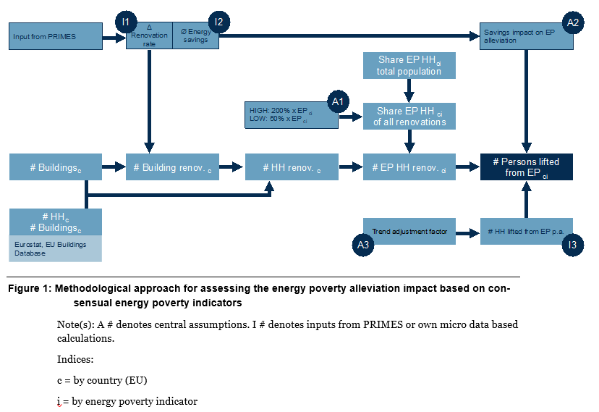
- Assumptions and inputs
To enable this assessment a set of assumptions have been made concerning:
- Share of energy poor households affected by renovations
- Impact of additional energy savings in existing buildings on energy poverty alleviation
- Adjustment factor to account for effects attributable to existing policies
- EED impact on renovation rate (in % points) (by scenario)
- EED impact on energy savings due to renovations (in %): Additional annual energy savings in existing buildings as a result of policy implementation (by scenario)
- Extrapolated energy poverty trends based on historical development

- Conclusions
Compared to the reference scenario, until 2030, depending on the indicator between 650,000 and 5.2 million people in the EU would additionally be lifted from energy poverty. The proportion of the population currently meeting each definition that would be lifted above the threshold for each indicator is shown in the table below. For each column, figures above the EU average are shaded red. The reference year for the indicator is the last year when a complete data set is available of the indicator.
Table 26 Percentage of the population lifted above energy poverty criterion by Member State

Other relevant legislation and policy areas
The EED is not the only policy instrument addressing energy efficiency but is part of a broader set of policies addressing energy efficiency potential. The EED can be considered as a ‘framework’ Directive that sets the overall target and complements the other instruments by ensuring that Member States create appropriate frameworks and implement policies to ensure investment in more energy efficiency.
- Legislation setting standards
Buildings
The Energy Performance of Buildings Directive (EPBD) is the main legislative instrument for promoting energy performance improvements in buildings within the EU. The Directive works through two complementary mechanisms: (1) minimum performance requirements for new and existing buildings (raising the depth of any upgrades and the standards for new-built); and (2) information for citizens and companies through certificates for buildings to enable them to choose the efficiency level that is right for them.
The cost-optimal methodology helps Member States set their ambition levels right and keep them under review. Taken together, these mechanisms contribute to set the right energy performance standard for different buildings, and facilitate information on more energy-efficient housing. To complement this, the EED promotes actual renovations and Member States’ action through the energy efficiency obligations (Article 7), the renovation of public buildings target (Article 5) and the provision of efficient heating and cooling services to buildings (Article 14). As such, the EED acts as an accelerator of the renovation rate of buildings.
The EU building stock requires energy renovation at a large scale: almost 75% of the EU’s building stock is inefficient according to current building standards, and 85-95% of the buildings that exist today will still be standing in 2050. The weighted annual energy renovation rate is persistently low at around 1%, and deep renovations that reduce energy consumption by at least 60% are carried out only in 0.2% of the building stock per year. Two thirds of the energy used for heating and cooling of buildings comes from fossil fuels. To further boost the energy performance of buildings, the Commission launched the Renovation Wave.
The EPBD requires Member States to establish a long-term renovation strategy to support the renovation of their national building stock into a highly energy efficient and decarbonised building stock by 2050. The long-term renovation strategies must include an overview of the national building stock policies and actions to stimulate cost-effective deep renovation of buildings policies and actions to target the worst performing buildings, split-incentive dilemmas, market failures, energy poverty and public buildings an overview of national initiatives to promote smart technologies and skills and education in the construction and energy efficiency sectors. The strategies must also include a roadmap with measures and measurable progress indicators indicative milestones for 2030, 2040 and 2050 an estimate of the expected energy savings and wider benefits and the contribution of the renovation of buildings to the Union's energy efficiency target.
Work has started to review the EPBD with a focus on setting more ambitious minimum requirements for buildings, and strengthen other provisions of the EPBD to intensify the efforts towards meeting the energy efficiency targets in the building sector. It will look at introducing new elements to enhance the performance of buildings, based on the specific areas and issues identified in the Renovation Wave:
- The phased introduction of mandatory minimum energy performance standards for different types of buildings,
- An update of the Energy Performance Certificates framework with a view to increasing their quality and availability e.g. through greater harmonisation, inclusion of additional information and more stringent provisions on availability and accessibility of databases.
Other measures that will be considered include the introduction of Building Renovation Passports and the introduction of a ‘deep renovation’ standard in the context of financing and building decarbonisation objectives. The requirements for new buildings and measures fostering sustainable mobility might also need to be updated in line with the enhanced climate ambition of the European Green Deal and the Climate Target Plan 2030, developing a new long term vision for buildings.
Products
In the products area, the Ecodesign Directive provides a framework for setting mandatory product-specific energy efficiency and other environmental performance requirements before products can be placed on the Union market. It is implemented through product-specific regulations, directly applicable in all EU countries. Currently, such requirements are in place for 30 product groups.
Ecodesign measures often go hand in hand with energy labelling requirements for the same product group. Energy and tyre labelling allow end-consumers to identify better-performing products, via the well-known A-G/green-to-red scale. The Energy Labelling Regulation provides a framework for establishing mandatory product-specific labelling requirements, allowing end-consumers to identify the better-performing products, via the well-known A-G/green-to-red scale. Currently, such requirements are in place for 14 product groups.
Of particular relevance are the reviews of the Ecodesign and Energy labelling requirements (including rescaling) for central/hydronic space and water heaters which are ongoing. Reviews for other types of (local or solid fuel) space heaters are also ongoing or to be launched in 2021, with the aim of having rescaling measures adopted by August 2023, which could trigger further energy savings and assist decarbonisation in heating.
Ecodesign contributes to the achievement of the overall energy efficiency goal set in the EED by taking away inefficient products from the market. Energy Labelling contributes to the achievement of the overall energy efficiency goal set in the EED by steering consumers towards more energy-efficient products and heating and cooling appliances, while Article 7(2) of the Energy Labelling Regulation steers financing towards the most efficient appliances.
The EED supports this framework, in particular by promoting the purchasing of more efficient products through its public procurement provisions which requires central governments to purchase only products that belong to the highest energy efficiency class on the energy label and, for those products not covered by an energy label, only procure products that comply with energy efficiency benchmarks specified in the relevant Ecodesign implementing measure.
EU road vehicle CO₂ legislation
The EU road vehicle CO₂ legislation requires manufacturers to reduce the new vehicle fleet average tail pipe CO₂ emissions from the vehicle mix they sell. Regulations have been put in place for Heavy Duty Vehicles and for passenger cars and light commercial vehicles. These regulations mean that manufacturers must either deploy technology to improve the energy efficiency of the vehicles (for example by reducing their aerodynamic or rolling resistance or powertrain efficiency) or by using an energy source with reduced CO₂ emissions in use. Switching to fully electric powertrains avoids the energy losses from internal combustion engines and leads to a fraction of the final energy use per km. Reduction of energy use in the transport sector as a result of the vehicle CO₂ legislation is reflected in the quantification of the overall EU energy efficiency target.
- Pricing measures
Emission Trading System (ETS)
As regards carbon pricing, the price of ETS allowances can lead to responses in the covered sectors, including reducing financial barriers for the energy transition. This may include increased energy efficiency, because companies would make operational changes or energy efficiency investments to lower the cost to them. However, in itself this does not remove non-financial barriers, which limits its effect. Moreover, carbon pricing may have distributional effects, since for example, low and medium income households are more affected by carbon pricing on buildings and transport unless mitigating measures are taken, for example through well-designed energy efficiency programmes. Although ETS revenues could be spent on energy efficiency measures for low and medium income households, this is currently not systematically happening. While energy savings from ETS pricing contribute to the overall EED target, this in itself is insufficient to meet the target as analysis shows.
Energy Tax Directive
The Energy Taxation Directive (ETD) lays down the EU rules for the taxation of energy products used as motor fuel or heating fuel and of electricity. An evaluation of the ETD published in September 2019 concluded that the EU rules on energy taxation no longer deliver the same positive contribution as when they first came into force in 2003.
The evaluation showed that the current requirements do not contribute to the new EU regulatory framework and policy objectives in the area of climate and energy, where technology, national tax rates and energy markets have all evolved considerably. For example, no link exists between the minimum tax rates of fuels and their energy content and CO₂ emissions and the ETD does not reflect the current mix of energy products on the market in the EU.
The evaluation also pointed out that the high divergence in national energy tax rates is not in line with other policy instruments and can lead to fragmentation of the internal market, a problem exacerbated by the widespread use of optional tax exemptions. It concludes that overlaps, gaps and inconsistencies significantly hamper EU objectives in the field of energy, environment, climate change and transport.
Work is ongoing to revise the ETD to better tax energy use, provide different tax rates for renewable fuels, and eliminate the current exemptions.
- Other legislation
Beyond specific energy efficiency legislation, other policy instruments also contribute to increased energy efficiency and savings. This is particularly true for the Renewable Energy Directive (RED) and the Effort Sharing Regulation (ESR)
Renewables
There is a strong interaction between the EED and the REDII because a higher overall share of renewable energy reduces the need for energy efficiency to achieve the same level of GHG savings, which ultimately contributes to meet ESR national targets. At the same time, a high level of energy efficiency reduces the need for energy and, therefore, allows for a higher share of renewable and clean energy in the energy mix. The strong coherence between the EED and the REDII is particular evident in the heating and cooling policy area, where the two directives are interlinked and complementary. Article 14 of the EED sets the planning framework in terms of identifying the energy efficiency and renewable energy potential in heating and cooling, and requires the Members States to implement policies and measures to exploit this potential. These policies and measures directly support the achievement of the renewable energy target in heating cooling laid out in Article 23 of REDII. Vice versa, this target contributes to the achievement of the energy efficiency objectives laid out in Article 14 of the EED and the entire directive. In addition, the REDII refers to specific provisions of the EED, most notably by linking several requirements to the definition of efficient district heating and cooling (Article 2(41) of the EED) and at the same time this definition directly promotes the deployment of renewable energy in district heating and cooling.
Effort Sharing Regulation
The EED contributes directly to the required emission reductions in ESR sectors. In particular, energy savings from Article 7 of EED contribute to the achievement of the ESR national targets. The additionality requirement under Article 7 of the EED provides incentives to Member States to implement national policies and measures that exceed the minimum energy performance requirements levels set at EU level (e.g. stricter national building codes and programmes promoting higher classes of appliances).
- Other relevant policy areas
Circular Economy
The European Green Deal states that it “…is a new growth strategy that aims to transform the EU into a fair and prosperous society, with a modern, resource-efficient and competitive economy where there are no net emissions of greenhouse gases in 2050 and where economic growth is decoupled from resource use. It also aims to protect, conserve and enhance the EU's natural capital, and protect the health and well-being of citizens from environment-related risks and impacts”. This sets out clearly the important of resource efficiency in achieving the EU’s goals.
Energy efficiency can make an important contribution to resource efficiency and a more circular economy. Fuels represent 20% of all material consumption and so saving energy contributes directly to reducing resource consumption. Reducing material use for products also means that less energy is used and therefore resource efficiency and reducing waste is a key route to industrial energy savings from audits. Recycling waste as secondary raw material can often also save energy. Increasing the lifetime of products and buildings may also reduce energy consumption and related emissions, although it is important to recognise that there may be trade-offs.
Energy can be consumed at all stages of a product’s lifecycle and therefore there are important synergies with a more lifecycle-based approach to products and circular economy. The importance of energy use in each part of the lifecycle varies enormously from product to product. Sub-optimal energy use choices can arise if the embedded energy in materials is not taken into account or decisions in one part of the lifecycle affect conditions in another. It is important that these aspects are fully considered during design, for example of buildings. However, the EED energy saving target encompasses energy savings from all aspects of the lifecycle occurring in the EU and therefore should not itself create an incentive to shift energy use between stages of the lifecycle.
If Member State measures aim to accelerate replacement or upgrading, their impact in terms of material use will depend on the materials replaced and the fate of those that become superfluous. Where materials are largely recycled such as metals there need be no additional material extraction (provided that the same quantity or less are used afterwards as before). However, in this case the energy impacts depend on the energy used for recycling which is highly variable depending on the material. Where materials have low rates of recycling it will be necessary to consider the trade-off between those increased material requirements and the energy savings.
In the case of building renovations, the majority of the materials remain in situ and there are changes that enhance the structures energy performance. In general in these cases it can be assumed that renovation requires less materials than a new building, regardless of the degree to which any materials removed may be recycled.
The life cycle energy savings themselves will depend on the degree of improvement in energy performance of the product in use and in manufacture and end of life. Whether energy use would be reduced from shortening or lengthening the average product life will depend on the share of energy use in its manufacture or end of life phases compared to the use phase. If the manufacturing or end of life phases are responsible for most of the energy use then extending the life may be a good energy saving strategy and this will align with reducing material consumption. Where energy consumption in the use phase is a large share of total energy use, then the benefit from increasing or decreasing the lifetime will depend on the rate of improvement in energy usage. In view of these complexities care needs to be taken in making simple claims. However, overall, provided attention is taken, the circular economy and energy saving objectives should be synergistic.
Industrial Emissions Directive
The Industrial Emissions Directive (IED) regulates the largest installations in the most polluting agro-industrial sectors. It requires installations to operate in conformity with a permit. The permit must be updated periodically and in line with the use of Best Available Techniques (BAT) as identified in EU level BAT conclusions that form part of sectoral BAT Reference documents (BREFs). BAT conclusions identify environmental performance levels for installations within the relevant sector. The Directive contributes to better energy performance of industry through the identification of BAT to reduce energy consumption and the definition of energy performance levels. These are not binding on permitting authorities.
A report looking at how the IED contributes to the circular economy assessed the BAT conclusions adopted for 17 industrial sectors. In these it identified 117 energy related BAT. However, of these only 25 are quantitative and the rest are qualitative. The recent evaluation of the IED found little evidence of the effect of these energy performance levels. A more recent assessment of cement kiln permits identified that of 31 permits reviewed, 11 included energy performance levels of which 7 specified limits within the BAT range. It is to be noted that this BAT energy performance level is only applicable to new plants and major upgrades and subject to raw material moisture content.
In addition, the IED can also contribute to energy savings through material efficiency and the reduction of waste. These are regulated in a similarly non-binding manner as energy performance. These elements show that while energy is clearly a key factor in the operation of large industrial installations, the IED’s requirements in this regard are limited and not strictly binding. Work is ongoing to revise the IED to ensure industry uses techniques that create a more sustainable EU economy and a cleaner environment that improves public health.
Energy savings and Life Cycle Assessment
Energy can be consumed at all periods of a product’s lifecycle, the stages of which are illustrated schematically by the circles in Figure 60Figure 60 Schematic representation of regulation affecting a product lifecycle below. There is much EU and national legislation that regulates the different phases of the lifecycle, shown by the rectangles in the figure, and some of this may implicitly or explicitly impact the energy use either in that or other phases.

Figure 60 Schematic representation of regulation affecting a product lifecycle
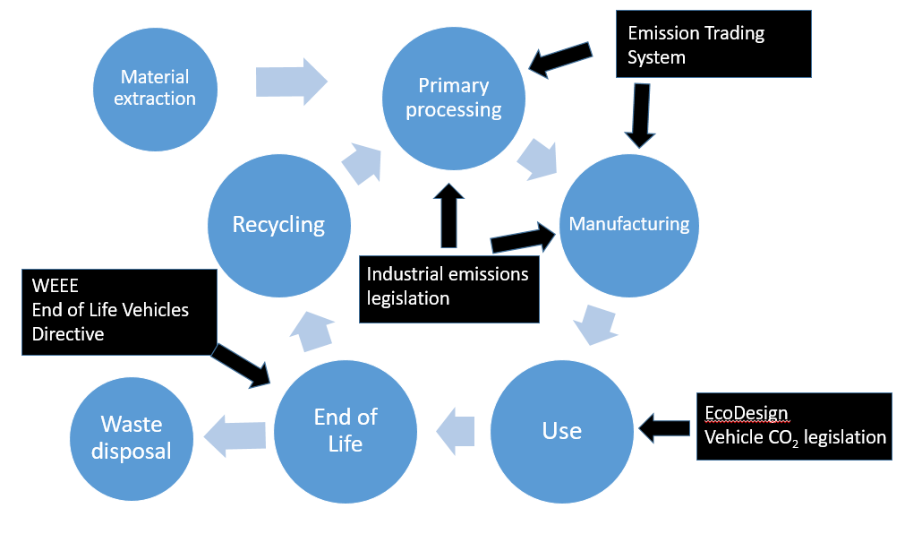
The importance of energy use in each part of the lifecycle varies from product to product. For example, a car might use 80% of the lifecycle energy in its use phase while for ceramics the majority of the energy use will be in manufacturing.
There is a risk that sub-optimal energy use choices can be made if the embedded energy in materials is not taken into account or decisions in one part of the lifecycle affect conditions in another. This can be as a result of market or regulatory forces. It is important that these aspects are fully considered during design, for example of buildings. The EED’s overall energy saving target encompasses energy savings from all aspects of the lifecycle that occur in the EU and therefore it does not create any incentive to shift energy use between stages of the lifecycle.
European Pillar of Social Rights & European Skills Agenda
The European Pillar of Social Rights sets out 20 key principles and rights to support fair and well-functioning labour markets. These principles are the beacon towards a strong social Europe that is fair, inclusive and full of opportunity. The evaluation of the EED referred to the importance of benefits from energy efficiency that go beyond the European energy and climate targets and contribute to the creation of social and economic impact.
More specifically, EED can contribute primarily to the delivery of Principle 20 “Access to essential services” (e.g. provision of affordable energy services) but also to the delivery of Principles 1 “Education, training and life-long learning” (e.g. accreditation and promotion of new skills), 10 “Healthy, safe and well-adapted work environment and data protection” (e.g. promotion of healthier work environments) and 19 “Housing and assistance for the homeless” (e.g. provision of better housing to vulnerable citizens). Pertinent to the delivery of Principle 1 is the European Skills Agenda and how EED as part of the European Green Deal shares the objectives of strengthening sustainable competitiveness, ensuring social fairness and building resilience to react to crises.

Estimated administrative costs
The estimation of the administrative costs imposed by the measures included in the preferred option is conducted using the 'Standard Cost Model', in the sense that administrative burdens are calculated on the basis of the average cost of the required administrative activity (Price) multiplied by the total number of activities performed per year (Quantity). Administrative costs are the costs incurred by the public or private sector in meeting legal obligations to provide information.
These are presented for the proposed measures of the preferred policy option in Table 27.
The results of the exercise using the standard cost model show that, overall, there is a net increase of the burden of €5.5 million per year. The burden on the private sector is increased by €0.3 million per year, and there is an increase in the burden for the public sector of €5.2 million per year.
A detailed explanation of the assumptions used, which are a simplification of the complex reality, are set out for each of the measures. To the extent possible, the assumptions are in line with the step-by-step application of the model set out in the in Better Regulation guidance. It is assumed that 2,080 working hours per year represents a Full Time Equivalent (FTE) employee.
Simplification measures
Change the basis for requiring energy audits to one based on energy use
This (IND.2) is a simplification measure, which would mean that the obligation to carry out a four yearly energy audit would only apply to enterprises with an energy consumption above a threshold. This is estimated to result in a significant reduction in the number of enterprises that would be subject to the obligation. It is estimated that some 600,000 enterprises that should have been audited under the original definition would no longer be subject to the audit obligation. In addition the verification of whether or not an enterprise should be subject to the obligation would be much more straightforward.
Administrative cost-savings for the public sector:
The requirement to verify that audits have taken place will be removed for the companies concerned. It is assumed that this represents 0.5 person-hours per enterprise. This amounts to a total of around 187 FTE saved every four years or equivalent to around 47 FTE per year.
Administrative cost-savings for the private sector:
It is assumed that providing information to the public authorities to show compliance with the audit requirement requires on average 0.5 person-hours per enterprise. Since this is only required once every four years, the avoided effort amounts to around 47 FTE per year.
Measures of the preferred policy option
Measure 1: EU energy efficiency target
The target is increased and made binding at EU level. This is not in itself expected to lead to different or additional monitoring requirements for Member States and therefore no administrative costs for the public sector or private sector.
Measure 2: Benchmarks for Member State contributions
Benchmarks will be calculated at EU level (TARGET.2). There is no additional work required at Member State level and therefore no administrative costs for the public sector.
Measure 3: Energy savings obligations
Measure 3a: Increase annual energy savings rate (ESO).
This measure changes the rate of energy savings required. It does not require a new system to be set up, but it will require an intensification of efforts to be made to achieve the needed savings.
Administrative costs for the public sector:
The doubling of savings effort is estimated to require an average additional effort of 1 FTE per Member State at central government level. No estimate is provided for other levels of government since it is likely to vary very much depending on the structures and mechanisms used to achieve the savings. The total estimate is therefore 27 FTE.
Administrative costs for the private sector:
Private sector companies will be involved in delivering some of the increased levels of energy savings. Administrative costs for them are likely to be low, and related to demonstrating the achievement of the necessary savings. This is likely to increase with the saving level. In view of this, it is assumed that the impact in the private sector is of the same magnitude as in the public sector at 27 FTE.
Measure 3b: Minimum sectoral savings and exclusion of measures promoting fossil fuel use (ESO.1, ESO.2, ESO.3).
Administrative costs for the public sector:
The obligations to achieve savings in certain sectors and to not include measures promoting fossil fuel use will require some additional effort. However this is estimated to be small in contrast to the impact of doubling the overall savings and is estimated at 9 FTE.
Administrative costs for the private sector:
The sectoral requirements should not substantially change the administrative burden on private sector companies since in principle the obligations don’t change. Similarly, the fossil fuel exclusion relates to measures put in place, and so should not create an administrative burden for private companies.
Measure 4: Energy Efficiency First
Measure 4a: Guidance on the application of the EE1st principle (EE1st.1).
This is intended to assist in applying the principle and therefore is not considered to create any administrative burden.
Measure 4b: Obligation for Member States to apply EE1st principle (EE1st.2).
Administrative costs for the public sector:
It will be necessary for Member States to ensure that they effectively apply the principle. This will relate to ensuring that energy saving options are adequately considered in appropriate activities. The assessment itself is not considered an additional administrative effort since in principle it ought already to be carried out as part of good project assessment. The additional administrative burden would arise from checking that this has been adequately carried out. It is assumed that this will result in one hour of work on average per relevant infrastructure project. If it is assumed that 2% of public procurement is for relevant infrastructure projects this would be around 5,000 per year leading to 3 FTE needed per year.
Administrative costs for the private sector:
The private sector should not be affected in any significant manner.
Measure 5) Exemplary role of the public sector
Measure 5a: Extend to all public buildings to NZEB standard and remove alternative measures (BUILD.3).
The actual standard to which renovation is required should not have an effect on administrative burden. The increase in the number of buildings and the removal of alternative measures can.
Administrative costs for the public sector:
Member States’ public authorities will need to report on their compliance with the renovation of their public bodies’ buildings stock. Since the renovation requirement would increase by a significant multiple it can be assumed that the efforts to gather the data will also take more effort, although probably less than a proportional increase. It is assumed that this additional monitoring effort will amount to 27 FTE per year.
Administrative costs for the private sector:
There are no specific information requirements related to this measure that would not fall within the normal contractual arrangements relating to the works.
Measure 5b: Guidance to authorities, on circularity and Green Public Procurement (PROCURE.1).
This is intended to assist in applying circular economy and green public procurement principles and therefore is not considered to create any administrative burden.
Measure 5c: Extend public procurement provisions to all public administration levels (PROCURE.2).
Administrative costs for the public sector:
This would extend the requirement that currently only applies to central government to require all contracting authorities to aim to procure the most energy efficient products and services. There are estimated to be around 250,000 contracting entities. Of these only a small proportion will be central government. It appears that there are around 230,000 tenders published each year on Tenders Electronic Daily. The majority of these are above the €144,000 threshold so the total number of tenders will be higher. The majority of these tenders are not covered by the existing requirement and incorporating energy efficiency criterion into each tender would require additional work. However, these processes do not result in any information requirements and therefore do not create an additional administrative burden.
Administrative costs for the private sector:
There are no specific administrative costs related to this obligation since all costs pertaining to tendering and performance of the normal contractual relationship.
Measure 6) Industry
Measure 6a: Change audit requirement to apply only to large energy users (IND.2a).
Administrative costs for the public sector:
Member States’ public authorities currently must verify whether enterprises are subject to the audit requirement as a non-SME. The obligation to verify whether their energy use exceeds a certain value will be less onerous. There is therefore no additional administrative burden.
Administrative costs for the private sector:
Enterprises will need to verify whether or not they are affected by checking their energy use. However, this will only be pertinent for those that have borderline energy use. Those that are substantially below or above the threshold will not need to check. It is estimated that a maximum of 50,000 enterprises would need to verify their consumption.
As an operating cost, all enterprises would be expected to have this information easily available. It is necessary to convert all energy consumption (which may be in different forms such as electricity, road fuel, gas, oil or solid fuel) into the format required. This can be carried out using a spreadsheet and the effort required to collect the necessary data and carry out the calculation is estimated to be a maximum of 1 hour.
The total estimated administrative burden therefore amounts to around 30 FTE. This will arise once every four years. The burden therefore averages to 8 FTE per year.
Measure 6b: Require energy management systems for largest energy users (IND.2b).
Administrative costs for the public sector:
Member States’ public authorities currently must verify whether enterprises are subject to the audit requirement as a non-SME. The obligation to implement an energy management system applies above a certain energy use threshold and therefore verifying this will be less onerous. In addition, since energy management systems are subject to external third party verification, public authorities need only ensure that the enterprise is correctly certified. It is considered that in view of this there is no additional administrative burden compared to the current situation.
Administrative costs for the private sector:
Enterprises will need to verify whether or not they are affected by checking their energy use and this will only be pertinent for those that have borderline energy use. For those above the threshold once they have an energy management system in place there is no burden since their energy use will be continuously monitored.
Enterprises under, but close to, the threshold will need to verify whether they fall under the requirement. This is expected to apply to a maximum of 10,000 enterprises. They will know their energy consumption from previous audits and can readily verify if this has increased or decreased. It is assumed that this will require no more than 30 minutes work. The resulting administrative burden would amount to about 3 FTE per year.
Measure 7) Heating and cooling:
Improve definitions and strengthen obligations for cost-benefit analysis and local cooling and heating planning (HEAT.2).
Administrative costs for the public sector:
Member States’ public authorities must approximately every five years review their comprehensive assessments. It is assumed that on average each Member State will need to dedicate 40 person-days to this task. This results in a total effort of 5 FTE every five years or 1 FTE per year.
Administrative costs for the private sector:
Additional burden could arise from information requests to enable the analysis to be updated. There are currently approximately 2,500 Large Combustion Plants and 5,400 Medium Combustion Plants above 20 MW thermal and it can be assumed that these would likely represent the majority of plants that would need to supply information. If they have to supply information it is assumed this would take a maximum of 2 person-hours work so the total effort would amount to around 10 FTE. This would occur once every five years so amounting to roughly 2 FTE per year.
Measure 8) Energy networks:
Enhance definition of losses and reporting (NET.2).
Administrative costs for the public sector:
There are no specific administrative impacts for Member States’ public authorities. While they might wish to be involved in discussion in developing uniform definitions this would not appear to be necessary.
Administrative costs for the private sector:
The purpose of NET.2 is to engage system operators in adopting uniform definitions. The reporting obligation for trade associations will take place periodically. Developing uniform definitions would largely be a one-off exercise and good be expected to require a few hundred person days of effort. The reporting obligation for trade associations, which would primarily require collating input from their members could be expected to require a total of 200 person-days each time a report is produced. The overall burden could be assessed at around 1 FTE per year.
Measure 9) Transport:
Include energy efficiency elements in line with the EE1st principle and the Sustainable and Smart Mobility Strategy, including, for example, in urban mobility policy planning (TRANS.1).
Administrative costs for the public sector:
The administrative impact of TRANS.1 would depend on the degree to which large urban areas already implement SUMPs. The obligation would only apply to the largest urban areas. The scope is narrower than to produce a SUMP and the information requirements would only relate to reporting the energy use and expected savings. It is envisaged that this would require no more than 2 hours per affected urban area. Overall the requirement would amount to less than 1 FTE.
Administrative costs for the private sector:
There are not expected to be administrative costs except to provide any input they choose to the elaboration of a transport energy plan.
Measure 10) Support measures:
Strengthen provisions on skills, energy services and financing mechanisms, consumer empowerment, addressing split incentives and the alleviation of energy poverty (SUPPORT.1; SUPPORT.2).
Administrative costs for the public sector:
The measures under SUPPORT.1 continue with the existing structure of the Concerted Action. They are voluntary and not envisaged to create any additional administrative burden.
The SUPPORT.2 measures will create some additional administrative burden. There will be one-off efforts needed to establish minimum quality assurance criteria for energy services providers. There will be recurring requirements to assess qualification and certification schemes and to strengthen oversight of energy services market intermediaries. It is assumed that these will amount to around third of the burden on the ESCOs at 1 FTE.
Administrative costs for the private sector:
While SUPPORT.1 does not create any burden, SUPPORT.2 would require efforts to demonstrate compliance with criteria set for energy service providers and qualification and certification schemes. There are around 3,000 ESCOs across the EU. If it is assumed that these are each subject to 2 hours additional administrative burden the total would amount to 4 FTE.
Measure 11) Monitoring and reporting:
Reinforcement of requirements (MONITOR.1; MONITOR.2), building on the integrated approach under the Governance Regulation.
Administrative costs for the public sector:
The measures under MONITOR.1 would involve the use of surveys and other data gathering to improve knowledge. Some of these will involve requests for information to be supplied by public authorities. This would not amount to more than a 2 FTE administrative burden per year across all Member States.
The MONITOR.2 and 3 measures will create some additional reporting requirements that will increase administrative burden. There will be one-off efforts needed to establish reporting arrangements. Regular gathering of the necessary information will add recurring requirements however, the effort required can be minimised through well designed electronic data gathering. This is assumed to amount to 54 FTE effort across all Member States.
Administrative costs for the private sector:
MONITOR.1 would only create a burden if the focus of the data gathering requires input from private sector organisations. It is assumed that there will be value in their input for some types of assessment, but that demands will be less than for public administrations. In view of this half the effort is assumed i.e. 1 FTE.
MONITOR.2 and 3 can be expected to result in data requests. It is assumed that the administrative burden would be somewhat less than that for public administrations at 5 FTE.
The results of these assessments for all elements of the preferred option are summarised and summed in Table 27.
Table 27 Estimated additional public and private sector administrative costs
Standard cost model
Calculation of additional administrative costs
 |  | Private sector |  |  | Public administrations |  |  | Total
 |  | Cost  €/hour | Quantity  FTE/year | Total  €/year | Cost  €/hour | Quantity  FTE/year | Total  €/year | €/year
Simplification measures
Require audits based on energy use |  | €32.1 | 47 | €3.1m | €32.1 | 47 | €3.1m | €6.3m
Preferred option
Measure 1: EU energy efficiency target
Energy targets |  | €32.1 | 0 | 0 | €32.1 | 0 | 0 | 0
Measure 2: Benchmarks for Member State contributions
TARGET.2 |  | €32.1 | 0 | 0 | €32.1 | 0 | 0 | 0
Measure 3: Energy savings obligations
ESO |  | €32.1 | 27 | €1.8m | €32.1 | 27 | €1.8m | €3.6m
ESO.1, ESO.2, ESO.3 |  | €32.1 | 0 | 0 | €32.1 | 9 | €0.6m | €0.6m
Measure 4: Energy Efficiency First
EE1st |  | €32.1 | 0 | 0 | €32.1 | 3 | €0.2m | €0.2m
Measure 5: Exemplary role of the public sector
BUILD.3 |  | €32.1 | 0 | 0 | €32.1 | 27 | €1.8m | €1.8m
PROCURE.1 & 2 |  | €32.1 | 0 | 0 | €32.1 | 0 | 0 | 0
Measure 6: Industry
IND.2 (a) |  | €32.1 | 8 | €0.5m | €32.1 | 0 | 0 | €0.5m
IND.2 (b) |  | €32.1 | 3 | €0.2m | €32.1 | 0 | 0 | €0.2m
Measure 7: Heating and Cooling
HEAT.2 |  | €32.1 | 2 | €0.1m | €32.1 | 1 | €0.1m | €0.2m
Measure 8: Energy networks
NET.2 |  | €32.1 | 1 | €0.1m | €32.1 | 0 | 0 | €0.1m
Measure 9: Transport
TRANS.1 |  | €32.1 | 0 | 0 | €32.1 | 1 | €0.1m | €0.1m
Measure 10: Supporting measures
SUPPORT.2 |  | €32.1 | 4 | €0.3m | €32.1 | 1 | €0.1m | €0.3m
Measure 11: Monitoring
MONITOR.1 |  | €32.1 | 1 | €0.1m | €32.1 | 2 | €0.1m | €0.2m
MONITOR.2 |  | €32.1 | 5 | €0.3m | €32.1 | 54 | €3.6m | €3.9m
TOTAL |  |  |  | €0.3m |  |  | €5.2m | €5.5m

The SME Test – Summary of results
(1) Preliminary assessment of businesses likely to be affected
The EED primarily functions by requiring action by Member States to achieve energy savings. The focus of the majority of the measures that will be undertaken under the EED are not determined by the provisions of the Directive, but by Member States as they choose what schemes to implement to achieve those requirements.
Some of the requirements of the EED are addressed to specific sectors, for example business (energy audits), heating and cooling, energy transmission and energy services. For some of these sectors, it is unlikely that the businesses involved will be SMEs. One example is energy transmission. Another example is, in the heating and cooling sector, the businesses that generate large amounts of waste heat or use cogeneration.
The case of energy audits is a bit different, since the existing EED already encourages Member States to facilitate SMEs receiving energy audits, while the obligation to carry out energy audits only applies to non-SMEs. The supporting study explores the difficulties that Member State authorities have had to implement this provision. It illustrates that the majority of the companies that fall under the non-SME definition only do so because of their links to other companies. Only around 12% are estimated to fall under the definition as a result of the entity itself, as shown in Figure 61 below – if it were not for these links they would be excluded.
Figure 61 Composition of enterprises meeting the non-SME definition
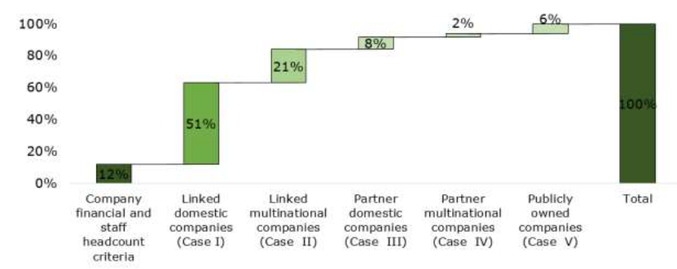
The Impact Assessment considers the desirability of changing from the non-SME definition to one based on energy use. The supporting study illustrates that, for a conceivable level of energy use threshold, this would have the effect of dramatically reducing the number of businesses that would be impacted by this requirement. Those businesses removed from the requirement will be the ones that do not use much energy but which, because of ownership or control relationships, are not classified as SMEs. This would result in a significant reduction in the burden of the obligation that applies to businesses for which it may make less sense including those that would be SMEs but for their links.
However, a shift to an energy-based threshold could conceivably also encompass highly energy intense SMEs. The assessment carried out in the support study concludes that this would be the case, but it needs to be borne in mind that the approach to allocate energy use to businesses in the study is rather crude, since it is based purely on number of employees, and that itself had to be estimated for a proportion of the businesses. In the case of the transport sector, the area where there is most likely to be an impact is in long distance road haulage. Long distance road haulage can be estimated to use around 1TJ per HDV employed full time, implying that a company would need to use more than 10 HDVs full time on long distance haulage to exceed a 10TJ energy use threshold. However, road haulage is a sector where the EU wide average business size is 5.2 persons employed and the vast majority (>80%) of companies in the road haulage sector are below this average. These factors suggest that a very limited share of road haulage companies would actually be affected.
Other sources of information are instructive in understanding the potential for energy savings in SMEs and the cost effectiveness of those actions. For example, a range of projects addressing energy efficiency measures in SMEs have been supported under the LIFE and HORIZON programmes. An ex-post assessment of 41 of these projects has recently been completed. The detailed assessment, based on project reporting, concluded that the potential energy savings rate was about 18% and the implementation rate averaged about 25%. The total energy savings are therefore estimated (from potential savings rate x implementation rate) to amount to 4.5%. These figures are reflective of real-world activities. These figures are lower than values from literature, which suggest that potential savings of 10% are possible from no and low cost measures, and up to 20% savings with all measures.
The payback times by type of measure identified in the projects are slightly longer than those identified in the DEEP database (except for compressed air, which is shorter). Nonetheless, they are the same order of magnitude and given the small number of projects and uncertainty over the key performance indicators, this suggests that the results are credible. Across all the projects, every Euro of funding achieved €1.9 per year cost savings for SMEs and average savings were 9.2 kWh/year per Euro of investment.
The DEEP database shows the results for over 9,400 energy saving projects financed in businesses. The website provides information on payback times for those projects, which can be compared by type of area of the investment and by company size. Figure 62 below shows the calculated payback times.
Figure 62 Simple energy efficiency payback time by company size
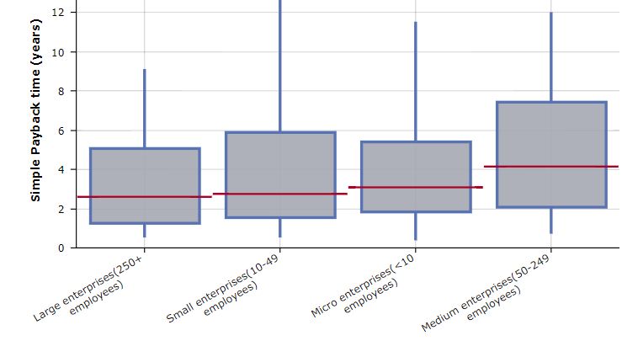
The red lines show the median payback time while the boxes cover the range between the 25th and 75th percentiles and the line extend to the 10th and 90th percentiles. It is evident that while there are minor differences between the payback times, with these being slightly longer in particular for medium sized enterprises, there is little fundamental difference in the attractiveness of energy saving investments based on company size.
(2) Consultation with SMEs representatives
SMEs have been consulted as part of the outreach to stakeholders.
Views of SMEs represent a reasonable (34%) share of the business views collected in the PC. Of the 92 respondents that identified themselves as companies, 61 are large (>250 employees), 6 medium (50-249 employees), 9 small (10-49 employees) and 16 micro enterprises (1-9 staff). In view of the relatively small SME sample size, in particular for medium sized companies, caution needs to be exercised about the robustness of the fully disaggregated results.
These companies classified themselves as whether they operate in the energy, climate or environment fields. Positive answers to this were given by 81% of micro, 78% of small, 50% of medium and 72% of large sized businesses. In terms of which of these areas the ones that answered yes operate in, the split is shown below, and it is clear that there is major distinction between company sizes and energy activities are dominant for all company sizes, with climate as the second most significant and environment as the third.
Figure 63 Self-classification of domain of business activity
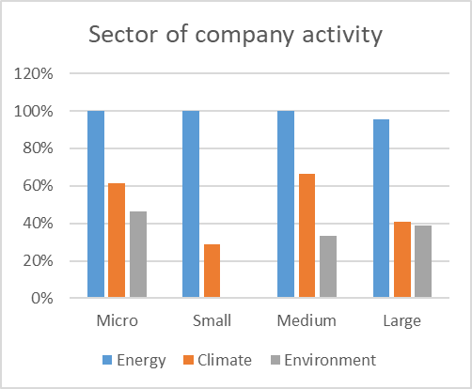
Although only a small proportion of companies indicated the sector in which they operate, Figure 64 shows that the most significant ones identified for all company sizes are production, followed by construction. Medium sized companies are dominated by production. A significant share stated ‘other’ and this covers a range of specific activities.
Figure 64 Reported area of activity by company size
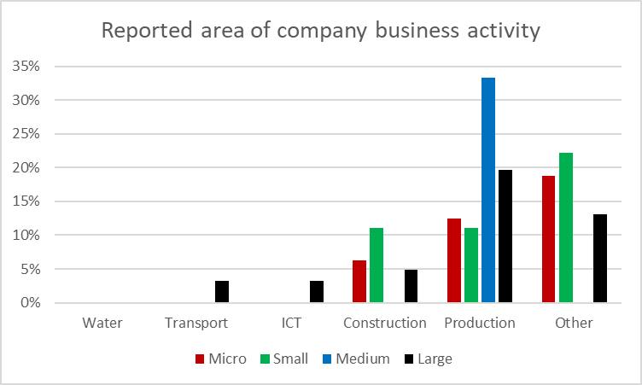
With regard to other specific interaction with SME representatives, a presentation was made to a meeting organised by the Commission with SMEs regarding the findings of the study on energy audits on 5 May 2021.
While there is some differentiation of views among businesses depending on company size, this variation is small. It is shown below for various of the PC questions that are referred to in the Impact Assessment. For reference, the four groupings of stakeholder responses used in the body of the Impact Assessment are shown in faded colour. The four coloured bars show the views of micro, small, medium and large businesses (red, green, blue and black).
Figure 65 shows the views of SMEs by size on the role that energy efficiency should play in attaining our climate goals. For all company sizes, there is little divergence from the overall business view although micro enterprises have a higher level of agreement with the statement than other sized enterprises.
Figure 65 Business views on the role of energy efficiency in achieving climate goals
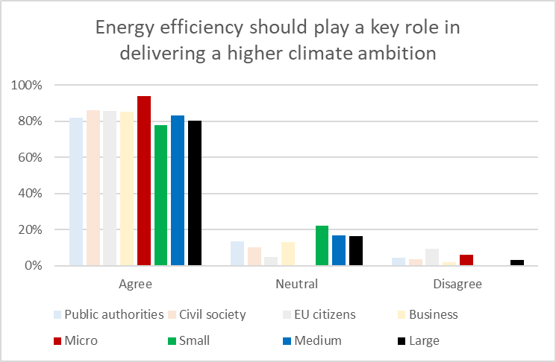
SME views about which factors had contributed to the EED achieving its objectives shown in Figure 66 were comparable to the overall responses from all stakeholder groups received that are shown in Figure 7 in Section 5.2.1. In terms of size-related variations, it appears that the smaller the business, the less they believe flexibility left to Member States and national planning policies have contributed to the EED achieving its objectives. There is also a modest tendency for smaller businesses to believe national targets and strong monitoring and reporting to have been more important.
Overall, there is little divergence in view between different company sizes or from the overall responses. Outlying views are the micro company opinion on the importance of the EU level targets and medium companies on national targets.
Figure 66 Business view by company size on the factors that helped achieve EED objectives
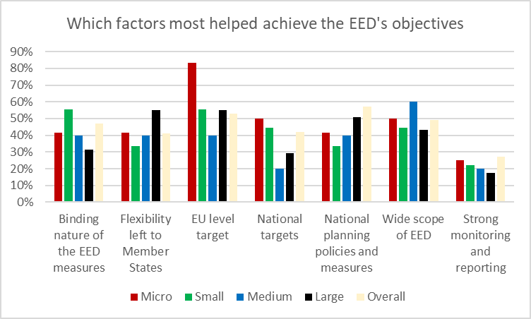
Figure 67 shows stakeholder responses by company size about which areas additional effort is desirable to achieve higher energy savings. There is no consistent impact of company size on the ranking of the responses. There is little divergence in SME responses from the overall view of business although small and medium sized companies are very positive about addressing buildings while medium-sized companies also believe heating and cooling, ICT and transport have a higher opinion of the importance of addressing these sectors than business in general.
Figure 67 Business view by company size on sectors where more energy savings are needed
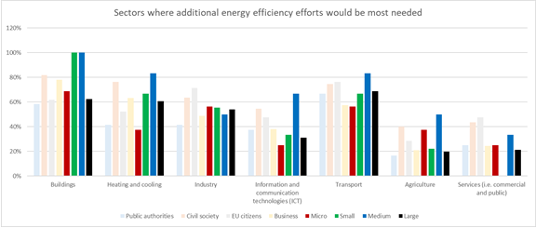
Stakeholders were asked in the PC about how Article 7 might be changed to achieve higher energy savings. The results of this by category are shown in section Error! Reference source not found.. The business results are further disaggregated by company size in Figure 68 below. It can be seen that in general the micro enterprises are most positive about all the possible measures with generally the support decreasing as company size increases. Overall, there is little divergence from the general business opinion.
Figure 68 Business opinion by company size on how Article 7 should be strengthened
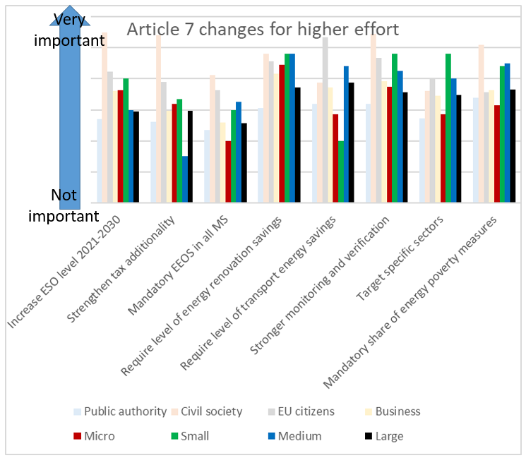
Stakeholders were asked for their opinion about how to address the shortcomings with the energy audit requirements. There was a limited response to this with less than a third of respondents in all business categories giving their view. In view of this, in Figure 69 below, the SME answers have been aggregated and shown alongside the answers for large businesses and the three categories shown in the Impact Assessment.
The results for SMEs are largely in line with those for business in general with the most noticeable difference being that they are significantly less negative about the options with which business overall disagreed.
Figure 69 Business views by company size on how to address energy audit weaknesses
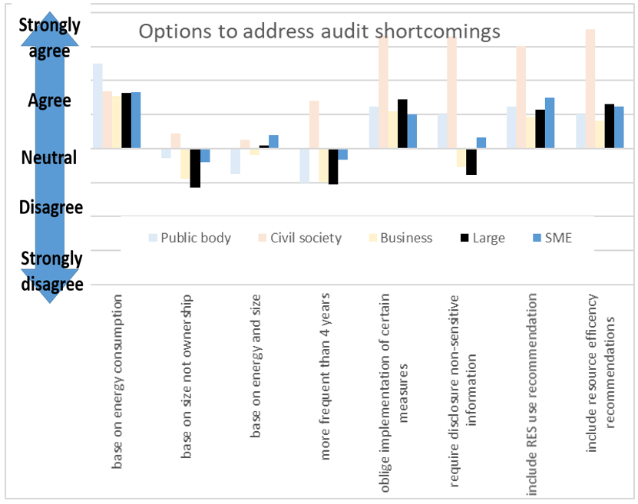
Stakeholders were asked in the PC about the benefits of certification and/or accreditation schemes in their country. The overall responses are shown in section 2.2.2 of the Impact Assessment. It is to be noted that only a small share of respondents answered this question so in Table 28 the results have been aggregated for all SME company sizes and should be treated as somewhat uncertain. The results are colour coded to indicate if they are above (green) or below (red) the overall response. It can be seen that there is no consistent trend.
Table 28 Business view by company size on certification and accreditation
Benefits of certification and accreditation schemes
 | Overall | Large | SME
Ensures availability of skills (providers of energy services, energy auditors, energy managers and installers) | 26% | 29% | 33%
Ensures quality of energy services offered by energy service providers | 17% | 33% | 0%
Increases confidence in the energy services sector | 12% | 5% | 17%
Facilitates the development of the energy services markets | 11% | 0% | 8%
Other | 34% | 33% | 42%

Stakeholders were asked in the PC about whether they thought certain measures should be considered in the heating and cooling area. The answers were scored on a scale from 1 to 6 and an average is calculated for all respondents answering. Table 29 shows in the first (white) column the overall stakeholder view as shown in section 2.2.2 of the impact assessment. The four right hand columns show the answers given by companies split by company size. Where the answer is more in agreement with the statement than the general stakeholder view it is shown in green, where it is a stronger disagreement it is shown in red. It can be seen that SMEs other than micro enterprises are more positive about all of the statements. In contrast, large companies are less positive.
Table 29 Business view by company size on how to strengthen heating and cooling aspects
Statement  [scoring is from 6 (strongly agree) to 1 (strongly disagree] | Overall stakeholder view | Micro | Small | Medium | Large
The recovery of waste heat from heating and cooling (air-conditioning) systems in individual buildings should be promoted | 4.8 | 5.1 | 5.1 | 4.3 | 4.7
Member States should facilitate local and district approaches to policy and infrastructure planning and development in heating and cooling | 4.8 | 4.4 | 5.4 | 4.8 | 4.3
Fossil fuels in heating systems (in buildings and district heating) should be gradually phased out with a faster phasing out of the most polluting ones | 4.4 | 4.1 | 5.7 | 5.0 | 4.1
Requiring district heating and cooling operators to prepare long-term plans to improve their energy efficiency in terms of primary energy intensity energy | 4.4 | 3.6 | 4.8 | 4.5 | 4.0
Fossil fuel heating system should be banned for new buildings whenever technical feasible | 4.2 | 3.9 | 5.7 | 4.6 | 3.6
Allow public support for heating systems only to non-fossil fuel technologies | 4.1 | 3.8 | 5.5 | 3.0 | 3.3
Member States should introduce specific energy efficiency targets for the heating and cooling sector to ensure that energy consumption in this sector is sufficiently taken into account | 4 | 3.6 | 4.4 | 4.4 | 3.8
Specific requirements for utilization of waste heat and waste cold should be set for industry and services | 4 | 4.3 | 4.4 | 3.3 | 3.6
Member States should unbundle the management of the generation and distribution heat network | 3 | 3.3 | 4.0 | 3.3 | 2.0
Overall, the disaggregation of the stakeholder responses by company size does not show any strong trend in relation to SMEs. In response to certain questions, there are some modest differences. Generally, the SME views fall within the overall spread of views expressed by stakeholders.
(3) Measurement of the impact on SMEs
Any SMEs that do fall under the energy threshold and need to carry out an energy audit will need to bear the cost of the audit. As a result, they will benefit from the identification of energy saving opportunities.
Some smaller transport companies would possibly be implicated under the audit obligation. In that case, consideration needs to be given to whether the cost impact of that would be justified by the benefits. The non-SME definition study report estimated the potential energy savings that could be identified by audits in the transport sector at 15.2% and that around 4.9% savings would be likely to be realised.
Based upon the threshold 10 TJ diesel consumption, using a conservative cost of 1 Euro per litre implies that this level of energy use amounts to a fuel expenditure of around 270,000 Euro per year. A potential 4.9% saving on that expenditure would realise savings of 13,000 Euro per year, which would vastly exceed the cost of an audit for a company with a small number of employees. In view of this, it can be considered that the energy saving payback for the transport company would be rapid if it chose to implement the measures identified.
Enhancement of the enabling and supporting measures, including information and awareness raising activities would be likely to be beneficial for SMEs. While these are important in terms of fairness and increase the likelihood of SMEs benefitting from energy saving opportunities the impacts are too uncertain to attempt any quantification of them. Nevertheless, it can be reasonably assumed that these will not increase costs for SMEs and will offer cost saving opportunities.

4) Assess alternative options and mitigating measures
The majority of the measures explored in the Impact Assessment do not directly address SMEs. The main measures place obligations on the Member States that might lead to changes in the situation for businesses. This will depend on the measures that Member States implement and could not be assessed in the Impact Assessment.
To the degree that the measures envisaged in the Impact Assessment will have any impact on SMEs, they are likely to be beneficial for them. Such an impact may arise through the creation of business opportunities such as building renovations to increase energy efficiency.
The most likely of any of the measures assessed to have a direct impact on SMES is the change to the definition for obligatory energy audits. The main effect of this will be to benefit small, low energy using businesses that were only subject to the obligation because of business links. The change would be likely to avoid some unjustified expenditure by companies in that situation.
In contrast, there is a possibility that some energy intense SMEs may become subject to the audit requirement. In those cases, the businesses will have a very high energy expenditure and are likely to be able to benefit considerably from the expertise in an audit.
It has been demonstrated there are substantial energy saving opportunities available to SMEs, as in larger businesses, and therefore taking advantage of those will lower SME operating costs and increase their competitiveness.
The crucial factor for energy audits to be cost-effective is for the energy expenditure to be high enough that the implementable energy savings identified can justify the cost of the audit. In the case of smaller companies exceeding the energy threshold, this is bound to be the case and will be vastly more attractive for them than many of the companies that were previously covered by the audit obligation due to their links with other businesses. In view of the fact that the impacts are likely to be beneficial for SMEs no alternative options have been considered and no mitigating measures are desirable.

For example monetary savings, better societal acceptance, more effective use of resources, improved health, reduced energy poverty, etc. See also www.combi-project.eu
ARES reference or link.
The Communication on the Climate Target Plan, adopted on 17 September 2020, puts forward an emissions reduction target of at least net 55% by 2030 as a balanced, realistic, and prudent pathway to climate neutrality by 2050. It also highlights that, to achieve this level of greenhouse gas emission reductions, there is a need to significantly step up energy efficiency efforts. See COM/2020/562 final.
https://ec.europa.eu/info/law/better-regulation/have-your-say/initiatives/12552-EU-energy-efficiency-directive-EED-evaluation-and-review
https://ec.europa.eu/info/sites/info/files/better-regulation-guidelines-evaluation-fitness-checks.pdf
See document Report Technical Assistance for an Ex-Post Evaluation and Impact Assessment of the Review of the Directive 2021/27/EU on Energy Efficiency. Analysis of Stakeholder Feedback.
The Impact Assessment identifies a range of 35.5 % - 36.7 depending on the overall design of policy measures underpinning the new 2030 target. This would correspond to a range of 39.2%- 40.6% in terms of primary energy consumption.
A 50% GHG target was also analysed
https://www.consilium.europa.eu/media/47328/1011-12-20-euco-conclusions-fr.pdf
COM(2020) 690 final
Importantly, all “Fit for 55” core scenarios reflect the Commission Work Programme (CWP) 2021 in terms of elements foreseen therein and their scheduling. This is why 2021 CWP proposals listed in the first Quarter are built in to all “Fit for 55” scenarios, whereas assumptions are made about legislative proposals submitted together with REDII revision and expected to be submitted later on - by Quarter 4 2021. On the energy side, the subsequent proposals are: the revision of the EPBD, the proposal for Decarbonised Gas Markets and the proposal for reducing methane emissions in the energy sector. In this way, core scenarios represent key policies needed to deliver the increased climate target.
In the CTP analysis ALLBNK was the most ambitious scenario because of a wider scope of the GHG target and thus comparable to higher than 55% GHG target for effort in the current scope. This scenario is no longer part of core scenarios even though it remains pertinent for initiatives dealing with aviation and maritime sectors.
References when available
The “current policy framework” includes EU initiatives adopted as of end of 2019 and the national objectives and policies and measures as set out in the final National Energy and Climate Plans.
https://eur-lex.europa.eu/legal-content/EN/TXT/?uri=CELEX:52020SC0176
https://eur-lex.europa.eu/legal-content/EN/TXT/?uri=CELEX%3A52020SC0331
https://ec.europa.eu/clima/sites/clima/files/docs/pages/com_2018_733_analysis_in_support_en_0.pdf
While cross-border trade is possible, the assumption is that there are no imports from outside EU as the opposite would require global modelling of hydrogen trade.
More information and model documentation: https://e3modelling.com/modelling-tools/primes/
E3Modelling (https://e3modelling.com/) is a private consulting, established as a spin-off inheriting staff, knowledge and software-modelling innovation of the laboratory E3MLab from the National Technical University of Athens (NTUA).
SEC(2011)1569 : https://ec.europa.eu/energy/sites/ener/files/documents/sec_2011_1569_2.pdf
https://www.odyssee-mure.eu/
Source: https://www.eia.gov/outlooks/aeo/info_nems_archive.php
Source: https://eippcb.jrc.ec.europa.eu/reference/
Source: https://data.jrc.ec.europa.eu/collection/id-00138
Source: https://data.jrc.ec.europa.eu/dataset/jrc-emhires-wind-generation-time-series
Source: https://www.renewables.ninja/
Source: https://www.entranze.eu/
Source: http://bpie.eu/
Source: https://ec.europa.eu/jrc/en/potencia/jrc-idees
Source: https://ec.europa.eu/energy/en/eubuildings
Source: https://www.tmleuven.be/en/navigation/TREMOVE
Several model enhancements were made compared to the standard TREMOVE model, as for example: for the number of vintages (allowing representation of the choice of second-hand cars); for the technology categories which include vehicle types using electricity from the grid and fuel cells. The model also incorporates additional fuel types, such as biofuels (when they differ from standard fossil fuel technologies), LPG, LNG, hydrogen and e-fuels. In addition, representation of infrastructure for refuelling and recharging are among the model refinements, influencing fuel choices. A major model enhancement concerns the inclusion of heterogeneity in the distance of stylised trips; the model considers that the trip distances follow a distribution function with different distances and frequencies. The inclusion of heterogeneity was found to be of significant influence in the choice of vehicle-fuels especially for vehicles-fuels with range limitations.
Source: https://ec.europa.eu/transport/facts-fundings/statistics_en
Bioheavy refers to bio heavy fuel oil.
Source: https://ec.europa.eu/transport/facts-fundings/statistics_en
https://mrv.emsa.europa.eu/#public/eumrv
Source: http://gains.iiasa.ac.at/models/
Source: http://www.iiasa.ac.at/
Source : http://www.iiasa.ac.at/
See You, L., Wood, S. (2006). An Entropy Approach to Spatial Disaggregation of Agricultural Production, Agricultural Systems 90, 329–47 and http://mapspam.info/ .
Herrero, M., Havlík, P., et al. (2013). Biomass Use, Production, Feed Efficiencies, and Greenhouse Gas Emissions from Global Livestock Systems, Proceedings of the National Academy of Sciences 110, 20888–93.
MCPFE (2015). Forest Europe, 2015: State of Europe's Forests 2015. Madrid, Ministerial Conference on the Protection of Forests in Europe: 314.
EU Agricultural Outlook for markets, income and environment 2020-2030, https://ec.europa.eu/info/sites/info/files/food-farming-fisheries/farming/documents/agricultural-outlook-2020-report_en.pdf
EUROPOP2019 population projections https://ec.europa.eu/eurostat/web/population-demography-migration-projections/population-projections-data
The 2021 Ageing Report : Underlying assumptions and projection methodologies https://ec.europa.eu/info/publications/2021-ageing-report-underlying-assumptions-and-projection-methodologies_en
https://ec.europa.eu/jrc/en/geco
IEA, Global Energy Review 2020, June 2020
IEA, Oil Market Report, June 2020 and US EIA, July 2020.
JRC118275
COM/2020/562 final
The 2021 Ageing Report : Underlying assumptions and projection methodologies https://ec.europa.eu/info/publications/2021-ageing-report-underlying-assumptions-and-projection-methodologies_en
https://ec.europa.eu/info/news/eu-agricultural-outlook-2020-30-agri-food-sector-shown-resilience-still-covid-19-recovery-have-long-term-impacts-2020-dec-16_en
COM(2016) 860 final.
Link to reference.
Energy system costs for the entire energy system include capital costs (for energy installations such as power plants and energy infrastructure, energy using equipment, appliances and energy related costs of transport), energy purchase costs (fuels + electricity + steam) and direct efficiency investment costs, the latter being also expenditures of capital nature. For transport, only the additional capital costs for energy purposes (additional capital costs for improving energy efficiency or for using alternative fuels, including alternative fuels infrastructure) are covered, but not other costs including the significant transport related infrastructure costs e.g. related to railways and roads. Direct efficiency investment costs include additional costs for house insulation, double/triple glazing, control systems, energy management and for efficiency enhancing changes in production processes not accounted for under energy capital and fuel/electricity purchase costs. Energy system costs are calculated ex-post after the model is solved.
See the EU Reference Scenario 2020 publication for a further discussion on the roles and levels of discount rates in the modelling, which also represent risk and opportunity costs associated with investments.
COM(2018) 773
A 50% GHG target was also analysed
https://www.consilium.europa.eu/media/47328/1011-12-20-euco-conclusions-fr.pdf
COM(2020) 690 final
Importantly, all “Fit for 55” core scenarios reflect the Commission Work Programme (CWP) 2021 in terms of elements foreseen. This is why assumptions are made about legislative proposals to be made later on - by Quarter 4 2021. On the energy side, the subsequent proposals are: the revision of the EPBD, the proposal for Decarbonised Gas Markets and the proposal for reducing methane emissions in the energy sector. For transport they refer to the revision of the TEN-T Regulation and the revision of the ITS Directive. In addition, other policies that are planned for 2022 are also represented in a stylised way in these scenarios, similar to the CTP scenarios. In this way, core scenarios represent all key policies needed to deliver the increased climate target.
This is a feature not implemented in the CTP CPRICE scenario.
For modelling purposes “national maritime” is considered as equal to “domestic navigation”, i.e. also including inland navigation.
“Intra-EU navigation” in this table includes both international intra-EU and national maritime. Due to modelling limitations, energy consumption by “national maritime” is assumed to be the same as “domestic navigation”, although the latter also includes inland navigation.
50% of all incoming and all outgoing extra-EU voyages
For more information on the roles and levels of discount rates applied per sector, see the EU Reference Scenario 2020 publication.
Post 2030, carbon values should not be seen as a projected carbon price in emissions trading, but as a shadow value representing a range of policies to achieve climate neutrality that are as yet to be defined.
The foresight and the discounting both influence the investment decisions. While in the modelling the discounting is actually applied to the investment to compute annualised fixed costs for the investment decision, its effect can be illustrated if applied to the future prices instead: for example, the average discounted carbon price in 2030 for the period 2030-2050 for renovation of houses and for heating equipment, applying a 12% discount rate, is €65 in the MIX scenario and €81 in the MIX CP scenario.
The existing legislation sets for newly registered passengers cars, an EU fleet-wide average emission target of 95 gCO₂/km from 2021, phased in from 2020. For newly registered vans, the EU fleet-wide average emission target is 147 gCO₂ /km from 2020 onward. Stricter EU fleet-wide CO₂ emission targets, start to apply from 2025 and from 2030. In particular emissions will have to reduce by 15% from 2025 for both cars and vans, and by 37.5% and 31% for cars and vans respectively from 2030, as compared to 2021. From 2025 on, also trucks manufacturers will have to meet CO₂ emission targets. In particular, the EU fleet-wide average CO₂ emissions of newly registered trucks will have to reduce by 15% by 2025 and 30% by 2030, compared to the average emissions in the reference period (1 July 2019–30 June 2020). For cars, vans and trucks, specific incentive systems are also set to incentivise the uptake of zero and low-emission vehicles.
Communication from the Commission to the European Parliament, the Council, the European Economic and Social Committee and the Committee of the Regions – An EU-wide assessment of national energy and climate plans driving forward the green transition and promoting economic recovery through integrated energy and climate planning (COM/2020/564 final)
JRC 2020
Ibid
Ibid
European Commission, Directorate General for Energy, Brussels, January 2019, Report of the Work of the Task Force on Mobilising Efforts to Reach the EU Energy Efficiency Targets for 2020.
COM(2020) 326 final (Progress Report July 2020)
JRC 2020
COM(2020) 326 final (Progress Report July 2020)
https://ec.europa.eu/energy/sites/ener/files/report_of_the_work_of_task_force_mobilising_efforts_to_reach_eu_ee_targets_for_2020.pdf
Technical assistance services to assess the energy savings potentials at national and European Level (ICF et al) – ongoing study; not yet published
The Potential for Energy Efficiency in the EU Member States – A Comparison of Studies. 2017. Katharina Knoop and Stefan Lechtenböhmer. Research Group Future Energy and Mobility Structures, Wuppertal Institute for Climate, Germany.
https://www.iea.org/commentaries/clean-and-efficient-heat-for-industry
https://www.eiif.org/sites/default/files/2020-12/EiiF_White%20paper_2020_REV.15.pdf And ‘The insulation contribution to decarbonise industry’; EIIF 2021
Peter Zwanziger, Efficient Motor and Drives Policy for Europe – Social and Technical Responsibility of CEMEP, EEMODS 2017 Conference, Rome, Italy https://cemep.eu/data/Zwanziger_eemods_2017_CEMEP_plenary_170904.pdf
Efficiency levels in IEC 60034-30-1, 2014 standard. See e.g. https://www.slideshare.net/sustenergy/electric-motor-systems-targeting-and-implementing-efficiency-improvements
Rolf Tieben, Rita Werle, Conrad U. Brunner, EASY- Lessons learned from four years of the Swiss EASY audit and incentive program, Impact Energy Inc., EEMODS 2015, Helsinki (Finland) on 15-17 September, 2015 https://www.topmotors.ch/sites/default/files/2018-06/E_PB_2015_09_EEMODS15_Paper_Tieben_Werle_Brunner_EASY.pdf
https://www.stenarecycling.com/news/an-abb-and-stena-recycling-collaboration-towards-a-more-sustainable-industry
http://ventilatorentausch.de/
Cyprus and Malta are required to achieve cumulative end-use energy savings equivalent to new savings of 0.24 % of final energy consumption for the period 2021 to 2030.
Commission Recommendation on transposing the energy savings obligations under the Energy Efficiency Directive, C(2019) 6621 final
Based on the internal estimates carried out by the Commission services during the negotiations of the EED (in 2012)
https://ec.europa.eu/energy/sites/ener/files/documents/final_report_v4_final.pdf
Indicators & Data | EU Energy Poverty Observatory
Directive 2010/31
https://ec.europa.eu/info/law/better-regulation/have-your-say/initiatives/12910-Revision-of-the-Energy-Performance-of-Buildings-Directive-2010-31-EU
Moreover, implementation of the product reviews under the Ecodesign Working Plan 2020-2024 and the “Renovation Wave” Action plan, together with the review of the EPBD, will make an important contribution to reaching the 2030 energy saving target.
2009/125/EC
Regulation (EU) 2017/1369
Regulation (EU) 2019/631 of 17 April 2019 of the European Parliament and of the Council setting CO₂ emission performance standards for new passenger cars and for new light commercial vehicles
SWD(2020)176
Rosenow, J., Graichen, J., and Scheuer, S. (2018). Destination Paris: Why the EU’s climate policy will derail without energy efficiency. Retrieved from: http://www.raponline.org/knowledge-center/destination-paris-why-eus-climate-policy-will-derail-without-energyefficiency/.
Directive 2003/96
SWD(2019) 329
https://ec.europa.eu/info/law/better-regulation/have-your-say/initiatives/12227-Revision-of-the-Energy-Tax-Directive
Directive (EU) 2018/2001 of 11 December 2018 of the European Parliament and of the Council on the promotion of the use of energy from renewable sources
‘Circular Economy: Theoretical Benchmark or Perpetual Motion Machine?’; Jonathan M. Cullen; May 2017
Directive 2010/75
IED Contribution to the circular economy; Ricardo energy and environment; May 2019
SWD(2020) 181
IED Additional Permit Assessment; Eunomia; August 2020
https://ec.europa.eu/info/law/better-regulation/have-your-say/initiatives/12306-EU-rules-on-industrial-emissions-revision
https://ec.europa.eu/info/european-pillar-social-rights/european-pillar-social-rights-20-principles_en
https://ec.europa.eu/social/main.jsp?catId=1223&langId=en
https://ec.europa.eu/growth/single-market/public-procurement_en
https://simap.ted.europa.eu/en_GB/web/simap/statistical-production-files
Assessment and summary of Member States’ reports under Commission Implementing Decision 2018/1135/EU
Impact Assessment for the Medium Combustion Plants Directive; SWD(2013)531
Energy Service Market in the EU; JRC; 2019
https://ec.europa.eu/clima/sites/default/files/transport/vehicles/docs/ec_hdv_ghg_strategy_en.pdf
An Overview of the EU Road Transport Market in 2015
Assessment and Communication of Relevant EU-funded Projects Supporting the Market Uptake of Energy Efficiency Measures in Industry and Services; Study contract number EASME/2019/OP/0011
De-risking Energy Efficiency Platform (DEEP), An open-source initiative to up-scale energy efficiency investments in Europe through the improved sharing and transparent analysis of existing projects in Buildings and Industry, https://deep.eefig.eu/

