

# Introduction and executive summary

Anthropogenic global warming continues at an accelerated pace and is impacting all the regions of the world, with Europe warming twice the rate of the global average[1]. To limit warming to the 1.5 °C Paris Agreement temperature target requires global greenhouse gas emissions to peak before 2025 at the latest and be reduced by 43% by 2030[2]. Climate change has caused widespread adverse impacts. Europe is facing the risk of more intense and frequent heatwaves, prolonged droughts, more intensive precipitation, lower average wind speeds and less snow.

The European Union (EU) and its Member States are committed to ambitious action in response to the threats posed by climate change. All 27 EU Member States are committed to achieving a climate-neutral EU by 2050, in line with the Paris Agreement. They ratified the Paris Agreement in October 2016 with a joint and binding target of an economy-wide reduction of greenhouse gas (GHG emissions) by at least 40% by 2030, compared to 1990 levels. Following the guidance by the European Council, in December 2022 the EU submitted a new and more ambitious climate target for the EU and its 27 Member States of a net domestic reduction of at least 55% in greenhouse gas emissions by 2030 compared to 1990, demonstrating greater ambition and commitment to delivering on the Paris Agreement.

This report and its accompanying Staff Working Document (SWD) constitute the first Biennial Transparency Report of the European Union. The Commission has prepared this report based on the guidelines adopted by the United Nations Framework Convention on Climate Change (UNFCCC), the Paris Agreement, and Article 29.5(a) of Regulation (EU) 2018/1999 on the Governance of the Energy Union and Climate Action[3].The EU has opted to submit its 2024 national greenhouse gas inventory as a stand-alone report.

The latest inventory figures show that the EU’s GHG emissions have continued to fall, with a net reduction of 32.6% by 2022 compared to1990, demonstrating progress towards its targets. This report provides detailed information on the emissions and removals of greenhouse gases in 2022 and shows the EU’s progress in implementing and achieving its Nationally Determined Contribution (NDC) under the Paris Agreement. In Chapter 3 it presents the EU’s mitigation policies and measures, including the ‘Fit For 55’ package of legislation adopted in 2023 which strengthens policies and measures to allow the EU to meet the updated 2030 target and shows projections of greenhouse gas emissions and removals. Then in Chapter 4, it outlines the EU’s strategy for adapting to the impacts of climate change and building resilience. While in Chapter 5 the report presents the support provided by EU institutions to developing countries. Finally in Chapter 6, there is information on how the EU is enhancing the consistency of finance flows with a pathway towards low GHG emissions and climate-resilient development.

## **Emissions and removals of greenhouse gases**

Total GHG emissions in the EU have fallen in recent decades due to the decrease in the use of coal, the increasing decarbonisation of the EU economy through the rapid expansion of renewable energy, progress on energy efficiency and ambitious climate change mitigation policies. Between 1990 and 2022, net greenhouse gas emissions decreased by 32.6%. These net emissions exclude emissions from international aviation and navigation (‘international bunkers’) and include emissions and removals from the Land Use, Land-use Change and Forestry (LULUCF) sector, which comprises a net sink, but decreasing, for GHG emissions in the EU.

Figure 1: GHG emissions/removals in the EU by sector, 1990 to 2022

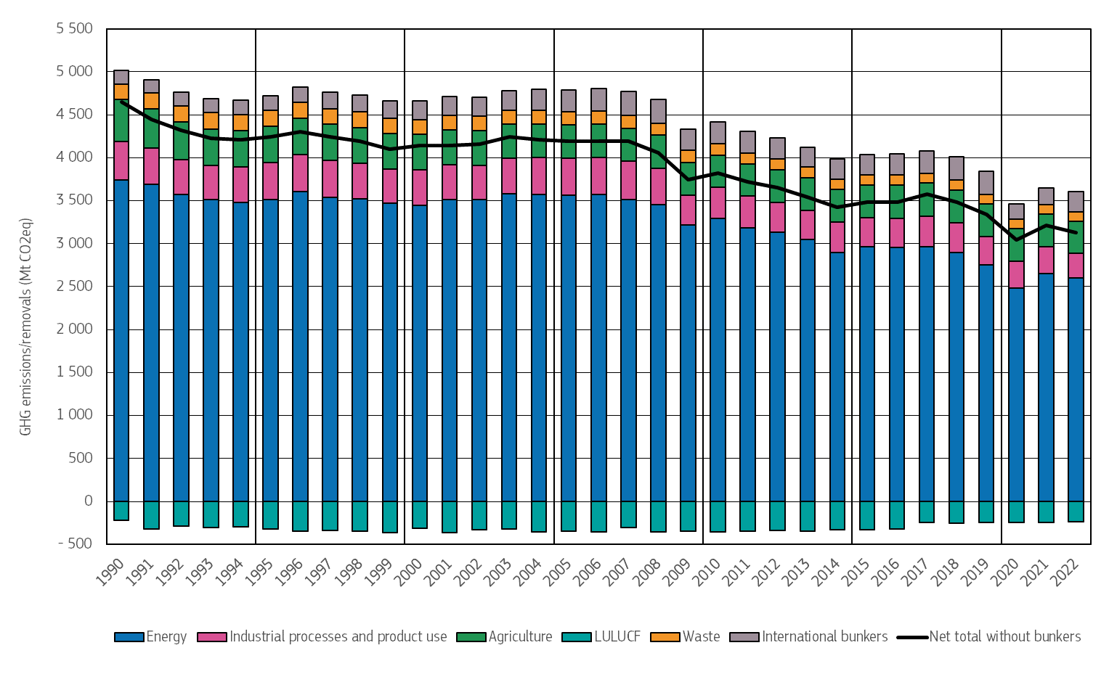

Source: Annual European Union GHG inventory 1990-2022

In 2022, the energy sector accounted for 77% of GHG emissions (excluding LULUCF), followed by agriculture (11%), industrial processes and product use (9%) and the waste sector (3%). Carbon dioxide is the principal GHG, contributing 81% of emissions. Methane accounts for 12%, nitrous oxide for 5% and fluorinated gases for 2% of emissions.

## **Progress towards the target of the EU nationally determined contribution (NDC)**

Under the Paris Agreement, the European Union and its Member States have committed to an ambitious target of reducing net GHG emissions by at least 55% by 2030 compared to 1990. The European Climate Law46 sets the goal of climate neutrality by 2050 and the intermediate target of reducing net greenhouse gas emissions by at least 55% by 2030 compared to 1990 levels. These targets cover emissions and removals that are regulated in Union law.

The EU NDC is described in the EU submission of 17 October 2023 to the UNFCCC. The EU NDC is an economy-wide net reduction target which includes net removals from the LULUCF sector and emissions from international aviation and maritime transport activities regulated as set out for 2030 in Annex I to the EU ETS Directive. Therefore, the EU NDC includes emissions from international aviation and international maritime transport. This target is to be achieved domestically (i.e. within the EU), without the use of international credits.

In this first Biennial Transparency Report (BTR), the EU reports on its progress towards achieving its NDC target. As this NDC target includes specific emissions from international aviation and international maritime transport, its scope is wider than that of the national GHG emissions inventory albeit narrower than that of the EU 2030 target under the Climate Law as regards aviation and maritime transport. Considering the NDC’s scope, emissions have decreased by 31.8% between 1990 and 2022.

Figure 2: Emissions under the NDC scope in 1990 and 2022

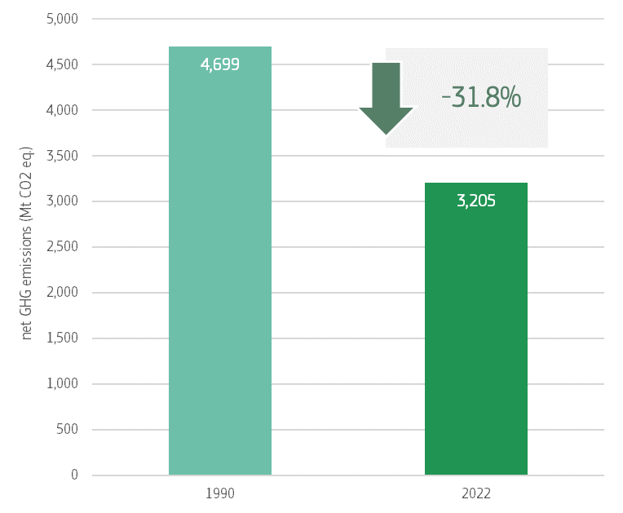

To achieve the target of an at least 55% reduction by 2030, further reductions in emissions are needed. To this end, the EU and its Member States have put in place a comprehensive framework of new and enhanced policies and measures, known as the “Fit for 55 package.” The package seeks to accelerate emissions reductions in the sectors covered by the EU emissions trading system (EU ETS) and those covered by the Effort-sharing Regulation, and to increase carbon removals in the LULUCF sector.

## **Mitigation policies and measures**

The European Union’s 2030 climate and energy framework is a set of policies to ensure that the EU and its Member States fulfil their climate change mitigation commitments under the Paris Agreement. This framework is governed by the European Climate Law, which includes the more ambitious 2030 climate target, provisions for developing a 2040 climate target, and the target of climate neutrality by 2050.

The EU emissions trading system (EU ETS) is a cornerstone of the 2030 climate and energy framework. It puts a price on carbon by setting a cap on the maximum number of emissions allowances in the energy and industrial sectors, and for specific flights and voyages in aviation and maritime transport. GHG emissions from these sectors must be reduced by 62% by 2030 compared to 2005 levels. Furthermore, emissions trading in the EU will be extended to cover emissions from fuel combustion in buildings, road transport and additional sectors (mainly small industry not covered by the existing EU ETS) as from 2027 with the creation of a Social Climate Fund, financed from the auction of emissions allowances to support the most vulnerable households and micro-enterprises The cap will be set to bring emissions from those sectors down by 42% by 2030 compared to 2005 levels.

The Effort-sharing Regulation sets individual, binding reduction targets for EU Member States for emissions in sectors outside the EU ETS and the LULUCF sector, namely domestic transport (except aviation), buildings, agriculture, waste and small industries. In these sectors, GHG emissions must be reduced by 40% by 2030 compared to 2005 levels, with targets for individual Member States of reductions ranging from 10% to 50%.

The achievement of these targets is supported by several sector-specific policies and measures, including the Energy Efficiency Directive, the Renewable Energy Directive, and CO2 emissions standards in road transport as well as supported through EU funding, including the Recovery and Resilience Facility, Cohesion Funds, Common Agricultural Policy, Modernisation Fund or Innovation Fund.

In the LULUCF sector, the LULUCF Regulation introduced an EU-wide net carbon removal target of 310 million tonnes of CO2 equivalent by 2030. Each Member State has an individual binding target, ranging from -47 to +5 million tonnes of CO2 equivalent, which taken together will achieve the EU’s collective target.

In 2024, the Commission issued a Communication and detailed impact assessment on the EU’s 2040 target, recommending a 90% net greenhouse gas reduction relative to 1990 levels by 2040.

## **Projections of greenhouse gas emissions and removals**

The latest projections of GHG emissions and removals show that net emissions in 2030 could be 47% below 1990 levels, in a scenario that includes the ‘with additional measures’ and when emissions from international aviation and navigation are considered. They could be 51% below 1990 levels if emissions from international aviation and navigation are excluded. Additional efforts, therefore, will be needed to achieve the -55% emission reduction target of the EU NDC.

Figure 3: Historical and projected total net GHG emissions in the EU

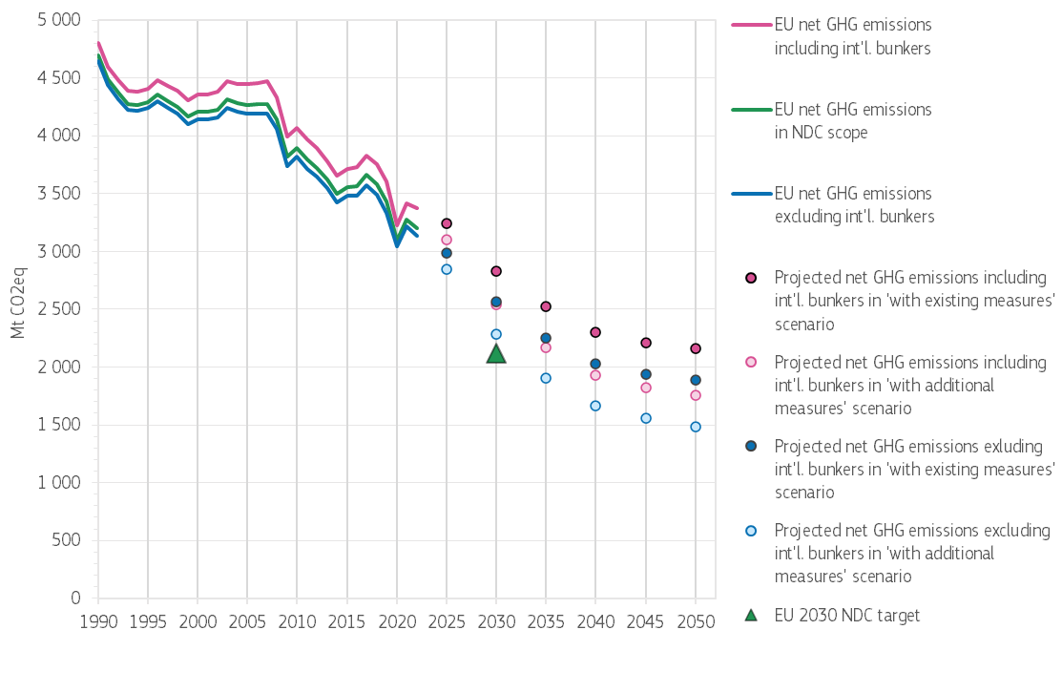

Sources: Annual European Union GHG inventory 1990-2022, EU Member States GHG emission projections submitted in 2023 and 2024 under the Governance Regulation

## **Preparedness for and resilience to climate change impacts**

Under the European Climate Law, the European Union and Member States are required to ensure continuous progress in improving adaptive capacity, strengthening resilience and reducing vulnerability to climate change in accordance with Article 7 of the Paris Agreement.

As a result, the 2021 EU Strategy on Adaptation to Climate Change contains a wide range of initiatives and actions that the European Commission is committed to carrying out, and its implementation is in full swing [4].

In March 2024, the European Environment Agency (EEA) published the first European Climate Risk Assessment (EUCRA)[5] assessing climate risks and identifying policy priorities for climate change adaptation and for climate-sensitive sectors. It identified 36 major climate risks for Europe within five clusters: ecosystems, food, health, infrastructure, and economy and finance. More than half of these climate risks demand more action now, and eight are particularly urgent. The same month, the Commission adopted a Communication on managing climate risks[6] setting out actions to strengthen resilience and preparedness and to clarify who is responsible for acting.

Finally, strengthening adaptation actions and preparedness remains a major priority for the EU, as reflected in the March 2024 Commission communication and in President von der Leyen’s Political Guidelines for the 2024-2029 European Commission[7].

## **Support to developing countries**

Climate finance contributions from the EU, its Member States, and the European Investment Bank (EIB) have increased over the past 9 years, from EUR 9.5 billion in 2013 to EUR 28.5 billion in 2022. Contributions from the EU budget and the EIB amounted to EUR 6.5 billion in 2022.

Of the climate finance provided by EU institutions to developing countries, 56% was allocated to mitigation purposes, 16% to adaptation purposes, and 29% of this support covered both mitigation and adaptation.

The EU supports capacity building in partner countries through a number of regulations, strategies, policies and programmes.

The Neighbourhood, Development and International Cooperation Instrument – Global Europe (NDICI-Global Europe Regulation)[8], which has a budget of approximately EUR 79 billion for 2021-2027 and a spending target of 30% for climate, supports sustainable development and the fight against climate change among others in Sub-Saharan Africa, Asia and the Pacific and the Americas and Caribbean countries.

This has been used for example in 2024 the EU provided capacity building to dedicated countries with expert matching function to allow quick and tailored advice on issues that arise in their BTRs, in addition to other support for capacity building to help developing countries in their GHG inventory and BTR reporting.

The Global Gateway, the new European Strategy, boosts investment in smart, clean and secure links in digital, energy and transport and strengthen health, education and research systems across the world. It draws on the **new financial tools** in the EU multi-annual financial framework 2021-2027. The European Fund for Sustainable Development Plus (EFSD) which is one of the financial tools under the global gateway plays a key role for sustainable development in the EU partner countries outside Europe. Several EFSD guarantees scaled financing for renewable energy[9].

The EU stimulates technology transfer activities in many development cooperation projects. Similarly, the EU has integrated capacity-building activities into all its development assistance in line with the Paris Declaration on Aid Effectiveness and the Accra Agenda for Action. Furthermore, the EU Adaptation to Climate Change strategy paves the way for the EU to step up its international action for climate resilience.

## **Making finance flows consistent with a pathway towards low GHG emissions and climate-resilient development**

In recent years the EU has made significant progress in improving the consistency of finance flows with the goals of the Paris Agreement at all levels. In line with Article 2(1)(c) of the Paris Agreement, the EU has integrated climate change into the heart of its economic, social and development practices through various domestic and international initiatives.

These actions signal a proactive approach to meeting the EU’s climate targets and to contribute to the global effort to combat climate change. As part of this global effort, the EU has taken the lead in mobilising climate finance domestically and internationally from a wide variety of sources, instruments and channels (including instruments to unlock the huge potential of private finance through the targeted use of public finance) and a variety of actions aligning financial flows with the aims of the Paris Agreement.

Besides providing and mobilising support to developing countries, the European Union is taking additional steps to make finance flows consistent with a pathway towards low GHG emissions and climate-resilient development, as stipulated in Article 2(1)(c) of the Paris Agreement. These steps include, among other things, the mainstreaming of climate change mitigation and adaptation into all major EU spending programmes, the use of the ‘do no significant harm’ principle, the implementation of the EU taxonomy for sustainable activities[10] and a comprehensive set of ESG disclosures requirements applicable to non-financial and financial undertakings, and the alignment of EIB financing with the principles and goals of the Paris Agreement.

1. Copernicus Climate Change Service (C3S), 2024: European State of the Climate 2023, Summary, p. 23:

   <https://doi.org/10.24381/bs9v-8c66>
2. IPCC, 2023: Summary for Policymakers. In: Climate Change 2023: Synthesis Report. Contribution of Working Groups I, II and III to the Sixth Assessment Report of the Intergovernmental Panel on Climate Change [Core Writing Team, H. Lee and J. Romero (eds.)]. IPCC, Geneva, Switzerland, pp. 1-34, doi: 10.59327/IPCC/AR6-9789291691647.001
3. [Regulation - 2018/1999 - EN - EUR-Lex (europa.eu)](https://eur-lex.europa.eu/legal-content/EN/TXT/?uri=uriserv:OJ.L_.2018.328.01.0001.01.ENG)
4. Report on the Implementation of the EU Adaptation Strategy on Adaptation to Climate Change, <https://climate.ec.europa.eu/document/download/72286a42-61af-4e8a-a51a-29a58c90274e_en?filename=swd_2023_338_en.pdf>
5. [European Climate Risk Assessment — European Environment Agency](https://www.eea.europa.eu/publications/european-climate-risk-assessment)
6. [EUR-Lex - 52024DC0091 - EN - EUR-Lex](https://eur-lex.europa.eu/legal-content/EN/TXT/?uri=CELEX:52024DC0091)
7. [Political Guidelines 2024-2029 | European Commission (europa.eu)](https://commission.europa.eu/document/e6cd4328-673c-4e7a-8683-f63ffb2cf648_en).
8. Regulation (EU) 2021/establishing the Neighbourhood, Development and International Cooperation Instrument – Global Europe, <https://eur-lex.europa.eu/legal-content/EN/TXT/PDF/?uri=CELEX:32021R0947>
9. The European fund for sustainable development 2020 operational report, The European fund for sustainable development, https://op.europa.eu/en/publication-detail/-/publication/6c93ad22-d299-11ed-a05c-01aa75ed71a1
10. [Regulation - 2020/852 - EN - taxonomy regulation - EUR-Lex (europa.eu)](https://eur-lex.europa.eu/legal-content/EN/TXT/?uri=CELEX:32020R0852)