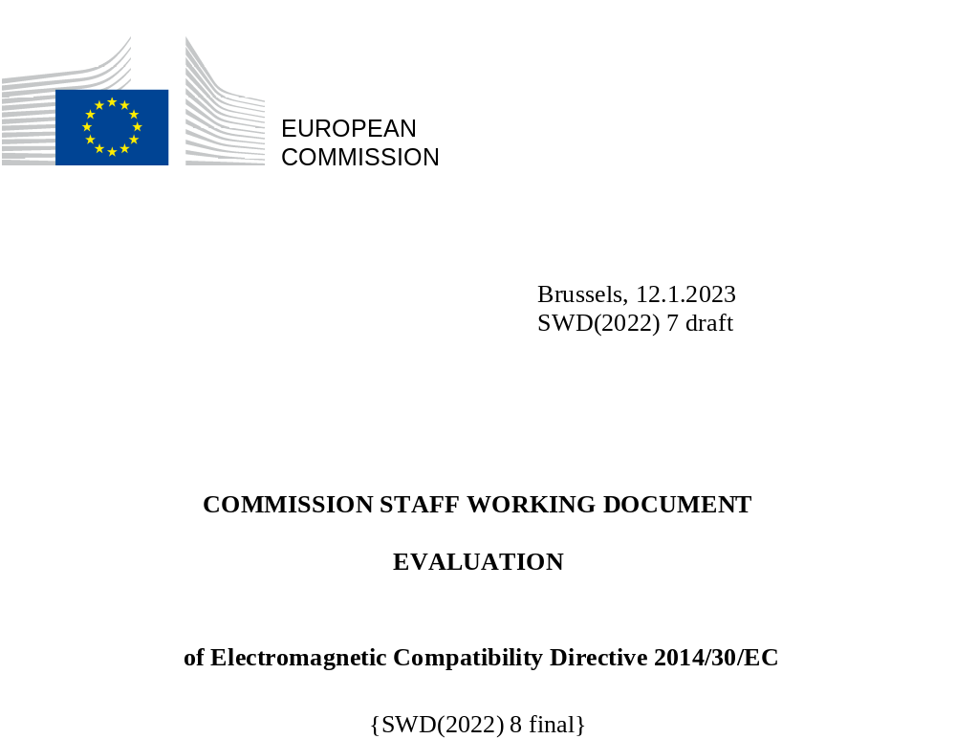

Table of contents

1 Introduction 5
1.1 Purpose of the evaluation 5
1.2 Scope of the evaluation 5
2 Background of the Intervention 6
3 Implementation / state of Play 8
3.1 Relevant Bodies 8
3.2 Guidelines 9
3.3 European standardisation 9
4 Methodology 9
4.1 Data collection and consultation strategy 9
4.2 Data analysis methodology 11
4.3 Statistical data on products in the scope of the EMCD 11
4.4 Cost-benefit analysis 11
5 Analysis and Answers to the Evaluation Questions 12
5.1 Findings in relation to the Effectiveness of the Directive 12
5.2 Findings in relation to the Efficiency of the Directive 20
5.3 Findings in relation to relevance of the EMCD 28
5.4 Findings in relation to the Coherence of the EMCD 30
5.5 Findings in relation to the EU Added Value of the EMCD 34
6 CONCLUSIONS 35
7 ANNEXES 39
ANNEX 1 - PROCEDURAL INFORMATION 39
ANNEX 2 - SYNOPSIS REPORT OF STAKEHOLDER CONSULTATIONS 40
ANNEX 3 - METHODS AND ANALYTICAL MODELS 48
ANNEX 4 - ANALYSIS OF THE EMCD MARKET 57
ANNEX 5 - CASE STUDIES 68
ANNEX 6 - DESK RESEARCHS 74
ANNEX 7 - EVALUATION QUESTIONS 79

Glossary
Term or acronym | Meaning or definition
AC | Alternating current
AdCo | Administrative Cooperation (Group)
ANSI | American National Standards Institute - has a role in developing EMC standards.
Benign equipment | Benign equipment is excluded from the scope of the EMC Directive – Article 2(2)(d). It is incapable of generating or contributing to electromagnetic emissions, or being disturbed... (from EDCD 2(2)(d) (ii)).
CABs | Conformity Assessment Bodies
CBA | Cost-benefit assessment
CISPR | Comité International Spécial des Perturbations Radioélectriques (International Special Committee on Radio Interference)
CEN | European Committee for Standardization
CENELEC | The European Organisation for Electrotechnical Standardisation is the European standards making body which has been mandated by the Commission of the EU to produce EMC standards for use with the European EMC Directive.
CENELEC TC210 | The horizontal committee working on standards development of the Generic and Product Family Standards.
CISPR | The Comité International Spécial des Perturbations Radioélectriques (CISPR; English: International Special Committee on Radio Interference)
Commission | European Commission
DG GROW | Directorate General for Internal Market, Industry, Entrepreneurship and SMEs of the European Commission
DoC | Declaration of Conformity
EEA | European Economic Area
EFTA | European Free Trade Association
EMC ADCO | Electromagnetic Compatibility Administrative Cooperation Group
EMC WP | Electromagnetic Compatibility Working Party
EMC | Electromagnetic Compatibility
EMCD | Electromagnetic Compatibility Directive (2014/30/EU)
EMI | Electromagnetic interference
EO(s) | Economic operator(s)
ESOs | European Standardisation Organizations
ETSI | European Telecommunications Standards Institute
EU | European Union
EUANB | Group of Notified Bodies notified under the EMCD to the European Commission
FCC | Federal Communications Commission
FTE | Full-Time Equivalent
GHz | Gigahertz - unit of measurement for electromagnetic wave frequencies equal to 1,000,000,000 (one billion) Hz (hertz).
DG GROW | Directorate-General for Growth - Internal Market, Industry, Entrepreneurship and SMEs
Harmonics | Digital signals and circuits generate noise sources known as harmonics, which are unwanted higher frequencies superimposed on the fundamental waveform. These may create distorted wave patterns and create EM interference.
HS | Harmonised Standards
IARU | International Amateur Radio Union
IEC | International Electrotechnical Commission is the international standards and conformity assessment body for all fields of electrotechnology.
IoT | Internet of Things
ISO | International Organization for Standardization. The ISO, along with the IEC has technical committees working on the development of emission and immunity requirements for devices and products.
LED | Light-Emitting Diode
LVs | Limit Values
LVD | Low Voltage Directive (2014/35/EU)
MD | Machinery Directive (2006/42/EC)
MHz | Megahertz unit of measurement for EM wave frequency
MRA | Mutual Recognition Agreement (several exist between the EU and other third country jurisdictions in the area of EMC, e.g. with the US).
MS | EU Member State
MSAs | Market Surveillance Authorities
NBs | Notified Bodies
NIST | National Institute of Standards and Technology, United States
NLF | New Legislative Framework
OJEU | Official Journal of the European Union (where harmonised standards adopted under the EMCD are published in the legal section of the OJ)
PLC | Power Line Communications
RED | Radio Equipment Directive (2014/53/EU)
RMCD | Ready-Made Connecting Devices
RF | Radio functionality
R&TTE | Radio equipment and telecommunications terminal equipment Directive (1999/5/EC). Directive was the predecessor to the RED
SDoC | Supplier’s Declaration of Conformity (allowed under Module A as one of the permissible conformity assessment procedures under the EMCD). This is a self-declaration of conformity.
WPT for EVs | Wireless-charging Power Transfer for Electric Vehicles

Introduction
The Electromagnetic Compatibility Directive 2014/30/EU (hereafter the EMCD) regulates electromagnetic compatibility aspects of a wide range of electrical and electronic products.
The EMCD has the objectives of facilitating the free movement of electrical equipment across the Union and avoiding any electromagnetic disturbance between equipment, which could in turn generate dysfunctions and prevent correct operation of the equipment. More specifically, the Directive ensures that electromagnetic disturbances/emissions produced by electrical equipment do not affect the functioning of other such equipment and that electrical equipment has an appropriate level of immunity to electromagnetic disturbances so that it can function as intended.
The first Electromagnetic Compatibility Directive 89/336/EEC was adopted in 1989. It was repealed and replaced by Directive 2004/108/EC. The current Electromagnetic Compatibility Directive 2014/30/EU was adopted in 2014, became applicable as of 20 April 2016 and repealed and replaced Directive 2004/108/EC. After more than 30 years without any major modifications, it was necessary to assess, in the context of a regular evaluation of the acquis, if the Directive has achieved its objectives in an efficient, effective, coherent and relevant way and still has EU added value. Therefore in line with the Commission's Regulatory Fitness and Performance (REFIT) programme, the Directive was subject to an evaluation.
The evaluation was supported by an external study (hereafter evaluation study), commissioned by DG GROW and conducted from January 2020 to May 2021.

Purpose of the evaluation
The purpose of the evaluation is to analyse the performance of the EMCD towards its objectives of facilitating the free movement of electrical equipment across the Union and avoiding any disturbance between equipment. The evaluation assesses the extent to which the Directive is still fit for purpose in terms of effectiveness, efficiency, relevance, coherence and EU added value. The evaluation provides evidence and conclusions that will form the basis for possible future improvements in order to keep the EMCD up to date so that it can achieve its objectives and produce the desired results.

Scope of the evaluation
The evaluation considers changes to the Directive over time through successive iterations. It covers the period since 1989 to 2020 and focuses on the period since the applicability of the current Electromagnetic Compatibility Directive 2014/30/EU.
The first Electromagnetic Compatibility Directive 89/336/EEC adopted in 1989 was repealed and replaced by Directive 2004/108/EC. A notable difference in the 2004 Directive compared with 1989 is that mandatory use of a notified body was no longer required.
The current Directive was adopted in 2014, became applicable as of 20 April 2016 and repealed and replaced the previous Directive 2004/108/EC. The 2014 revision of the EMCD was part of the alignment process with the New Legislative Framework (NLF), a horizontal piece of legislation, which includes common requirements in respect of placing goods (equipment) on the market, common arrangements for market surveillance and common accreditation rules to ensure the quality of the services of conformity assessment bodies. The essential requirements in the current Directive have not been modified and the scope remains essentially the same compared to 2004, except for the introduction of an exception for custom built kits and kits of components to be assembled by radio amateur and equipment made available on the market.
The current EMCD has in the meantime been modified by Article 137 of the Regulation on common rules in the field of civil aviation (EU) 2018/1139. This article modified Annex I (3) of the EMCD. As a result, equipment within the scope of Regulation (EU) 2018/1139 is excluded from the EMCD, except for some specific categories of drones.
Given the large scope of the EMCD, the evaluation limits the analysis to 14 selected products, with a balance between apparatus and installations. The selection was done in collaboration with the EMC market surveillance authorities (see section 4 on Methodology for more details). Additionally, five product based case studies were used for the analysis.
The geographic scope of the evaluation focuses on the EU-27, the UK (it was a Member State for much of the time period within scope and is considered as a third country in the analysis), and the EFTA countries. EEFTA allows products complying with the EMCD to benefit from free movement in Iceland, Liechtenstein and Norway by virtue of the European Economic Area (EEA) Agreement.

Background of the Intervention
The scope of the EMCD covers a wide range of electrical equipment placed on the internal market, both for consumers and industrial use, classified in apparatus and fixed installations. Apparatus are defined in the EMCD as “any finished appliance, or combination thereof made available (i.e. making available) on the market as a single functional unit, intended for the end-user, and liable to generate electromagnetic disturbance, or the performance of which is liable to be affected by such a disturbance’ (Article 3). Apparatus also includes mobile installations and components or sub-assemblies that are incorporated into the apparatus by an end-user. Typical example of apparatus are, but not limited to, household appliances such as refrigerator, oven, microwave, vacuum cleaners, toaster, blender, but also other type of equipment such as measuring devices, chargers, computers, printers, equipment for transmitting sound, images or other information by telecommunication, equipment for the purpose of recording or reproducing sound or images, powered tools for different activities (e.g. gardening), etc.; but also power supply units; electric motor systems, powered tools, etc. Fixed installations are defined in the Directive as a ‘particular combination of several types of apparatus and, where applicable, other devices, which are assembled, installed and intended to be used permanently at a predefined location’ (Article 3). Fixed installations are, for example, industrial plants, telecommunication networks, airport luggage handling installations, wind turbine stations or air conditioning installations. However, if the products within the scope of the EMCD include a radio functionality (communicate wirelessly), the Radio Equipment Directive (RED) applies instead of the EMCD. Furthermore, the EMCD shall not apply if electromagnetic compatibility requirements for equipment are wholly or partly laid down by other more specific EU legislation. For example, this is the case of medical equipment, motor vehicle equipment, marine equipment, agricultural and forestry tractors and two or three-wheel motor vehicles. The EMCD is not a health and safety or environment related Directive. For functional safety or environmental aspects of the products within the scope of the EMCD, other legislation applies in parallel with the EMCD.
The Directive has some exclusions for certain categories of equipment, such as equipment for radio amateurs (unless made available on the market) or benign equipment and custom-built evaluation kits. The other exclusions are for equipment falling under specific legislation that also covers electromagnetic compatibility as specified above.
The EMCD provides a stable regulatory framework with rules concerning the essential requirements, conformity assessment procedures and CE marking.
The EMCD is a New Approach harmonised legislation meaning that it establishes mandatory essential requirements, but does not translate them into detailed specifications or processes. The use of European harmonised standards is voluntary, but a product manufactured in conformity with a European harmonised standard published in the Official Journal of the EU is presumed to comply with the Essential Health and Safety Requirements (EHSR) of the Directive that are covered by that standard. The EMCD also prevents non-compliant apparatus from being placed on the EU market and the national Market Surveillance Authorities are responsible for the enforcement of the Directive.
Figure 2-1 – The figure below provides an overview of the intervention logic of the EMCD.
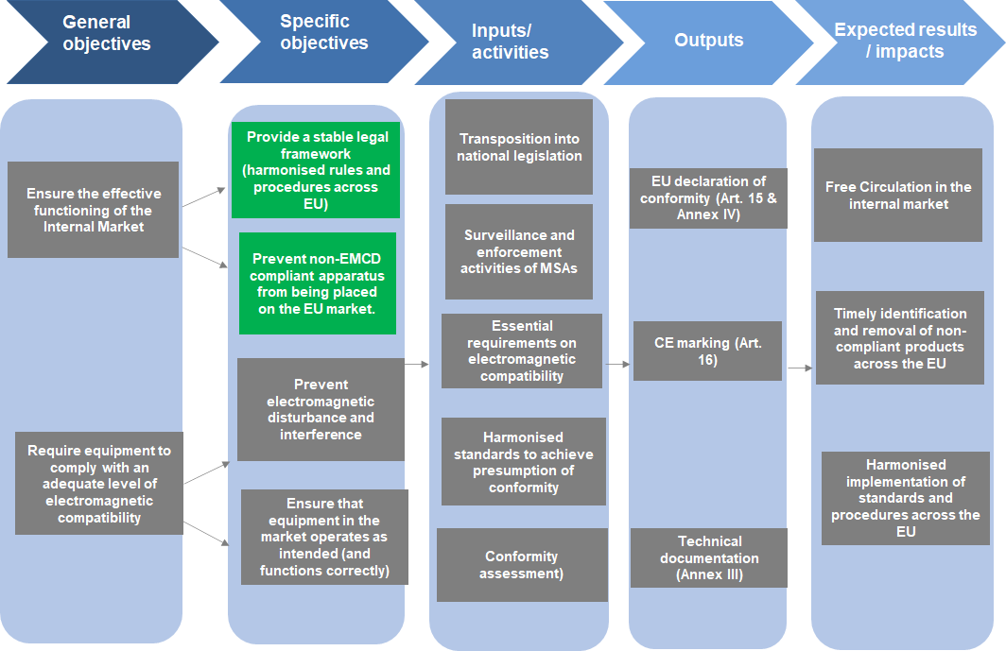

Implementation / state of Play
All Member States have communicated to the Commission the texts of the main provisions of national law which they adopted in the fields covered by the EMCD. Currently, there are no infringement procedures in relation to the EMCD.
Member States are responsible for appointing competent authorities responsible for the implementation of the Directive at national level and for ensuring that the Directive is effectively enforced within their territories. As such, they are also responsible for market surveillance, including penalties.

Relevant Bodies
Several specific bodies assist the Commission in managing, monitoring and enforcing the implementation of the EMCD:
The Committee on Electromagnetic Compatibility was established under Article 41 of the EMCD. It consists of representatives from the EU Member States as members, as well as EFTA countries and Turkey, as observers. The European Commission is required to consult the committee when implementing acts that are prepared under the EMCD and on any questions where the opinion of sectoral experts is required by EU legislation (notably Regulation (EU) No 1025/2012 on European standardisation).
The EMC Working Party (EMC WP) provides a forum to discuss specific issues related to the implementation of the EMCD between the Commission and relevant stakeholders. It consists of representatives from the Member States, who are members, as well as EEA/ EFTA countries and Turkey, who participate as observers and it is chaired by the Commission. Non-state stakeholders, such as standardisation organisation, industry representatives, consumers associations, etc., are also invited to participate as observers.
The EMC Administrative Cooperation Group’s (EMC ADCO) purpose is to discuss market surveillance issues relating to the EMCD at EU level. It is composed of the national market surveillance authorities responsible for the enforcement of the Directive and it is chaired by the Member States’ Market Surveillance Authorities (MSAs).
The role of the EUANB Group of Notified Bodies (NBs) is to discuss key issues relating to the role of notified bodies in supporting the conformity assessment of products within the EMCD’s scope. Economic operators may use the services of a notified body, the only recognised third-party approved to do so, but their use is voluntary.

Guidelines
Additionally to the above groups, the Guide on the application of the EMCD developed in cooperation with all stakeholders represented in the EMCD Working Group, is a widely used tool that is highly appreciated for facilitating the effective and efficient application of the Directive.

European standardisation
The European harmonised standards (hENs) give presumption of conformity with the Directive when published in the Official Journal of the EU (OJEU). They underpin the implementation of the EMCD but their use is voluntary. These harmonised standards are developed by the European standardisation organisations (CEN, CENELEC and ETSI) with an active participation of the industry, consumers and workers representatives. Harmonised standard translate the Essential Requirements into detailed technical specifications for certain types of product. The functioning of the European Standardisation System has an impact on the implementation of the EMCD. Stakeholders signal issues with inter alia timely publication of hENs and the inclusiveness of the system. However, evaluation of the European standardisation is out of the scope of this evaluation. The Commission plans as regards the European standardisation are presented in the Standardisation Strategy of February 2022.

Methodology

Data collection and consultation strategy
The evaluation study was conducted from January 2020 to May 2021, with data collection activities running until February 2021, as presented in detail in Annex 3. The findings of the study are based on a programme of research and analysis, which included the following:
- Desk research
Desk research was a constant activity during the whole study. Relevant documentation was analysed, including the EMCD and its predecessors, and other relevant safety legislation impacted by EMCD (e.g. the Machinery Directive and Low Voltage Directive, Radio Equipment Directive), along with the horizontal legal framework provided for by the New Legislative Framework (NLF). A review of the EMC ADCO Joint Market Surveillance Campaigns on specific products was undertaken, as well as other previous studies. Academic research focusing on electromagnetic disturbance related issues relevant to five product-based case studies was also reviewed. In addition, as part of an analysis of the electrical equipment market and its evolution, three sets of Eurostat databases were considered, namely Prodcom, Comext and the Structural Business Statistics datasets and some market research data were also analysed.
- Interviews
A total of 112 interviews were carried out as part of the consultation activities. The consultations were as wide as possible, with an effort to ensure an appropriate balance across different types of stakeholders and in terms of broad representativeness. Stakeholders from third countries were also interviewed with the aim of completing the understanding of legislative systems for EMCD products in other regions of the world (presented in Annex 5), and possibly spot ‘best practices’.
- Consultations
Two online consultations were carried out:
  - Targeted stakeholder survey
The stakeholder survey was launched on 20 July 2020, addressed to the sector’s relevant stakeholders and closed the 20 of October (total of 14 weeks).
In total, 458 respondents answered the survey. A good balance was achieved in the survey responses between the different types of stakeholders involved. Overall, industry represented 56.1% of the total responses (industry associations + economic operators) to the targeted consultation. The other types of survey respondents were mainly laboratories (14.2%), MSAs (5.5%), national authorities (7.2%), notified bodies (3.5%) and standardisation organisations (2.8%). There were challenges in obtaining responses however from SMEs and consumer associations. The latter was because the EMCD is quite technical and few consumer associations follow the Directive, but instead responses were received from users and radio amateurs. It can be assumed that to some extent these could represent the consumer perspective.
  - Public Consultation
A public consultation was launched on 9 October 2020 for 16 weeks (extended from 12 weeks due to Covid-19). The questionnaire was addressed to all EU citizens and stakeholders, and gathered 854 replies across 15 Member States and 7 other countries. The most common country of origin of respondents was Germany with 59.4% of responses (507). Respondents from EU Member States (836) accounted for 98% of the total.
The largest group of respondents by type were ‘users of electric equipment/apparatus/fixed installation (individual citizen or other types of organisations)’. This group represented 60% of all consultation responses. The next largest group was the ‘radio amateur organisation or other citizen-based organisation’, accounting for 29% of responses (248). The answers for these two groups tend to follow a similar pattern, suggesting coordinated replies and that the ‘user’ group mainly includes radio amateurs.
Few SMEs replied to either of the two consultations.
- Workshops
Four separate webinars were organised in October 2020. These involved the participation of a wide range of stakeholders from among members of the EMC Working Party (WP) and EMC ADCO. In addition, various presentations were made to engage with relevant stakeholders, including the EUANB (notified bodies).

Data analysis methodology
The data analysis was based on an assessment of the data gathered through desk research and stakeholder consultations. This consisted of a review of the results of the stakeholder consultations (interview and both consultation on line), analysing the results to the evaluation roadmap consultations (25 respondents), analysing the data on market size and structure and the data on costs and benefits. Mitigation measures have been taken to ensure impartiality of responses to the consultation activities, for example by tackling the under representation of certain stakeholders groups (as explained in section 4.1 on Methodology).
Given the very wide range of the products across different sectors covered by the Directive, in agreement with the Market Surveillance authorities, 14 products were selected for the market analysis. From these, 5 were selected for case studies (presented in Annex 5).

Statistical data on products in the scope of the EMCD
The EMCD covers the great majority of the electrical products. For this reason the market analysis was streamlined to 14 products, (including both apparatus and fixed installations) selected in collaboration with the EMCD ADCO members. While the 14 products represent a relatively small share of the entire European electrical equipment market, their choice was intended to strike a balance between products identified as being problematic from an electromagnetic disturbance perspective, and other products under the EMCD scope that do not necessarily cause emissions concerns or present immunity problems. See Annex 3 for a detailed list and choice.
While for 9 products it was possible to identify the corresponding NACE Prodcom and CN categories (microwaves ovens, washing machines, vacuum cleaners, power tools, solar inverters, screens signage, air conditioning installations, wind turbines, and cable TV networks), for other 5 (LED lights, induction hob, switching power supply, Powerline Communications, and computer networks) the matching of products to available statistical sources was more challenging. This is because the available product codes are not specific to these product types, but encompass a broader range of products. For instance, LED lights comprise a share of the Electric lamps and lighting fittings covered by a Prodcom code which also includes fluorescent, HID, incandescent lamps and lighting fittings.
The collection of specific market data for some fixed installations was more challenging than for individual apparatus. One installation may embed several apparatus (for example, an air conditioning system is made of an outside condenser, an inside vent, and connectors) thus making the identification of the specific units of the statistical analysis more challenging. Nevertheless, for most of the fixed installations selected (air conditioning installations, computer networks, screens signage, wind turbines and cable TV networks), it was possible to identify the product codes of the components which make up the major part of the installation and which most likely act as source of the disturbance, or raise other EMCD related issues under the study scope.
From the available market data, it is not possible to measure the impact of the EMCD on the market. This data is therefore only sufficient to paint a background picture. Hence, the evaluations findings are more based on other sources of information, such as the consultations, than the market data which was summarised in Annex 4.

Estimation of Cost and benefits for EMCD
A list of possible costs and benefits generated by the EMCD was composed and used to collect feedback from relevant stakeholders through the targeted consultation and in-depth interviews. It should be noted however that stakeholders consulted provided very limited quantitative data on the costs and the benefits of the EMCD.
Detailed information on statistical data used for products within the scope of the EMCD and cost and benefits data is provided in Annex 3 (Table 1-1 Costs generated by the EMCD and Table 1-2 Benefits generated by the EMCD)

Analysis and Answers to the Evaluation Questions

Findings in relation to the Effectiveness of the Directive
This section presents the findings on the EMCD's effectiveness at the level of its core objectives: facilitating the free movement of electrical equipment across the Union and avoiding any electromagnetic disturbance between equipment.
The majority of respondents to the targeted stakeholder survey (e.g. industry associations, economic operators and market surveillance authorities) agreed that the Directive is effective in achieving its general objectives (Figure 5-1). The most notable exception is that radio amateur associations and their members were less positive regarding the perceived electromagnetic disturbance generated by certain types of equipment.
It should be noted that a low number of responses from SMEs and consumer associations were provided. For instance, only three national consumer associations responded to the questionnaire and there was no qualitative open feedback from these to justify their responses.
The general perception of the effectiveness of the EMCD among targeted respondents seems to be more positive than the perceptions occurring from the public consultation.
Figure 5-1 – Overall, to what extent has the EMC Directive been effective in achieving its general objectives? (N = 299)
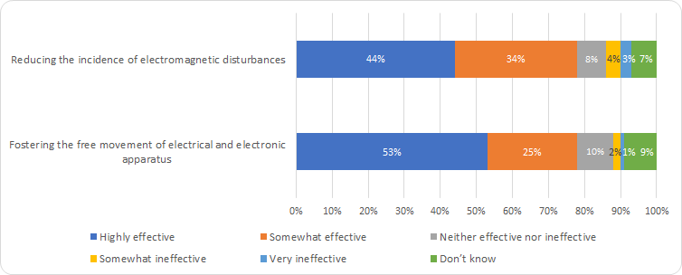
Source: Targeted consultation for the European Commission
Free movement of goods

Regarding the Directive’s contribution to the internal market, it is difficult to disentangle the role of the EMCD from other factors in the growth of intra- and extra-EU trade. The analysis of data presented in Annex 4 – Analysis of the EMCD market, indicate clearly that the production and trade have been growing. It can be assumed that this was the case partly due to the existence of EU-level legislation setting EMC-relevant requirements for products, however the exact magnitude of this impact is not possible to obtain.

The above assumption seems to be confirmed with stakeholder views. The majority of the targeted consultation respondents (78.3% out of 299 who replied to this question) perceived the EMCD as having been either very effective (159 respondents, 53.2%) or somewhat effective (75 respondents, 25.1%) in ensuring the free movement of electrical and electronic apparatus in the internal market. Only 3.0% perceived that the EMCD had been either very ineffective, or somewhat ineffective.
Industry associations were most favourable about the EMCD having fostered the uptake of electrical/electronic goods by ensuring that apparatus placed on the market complied with an adequate level of electromagnetic compatibility (EMC). Manufacturers were also positive, but less than industry associations. Notified bodies were also positive about the Directive’s role in fostering the single market’. Laboratories and MSAs also commonly either perceived the EMCD as ‘highly effective’ or ‘somewhat effective’.
Figure 5-2 – Fostering the free movement of electrical and electronic apparatus in an internal market context – answers by stakeholder group (N=299)
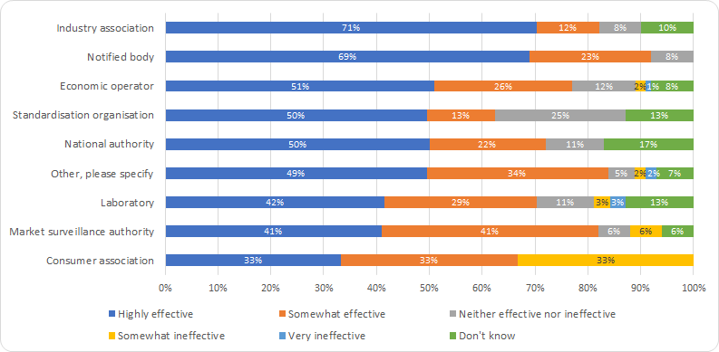
Source: Targeted consultation for the European Commission
When it comes to the size of stakeholders’ groups, medium and large organisations strongly agreed that the EMCD has either been ‘highly effective’ or ‘somewhat effective’ in fostering the free movement of electrical/electronic goods in the internal market (Figure 5-3). Unfortunately, there were quite limited responses from micro (2 firms) and small firms (10 firms) to the consultation, and 7 of the small firms were also consultancies providing advice to manufacturers regarding EMCD compliance rather than being producers themselves. Their appreciation is also “highly effective”.

From a trade flow perspective, intra-EU27 trade for the 14 products within the scope has consistently been larger than extra-EU27 trade in the period between 2002 and 2018 (the period data was available for). More specifically, in the past two decades, the value of trade among the current EU Member States has fluctuated around 55% of total trade in the products concerned. Furthermore, in the past 5 years, intra-EU27 exports have grown more rapidly than extra-EU27 exports (Table 5-1), pointing to the importance of the internal market for the selected products.
Despite the significant growth in intra-EU trade for products falling under EMCD scope, it is difficult to establish attribution, in that changes in market size and trade over time are not solely due to the EMCD but also to other factors.
Table 5-1 - Intra and extra-EU27 export of the 14 selected products, compound annual growth rate (CAGR). 2002-2018. EU27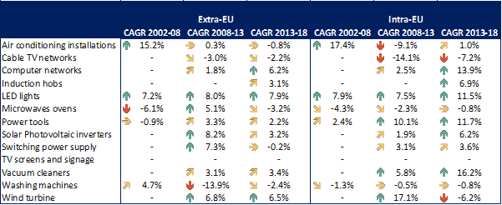

Figure 5-3 – Fostering the free movement of electrical and electronic apparatus in an internal market context – answers by size of economic operator (N=109)
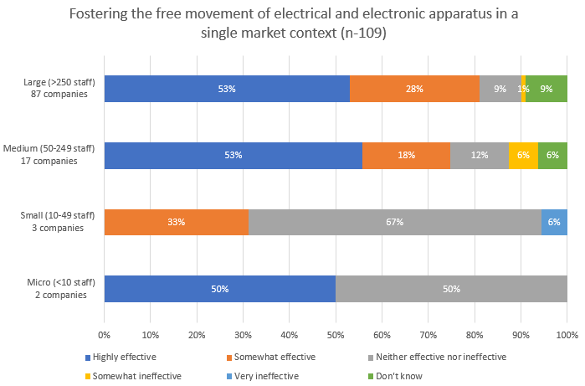
Reducing electromagnetic disturbances
EMCD aims to create an acceptable electromagnetic environment whilst ensuring that equipment will function as intended in that environment. Most electrical and electronic equipment generates electromagnetic fields that are perceptible in their environment; all of these fields create pollution that sometimes disturbs the operation of other equipment.
Regarding the Directive’s contribution towards reducing the level of EM disturbance, the analysis was mainly supported by consultations given that there is not systemic measurement of EM disturbances other than surveillance campaigns on targeted products. This said, 78% of respondents to the targeted consultation who replied to this question perceived that the Directive had been either highly effective (44%, 133) or somewhat effective (34%, 101). These findings were broadly corroborated through interviews, with almost all categories of stakeholders stating that in their view, the Directive had been effective overall. However, some respondents to the public consultation were less positive regarding the Directive’s effectiveness in this respect, namely radio amateurs and their representative associations (see later for more details).
According to interviews results, the EMCD has reduced disturbance overall for instance through the setting of Limit Values in products, which have encouraged manufacturers to take issues around EM disturbance and immunity more seriously and to invest in some measures, such as fostering interest in good EMC design, the use of shielding and filtering. This in turn has helped to foster the free movement of electrical equipment. However, radio amateurs and some MSAs noted that some problematic products continue to generate disturbance (e.g. Powerline Communications, some low-quality LED lights, solar panel inverters). The reasons for this are that some products are poorly designed from an EMC-perspective (e.g. PLCs as they frequently do not contain filters), others are of varying quality and fail to include appropriate immunity measures, such as filters and shielding.
Case study findings indicated that even though there may be some products where disturbance remains a problem, this does not suggest that the Directive is ineffective, as it is more a question of strengthening the effectiveness of harmonised standards and of standards development processes to ensure that problematic products with high levels of disturbance are addressed. Harmonised standards are however voluntary. Also, the functioning of the European Standardisation System is however not in the scope of this evaluation (please see the Standardisation Strategy).
There was an agreement among the respondents to the targeted consultation that the EMCD has made an important contribution in reducing the incidence of EM disturbance leading to the incorrect functioning of equipment (44.5% responded ‘highly effective’ and 33.8% ‘somewhat effective’), with a combined total of 78.3% of the 299 respondents who replied to this question. This was also confirmed through the interviews. Many stakeholders (especially industry associations, manufacturers, MSAs) commented that the Directive has played an important role in drawing attention to the issue of electromagnetic compatibility and of the importance of designing products that design-in EMC from the outset. This was viewed as having improved the situation by ensuring that electromagnetic emissions produced by apparatus are within acceptable levels and in strengthening the inclusion of EMC immunity measures in products (such as shielding, casing, etc.).
Promotion of good engineering practices, in particular as regards fixed installations, were also credited to the EMCD, particularly by development of practices in terms of how to follow suppliers’ instructions and documenting EMC compliance. In the respect, adding fixed installations to the scope of the Directive in 2004 is considered to have been a substantial improvement.
The good practices that have been fostered by the EMCD in turn brought reputational benefits to the EU, which may encourage other geographies decide to adopt EU approaches to the regulation of EMC.
Among the 14 products on which the evaluation focused, 5 products were chosen for more in-depth case studies. These 5 products are well known for having EMC disturbance problems, such as some types of LED lights, powerline communications, RMCD cables (presently outside the EMCD’s scope) etc. Some of these products (e.g. powerline communications) were found to interfere with other equipment in some cases and although harmonised standards have played a role in addressing the problem, challenges remain in the views of radio amateurs and MSAs. In particular, the case studies showed that there are concerns regarding the cumulative impacts of disturbance.
Feedback through the interview programme and targeted consultation stated that immunity to electromagnetic disturbances should remain part of the EMC Directive. In third countries, immunity is often not an EMC requirement, and therefore not regulated. This issue is explored in Annex 3.
Figure 5-4 – Effectiveness of the EMCD in reducing the incidence of electromagnetic disturbances leading to the incorrect functioning of electrical equipment – answers by stakeholder group (N=299)
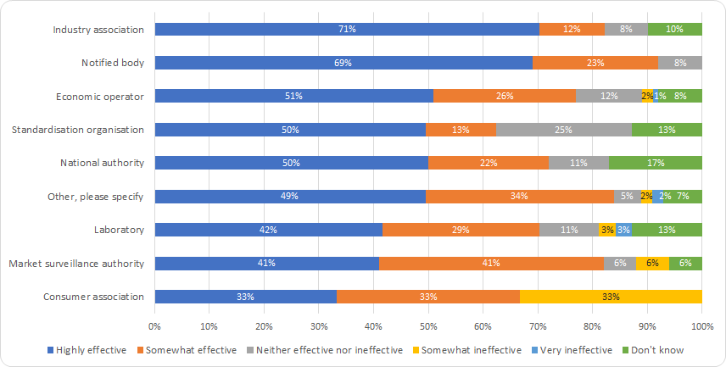
Source: Targeted consultation for the European Commission

Many industry associations and individual firms pointed out that despite the huge increase in the volume of electrical equipment on the market (see Section 5, Analyses of the EMCD Market), the incidence of complaints and problems regarding equipment not working does not appear to have increased.
During the public consultation, 40% of respondents (339 of 848 respondents) found the Directive ineffective in reducing electromagnetic disturbance and the incorrect functioning of electric equipment placed on the European single market. It should be noted that this reflects the fact that many radio amateurs responded to the public consultation, many of whom were part of a coordinated response organised by radio amateur associations (129 out of 245 ) or answered as a user of electric equipment (184 out of 514).
Their main concern was that despite the Directive having been in existence for more than 30 years, there continues to be a problem around EM disturbance. Indeed, many radio amateurs perceived the situation as having progressively worsened in the past decade in particular. They attributed this to the growing ubiquity of electrical equipment, and to the cumulative effects on disturbance. This may prevent amateur radio equipment from working correctly.
The increase of electrical devices on the market related to IoT concerns mainly wireless devices which fall under the scope of the RED rather than the EMCD. Nonetheless, in parallel there has been a corresponding growth of the market of the electrical equipment in general with new products for new uses. This means that the scope of products falling under the EMCD remains very large. Moreover the EMCD’s relevance has increased because the large amount of electrical devices falling under its scope now operate in a changed environment, for which they might not have been initially intended. This might warrant considering more stringent limit values in some cases and also reviewing limit values in harmonised standards more regularly.
New Legislative Framework
Within the New Legislative Framework (NLF), legislation only sets out high-level essential requirements. The EMCD was converted to the NLF with the last revision. Its essential requirements simply state that (a) the electromagnetic disturbance generated does not exceed the level above which radio and telecommunications equipment or other equipment cannot operate as intended; and that (b) it has a level of immunity to the electromagnetic disturbance to be expected in its intended use which allows it to operate without unacceptable degradation of its intended use.
For any NLF legislation, the Commission can ask the European Standardisation Organisations to develop standards that give the technical details to fulfil the essential requirements. If a manufacturer then uses one of those Harmonised Standards for its products, that have been cited in the Official Journal, it is presumed that the product is compliant with the EU legislation, in this case the EMCD. However, the use of Harmonised Standards to demonstrate compliance is voluntary.
Respondents to the targeted survey had a positive perception. They attributed the effectiveness of the Directive mainly to a high-level essential requirements which are formulated in such a way that they cover all EMC phenomena and all technologies including new technological developments at a high-level, but also with voluntary harmonised standards as an appropriate means of addressing the detailed technical requirements (the directive should remain technology neutral).
The targeted survey shows that the impact of the NLF alignment was quite positive. Thanks to the alignment to the NLF, the current EMCD clarifies the definitions and obligations of economic operators, regulates the conformity assessment, clarifies the meaning of CE marking and improves the procedures on market surveillance. The main improvement identified by industry was the clarification of responsibilities among different economic operators (EOs) in the supply chain for ensuring compliance with the EMCD’s essential requirements, and strengthening the traceability of products. The integration of common arrangements for market surveillance and common accreditation rules to ensure the quality of the services of conformity assessment bodies was also viewed positively.
Regarding the use of Harmonised Standards (HS), stakeholders were positive about the role played by harmonised standards as a mechanism for implementing the EMCD in a technology-neutral manner. The Economic Operators view them as being an essential part of the overall implementation regime to support the Directive’s implementation, even if non-obligatory. As European Harmonised Standards are not mandatory under the EMCD, they are outside the scope of this evaluation, but feedback was received regarding their effectiveness in supporting the implementation of the EMCD through the stakeholder consultations (See Annex 2)
Others believe that the requirements for EMC emissions of products set in the harmonised standards are too low and that setting more demanding standards would be more likely to drive innovation (or, at least, less likely to stifle it).
While all targeted stakeholders recognised the positive role played by the NLF in strengthening coordination within the EU-27, they expressed concerns about the effectiveness of market surveillance. The respondents to the targeted consultation and interviews reported enforcement divergences among market surveillance authorities in terms of the number of inspections or the type of enforcement activities (e.g. with limited checks of the technical characteristics of products physically in some countries and a perceived over-dependence on checking product technical documentation).
Furthermore, the e-commerce with online platforms and the related use of fulfilment centres caused some concerns for stakeholders. While they have potential to ease the distribution of various electrical equipment from third countries into the EU, they also ease the entry on the market of potentially sub-standard or non-compliant products. Such products cannot be distinguished by consumers. Moreover, non-EMCD compliance was not perceived as being a sufficient reason that would deter consumers from purchasing the product, as they are mainly influenced by the price. This situation points to the necessity of an effective market surveillance.
This being said, some steps are being taken by the Commission to clarify e-commerce rules but challenges remain in particular related to market surveillance. Market surveillance authorities have – to various degrees - started developing capacities and tools to help market surveillance for products sold online, but have not yet caught up with this fast-evolving sector.
Barriers to innovation
Electromagnetic disturbances could, for example, slow down the development of connected radio equipment, because it would be in a disturbing electromagnetic environment (surrounded by other emitting equipment), which would prevent their correct operation. This is relevant as a lot of new innovative equipment is based on wireless communication. This problem can also apply to non-radio equipment which can also be impacted by these disturbances and thus risk having a brake on their development and therefore on innovation. Regarding the extent to which the EMCD has prevented barriers to innovation in the development of electrical equipment, there are high levels of perceived effectiveness. Just over half of the 299 respondents to the targeted survey considered that the EMCD had been highly effective (33.4%, 100 respondents) or somewhat effective (21.7%, 65 respondents) in this respect, in particular due to essential requirements’ technological neutrality that can be met though the voluntary use of harmonised standards, which are developed by the industry.
Only 9% of the targeted survey respondents considered that the Directive had been somewhat ineffective at preventing barriers to innovation and 2% very ineffective. Among the 119 firms which provided data on their size, 5 out of the 89 large firms found the EMCD to be somewhat ineffective in this respect. Among the 30 SMEs that responded, only 7 found the EMCD somewhat ineffective. As neither larger nor smaller firms further substantiated their views, it is unknown why SMEs take a more optimistic view than larger firms. Of the 119 firms which provided data on their size expressed the view that the EMCD was highly ineffective, nor did any of the responding manufacturers. Figure 5-4 presents general replies to this question.
Stakeholders consider that the essential requirements have been formulated in a way that they are able to cover all EMC phenomena and all technologies, including new technological developments. More generally, one of the ways in which EMCD has prevented barriers to innovation, is that without a legally binding text (EMCD) requiring manufacturers to take charge of the electromagnetic effect of their equipment, there would potentially be lower-quality equipment on the market without appropriate mitigation measures to address disturbance and to ensure immunity (e.g. filters, shielding) leading to an increased risk of electromagnetic disturbance.
In addition, some industry stakeholders pointed to requirements in the EMCD and in harmonised standards as driving innovation in terms of good practices in electromagnetic compatibility by encouraging manufacturers to design-in good EMC from the outset and to strive to achieve reductions in disturbance that go beyond the Limit Values specified in harmonised standards.
Figure 5-5 – How effective is the role played by the Directive in terms of preventing barriers to innovation in the development of electrical equipment? (N=299)
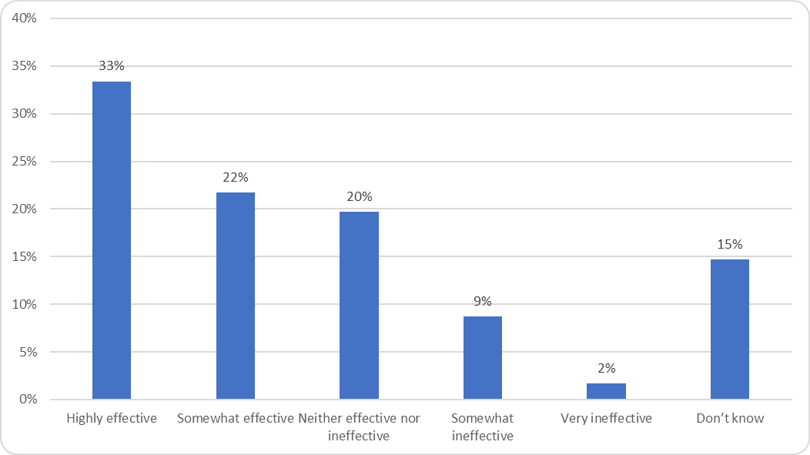
Source: Targeted consultation for the European Commission

Many stakeholders, across all stakeholder groups, expressed the view that harmonised standards are the best instrument to keep pace with technological ‘state of the art’.
Among stakeholders who considered the EMCD to have been effective in preventing barriers to innovation, a commonly held view was that harmonised standards are the best means of addressing the technical requirements for existing and emerging technologies. The essential requirements were seen as being technology-neutral and sufficiently generic to be open to innovative products (even to the extent of promoting innovation in the view of some stakeholders), while still being sufficiently precise to achieve the EMCD’s other regulatory objectives.
Some consider that a lack of standards for new and emerging technology has an adverse impact on product innovation with electromagnetic interference cases emerging until new standards are issued.

Findings in relation to the Efficiency of the Directive
This section maps the costs and benefits generated by the EMCD and examine the extent to which its objectives were achieved in an efficient manner.

Overall appreciation of costs and benefits
The results of both the targeted consultation and the interviews, despite the limitations in terms of representativeness, indicate that benefits generated by the EMCD are considerably higher than its costs.
According to information collected through interviews with small and micro enterprises and EMC experts, cost drivers for small businesses are largely similar to those identified through the consultation of large enterprises, with a stronger emphasis on the burden for small businesses of familiarisation with obligations included in the EMCD. Maintaining the expertise in the field of EMCD is reported to be harder for a small firm than it is for a large one, since it requires special knowledge and understanding but hardly any small business can afford to have employees dealing with it full time. In turn, this difficulty in developing EMCD expertise within small businesses can lead to more misinterpretation and misunderstanding of the requirements. Also product testing tends to be more costly for smaller businesses, because they usually do not have their own testing facilities.
Figure 5-6–––Overall, to what extent do you think the benefits outweigh the costs (or vice versa) deriving from the EMCD? (N = 212)
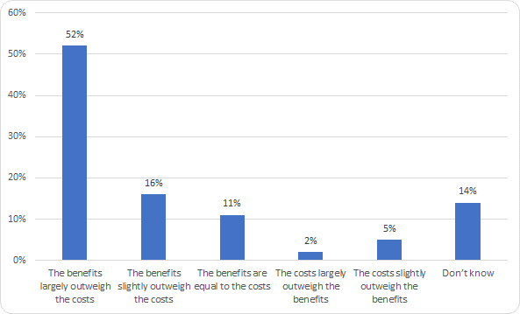
Source: Targeted consultation for the European Commission

The public consultation indicated as well that EMCD’s benefits outweighs the costs. Almost half of the respondents (19 out of 41 respondents) considered that benefits greatly outweigh costs and 12 respondents that benefits somewhat outweigh costs (see figure 5-7).
Figure 5‑7– Public consultation – Shares of replies to question on benefit-cost ratio (N = 41)

Source: Public consultation for the European Commission

The analysis of stakeholders’ replies concerning costs and benefits also indicates that benefits generated by the EMCD outweigh costs, and the affordability of costs has not been put in question by the different respondent types: benefits have thus been achieved at a reasonable cost. However, this is difficult to quantify precisely in monetary terms due to the lack of data, especially on benefits. Nonetheless, the structured analysis of costs and benefits sheds light on a crucial difference in their nature: the benefits of the EMCD are predominantly of a strategic nature, while the costs pertain to enforcement and implementation.

Figure 5‑8 – Targeted consultation – Share of replies to question on benefit-cost ratio by stakeholder type (N = 212)
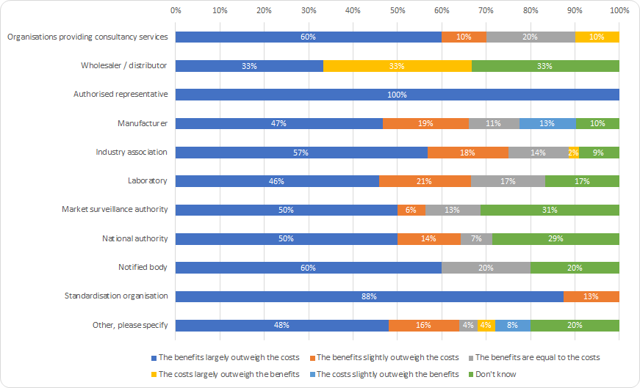
Source: Targeted consultation for the European Commission
In the overall opinion of the stakeholders consulted, the EMCD is currently working well in terms of its efficiency. No significant scope for cost reduction has in fact been identified by the stakeholders consulted.

Analysis of costs for the economic operators

Manufacturers see the costs of complying with the EMCD as an integral part of the product development. Therefore, they are difficult to specify. For 23 out of 38 respondents, the EMCD-compliance costs indicated the range between 5 and 15% of the total production costs (Figure 5-9). The interviews confirmed that the costs have that order of magnitude.
Figure 5‑9 – Targeted consultation – Replies to question on compliance with the EMCD as a percentage of the total cost of production (N = 38)

Source: Targeted consultation for the European Commission
As we can see in the figure (5-10) below, EMC-relevant costs of product development and costs related to the conformity assessment to produce the technical file are the types of costs most frequently identified as being costly. Considering the costs of product development, 80% of N=83 respondents (means 66 respondents) perceived these costs as “quite costly” for 49% (means 41 respondents) or “very costly” for 31% (means 26 respondents). Similarly, 79% of respondents (66) considered the conformity assessment-related costs to be either “quite costly” (46% means 38) or “very costly” (33% means 27). The costs of keeping technical documentation updated for 10 years and the costs of familiarisation with the legal obligations of costs are perceived as relatively costly (“quite costly”). The cost of an authorised representative has been pointed out as costly by 25% (21) of respondents, with just a marginal share (5% means 4 respondents) highlighting it as “very costly”. While other costs have in some cases been signalled by stakeholders, no evidence has been found of a wide perception of additional burdensome costs.
Figure 5-10 – Targeted consultation – Shares of replies to question on cost types (N = 83)
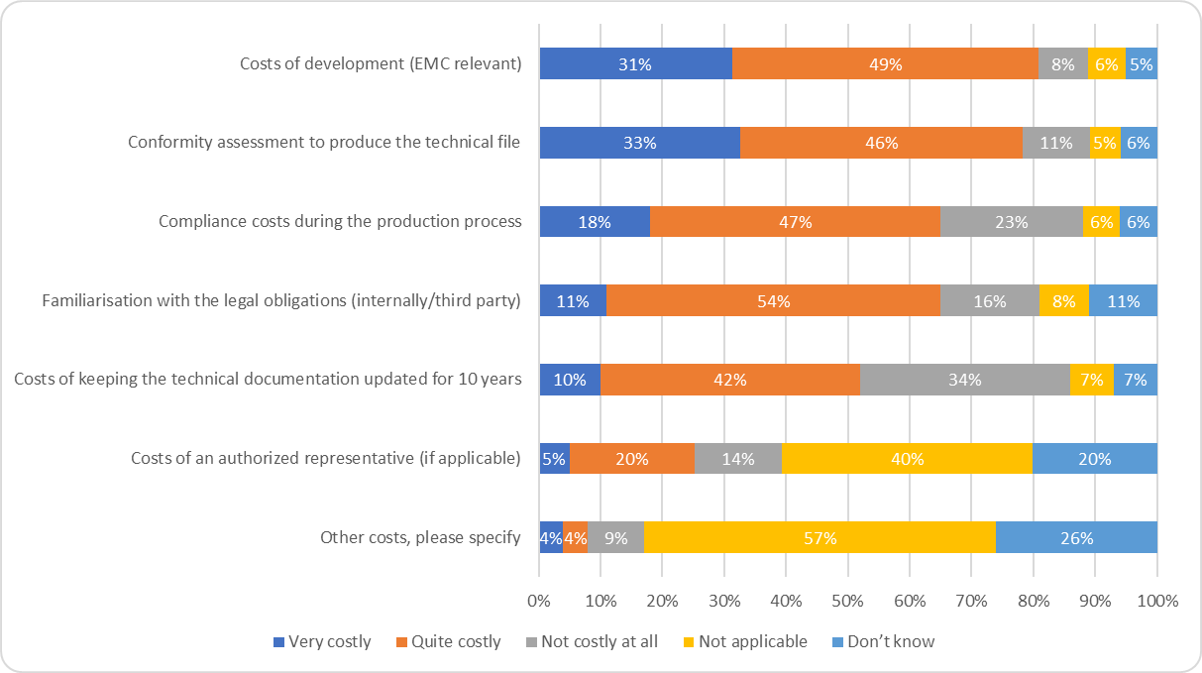
Source: Targeted consultation for the European Commission

However, even though manufacturers do incur costs that are EMC-related, only a small percentage of these costs can be attributed to the EMCD, as it is strongly in manufacturers’ interest to ensure the correct functioning of the products they manufacture and to prevent disturbance. According to the interviews and experts, it was estimated that business-as-usual costs account for a least 80% of the identified costs.
EMC-relevant costs of product development for an EMCD-compliant product can be split into cost of purchasing the relevant standards, the related engineering costs, the cost of pre-testing; and the cost of risk assessment. Given that a considerable percentage consultation respondents considers the costs to be quite high, ways to lower the costs should be investigated, in particular whether there is any potential for simplification.
Operators can purchase the relevant standards in order to satisfy the EMCD essential requirements. The cost for standard varies depending on the product. The interview feedback provided evidence that there are many long-established EMC-related product family standards that are generic and used across many different product categories that have common characteristics and may operate in the same environment (e.g. low-voltage household equipment). There are also product-specific standards, which are typically costlier. Evidence collected through the targeted consultation points to a cost ranging from €1,000 (for products such as personal computers, servers, notebooks, telecommunications equipment and frequency converters of 7,5kW) up to €15,000 for elevators and escalators. In total, 7 responses were received to the open-ended question on the costs of purchasing relevant standards. These estimates all are provided by individual respondents in relation to different product types.
EMC-related engineering costs (i.e. EMC costs as part of product development) are the key driver among development costs and the most significant EMC-related cost for operators, according to evidence collected from the interview programme. Frequently, the solution to overcoming challenges in designing products in a way that ensures good EMC lies in the overall product layout (which requires sound and state of the art engineering practices), and not necessarily primarily measures to strengthen immunity. Notwithstanding, immunity measures such as shielding, filtering or casing are sometimes incorporated into product design and there are associated costs.
According to EMC experts interviewed, the cost of pre-testing for EMC purposes, as part of product development, is extremely variable depending on the frequency of testing, the needs and the tools used. Tools can cost between €2,000 and €30,000 – only as far as testing electromagnetic emissions are concerned. For the immunity part, tools for pre-testing cost between €7,000 and €30,000. It should be stressed that the pre-testing phase may require that products’ EMC performance is tested more than once, as there are commonly several stages in product development. Some economic operators interviewed explained that products can be tested up to several times as part of product development processes, initially at the prototyping stage, and then subsequently, as the product is developed.
The costs of ensuring compliance during the production process is considered as being either quite costly or very costly by 65% of stakeholders, while 23% of respondents considered it not costly.
The costs of conformity assessment, which is borne by economic operators (mainly manufacturers), is overall considered to be either quite costly or very costly by 80% of EMC experts (eight of ten respondents) and 80% of manufacturers (56 of 70 respondents) (80% among both large and medium manufacturers). However, while 40% of medium-sized manufacturers view this item as very costly, the share decreases to 27% when it comes to large manufacturers.
There are three types of conformity assessment costs, namely: the cost of preparing technical documentation; the cost of laboratory tests; and the cost of a notified body should the manufacturer wish to use their services (the use of NBs is not mandatory under the EMCD).
According to replies to the targeted consultation, the costs of technical documentation as part of the conformity assessment procedure ranges between €1,000 and €10,000 per product.
The costs of performing laboratory tests as part of conformity assessment procedures can refer to testing in either third-party laboratories or internal laboratories. De facto, only large companies generally have internal laboratories, due to the high costs associated with EMC testing. According to an industry association, the cost of setting up an EMC testing laboratory is approximately €1 million minimum (one-off cost of a 3-meter EMC testing chamber). Costs of a 10-meter testing chamber are significantly higher (even 4-5 times higher)
In addition to the significant initial capital investment for setting up a laboratory, there are annual maintenance costs, related to the need for the recalibration and repair of equipment, staffing costs, and the costs of testing products’ compliance with the essential requirements when new harmonised standards are adopted, and/or existing standards are updated.
Different stakeholders reported that external laboratories have a fee per day of €800- €1,500 in the EU. Testing a product requires several days, and is estimated to cost about €15,000 on average, irrespective of the product type. Other estimates distinguish between lower testing costs for less complex products (about €5,000) and higher costs for more complex ones (up to €20,000)
The involvement of a notified body, according to evidence gathered through the interview programme, is generally less favoured than internal production control. According to EMC consultants, involving a notified body is considered useful for new market participants, who have less experience. Some interviewees stated that using a notified body could typically add €5,000 – €20,000 in costs, depending how complex the product is. Several individual firms commented that they were reluctant to use a notified body, as they already use third-party external testing laboratories during the conformity assessment process and therefore, using a notified body provides an additional layer of costs that, as it is non-mandatory, they would prefer to avoid
Testing costs were seen as higher than for product safety directives due to the specialist nature of laboratory equipment (e.g. EMC testing chamber). However, the self-certification approach made possible by the EMCD significantly contributes to keeping costs relatively low and grants a certain level of flexibility to economic operators.
The cost of familiarisation with the legal framework (e.g. familiarisation with applicable obligations; identification of relevant standards; training of staff) is considered as quite costly by more than 50% of respondents (45 out of 83) and 11% perceive such costs as being very costly.
During the interview programme, familiarisation costs were not considered to be one of the main drivers of compliance costs by large firms. While some effort and resources are necessary to familiarise with the EMCD regulatory framework (as suggested by the targeted consultation at an anecdotal level), stakeholders underlined that thanks to the harmonised regulatory framework, economic operators do not face 27 different national legal regimes and therefore can avoid a significantly higher cost of familiarisation with legal rules. In other words, there are cost savings compared with a counterfactual scenario in which there were no EU rules. According to interviewed small and micro enterprises, however, costs of familiarising with legal obligations are relevant for them, especially in cases where no specialised full-time position is present within the firm to deal with compliance.
The costs of keeping technical documentation updated for 10 years, as required by the EMCD, is not considered as a major cost driver by respondents to the targeted consultation. It remained unclear why respondents considered these administrative compliance costs as disproportional.
The costs of using an authorised representatives is mainly applicable to manufacturers in third countries that do not have a legal presence in the EU. Accordingly, it is not surprising that 40% of respondents chose the option “Not applicable” and 20% “Don’t know”. Of the remaining manufacturers, 17 considered authorised representatives to be “Quite costly” (16 respondents) or “Very costly” (1 respondent).

Analysis of benefits
The assessment of benefits has considered the extent to which the existence of the EMCD has brought about benefits and whether any of these can be monetised. The results of the targeted consultation indicate that different benefits have been strongly associated with the EMCD’s implementation (see Figure 5-11 below).
Figure -5-11 – Targeted consultation – Shares of replies to question on benefit types (N = 216)
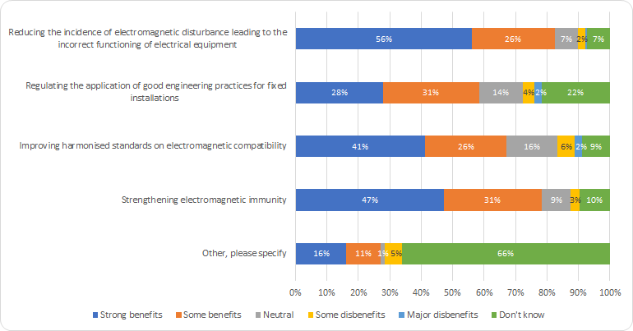
Source: Targeted consultation for the European Commission

Overall, the reduction of the incidence of electromagnetic disturbance leading to the incorrect functioning of electrical equipment is a benefit accrued to overall society. A broad consensus was found among respondents to the targeted consultation: 82% of respondents (178 out of 216) stated that this reduction generates “strong benefits” (56%) or “some benefits” (26%). This opinion is shared across countries and across all different stakeholder types participating in the survey. In particular, 68% of manufacturers (42 out of 62) and 75% of industry associations (33 out of 44) considered the reduction as a strong benefit.
The EMCD brings about benefits for businesses in terms of market efficiency as it reduces market barriers and costs for economic operators. First and foremost, by setting up an EU-wide framework, the EMCD prevents fragmentation into different national regulatory systems, which would entail significantly higher costs for industry in accessing different national markets. Thanks to the single market, the manufacturers’ burden in terms of familiarisation with legal obligations is reduced and, most importantly, costs associated with exporting goods are reduced as well.
In addition, whereas when the EMCD was first adopted in 1989, internal production control using self-assessment wasn’t possible. This was changed in 2004. The EMCD’s alignment with the NLF in 2014 with its modular approach improved the conformity assessment with the explicit possibility of self-assessment. This was viewed by stakeholders interviewed (e.g. industry associations, individual economic operators) as having helped to reduce the costs of compliance for businesses, as it allows scope for a self-declaration of conformity based on internal production control.
Based on the opinions gathered from a variety of manufacturers and EMC experts interviewed, it is clear that the EU regulatory regime (the EMCD and CE marking in particular) has strong international standing: the EMCD has de facto near-global relevance. Several interviewees highlighted that economic operators in markets such as Australia, China and Singapore frequently refer to EU legislation in their EMC-related requests, even in cases where different local regulatory requirements are also applicable. As a result, companies that are EMCD-compliant are well-positioned to compete globally, as their products generally do not have to undergo further modifications to enter numerous other markets worldwide.
Accordingly, a clear benefit of the EMCD is that it has strengthened industrial competitiveness as the Directive is regarded as being robust, in that it covers both EM disturbance and immunity, flexible in that manufacturers determine how they comply with the essential requirements and easing access to other markets. Due to the strong reputation of the EMCD (and more generally of the EU product legislation), EMCD-compliant economic operators have an advantage when expanding to other markets.
During the interview programme, a broad consensus was also reached about the benefit of preventing the incorrect functioning of electrical equipment being of crucial importance. Even though, economic operators may invest in good engineering practices even in the absence of a dedicated Directive, the EMCD has had a crucial role in raising awareness about EMC-related issues among manufacturers and industry more broadly. The reduction of the incidence of electromagnetic disturbance was perceived as being associated with the Directive. This has also been confirmed through interviews that identified examples of increased interest and awareness about the EMC of apparatus after the 2014 revision of the Directive, which increased economic operators’ attention to the topic (especially among manufacturers in Member States that gained EU accession more recently).
The application of good engineering practices for fixed installations was considered as generating “some benefits” by about one-third of respondents (66 out of 216), followed by “strong benefits” (60). A high number of respondents stated they were not familiar with the issue (47 “Don’t know” replies). This was likely because they only deal with apparatus.
Finally, the responses were analysed regarding how far the EMCD has increased electromagnetic immunity. 78% of targeted consultation respondents (169 out of 216) were of the opinion that “strong benefits” (102) or “some benefits” (67) were achieved as a result of EMCD implementation. Positive opinions remain prevalent across different stakeholder types and countries (to be noted, no notable differences by country). According to an EMC expert interviewed working at a large multinational based in a third country, the EMCD’s focus on electromagnetic immunity has proved to be a crucial benefit: even if initially faced with a certain scepticism (as third country legislation only focuses on emissions), this has ensured certainty for users and across the industry.

Findings in relation to relevance of the EMCD
There is a general consensus among stakeholders that the general objectives of Directive 2014/30/EU remain relevant today.
As can be seen in the figure (5-12) below, the vast majority of respondents to the targeted consultation perceived the EMCD to be either ‘highly’ or ‘quite’ relevant today (N=237) in terms of achieving its two main objectives: creating free movement of goods and preventing electromagnetic disturbances.
Figure 5-12 – To what extent do the following needs in relation to regulating electromagnetic compatibility remain relevant today? (N=237)
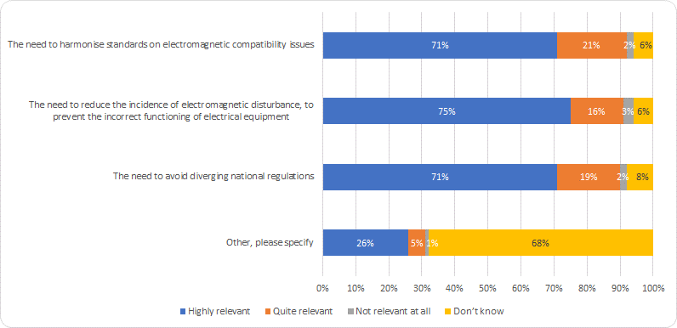
Source: Targeted consultation for the European Commission
The results from the public consultation were strongly aligned to the findings of the targeted consultation. More specifically, 80% of public consultation respondents (N=844) considered the EMCD to still have a ‘high level of relevance’ (73%) or to have ‘some relevance’ (9%). However, radio amateurs responding to the public consultation thought that the EMCD is less relevant, as it wasn’t sufficiently effective in reducing electromagnetic disturbances, whereas other stakeholders responding to the public consultation, the targeted consultation and the interviews perceived the EMCD overall was relevant, despite the ongoing challenges associated with problematic products.
There has been a significant evolution in the electrical equipment market in the last 5-10 years. This includes the advent of the Internet of Things (IoT), i.e. the trend towards more equipment being internet connected, and the emergence of new market players, including online platforms.
The changes on electrical product market can be subdivided into two broad categories or themes, one of which relates to the changes affecting the distribution of products, while the other relates to the introduction of new products and functionalities.

Distribution of products
The EMCD has gained in relevance due to three main market changes: new economic operators entering the value chain; the development of e-commerce; and new distribution channels for putting products on the European market.
Figure -5-13 – During the last 10 years, the electrical equipment market has changed dramatically. To what extent have each of the following changes affected the relevance of the EMCD? (In terms of Distribution) (N=237)
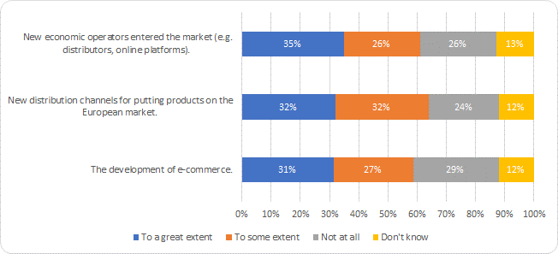
Source: Targeted consultation for the European Commission
A majority of respondents (combined 61% ‘to some extent’ corresponding to 61 respondents or ‘to a great extent’ corresponding to 82 respondents) perceive the presence of new economic operators entering the market to be a key change that is impacting the relevance of the EMCD. Those new types of operators (e.g., online platforms) are not defined in the EMCD. There is an ongoing horizontal discussion across NLF legislations on how to include such new operators.
The development of e-commerce was considered as a change impacting the relevance of the EMCD by 139 out of 237 of the stakeholders surveyed (targeted survey). In particular, e-commerce trends were described by stakeholders as having the potential to facilitate the distribution of various electrical equipment from third countries into the EU. From a market surveillance perspective, products from non-EU countries sold in online marketplaces or online shops bear a higher risk of non-EMCD compliance.
New distribution channels for placing products on the European market refers to the increase in sales directly to consumers from online platforms and the related use of fulfilment centres. 152 out of 237 stakeholders thought it affected the relevance of the EMCD. For example, when ordered on foreign online platforms and arriving in Europe in small postal packages rather than as large lots in containers, it is much more difficult for market surveillance authorities to verify the products’ compliance.
Stakeholders perceived that one of the main changes in the last 10 years is the presence of more connected products that integrate new technologies with radio functionality (IoT, but also beyond). 50% of survey respondents (119 respondents) stated that this change impacted the relevance of the EMCD ‘to a great extent’, and 26% (62 respondents) ‘to some extent’, due to the integration of radio functionality in those products and thus convergence/overlap with the RED. The emergence of new types of electric equipment was also seen by the majority of stakeholders as affecting the EMCD’s relevance, with a combined 72% of respondents (171) agreeing with this statement ‘to a great extent’ (34% meaning 81 respondents), or ‘to some extent’ (38% meaning 90 respondents). Feedback gathered through the interviews and evaluation webinars conducted also indicated that these changes have had an impact on the EMCD’s ongoing relevance, particularly in terms of product scope.

The scope of the EMCD
Under the EMCD’s scope, certain categories of equipment are covered by a few exclusions, of which benign equipment is the most prominent.
The majority of respondents to the targeted consultation (173 of 233 respondents, 74%) perceive that the exclusion of benign equipment from the EMCD remains appropriate. However, qualitative feedback from the targeted consultation and the interviews, particularly with MSAs highlighted challenges as to the continued relevance of this exclusion. For example, unconnected cables are considered inherently benign. They are only falling under the EMCD if they are connected to devices falling within the EMCD’s scope. More specifically, it was noted that the wording of Article 2(2)(d), which defines which devices fall outside the EMCD’s scope, could be better specified in the Guide of the EMCD to provide greater clarity. Additionally, it was suggested that the EMCD’s relevance for ready-made connecting devices, including cables, could be reconsidered.
MSAs were of the opinion that “ready-made connecting devices (and other cables)” should clearly be addressed by the EMCD. They contribute significantly to EM disturbance”.

The degradation of old equipment and concept of reasonably expected lifetime of a product
Old equipment can potentially become non-compliant and create high levels of disturbance which leads to the question of the relevance of introducing a product lifetime concept.
Stakeholders (all types with prominent industry voice) highlighted a range of reasons why it is difficult to legislate old equipment which can potentially become non-compliant.
There was a concern that introducing maximum product lifetime requirements could duplicate what is already in the Directive, as the degradation of equipment already needs to be considered by economic operators before equipment is placed on the market. As such, industry representatives noted that new provisions related to maximum product lifetime requirements could result in duplication of these existing requirements. The EMCD is presently concerned with placing on the market and not end-of-life disposal timeframes.
As monitoring and surveillance activities are concerned with the period post placement on the market, the question was also raised whether there would be resources for surveillance authorities to monitor additional requirements.

Findings in relation to the Coherence of the EMCD
Overall, there was a strong positive consensus regarding the internal coherence of the text of the EMCD and its ease of application, in both the targeted consultation and interviews. None of the consulted people identified any major incoherence.
In response to the targeted consultation 75% of the respondents (174 of 232 respondents) considered the EMCD to be coherent: 56% (131 respondents) considered it to be fully coherent and 19% (means 43 respondents) considered it to be partially coherent. Only 1% of the sample of respondents deemed the EMCD to be non-coherent, while 24% stated they do not know. As illustrated in the below figure, the EMCD is generally seen as a coherent directive, and the legal text is viewed as being clear.
Figure 5-14 – In your view, to what extent is the legal text of the EMC Directive (2014/30/EU) internally coherent (e.g. consistency of the different provisions in the legislation)? (N=232)

Source: Targeted consultation, CSES for the European Commission

The internal coherence and definitions used in the EMCD
The definitions used in the EMCD were generally seen as being clear and coherent, with only limited evidence emerging regarding any problems, challenges and gaps.
Figure 5-15 – Overall, to what extent is the EMCD clear and easy to apply? (N=237)
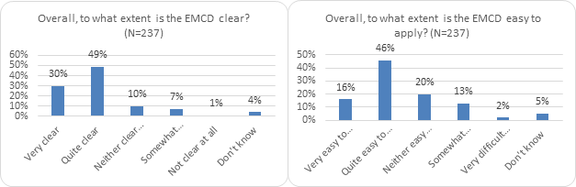
Source: Targeted consultation for the European Commission
The definition of a fixed installation was regarded as being unclear by some stakeholders, and participants to the webinars with EMC ADCO raised the issue of the definition of a ‘fixed installation’, with some products having an uncertain delineation between equipment and fixed installations e.g. solar panels, air conditioners. Likewise, there was feedback regarding the need to clarify the definition of the “placing on the market of apparatus intended for fixed installations”. Some stakeholders perceived that there are somewhat divergent interpretations across different Member States, in particular among MSAs that carry out inspections of such installations.
Stakeholder feedback was mixed about the exclusion of benign equipment. Clearer definitions could be included in the Directive as to when benign equipment should no longer be considered to be benign. In particular, cables may be benign but once plugged in and connected to apparatus, the cables may themselves generate emissions even if falling outside the EMCD’s scope. Whilst there was no consensus that cables should be included, and industry was against this idea, there were alternative suggestions made as to how to address the problem of passive equipment generating emissions in certain circumstances e.g. low-quality cables, incorrect cables not used with the correct device.
Regarding the external coherence of the Directive, the evaluation analysed the coherence between the EMCD and other relevant legislation that the EMCD interplays with. For the external coherence of the Directive, there are two possibilities of application of the EMC requirements: One possibility is that the EMC requirements apply to products which fall under EMCD in conjunction with other applicable legislation (e.g. safety Directives such as the Low Voltage Directive (LVD), Machinery Directive (MD)). The second possibility is that the EMC requirements for products categories that fall exclusively under other EU legislation, such as for electrical equipment integrating radio functionality falling under the Radio Equipment Directive (RED) or for medical equipment falling under Regulation 2017/745, are already included in those pieces of legislation. Then, the EMCD does not have to be applied.
Generally speaking, many interviewed respondents consider that the New Legislative Framework (NLF) has facilitated coherence between the different Directives, enhanced the coherence of the EMCD, has clarified definitions and has strengthened the coherence across legislation of the obligations for economic operators. For interviewed stakeholders, the common horizontal provisions introduced meant that the EMCD, the LVD (when the LVD is applied in conjunction with the EMCD) and the Radio Equipment Directive (RED), became more coherent with one another. Some industry associations would like to see electronic labelling introduced within the NLF, as it is the case in other jurisdictions, and also to have the same formal requirements in all legislation, including the EMCD.
However, particular concern was raised when considering the relationship between the EMCD and the RED. 45.0% of the respondents in the targeted consultations experiencing some problems due to a perceived overlap and inconsistencies between the two pieces of legislation, as illustrated in Figure 6-16- below. Please see the section below dedicated to RED for further details.
Figure 5-16 – Have you experienced any problems due to overlaps, inconsistencies or a general lack of coherence between the EMCD requirements and other applicable legislation? (N=229 respondents)

Source: Targeted consultation
Concerns were less strong with regard to the safety directives being applied in parallel with the EMCD requirements (i.e. the MD and the LVD). Indeed, only 6.6% of respondents stated that there was an issue in applying the MD together with the EMCD, and 11.4% the LVD and EMCD.

Coherence between the EMCD and the RED
Despite the fact that the two Directives, EMCD and RED, are mutually exclusive, a relatively high percentage of respondents perceived incoherence between the EMCD and the RED and difficulty in determining which directive they should follow.
For instance, during the interviews it turned out that the delineation between certain products falling under the EMCD and RED was not always clear for manufacturers. Some respondents, such as industry associations, stated that their members had experienced some confusion as to which directive to follow for specialised equipment. This was mostly due to a perceived lack of adequate coherence in the RED itself, rather than the EMCD.
Additionally, the fact that there is a wider range of harmonised standards available under the EMCD than EMC standards under the RED, led to confusion among some manufacturers. Whilst it is clear that the two Directives are mutually exclusive, the same product might still have to comply with harmonised standards supporting different pieces of legislation. It was perceived as being challenging for products to follow different EMC-related harmonised standards (HS) for radio functionality and electromagnetic functionality respectively, mostly because of the lacking coordination of their publication. However, this lack of synchronisation is extraneous to the Directive and can be addressed through an improved coordination in the adoption of these standards by the ESOs.

Coherence between the EMCD and other relevant sectoral legislation
As shown in the targeted survey findings, it was not generally perceived that there was a coherence problem between the EMCD and safety directives, notably the Low Voltage Directive (LVD) and the Machinery Directive (MD). The Directives were rather seen by stakeholders as being complementary. Respondents also emphasised that the EMCD is “phenomenon-related” rather than a safety directive. According to a large enterprise interviewed, the distinction is considered important and should be maintained.
The EMCD requires that manufacturers ‘shall include an adequate analysis of the risk(s) (e.g., perturbation). However, this does not include any assessment of safety risks. The general consensus across the majority of stakeholders interviewed (including MSAs, notified bodies and industry) is that the EMCD should remain concerned with electromagnetic compatibility only, and not with safety. Interviewees stated that the Low Voltage Directive (LVD) already deals with electrical safety and other Directives such as the Machinery Directive with product safety. The majority of stakeholders responded that there weren’t any problems related to overlaps and inconsistencies between the EMCD and the Machinery Directive (58%), and between the EMCD and Low Voltage Directive (69%).
Additional legislation identified as a potential source of incoherence with the EMCD includes the Car Vehicle Regulation (mentioned by a testing laboratory), the Medical Device Regulation (EU) 2017/745 (mentioned by a notified body), the National Grid Regulation (mentioned by a manufacturer) and the Lifts Directive (mentioned by a testing laboratory). Such legislation is applicable in place of the EMCD for the types of equipment falling under these Directives. For instance, manufacturers reported challenges determining which types of electronics integrated within cars should follow the Car Vehicles Regulation and which should follow the EMCD but this issue has been clarified through the issuance of a guidance note on the topic.

Findings in relation to the EU Added Value of the EMCD
The main areas of added value of the EMC Directive, according to stakeholders as a whole, were:
- The internal market benefits of having a stable regulatory framework in place with harmonised legislation and standards EU-wide;
- Avoiding the situation which would exist in a counterfactual scenario (where the EMCD did not exist) of different national laws regulating electromagnetic compatibility in each of the 27 EU Member States.
The perception that the EMCD adds value was echoed in the public consultation responses: nearly three out of four respondents (74%, 623 respondents) agreed that having rules for electromagnetic compatibility at EU level (as opposed to national level) continued to have a high level of relevance.
Figure 5-17 – Relevance of having EMC rules at EU level (N=845 respondents)

Source: European Commission public consultation
Stakeholders as a whole consider that the EMCD adds value to the internal market – and the economic operators who depend on it - by providing a stable regulatory framework with harmonised legislation and standards EU-wide.
The existence of EU legislation is substantially preferable to the most likely alternative situation: a fragmented regulatory landscape where different national laws on electromagnetic compatibility apply in each of the 27 EU Member States.
That the EMCD addresses both emissions and immunity is seen as an advantage compared to equivalent regimes in third countries that only regulate electromagnetic emissions.
On the whole, stakeholders interviewed were positive about the EMCD’s ability to prevent the emergence of different national laws. In both the interviews and the targeted questionnaire, they were asked about the extent to which the Directive and its preceding versions has been beneficial since 1989. Many of these stakeholders acknowledged that the EMCD has prevented the emergence of national divergent regulations on EMC.
Stakeholders across categories and of different sizes acknowledge that the EMCD has prevented the emergence of national divergent regulations on EMC.
In particular, industry associations and large manufacturers operating in multiple jurisdictions value the EMCD as providing a solution to a complex problem that cannot be handled at national level without confusion.
The EMCD’s common legal framework and harmonised standards has led to some cost savings for economic operators who would otherwise have to comply with multiple, and potentially diverging, national regulatory regimes for EMC.

Additional value of the EMCD for stakeholders, compared to what could have been achieved at national level
Stakeholders tended to agree that, by providing uniform EMC requirements across the EU, the EMCD has facilitated the internal market and prevented the fragmentation of EMC rules across the Member States. This provides the basis for growth within the European market and has paved the way for European manufacturers to expand into global markets (as the EMCD’s standards have become an accepted reference worldwide).
A common set of EMC rules applying across the EU was considered preferable to the most likely alternative of mutual recognition by the Member States of each other’s EMC standards.
Some economic operators and industry associations claimed that the benefits of the EMCD’s regulatory regime also provided added value for consumers, as manufacturers passed on cost savings in the form of lower prices for electronic goods.

CONCLUSIONS
Concerning the Directive’s effectiveness for the internal market, most stakeholders (e.g. industry associations, economic operators and market surveillance authorities) agree that overall the Directive has successfully contributed towards its objectives of firstly ensuring the effective functioning of the internal market for electrical equipment, (encompassing electrical and electronic appliances, systems and installations) and secondly, avoiding any electromagnetic disturbances between equipment.
The Directive’s essential requirements are seen as fit-for-purpose, according to industry stakeholders (e.g. industry associations and economic operators). The alignment with the NLF’s horizontal provisions is considered to have been positive by all stakeholders, by improving the clarity and ease of application, through the use of common terminology and definitions to describe the responsibilities of economic operators in the value chain.
EMCD was perceived by stakeholder as adopting a technology-neutral approach, with essential requirements laid down in the legislation and harmonised standards providing voluntarily the means of addressing the essential requirements for new technologies. The option to choose between self-assessment and notified bodies for conformity assessment, first introduced in 2004 and strengthened by the alignment with the New Legislative Framework in 2014, was seen as positively contributing to Directive’s effectiveness. Additionally, the inclusion of references to good engineering practices, in particular for fixed installations, in the EMCD in 2004 has also had a positive impact.
Market surveillance is seen as not effective in implementing and enforcing the EMCD. E-commerce adds additional challenges to EMCD enforcement as it leaves room for uncompliant products not being intercepted, therefore affecting the level playing field on the internal market. However, enforcement activities are outside the scope of the Directive, being dealt with by specific legislation on market surveillance. With the implementation of the Regulation (EU) 2019/1020 on market surveillance, the issues related to enforcement, identified by the evaluation, including with e-commerce will be addressed.
Regarding the Directive’s effectiveness for requiring equipment to comply with an adequate level of electromagnetic compatibility, the EMCD has prevented apparatus causing electromagnetic disturbances from being placed on the EU market and has provided an impetus to encouraging industry to prevent electromagnetic disturbance and interference. Electromagnetic compatibility is now designed into the devices.
However, a minority of stakeholders indicate that some problematic products continue to generate disturbances. The evaluation’s findings indicate that even though there may be some products where disturbance remains a problem, this does not suggest that the Directive is ineffective, as it is more a question of strengthening the effectiveness of harmonised standards and of standards development processes to ensure that problematic products with high levels of disturbance are addressed.
Many stakeholders, across all stakeholder groups, expressed the view that harmonised standards are the best instrument to keep pace with technological ‘state of the art’ and therefore the quality and availability of standards system may indirectly affect the effectiveness of the Directive
Concerning the efficiency of the Directive, the benefits generated by the EMCD outweigh its costs for each type of stakeholders and the affordability of costs has not been put in question by the different stakeholders. Cost to ensure electromagnetic compatibility were seen as an integral part of the product development costs. The cost of complying with the EMCD were estimated to correspond to 5-15% of the total costs of production, including administrative compliance cost as well as compliance costs of designing low-EMC emission products, i.e. building in shielding and immunity measures to address sources of electrical noise. In particular, costs to keep the technical documentation updated for 10 years were considered to be relatively high. Some costs such as familiarising themselves with the legal obligations are relatively higher for SMEs. The self-certification approach significantly contributes to keeping conformity assessment costs relatively low and grants a certain level of flexibility to economic operators.
In terms of benefits, both technical and strategic economic benefits of the EMCD have been identified. The main technical benefits include the reduced incidence of electromagnetic disturbance (leading to incorrect functioning of electrical equipment) and the strengthening of electromagnetic immunity. In terms of strategic benefits, the avoided fragmentation into national regulatory systems prevents higher costs for industry in accessing markets and reduces costs related to exporting goods and familiarising with legislation, and fosters the free movement of products in the internal market. Strategic economic benefits for businesses are generated in terms of international industrial competitiveness, as well: the EMCD’s high reputation at international level puts compliant businesses in a favourable position to compete on the global scene.
The objectives of the EMCD are still relevant today. This is true for both objectives ensuring the effective functioning of the internal market for electrical equipment (encompassing electrical and electronic appliances, systems and installations) and secondly, requiring equipment to comply with an adequate level of electromagnetic compatibility.
The market for electronic equipment has changed and is changing rapidly. This development affects the relevance of the EMCD in two ways. First, it draws attention to the scope of the Directive, i.e. whether the provisions of which products are included have sufficient clarity. For example, some “benign” products, such as cables, currently only become relevant for the Directive after they have been integrated into other products. Second, e-commerce has increased significantly. In this respect, products from overseas have more relatively compliance issues than products produced in the EU. This poses a horizontal challenge (beyond the EMCD) for market surveillance authorities to verify the compliance of the products ordered online from abroad, especially those arriving in small packages rather than as large lots in containers.
The internal and external coherence of the EMCD is generally positive. The clarity of the legal text and ease of use was seen positively by the majority of respondents in both the interviews and targeted consultation. However, two issues have been indicated by the respondents to the consultation activities, such as the lack of clarity regarding the definitions of a ‘fixed installation’ and the exclusion of ‘benign equipment’.
Regarding the external coherence of the Directive, the alignment to the New Legislative Framework ensures to a certain extent Directive’s coherence with the rest of the internal market legislation for products. The EMCD was perceived as being complementary to Union product safety legislation, such as the Machinery Directive and the Low Voltage Directive, given the potential impact of ensuring adequate levels of electromagnetic compatibility on enhancing functional safety.
The main issue identified in the targeted consultation and interviews in respect of the external coherence was the interplay between the EMCD and the RED, and between the EMCD and other legislation. Stakeholders may find it difficult to determine whether particular products fall within the scope of the EMCD, or other specific sectoral legislation, such as the Car Vehicle Regulation. However, this issue has already been clarified by the Commission in a guidance note, so it is more a matter of raising awareness about which types of products fall under which sectoral legislation, and not an incoherence in the EMCD itself.
There was a broad consensus among stakeholders, especially from an industry perspective, that the EMCD has added significant value at EU level since the adoption of the first Directive in 1989. It brought regulatory stability and prevented divergent legislation at national level which could potentially emerge to regulate electromagnetic compatibility and immunity.
The overall conclusion is that the Directive is relevant, effective, efficient, coherent, and has EU added value. Some stakeholders would find a more precise definition of “fixed installations” helpful, and some proposed integrating “benign equipment” into the Directive. However, those opinions were not shared widely among the different stakeholders. A clarification in the guidelines, after discussion in the expert group, would be sufficient to address these issues.
The EMCD’s benefits are obvious to stakeholders. There wasn’t any discussion whether the EMCD is necessary, regardless the costs. Without it, much electronic equipment would function badly or not at all. The main potential for cost savings would be regarding administrative compliance costs.
Other two issues were identified but fall outside the remit of the Directive. In particular, the quality and availability of harmonised standards that may need further improvement. Some stakeholders believe that the requirements for products set in the harmonised standards for electromagnetic emissions are too low and that setting more demanding requirements would be more likely to drive innovation, or, at least, less likely to stifle it. Also, the growth of e-commerce leaves room for uncompliant products to be sold in the internal market by extra-EU traders. In this respect, some steps are taken for increased clarity of e-commerce rules but challenges remain in particular related to market surveillance. The new market surveillance Regulation (EU) 2019/1020 should address these concerns.

ANNEXES

ANNEX 1
PROCEDURAL INFORMATION
1. Lead DG, Decide Planning/CWP references
Lead DG: Directorate-General for Growth - Internal Market, Industry, Entrepreneurship and SMEs (DG GROW); Unit H2: Machinery & Equipment.
Agenda planning/work programme reference: PLAN/2019/5623
2. Organisation and timing
Organisation and timing: the inter-service Steering Group consisted of SG, DG JUST, DG EMPL, DG ENER, and DG CNECT. After the kick-off meeting on 31 January 2020, it met two times in 2020 (12th February and 30th of November), two times in 2021 (19th April and 8 of October).
3. Exceptions to the better regulation guidelines
Not applicable.
4. Consultation of the RSB (if applicable)
Not applicable.
5. Evidence, sources and quality
The “Study on the Evaluation of the Electromagnetic Compatibility Directive 2014/30/EU - Final Report” was outsourced to a consultant (CSES) and was one of the main sources of information for this Evaluation of EMCD. The study aimed to obtain a better understanding of the market, to monitor the implementation of the EMCD in EU Member States, and to assess the effectiveness, efficiency, coherence, relevance, and EU added-value. Each phase contains several tasks which take into account the data collection tools, timetables and deliverables. These tasks are aligned with the objectives of the study and with the requirements of the Better Regulations Guidelines for evaluations.

ANNEX 2
SYNOPSIS REPORT OF STAKEHOLDER CONSULTATIONS
The present synopsis resumes the main inputs received from all consulted stakeholders during the evaluation through a roadmap, an interview programme, webinars, targeted and public online stakeholder consultations.
The Stakeholder consultations’ objective was to gather information on understanding, implementation and enforcement of the EMCD from economic operators, standardisation bodies, national authorities and consumers.
The interviews and the Targeted and Public Consultation were aimed at gathering factual information, data, knowledge and perception by final users of the Directive across the EU about relevance of the scope and the objectives of the EMCD compared to the requirements and needs of the market; and also about effectiveness of the Directive in ensuring fulfilment of essential requirements.
- Introduction and overview of stakeholder consultation activities
• 458 responses to the targeted stakeholder consultation, conducted through an online survey (from July to October 2020). 37% of these responses (170/458) came from economic operators, 71.7% (132/184) of which were large enterprises, 13.6% (25/184) from medium enterprises and 14.7% (27/184) from small or micro enterprises. The remainder of responses were from industry associations (15% means 70/458), laboratories (14% means 65/458), national authorities (7% means 33/458), MSAs (5% means 25/458), notified bodies (3% means 16/458), consumer associations (1% means 5/458) and other stakeholders (13% means 61/458). Although there was a balance of responses across the EU Member States, German respondents comprised a high proportion of respondents (21% means 97/458), 12 percent above the next most responsive country (France – 9% means 41/458).
• 854 responses to the public consultation (open from October 2020 to January 2021). A very high percentage of the total responses were from users of electrical equipment/apparatus/fixed installations, radio amateurs and their representative associations (a combined 89.4%), with a more limited number of responses from industry associations (1.4%), economic operators (3%) and other types of organisations. German respondents were the most active in the public consultation, comprising 59.4% of responses, followed by the Netherlands, EU-level stakeholders (both 13%) and Finland (6.3%). Together, respondents from these four countries made up more than 92% of all responses.
Analysis of both public consultations responses is developed with detailed answers to the questions and figures in the Annex 9 of the “Study on the evaluation of the electromagnetic compatibility directive 2014/30/EU (EMCD)”.
• 109 in-depth interviews with stakeholders representing economic operators, EU and national level industry associations, market surveillance authorities (MSAs) and national competent authorities, notified bodies and testing laboratories, technical standards bodies, academics/RTOs/consultants, radio amateur associations and radio amateurs, and select third countries. Although an effort was made to interview EU and national consumer associations, those approached declined to participate as they do not follow the EMCD.
• Four evaluation webinars were held in October 2020. A total of 52 stakeholders from the EMCD Working Party and the EMCD Administrative Cooperation Group (ADCO) participated across the four webinars. These webinars replaced the planned evaluation workshop, which could not take place due to COVID-19.
• In addition, 25 responses to the Evaluation Roadmap Consultation conducted by the European Commission were analysed and the findings were triangulated with the above stakeholder consultation activities. The replies to the roadmap can be distinguished in two groups:
The first group, businesses operating in the field of apparatus, electrical equipment and/ or installations and their representative associations (17 responses), thought that the EMCD was mostly fit for purpose with no need for modification or revision. It should be kept technology-neutral and should not be merged with other NLF Directives (e.g. RED).
The second group, citizens and organisations representing radio amateurs (6 responses), do not consider the EMCD fit for purpose. Three citizen respondents with an interest in amateur radio also point to a lack of enforcement, citing their own experiences as examples, pointing to the fact that, since the introduction of power line communications, energy-efficient switched mode power supplies and solar photovoltaic systems, (amateur) radio services have experienced an increase in radio spectrum pollution.
2. Stakeholder Perceptions by Evaluation Criterion
2.1 Effectiveness
Targeted consultation
The respondents to the targeted consultation were generally positive regarding the EMCD’s perceived effectiveness in making progress towards its general objectives. Regarding the EMCD’s role in providing a stable legal framework for the electrical equipment industry in the EU, overall, among 299 respondents, 39.5% (118) of respondents found that the EMCD has been ‘highly effective’ and 28.8% (86) of stakeholders ‘somewhat effective’ (as supported by the interviews). The majority of respondents (78.3%/ 234) perceived the EMCD as having been either very effective (53.2%/ 159) or somewhat effective (25.1%/ 75) in ensuring the free movement of electric and electronic apparatus in the internal market. Regarding the related objective of ensuring an adequate level of electromagnetic compatibility, there was also strong agreement among stakeholders that the EMCD has made an important contribution. For instance, a significant percentage of respondents agreed that the EMCD has helped to reduce the incidence of EM disturbance leading to the incorrect functioning of equipment (44.5% / 133) responded ‘highly effective’ and 33.8% / 101‘somewhat effective’), or a combined total of 78.3% (i.e. 234 out of 299 respondents).
Public consultation
In contrast with the targeted consultation, the public consultation results were less positive regarding the perceived effectiveness of the EMCD in achieving its general objectives. 40% of respondents to the public consultation found the Directive to have been ineffective in reducing electromagnetic disturbance and the incorrect functioning of electrical equipment placed on the European single market. This reflects the fact that a significant number of radio amateurs responded to the public consultation. It was identified by the consultants that many of the responses from radio amateurs were part of a coordinated response organised by radio amateur associations.

Coordinated responses
While analysing the consultation responses, it came to the attention of the evaluation team that a large number of responses are likely to have been coordinated by radio amateurs and their organisations. 210 responses, almost all from German users or amateur radio organisations, used the same or very similar wording in their answers to the consultation’s open questions. This wording followed, in many cases to the letter, a model answer found on the website of a local chapter of the German amateur radio club, DARC. A message on the website encouraged DARC’s members to submit responses to the public consultation. A further 11 responses from Finnish respondents are almost identical to each other. Together, these coordinated responses make up over a quarter of the total.
Those answers were not discarded, as radio amateurs provided their names and contact details and are entitled to their views. Instead, the disaggregated responses to all questions were analysed by stakeholder group and, where necessary, reported these disaggregated results here. In addition, responses suspected to be coordinated by DARC constitute almost 40% of all ‘user’ responses. To take account of this in the analysis, where appropriate the coordinated responses have been compared against those of other ‘users’ to see whether these coordinated responses are impacting the general perceptions and inputs of the wider user / radio amateur population.

The EMCD was seen as effective by most stakeholders, but ineffective by radio amateurs on the basis that the perceived level of EM disturbance remains high, and that even if the EMCD requirements are complied with by economic operators, some product categories remain problematic in terms of the level and frequency of disturbance to other users of equipment, especially for equipment used by radio amateurs. The case study analysis supports this finding that whilst the EMCD has been positive in addressing disturbance overall, there are some products where electro-magnetic disturbance remains a problem. Whilst this especially affects radio amateurs, it could potentially affect other types of electrical equipment. Similar patterns were observed in the public consultation regarding the ECMD’s effectiveness in strengthening the immunity of new apparatus: users, radio amateur organisations and ‘others’ were far more likely than economic operators and industry associations to consider the Directive ‘ineffective’ in achieving that objective.
In-depth interviews
Interviewees commented that the EMCD has contributed to fostering an effectively functioning internal market by ensuring that apparatus placed on the market complies with an adequate level of electromagnetic compatibility (EMC). The majority of interviewees from industry associations and individual economic operators confirmed that, as the essential requirements have not changed fundamentally for 32 years since the Directive’s adoption, the EMCD has provided a high degree of regulatory stability.
Stakeholder webinars
The lack of a clear explanation as to which harmonised standards (HS) are applicable to particular types of electrical equipment and other relevant products under the EMCD’s scope was mentioned by some of the MSAs during the webinars as a factor limiting the Directive’s effectiveness. They gave examples that some manufacturers may inadvertently choose to comply with a different HS from that which they should have used, which could attributed to lack of clarity in the scope of harmonised standards This can make the process of checking EMCD compliance harder for MSAs. Beyond this specific point, which is outside the scope of the evaluation but indirectly affects its implementation, the webinars validated the findings of the research on the effectiveness of the EMCD.
Roadmap consultation
Economic operators and industry associations responding to the roadmap consultation appreciated that the EMCD essential requirements were formulated in such a way that allows them to remain valid and fit for purpose for new and future technologies. The EMCD’s technological neutrality was considered important to the Directive’s continuing effectiveness.
2.2 Efficiency
Targeted consultation
The targeted consultation indicated that benefits generated by the EMCD are considerably higher than its costs. For 52% of the 212 respondents who answered on this topic (including 63 manufacturers and 44 industry associations), the benefits largely outweighed the costs. Benefits largely or slightly outweighed costs according to almost all stakeholder types, with the exception of wholesalers/distributors. However, in this case, the low number of replies (three in total) may impact the results’ representativeness. Although it should be noted that only large and medium firms responded to the section on costs and benefits in the targeted consultation, and no small or micro firms, where there was generally a low response level. Costs relating to ensuring adequate EMC during product development and conformity assessment related costs (especially testing and production of the technical file) are the types of costs most frequently identified as being costly. There was no indication from stakeholders that simplification / cost reductions could occur. To be noted that the conformity assessment provided by the Directive is not requiring the obligatory involvement of a third party assessment body, while testing and production of technical file are compliance requirements under any product legislation. Four out of five respondents perceive these costs as at least “quite costly” (80% and 79%). They are considered “very costly” by about one third of respondents (31% and 33%).
Public consultation
There was a positive opinion about the EMCD’s benefits greatly outweighing costs in the public consultation too. Out of the 41 replies (including 25 economic operators and 11 industry associations) to a question on the cost-benefit ratio, according to 46% (19 replies), the benefits greatly outweigh the costs, and somewhat outweigh costs for a further 29% (12 replies).
In-depth interviews
Interviews with large enterprises confirmed that some types of EMCD compliance costs are perceived to be either ‘very’ or ‘quite’ costly by economic operators, in particular the costs of compliance during the development process, testing costs given the need for specialist EMC laboratory equipment and the costs to produce the technical file. Nevertheless, the interviews also indicated that benefits generated by the EMCD are considerably higher than its costs. According to interviews with small enterprises and with EMC consultants and experts, cost drivers for small businesses are largely similar to those identified through the consultation with large enterprises, but SMEs are more likely to have to use third party testing laboratories, as in-house testing equipment and EM chambers are costly.
2.3 Relevance
Targeted consultation
The overwhelming majority of respondents to the targeted consultation perceived the following needs to be either ‘highly’ or ‘quite’ relevant:
• The need to harmonise standards on EMC issues: 71% think this need remains highly relevant and 21% perceive this remains quite relevant. Only 2% of respondents perceive this need to be irrelevant.
• The need to reduce the incidence of EM disturbance, to prevent the incorrect functioning of electrical equipment: 75% think this need remains highly relevant, while 16% perceive this need to remain quite relevant and only 3% perceive this need to be irrelevant.
• The need to avoid divergent national regulations: 71% think this need remains highly relevant and 19% perceive this need to remain quite relevant. Only 2% of respondents perceive this need to be irrelevant.
The emergence of new types of electrical equipment was seen by the majority of stakeholders as affecting the EMCD’s relevance, with a combined 72% of respondents agreeing with this statement ‘to a great extent’ (34%), or ‘to some extent’ (38%).
Public consultation
The results of the public consultation were strongly aligned with the findings of the targeted consultation. 80% of respondents considered the EMCD to still have a ‘high level of relevance’ (72%) or to have ‘some relevance’ (8%).
In-depth interviews
The consensus across all stakeholders interviewed is that the needs influencing the objectives of the EMCD, as well as previous iterations of the legislation, remain relevant today. Feedback gathered through the interviews also suggests that the emergence of new types of electrical equipment has had an impact on the EMCD’s ongoing relevance, particularly in terms of product scope.
Stakeholder webinars
As well as confirming the impact of new types of equipment on the EMCD’s ongoing relevance, the EMC ADCO and EMC WP webinars also raised the ongoing debate as to whether specific types of installations, such as solar panels, can be considered to be fixed installations. The need to define fixed installations more clearly was raised during the webinars.

Roadmap consultation
The large manufacturing businesses and industry representatives that responded to the roadmap consultation emphasised that the EMCD has been in force (in several iterations) for three decades. The prevailing view was that, during this period, the Directive has demonstrated that it is fit for purpose in terms of both its requirements and scope. In contrast, among citizens and amateur radio associations, the EMCD was perceived as failing to keep pace with the increase in the usage of electrical devices, with a concern that increased density of apparatus is causing unacceptable levels of disturbance to the operation of amateur radio equipment.
2.4 Coherence
Targeted consultation
Overall, in the targeted consultation, there was a positive consensus regarding the EMCD’s coherence, for instance in the clarity of the legal text and ease of application. 75% of respondents considered the EMCD to be coherent: 54% considered it to be fully coherent and 19% considered it to be partially coherent. Only 1% of the sample of respondents deemed the EMCD to be non-coherent, while 24% stated they do not know. In terms of the EMCD’s coherence with other relevant legislation, the majority of stakeholders responding to the targeted consultation reported that there were no problems related to overlaps and inconsistencies between the EMCD and the Machinery Directive (58%), and between the EMCD and Low Voltage Directive (69%). This is because, as highlighted by several industry associations in their open comments to the targeted consultation, the Machinery and the Low Voltage Directives are safety legislation, whereas the EMCD is concerned with ensuring the correct functioning of electrical equipment, as well as the protection of other equipment. However, there were some concerns regarding coherence between the EMCD and the Radio Equipment Directive (RED), despite these being mutually exclusive. The main concern was that manufacturers have to use different EMC-related harmonised standards depending on whether their product is internet-connected / has radio functionality or not, given timing differences in the citation of such standards between the two Directives.
Public consultation
The findings diverged somewhat from the targeted consultation regarding coherence. A small majority of respondents held that they were ‘neutral’ as to whether the Directive is clear and easy to apply (54%). Another 20% found the EMCD to be ‘very’ or ‘quite’ clear and easy to apply, with 17% contending that the EMCD is ‘very’ or ‘quite’ unclear and difficult to apply. Only 9% of respondents and 10% of users answered ‘don’t know.’ The number of respondents answering ‘don’t know’ is perhaps surprisingly low, given that many of them, particularly users, would be unlikely to have direct experience applying the EMCD’s rules and so may not have the knowledge to respond appropriately to this question.
Respondents from economic operators, industry associations, laboratories and academics tended to consider the EMCD’s coherence with other applicable product safety legislation to be high, though some improvements were identified as being necessary. For instance, one industry association highlighted that the definition of ‘end user’ and ‘making available on the market’ are unclear within the EMCD guidelines and blue guide, which impacts the Directive’s coherence with the Machinery Directive. However, the latter is addressed through the common reference provisions of the New Legislative Framework (NLF).
In-depth interviews
Overall, there was a strong positive consensus in the interviews regarding the EMCD legal text’s coherence, and its ease of application, confirming the results of the targeted consultation. The interviewed stakeholders also agreed that there is a strong level of coherence between the EMCD and wider EU legislation, such as the Low Voltage Directive and Machinery Directive.
Stakeholder webinars
In the EMC ADCO webinars on the evaluation, it was mentioned that there can be challenges for manufacturers in the automotive sector in understanding which types of electronics and equipment integrated within cars should follow the Car Vehicle Regulation, and which should follow the EMCD. This issue has been clarified through the issuance of a guidance note on the topic.
Roadmap consultation
Industry associations and manufacturers responding to the evaluation roadmap consultation appreciated the current modularity of EU product legislation in terms of conformity assessment modules available under the EMCD, and feared that any kind of merger of product laws such as a merger between the EMCD and the RED, would lead to confusion or even disruption. They opposed the merging of the EMCD with the RED. Conversely, some stakeholders in the interviews and targeted consultations favoured such a merger over the medium term on the grounds that in future, almost everything will become internet-connected. However, this was contested by other industry associations, as not all products will become connected and smart.
2.5 EU added value
Targeted consultation
Feedback from the targeted consultation was overwhelmingly positive in emphasising the Directive’s added value. “By providing uniform EMC requirements across the EU single market, the EMCD facilitates the single market and prevents fragmentation of EMC rules across the Member States”, commented one industry association. A Belgium-based consultancy advising EU clients reported that the Directive had “sparked the emergence of EMC requirements in other countries” helping to create a level-playing field in relation to electrical products around the world. Setting the Directive in its broader context, an Austria based manufacturer described the EMCD as a typical success story for the standardised approach of the NLF and the European single market: “Since EMC characteristics and impact don't change by crossing any border, it makes sense to have a single applicable Directive to ensure the free movement of products and to avoid administration efforts. Beyond this, it's important, that the harmonised EMC standards are coherent in content and timing with the international standards”. An organisation representing notified bodies commented that EU harmonisation of EMC requirements was undoubtedly a big advantage for all economic actors and for users.
Public consultation
The perception that the EMCD adds value was echoed in the public consultation responses: nearly three out of four respondents (74%) agreed that having rules for EMC at EU level continued to have a high level of relevance. A further 13% thought having such rules at EU level had at least ‘some relevance’. These figures were even more positive among the economic operators and industry associations that responded: 81% of economic operators (21 respondents) and 92% of industry associations (11 respondents) took the view that having EMC rules at EU level continues to be highly relevant. Conversely, only 57% of radio amateur organisations took this view (142 respondents), while 19% of this group considered that having rules for EMC at EU level was of either limited or no relevance at all (47 respondents).
On average, respondents also rated positively the EMCD’s role in improving harmonised standards on electromagnetic compatibility: 15% thought the Directive had brought ‘strong benefits’ in this respect and a further 54% thought it had brought at least ‘some benefits’. Its role in improving harmonised standards helps ensure that the Directive continues to maintain its relevance and add value over time, particularly to economic operators and, indirectly, to consumers.
In-depth interviews
The interview feedback confirmed the findings from the targeted consultation, with stakeholders overwhelmingly positive in emphasising the Directive’s added value. Regarding added value in the area of harmonised standards, it was perceived as being highly beneficial that European Standards Organisations (ESOs) have developed such standards in close alignment with international EMC standards.

ANNEX 3
METHODS AND ANALYTICAL MODELS
The evaluation study was conducted from January 2020 to April 2021, with data collection activities running until February 2021. Data was gathered through the following means:
- Desk research by analysing previous existing studies, legislative and guidance documents, Joint Market Surveillance Campaigns on specific products. Academic research focusing on electromagnetic disturbance related issues relevant to five product-based case studies was also reviewed. In addition, as part of an analysis of the electrical equipment market and its evolution, three sets of Eurostat databases were considered: Prodcom, Comext and the Structural Business Statistics datasets and some market research data were also analysed.
- Interviews with stakeholders such as National authorities, Businesses & industry representatives, Standardisation bodies, Consumers and Third country stakeholders. A total of 112 interviews were carried out as part of the consultation activities.
- Two Consultations (public consultation and targeted consultation) addressed to all categories of stakeholders (industry, industry associations and economic operators, laboratories, MSA, national authorities, Notified bodies and standardisation organisation) and EU citizens. The latter category was addressed only in the public consultation. In total, 458 respondents answered to the Targeted stakeholder consultation and for the Public Consultation 854 replies across 15 Member States and 7 other countries.
- Workshop, organised in October 2020 in four separate webinars. The purpose was to discuss the preliminary findings around understanding, implementation and enforcement of the EMCD. The participants were stakeholders, members of the EMC Working Party (WP) and EMC ADCO
The figure below provides an overview of the methodological approach to the study in three phases.

Figure – Methodological approach
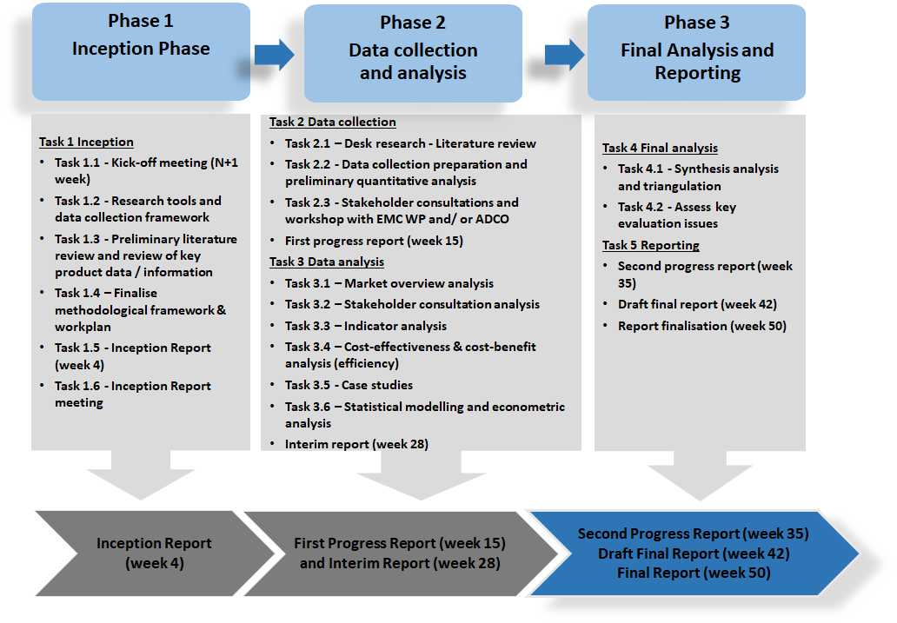
Summary of key evaluation issues framework
The most important evaluation questions are mentioned in the table below, detailed evaluation questions by criterion are in Annex 7.
Evaluation criteria | Key considerations
Effectiveness | - Overall, how effective has the EMCD been in achieving its objectives of requiring apparatus to comply with an adequate level of electromagnetic compatibility, and guaranteeing the free movement of such equipment within the single market?  - How far has the EMCD provided a stable legal framework since the Directive was adopted in 1989?
Efficiency | - What are the costs and benefits of EMCD compliance for economic operators and other relevant stakeholders (e.g. market surveillance authorities)?  - To what extent are administrative and reporting costs proportionate?  - Were the effects achieved at a reasonable cost?  - How far – if at all – do the benefits outweigh the costs?
Relevance (including fitness for purpose) | - To what extent does the EMCD remain relevant today in regulating electromagnetic compatibility and addressing identified needs?  - How far is the legal text clear and coherent?  - Given the evolution of the electrical equipment market since the Directive was adopted, how far does it remain fit for purpose?
Coherence | - Are there any coherence issues regarding the relationship between the EMCD and other wider EU legislation?
EU added value | - What is the EU added value of the current EMC Directive?  - In the absence of the EMCD, what would be the situation (counterfactual evaluation consideration)?

Selection of 14 products for the Market analysis
The EMCD address almost all electrical products which thus are not a defined sector in the industry and are also not logged as a separate group of products in statistical databases. Taking this into account, 14 products, including both apparatus and fixed installations, were selected for in-depth analysis. The methodology for selecting these products was based on desk research, and in collaboration with the EMC ADCO members who provided their view regarding which products either caused disturbance or which they would generally find interesting to include. In order to collect statistical data for each of the considered apparatus and fixed installations, it was necessary to attribute a corresponding NACE, Prodcom and CN code to each of them.
Figure– Products covered by the market analysis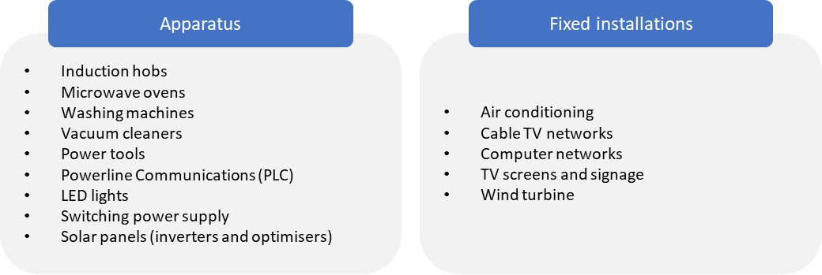
Stakeholder consultations
The stakeholder consultations consisted of:
- Initial consultation carried out as part of the evaluation roadmap (organised by the Commission and analysed by CSES);
- Interviews with 112 interviewees;
- Targeted stakeholder consultations (carried out through an online survey managed and analysed by the study team);
- Public Consultation (carried out on the Commission’s EUSurvey platform);
- Four stakeholder webinars focusing on the key evaluation issues held together with the EMC ADCO and EMC Working Party members; and
- Several other presentations outlining the emerging evaluation findings to different EMC stakeholder groups, including presenting emerging findings at EMC ADCO meetings and to the EUANB.
In carrying out the stakeholder consultations, the Commission’s Better Regulation guidelines were followed. The interviews were as wide as possible, with an effort to ensure an appropriate balance across different types of stakeholders and in terms of broad representativeness as regards:
- Geographic coverage across the EU-27 – e.g. stakeholders located in southern, northern, central and eastern European countries;
- Coverage by stakeholder type – e.g. industry stakeholders (industry associations, economic operators), Market Surveillance Authorities (MSAs), standardisation organisations, notified bodies, testing and certification laboratories, consultants and academics specialising in EMC and radio amateur organisations and individuals; and
- Coverage of both apparatus and fixed installations. The product scope covered 14 different apparatus and fixed installations.
Table - Summary of the interviews completed
Stakeholders by type | Completed
Third country contacts | 7
Academic/RTOs/Consultants | 7
Economic operators (incl. SMEs) | 30
EU/national consumer associations | 0
Industry associations | 29
MSAs and national competent authorities | 17
Notified bodies and testing labs | 10
Radio amateur associations and radio amateurs | 5
Technical standard bodies | 7
Total | 112

Whilst the number of interviews undertaken exceeded the target of 90, it was not possible however to interview all types of stakeholders. Although an effort was made to interview EU/national consumer associations, those approached declined to participate, as they do not follow the EMCD. However, a consumer perspective was nonetheless ensured through the interviews with radio amateur associations and radio amateurs. It was also difficult to persuade Small and Medium-sized Enterprises (SMEs) to take part in interviews, although some SMEs responded to the online survey. Large firms and multinationals were in contrast well represented among economic operators.
Concerning the Target consultation answers, an overview of the responses by country is provided below:

Figure – Targeted survey responses by country – (N = 458)
Source: Targeted online consultation
The Figure shows that participation in the targeted consultation was of a strong interest from a small number of EU Member States, such as Austria (5%), Belgium (7%), Portugal (5%), the Netherlands (5%), Sweden (6%) and France (9%). Reflecting the market for electrical equipment, Germany accounted for the highest volume of responses by a considerable margin (22%). In addition, there were also a high proportion of responses from outside the EU-27 (14%), especially from the UK and the US. Stakeholders outside the EU include, for example, accredited conformity assessment bodies able to carry out conformity assessment and testing under the EMCD. Some larger economic operators outside the EU also completed the survey, especially multinationals.

Figure–– Overview of the responses by type of stakeholder (N = 458).
Source: Targeted online consultation
A good balance was achieved in the survey responses between the different types of stakeholders involved. A high response was received from economic operators, 40.8% of the total. This was comprised of 34.3% of respondents that were manufacturers, 1.5% distributors, 0.7% importers and 0.7% authorised representatives and 3.7% organisations providing consultancy services). In addition, a further 15.3% were received from industry associations. Overall, industry represented 56.1% of the total responses (industry associations + economic operators) to the targeted consultation. The other types of survey respondents were mainly laboratories (14.2%), MSAs (5.5%), national authorities (7.2%) and notified bodies (3.5%) and standardisation organisations (2.8%). There was a low response from consumer associations, as very few consumer associations follow the EMCD closely.
Only 40.8% of the total 458 responses (i.e. 184 responses) were from economic operators which answered the question regarding their firm size, as shown in table below:

Table – Overview of responses to targeted survey from economic operators (EO) – question on enterprise size class (N = 184)
Type of firm by size | Number (all EO) | Percentage (%) of total economic operators
Large (>250 staff) | 132 | 71.7
Medium (50-249 staff) | 25 | 13.6
Small (10-49 staff) | 12 | 6.5
Micro (<10 staff) | 15 | 8.2
Total | 184 | 100.0%
Source: targeted online consultation. Note – not all economic operators responded to the question on size breakdown
A weakness in the quality of data for economic operators is that whilst there was a good response overall, only a limited number of responses were received from micro, small and medium-sized enterprises. A further challenge is that 7 of the 12 enterprises responding categorised as small were actually consultancies working with manufacturers advising on EMCD compliance. More positively, a high number of responses were received from large firms.
Regarding the public consultation, in total, 854 responses were received. A very high number of the total responses were from radio amateurs and their representative associations. Users of electrical equipment (especially radio amateurs) comprised 60.4% of respondents to the consultation, and radio amateur organisations comprised 29.0%. There were a more limited number of responses from industry associations, economic operators and other types of organisations.
The most common country of origin of respondents was Germany, which accounted for 59.4% of responses (507 respondents). This was followed by the Netherlands and Belgium (114 and 113 respondents respectively) and Finland (54 respondents). Together, respondents from these four countries made up more than 92% of all responses. Among the 2% from non-EU countries (18 respondents), the most-represented country was the United Kingdom (1%, 8 respondents).
Figure – Country of origin of respondents to Public consultation (N = 854)

The largest group of respondents by type were ‘users of electric equipment/apparatus/fixed installation (individual citizen or other types of organisations)’ with 60% of all consultation responses (516 respondents). The second largest group was ‘radio amateur organisation or other citizen-based organisation’, accounting for 29% of responses (248 respondents). Together, those two groups make up almost 90% of all responses. Economic operators accounted for 3.0% of all responses (26) and industry associations 1.4% (12). Laboratories accounted for 0.5% of the responses (4) and notified bodies and academic and research institutions 0.4% (3 each). Other respondents were below 0.2% of the responses. It should be noted however that economic operators, industry associations, notified bodies etc. were better represented in the targeted consultation. There were no responses from consumer associations as they don’t generally follow the EMCD, but consumers are instead represented through the significant numbers of respondents from user associations and users (i.e. radio amateurs and their representative associations).
Throughout the analysis that follows, the answers for these two groups tend to follow a similar pattern, suggesting that their interests are aligned. The ‘user’ group probably accounts for a large number of the total response, and these were mainly from radio amateurs.

Figure–– Overview by stakeholder type for Public consultation responses (N=854)

Source: CSES

The most common country of origin of respondents was Germany, which accounted for 59.4% of responses (507 respondents). This was followed by the Netherlands and Belgium, each accounting for just over 13% of responses (114 and 113 respondents respectively), and Finland (6.3%, 54 respondents). Together, respondents from these four countries made up more than 92% of all responses.
Respondents from EU Member States accounted for 98% of the total (836 respondents). Among the 2% from non-EU countries (18 respondents), the most-represented country was the United Kingdom (1%, 8 respondents).
The evaluation roadmap consultation was organised by the Commission between January and February 2020, and received 25 responses. Respondents were drawn from eight countries with the largest numbers based in Germany (nine responses) and Belgium (six), the latter including five EU-level industry associations. Four responses were received from France, two from Denmark, and one each from the Netherlands, Italy, Switzerland and the United Kingdom.
Four separate webinars were organised as part of the evaluation in October 2020. These involved the participation of EMCD Working Party (WP) and EMCD ADCO members. These webinars replaced the planned evaluation workshop, which could not take place in Brussels due to COVID-19. Presentations of the emerging evaluation results were also made to various stakeholder fora, including to the EMC ADCO members and EUANB members.
Data analysis
The data analysis was based on an assessment of the data gathered through desk research and stakeholder consultations. This consisted of:
- A review of the results of the stakeholder consultations, in particular:
- Interview feedback (with 112 interviewees).
- Survey feedback from the targeted consultation (458 respondents).
- Survey feedback from the public consultation (854 respondents).
- Analysing the results to the evaluation roadmap consultations (25 respondents), presented in Annex 7.
- Analysing the data on market size and structure for 14 selected products (see Annex 4)
The analysis was carried out using descriptive statistics from three sets of publicly-available Eurostat databases, Prodcom, Comext and the Structural Business Statistics datasets.
In the analysis, the statistical data consistently refers to the 27 current EU Member States. In agreement with the European Commission, the United Kingdom is treated as an extra-EU partner in the foreign trade analysis.
Methodology for the assessment of efficiency
The assessment of efficiency in the main evaluation report was based on an analysis of costs and benefits generated by the EMCD.
Data and information were gathered through the targeted online consultation about the average costs of compliance as a percentage of the total, and through the in-depth interviews conducted with economic operators, experts and national authorities. However, in many cases, it was difficult to obtain any costs data through interviews. Nonetheless, some useful data was obtained which informed the analysis of costs.
The analysis was complemented by desk research, for instance, reviewing the approach adopted to undertaking the assessment of costs and benefits in other recent relevant evaluations and impact assessments (e.g. Interim evaluation of the Low Voltage Directive, Impact assessment of the Machinery Directive). The lists are structured based on the categories set out in the European Commission’s Better Regulation Toolbox, which distinguishes between direct costs, enforcement costs and indirect costs, and between direct and indirect benefits.

Table - Costs generated by the EMCD
Direct costs |  | Cost of product development (EMC relevant):  - Cost of purchasing the relevant standard  - Cost of engineering  - Cost of pre-testing  - Cost of risk assessment
Direct costs |  | Cost of conformity assessment to produce the technical file:  - Documentation  - Cost of laboratory tests (internally / third party)  - Involvement of a notified body
Direct costs |  | Compliance costs during the production process:  - EMC-relevant measures (e.g. shielding)  - Including information to the user  - Markings (traceability, identification, CE marking)  - Ensuring that the manufacturing process and its monitoring are compliant with the technical documentation
Direct costs |  | Cost of familiarisation with the legal framework
Direct costs |  | Cost of keeping technical documentation for 10 years
Direct costs |  | Cost of authorised representative
Enforcement costs |  | Enforcement costs:  - Enforcement costs (for authorities)  - Enforcement costs (for manufacturers)
Source: EMCD Evaluation Study – CSES with CSIL.

Table - Benefits generated by the EMCD
Direct benefits |  | Technical benefits  - Reduction of the incidence of electromagnetic disturbance leading to incorrect functioning of electrical equipment  - Regulation of application of good engineering practices for fixed installations  - Improvement of harmonised standards relating to EMC  - Increased electromagnetic immunity
Indirect benefits |  | Market efficiency
Indirect benefits |  | Industrial competitiveness (EU vs Third countries)
Source: EMCD Evaluation Study – CSES with CSIL.

ANNEX 4
ANALYSIS OF THE EMCD MARKET

This Annex provides an indication about the economic importance and the trade levels for the selected apparatus and fixed installations for this study (14 products).

Economic importance in the EU of selected apparatus and fixed installations
According to Eurostat data, in 2017 there were nearly 67,000 enterprises in the EU27 operating in the manufacturing sectors producing the 14 products, with about 2.37 million employees and a cumulative turnover of €566 billion. Between 2012 and 2017, the number of companies operating in the manufacturing sectors subject to the EMCD and covered by the analysis decreased by 4%. Yet, employment increased by 3% over the same period. In terms of size, micro enterprises are those which experienced a drop in their number. Conversely, the number of large enterprises and their share over the total have increased, which reflects a process of industry consolidation.
Between 2012 and 2017, the level of manufacturing activity in sectors producing the 14 selected products has grown at a slightly lower rate than the overall average for the EU27 manufacturing industry. The cumulative production of the 14 selected apparatus and fixed installations in 2018, accounted for 5.3% of the value of the total electrical equipment production. The drop recorded in 2013 can be attributed especially to a contraction in the production of computer networks, and, in general, to an increase in imports of the considered products from the extra-EU countries.
When considering consumption, the market size for the selected products represents approximately 0.3% of EU27 GDP. This share has been progressively decreasing since 2007 (from 0.4% to 0.31%), suggesting that cumulatively their markets were hit harder than those of other manufacturing sectors by the 2008 financial and economic crisis. Since then, their share has not returned to pre-2008 levels.
There are important differences in the production values for the selected products among the EU27 Member States as shown in Figure 5-1 for the average annual production values over the last five years compared with the previous five years. Product-specific information by country are provided later in this Annex.

Figure– Top 10 Member States in terms of annual average production of the 14 selected products, million Euro. 2007-2012 and 2013-2018.

Source: CSIL processing Prodcom data

Looking at the contribution of each country to the total EU27 production of each product, it emerges that:
• Denmark accounts for 57% of the EU27 production of wind turbines;
• Germany accounts for 57% of solar photovoltaic inverters (and Finland also has a high market share, 14%);
• Poland accounts for 47% of washing machines;
• Slovakia accounts for 43% of switching power supplies.

Intra- and extra- EU trade for selected apparatus and fixed installations
This section presents cumulative trade levels for the selected group of products, both within and outside the EU27, and the main trade partners.
Between year 2007 and 2018, imports from intra-EU27 and extra-EU27 countries grew at similar rates. However, exports to intra-EU27 countries increased more rapidly than exports to extra-EU27 countries.
Overall, the EU has a negative trade balance for the selected electrical equipment products, with China being the largest partner for imports to the EU (see Figure 5-3) and the UK accounting for largest share of exports from the EU (see Figure 5-4).

Figure– Extra-EU27 trade of the 14 selected products, million Euro. 2007-2019. EU27

Source: CSIL processing Comext data

As a result of growing competition from manufacturers outside the EU27, some companies have been pushed out of the market, others have consolidated in larger groups, others have relocated part of their production outside the EU27.
Electronics (computers, televisions, and mobile phones) and electrical products (domestic appliances) were two of the three manufacturing subsectors that suffered the most from offshoring trends, together accounting for around 60% of total offshoring job losses, according to a 2016 ERM report.
It remains to be seen to what extent supply chain disruptions in the availability of key electronic parts and components due to the COVID-19 pandemic will lead to changes in practices of EU manufacturers regarding their sourcing.
When considering the contribution of each Member State to the total value of exports and imports of the selected products, it can be highlighted that the Netherlands emerges, by far, as the largest exporter and importer both intra and extra-EU, thanks to its position as a large ports hub. Germany ranks second but it is the largest manufacturing country for export and consumption market for import. Czechia and Poland are respectively the 3rd and the 5th largest exporters of the selected products (with France being the 4th). For both Czechia and Poland, intra-EU27 flows account for over 83% of the total values, whereas for Germany and France this share is around 61%.
Among the top 10 countries where EU exports go to, besides the United Kingdom, Turkey, the United States, Malaysia, and Mexico, the other importers are from the South-East Asian region, with China being the main importing country in this region.
Approximately 60% of extra-EU27 imports of the 14 selected products to the EU in 2018 came from China. The significant growth of imports from China started in the early 2000s and has been growing exponentially since 2014. As a result, the same exponential growth was observed in terms of the trade deficit with China.

Figure – Imports to the EU: Top 10 non-EU countries for the 14 selected group of products, million Euro. 2010-2019. EU27

Source: CSIL processing Comext data

Export partners are more varied, with the UK accounting for the largest share of extra-EU exports, followed by the US. They are followed by Russia (whose imports from the EU recorded a strong contraction in 2014 due to trade restrictions but have been improving over the last three years), Switzerland, and China.
The US accounted for only 15% of extra-EU27 exports in 2019. The trend of trade between the EU27 and the US has been fluctuating over the last ten years. The contraction in exports to the US between 2010 and 2013 was mainly due to a decline in the export of wind turbines. After 2013, exports have been steadily growing.
It should be noted that whilst trends in exports and intra-EU trade data provide interesting context, as the essential requirements have not changed in 32 years since the EMCD’s adoption in 1989, no correlation or causation in terms of market size and structure and the EMCD can be easily derived. However, the survey results and interviews confirmed that most stakeholders viewed the impacts of the EMCD on facilitating trade within the EU and exports globally as beneficial. Also, the trend of increasing trade exchanges has not been reversed.

Figure – Exports from the EU: Top 10 non-EU destination countries for the 14 selected groups of products, million Euro. 2010-2019. EU27

Source: CSIL processing Comext data
Production evolution and supply structure
The aggregated data on the production evolution of the 14 selected products between 2007 and 2018 in the EU27 shows cumulatively a decline in production by an annual average rate of 3%.
A longer time series (1995-2018) is available for 7 out of 13 categories of products. Overall, their production has grown steadily since the mid-1990s, with an annual average growth rate of 5%. Their performance in the period 1995-2007 was much stronger than in the subsequent period (2008-2018), with an overall annual growth rate of 11% (Table 1).
Table - Production of the 14 selected products, compound annual growth rate (CAGR). 1995-2018. EU27
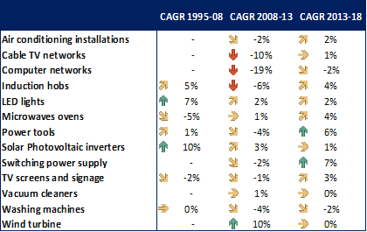
Source: CSIL processing Prodcom data
Note: “Power Line Communication” apparatus is not displayed in the table because it is part of the “Computer networks” installation.
Looking at the contribution of the individual products within scope allows to identify different patterns:
- Most of the cumulative negative trend observed at the aggregate level is due to the negative performance of computer networks and cable TV networks, and, to a smaller extent, to washing machines and induction hobs. In fact, these are the only products in scope that did not overcome their pre-crisis level by 2018.
Figure - Production of selected products, million Euro. 2007-2018. EU27
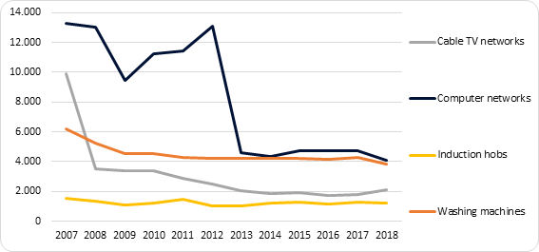
Source: CSIL processing Prodcom data.
Note: The selection of the sub-group of four products included in the Figure was driven by the identification of a negative trend over the considered timespan.
- The production of LED lights, solar inverters and wind turbines shows an overall positive dynamic over the 2007-2018 period, as these products do not show signs of a permanent impact of the 2008 crisis. Different reasons underlie their positive trends: the growth of LED lights was mainly driven by technological innovation, but also by regulations supporting energy efficiency (e.g. the Eco-design Directive) and solar inverters and wind turbines benefited from public support programmes and incentives in support of renewable energy.
Figure - Production of selected products, million Euro. 2007-2018. EU27
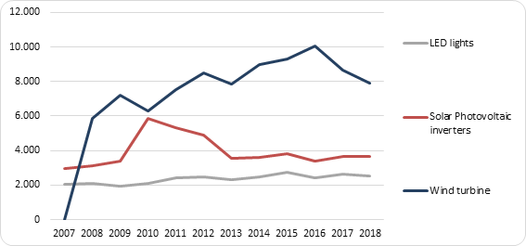
Source: CSIL processing Prodcom data.
Note: The selection of the sub-group of three products included in the Figure was driven by the identification of a positive trend over the considered timespan.
- Before 2008, some electrical appliances (Washing machines, Power tools, TV screening and signage, and Microwave ovens) already showed a declining or stable trend in the 2003-2007 period, which contrasts with the positive dynamic characterising the 1995-2002 years and which can be attributed mainly to the offshoring process and import competition. The financial crisis has further negatively affected these productions, and only Power tools show a clearly positive trend from 2011 onwards.
Figure - Production of selected products, million Euro. 1995-2018. EU27^{[3]}
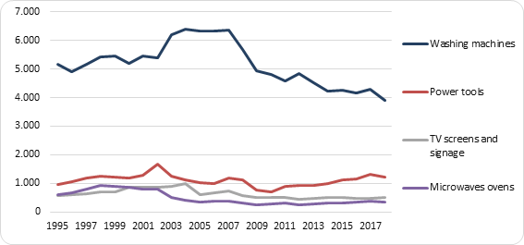
Source: CSIL processing Prodcom data.
Note: The selection of the sub-group of four products included in the Figure was driven by the identification of a stable or declining trend over the 2003-2007 period.
Three products (air conditioning systems, switching power supply and vacuum cleaners) cannot be attributed to any of the three patterns identified. As illustrated in Table 1, Air conditioning systems and Switching power supply suffered a moderate decline in terms of compound annual growth rate between 2008 and 2013 (-2%), followed in the 2013-2018 period by a moderate recovery for Air conditioning systems (+2%) and a stronger one for Switching power supply (+7%). The production of Vacuum cleaners, by contrast, remained rather stable over the entire period (+1% in 2008-2013 and 0% in 2013-2018, in terms of annual compound growth rate). No data are available on the pre-2008 production of these three products.
Considering production data by EU Member State, Section 3 illustrates that Germany is cumulatively the largest producer of the selected products, followed by Denmark and Italy.
As shown in Figure 4, most of Denmark’s production is due to their strong global market position in wind turbines, without which it would rank 9th after Sweden and report a negative 10-year performance for the other products within scope. Similarly, washing machines account for most of the production from Poland, and computer networks account for a high percentage of production in Hungary and Sweden, solar photovoltaic inverters in Finland, and switching power supply in Slovakia.
More specifically, looking at the contribution of each country to the total EU27 production of each product, it emerges that:
- Denmark accounts for 57% of the EU27 production of wind turbines;
- Germany accounts for 57% of solar photovoltaic inverters (and Finland also has a high market share, 14%);
- Poland accounts for 47% of washing machines;
- Slovakia accounts for 43% of switching power supplies.

Figure - Top 10 largest Member State production by product type, million Euro. 2018.
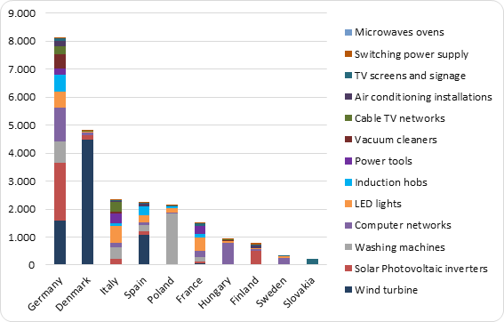
Source: CSIL processing Prodcom data
Note: “Power Line Communication” apparatus is not displayed because it is part of the “Computer networks” installation.
Trade evolution
Table 2 shows the levels of EU27 trade for the selected products with EU27 Member States and countries outside of the EU27 (referred to as intra- and extra-EU countries). Table 3 and Table 4 present the evolution of EU27 trade of each of the considered category of products between 2002 and 2018.
Table - Intra and extra-EU27 trade of the 14 selected products, million Euro. 2018. EU27
 | Intra-EU |  | Extra-EU
 | Export | Import | Export | Import | Trade Balance | Top importing partner
Air conditioning installations | 541 | 729 | 155 | 1,456 | -1,301 | China
Cable TV networks | 245 | 413 | 462 | 362 | 100 | USA
Computer networks | 21,319 | 18,160 | 14,590 | 23,914 | -9,324 | China
Induction hobs | 1,007 | 990 | 424 | 180 | 244 | China
LED lights | 3,279 | 3,003 | 1,626 | 3,799 | -2,173 | China
Microwave ovens | 291 | 307 | 89 | 576 | -487 | China
Power tools | 2,579 | 2,416 | 838 | 1,629 | -791 | China
Solar Photovoltaic inverters | 2,477 | 2,007 | 2,263 | 823 | 1,440 | China
Switching power supply | 1,420 | 1,266 | 949 | 1,939 | -990 | China
TV screens and signage | 319 | 261 | 221 | 346 | -125 | China
Vacuum cleaners | 2,526 | 2,525 | 626 | 1,859 | -1,233 | China
Washing machines | 2,151 | 2,049 | 877 | 1,264 | -387 | Turkey
Wind turbine | 2,107 | 2,017 | 2,711 | 121 | 2,589 | China
Total | 40,260 | 36,142 | 25,831 | 38,268 | -12,437
Source: CSIL processing Comext data
Note: “Power Line Communication” apparatus is not displayed in the table because it is part of the “Computer networks” installation.
Table - Intra and extra-EU27 export of the 14 selected products, compound annual growth rate (CAGR). 2002-2018. EU27
Source: CSIL processing Comext data
Note: “Power Line Communication” apparatus is not displayed in the table because it is part of the “Computer networks” installation.
Table - Intra and extra-EU27 import of the 14 selected products, compound annual growth rate (CAGR). 2002-2018. EU27
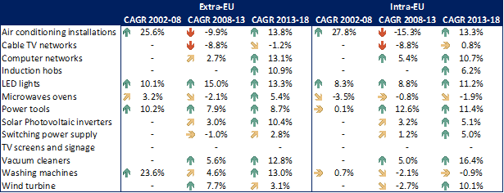
Source: CSIL processing Comext data
Note: “Power Line Communication” apparatus is not displayed in the table because it is part of the “Computer networks” installation.
With reference to specific products, the analysis of trade data leads to the following findings:
- The most traded product is by far Computer networks.
- Intra-EU27 trade shows similar monetary values for all products except for Cable TV networks, Microwave ovens, and TV screens and signage, whose aggregate monetary trading value is well below the level of the other products.
- Some of the products within scope have high levels of extra-EU27 exports, such as wind turbines, Solar Photovoltaic inverters, and LED lights.
- Wind turbines and solar photovoltaic inverters are also the products that recorded the highest trade surplus.
- A positive trade balance was also reported for Cable TV networks and Induction hobs but with much smaller values.
- Washing machines (for which the entire 1995-2018 time series data is available, see data presented above) used to be the product with the highest trade surplus until 2007. After 2007, the trade balance started to decline, and became negative in 2011. It has worsened progressively since then.
Trends and developments within the EMC market
There is a growing need to consider the following factors in the evolution of electrical and electronic product markets: (1) the increase in connected products, (2) the emergence of new types of electrical equipment, (3) the presence of new economic operators in the market and (4) the development of e-commerce.
Over the past 5-10 years in particular, electronic products and equipment have increasingly been influenced by the emergence and growth of the Internet of Things (IoT), meaning more and more products can be connected through internet. The growth in the IoT is expected to have a significant impact on the application of the EMCD, as products connected to the Internet via radio (wirelessly) are not covered by the EMCD. They fall within the RED’s scope - see section 5 for more details.
Overall, whilst the IoT is a growing market that has impacted on the scope of products falling under the EMCD, there has in parallel been a corresponding growth of the market of the electrical equipment in general with new products for new uses. This means that the scope of products falling under the EMCD remains very large.
Although the growth of internet-connected electrical equipment (falling under the EMC requirements of the RED) is an important trend, it needs to be considered in the wider context of significant overall growth in the EU electrical equipment market – Figure – Production evolution of electrical equipment, Million Euro. 2008-2018. EU27 below. A greater number and variety of products which fall under the EMCD are present in the market than when the Directive was adopted in 1989. A significant evolution could be observed since the 2004 recast Directive, and even the 2014 NLF-aligned Directive. The environment in which apparatus are placed contains a lot more electrical equipment located at closer distance from one another than in the past. As a result, the EMCD is considered to have increased in relevance as the environment for which products are intended for use has changed, resulting in the need to consider the possibility of putting in place more stringent limit values (LVs) in some cases, and also reviewing LVs in harmonised standards more regularly. This would help to address concerns among radio users about the cumulative impacts of disturbance.

Figure – Production evolution of electrical equipment, Million Euro. 2008-2018. EU27

Source: CSIL processing Eurostat data

The relevance of e-Commerce is envisaged to grow over the coming years, as this form of shopping becomes more ubiquitous and is further invigorated by the effects of the Covid-19 pandemic. The increasing digitalisation of distribution channels for electrical products resulting from the growth of e-commerce means that Market Surveillance Authorities (MSAs) face more difficulties in identifying non-compliant products placed on the European market. To give an example, this is the case for LED products sold via online platforms as indicated by the case studies. MSAs suggested that marketplaces outside the EU pose a particular challenge in this regard, although national MSAs reported good cooperation with the biggest marketplaces in removing non-EMCD compliant products, after having been alerted by MSAs. E-commerce in Europe grew to €621 billion in 2019 and to €757 billion in 2020, which constitutes an increase by 21,9% compared to 2019.
The key challenges stemming from the above market-related developments are the increasing presence of non-compliant products on the market including the increased proportion of products from third countries, which according to stakeholder were more often non-compliant. In addition, the growing number of products in the market makes it more difficult for the Member States to monitor their compliance and enforce EU rules. Furthermore, there has been a large increase in the entry of goods into the EU through direct consumer online purchases, which cannot be controlled and tracked through traditional methods. The sheer volume of products makes it impossible to control all shipments, as imports constitute 30% of all products placed in the EU.
^{[1]} Induction hobs, LED lights, Microwave ovens, Power tools, Solar Photovoltaic inverters, TV screens and signage, Washing machines.
^{[2]} As explained under Section 1.3.5, Powerline Communications can be considered included into the data for “Computer networks”.
^{[3]} Before 2003, data refer to EU15 Member States only (Austria, Belgium, Denmark, Finland, France, Germany, Greece, Ireland, Italy, Luxembourg, Netherlands, Portugal, Spain, Sweden, and the United Kingdom).

ANNEX 5

CASE STUDIES
The case studies presented cover the following products:

• Case study 1 – Powerline Communications (PLCs);
• Case study 2 – Ready-made connecting devices (RMCD);
• Case study 3 – Solar photovoltaic inverters and optimisers;
• Case study 4 – LED lights; and
• Case study 5 – Wireless power transfer chargers for electric vehicles (WPT for EVs).

Case studies – overview of key issues identified
Product type | Key issues identified in case studies
Powerline Communications (PLCs) | - PLCs were raised as a concern in terms of the electromagnetic disturbance generated by many radio amateurs and some MSAs in the interviews, targeted and open consultations. There were concerns for a period of years that no suitable Harmonised Standard (HS) was available for such products, despite the disturbance issue being discussed in technical communities. However, a HS was developed ^{[1]} and published in 2015.  - On the positive side, there have been technological advances in the design of PLCs to reduce disturbance through the use of notching techniques to avoid creating disturbance to short-range radio waves used by radio amateurs.  - However, whereas powerline equipment searches for any potential conflicting radio signals used by other electrical equipment using dynamic notching to check for compatibility with other frequency bands being used, some radio frequency bands may not be detectable whilst in use (e.g. radio amateur and aeronautical frequency bands).  - The Harmonised Standard EN 50561-1 requires notching broadcast and other essential radio services. However, mandatory notches appear to create interference, which could be caused by intermodulation in the unit itself or by other units connected to the power line. Accordingly, a revised standard is under development to overcome these technical challenges which could in future be put forward as a harmonised standard.  - The effectiveness of the only existing harmonised standard in reducing disturbance created by PLCs was questioned by some stakeholders (e.g. radio amateurs, some MSAs). Some PLC products remain on the European market, even though the manufacturers know that the EM disturbance being created may impede some radio equipment from functioning. However, they are legally able to demonstrate presumption of conformity with the essential requirements based on the existing harmonised standard.  - PLC technologies are evolving, such as the growing use of MIMO technologies. This poses challenges for standardisation bodies in terms of the timeframes for developing new harmonised standards to ensure that these represent state of the art.  - The non-inclusion of noise filters could be an unintended consequence of allowing PLC products onto the market without stricter requirements, according to some stakeholders (e.g. radio amateurs, consultants specialising in EMC). This can disturb the operation of the equipment of radio amateurs.  Conclusions  - PLCs were seen as being a problematic product in terms of EM disturbance generated, although interference levels vary across products.  - Whilst several stakeholders indicated that PLCs remain a product group of concern from the point of view of radio interference levels due to both EM emissions and high noise levels (80 – 90 dB), PLCs may become less widely used in future. Wireless technologies are becoming more ubiquitous, and technological progress has been made through the development of Wi-Fi 6 (802.11ax). This is expected to enable routers to better handle the growing number of internet-connected devices in homes, offices and industrial environments.  - The delay in the development of the harmonised standard for PLCs prior to its citation created some degree of regulatory uncertainty for a number of years. Some PLC manufacturers were able to exploit gaps in the availability of a harmonised standard in the interim period before it was available and then cited.  - Harmonised standards appear to be an effective tool to address the problem of EM disturbance generated by PLCs, although the technical characteristics of the original HS for PLCs needs to be updated to rectify some challenges in the efficacy of notching in some circumstances
Ready-made connecting devices (RMCD) | - RMCD are considered to be passive but are designed to be connected to apparatus covered within the EMC or RE Directive's scope. RMCD are presently outside the scope of the EMC Directive (Directive 2014/30/EU), due to being considered 'inherently benign’.  - Whilst cables are passive, and therefore outside the Directive’s scope, RMCD were raised as a concern by many radio amateurs and MSAs in terms of the disturbance they generate.  - A further problem is that even though some industry standards exist for cables, as cables are excluded from the Directive’s scope, these are not harmonised standards. Moreover, there are cheap cables on the market that fulfil the technical requirements of industry standards, but expensive cable that do not fulfil the requirements, but as the products are not regulated, MSAs cannot remove these products from the market.  - RMCD have been subject to joint surveillance campaigns twice by the EMC ADCO firstly in 2012, with a follow-up campaign in 2021.  - The 2012 benchmarking assessment, conducted by three MSAs – Bundesnetzagentur (DE), OFCOM (CH) and Agentschap Telecom (NL) – focused on assessing the level of interference caused by ready-made coaxial connecting devices (receiver leads) for cable TV and IT services with IEC and F- connectors. Other types of ready-made connecting devices, such as SCART or HDMI cables were excluded from the exercise at that time. However, a limitation is that coaxial cables for TVs now mainly fall under the RED’s scope.  - Among the findings from the 2021 surveillance campaign, which focused on cables falling under the EMCD’s scope, were that:  - Only 13% of coaxial RMCD meet the respective class A requirements (screening classes according to EN 60966 series).  - Only 11% of the coaxial RMCD meet their own declaration with regard to screening attenuation or class.  - Compared to the benchmark results from 2012 a medium decrease of quality parameters of coaxial RMCD has been observed.  - Only 10% of the HDMI RMCD meet an acceptable quality limit of 50 dB coupling attenuation.  - For both types of RMCD, no correlation between price and EMC quality could be observed  - Spot checks of the mechanical resistance of the samples to pull force stress showed negligible impacts.  Conclusions  - Ready-made connecting devices are inherently benign equipment, but when connected to electrical devices falling under the EMCD scope, may system-wise become non-benign, leading to EM interference.  - The level of such interference cannot presently be checked by MSAs as RMCD are outside the Directive’s scope. Poor quality cables that generate disturbance cannot be removed from the market.  - There was a consensus that product testing of apparatus against the EMCD’s essential requirements should be made with RMCD connected to the apparatus, as there is a need to ensure testing occurs in a real-world environment. As equipment is used with cable connecting devices plugged in, RMCD should be plugged in with the specific equipment it is designed for.  - Consideration should be given to bringing RMCD within the Directive’s scope, supported by a clear definition of such devices. Article 2 (d)(i) on benign products could therefore be reviewed by the Commission.  - However, it should be noted that the European industry association, Europa cable and their members are against any changes to the EMCD in bringing some types of cables within the EMCD’s scope and are in favour of a continuation of the status quo.  - The results from the 2021 study demonstrated the poor EMC quality levels of both coaxial and HDMI RMCD in the current market. These findings should be considered to estimate whether a regulatory or non-regulatory approach would be more effective.  - It would be easier for MSAs to address the challenges identified if certain types of cables, namely RMCD, were included within the Directive’s scope, as their exclusion means that they are not part of European standardisation processes. Harmonised standards could help to resolve some of the technical problems identified and improve cable quality.
Solar photovoltaic inverters and optimisers | - There is a debate among EMCD stakeholders regarding whether solar panels should be classified as apparatus or as fixed installations.  - According to most but not all MSAs, they should be considered as apparatus (so long as they include standardised parts that are then reassembled in a solar panel installation), with all consequences this entails in terms of regulatory compliance.  - There is a question mark as to whether it is sufficiently clear which actors are responsible for EMCD compliance of solar panels. In MS where MSAs consider them to be a fixed installation, the building owner is responsible for checking disturbance. Installers are not presently directly responsible under the EMCD, although there may be requirements for them to assume responsibility under national legislation pertaining to the installation of equipment in buildings.  - Both inverters and optimisers that are parts integrated into solar panel installations have been found to cause EM disturbance in many product types.  - As two ADCO campaigns have demonstrated (in 2014 and 2019), many solar inverters are non-compliant with existing harmonised standards. In this regard, increasing market surveillance actions could be part of the solution.  Conclusions  - Due to rapid changes in electrical current, solar panel inverters, can generate high electromagnetic interference emissions. Through cables, disturbance can also be radiated into the surrounding environment. To avoid this, EM reduction and minimisation measures need to be implemented, such as making greater use of shielding and filtering.  - During its 2014 campaign, the MSAs from the EMC ADCO taking part found a low level of both administrative and technical compliance among sampled inverters. In its 2019 campaign, compliance was not found to have improved.  - While solar panel inverters can be problematic in terms of EMC, the difficulty appears to be not related to the EMC Directive, but rather to standardisation, and more specifically to non-compliance with existing standards. Whilst previously there was a lack of specific standards for solar inverters, since 2010 standards have been in place, but not necessarily complied with. In this regard, increasing market surveillance actions could be part of the solution. Currently, the highest EMCD-related priority with regard to solar panels lies in increasing the number of compliant solar inverters.  - While non-compliant products represent the biggest issue, a second problem is that some harmonised standards are perceived as not yet being optimal to prevent or at least to reduce EM disturbance sufficiently. Overall, it is difficult to generalise whether additional changes in standards are needed or not. Current measures could potentially be sufficient, if consistently applied across the board. For standards for microinverters/optimisers in particular, it can be argued that there is room for further developments (e.g. with regard to measurements on cables under 3 meters).  - In the case of optimisers, further standardisation work could be undertaken to set technical parameters that would enable an adequate level of EM compatibility.
LED lights and luminaries integrating LEDs | - Whilst not all LED lights and luminaries integrating LEDs cause disturbance, LEDs were mentioned relatively often by respondents to the targeted and public consultations as being problematic.  - One of the key issues is the fact that there has been a proliferation in the use of LED lights, and these lights are often placed in close proximity to one another. They may therefore sometimes cause EM disturbance that interferes either with other LED lights, and / or with other equipment.  - Similar to RMCD, LEDs have been subject to a previous joint surveillance campaigns by the EMC ADCO (4th EMC Market Surveillance Campaign 2011), and a new campaign will be launched to test them in 2021.  - A technical issue raised was that there is evidence of minor divergence in the limit values set for LEDs in HS under the EMCD and the RED respectively, depending if a LED product has been integrated with radio functionality / internet connectivity. This means that there is divergence in the limit values for wired and wireless products, which is complex from a manufacturers’ perspective. They would prefer common LVs across a suite of wired and wireless products.  Conclusions  - MSAs should engage in more proactive surveillance of LED products from third countries. There should be a particular focus on improving the surveillance of online marketplaces which introduce LED products to the European market where non-compliance levels and the prevalence of cheaper, lower-quality products is perceived to be higher.  - Use of dissuasive penalties for non-compliant economic operators.  - The cumulative effects of the use of numerous individually compliant LED in office-, industrial lightning and LED-panels at the same time in LED walls needs to fully considered within the EMCD’s legal implementation framework. The cumulative effects of disturbance could be incorporated into the design of harmonised standards and the setting of limit values rather than in the EMCD itself, although the need for manufacturers to strengthen attention to cumulative EM emissions could be mentioned in the Directive’s recitals.  - The development of harmonised standards should be accelerated by the responsible European standardisation organisations, to ensure that new technologies can be accommodated more quickly such as to maintain their role as accommodating state-of-the-art.  - Better awareness of the negative impact of the use of low-quality LEDs that generate disturbance is required among economic operators and the general public.  - Awareness-raising of the possible technical solutions to limit LED-related disturbance, e.g. using two-stage power supplies or replacing transformers of MR16 lamps, might constitute a practical mitigating measure.
Wireless power transfer chargers for electric vehicles (WPT for EVs) | - Wireless power transfer for electric vehicles (WPT for EVs) is a state-of-the-art technology. It offers the advantages of convenience and flexibility, as well as the capability of enabling fully automated charging.  - Most WPT for EVs fall within the scope of the RED, but some that do not have communication capabilities fall under the EMCD.  - There is a need to strike a balance between high switching frequency (and increased power) and high frequency electromagnetic interference: when the switching frequency increases, high frequency electromagnetic interference or frequency electromagnetic compatibility becomes a challenge.  - There are concerns regarding the risk of the degradation of WPT chargers for EV cars and buses over their full lifetime, which may be up to 20 years, as these are embedded in tarmac and risk erosion with the weather. The impacts on health and on levels of disturbance over time need to be checked and factored into the development of HS.  - EMCD-related issues needs to be considered alongside health and safety issues, given concerns around the use of WPT for EVs and human health raised by some interviewees and in literature.  Conclusions  - With WPT for EVs, there is a need to strike a balance between high switching frequency (and increased power) and high frequency electromagnetic interference: when the switching frequency increases, high frequency electromagnetic interference or frequency electromagnetic compatibility becomes a challenge.  - Research has demonstrated that shielding structures can significantly mitigate the magnetic field in an automotive WPT system with very limited influence on electrical performance. Further research in this domain is ongoing.  - Unsurprisingly, manufacturers of WPT for EV are confident of the safety of the technology with regard to human health. However, as other stakeholders have expressed some considerable concerns, this issue could be examined in parallel with EMC-related issues by regulators (i.e. the implications of WPC for EVs extend beyond the EMCD alone.  - WPT for EVs could be vulnerable to cybersecurity threats, particularly high-power WPT and wired extreme fast charging installed in public places. Vulnerabilities may result in negative impacts on public safety and electric grid security, in addition to denial of service, hardware damage, and theft or alteration of data.  - Stakeholders agree on the need to regulate WPT for EVs. There is a lack of clarity regarding whether the EMCD or RED should be applicable for such technologies. The issue of how ‘radio waves’ are defined is at the heart of this question, and is an issue that may need to be addressed in future.  - There is currently no harmonised standard covering WPT for EVs. Stakeholders expect the process of developing an appropriate standard to take considerable time, based on recent experience with other new technologies. This risks leaving a gap for manufacturers in the interim period until such a HS has been developed.
^{[1]} EN 50561-1;2013/AC:2015; Power line communication apparatus used in low-voltage installations - Radio disturbance characteristics - Limits and methods of measurement - Part 1: Apparatus for in-home use

ANNEX 6

DESK RESEARCHS
EU legal framework - EMCD
- Council Directive 89/336/EEC of 3 May 1989 on the approximation of the laws of the Member States relating to electromagnetic compatibility (OJ L 139, 23.5.1989, p. 19–26).
- Directive 2004/108/EC of the European Parliament and of the Council of 15 December 2004 on the approximation of the laws of the Member States relating to electromagnetic compatibility (OJEU L 390, 31.12.2004, p. 24–37).
- Directive 2014/30/EU of the European Parliament and of the Council of 26 February 2014 on the harmonisation of the laws of the Member States relating to electromagnetic compatibility (recast) Text with EEA relevance, OJ L 96, 29.3.2014, p. 79–106, https://eur-lex.europa.eu/legal-content/EN/TXT/?uri=celex%3A32014L0030
- COMMISSION IMPLEMENTING DECISION (EU) 2019/1326 of 5 August 2019 on the harmonised standards for electromagnetic compatibility drafted in support of Directive 2014/30/EU of the European Parliament and of the Council
- Regulatory Impact Analysis (RIA), European Union (Electromagnetic Compatibility) Regulations 2016 to transpose Directive 2014/30/EU of the European Parliament and of the Council of 26 February 2014 on the harmonisation of the laws of the Member States relating to electromagnetic compatibility (recast), Department of Jobs, Enterprise & Innovation, April 2016
- Directive 2004/104/EC of 14 October 2004 of 14 October 2004 adapting to technical progress Council Directive 72/245/EEC relating to the radio interference (electromagnetic compatibility) of vehicles and amending Directive 70/156/EEC on the approximation of the laws of the Member States relating to the type-approval of motor vehicles and their trailers.
- DG GROW Guidance document on the application of the EMC, December 2018 – note, non-binding guidance document.
- The EMCD website of DG GROW. This includes documents adopted or endorsed by the EMCDD WP, the EMCD ADCO's recommendations, reports and information documents, and EC opinions within the framework of the EMCD. See https://ec.europa.eu/growth/sectors/electrical-engineering/emc-directive_en
Horizontal legal framework relevant to the EMCD
- Regulation (EU) 2019/1020 of the European Parliament and of the Council of 20 June 2019 on market surveillance and compliance of products and amending Directive 2004/42/EC and Regulations (EC) No 765/2008 and (EU) No 305/2011 - https://eur-lex.europa.eu/legal-content/EN/TXT/?uri=celex:32019R1020
- New Legislative Framework and the associated Decisions and Regulations from 2008.
- Regulation (EC) No 765/2008 setting out the requirements for accreditation and market surveillance relating to the marketing of products.
- Decision No 768/2008/EC on a common framework for the marketing of products.
- Regulation (EC) No 764/2008 laying down procedures relating to the application of certain national technical rules to products lawfully marketed in another Member State.
- DIRECTIVE 1999/5/EC OF THE EUROPEAN PARLIAMENT AND OF THE COUNCIL of 9 March 1999 on radio equipment and telecommunications terminal equipment and the mutual recognition of their conformity
- DIRECTIVE 2014/53/EU OF THE EUROPEAN PARLIAMENT AND OF THE COUNCIL of 16 April 2014 on the harmonisation of the laws of the Member States relating to the making available on the market of radio equipment and repealing Directive 1999/5/EC
Standardisation
- Summary list of harmonised standards
Relevant studies and evaluations
- REPORT OF THE SLIM III TEAM ON THE ELECTROMAGNETIC COMPATIBILITY DIRECTIVE (89/336/EEC as amended) Brussels, 24th September 1998.
- Cost Benefit Analysis on the Draft Amendment of the EC Directive on Electromagnetic Compatibility, Final Report, RPA for DG Directorate-General for Enterprise, European Commission, 2002
- Evaluation of the Machinery Directive (Directive 2006/42/EC), Technopolis, 2017
- Interim Evaluation of the Low Voltage Directive (2014/35/EU). https://ec.europa.eu/docsroom/documents/38701
- Ex-post evaluation of the application of the market surveillance provisions of. Regulation (EC) No 765/2008. FINAL REPORT. May 2017 - https://ec.europa.eu/docsroom/documents/26963/attachments/1/translations/en/renditions/pdf
- Commission Staff Working Document, Evaluation of the Machinery Directive, [SWD(2018) 161 Final], 2018
- CIRCABC interest groups related to the EMCD 2014/30/EU (see https://circabc.europa.eu)
- Analysis of consultation responses received to the February 2020 evaluation roadmap published by DG GROW
Reports and guidance provided by EMC stakeholder fora (e.g. EMC ADCO, EMC WP, meeting minutes)
- EMC ADCO recommendations and meeting minutes and those of the EMC WP.
- 1st - 10th EMC Market Surveillance Campaigns (e.g. covering LED floodlights, induction cooking hobs, etc.).
- EMC ADCO list of national language requirements (2018). European language requirements for products covered by EMCD 2014/30/EU v.2.0. https://ec.europa.eu/docsroom/documents/26690
- Guide for the EMCD (Directive 2014/30/EU) – non-legally binding guidance document updated in 2018 - https://ec.europa.eu/docsroom/documents/33601/attachments/1/translations/en/renditions/native
Position papers on the EMCD e.g. by industry associations, other stakeholders
Orgalim have published two position papers on the EMCD.
- Orgalim Comments on EMC Directive Evaluation Consultation Roadmap, 2020 - https://orgalim.eu/position-papers/internal-market-orgalim-comments-emc-directive-roadmap
- CEEMET / ORGALIM Position Paper on the Electromagnetic Fields Directive (2004/40/EC), 2007
https://orgalim.eu/position-papers/ceemet-orgalime-position-paper-electromagnetic-fields-directive-200440ec
International studies
- Canada's Communication's Future - Time to Act, Broadcasting and Telecommunications Legislative Review. January 29, 2020, the Broadcasting and Telecommunications Legislative Review Panel presented their final report, Independent report - https://www.ic.gc.ca/eic/site/110.nsf/vwapj/BTLR_Eng-V3.pdf/$file/BTLR_Eng-V3.pdf
- Ryan, Mike H. A Comparative Analysis of Institutional Frameworks for the Communications Sector in Canada, the United States of America, Australia, the United Kingdom, France and Germany. London: MHRyan Law, 2019.
Other studies and research (including literature related to products in scope)
Risk assessments, functional safety and EMC
- EMI Stories, Cherry Clough Consultants, Limited, A collection of 890 real-life short stories about the dangers of electromagnetic interference (EMI) Indexed by type of application, type of EMI, and whether safety was an issue, to aid research. Numbers 1-855 were originally published as ‘Banana Skins’ in The EMC Journal, www.theemcjournal.com
- How to perform a risk assessment in accordance with Directive 2014/53/EU?, Mr Holger Bentje, PHOENIX TESTLAB GmbH, Mr Thoralf Schulz, Federal Network Agency, REDCA, Copenhagen, 15-May-2018, http://redca.online/Unrestricted%20Documents/RED%20Risk%20Assessment%20introduction.pdf
Installations
- Leferink, F. ‘Risk-Based vs Rule-Based Electromagnetic Compatibility in Large Installations’. In 2018 IEEE 4th Global Electromagnetic Compatibility Conference (GEMCCON), 1–4, 2018.
Power Line Communications (PLC)
- P. Mlynek, R. Fujdiak, J. Misurec and J. Slacik, “Experimental Measurements of Noise Influence on Narrowband Power Line Communication”, 8th International Congress on Ultra-Modern Telecommunications and Control Systems and Workshops (ICUMT) Lisabon: pp. 1–7, 2016.
- Special issue of the 3rd International Conference on Computational and Experimental Science and Engineering (ICCESEN 2016), Application of Multiple Input Multiple Output Power Line Communication (MIMO-PLC) to Power Systems, A. Recioui∗
- Laboratory Signals and Systems, Institute of Electrical Engineering and Electronics
- University of Boumerdes, Algeria
- P. Mlynek, J. Misurec and M. Koutny, “Noise Modelling for Power Line Communication Model”, 35th International Conference on Telecommunications and Signal Processing (TSP), pp. 282–286, 2012.
- F. Hossner, J. Hallon, M. Orgon and R. Roka, “Testing of Electromagnetic Compatibility of PLC Modems”, International Journal of Engineering Research & Technology (IJERT), vol. 5, no. 01, 2016
- R. Roka, “Modelling of Environmental Influences at the Signal Transmission by means of the VDSL and PLC Technologies”, International Journal of Electrical Communication Networks and Information Security - IJCNIS, vol. 1, no. 1, 2009, pp. 6–13.
- M. Zimmermann, K. Dostert. “Analysis and Modelling of Impulsive Noise in Broadband Powerline Communications”, IEEE Transactions on Communications, pp. 249 – 258, 2002
LEDs and lighting
- Electromagnetic Compatibility Requirements for LED Lighting Products, White Paper, TuV, https://www.tuv.com/media/india/informationcenter_1/products/documents_4/light/EMC_LED_Whitepaper.pdf
- EMC measurement systems and noise suppression methods for led lamps and RF lighting controls, Róbert Istók, Peter Kadar, 2016, https://www.researchgate.net/publication/311212144_EMC_measurement_systems_and_noise_suppression_methods_for_led_lamps_and_RF_lighting_controls/citation/download
- Electromagnetic Compatibility of Light-emitting Diode (LED) Lamps and Wireless Medical Telemeters, Kai Ishida, Sazu Arie, Kaoru Gotoh, Eisuke Hanada, Minoru Hirose, Yasushi Matsumoto, 2017 https://www.researchgate.net/publication/320016393_Electromagnetic_Compatibility_of_Light-emitting_Diode_LED_Lamps_and_Wireless_Medical_Telemeters
- Minimizing EMI from LED Lighting - Case Study - EMC FastPass, 2020 https://emcfastpass.com/emi-led-lighting/
- How to solve the LED power supply design EMC / EMI problems, 2015 - http://www.nbpengwang.com/index.php?c=article&id=128
- Schaffner, Electromagnetic compatibility of lighting equipment - Common mode chokes for lighting
Wireless Power Chargers
- Baikova, Elena & Valtchev, Stanimir & Melicio, Rui & Pires, Vítor. (2016). Electromagnetic Interference from a Wireless Power Transfer System: Experimental Results. Renewable Energy and Power Quality Journal. 1020-1024. 10.24084/repqj14.560.
- European Commission's JRC (2018), Pliakostathis K., Scholz H. On the evaluation of Electromagnetic Compatibility (EMC) of a prototype electric vehicle: Electromagnetic interference filters and EMC remedies to conducted disturbances in AC-charging.
- UNWANTED EMISSIONS IN THE SPURIOUS DOMAIN FROM WIRELESS POWER TRANSFER FOR ELECTRIC VEHICLES WPT(EV), International Amateur Radio Union (IARU)
Market Surveillance
- GOOD PRACTICES for joint Market Surveillance actions Sectoral and cross sectoral actions in the new Product Compliance Network (PCN), JRC Technical Report, Larcher. F and Robouch P, February 2020.
Other
- Chu, J. ‘Electromagnetic Compatibility-An Expert Overview [Book/Software Reviews]’. IEEE Microwave Magazine 19, no. 2 (March 2018): 85–86.
Section on Efficiency:
- Court of Justice of the European Union (2016), James Elliott Construction Limited v Irish Asphalt Limited, Judgment of the Court (Third Chamber) of 27 October 2016.
- European Commission (2019). Interim evaluation of the Low Voltage Directive 2014/35/EU.

ANNEX 7

EVALUATION QUESTIONS
The following evaluation matrix outlines the evaluation questions relating to each of the five evaluation criteria of effectiveness, efficiency, relevance (including fitness for purpose), coherence and EU added value. The matrix sets out judgement criteria, indicators, data sources and assessments methods. The evaluation matrix was aligned with the intervention logic mapping presented in the inception report and guided the data collection and analysis during the study.

Evaluation matrix

Question | Judgement criteria | Indicators | Sources of evidence | Assessment methods
Market overview
What is the economic importance of the equipment affected by the directive? | - Importance, growth and trade in the selected product groups and other measures of economic performance since 1989 baseline | - Market data on main EMC products groups e.g. market size (i.e. total consumption in the EU), turnover, employment, investment, value and volume of Internal and external trade | - Commercial Data Sources e.g. CSIL / MarketResearch.com  - Eurostat’s SBS  - COMEXT | - Trend analysis  - Descriptive statistics analysis
Effectiveness: How effective has the EMCD been in achieving its objectives?
- To what extent has the EMCD contributed to an effectively operating internal market for the products within scope? | - Existence of obstacles to an effective Single Market (“SM”) e.g. extent of non-compliance, extent of gold-plating  - EMC contribution to the removal of conflicts of jurisdictions of authorities and related advantages  - Extent to which CE marking is being applied correctly.  - Effect on coordination among national authorities  - Elements of EMCD implementation that negatively influence its effectiveness  - Extent to which the EMCD applies special measures coherently | - Estimated % of products that comply with the essential requirements relating to electromagnetic compatibility  - Number of infringement procedures against Member States  - Feedback on perceived obstacles  - Number of non-compliant products withdrawn from the market, by reason for non-compliance  - Formal objections to harmonised standards  - Complaints regarding disturbance (EMC fields)  - Number and types of “gold plating” requirements and other obstacles introduced by Member States  - Annual frequency of disagreement / conflicts of jurisdictions  - Degree of coordination among national authorities  - Reported court cases relating to the EMCD (including litigation) and if possible, also EMC requirements under other EU legislation (e.g. the RED, MDR)  - Number of accidents, by Member State | - Single Market Scoreboard (SMS)  - ICSMS  - Survey of stakeholders (national authorities, MSAs, industry associations and economic operators)  - Interviews with national authorities, MSAs, industry associations and economic operators  - Desk review | - Case studies  - Descriptive statistics analysis  - Contextual multi-stakeholder analysis of perceptions around advantages  - Qualitative assessment of ‘effectiveness’ evaluation criterion (focus on Single Market)
- To what extent has the EMC directive achieved its aims with regards to the functioning of the equipment? | - Extent of compliance of electrical equipment under EMCD  - Extent of disturbances reported  - Extent harmonised standards have improved the EMC environment  - Extent (self-)certification is sufficient to ensure compliant equipment  - Degree to which the concept of ‘intended use’ is sufficient  - Extent to which there is evidence of applying good engineering practice for fixed installations.  - Whether good practices being shared in this regard by EU MS. | - Number of non-compliant products withdrawn from the market, by reason for non-compliance e.g. related to CE marking, declaration of conformity, technical documentation  - Complaints regarding disturbance by product type (apparatus / fixed installation)  - No. of requests for evidence of compliance of the fixed installation from MSAs Number of harmonised standards developed under the EMCD  - Number of objections received by CEN /CENELEC when launching standardisation processes  - 1 to 5 Likert scale measure of the perception regarding (self-) certification  - Reported court cases, litigation or accidents, by Member State | - ICSMS  - Market Surveillance / Consumer / Other Authorities  - EU - European Injury Data Base (IDB) https://ec.europa.eu/health/data_collection/databases/idb_en  - Survey of stakeholders  - Interviews  - Desk review  - CEN/CENELEC  - Standardisation Experts | - Qualitative assessment of ‘effectiveness’ criterion (focus on the functioning of equipment)  - Analysis across 14 product groups for which data available  - Desk research to review non-compliance levels (e.g. in Market Surveillance reports by EMC ADCO.  - Case studies  - Contextual multi-stakeholder analysis of perceptions around advantages
- To what extent do notified bodies help to guarantee that electrical equipment and appliances avoid unacceptable levels of electromagnetic interference in the environment? | - Whether a different type of enhanced role for notified bodies could improve the effectiveness of the EMCD’s implementation  - Whether notified bodies are consistent in their approaches  - Extent to which technical documents ensures an acceptable EMC environment. | - % of products where manufacturers (or their authorized representatives) have requested a Notified Body to be involved in the conformity assessment procedure of apparatus.  - Number of EU-Type Examination certificates approved by Notified Bodies  - Number of complaints against notified bodies  - Number of complaints related to technical documents  Context indicators  - % of products that comply with the essential requirements relating to electromagnetic compatibility | - Survey of specific stakeholders (e.g. notified bodies, MSAs)  - Desk review  - Focus group  - ICSMS | - Qualitative assessment of role of notified bodies in ensuring an acceptable electromagnetic environment
- To what extent are users aware about the EMC? Is information sufficient to avoid misuse? | - User awareness about the EMC Directive and the essential requirements  - Adequacy of product information regarding product misuse | - Number / % of users aware of the EMC Directive and the essential requirements  - % of users not satisfied with sufficiency of product information | - Survey of stakeholders (OPC)  - Market surveillance authorities (“MSA”)  - Database of complaints | - Assessment of survey results (perception-based survey)  - Interview feedback
- How effective are the MS authorities at identifying/adopting restrictive measures for non-compliant electrical equipment and electrical products? How does this affect the EMCD? | - Effectiveness of MS authorities in identifying and adopting measures to deal with non-compliant products  - Effectiveness of information exchange among market surveillance authorities and subsequent action  - Extent to which MSA measures for non-compliant online products are sufficient  - Whether MS authorities could learn from key international trading partners | - Number / % of non-compliant equipment recalled from the market per Member State, per EU/non-EU product, and in comparison to (major) trading partners  - Number / % of objections raised regarding non-compliant equipment per Member State  - Ratio of number of annual product recalls to national market size for main EMC products by value  - Similar measures for key trading partners  - Number of inspections carried out by MSA of the Member States as reported in the national reports  - Ratio of number of inspections to national market size for main EMC products by value | - Interviews and survey with Market Surveillance Authorities  - Review of data on complaints made and national technical regulations commented on in ICSMS  - EMC ADCO  - Member State national reports  - Commercial Data Sources e.g. CSIL / MarketResearch.com | - Qualitative assessment, lack of EU-27 wide data
 | - The time necessary to take product off the market in MS/ across the EU | - Average time to take a product off the market  - Average time for all Member State authorities to jointly respond to product removal requests | - Survey of Market Surveillance Authorities | - Not possible to obtain data
 | - The timeframe from placing a product on the market to assessment of non-compliance; | - Average time taken from the initial placing on the market to assessment of its non-compliance | - Survey of Market Surveillance Authorities | - Not possible to obtain data
 | - Frequency of controls, per Member State  - Frequency of controls disaggregated across the main EMC product groups selected (up to 15) | - Annual number of product controls broken down by Member State  - Annual number of product controls broken down by the main EMC product categories | - Survey of Market Surveillance Authorities | - Not possible to obtain data
 | - Methodology for how products are targeted for control (differences between Member States) | - Benchmarking of Member States methods for targeting of products against best practice, considering assessments of the extent of risks (e.g. 1 to 5 score) | - Interviews of Market Surveillance Authorities  - Document review | - Qualitative assessment of Member State methods
 | - Percentage of controls that resulted in identification of non-compliance (by type of product and reason for non-compliance)  - Percentage of controls that resulted in taking products off the market broken down by: Member State, and across key EMC product categories | - Proportion of controls by Member State and by main EMC products falling into specified non-compliance types and removals from the market | - Survey of Market Surveillance Authorities | - Descriptive statistics analysis  - Analysis of data on levels of non-compliance produced by EMC ADCO reports on particular product types
- Are there any discrepancies in MS interpretation of the EMCD’s requirements? | - Extent to which discrepancies and inconsistencies have emerged across different MS, by type of product  - Extent of gold-plating | - Number of discrepancies by area  - Type of inconsistencies in legal transposition  - Number of discrepancies by product group for main EMC products  - Number of discrepancies by Member State  - Number of infringement proceedings | - Interviews (DG GROW responsible for monitoring the national transposition and infringement deficit, national authorities) | - Qualitative assessment of how far there are discrepancies in MS interpretation of the EMCD’s requirements
- To what extent has the EMCD requirements had an impact on technological progress/innovation? | - Role of the EMCD in stimulating technological progress/innovation (e.g. integrating EMCD requirements at low cost, investing in R&D&I into alternatives, manufacturers removing non-compliant equipment from the market)  - Innovative technologies that are/could be affected by the effective (or conversely non-effective) implementation of the EMCD | - Number and type of technologies affected  - Number and type of obstacles identified affecting technological progress and innovation broken down by severity (1 to 5)  - Main types of innovation stimulated  - % of electrical equipment and apparatus that incorporates radio functionality whereby EMC RED requirements applicable rather than the EMCD essential requirements | - Stakeholder consultations  - Interviews (all stakeholders, but especially with ESOs, national authorities and notified bodies)  - Surveys (stakeholder targets as above). | - Quantitative assessment of technological progress  - Content analysis based on survey and interview data  - Qualitative assessment of technological progress and its implications for EMCD vs. RED applicability
Efficiency: Were the effects achieved at a reasonable cost?
- What are the regulatory costs and benefits for the different stakeholders/actors? | - Regulatory costs and benefits for economic operators  - Regulatory and administrative costs and benefits for notified bodies and market surveillance authorities  - Actions required for inspections and their costs for national authorities and economic operators  - Costs to follow/participate in the standardisation process  - Main benefits for consumers, civil society and other stakeholders | - Benefits Costs Ratio and Net Present Value for economic operators  - Benefits Costs Ratio and Net Present Value for all stakeholders  - Estimation of reputational benefit for economic operators to have CE marking in worldwide markets  - Estimated benefit of the harmonisation in case of national divergent regulations for the same product  - Number and cost of eliminated inspections (as conducted in other MS)  - Benefits for MSA regarding labelling requirements  - Average time and cost for manufacturers to ensure conformity of equipment | - Survey and interviews with economic operators and industry associations  - Survey of Market Surveillance Authorities | - Cost-benefit assessment (CBA)
- To what extent do discrepancies in interpretation create extra burden for MS? | - Extent to which discrepancies and inconsistencies in transposition and interpretation of legislation influence compliance costs.  - How discrepancies influence market behaviour (e.g. decision of economic operators to enter the European market via certain MS). | - Number of discrepancies by type and Member State  - Average associated costs  - Main influence on market behaviour | - Survey and interviews with economic operators and industry associations  - Survey of Market Surveillance Authorities | - CBA  - Analysis based on survey and interview data
- How affordable were the costs borne by the different stakeholders? Proportion of admin and reporting costs? Benefits achieved at reasonable cost? | - Costs of self-certification as a % of product costs (for main EMC products, per Member State, and by enterprise size threshold (SMEs and large) | - Average cost of compliance as percentage of product turnover broken down by company size and Member State  - Quantitative benchmarking of cost of compliance against other similar regulations to determine relative affordability | - Interviews / Surveys  - Literature Review | - Cost-benefit analysis (CBA)
 | - Level of certification costs with the involvement of a notified body as a % of product costs (for main EMC products, per Member State, and by enterprise size threshold (large firms, SMEs) | - Average cost of compliance as percentage of product turnover broken down by company size and Member State  - Quantitative benchmarking of cost of compliance against other similar regulations to determine relative affordability | - Consultation / Interviews / Survey  - Literature Review | - CBA
 | - Level of costs for economic operators to engage with authorities during inspections (in terms of time, persons involved, in absolute value and as % of turnover - for main EMC products, per Member State and by enterprise size threshold (large firms, SMEs) | - Average annual cost for economic operators to engage with authorities considering the cost incurred and the proportion of the product value, considering:  - Overall cost to the main EMC products selected;  - Overall cost to the population of firms that are inspected only;  - Average costs to the firms that are inspected. | - Consultation / Interviews / Survey | - CBA
 | - Likelihood of economic operators to be inspected (qualitative) | - Estimated % of EO that are inspected to check EMCD compliance. | - Consultation / Interviews | - Data obtained from selected MSAs on number of EMCD compliance checks performed annually.
 | - Extent to which inspection is restricted to one product/one family of products, or whether all products are inspected. | - Inspection practice approach using categorical variables e.g. a score of 1 equates to only one product covered and a score of 5 equates to all products covered. Per Member State. | - Interviews with MS authorities | - Qualitative analysis of efficacy of surveillance and enforcement regime  - Quantitative analysis of surveillance and enforcement regime
 | - Trends in respect of the costs involved for economic operators in carrying out the necessary tests.  - Extent to which costs are borne by different actors in the value chain | - Cumulative and annual costs, per main EMC product, per stakeholder and per MS | - Consultation / Interviews / Survey  - Commercial Data Sources e.g. CSIL / MarketResearch.com | - Cost-benefit analysis
 | - Impact of the lack of harmonised standards for small actors like SMEs. | - Level of competition  - Change in market size  - Changes in imports and exports | - Commercial Data Sources e.g. CSIL / MarketResearch.com  - COMEXT | - Qualitative analysis
Relevance: Do the objectives correspond to the current needs?
- To what extent do the objectives correspond to the current needs? | - Extent to which identified needs and objectives are aligned.  - Extent to which the scope of the EMCD is considered appropriate  - Whether provisions are needed to ensure the product remains compliant during its lifetime. | - Degree of alignment between the EMCD’s objectives, the essential requirements and identified needs | - Interviews with MS authorities and MSA  - Interviews with manufacturers  - Literature review | - Qualitative analysis based on interview feedback and survey data  - Contextual multi-stakeholder analysis of the relevance of the EMCD
 | - Whether conformity assessment and safeguard clause procedures (article 39) efficient. | - 1 to 5 Likert scale measure of the efficiency of procedures | - Survey and interviews with MS authorities and MSA  - Literature review | - Descriptive statistics analysis  - Content analysis based on interview data
 | - Adequacy of EMCD definitions  - Examples of good and bad application of the Directive | - Differences in national legislation/regulations transposing EMCD regarding product disturbance/immunity  - Annual frequency of the number of complaints received by authorities broken down by MS and type | - Document review  - Consultation / Interviews / Survey  - Market Surveillance / Consumer / Other Authorities | - Contextual multi-stakeholder analysis of perceptions of good and bad application of the Directive
 | - Whether certain concepts and exclusions of the EMCD require clarification or updating e.g. benign equipment or fixed installations | - Differences in national legislation/regulations transposing EMCD regarding product disturbance/immunity | - Document review  - Consultation / Interviews / Survey | - Contextual multi-stakeholder analysis regarding exclusions
 | - Whether the EMCD scope and tracking is relevant to today’s business markets e.g. e-commerce and sales techniques | - Rating scale of 1-5 (e.g. 1 = not relevant; 5 = extremely relevant) | - Document review  - Consultation / Interviews / Survey | - Contextual multi-stakeholder analysis of relevance of EMCD scope to e-commerce
 | - Extent to which economic operators’ responsibilities and obligations as contained in the EMCD be changed | - Trends in complaints filed for non-compliant products by type of non-compliance, per Member State  - Clarity of obligations and responsibilities for economic operators | - Survey of stakeholders  - ICSMS  - Market Surveillance / Consumer / Other Authorities | - Content analysis based on survey and interview data
- To what extent is the EMCD suited to technological innovation?  Note: the EMCD impact on tech innovation is also covered under the effectiveness criterion. | - Extent to which technical standards are able to keep pace with technological innovation sufficiently quickly.  - Fitness for purpose of EMC WP and EMC Committee and EMC ADCO in dealing with how legislation and technical standards respond to technological innovation and progress | - Number and type of technological developments affecting EMCD  - Main effects of emerging technical developments (IoT, wireless power transmission, 5G, etc)  - Degree to which essential requirements (immunity/disturbance) are adjusted to new technologies | - Interviews  - Survey | - Qualitative analysis based on survey and interview data
Coherence: Are there any issues of coherence with other interventions and wider EU policy or legislation?
- To what extent are there issues of coherence within the EMCD or with other legislation with similar objectives? | - Extent of clarity to manufacturers and authorities which kind of requirements they need to follow  - Extent to which there are additional administrative or financial costs due to an unclear borderline between legislation  - Impact (in terms of administrative or financial costs) to economic operators within EMC due to the fact that more and more equipment includes radio functionality, and therefore the essential requirements relating to electromagnetic compatibility are covered by the RED. | - 1 to 5 Likert scale measure of clarity of requirements  - Additional expenditure related to coherence/borderline issues | - Document review of relevant legislation  - Interviews  - Survey | - Cost-benefit analysis  - Qualitative analysis based on survey data and interview feedback  - Contextual multi-stakeholder analysis of perceptions
 | - Extent to which similar additional requirements from other legislation than the ones already defined by the EMC (both EU and national level) with regard to certain products  - Extent to which these conflict | - Identified number of similar additional requirements broken down by product types 1 to 5 Likert scale measure of severity of conflicting requirements | - Interviews  - Survey | - Cost-benefit analysis  - Cross tabulation  - Content analysis based on survey and interview data
 | - Whether coherence with other EU legislation has been maintained over time | - Rating scale of coherence vs non-coherence | - Consultation / Interviews / survey  - Document review | - Qualitative time series analysis
 | - Extent of overlap with other EU legislation (e.g. Radio Equipment Directive 2014/53/EU (RED), 2018/1139) and impact on administrative burdens faced by economic operators.  - Degree to which administrative simplification has avoided duplication of requirements (e.g. between the EMC and the RED) | - % of products that have to comply with the essential requirements relating to electromagnetic compatibility in the RED instead of the EMC, since they contain radio functionality  - Comparison of evolution over time compared with 10 years ago  - Additional expenditure related to additional legislation | - Consultation / Interviews / survey | - Cost-benefit analysis  - Descriptive statistics analysis
 | - Main products where there are discrepancies. | - Number of products removed from the market subject to product regulations requirements that have similar objectives / overlaps / complementarities | - Data from MSAs | - Analysis based on feedback from MSAs
EU added-value: What is the additional EU value added of the current EMC directive?
- What is the additional value of EMCD for stakeholders, and compared to what could have been achieved at national level? | - Extent to which there are foreign companies that consciously decide to choose to use the EU regime for the certification of their products.  - Assessment of the extent of European value added for manufacturers of following regulatory requirements at EU rather than national level.  - Assessment of the extent of European value added for consumers. | - Estimated costs saved by complying with a harmonised regime over several national regimes.  - Estimated reputational benefits  - Estimated savings for national authorities from common requirements and EU wide-withdrawals of non-compliant products | - Survey of economic operators | - Qualitative assessment of EU value added  - Quantitative assessment of estimated cost savings  - Contextual analysis of the rationale for manufacturers selecting different conformity assessment modules (including Module A internal production control involving self-certification).

Directive 2014/30/EU of the European Parliament and of the Council of 26 February 2014 on the harmonisation of the laws of the Member States relating to electromagnetic compatibility (OJ L 96, 29.3.2014, p. 79).
Council Directive 89/336/EEC of 3 May 1989 on the approximation of the laws of the Member States relating to electromagnetic compatibility (OJ L 139, 23.5.1989, p. 19–26).
Directive 2004/108/EC of the European Parliament and of the Council of 15 December 2004 on the approximation of the laws of the Member States relating to electromagnetic compatibility (OJEU L 390, 31.12.2004, p. 24–37).
“Study on the Evaluation of the Electromagnetic Compatibility Directive 2014/30/EU” by CSES, Center for Strategy and Evaluation Services.
Apparatus: 1. Induction hobs 2. Microwave ovens 3. Washing machines 4. Vacuum cleaners 5. Power tools 6. Powerline Communications (PLC) 7. LED lights 8. Switching power supply 9. Solar panels (inverters and optimisers and Fixed Installation : 10. TV screens and signage 11. Computer networks (only those covered by EMCD i.e. unless falling under the RED) 12. Wind turbines 13. Air conditioning systems 14. Cable TV Networks.
Since the UK has left the European Union (EU), the UK is considered as a third country in the analysis. However, as the UK was a Member State for much of the time period within scope, the survey results for the UK are presented separately from those for other third countries.
The EMCD applies only to equipment having no communication wireless (by radio) function.
Radio Equipment Directive 2014/53/EU
According to Article 2(3) of the EMCD
Regulation (EU) 2017/745 of the European Parliament and of the Council of 5 April 2017 on medical devices
REGULATION (EC) No 661/2009 OF THE EUROPEAN PARLIAMENT AND OF THE COUNCIL of 13 July 2009 concerning type-approval requirements for the general safety of motor vehicles, their trailers and systems, components and separate technical units intended therefor
DIRECTIVE 2014/90/EU OF THE EUROPEAN PARLIAMENT AND OF THE COUNCIL of 23 July 2014 on marine equipment and repealing Council Directive 96/98/EC
Regulation (EU) No 167/2013 of the European Parliament and of the Council of 5 February 2013 on the approval and market surveillance of agricultural and forestry vehicles
Regulation (EU) No 168/2013 of the European Parliament and of the Council of 15 January 2013 on the approval and market surveillance of two- or three-wheel vehicles and quadricycles
Functional safety: the Machinery Directive 2006/42/EC, the Low Voltage Directive 2014/35/EU and the General Product Safety Directive 2001/95/EC; Environment: RoHS (Restrictions of Hazardous Substances) Directive 2011/65/EU, WEEE (Waste Electrical and Electronic Equipment) Directive 2012/19/EU, Ecodesign Directive 2009/125/EC and Energy Labelling Regulation (EU) 2017/1369. Any future EU legislation strengthening environmental requirements within products could also be applicable in parallel with the EMCD (ex: Sustainable Product Policy Initiative - SPI).
See online database of infringement decisions: http://ec.europa.eu/atwork/applying-eu-law/infringements-proceedings/infringement_decisions/?lang_code=en
Regulation (EU) No 1025/2012 of the European Parliament and of the Council of 25 October 2012 on European standardisation, amending Council Directives 89/686/EEC and 93/15/EEC and Directives 94/9/EC, 94/25/EC, 95/16/EC, 97/23/EC, 98/34/EC, 2004/22/EC, 2007/23/EC, 2009/23/EC and 2009/105/EC of the European Parliament and of the Council and repealing Council Decision 87/95/EEC and Decision No 1673/2006/EC of the European Parliament and of the Council, available at: http://data.europa.eu/eli/reg/2012/1025/oj
Guide for the EMCD (Directive 2014/30/EU)- 19 December 2018
https://ec.europa.eu/info/law/better-regulation/have-your-say/initiatives/13099-Standardisation-strategy_en
Cases studies on: Powerline Communications (PLC), ready-made connecting devices (RMCD), Solar photovoltaic inverters and optimisers, LED lights; and Wireless EV chargers.
A Commission Notice on the market surveillance of products sold online (2017/C 250/01) was published: https://eur-lex.europa.eu/legal-content/EN/TXT/?uri=CELEX%3A52017XC0801%2801%29
Business as Usual: the costs that would be required anyway due to the normal business practices
In 12% of cases, respondents chose the replies “not applicable” (5 replies) or “don’t know” (5).
See full data on targeted consultation replies split by stakeholder type in Annex 5 of the Study on the evaluation of the EMCD - Impact fiches
Product types covered by the replies: defence electronics; control devices; multifunction remote product, handheld with radio and cable communication; Personal Computers, servers, notebooks; telecommunication equipment (radio and non).
See detailed results of the survey in the impact fiches dedicated to technical benefits in the Annex.
The modular approach was introduced by the NLF alignment to provide a flexibility to the manufacturers to demonstrate their equipment is fulfilling the essential requirements. The manufacturer can chose among different modules, i.e. possibilities for conformity assessment, listed in the annex of the Directive.
Product lifetime concept: introduce a date which limit time of life for a product (sort of expiration date).
Art. 3(3) ‘fixed installation’ means a particular combination of several types of apparatus and, where applicable, other devices, which are assembled, installed and intended to be used permanently at a predefined location.
Alternatives to regulating cables could be considered, such as encouraging industry-driven standards organisations (e.g. CEN-CENELEC) to develop more voluntary industry standards for ready-made connecting devices and/ or to develop a marking scheme. Whilst marking would be voluntary, this could help over time to improve the quality of cables and raise awareness about the need to test emissions and immunity when cables are connected to equipment.
EMCD is about the functionality of equipment, it does not include any assessment of safety risks even though some electromagnetic phenomena can lead to equipment malfunctions that can have a dangerous consequence for people.
REGULATION (EC) No 661/2009 OF THE EUROPEAN PARLIAMENT AND OF THE COUNCIL of 13 July 2009 concerning type-approval requirements for the general safety of motor vehicles, their trailers and systems, components and separate technical units intended therefor - https://eur-lex.europa.eu/legal-content/EN/TXT/PDF/?uri=CELEX:32009R0661&rid=5
Regulation (EU) 2017/745 of the European Parliament and of the Council of 5 April 2017 on medical devices
Directive 2014/33/EU of the European Parliament and of the Council of 26 February 2014 on the harmonisation of the laws of the Member States relating to lifts and safety components for lifts
APPLICATION OF EMC DIRECTIVE AND/OR VEHICLE REGULATION TO AFTER-MARKET EQUIPMENT, January 2016 : https://ec.europa.eu/docsroom/documents/ 16513/attachments/1/translations
Guidance note on the Application of EMC directive and/or EMC vehicle directive to after-market equipment (15 January 2016) : https://ec.europa.eu/docsroom/documents/16513/attachments/1/translations
A Commission Notice on the market surveillance of products sold online (2017/C 250/01) was published: https://eur-lex.europa.eu/legal-content/EN/TXT/?uri=CELEX%3A52017XC0801%2801%29
Link to be provide
https://ec.europa.eu/info/better-regulation-guidelines-and-toolbox_en
https://www.x26.de/wp-content/uploads/2021/01/EU-Fragebogen.pdf
“It is very important and indispensable for frequency protection to take part”. They also say that the information in their model “can be modified and changed according to personal experience” and they asked members to adjust the personal details accordingly.
Although we note that many of the DARC email addresses seem to be automated (potentially just for this purpose) as they follow a strict format that does not seem to reflect the names of respondents.
Responses suspected to be coordinated by DARC make up 5% of all radio amateur organisation responses, while suspected coordinated responses from Finland represent a further 4%.
237 respondents completed this section of the targeted consultation
237 respondents completed this section of the targeted consultation
Regarding Q41 of the Targeted Consultation, in your view, to what extent is the legal text of the EMC Directive (2014/30/EU) internally coherent? (e.g. consistency of the different provisions in the legislation)
Guide on the implementation of EU product rules ‘Blue Guide’ on the implementation of EU product rules Published on: 28/02/2014 The update of the Guide to the implementation of directives based on the New Approach and the Global Approach (the "Blue Guide") is now available.
Application of EMC Directive and/or vehicle regulation to after-market equipment, January 2016.
A review was carried out of the Joint Market Surveillance Campaigns undertaken annually by the EMC ADCO, which focuses on products identified as being potentially problematic from an EM disturbance perspective. There have been 14 Joint Cross-Border EMC Market Surveillance Campaigns to date.
European Commission’s Better Regulation guidelines, Chapter VII, Guidelines on Stakeholder Consultation. https://ec.europa.eu/info/sites/info/files/better-regulation-guidelines-stakeholder-consultation.pdf
For instance, neither of the two main EU level consumer associations monitor the EMCD, whereas they do participate in expert meetings and stakeholder discussions pertaining to the RED.
Austria, Belgium, Bulgaria, Croatia, Cyprus, Czechia, Denmark, Estonia, Finland, France, Germany, Greece, Hungary, Ireland, Italy, Latvia, Lithuania, Luxembourg, Malta, Netherlands, Poland, Portugal, Romania, Slovakia, Slovenia, Spain and Sweden.
Direct costs from regulation include: regulatory charges, substantive compliance costs, administrative burdens, hassle costs. Enforcement costs are associated with activities linked to the implementation of an initiative (e.g. monitoring). Indirect costs include negative impacts on market functioning, costs related to substitution, and costs incurred by stakeholders not directly targeted by the regulation. Source: European Commission (2017).
Direct benefits include improvements in well-being (e.g. safety or health improvements) and efficiency improvements (e.g. cost savings, information availability, enhanced quality for end consumers). Indirect benefits include wider macroeconomic benefits, spill-over effects and other non-monetizable benefits.
Eurostat Structural Business Statistics (sbs data)
Defined as the aggregation of the two NACE Rev. 2 codes C26 – “Manufacture of computer, electronic and optical products” and C27 – “Manufacture of electrical equipment”
The apparent consumption was calculated as Production level + Extra-EU27 imports – Extra-EU27 exports.
At the same time, external factors such as the emergence of new products and services may help explain the overall evolution.
A five-year average is used, as annual data could give an inaccurate picture because there can be significant fluctuations in production values, largely due to data availability.
Televisions and mobile phones are not product under EMCD but they are also impacted by EMCD product, and here the electrical market is presented on a whole.
ERM annual report 2016: Globalisation slowdown? Recent evidence of offshoring and reshoring in Europe (2016). The third manufacturing sector included in the 60% figure is the production of motor vehicles.
V. J Massad and K. Berardelli. (2016). The Roles of Bounded Rationality and Ethical Self-efficacy in Online Shopping Orientation. Academy of Marketing Studies Journal, Vol. 20, No.3, 2016, pp. 26-37
Information and Communication System on Market Surveillance (ICSMS)

