Contents

1. Introduction 3
2. Increasing importance of reliance on DIAs 3
3. An overview of DIA use in the Member States 6
4. Key components of a good quality DIA 11
a. Who and when should do a DIA and at what level of granularity? 11
b. What policy areas to choose for DIAs and what length of time to consider? 13
c. What tools to use? 17
d. What data to use? 23
e. What indicators to use? 28
f. How to disseminate DIAs? 34
5. Conclusion 36
Annex 37

List of abbreviations
AROP at-risk-of-poverty rate
DBP Draft Budgetary Plan
DIA Distributional impact assessment
EU-SILC European Union’s Survey of Income and Living Conditions
HBS Household Budget Survey
HFCS Household Finance and Consumption Survey
GDP Gross Domestic Product
LMA Labour Market Adjustment
NRP National Reform Programme
SCP Stability or Convergence Programme

Introduction

Distributional impact assessment (DIA) can be referred to as an analysis, usually quantitative in nature, which assesses the distributional effects of policies on the income of various groups across the population. More specifically, DIA refers to the assessment of the impact of policies on the income distribution in a country by analysing their impact on disposable income, poverty and income inequality indicators (e.g., at-risk-of-poverty rate, income quintile share ratio S80/S20). This can be done either before the policy is implemented (i.e., ex ante DIA, which is the main focus of this Staff Working Document), by simulating and assessing its distributional impact through microsimulation models, or after the policy is implemented (ex post DIA) to evaluate its actual performance and impact. An appropriate account of the impact of new measures on the income distribution contributes to evidence-based policy making and builds up a comprehensive framework where costs and benefits of (to be) adopted measures are considered, both in terms of their overall budgetary impact but also whether they may affect, in a disproportionate way, different groups of the population.
This Staff Working Document (SWD) supports the Commission Communication on better assessing the distributional impact of Member States’ policies. As such, it presents further considerations on elements of the current context that call for making more systematic use of DIA. It then gives an overview of the extent to which DIA is used in EU Member States. Finally, it provides additional information on various aspects of conducting quality DIA.

Increasing importance of reliance on DIAs

Recent years have seen an increase in the calls for a better understanding of the distributional impacts of policies. The 2008 financial crisis gave a strong push to the inequality and redistribution related research, including improvements and wider use of microsimulation models for redistributive analyses. The challenges brought about by the green and digital transitions, and the COVID-19 pandemic contributed further to that.
Poverty and inequality-proofing of new policies in a context of growing economic inequalities
Reliable assessment of the distributional impact of the planned budgetary measures is particularly important in a context of overall increasing inequalities. Europeans feel strongly about the need to address income inequalities and for national governments to take measures in this respect as expressed in a recurrent manner in Eurobarometer surveys. Income inequality has become one of the main concerns for EU citizens. Eurobarometer surveys from before the COVID-19 crisis (2017) show that, overall 84 % of people in Europe think that income inequality in their country is too high, with 81 % saying their governments should take measures to reduce income inequality. This highlights public perceptions of unfairness about the impact of public policies on inequalities, which may feed discontent and mistrust towards institutions and governments.
Over the last decade, overall income inequality has been quite stable in the EU. The 2008 crisis had seen an increase of income inequality with different situations in EU countries. Income inequality then slightly decreased in the years before the COVID-19 pandemic. The income quintile share ratio in the EU27, which compares the share of total income received by the 20% of the population with the highest disposable income to that received by the poorest 20%, stood at 4.90 in 2020, slightly lower than in 2011 when it was 4.99. However, inequality increased at the lower end of the income distribution (as captured by S50/S20) in the first half of 2010s and in spite of the subsequent decrease in 2020 was still slightly higher than a decade earlier, raising concerns about the inclusiveness of economic growth. The income share of the bottom 40% of the population has also remained rather constant at 21.4% in 2020 compared to 21.2% in 2011. During the economic recovery preceding the COVID pandemic, labour market improvements have generally favoured high-income families, whereas levels of long-term unemployment and inactivity remained high, and in-work poverty did not decline significantly.
Addressing poverty and income inequalities is important not only for fairness reasons but also to support economic growth. For instance, an OECD report (2021) suggests how well-designed tax policies can support inclusive and sustainable growth and address the distribution of income and wealth. Inclusive growth involves a number of dimensions and captures whether the benefits of economic growth are shared broadly, thereby including the distributional effects of growth, the inclusiveness of labour markets, and the improvement in the well-being of low income groups.
Tackling income inequalities requires reforms by Member States in different policy areas, including the design of their tax and benefit systems, wage setting mechanisms and labour market incentives, inclusiveness and equal opportunities in education and training (starting from early age), and access to affordable and quality services for all. Redistribution systems alone may not suffice to address the challenge of increasing income inequality. Fostering growth while addressing inequality concerns requires a comprehensive approach to policy design, calling for action at the pre-market, in-market, and post-market stages. At the same time, distributional impact of all reforms, whether they aim at reducing inequalities or not, should be scrutinised, so that if need be compensatory measures can be designed.
Assessing the impact of new policies in the face of short-term shocks and longer-term challenges
The massive public support put in place at national and EU levels together with the strong automatic stabilisation cushioned the consequences of the COVID-19 pandemic, in particular for low income groups. As a result, according to Eurostat’s flash estimates, the average income quintile share ratio (S80/S20) in the EU remained stable or registered a slight drop in 2020. While employment incomes are estimated to have dropped by 10% for the first income quantiles and 2% for the fifth, the overall impact on disposable incomes was largely contained across the whole income distribution, thanks to the strong smoothing effect of the tax and benefit systems, including the operation of short-time work and other job retention schemes. However, it is important to pay attention to distributional considerations as Member States withdraw the emergency support measures and the current surge in prices also lead to a number of measures to protect poorer households.
Such short-term shocks, such as the war in Ukraine, compound with structural changes, such as the twin climate and digital transition, that should be taken into account when designing tax and spending policies for a resilient and inclusive recovery. For the digital transition reskilling and upskilling is important in order to prevent exacerbating the digital divide, and possible increased wage differences between low- and high-skilled workers. All public policies that have distributional effects should in principle be accounted for in this respect, not just tax and benefit policies, such as for instance environmental and climate policies, which similarly to tax and benefit policies can be more or less progressive depending on their design (i.e. targeting, policy instrument, etc.). The SWD accompanying the Commission Proposal for a “Council Recommendation on ensuring a fair transition towards climate neutrality”, presented on 14 December 2021, also provides modelling evidence on some available tools to address potentially adverse distributional effects linked to environmental and climate policies and to adequately support what they refer to as disadvantaged households.
Building trust and supporting the implementation of new policies
Better-informed and transparent reforms are more likely to be better implemented. Evidence-based policy design is important for reform implementation. Trust in the decision-making process can be built by having a quality collaborative preparatory and implementation process in place, accompanied by reliable distributional assessments which increase transparency and efficiency. Implementation of complex reforms also comes with difficulties associated with social and economic costs, which often fall on specific groups while their benefits can be more diffused. Challenges associated with the reform, alternative policy choices and likely trade-offs should be understood before implementation. This includes distributional impacts as all policies may not be win-win in terms of encouraging economic growth and reducing inequality but rather having groups seeing increases in their incomes and others losing income as a result of reforms, which can also lead to the adoption of measures focussed on specific groups (that will reduce or eliminate the negative impact on poverty or the widening of inequalities).The opposition from those who might lose and the perceived unfair distribution of gains can result in a lack of support and commitment to these reforms. Reform implementation can be affected by political economy factors, which highlights the importance of the assessment of potential groups affected. Possible compensatory measures, as well as consultation of stakeholders and general public and timing of implementation may improve the design of reform and their acceptability.

An overview of DIA use in the Member States
Member States differ in terms of the types and number of national budgetary documents in which DIA results are presented. Table 1 summarises for each Member State whether at least some DIA analysis was performed during the preparation of national budgetary documents, i.e. those not submitted to the European Commission, and whether the DIA results were then presented in them. The following types of budget-related documents at the national level are considered: National Growth Strategy, progress towards EU2020 indicators, progress in implementing Country Specific Recommendations, national document introducing expenditure and revenue measures and documents with an ex ante or ex post evaluation of budgetary measures. A significant heterogeneity among the Member States emerges from the table: Belgium, Cyprus, Luxemburg and Romania did not perform any DIA here. Bulgaria, Czechia, Germany, Italy, the Netherlands, Portugal and Slovakia presented some DIA results in no more than two of the types of budget-related documents considered. Austria, Denmark, France, Latvia, Malta, Sweden and Slovenia had at least one DIA occurrence in at least five of these types of documents.

Table 1 – DIA presences outside DBPs, SCP and NRP, for seven different kinds of national budget-related documents (2019-2020)
MS | National Growth Strategy | Progress towards EU2020 indicators | Progress in implementing country-Specific recommendations | National document introducing expenditure measures | National document introducing revenue measures | Document with an ex ante evaluation of an adopted budgetary measure | Document with an ex post evaluation of past adopted budgetary measures
AT
BE
BG
CY
CZ
DK
DE
EE
EL
ES
FI
FR
HR
HU
IE
IT
LT
LU
LV
MT
NL
PL
PT
RO
SE
SI
SK
Legend:
No DIA performed
DIA details included in the document
DIA analysis commented but without presenting details of the analysis.
Source: Study on Distribution Impact Assessment by the University of Milan, financed by the Commission (DG EMPL): https://data.europa.eu/doi/10.2767/511644

Figure 1 shows how many Member States had some DIA analysis for each of the seven types of budget-related documents at the national level considered. More than half of the Member States declared to have had at least one DIA occurrence in national documents that introduce either revenue (20 out of 27) or expenditure (18 out of 27) measures. About half of Member States had at least one DIA occurrence in national documents with an ex ante (13 out of 27) and an ex post (12 out of 27) evaluation of an adopted budgetary measure. Having at least one DIA occurrence was less frequent in progress towards EU2020 indicators (8 out of 27) and in progress in implementing country-specific recommendations (6 out of 27) documents. Finally, only four countries (Austria, Denmark, Slovenia and Sweden) declared to have had at least one DIA occurrence in the National Growth Strategy document.
Figure 1 – Number of EU Member States with at least one DIA occurrence outside DBPs, SCP and NRP, for seven different kinds of documents (2019-2020) (N=27)
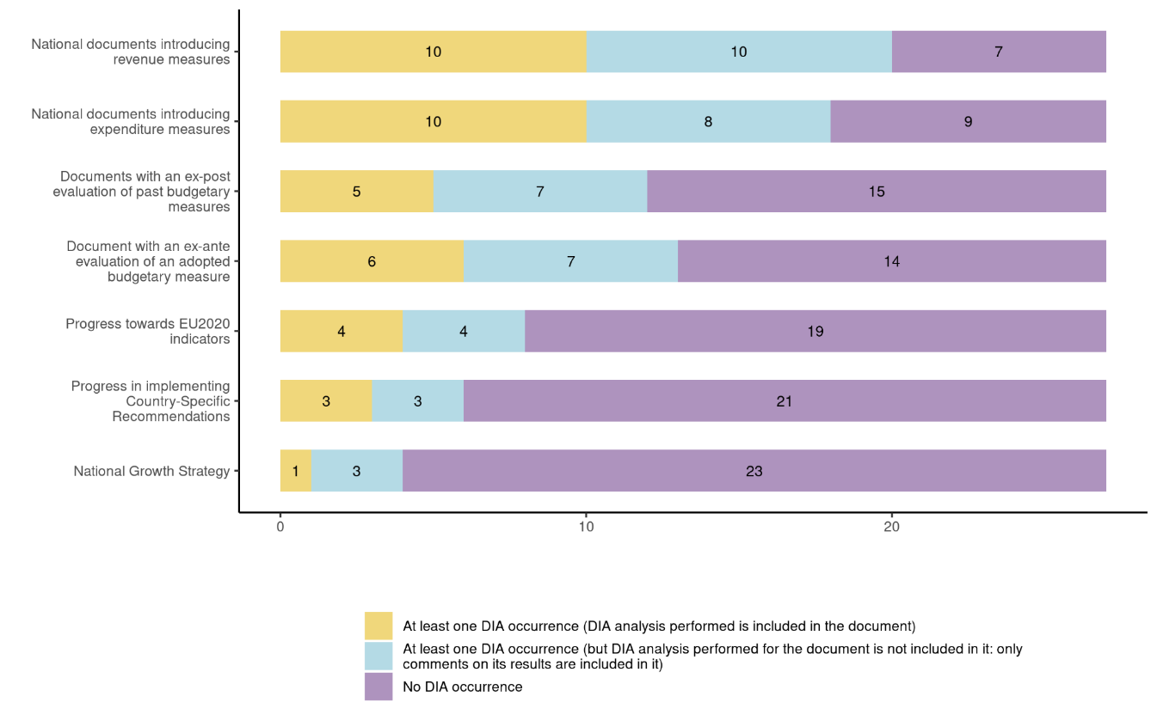
Source: Study on Distribution Impact Assessment by the University of Milan, financed by the Commission (DG EMPL): Study on distributional impact assessment - Publications Office of the EU (europa.eu)
Very few Member States use DIA for analysing the impact of reforms that might not have a direct bearing on the state budget. Only the Netherlands explicitly reports analysing with DIA reforms that result in transferring benefits from one group to another without having a direct bearing on the state budget. In Czechia and Poland, regulatory impact assessments of new legislation are required by law and sometimes (but not always) include DIA analysis.
The presentation of DIA results in Draft Budgetary Plans submitted to the Commission by euro area Member States remains infrequent in spite of Regulation (EU) 473/2013 calling for it where possible. For any given budget year in the 2015-2020 period, at most 6 out of 19 euro area Member States included DIA analysis in their DBP. Only two included DIA on a regular basis (IE and NL) and eight included DIA occasionally (AT, EE, FI, FR, EL, LT, LV and MT). 9 euro area Member States did not present any DIA in their DBPs in that period. In general, euro area Member States do not perform separate DIAs for each budgetary measure. In most cases, all or most of the budgetary measures are analysed simultaneously in a single joint DIA, irrespective of budgetary measure type (revenue/expenditure) and area. Their aggregated impact is reported by income level or by specific socio-demographic groups. Revenue and expenditure measures are, on average, included in roughly equal numbers, even though some differences between the euro area Member States and across time do exist. Finally, the most frequent policy areas considered are those regarding welfare and social inclusion.
Box 1: Presentation of DIA results in the 2022 Draft Budgetary Plans (DBPs) by Ireland
The DIA results of the main budgetary measures in Ireland’s 2022 DBP are presented in a form of a short text and two charts. One chart shows the distributional effects of budgetary measures in 2022 in terms of percentage change in equivalised disposable income by decile. Both the total effect and the separate effects are presented (for carbon tax, excise, direct taxes and changes in benefits). Another chart shows the impact by family type.

A few Member States included DIA analysis either in their Stability or Convergence Programme (SCPs) and/or the National Reform Programme (NRPs) in the recent past. In terms of the SCPs, only Croatia included DIA results in 2019, and no country included it in 2020. Regarding the NRPs, four countries presented DIA analysis in 2019 (BE, HR, MT and PT), and four countries used DIA in 2020 (HR, IT, MT and PT). Member States also made only limited use of DIA in their National Energy and Climate Plans (NECPs) submitted to the Commission. In its assessment, in September 2020 the Commission concluded that there was little information on energy poverty and distributional impacts.
Figure 2: DIA use by Member States (in their DBPs and other budgetary national documents)
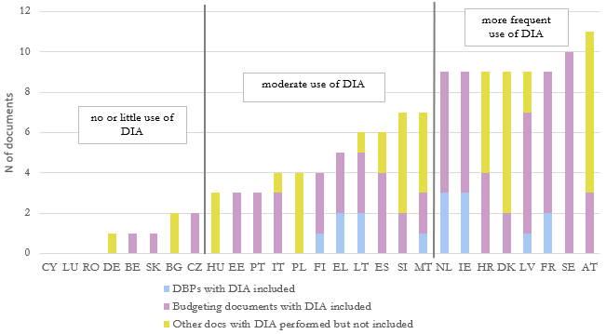
Source: Study on Distribution Impact Assessment by the University of Milan, financed by the Commission (DG EMPL), link. Note: use in DBPs relates to budget years 2018-19 and use in other national documents relates to budget years 2019-2020.
The Figure 2 depicts the fact that reliance on DIA varies significantly across Member States, but most use DIAs in their national budgeting processes, though to varying extent. Only a few Member States appear not to be conducting such analysis at all. It is also noteworthy that many countries perform DIA analysis that is not included in publicly available documents.
DIA can also be used for other reforms/investments, but the literature reviewed does not provide a synthetic view in that respect. This typically relates to the design of reforms that may not have a (direct) impact on public budgets, but can have an impact on households’ incomes and certain groups. For instance, this can relate to reforms of minimum wages or of co-payment features for healthcare. However, estimating the distributional impact of such reforms or investments beyond the tax and benefit systems can also be made more difficult due to the lack of appropriate data and simulation tools.

Key components of a good quality DIA

Who and when should do a DIA and at what level of granularity?
Ex ante and ex post evaluations
DIA analyses can be undertaken before a proposed policy change have taken place (ex ante evaluation) or after the policy change (ex post evaluation).
Whereas DIAs can be conducted at various stages of policy design and implementation of policy reforms, carrying out such assessments ex ante is particularly useful for policy making. Ex ante DIAs allow capturing the expected effects of policies on income of various groups. They are typically carried out using lagged survey or administrative data. Uprating of monetary variables and nowcasting techniques can be used to help make this lagged data more representative of the current (or targeted) fiscal year. As such, the distributive impact of the policy reforms are estimated in an analysis, where all changes are induced by the policy reforms.
Running ex post DIA is important in that it allows understanding the actual impact of implemented policy reforms. These ex post analyses typically make use of data from before and after the policy reform to evaluate its effect and this reduces the need for a microsimulation model to create counterfactual income distributions.
The result of an ex post analysis are often contaminated by other changes that occurred – to incomes, demographics or policies other than the one studied – around the same time. To estimate an ex post effect, sufficient time needs to pass such that the effect of the policy reforms on the population will have passed through to survey/administrative data sources. To conduct ex post DIA analysis with microsimulation models, practitioners can use decomposition methods to separately identify the effect of policy reform(s) from general changes to market incomes (see for instance Bargain and Callan, 2010; Paulus and Tasseva, 2020; Doorley et al, 2021). Other techniques used for policy analysis, such as the difference-in-difference estimator, may also be appropriate for ex post policy analysis.
Ex post evaluation of the ex ante DIA is also useful, depending on the type of policy and its implementation framework. For instance, Fioramanti et al. (2016) assess the accuracy of the European Commission’s ex ante forecast of real GDP growth, inflation and general government balance (as a % of GDP) by comparing ex ante forecasts of these variables with ex post realisations. This is a valuable exercise as it can help diagnose the accuracy of ex ante assessments and aid model development. Comparing ex ante and ex post analyses of policy reforms in DIA may be more difficult than similar comparisons using aggregates such as GDP. The main barrier is that the ex post effect of policy changes on income distribution is more difficult to estimate than an aggregate such as GDP, which is measured in an accounting framework by statistical bodies and is easily available to researchers. Some academic research has tried to use ex post analysis to validate the findings of ex ante analysis using microsimulation (Bargain and Doorley, 2017). However, this type of validation is not usually carried out.
The euro area Member States typically perform DIA at different stages in the policy process. For instance, it appears that most (14) euro area Member States conduct a DIA before the budget approval. There are 6 of them that also conduct a DIA before the implementation of the policy but after the budget approval. It also appears that 10 euro area Member States conduct a DIA after the implementation of the policy (i.e., ex post evaluation). In this respect, there are 8 euro area Member States in which DIA is typically performed both ex ante (before the budget’s approval and/or the implementation of the policy) and ex post (IE, IT, MT, LV, NL, DE, FR, BE).
Box 2: Timing of conducting DIA in the Netherlands
In the Netherlands DIA is conducted before, during and after the budget decision-making process. DIA is performed before the approval of the budget to predict the policies’ effects, but also during and after the implementation of the budget to monitor the policies’ implementation and to assess their actual distributional effects.
In some Member States (e.g. FI, EL, IE), DIA is usually conducted near the adoption of the budget, while others (e.g. MT, LV) start the DIA analysis earlier and thus have a longer period to conduct DIA. The difference between the two approaches is mirrored in the size of the staff involved, which is smaller in Latvia and Malta. Moreover, it should be noted that Malta and Latvia performed DIA in the DBP only once over the period 2018-2020 (in 2018) for specific measures and this fact could also explain the aforementioned differences. In some other Member States (e.g. LT and FR), DIA is carried out throughout the year when it is requested by policymakers.

Granularity of DIA analysis
An important decision to make while running DIA is whether to assess the impact of policy reforms separately or jointly. In general, it is good practice to present the effect of the bundle of changes. The impact of a whole package of policy reforms is of interest to the members of national Parliaments and the public. Also the assessed impact should take into account changes both in taxes and benefits. Moreover, budgetary changes are often decided as a package with some measures designed to compensate for others. Last but not least, there may also be interactions between the proposed policy reforms and therefore it is more useful to present their combined effect.
On top of this, it is preferable to account separately for all policies that have a significant impact on households’ incomes. A useful yardstick for deciding whether the policy has a sizeable effect is to consider whether it corresponds to a change higher than 0.1% of GDP. Beyond measures with a large budgetary impact, it also suggested that DIA be performed for those measures that have the potential to redistribute more than 0.1% of GDP in disposable income between different population groups (even though those measures may have a net overall budgetary impact of less than 0.1% of GDP). The population groups to consider here are whichever groups are most relevant for the policy at hand. This will often refer to income deciles, but could equally refer to different age groups, urban-rural groups, wealth quantiles or indeed other categorisations (e.g. tax brackets). A qualitative judgement in terms of which measures to submit to DIA should complement the more quantitative considerations.
Many Member States analyse the impact of policies both separately and jointly (BE, CZ, DK, EE most of the time, EL, FR, HR, HU, IE, IT, LV most of the time, MT, NL, RO, FI, SE). In Portugal and Slovakia, the measures are considered separately. When measures are analysed jointly, separate effects might also be shown (CZ). In the Netherlands, all the policies are combined and a single joint DIA is performed on their total impact.

What policy areas to choose for DIAs and what length of time to consider?
Conducting DIA based on a microsimulation model enables estimating the effect of a number of types of policies, in particular direct taxation and various benefits, but also indirect taxation, non-cash benefits and wealth taxes, depending on the model and data in question.
Standard microsimulation models allow first and foremost simulating the impact of changes to direct personal taxes (as well as social security contributions) and social benefits. Almost all Member States run DIA on changes in direct taxes and social benefits. Examples of specific benefits analysed include support for the elderly (BE, SE), minimum state old age pension (LV) support for persons with disabilities (BE), disability insurance benefits (BE), minimum state disability pension (LV), child benefits (BE, HR), unemployment insurance benefits (BE, SE), sickness benefits (BE, SE), maternity and parental benefits (HR, SE), minimum income reform (LV), in-work benefit (MT), social assistance (MT), housing benefits (SE).
Another major category of household taxation is consumption taxes (mostly value-added tax and excise). Estimating their distributional effect requires a model integrating consumption data. In general, expenditure data can be imputed, or is available alongside detailed income data in a household budget survey, which is usually collected separately from the income and living conditions surveys. The effect of changes to indirect taxes can be estimated across the income distribution and added to the effect of changes to direct taxes and benefits in order to give the distributional effect of the package of reforms. This functionality is for instance available in the EUROMOD Indirect Tax Tool (see Box 6). Consumption taxes are an important policy area as distributional impact of changes to them tends to be large and often regressive as lower income households spend a larger portion of their income on goods and services (see for instance Savage, 2017). The importance of integrated direct tax-benefit and indirect tax modelling has grown in the context of the green transition. Research has shown that the disproportionate effect of carbon tax increases on low-income households can be offset by recycling the revenue generated from the carbon tax into tax cuts and increases in social welfare rates. This also concerns the Social Climate Fund using revenues from the Emissions Trading Scheme. At the moment, only few Member States seem to be analysing indirect taxes in their DIA (DK, IE, IT, NL, SE).
Ideally, Member States should also be able to perform a DIA analysis on wealth tax reforms. Even though they can have significant distributional impacts, they are generally not taken into account in current models, due in particular to the lack of suitable underlying data. Estimating the effect of changes to wealth tax is not common but can be performed if the underlying model is linked to data with detailed wealth and asset data. Such data was first made available by the European Central Bank in a standardized fashion in the euro area with the Household Finance and Consumption Survey (HFCS), which can be incorporated in EUROMOD to allow for wealth tax modelling. Kuypers et al., (2017) outline how the Household Finance and Consumption Survey can be incorporated in EUROMOD (also see Box 6 for EWIGE) to allow for wealth tax modelling for a limited number of countries. Boone et al. (2019) describes how this is expanded to simulate wealth tax rules for 17 EU Member States.
Estimating the effect of changes to in-kind benefits completes DIA analysis. However, it is a complex exercise as it requires the data underlying the microsimulation model to contain (imputed) information about eligibility for these benefits (such as health status for health benefits or childcare usage for childcare benefits) as well as assumptions regarding the monetary value of the benefits. As a result, the redistributive impact of in-kind benefits is largely overlooked, in spite of the fact that in-kind social benefits represent over 30 percent of the overall social benefits, as it is not systematically measured. For instance, current evidence does not show if the financial burden of paying for healthcare is not shifted to those who can least afford it: poorer groups and regular users of health services. This can encourage inefficient patterns of use of healthcare. Furthermore, there is a risk that poverty reduction fostered by policy changes related to cash transfers would be offset by accompanying changes in policies covering in-kind benefits (such as healthcare). At the moment, social transfers in-kind are taken into account to some extent in Estonia, Ireland and Slovakia (such as recreational vouchers, meal vouchers, free school lunches), Sweden (such as fees for childcare and for elderly care). Examples of other measures analysed by Member States’ DIA include reimbursements of medical costs (BE), payments for welfare services, doctors (DK) and some heating and water benefits (LT).
In principle DIA can also be used in other areas where reforms and investments have an impact on households’ incomes. This can relate to a number of areas where reforms can have significant distributional effects, such as for instance labour market reforms (eg. reforms to the design and levels of minimum wages), or reforms that have an impact on prices (such as energy prices, as well as housing or medicines prices). However, a lack of relevant data or simulation tools, and difficulties in determining the effects of such policies compared to an alternative, may in practice limit the possibilities to undertake such broader analyses.
Box 3: Importance of DIA analysis of healthcare benefits
Capturing the impact of healthcare benefits on poverty and inequality is highly pertinent. However, while the impact of cash benefits is well measured, there is a gap when it comes to monitoring the impact of healthcare benefits on poverty and inequality.
Examples of assessing the redistributive impact of healthcare benefits remain rare. Still, evidence available shows that in-kind healthcare benefits have substantial redistributive effects (placeholder for key messages once the Eurostat’s paper is published) and better measuring these effects would also help design health policies that further contribute to the reduction of poverty and inequalities. The paper ‘Social transfers for education and health –imputation into EU SILC data’ (Grundiza, 2019) shows that in-kind health benefits reduce income inequalities –although the extent differs by country-, having the biggest impact on the disposable income of two bottom income quintile groups. The Finnish Institute for Health and Welfare used an analysis based on the actual consumption approach with a focus on older people as the input to the discussion on the on-going healthcare reforms. This analysis shows that in-kind health benefits narrow the income gap with elderly people in the two bottom income quintiles benefiting most. The Belgian Healthcare Knowledge Centre presented in 2020 the assessment of the redistributive impact of healthcare benefits, based on insurance-based approach, as part of the framework of the Healthcare System Performance Assessment, which provides scientific expertise used to improve the healthcare system. This analysis shows that the way the public health insurance is financed matters for redistributive effect. Social contributions and government subsidies that represent nearly three quarters of the revenue for public health insurance have a progressive effect. However quite high out-of-pocket payments (about 19% in 2018) reduce the redistributive effect, affecting low income household relatively more than high income households.
Results of these studies confirm that including in-kind healthcare benefits in DIA would help to assess the redistributive role of changes of healthcare coverage policies (introducing, increasing or decreasing co-payments, introducing ceilings for costs). WHO work on affordability of healthcare also confirms that relying on microsimulation models such as EUROMOD would allow to account for all the parameters that matter to ensure that healthcare is affordable and lack of healthcare access does not push people into poverty (in particular coverage of health benefits and impact of out of-pocket payments, particularly for poor people and regular users of health services; timely access to a broad range of health services without informal payments). Importantly, this also allows to assess the impact of various financing options (i.e. through taxes and/or social contributions) of the healthcare system and exploring scenarios of alternative policy measures (e.g. related to the design of co-payment schemes). WHO work on affordability of healthcare also shows that sequencing of policy measures is very important. Some countries will need to redesign health coverage policy at the same time as seeking additional public investment in the health system. DIA can help with providing feedback for such sequencing and ensuring that policy changes do not produce disproportional effects on the most disadvantaged groups.
In the end, the choice of policy area to examine beyond the standard play of the tax and benefit systems is likely to depend upon the model and underlying data. Simulation of tax reforms is likely to be more robust with administrative data as survey data is known to underrepresent the top of the income distribution. Simulation of welfare reforms, conversely, may be more accurate with survey data as low-income households or administrative social data may better capture household’s structures. The examination of indirect or wealth taxation or non-cash benefits requires extra data which is not usually standard in microsimulation models. Policies selected for running DIA vary between countries. Important considerations in a number of countries seems to be factors such as the size of the impact of measures (DK, FR, SK, IT, RO), availability of data (DK, NL, LV), if the measures could be simulated in a reliable way (BE, EL, LV, MT, RO, FI, SE, SI), policy priorities (IE, DE, ES, HU, PL) and time constraints (EE).
Time horizon of the DIA analysis
Most Member States focus in their ex ante DIA analysis on capturing the impact of policies in the following year (DE, IE, EL, ES, FR, HR, CY, LT, HU, PT, RO, SK, FI). Short-term effects are often the focus in static models (like EUROMOD) used for budget analysis.
However there may be good reasons to think across multiple years. Dynamic microsimulation models such as PENSIM, SESIM and MIDAS (Curry, 1996; Flood, 2007; Dekkers et al. 2010), simulate inter-temporal transitions in the population. This allows researchers to project how socio-economic development will evolve under current policies. Dynamic microsimulation models can also be used to evaluate the future performance of various long-term programmes such as pensions, education, health and long-term care, by analysing simulated future cross-sectional data. Dynamic microsimulation models are more complex than static models and this makes them more costly to develop with more methodological challenges.
Some Member States (BE, CZ, DK, EE, IT, LV, MT, NL, AT, PL, SE) also take into account longer-term effects. This could be more medium-term analysis (4 years) or very long-term effects (until 2070). Some countries like Belgium, Malta and Austria have separate models for analyses of short-term and long-term effects. The short-term models could typically analyse changes in tax and benefit systems, while longer term models could focus more on pensions and pension reforms, and any other ageing-related expenditure.
Box 4: Microsimulation used for long-term projections in Malta
For Malta the model PROST analyses pension contributions, entitlements, system revenues, and system expenditure, over a long time frame. The model can undertake simulations of the development of the current pension system, analyse various options for pension reform, and assess together future aggregate expenditure levels, the adequacy of individual pensions and the distribution of pension levels across the population as well as the impact of changes in coverage, eligibility, benefit levels, or contribution rates on these.
When simulating policy changes one has to decide on how to model changes that will have effect during a calendar year. One option is to pro-rata changes that are not in place for the full calendar year. Another option – and that followed by the EUROMOD model – is to include all policy changes made by 30 June in the policy system for that year. Policy changes which occur later in the year are modelled in the subsequent year.

What tools to use?
DIAs need to be based on sound models to provide an overall reliable picture of the impact of policy changes. Therefore, conducting DIA that gives credible results requires reliance on microsimulation models, their extensions and linkages with labour supply-demand and general equilibrium macrosimulation models.
Policy changes are often considered in terms of their effects on a number of “hypothetical families”. In this approach, a number of typical households are considered and the effect of budgetary changes on their income is assessed (see Box 5). Such an analysis - no matter how well chosen - simply cannot give an overall picture of the distributional impact of a policy change on incomes and work incentives at the population level. This approach has limitations as households within a category might differ in terms of income, housing tenure, number of children and other characteristics that affect their tax-benefit position.
Box 5: Hypothetical household models
The OECD Tax-Benefit Simulation Model (TaxBEN)
The tax-benefit model TaxBEN (TaxBEN) is the cross-country tax and benefit simulation model developed and maintained by the OECD. It is a unique tool for exploring the detailed mechanics of tax-benefit policies and reforms on working age individuals and their families across countries. The scope of TaxBEN includes taxes and social benefits that, together, account for a large share of government budgets. TaxBEN produces policy indicators on household incomes, labour costs and work incentives in different family situations and policy settings. It covers a broad set of income support and tax policies going back to early 2000s for more than 40 OECD member and non-member countries. The model draws on a comprehensive library of tax and benefit policy rules that are relevant for working-age individuals and their families.
Hypothetical Household Tool (HHoT)
The Hypothetical Household Tool (HHoT) is a EUROMOD (please see below for details about EUROMOD) plugin for designing hypothetical households and generating data according to the chosen household and individual characteristics. The generated dataset can then be used to estimate the effects of taxes and benefits on household disposable income, by running EUROMOD.
With the HHoT plugin users can create their own hypothetical data, which allows them to better understand how policies impact households with specific characteristics, while giving full control over the characteristics of interest (see for instance Gasior and Recchia 2019). HHoT generates specified hypothetical household input datasets. The flexibility of the tool allows users to specify a broad spectrum of different hypothetical households. The specification of household composition and other characteristics is only limited by the scope of variables in EUROMOD input data. For example, various household types can be included, as well as a variety of labour market statuses and income sources. HHoT allows users to compose, save, use and re-use their own database of hypothetical households. This plugin is included with the default installation of EUROMOD, and can be found under the "Applications" toolbar ribbon, inside the "Tools" group.
Microsimulation models provide a suitable alternative to hypothetical household analysis for conducting DIA (see for instance Bourguignon and Spadaro, 2006). They are based on large-scale representative samples of households. This ensures that the models represent as fully as possible the great diversity of household circumstances relevant to tax and social benefits.
Broadly speaking, there are two main classes of microsimulation models that Member States use for conducting DIA. On the one hand, EUROMOD is a harmonised microsimulation model for the EU, currently managed, maintained and developed by the Joint Research Centre (JRC) of the European Commission. The model is continuously updated in collaboration with Eurostat and national teams from each EU Member State, making use of microdata from the European Union Statistics on Income and Living Conditions (EU-SILC). On the other hand, many Member States also use country-specific microsimulation models (Figure 3).
Figure 3: Number of EU Member States by type of model(s) used for DIA
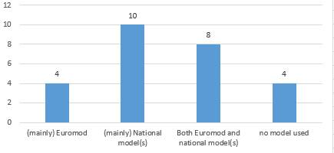
Note: total = 26 (no information on LU). Source: questionnaire to the Member States.
EUROMOD microsimulation model
EUROMOD is a tax-benefit microsimulation model available for all EU Member States enabling researchers and policy analysts to calculate, in a comparable manner, the effects of direct taxes and benefits on household incomes, poverty and income inequality and work incentives for the population of each Member State. Cross-country comparability is enabled by coding the policy systems of the EU Member States according to a common framework based on a standard set of modelling conventions. The input microdata used in the model (based on EU-SILC microdata) are processed according to a standard set of protocols. The EUROMOD platform is highly flexible but also documented, validated and transparent. Underpinning the model is the purpose-built software comprising a user-friendly interface, supplemented by extended functionalities (plugins and add-ons) for special purpose analysis. EUROMOD is used by around half of the EU-27 Member States for conducting DIA analysis (AT, BE, EE, EL, FI, IE, HR, IT, MT, NL, LV, RO, SK).
An annual release of a stable version of EUROMOD occurs in January each year, while two beta versions are released in April and September. EUROMOD is open source, free and transparent to use. It can also be made compatible with country-specific administrative data, which is a significant advantage. It allows the automatic computation of a range of costings and indices relating to income distribution. While there are multiple advantages of the model, some substantial initial investment is required (in terms of time dedicated to learning how to use the model and maintaining the skills required for regular use of the model due to the specificity of its programming language).
EUROMOD can be particularly useful for Member States which have none or rather limited DIA practice in place. It is readily available for free to all Member States. Greece is an example of a country which recently successfully adopted EUROMOD as part of its budgetary cycle, which in turn resulted in presenting DIA outcomes in the Draft Budgetary Plans on a regular basis. While setting up the DIA process, the Greek national administration officials benefited from the technical assistance provided by the JRC. This also contributed to building trust in the results of the model. This has enabled the Greek authorities to provide timely analysis on reforms to taxes and benefits along with analysing the effect of labour market shocks.
An interesting feature of EUROMOD is the In-depth Analysis plugin. It is a user-friendly tool that produces a set of eighteen fully customisable tables for analysing the impact of tax-benefit reforms, classified in three groups: fiscal, distributional, and inequality and poverty. The user can select and construct variables for analysis and variables for breakdowns, restrict the calculations to specific target populations, define specific income variables for inequality and poverty calculations, and change parameters for those indicators. Additionally, users can save their sets of preferences and load them at any time, so that they can replicate the same calculations in the future, with the same or different outputs. The output tables are shown on screen, with the possibility to save them in Excel format. The user can optionally save the microdata of the simulated scenarios in a single dataset. This plugin is included with the default installation of the EUROMOD software.
EUROMOD can be very useful for gauging the distributional impact of the green transition and energy price shocks. For example, in an ongoing Commission project GD-AMEDI (Green Deal - Assessing and Monitoring Employment and Distributional Impacts of the Twin Transition) EUROMOD is used for assessing employment and distributional impacts of climate and energy policies across Member States, regions, sectors, occupations, skills, households and income group. As such, the project endows the Commission with instruments and background to conduct policy analyses related to the impacts of measures taken in carbon/GHG intensive sectors on the labour markets, employment and skills and on relevant social outcomes, including energy poverty or mobility poverty.
Country-specific models
Many Member States use their country-specific models. National models can take two forms. Some are standalone models which were built separately from EUROMOD and which are maintained by country experts, often located within ministries, think-tanks or central banks (e.g. DK, FI, NL which have a long-standing tradition of running DIA analysis). Other national models use EUROMOD but extend it to the needs of the country-specific context (e.g. IE, LV).
National models have some advantages and disadvantages compared to EUROMOD. On the one hand, the national models are often based on more detailed data (such as administrative records) than EU-SILC, which allows for more accurate and detailed simulations but may not allow access for some users. On the other hand, EUROMOD benefits from large economies of scale as there are 27 national teams as well as a team at the JRC working to maintain and update the model. This allows for a harmonised data preparation process, which tends to reduce the likelihood of error. There is also extensive documentation and validation of the EUROMOD model which may happen to a much lesser extent, if at all, for national models.
Linking microsimulation models with other tools and models
Incorporating behavioural responses and macroeconomic feedback helps make DIA results more realistic but requires additional tools. Many policies cause important macroeconomic feedback effects, which cannot be captured by static models which is the case for the vast majority of microsimulation models. One option is to use macroeconomic models that allow for some degree of heterogeneity in terms of household or labour types. For example, Roeger et al. (2019) use QUEST, a dynamic stochastic general equilibrium (DSGE) model with different skills types. Many computable general equilibrium (CGE) models account for considerable disaggregation by household types (Dixon and Jorgensen, 2013, provide many examples). Furthermore, each of these types of macroeconomic models can be linked to a microsimulation model, such as Barrios et al. (2019) (link of EUROMOD to QUEST), d’Andria et al. (2019) (link of EUROMOD to an overlapping generation model) and Bourguignon et al. (2010) (overview of linking microsimulation models to CGE models).
It is also important to ensure consistency with other exercises. It helps when the assumptions and some of the main variables in the models are consistent with other relevant exercises. This can be ensured by applying the same assumptions, constraining variables to follow pre-determined values, and comparing results. This would make the model results more relevant in the ongoing policy debate, and prevent discussions on the plausibility of underlying assumptions.
EUROMOD may be complemented by add-ons or extensions which enable a more comprehensive assessment of the impact of reforms (see Box 6). For example the labour market adjustment (LMA) tool proved to be convenient for modelling employment losses as a result of lockdown policies during the COVID-19 pandemic. This allowed the assessment of the impact of emergency policy responses in terms of wage subsidy schemes and emergency unemployment supports.
Box 6: EUROMOD extensions
Indirect Tax Tool (ITT)
This extension of EUROMOD uses EU-SILC data matched with HBS data. In collaboration with the University of KU Leuven, the University of Essex and Praxis Centre for Policy Studies, the JRC has expanded EUROMOD to account for the simulation of indirect taxes in all Member States. During 2022 this tool is being tested with the objective of incorporating it to the public version of EUROMOD distributed by the JRC in the future.
This new tool allows to simulate tax reforms at a highly disaggregated level of consumption (in most cases at the commodity level, e.g. "rice"). Also it does not rely on a EUROMOD plug–in, but on a specific policy module. The full integration aims at increasing the model’s transparency and ease of use and no additional knowledge is required to run a policy simulation including an indirect tax reform. For tax reform simulations, three behavioural assumptions are allowed: constant income shares of consumption, constant expenditure shares and constant quantities, which correspond to different price and income elasticities.
European Wealth data InteGration in EUROMOD (EWIGE)
It is an alternative version of EUROMOD that uses input data based on the Household Finance and Consumption Survey (HFCS) data, allowing to simulate wealth-related taxes. Indeed, analytical tools are still underdeveloped when it comes to empirical analyses of different types of wealth-related taxes and policies. Distributional analysis of income and wealth requires information on disposable income and wealth. Integrating the HFCS data in EUROMOD makes it possible to assess the effect of different current and hypothetical wealth taxes and policies on the distribution of income and wealth.
JRC's EUROLAB labour supply-demand model
It is an EU labour supply-demand microsimulation model built on EUROMOD and based on the modelling of discrete choice labour supply through a Random Utility Maximization approach. It estimates a set of structural parameters of the utility function and applies them to estimate labour supply behaviour. The main contributions of EUROLAB are the assessment of: 1) labour supply elasticities, 2) changes in the labour participation rate and working hours, and 3) changes in labour supply when labour demand is taken into account. Other individual or household decisions can be factored in. Currently it appears that most Member States use their microsimulation models as such for DIA and in particular do not link a macro-model to their micro-model. When a Member State uses a macro-model (not necessarily for DIA), it is often used separately from the micro model although some Member States take into account macro-economic forecasts in (some of their) microsimulations (BE, DK, FR, HU, PL).
Defining the baseline for the assessment of the distributional impacts
An important question to answer before running a DIA analysis is whether the policy reforms will be compared to an indexed baseline or a baseline that is fixed in nominal terms. Comparing to an indexed baseline – in which the parameters of the tax and welfare system are adjusted to account for forecast inflation or wage growth – allows to show what the effect of budgetary reform is compared to a scenario in which purchasing power is maintained and/or income inequality is constant. Comparing to a nominally fixed baseline, on the other hand, shows the effect of policy reform in nominal terms, without accounting for inflation or income growth.
Defining the baseline is an important decision as there is a number of possibilities for a baseline policy to evaluate year-to-year changes including indexation of tax-benefit parameters (or benefit parameters alone) by wage/price growth. It also needs to be decided whether the baseline should include policy changes which were pre-announced and temporary policies. Whatever decision is taken in that respect, it is crucial to clearly describe what the baseline is and how this affects the interpretation of results. In their budgetary plans eleven euro area Member States rely primarily on the previous year’s status quo as the baseline scenario. Using a projected baseline scenario for today (nowcasting) or a dynamic projection for the future (forecasting) is less common (with five and seven countries using them respectively). Nevertheless, about one third of countries use more than one baseline scenario when conducting DIA.
The data used for the model baseline should be timely, whereas there is inevitably a time lag between a survey being conducted and the data being available. (In the case of EU-SILC, in the framework of Regulation (EU) 2019/1700, Eurostat receives microdata from Member States for operation year N by the end of year N, and complete datasets with final income data is received by 28 February of year N+1. Country indicators are published as soon as the data is validated and approved. In a period of minimal demographic and labour market change, this is usually not problematic. However, in a period of recession or significant labour market change, using older data can have significant implications for DIA. A common solution to this is to use uprating factors to adjust the data to subsequent years. The model ‘uprates’ the data to current year’s price and income levels using price and wage inflation and this is typically sufficient to approximate the current income distribution.
Most Member States apply uprating and reweighting to the data to take into account latest developments in income and tax-benefits systems as well as to reflect the population's latest situation/composition. A few Member States account for changes in demography (e.g. use of ageing projections in some Member States) (BE, DK, IE, FR, LT) and uprating for various macroeconomic developments.
Human resources
DIA is usually performed by a team of 3 or 4 people, consisting mostly of economists, often working within the ministry of finance. Some countries (Slovenia, Germany, Ireland and Latvia) employ external consultants (e.g. research institutes) to support them.
In terms of training on DIA, on-the-job training is usually the preferred option. This training is often complemented by the participation in the courses organised by the EUROMOD network. The training needs depend on the complexity of the model used. For the full model, a sufficient level of training is needed to use the model correctly.
More complex models are more challenging to extend and maintain. The Member States that successfully do this tend to have solid structures to ensure the quality of production. For the others, it is suggested that they maintain a team of experts for the DIA model and to ensure the continuity of DIA expertise. This team would need to be given adequate time and resources (such as training resources) for having reliable DIA model in place and for performing DIA of advanced quality using it.
Entrusting independent bodies with doing DIAs can help make them more credible and accurate. Thanks to their expertise, academia or research institutes are well placed to develop advanced DIA techniques. Moreover, they are not affected by the same political motives as administrations when assessing decisions to which they have often not contributed. The replication of results by various institutions can also make for a more comprehensive analysis, and enhance its quality and credibility.

What data to use?
Two types of data sources can be linked to a microsimulation model to conduct DIA. Survey data, such as EU-SILC, tend to be most straightforward to access and are widely used. Alternatively, administrative or register data can be linked to the model. A third option combines the analysis based on survey data with that based on some administrative data to allow a more accurate simulation of incomes, benefit eligibility and tax liabilities.
Figure 4: Number of EU Member States by type of data used for DIA
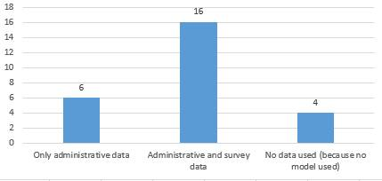
Note: total = 26 (no information on LU). Source: questionnaire to the Member States.
There are differences as to the type of data feeding into DIA across countries. Some Member States conducting DIA only rely on administrative data, using one or multiple datasets (BE, EE, ES, NL, PT, SE). Some other Member States use administrative data in combination with survey data (SILC or HBS data for instance) (AT, CZ, DK, FI, FR, IE, EL, HR, IT, HU, LV, MT, PL, RO, SK). In most Member States, administrative data used for DIA are not publicly available, but they are easily accessible (possibly upon request) in some countries (DK, ES, IE, SE).
Figure 5 – Data used for producing DIA analysis - euro area Member States(*) (N=17)
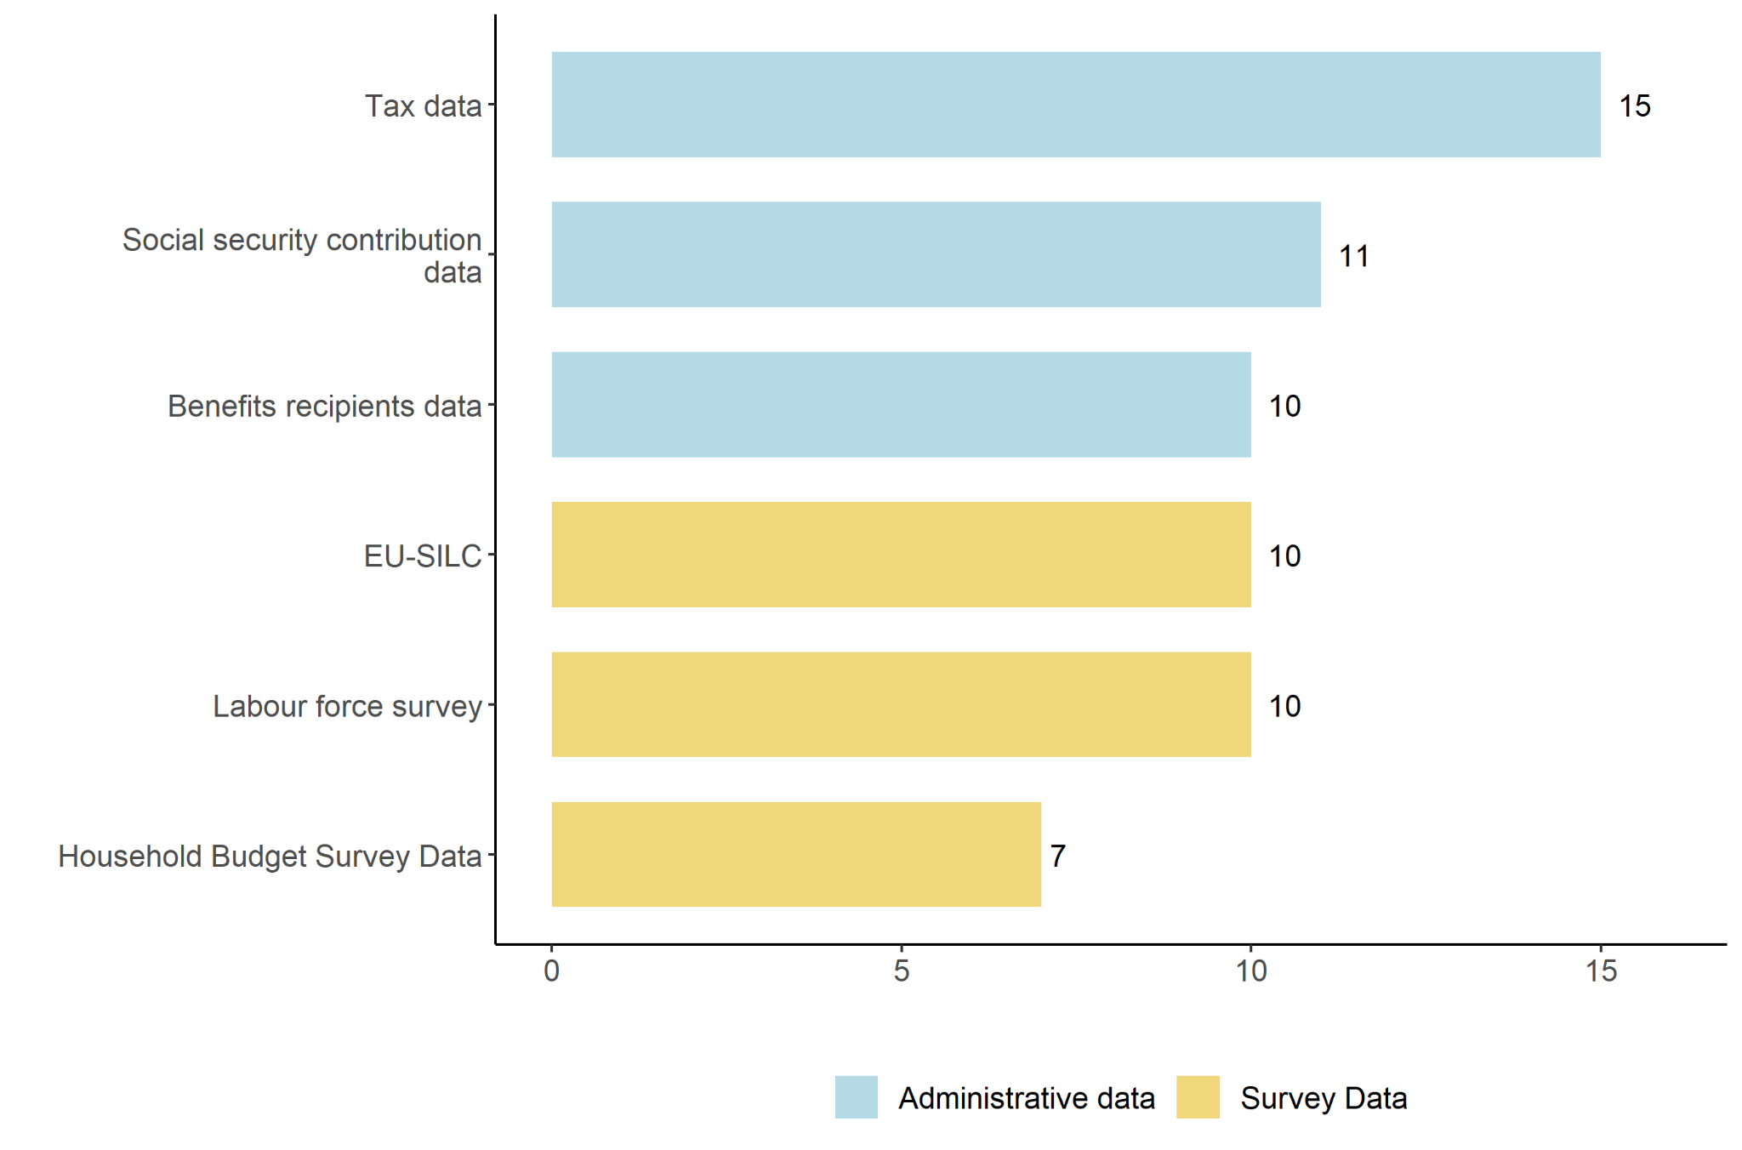
Note: respondents are allowed to choose multiple answers. (*) Cyprus and Luxembourg are excluded since no DIA is performed in these Member States. Source: Study on Distribution Impact Assessment by the University of Milan, financed by the Commission (DG EMPL): https://data.europa.eu/doi/10.2767/511644
Survey data
Survey data, such as EU-SILC, which is readily available to researchers, is widely used in DIA by academics and public administrations. Depending on the national practices, many benefits in the survey data may be aggregated together. This can make it difficult, for instance, to ascertain whether somebody is in receipt of unemployment assistance or unemployment insurance benefit, with implications for simulating policy changes to either of these. Those countries that have their microsimulation models based on national survey data need to have in place methods to ensure that the data are of sufficient quality and timeliness and include adequate details on the income and living conditions of individuals and households.
Box 7: Sources of survey data

EU Survey on Income and Living Conditions (EU-SILC)

The EU Statistics on Income and Living Conditions (EU-SILC) collects comparable cross-sectional and longitudinal data on income, poverty, social exclusion and living conditions. EU-SILC provides two types of data: cross-sectional data over a given time or a certain time period with variables on income, poverty, social exclusion and other living conditions and longitudinal data on individual-level changes over time, observed periodically over a 4-or 6-year period. Information on social exclusion and housing conditions is collected mainly at household level, while labour, education and health information is obtained from individuals aged 16 and over. Income variables at detailed component level are also mainly collected from individuals.

EU-SILC data are used to monitor poverty and social inclusion in the EU as part of the European Pillar of Social Rights and European Semester - the framework for coordinating economic policies across the EU – through the social scoreboard. EU-SILC data also provide quantitative evidence for monitoring the implementation of the social protection and inclusion dimension of the European Pillar of Social Rights, provide data for the Social Protection Performance Monitor and are used in the context of the Open Method of Coordination on social inclusion and social protection.

Household Budget Survey (HBS)

The Household Budget Survey (HBS) is a national survey focusing on households' expenditure on goods and services, giving a picture of living conditions in the EU. It is carried out by each Member State and is used to compile weightings for important macroeconomic indicators, such as consumer price indices (used as measures of inflation) and national accounts. They were launched in most EU Member States at the beginning of the 1960's and Eurostat has been collecting and publishing these survey data every five years since 1988. The two last collection rounds (waves) were 2015 and 2020.

Household Finance and Consumption Survey (HFCS)

The HFCS collects information on the assets, liabilities, income and consumption of households. The dataset provides insights into their economic behaviour and financial situation – highly relevant factors in terms of monetary policy and financial stability. The survey is based on 84,000 interviews conducted in 18 euro area countries, as well as Poland and Hungary, mainly in 2013 and 2014. There have been three survey waves so far, on which the data were released in April 2013, December 2016 and March 2020, respectively.

The HFCS questionnaire consists of two main parts: (i) questions relating to the household as a whole, including questions on real assets and their financing, other liabilities and credit constraints, private businesses, financial assets, intergenerational transfers and gifts, and consumption and saving; (ii) questions relating to individual household members, covering demographics (for all household members), employment, future pension entitlements and income (for household members aged 16 and over).

Administrative data
The main advantages of administrative data include the larger sample size higher level of disaggregation and accuracy of incomes (even though in practice, analysis is often carried out using synthetic data to protect taxpayer anonymity For example, BELMOD, the new EUROMOD-based microsimulation model developed in Belgium, incorporates administrative data based on a sample of almost 9% of the total population.
Box 8: Data used for DIA in Finland
The SISU model used for DIA in Finland relies on administrative data representing a sample of 15% of the whole population, which is a high proportion by international comparison. The data based on income distribution statistics collected by Statistics Finland comes from various administrative sources such as the Population Register, Tax Administration, the Social Insurance Institution, Centre for Pensions and the Financial Supervisory Authority. The housing costs are imputed based on a regression model. The data is published with a lag of 1.5 years, and Statistics Finland publishes nowcasted and forecasted data (adjustments e.g. to incomes and employment rates used in the budget process).
Some drawbacks to administrative data include the limited socio-demographic information they contain. Administrative data may also be skewed by tax evasion. Sometimes, the data must be used on the Virtual Desktop Interface (VDI) of a statistical agency with a statistician charged with checking that statistical disclosure rules are not violated before results are transferred to the user’s own PC (see Box 9 for more details on the pros and cons of using administrative data).
Box 9: Advantages and disadvantages of using administrative data

Opportunities of administrative data

Using administrative data allows for more precise simulation of policy reforms, improving the accuracy of simulated outcomes. This is due, among others, to a larger coverage of population, availability of work histories, the possibility to study small subgroups (e.g. persons with disabilities) or rare events (e.g. multiple births); and a more accurate recording of information (no misreporting, sampling errors, etc.). Analysis based on administrative allows assessing crucial policy matters such as sustainability of pension systems or labour market transitions (especially atypical workers). Administrative data also help simulate subnational policies better as it can provide more geographical details, allowing to zoom in on the geographical distribution of income beyond the usual regional disaggregation (e.g. at local level). This is also important as in-kind transfers are often provided through local services.

Challenges of administrative data

However, using administrative data has also its challenges due a number of aspects, such as gaining access can be difficult and time consuming, privacy concerns when the data is used by researchers, clear and informative accompanying documentation is often missing, understanding the units included in administrative sources may not be straightforward (and requires communication with data provider), policy changes may lead to changes in data collection, there may be computational issues given the size of administrative datasets, suitable “background” variables (e.g. sociodemographic characteristics) might be lacking as compared to survey data.

Typical national administrative datasets that are useful for DIA include records of taxpayers of Personal Income Tax, other records of taxpayers (wealth taxes, immovable property taxes, inheritance and gift taxes, etc.), databases of recipients of social benefits, pensioners, unemployment benefits, records of social insurance contributions paid by employees, self-employed and employers.
Combining survey and administrative data
Using survey data next to administrative data can enhance the quality of DIA results. Combing a survey dataset, such as SILC, with administrative records relating to income, welfare and taxation can often provide a solution to some of the drawbacks of either survey or administrative data used alone. The SWITCH model used by the Economic and Social Research Institute and government departments in Ireland is an example of a national microsimulation model based on linked survey and administrative data.
Administrative data is best seen as a complement to surveys such as EU-SILC, rather than a replacement. Simulations using administrative data allow for more accurate modelling of social security contribution history and certain policies. The adaptability of EUROMOD to be compatible with national level administrative data is a significant advantage. In the Greek case, this has been particularly advantageous as EUROMOD has been twinned with rich administrative tax data, which is generally considered as more robust than EU-SILC in some key aspects, most notably revenue estimation.
It is also important to stress the crucial role on the national statistics institutes in providing timely, comprehensive and detailed data that can be used for running DIA analysis. Further efforts should be made in that respect. Officials in France and Finland pointed at the lack of variables in available data that would enable DIA to be carried out for more policies. More precisely, in France, the issue is that income data are only available on yearly income, while monthly information would be useful for performing DIA on some specific social benefits. In Finland, the survey data on consumption lacks variables about the consumption of alcohol and tobacco.

What indicators to use?
A number of indicators lend themselves to illustrate the distributional impact of policy reforms. These are typically those that capture the impact of policy changes on the household income along the income distribution as well as on the levels of inequality and poverty. Using the common indicators agreed at the EU level makes comparisons across Member States easier.
In order to illustrate the impact on household income distribution, the decile (or quintile) impact of policy reform are commonly used to show how reforms affect low-income and high-income households differently. It is suggested to use mean equivalised (i.e. adjusted for household composition) disposable income, meaning income after direct taxes have been paid and benefits have been received. This has the benefit of being comprehensive and comparable between individuals and households. Having such clear view on the impact of a measure on the deciles’ mean disposable incomes also enables to shows the impact of policies on households’ purchasing power along the income distribution.
DIA analysis should also show the impact of policy reform on the level of inequality by relying on (a selection of) key indicators, such as the income quintile share ratio (S80/S20) that is the share of income going to the richest 20 per cent compared to the poorest 20 per cent of the population), which is the related European Pillar of Social Rights Scoreboard indicator (as well as its decomposition between the upper part S80/S50 and lower part S50/S20 of the income distribution). It can be complemented by the income share of the bottom 40% of the population along the income distribution (S40) or the Gini index (which is the most widely used aggregated measure of income inequality, capturing what percentage of the domestic income of a country each cumulative percentile of the population owns and converting it into an index). Such summary measures of income inequality can be used to illustrate the effect of policy reform on the income distribution, but at the same time they can mask heterogeneity at different points of the income distribution, which decile and quantile impact assessments pick up on.
DIA results should also capture the impact on the level of poverty. It is suggested to use the at-risk-of-poverty (AROP) rate and the relative median at-risk-of-poverty gap. The first one is calculated as the share of persons with an annual equivalised disposable income below 60 per cent of the median annual equivalised disposable income and is the main component of the AROPE indicator that underpins the EU target of reduction of poverty and exclusion by 2030. The relative median at-risk-of-poverty gap shows how far below the poverty line the median person in poverty is as a share of the value of the poverty line.

Box 10: Additional indicators of inequality
Additional measures of income inequality such as the Atkinson Index or Theil Index (or other general entropy measure) do not display some of the known weaknesses of the Gini Index, such as being more sensitive to changes in the middle of the income distribution than to changes at the top or bottom, but are seldom used.
Atkinson Index: A measure of income inequality that includes the level of aversion to inequality (measured in the coefficient ϵ), which weights incomes along with the distribution differently. Depending on the level of inequality aversion, the index becomes more or less sensitive to changes at different ends of the distribution. For example, if the inequality aversion is high, the marginal social welfare of an increase in income is higher for the lower end of the distribution. If there is no aversion (ϵ=0), the marginal social welfare for an income increase for the lower end of the income distribution is the same as for an increase for the higher end.
Theil Index: A measure of income inequality that is built on statistical information theory and belongs to the generalised entropy family of inequality indices. The Theil index, like all members of the generalised entropy family, can be exactly decomposed in between and within the inequality of mutually exclusive groups. The value of the index can range from 0 (perfect equality) to infinity.
Reynolds-Smolensky Index: The most commonly used index of redistribution. It measures redistribution as the difference between the Gini index of income before tax and the concentration index of post-tax income.
Kakwani Index: It uses the Gini framework to measure how progressive a social intervention is. It is equal to the difference between the Gini index for the social intervention, and the Gini index for incomes before imposition of the policy intervention. Theoretically, the Kakwani index can vary between −1 to 1; the larger the index is, the more progressive is the social intervention.
The mean disposable income by income group and the Gini coefficient are the most frequently used indicators for presenting DIA results in DBPs (Figure 6). Over the period 2018-2020, three countries used the AROP rate, the relative median at-risk-of-poverty gap and performed a “winners and losers” analysis from the implemented policy across different income groups. Two countries included the total share of income of the bottom 80% in the income distribution (S80), while Theil index, Atkinson indices and wealth inequality indicators are used by only one country.

Figure 6 –Types of DIA analysis by euro area Member States in DBP (2018-2020) (N=9)
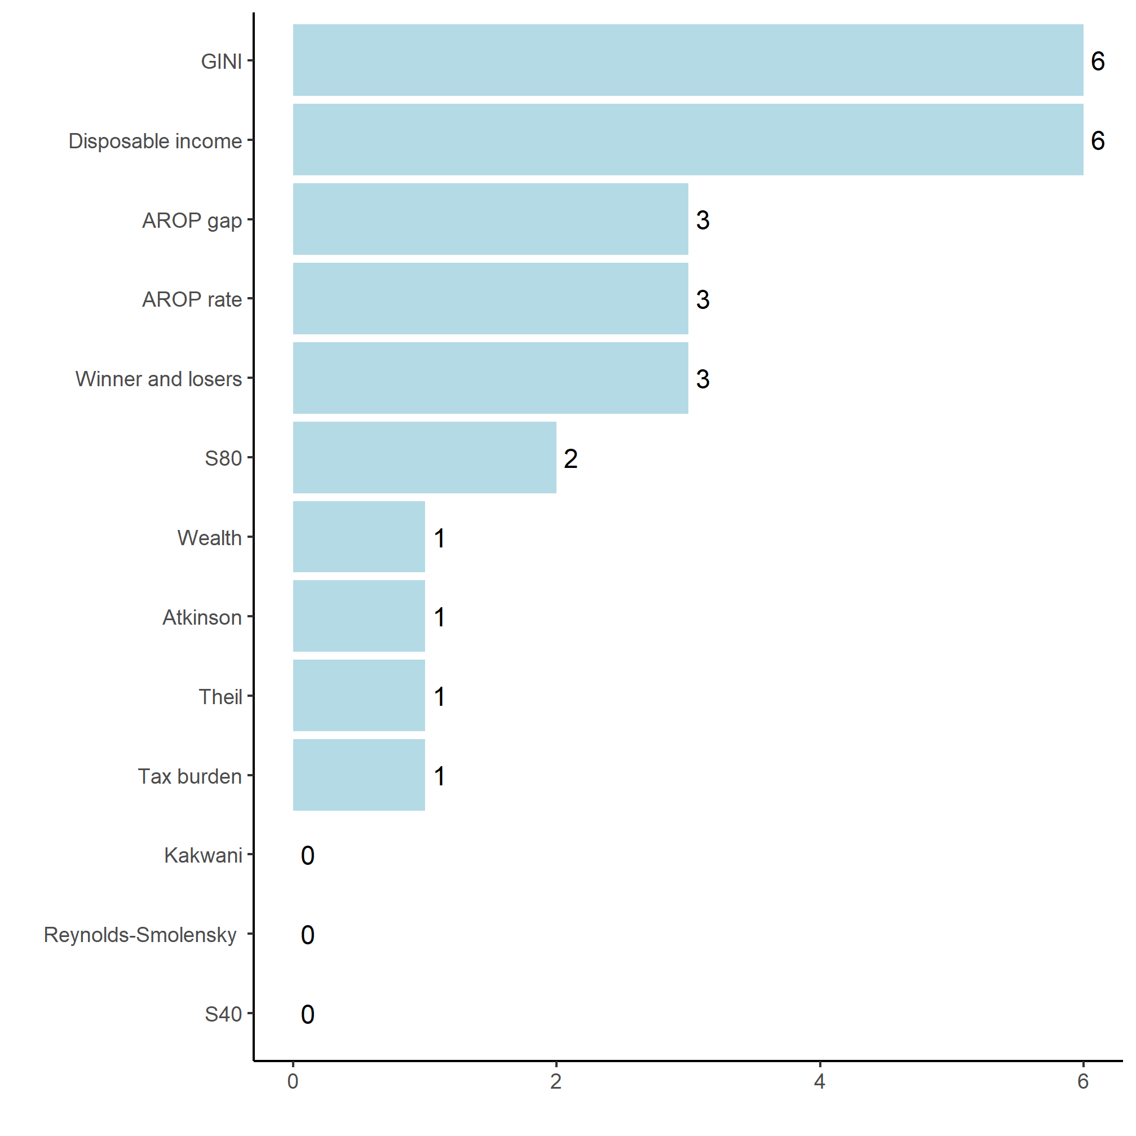
Note: The analysis includes only Estonia, Finland, France, Greece, Ireland, Latvia, Lithuania, Malta and the Netherlands, as they are the only Euro Area Member States that performed at least one DIA occurrence in their DPB in 2018-2020. Respondents are allowed to choose multiple answers. Source: Study on Distribution Impact Assessment by the University of Milan, financed by the Commission (DG EMPL): https://data.europa.eu/doi/10.2767/511644
Outside the DBPs, the majority of Member States conducting DIA used winners and losers across different income groups (changes in income levels for various groups, such as income deciles or quintiles), Gini coefficient, average tax burden by income group, at-risk-of-poverty rate and mean disposable income by income group to present the results (Figure 7). About half of Member States included the total share of income of the bottom 80% in the income distribution, S80, and at-risk-of-poverty gap. Only a few Member States based its analysis on Kakwani index, wealth inequality indicators, Reynolds-Smolensky index, Theil index, total share of income of the bottom 40% in the income distribution and Atkinson index.
Figure 7 – Types of indicators used for DIA analysis outside DBPs (2019-2020) - EU Member States (N=23)
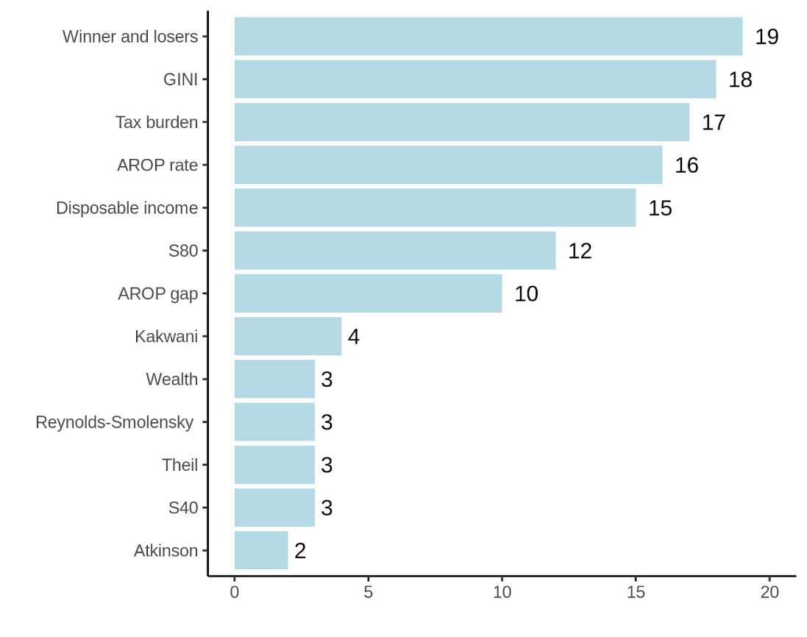
Note: Cyprus, Romania and Luxembourg do not perform any DIA outside DBPs. For Bulgaria, information is missing. Source: Study on Distribution Impact Assessment by the University of Milan, financed by the Commission (DG EMPL): https://data.europa.eu/doi/10.2767/511644
Besides comparing the types of DIA indicators used both in and outside DBPs, it is also interesting to compare the number of those different indicators used by each euro area Member State in and outside its DBP. Figure 8 below shows this comparison for the year 2020. It appears that, overall, the euro area Member States used a larger number of different DIA indicators outside their DBPs than in their DBPs, with Finland being the only exception. This result is not completely unexpected as the DBPs are mainly centred on macroeconomic issues, with possibly less consideration for distributional concerns than in other types of budget-related documents. These results are consistent with the results shown in Figure 2 where, overall across the euro area Member States, it appears that DIA was more frequently performed outside the DBPs than in the DBPs in the years 2019-2020.
Figure 8 – Number of different types of DIA indicators used in the DBPs and outside the DBPs in 2020, for those euro area Member States with at least one DIA occurrence in 2020 in their DBPs and/or outside their DBPs (N=9)
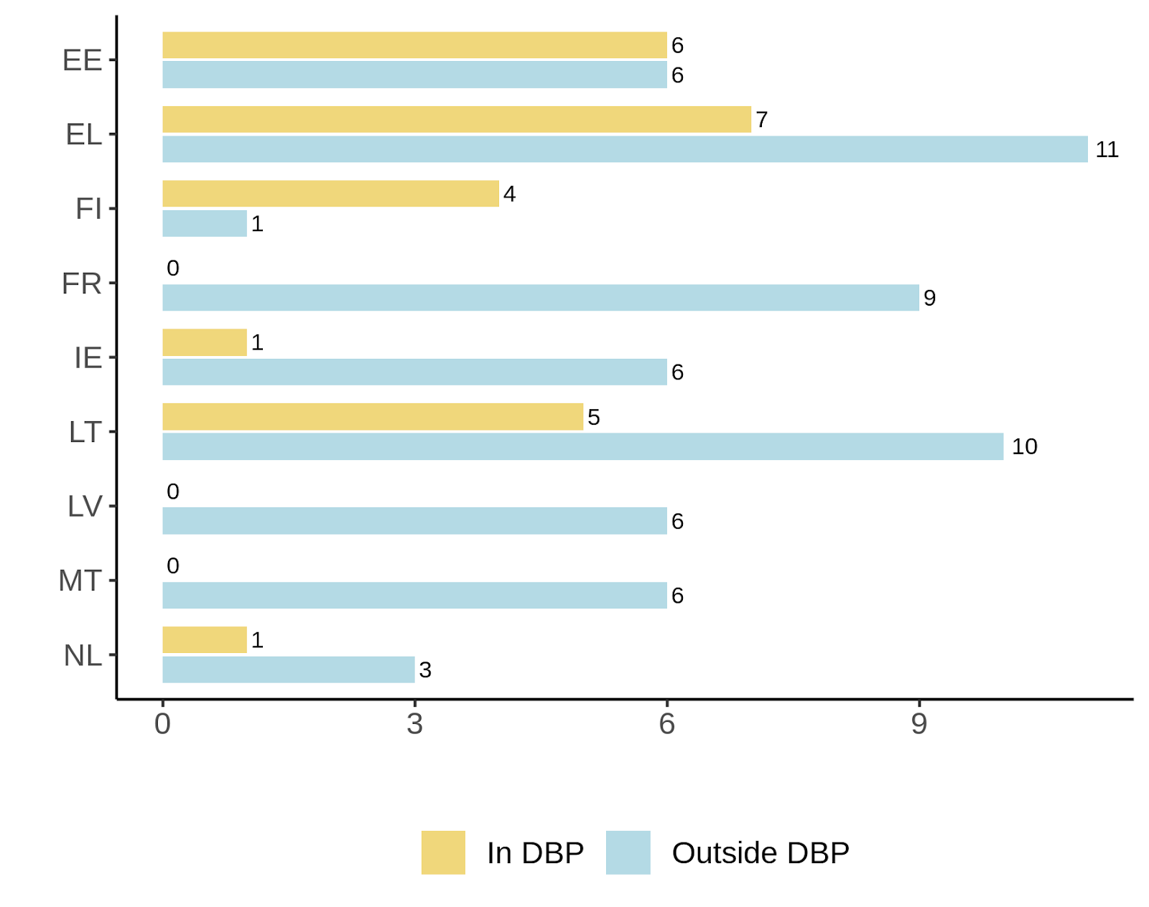
Note: Latvia and Malta did not implement any DIA in the DBP 2020. Source: Study on Distribution Impact Assessment by the University of Milan, financed by the Commission (DG EMPL): https://data.europa.eu/doi/10.2767/511644
Figure 9 – Types of indicators and sub-groups’ decomposition used in the DIA and various aspects of DIA methodology (stage at which DIA is performed and baseline used) - euro area Member States (*) (N=17)
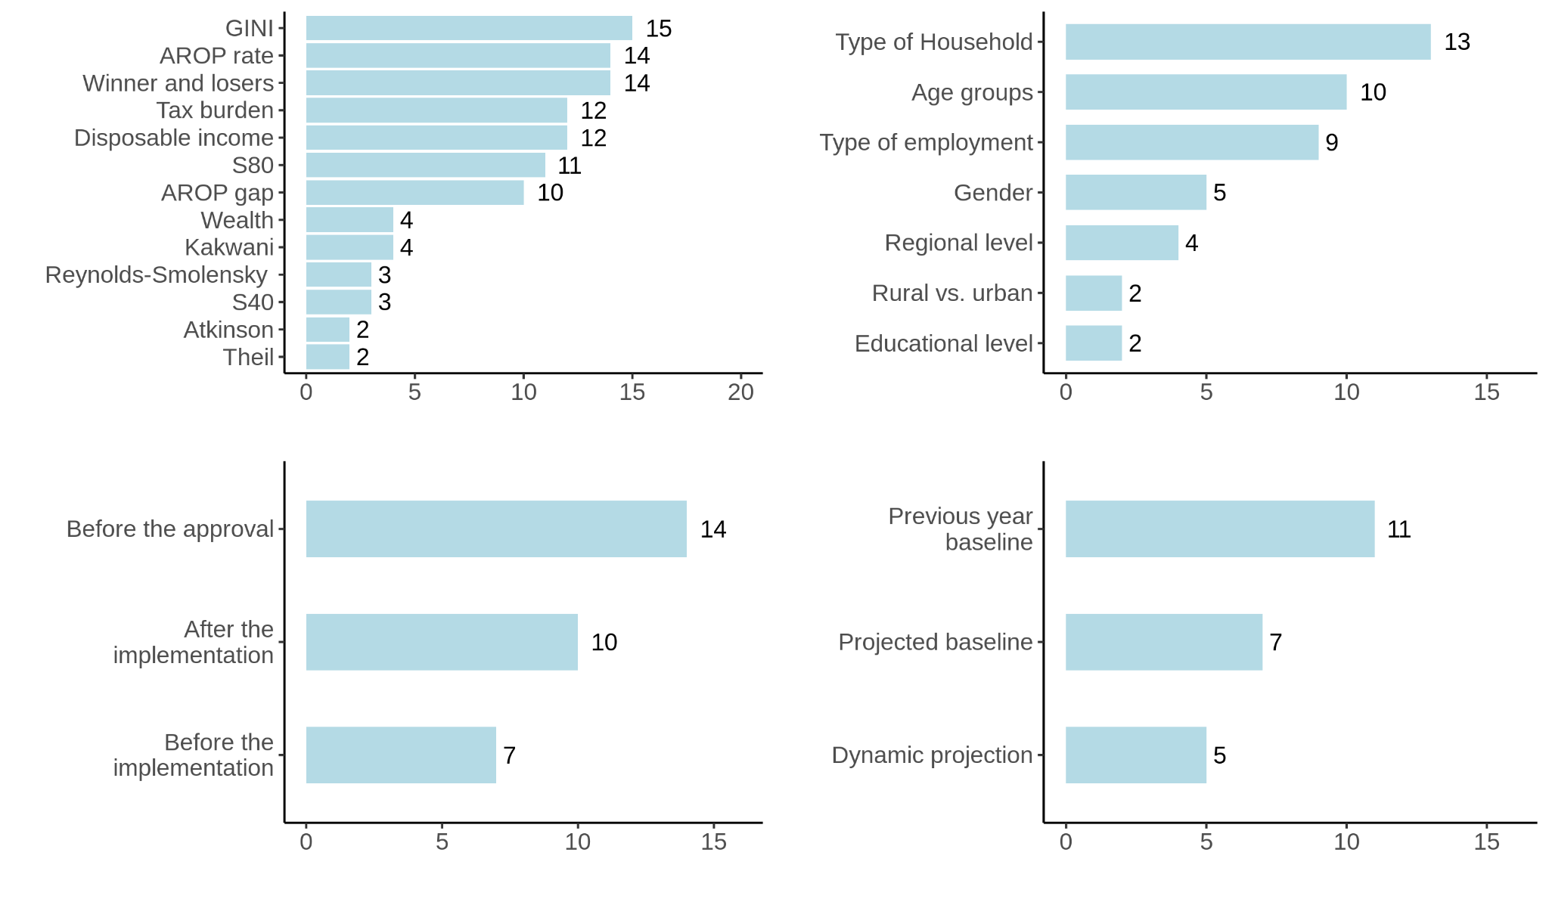
Note: respondents are allowed to choose multiple answers. (*) Cyprus and Luxembourg are excluded since no DIA is performed in these Member States. Source: Study on Distribution Impact Assessment by the University of Milan, financed by the Commission (DG EMPL): https://data.europa.eu/doi/10.2767/511644
DIA analysis can usefully be complemented by presenting results concerning certain socio-economic groups and the majority of Member States consider subgroups in the analysis (BE, CZ, DK, DE, EE, IE, EL, ES, FR, HR, IT, LV, LT, HU, MT, NL, PL, RO, SK, FI, SE). Subgroups considered vary between countries and depending on the actual analysis undertaken. Subgroups could include (children, working age, and older people), gender, connection to labour market (employed, self-employed etc.) and by level of education. For instance, in Belgium, depending on the kind of policy reforms, the subgroups for which some additional results are presented may differ (e.g. regional child benefit reforms versus unemployment benefit reforms). In Denmark, changes in equalised disposable income are presented depending on type of connection to labour market (employees, self-employed, unemployed, students, pensioners etc.). In Germany, the assessment of effects for households of social benefit recipients and different type of households, based on criteria’s such as such as age, education and migration. In Austria, it is assessed whether a proposal has significant impacts on the AROPE target group. In Estonia, the assessment of the impact of benefits on poverty and other monetary variables is made by different age groups, number of children in the household, household type or other socio-demographic characteristics (e.g. impact of unemployment benefits on unemployed persons poverty rates; pensions increase on the pensioners poverty). In Poland, regulatory impact assessments estimate the number of households affected by a particular intervention in terms of size and type of households (retirees and pensioners, households with children, single parents with children, households with persons with disabilities); and also age groups (e.g., effects of tax interventions on workers under 26). In Romania, the results are usually analysed by age groups, type of household (rural/urban, household size, number of children, etc.), region, educational level, employment type. In Sweden, estimates for subgroups are sometimes used in the budget process (age groups, types of household, educational level, regional level), but are usually not included when the overall effect of all reforms is presented in the budget bill.

How to disseminate DIAs?
Apart from allowing policymakers to make informed decisions, one of the functions of DIA is arguably to give a credible picture to the general public of how policy reforms will affect them. In several Member States, the public or the media pay significant attention to DIA analysis (BE, DK, IE, EL, FR, IT, LT, NL, AT, PL, SE).
A well-written press release or infographic to accompany the more detailed report or presentation is key to facilitating the reporting of DIA in the media. These communications should focus on the results and what they mean for the general public, without dwelling much on the technical detail of the model documented in the underlying report or presentation. For example, the public is likely to be interested in whether budgetary changes are more beneficial to low- or high-income households and the implications of reforms for poverty rates; income inequality and living standards. An author of the DIA – ideally one who has received media training – could also be made available to speak to the media in the event that clarifications or interviews are requested.
DIA results gain to be communicated in a way that raises the interest of the media and the public, which is the case in a number of Member States (BE, DK, IE, EL, FR, IT, LT, NL, AT, PL, SE). There is also coverage of distributional considerations of programmes of political parties in the run-up to parliamentary elections (BE, FI). The media attention may depend on the size of expected distributional impact of proposed measures (CZ, AT, SK). DIA considerations often feature high during parliamentary debates (BE, CZ, DK, DE, FR, IE, IT, LV, LT, AT, PL, FI, SE).
Where they are disseminated publicly, DIA results are usually included in budgetary documents and other documents either proposing or implementing reforms (CZ, DK, EE, ES, FR, IT, LV, LT, NL, AT, PL, FI and SE). Other than that, DIA results are presented in annual reports published by public institutions sometimes presented during press conferences (e.g. Study Commission on Ageing in BE). Greece appears to be the only country where the DBP is the only document where DIA results are publicly disseminated on a regular basis. DIA results are occasionally published as policy briefs or analytical reports (IT, LV, LT, HU, MT and SK). In the Netherlands, DIA calculations on policy measures included in the coalition agreements are also published. In some Member States, DIA results are only disseminated internally and mainly used to guide policy discussions behind closed doors where specific reform scenarios are being considered (EE, PT and RO).
DIA results presented to the public are usually accompanied by very brief comments, while details are presented in the form of a table or a graph. In Malta, the results are presented with a short explanation as to which cohorts and deciles are expected to be mostly impacted by the reform. In Denmark, if deemed relevant, Members of Parliament can request more detailed analysis and comments. No comments are provided on the results of the DIA analysis that are included in the Greek DBP.
Member States differ in terms of the extent to which the models and the underpinning data are made available to researchers and analysts on the one hand and the public on the other. Generally speaking, access seems to be more restricted in Member States that use country-specific models, as opposed to those using EUROMOD which is by definition available to all users. For example, in Finland, the microsimulation models and datasets used in the analysis are accessible to researchers and analysts, but not to the general public. In Denmark models as such are not available to researchers, media or Members of Parliament. However, the latter can request to have results of (in principle any) type of reform proposal. In Sweden, academia, research institutes and other state authorities than the government offices can request access to the entire model including data.
Box 11: National examples of DIA dissemination
In Ireland, the Department of Finance regularly publishes DIA results on the day the budget package is announced. Ireland has committed to a multi-year budgetary package of increasing carbon taxes, so there is an onus to produce DIA to show that the direct tax and welfare system is offsetting the regressive pattern of losses induced by carbon taxes. The Ministry also produces backward-looking analysis examining how tax changes affect measures such as the Gini coefficient as well as hypothetical household examples. The Irish Economic and Social Research Institute publishes its own DIA results in the days following the presentation of the budget by the government. Hereby ESRI acts in its role of an independent analyst and commentator. The ESRI also undertakes a public briefing on their DIA.
In Greece, outputs produced by the Ministry of Finance each year for their DBP are standardised to save time and allow automation. When communicating the results, the interpretation and analysis by the Ministry remains minimal. Media coverage of this analysis is relatively extensive.
An interesting example of a succinct form of presentation is the key output from the Dutch model MIMOSI, is a boxplot of the purchasing power growth year-to-year. The boxplot is shown for all households, by gross income quintile and for those working, pensioners and social welfare recipients separately. Households with and without children alongside singles, double-earner and single-earner households are also shown. A scatterplot of purchasing power growth is also shown. This gives more detailed insights as each data point in the plot represents a household.

Conclusion

Various considerations need to be taken into account while conducting DIAs and disseminating their results. Obtaining accurate DIA results hinges on using a well-developed microsimulation model, which ideally goes beyond the static analysis and includes behavioural responses or a longer term perspective. For the model to deliver accurate results, it needs to be fed with comprehensive and timely data. It is hence essential to make such data available both to various public administration entities but also to external researchers, also to allow that the analysis can be replicated. To the extent that data allow, the choice of policy reforms on which DIAs are run can be gradually extended beyond the tax-benefit measures, which is the core of DIA. The dissemination of the analysis can take different channels, but it is important to ensure that the main results are made available in a synthesised and easy to read manner. The information provided above constitutes a snapshot of existing tools and methods, but is important to note that these should and can be further developed in order to provide sound DIA results disseminated to a broader audience, including social partners and civil society.

Annex
Discussions with the Council Committees
During the preparation of the Communication on increasing the use of ex ante DIAs by Member States, the Commission engaged in a dialogue on the issue with the Employment Committee and Social Protection Committee (advisory committees for the Employment and Social Affairs Council) as well as the Economic Policy Committee (an advisory committee of the Economic and Financial Affairs Council). During the dedicated discussions that took place in March and April 2022, the relevance of conducting ex ante DIAs of budgetary measures and reforms was highlighted and its potential contribution to reducing inequality and poverty was duly acknowledged. Members agreed that DIAs were important for the Committees’ work in view of the various major transitions at play. The discussions confirmed the obstacles to more systematic use of DIA (in particular, tight timelines and lack of sufficient human resources as well as lack of a specific request) but also pointed at the problem of missing sufficiently granular data (among others due to data protection rules). There was an interest among the Member States to exchange more on using DIA, in particular in the context of the poverty reduction target as well as the transitions, energy prices hikes and associated compensatory measures. Discussions on new developments in terms of DIA methodologies would be appreciated.
Call for evidence on the Commission initiative on DIA
In April 2022, the Commission launched a call for evidence regarding the guidance to Member States on increasing the use of ex ante DIAs and as a result received 35 contributions coming from 12 Member States and Iran. More than half of them were submitted by EU citizens (see Figure 10 below), whereas non-governmental organisations (representing various sectors of society) were responsible for almost a quarter of the contributions. There were also submissions by public authorities and trade unions’ organisation.
Figure 10: Response to the Call for Evidence by category of respondents

Consulted parties acknowledged DIAs’ useful contribution to evidence-based policymaking and stressed the importance of conducting DIAs with a view to stepping up public investment in social infrastructure. They also stressed that DIAs were of particular importance in the context of economic inequalities and social vulnerabilities that were rising across the continent. At the same time, the importance of supporting economic growth for reducing inequality and poverty was also underlined.
DIAs should cover not only economic impacts of policy reforms, but also include social and environmental considerations. However, combatting social and economic inequalities should not be viewed only as an underpinning dimension of the green and digital transitions, or as a bottleneck to economic growth, but as a key objective in its own right. DIAs’ relevance was recognised in the context of scaling back the emergency measures adopted to cushion the impact of the pandemic.
It was stipulated that DIAs should acknowledge, among others, the contribution of social integration enterprises to the reduction of poverty and inequality. It was also suggested that DIAs could help tackle administrative barriers to accessing social benefits. It was also highlighted that using DIA was of particular importance for regional governments to inform their decision-making processes. The importance of ex post DIAs was also noted as it could set a strong foundation for a potential ex ante DIA of another similar project.
Disseminating DIA results was pointed at as a crucial aspect. It was underlined that these results should not be presented only in budgetary documents, which usually fall outside the scope of the interest of the public And that efforts should be made to communicate the results using fora and language easily accessible to European citizens and in particular the youth.
Some organisations called for making DIA analysis more uniform across Member States so that they could be easier to compare. At the same time this should be done acknowledging the specific national contexts. The importance of providing for independence to those conducting DIA analysis was also stressed so that the results would be deemed credible. The issue of access to data as well as their quality and timeliness was pointed at as a major enabler of robust DIA results. A call was also made for making models and data easily accessible to researchers, thereby allowing replicability which in turn could enhance the credibility of results. A suggestion was also made to set aside some European funds for supporting organisations involved in conducting DIAs.
Several respondents called for the Commission to provide further support to Member States to assist them in developing their DIA processes, in particular by identifying best practices and facilitating exchanges between national experts. Moreover, it was mentioned that the Commission guidelines should make clear and explicit that DIAs should be streamlined and applied in all policy fields. An idea of establishing a dedicated scientific committee was also put forward, which would bring together researchers and decision-makers who would be in charge of reviewing, supplying templates, sharing good practices, and hosting workshops.
A view was expressed that the Commission’s guidance issued by means of a Communication was not as effective as binding targets or a directive/a regulation. Therefore, the envisaged monitoring process of the implementation of DIAs by the Member States by the Commission could be usefully strengthened beyond regular information provided to the Social Protection Committee and the Employment Committee and regular reviews of DIA practice in Member States and mutual learning events aimed at further improving tools and methodologies used to conduct DIAs.

See for instance Livermore, M. A. and Rosenberg. J. S. (2014) L'analyse distributive dans les études d'impact, ou comment prendre en compte la répartition des conséquences d'une règlementation, Revue française d’administration publique, 149(1), 145-161. https://www.cairn.info/revue-francaise-d-administration-publique-2014-1-page-145.htm
Eurobarometer on Fairness, inequality and inter-generational mobility (April 2018) https://europa.eu/eurobarometer/surveys/detail/2166 Eurobarometer on Social Issues (March 2021) Social issues - March 2021 - - Eurobarometer survey (europa.eu)
See Joint employment report 2022 and EU-SILC income inequality indicators, “Income quintile share ratio S80/S20 for disposable income” (ilc_di11) and “Gini coefficient of equivalised disposable income” (ilc_di12). and “Income quintile share ratio” definition and related terms for more information Link
Income quintile share ratio S50/S20 for disposable income by sex and age group - EU-SILC survey (ilc_di11e)
Income quintile share ratio S40/S100 for disposable income by sex and age group - EU-SILC survey (ilc_di11f)
See Joint Employment Report 2022 (https://op.europa.eu/en/publication-detail/-/publication/316112f2-fda1-11ec-b94a-01aa75ed71a1/language-en/format-PDF) and the SPC Annual Report 2021 (https://ec.europa.eu/social/main.jsp?catId=738&langId=en&pubId=8432&furtherPubs=yes)
OECD (2021), Tax and Fiscal Policies after the COVID-19 Crisis: OECD Report for the G20 Finance Ministers and Central Bank Governors, October 2021, Italy, OECD, Paris, www.oecd.org/tax/tax-policy/tax-and-fiscal-policies-after-the-covid-19-crisis.htm
Released in July 2021, available on Eurostat website. The full data for 2020 will be available in the autumn 2022. It is noteworthy that top incomes/capital incomes in EU-SILC (as in all income surveys as opposed to administrative data) are underestimated, hence national inequality estimates are underestimated too.
For examples of analysis distributional effects of environmental and climate policies see: Vona, F. (2021), "Managing the distributional effects of environmental and climate policies: The narrow path for a triple dividend", OECD Environment Working Papers, No. 188, OECD Publishing, Paris, https://one.oecd.org/document/ENV/WKP(2021)20/en/pdf and Shang, B. (2021). The Poverty and Distributional Impacts of Carbon Pricing: Channels and Policy Implications. IMF Working Papers, 2021(172) https://www.elibrary.imf.org/view/journals/001/2021/172/article-A001-en.xml
https://ec.europa.eu/commission/presscorner/detail/en/qanda_21_6823
Aphecetche, T., Canton E., Garrone M. and Hobza A. (2022) Understanding the Political Economy of Reforms. Lessons from the EU, Economic Brief 70, European Commission: https://ec.europa.eu/info/publications/understanding-political-economy-reforms-lessons-eu_en
Here as well, a DIA occurrence can refer to the inclusion of the DIA analysis(es) itself in the document or to only the inclusion of comments on the results of this/these DIA analysis/es.
In the European Semester, the European Commission requires MS to publish macroeconomic forecasts and constantly assesses progress towards the European 2020 targets.
According to ”Study on Distributional Impact Assessment” by the University of Milan 2022 https://data.europa.eu/doi/10.2767/511644
See “Study on DIA” by the University of Milan 2022 above
A link to the full documentation of the analyses undertaken in the budget is also provided (https://www.gov.ie/en/publication/7599a-budget-publications/).
According to the “Study on Distributional Impact Assessment” by the University of Milan which looks at the DIA use in the DBPs and in budget-related documents at the national level, such as National Growth Strategy, progress towards EU2020 indicators, progress in implementing country-Specific recommendations, national document introducing expenditure and revenue measures and documents with an ex- ante or ex- post evaluation of budgetary measures.
CY, LU and RO according to the “Study on Distributional Impact Assessment” by the University of Milan.
For instance, as part of the Semester cycle, some analysis has been done of the impact of the introduction of a minimum wage (such as in Cyprus, see European Commission Staff Working Document 2022, Country Report – Cyprus, accompanying the document Recommendation for a COUNCIL RECOMMENDATION on the 2022 National Reform Programme of Cyprus and delivering a Council opinion on the 2022 Stability Programme of Cyprus {COM(2022) 604 final} - {SWD(2022) 640 final}, p. 47.)
See for instance Aaltonen K, Tervola J & Heino P (2021). Analysing the effects of healthcare payment policies in conjunction with tax-benefit policies: A microsimulation study with real-world healthcare data. INVEST working paper 34/2021.
Bargain, O., & Callan, T., (2010). Analysing the effects of tax-benefit reforms on income distribution: a decomposition approach. Journal of Income Inequality. Vol. 8.pp. 1-21: https://link.springer.com/article/10.1007/s10888-008-9101-4
Paulus, Alari & Tasseva, Iva V. 2020. "Europe Through the Crisis: Discretionary Policy Changes and Automatic Stabilizers," Oxford Bulletin of Economics and Statistics, Department of Economics, University of Oxford, vol. 82(4), pages 864-888, August: https://ideas.repec.org/a/bla/obuest/v82y2020i4p864-888.html
Doorley, K.; Callan, T. & Savage, M. 2021. "What drove income inequality in EU crisis countries during the Great Recession?," Fiscal Studies, John Wiley & Sons, vol. 42(2), pages 319-343, June: https://ideas.repec.org/p/esr/wpaper/rb202102.html
Fioramanti, M., González Cabanillas. L., Roelstraete, B.,and & Ferrandis Vallterra, A., (2016). European Commission’s Forecasts Accuracy Revisited: Statistical Properties and Possible Causes of Forecast Errors. European Commission Discussion Paper 027: https://econpapers.repec.org/paper/eufdispap/027.htm
Bargain, O. & Doorley, K. "The Effect of Social Benefits on Youth Employment: Combining Regression Discontinuity and a Behavioral Model." Journal of Human Resources, vol. 52 no. 4, 2017, p. 1032-1059: https://ideas.repec.org/a/uwp/jhriss/v52y2017i4p1032-1059.html
According to the “Study on Distributional Impact Assessment” by the University of Milan
Savage, M. (2017). Integrated Modelling of the Impact of Direct and indirect Taxes Using Complementary Datasets. The Economic and Social Review, 48(2), 171-205: https://ideas.repec.org/a/eso/journl/v48y2017i2p171-205.html
Bercholz, M., & Roantree, B. (2019). Carbon Taxes and Compensation Options. Budget Perspectives 2020 : https://www.esri.ie/sites/default/files/media/file-uploads/2019-06/Carbon%20taxes%20and%20compensation%20options.pdf
Kuypers, S., Figari, F., Verbist, G., & Verckist, D. (2017). EWIGE- European Wealth data InteGration in EUROMOD. JRC Working Papers on Taxation and Structural Reforms No. 4: https://ideas.repec.org/p/ipt/taxref/201704.html
Boone, J., Derboven, J., Figari, F., Kuypers, S., & Verbist, G. (2019). EWIGE 2- Update and Extension of the EUROMOD Wealth Taxation Project. JRC Working Papers on Taxation and Structural Reform No. 7: https://www.econstor.eu/bitstream/10419/202265/1/jrc-wptsr201907.pdf
These are Austria, Belgium, Cyprus, Estonia, Finland, France, Germany, Greece, Hungary, Ireland, Italy, Luxembourg, Poland, Portugal, Slovakia, Slovenia and Spain.
EUROMOD does this as a general rule, but has a feature (Full Year Adjustment extension) that allows to take into account the date of implementation. In several countries this extension is used to adjust policies approved before or after 30th June. This is available in the public model.
More information on HHoT can be found on the EUROMOD website: https://euromod-web.jrc.ec.europa.eu/overview.
Microsimulation models are usually based on a representative set of data for a country’s population (administrative or survey data) as well as a detailed modelling of the tax and benefit system of a country. These characteristics make them suitable for detailed distributional analyses of changes in tax or benefit systems.
(PDF) Microsimulation as a tool for evaluating redistribution policies | Amedeo Spadaro and Francois Bourguignon - Academia.edu
For detailed information about the model and access to it, check the EUROMOD website: https://euromod-web.jrc.ec.europa.eu/.
Microsimulation models often do not account for behavioural responses (such as the estimated effects on labour supply of changes in the income tax) or macroeconomic feedback (for instance increased labour supply may increase GDP and government revenues). Incorporating behavioural responses and macroeconomic feedback can be done by building more advanced models taking into account the various effects (such as incorporating behavioural replies into a microsimulation model or linking it to a macroeconomic model).
https://www.researchgate.net/publication/356305566_The_Distributional_Impact_of_Labour_Market_Reforms_A_Model-Based_Assessment
Peter B. Dixon and Dale W. Jorgenson (Ed.), Handbook of Computable General Equilibrium Modeling. Elsevier: https://www.sciencedirect.com/handbook/handbook-of-computable-general-equilibrium-modeling/vol/1/suppl/C
https://wittneben.eu/publication/barrios-2019/barrios-2019.pdf
https://joint-research-centre.ec.europa.eu/publications/edge-m3-dynamic-general-equilibrium-micro-macro-model-eu-member-states_en.
https://microsimulation.pub/articles/00020
The model has been linked to EUROLAB (JRC’s labour supply/demand model), QUEST (Dynamic Stochastic General Equilibrium model of the European Commission’s Directorate General for Economic and Financial Affairs), JRC GEM-E3 (energy and environmental model) and JRC EDGE-M3 (pension and demographic model).
Labour transition model based data are produced by Eurostat, using detailed distributional information on the loss of jobs and short-term work schemes from the Labour Force Survey and administrative data. The impact across different categories of individuals, the duration of unemployment/absence and percentage of hours worked are modelled using the EU-LFS longitudinal and quarterly transitions as target.
https://joint-research-centre.ec.europa.eu/publications/ewige-2-update-and-extension-euromod-wealth-taxation-project_en
Bargain and Callan (2010) show that gross income inflation is a distributionally neutral factor that seems most appropriate for indexed benchmarks: https://econpapers.repec.org/article/kapjecinq/v_3a8_3ay_3a2010_3ai_3a1_3ap_3a1-21.htm
O'Donoghue, Cathal and Loughrey, Jason (2014) 'Nowcasting in Microsimulation Models: A Methodological Survey' Journal of Artificial Societies and Social Simulation 17 (4) 12 https://www.jasss.org/17/4/12.html
Navicke, J., Rastrigina, O., & Sutherland, H. (2014). Nowcasting indicators of poverty risk in the European Union: A microsimulation approach. Social Indicators Research, 101-119. https://www.jstor.org/stable/24721071
It is important to note that EU-SILC also has some data coming for administrative records, in particular for income data for approximately half of the EU countries.
According to Commission delegated regulation 2020/258 supplementing regulation 2019/1700, from 2021 member states should provide disaggregate benefits variables as part of the yearly mandatory EU-SILC variables, i.e. benefit variables are breakdown by whether they are contributory or not, and if they are means-tested or not.
EUROMOD has embedded tools (Statistics Presenter and In-depth Analysis plugin) that can automatically calculate most of the indicators described. Additionally, the outcomes can be fully customised (e.g. for the population groups mentioned at the end of this section).
Meaning an analysis of who and how many are those who gain or lose from the implemented policy as opposed to the situation without the policy.
The indicators considered in the questionnaire used for the interviews are: mean disposable income, average tax burden, winners and losers, AROP, AROPE, Gini, S80/S20, S40, Theil index, Atkinson index, Reynolds-Smolensky index, Kakwani index, wealth groups.
Considering only Euro Area Member States in this table.
In SCP/NRP and/or in one of the seven types of budget-related documents considered in table 3.6.

