‘Doing business around the world, global trade – all that is good and necessary.
But this can never be done at the expense of people’s dignity and freedom…
Human rights are not for sale – at any price.’
President of the European Commission Ursula von der Leyen
State of the Union Address, 15 September 2021

      - Introduction

According to the latest global estimates, 160 million children worldwide are in child labour. That is one in ten children in the world, and their number is growing. Nearly half of these children are performing hazardous work. At the same time, 25 million people worldwide were in a situation of forced labour. These figures act as a stark reminder that decent work is still not a reality for hundreds of millions of people worldwide, despite a clear commitment by the international community in the United Nations Sustainable Development Goals.
In parallel, global megatrends are rapidly transforming the world of work. Technological advances, the environmental and climate crisis, demographic change and globalisation are drivers of this development. These transformations have the potential to generate economic growth and create new job opportunities, but in some instances they can also contribute to a lowering of labour standards.
Promoting decent work is increasingly coming into focus in the international context, particularly through the work of the International Labour Organization (ILO), the United Nations (UN) and the Organisation for Economic Co-operation and Development (OECD), but also within the G7 and G20 groups of nations. International commitments and guidance reflect rising concerns that globalisation is not always happening in a sustainable manner and address the role of business corporations in this regard.
The EU is committed to shaping the global agenda on decent work and promoting a human-centred future of work. The EU aspires to champion decent work both at home and around the world, in line with the UN 2030 Agenda for Sustainable Development. Within the EU, the European Pillar of Social Rights Action Plan, as welcomed by the Porto Summit in May 2021, will help to further these objectives.
As a responsible global player, supporting the universal values of human rights, and a major economic power, the EU takes a strong stance on upholding and updating the multilateral rules-based global order, including international labour standards, in line with the concept of open strategic autonomy and as reflected in the Global Gateway.
The EU economy is connected to millions of workers around the world through global supply chains, while EU consumers are increasingly demanding goods, which are produced in a sustainable and fair way that ensures decent work of those who produce them. As reflected in debates in the Conference on the Future of Europe, European citizens expect the EU to act and the Commission takes that responsibility seriously. It is also in the interest of EU workers and companies, as well as responsible public and private actors around the world, to strengthen the respect of decent work globally and thereby avoid a race to the bottom based on a model of attracting investment by lowering labour protection standards.
The COVID-19 pandemic has exacerbated income and labour market inequalities and disproportionately affected women and vulnerable and disadvantaged groups such as young people and children, persons with disabilities, older persons, migrant workers and workers in the informal economy. The pandemic has aggravated occupational health and safety and the exercise of fundamental labour rights and it has highlighted the urgency of promoting decent work including in global supply chains.
Millions of workers are affected by health- and life-threatening workplaces and suffer from in-work poverty, excessive working hours, discrimination, harassment and violence, including gender-based violence, without the freedom to associate. People working in labour-intensive sectors such as agriculture, fisheries and textiles are particularly affected. Poor living and working conditions are linked to various factors such as the stage of economic development, low levels of legislation on labour and social protection, weak law enforcement, ineffective public administration and irresponsible business practices.
The prospect of an asymmetric global recovery risks aggravating the poor conditions even further and of entrenching them more deeply. As countries strive to “build back better” and implement the clean energy transition and decarbonisation of the economy, new distributional impacts are to be expected, especially in certain regions, sectors and/or social groups with a strong reliance on fossil fuels. New jobs will be created, while some jobs will be replaced and others redefined. It is vital for countries to anticipate these changes and up- and reskill workers accordingly. The transition of the global economy and of labour markets following the climate change and other global megatrends must be socially fair and just, which will require strong political commitment and powerful action based on a human-centred approach.
This Communication sets out how the European Union will act upon these challenges, putting the promotion of decent work worldwide at the heart of a just transition and an inclusive, sustainable and resilient recovery from the pandemic. This approach is in line with the ILO Global Call to Action.

- A comprehensive approach to promoting decent work worldwide
The EU approach supports the universal concept of decent work as developed by the ILO and as reflected in the UN Sustainable Development Goals, consisting of the four inseparable and mutually reinforcing objectives of productive employment, standards and rights at work, social protection and social dialogue. Gender equality and non-discrimination are cross-cutting issues in these objectives.
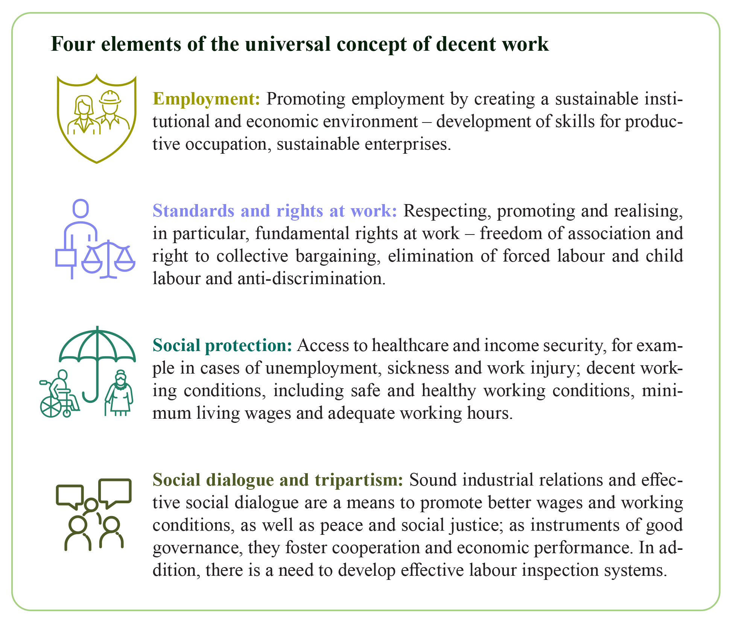
The EU’s comprehensive approach aims at effective promotion of decent work for all. and specifically addresses vulnerable and disadvantaged groups such as children and young people, older workers, migrant workers, persons with disabilities, ethnic minorities and workers in the informal economy. It also aims to promote gender equality including through women’s economic empowerment, increasing women’s participation on the labour market in all sectors and at all levels and ensuring equal pay for work of equal value. This comprehensive approach addresses workers in domestic markets in third countries and in global supply chains. It includes all relevant stakeholders: governments, social partners, civil society, business actors and consumers. The comprehensiveness of EU action is expressed by different EU initiatives in the area, including the proposal for a Corporate Sustainability Due Diligence Directive that is adopted together with this Communication, and the ongoing review of the 15-point Action Plan on Trade and Sustainable Development in the EU’s trade policy.
A specific focus on eradication of child labour and forced labour
The United Nations declared 2021 the International Year for the Elimination of Child Labour, as a rallying call for the international community to step up its efforts to eradicate child labour by 2025. Following a decrease in child labour from 2000 to 2016, the absolute number of children in child labour increased by 8.4 million from 2016 to 2020. Due to the COVID-19 pandemic, and related economic shocks and school closures, an additional 9 million children are at risk of being pushed into child labour by the end of 2022, while children already in child labour may be working longer hours or under worsening conditions. If there is insufficient social protection coverage, this number could rise to 46 million additional victims of child labour.
Child labour in numbers

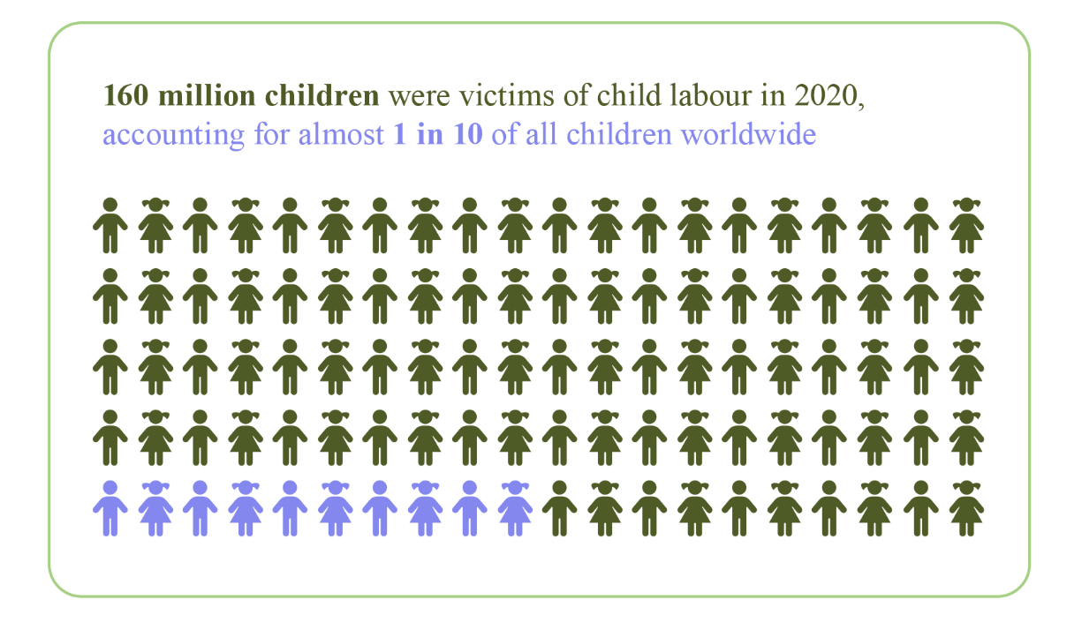

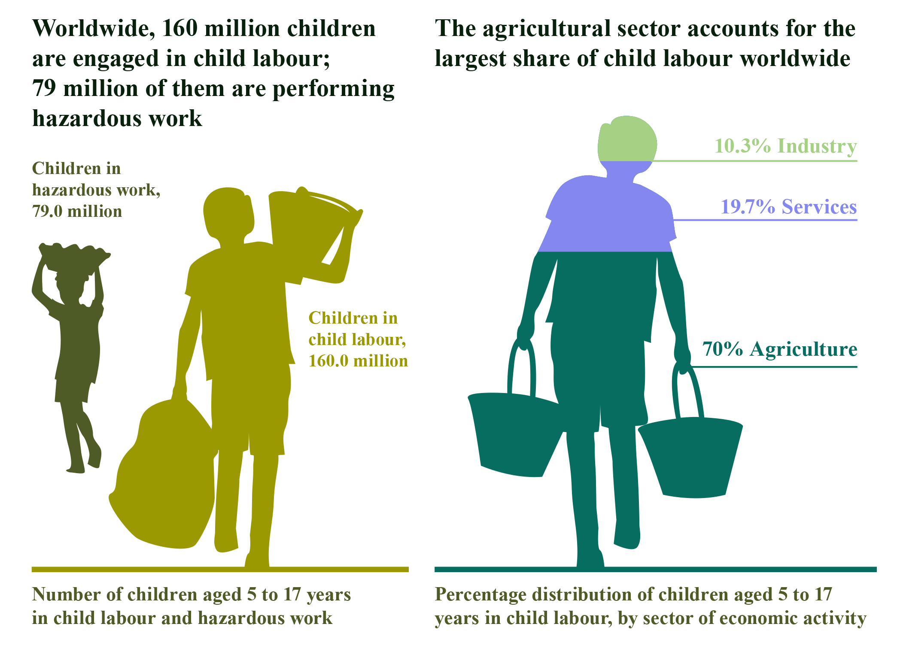
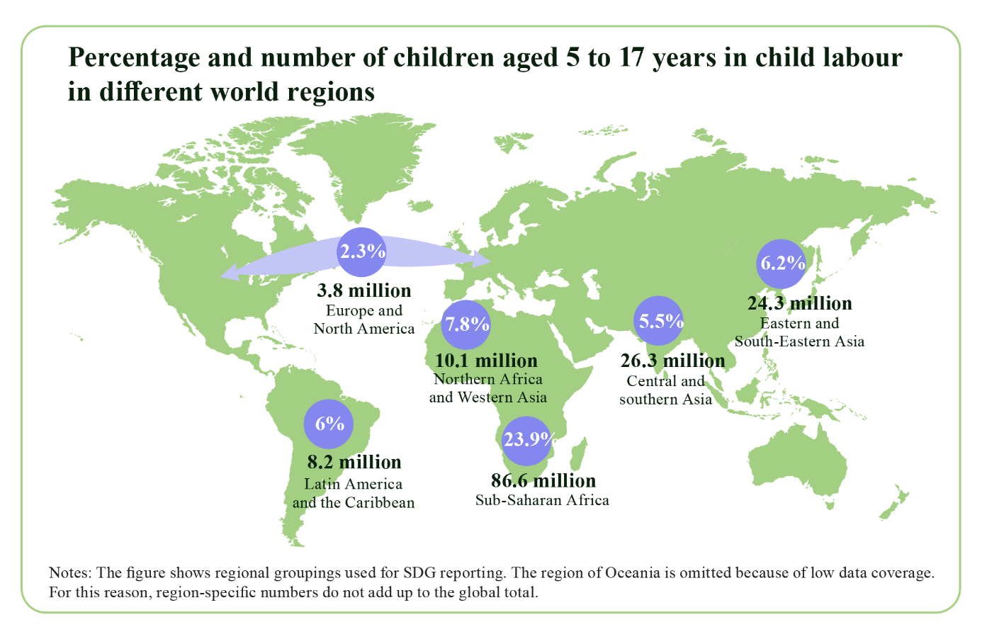
In line with the Commission’s zero tolerance policy towards child labour, the elimination of child labour is a priority within its comprehensive approach of promoting decent work worldwide. It needs to be kept at the forefront of reflections in all relevant policy areas. EU actions in this area include supporting and enforcing effective legislation against child labour promoting social welfare programmes for poor households that are vulnerable to child labour; and strengthening access to education, including in situations of conflict or crisis and for children who are on the move both within and between countries, and providing them with protection services. The EU Comprehensive Strategy on the Rights of the Child engages the Commission to work towards making EU supply chains free of child labour and to provide technical assistance to strengthen labour inspection systems.
Forced labour in numbers
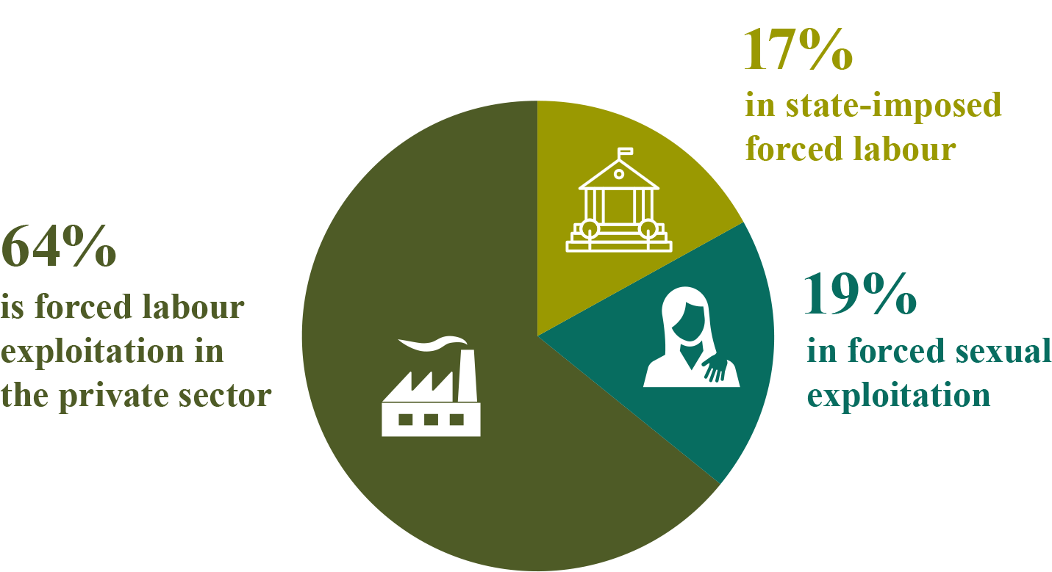
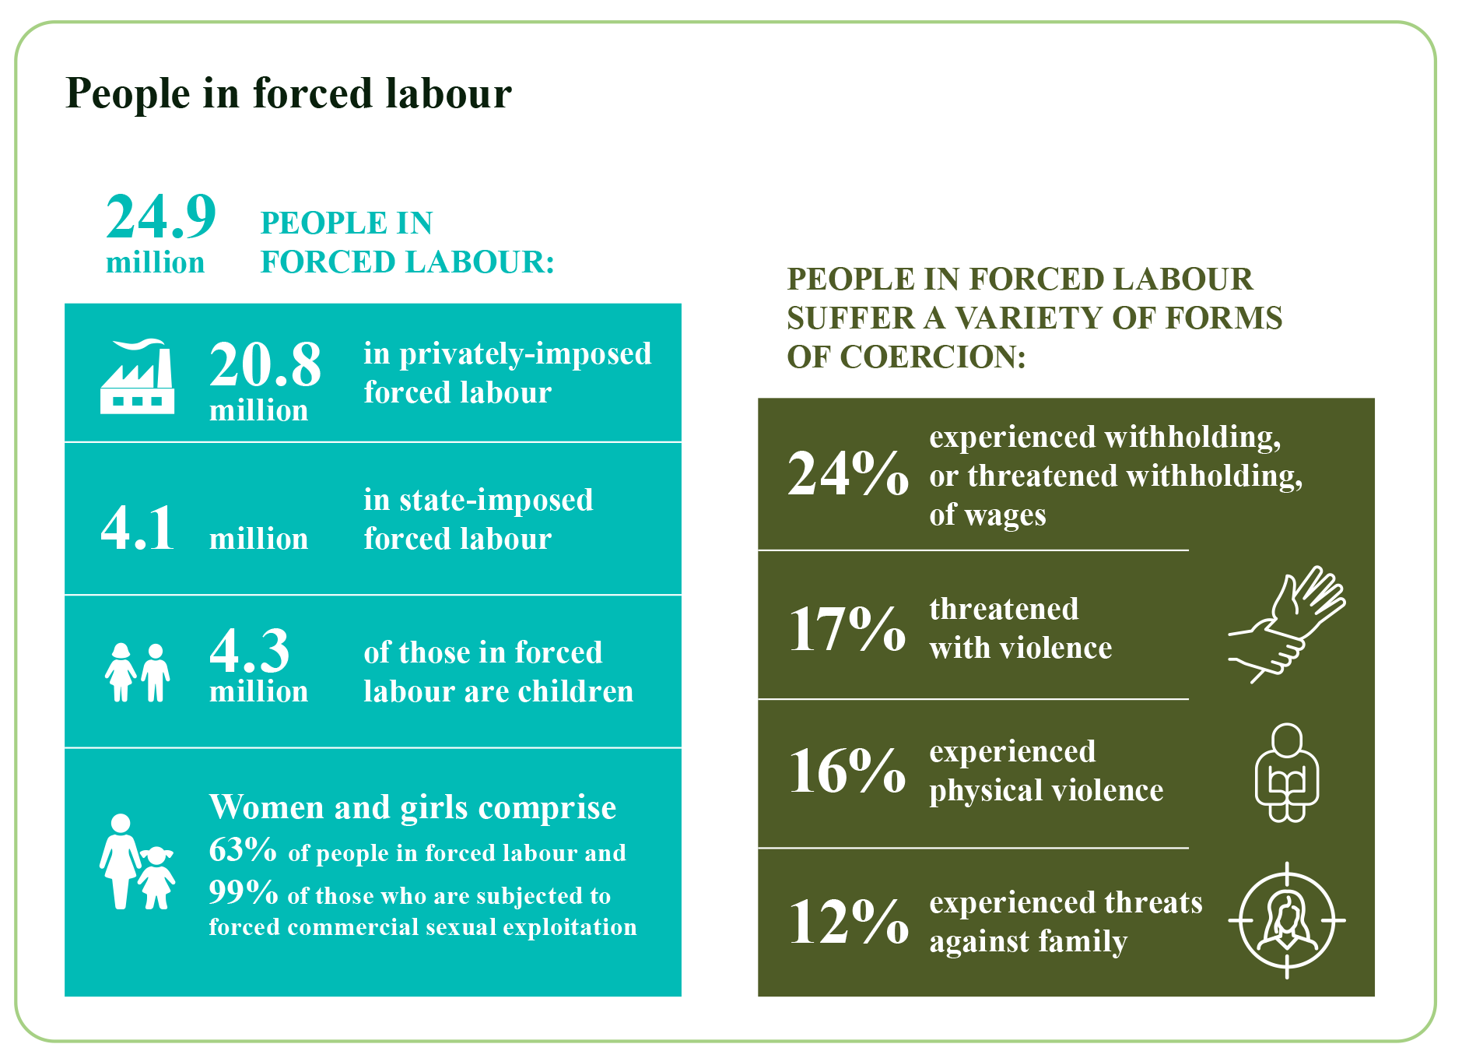
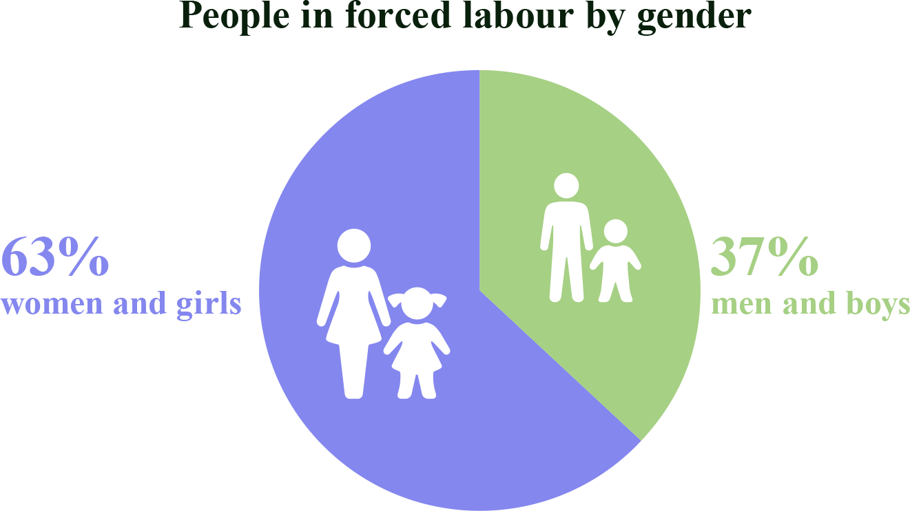

The eradication of child labour and forced labour can only be achieved if other objectives of decent work, such as sustainable business conduct, social dialogue, freedom of association, collective bargaining and social protection, are promoted. This demonstrates the effectiveness of a comprehensive approach to promoting decent work worldwide.
- How is EU promoting decent work worldwide
3.1. EU policies and initiatives with outreach beyond the EU
Internal EU action also has implications for the well-being of workers around the globe. In line with the EU’s commitment to promote decent work in global supply chains, EU policies set standards that are frontrunners for corporate responsibility and transparency globally; they set frameworks for sustainable finance, sustainable production and consumption, and strengthen the public sector in leading by example in public procurement activities. They are an essential element of the European Green Deal, which underlines that green and social sustainability need to go hand in hand to ensure a socially just transition worldwide. The EU initiatives pursuing decent work are both of a general and a sector-specific nature. In addition, EU has launched a number of dedicated initiatives to combat child and forced labour.
3.1.1 Initiatives covering Decent Work
Several EU policies and strategies relate to the promotion of decent work worldwide, including in global supply chains. They use a variety of tools including due diligence requirements for businesses, disclosure standards on social matters and transparency and information provisions on the sustainability of products allowing consumers to make more informed choices.
In its proposal for a Corporate Sustainability Due Diligence Directive, the European Commission sets out due diligence obligations for large companies over a certain threshold and for certain other companies in particularly sensitive sectors, to identify, prevent, mitigate and account for actual and potential adverse impacts on human rights, including labour rights, and the environment along global supply chains, in accordance with international human and labour rights standards. The proposal will set out a horizontal framework to ensure that businesses operating in the single market contribute to the respect of the human rights and environment in their own operations and through their value chains, by mitigating adverse impacts on human rights and the environment, and having an appropriate governance, management systems and measures in place. The proposal also provides for an effective enforcement mechanism through a combination of administrative sanctions and civil liability.
The EU is taking various policy measures on sustainable finance to redirect private investment flows towards economic activities that are sustainable from both an environmental and a social perspective. Europe is the region with one of the largest volumes of sustainable investing assets globally, with about EUR 10 trillion in 2020, making sustainable finance a powerful tool for promoting labour rights in supply chains. As presented in the Sustainable Finance Strategy of 6 July 2021, the Commission will review disclosure standards regarding social and employee matters and respect for human rights in the financial sector, among other aspects. Furthermore, the Commission will publish a report on the possible extension of the Taxonomy Regulation to cover other sustainability objectives, such as social objectives.
A transition to a clean and circular economy can provide opportunities to reduce pollution, waste and stimulate product innovation, while at the same time contributing positively to sustainable human development, including through the creation of decent jobs. Following up on the Circular Economy Action Plan, the Commission will promote measures linked to environmental and social aspects along the supply chain of products and services.
Consumers need better and more reliable information on the sustainability of goods and services to make informed choices. The Commission will promote decent work in global supply chains in upcoming initiatives on EU consumer policies.
Under Horizon 2020, the Commission supported decent work-related research, including on the role of sustainable market actors for responsible trade. In consistence with the UN 2030 Agenda for Sustainable Development, the Commission will strengthen promotion of decent work worldwide under the European Framework Programme for Research and Innovation, Horizon Europe (2021-2027).
Under EU development and cooperation instruments, the EU has been supporting the implementation of the decent work agenda in partner countries including via the Technical Assistance Facility Socieux+ that provides since 2013 expertise in the area of employment and social protection.
3.1.2. Promoting decent work in specific sectors
Through the initiatives in the Farm to Fork Strategy, the Commission will amongst others promote decent work in global food supply chains, including safe and fair working conditions and rights. The considerations of workers’ social protection, working and housing conditions as well as protection of health and safety will play a major role in building fair, strong and sustainable food systems.
The Raw Materials Initiative and the Critical Raw Materials Action Plan aim for a fairer and more sustainable sourcing of raw materials from global markets. They promote responsible mining practices for critical raw materials, given that high supply concentration of raw materials in countries with low standards of governance may exacerbate environmental and social problems. In this connection, through its cooperation programmes, the Commission is engaged in supporting the sustainable development of the mineral resources in its partner countries. The Commission supports the implementation of Regulation (EU) 2017/821, which sets out due diligence obligations for EU importers of certain metals and minerals originating from conflict-affected and high-risk areas, by means of guidance documents and accompanying measures. The Commission proposal for a Regulation concerning batteries and waste batteries contains obligations for economic operators to carry out due diligence obligations on their supply chains.
In recent years, the EU has developed a set of policies and supported actions to address decent work in the garment sector and reduce vulnerabilities, making supply chains more sustainable. For instance, the EU has supported Better Work to improve working conditions in the garment industry and the Vision Zero Fund to improve occupational health and safety in the garment sector. The EU also supports interventions to increase knowledge and awareness aiming to improve working conditions in the garment sector through responsible production and consumption. In the framework of the Circular Economy Action Plan, the Commission is preparing a strategy for sustainable textiles, focusing on a sustainable recovery from the COVID-19 crisis and to reduce the sector‘s environmental and social impacts. In this context, the EU will take into account current challenges in the textiles value chain, including the need to protect human rights, including labour rights, and promote due diligence across supply chains in the textile sector. Such efforts will be ensured primarily by the proposed Corporate Sustainability Due Diligence Directive.
The EU will seek to secure commitments in all EU air transport agreements to provide high levels of labour protection in the aviation sector, in line with international labour standards.
The EU will include labour provisions on protection of workers in all EU bilateral and multilateral agreements for international road transport and in its Association Agreements with third countries. It will also review the European Agreement concerning the Work of Crews of Vehicles engaged in International Road Transport (AETR) to include relevant labour-related EU acquis and will align the multilateral Interbus Agreement on the occasional carriage of passengers by coach and bus with the EU social rules in road transport.
All EU Member States have ratified the international Maritime Labour Convention (MLC), which regulates the working conditions in the maritime transport. The EU will continue to work towards enforcing the provisions of the convention in cooperation with IMO and ILO, and propose including commitments linked to the effective implementation of the MLC in maritime-related EU agreements with third countries.
Through its International Ocean Governance agenda and Common Fisheries Policy, the EU promotes decent work in fisheries in line with the objectives of the International Labour Organization (ILO), the International Maritime Organization (IMO) and the UN Food and Agriculture Organization (FAO) and in cooperation with partner countries. The EU will continue promoting the ratification and effective implementation of the ILO Work in Fishing Convention C 188, and other relevant international standards. To this aim, it uses the Sustainable Fisheries Partnership Agreements (SFPAs), in particular through the implementation of a coherent set of social provisions, and the Regional Fisheries Management Organizations where appropriate. In bilateral dialogues and in regional and international fora, the Commission and the High Representative will address forced labour and other forms of work that violate human rights in the area of fisheries, including when detected in the context of the fight against illegal, unreported and unregulated (IUU) fishing.
With its Action Plan for the Social Economy, the Commission will further promote the social economy at international level for example through the Instrument for Pre-accession Assistance, the Neighbourhood, Development and International Cooperation Instruments and by improving the access to finance for social entrepreneurs in the Western Balkans, the Eastern Partnership and Southern Neighbourhood. There is also scope to strengthen dialogue and collaboration on the social economy with key international partners.
3.1.3. Increased efforts to combat forced labour and child labour
Respect for human dignity and the universality and indivisibility of human rights are firmly enshrined in the Treaty. In addition, the Charter of Fundamental Rights of the European Union explicitly prohibits slavery and forced labour. In order to give effect to these provisions, the Commission mobilises all available horizontal and sector-specific initiatives to combat forced labour and child labour, working with Member States authorities as well as private businesses and other stakeholders.
All 27 EU Member States have ratified the fundamental Conventions of the International Labour Organization (ILO) on forced labour and child labour. As a result, they are legally obliged to prevent and eliminate the use of forced labour and to regularly report to the ILO’s standards supervisory bodies. The references to the relevant ILO conventions are also included in numerous free trade agreements concluded by the Union. Under the EU Regulation on the Generalised Scheme of Preferences, the EU can grant unilateral trade preferences on the condition that benefitting countries comply with international labour standards, including on the elimination of child and forced labour.
The EU Anti-Trafficking Directive requires Member States to ensure that trafficking in human beings, including for the purpose of forced labour, is punishable by law. The Directive also requires Member States to consider criminalising the knowing use of exploited services. However, the final decision is left to the Member States, which has led to a diverse legal landscape across the EU. Given the prevalence of human trafficking across the Union and the divergences of national legal frameworks, Commission is carrying out an assessment of the possibility to have minimum EU rules criminalising the use of exploited services of trafficking victims. Meanwhile, the Commission also organises awareness campaigns in cooperation with civil society organisations to help detect and prevent the practice.
Socially responsible public procurement is a powerful tool to combat forced labour and child labour. Given that public procurement presents around 14% of the EU’s GDP (approximately EUR 2 trillion annually), it can provide strong incentives to companies to adopt socially responsible management practices. The public procurement Directives require Member States to take appropriate measures to ensure that contractors and suppliers effectively comply with the obligations stemming from the ILO conventions, including in the area of forced labour and child labour. To raise contracting authorities’ awareness of the potential benefits of socially responsible public procurement, the Commission has recently updated its “Buying Social”-guide.
The fight against forced labour cannot be won by public authorities alone. Private businesses have an important role to play. This is why, as part of the new EU trade policy, the Commission promotes due diligence in line with international guidelines and principles to ensure that forced labour does not find a place in the value chains of EU companies. In this context, the Commission and the European External Action Service published in July 2021 guidance to assist EU businesses in taking appropriate measures to address the risk of forced labour in their operations and supply chains, as a bridge towards mandatory horizontal due diligence legislation. In its proposal for a Corporate Sustainability Reporting Directive, the Commission also put forward detailed reporting requirements with respect to labour rights, such as the elimination of child and forced labour, including in global supply chains.
The Commission is also promoting industry-led strategies in the sectors most at risk. For example, the Clear Cotton project puts forward an integrated approach to eliminate child and forced labour in the cotton, textile and garment supply chains. The elimination of child and forced labour also takes up a prominent place in the Raw Materials Initiative and the Critical Raw Materials Action Plan.
Despite these important legislative steps, further action is needed to effectively tackle forced labour. This is why President von der Leyen announced an initiative banning products made by forced labour from the Single Market. To this effect, the Commission is preparing a new legislative initiative, which will effectively prohibit the placing on the EU market of products made by forced labour, including forced child labour. The initiative will cover both domestic and imported products and combine a ban with a robust, risk-based enforcement framework. The new instrument will build on international standards and complement existing horizontal and sectoral EU initiatives, in particular the due diligence and transparency obligations.
The fight against child labour requires additional action. Child labour has very complex drivers such as economic hardship, lack of adequate educational opportunities, popular perceptions and local customs related to the role of children in society. As a result, the eradication of child labour requires a holistic approach to sustainable economic development, including broad-based measures and adequately funded initiatives to support quality education, decent income and social protection for all. In line with the EU strategy on the Rights of the Child, the Commission supports governments, local actors and businesses, especially in the most affected countries.
Key tools:
- Promoting human rights and environmental due diligence by companies, including through legislation, to ensure identification, prevention, mitigation and accountability for actual and potential adverse impacts on human rights, including labour rights, and the environment along global supply chains.
- Banning of products made by forced labour from being placed on the EU market.
- Strengthening companies’ disclosure of information on sustainability aspects, including on decent work in global supply chains, to enhance sustainable investments and transparency for other stakeholders.
- Providing guidance and strong legal provisions on socially sustainable public procurement and making sustainable products the norm to enhance fair consumption.
- Using EU sectoral policies, including those on food, minerals, textiles, fisheries and transport, including maritime, to strengthen respect for international labour standards and the ratification and implementation of international labour conventions.
3.2. EU bilateral and regional relations
In its trade policy, the EU expects its trading partners to respect international labour standards. Free trade and investment agreements play an essential role in this regard, by including obligations to comply with international labour standards and promote decent work through national laws and practices, including effective labour inspection. For instance, these provisions incentivised South Korea to ratify three fundamental ILO conventions in April 2021. Furthermore, in 2020 the Commission appointed the Chief Trade Enforcement Officer (CTEO) to ensure that its trade partners meet their commitments, including under sustainable development chapters. It has also established a single entry point, where EU companies, trade organisations or non-governmental organisations can submit complaints.
The EU will use the ongoing review of the 15-point Action Plan on Trade and Sustainable Development to assess the implementation and enforcement of labour provisions in free trade agreements. This will include the scope of commitments, monitoring mechanisms, the possibility of sanctions for non-compliance, the essential element clause, the institutional set-up, working with civil society, and the resources required.
In the proposal for a new EU Regulation on the Generalised Scheme of Preferences (GSP Regulation) for the period 2024-2034, the Commission has increased its support for the promotion of international labour standards in GSP beneficiary countries by adding two new labour rights conventions and by rendering the export of goods made by internationally prohibited child labour and by forced labour a ground to possibly withdraw trade preferences.
A key objective of the EU’s international partnership policy is to promote decent work, including social protection, in line with the EU’s strong commitment to fully implement the UN 2030 Agenda for Sustainable Development and its Sustainable Development Goals, which is also reflected in 2017 European Consensus on Development. Social inclusion and decent work, paying a particular attention to the elimination of child labour, is one of the priorities in the programming exercise for the 2021-2027 period under the new “NDICI – Global Europe” to be defined at national, regional and global level. More specifically, the NDICI-GE Programme on Human Rights and Democracy, as well as other thematic and geographic programmes, envisage dedicated actions to promote decent work for all, including fighting child labour and forced labour, in particular at country and regional levels. NDICI-GE supports actions, which include promoting social dialogue and providing assistance to partner countries to ratify and effectively implement up-to-date ILO conventions in particular fundamental and governance conventions. Further to the European Consensus, actions will include engagement with the private sector on implementing responsible business conduct in global supply chains and support governments and businesses in partner countries in adopting responsible business conduct through relevant accompanying measures. It also provides opportunities to engage in partner countries with all relevant stakeholders in formalising the economy and reducing the informal sector, and to share best practices and approaches with partner countries through technical assistance. Moreover, recognising that many of the most vulnerable will continue to be employed in the informal economy, development policy will ensure that measures to promote decent work are extended into the informal economy. Where appropriate, action will be pursued with the Member States and European development financial institutions in the context of Team Europe Initiatives.
The European Union also support actions on protecting children in humanitarian crises settings, including against child labour of the worst kinds. Activities include prevention of and response to violence, family tracing and reunification, prevention, release and reintegration of Children Associated with Armed Forces and Armed Groups. A substantial investment is made to restore and maintain access to quality education for children affected by crises and humanitarian emergencies.
In accordance with EU enlargement policy, candidate countries and potential candidates are expected to fully align with the EU’s social policy and employment acquis and standards before acceding to the EU. The EU continues to promote the implementation of the European Pillar of Social Rights in the Western Balkans, by discussing the performance of candidate countries and potential candidates towards embedding principles of the European Pillar of Social Rights in the Economic Reform Programme process, and supporting our partners in improving their data availability and data collection in line with the Social Scoreboard. The EU also offers financial support to promote quality employment and supporting the effective enforcement of labour rules and standards across the region through the Instrument for Pre-Accession Assistance (IPA).
Through the European Neighbourhood Policy, the EU supports political and economic reforms in the EU’s Southern and Eastern neighbourhood, including the creation of decent jobs. The EU will share, through the European Neighbourhood Policy, best practices in human rights and fundamental labour standards, between the EU and Southern partners at bilateral and regional level, and in the Union for the Mediterranean sectoral policy dialogue on employment and labour.
Through financial support and other flagship initiatives, the EU will help Southern Neighbourhood partners to design and implement economic reforms (including on trade and investment) that result in decent employment, especially for women and young people, and support a well-functioning social dialogue at all levels.
In the Eastern Partnership, policy support for decent work through investing in people and human capital development will remain a top priority. The EU will also mobilise public sector expertise to share best practices and approaches with partner countries, for instance through TAIEX and Twinning instruments, which bring administrators in the target countries together with their peers from EU Member States.
Promoting respect for labour rights in third countries is an essential part of the EU’s human rights policies. Building on the various instruments in this area, the EU will ensure, where relevant, coverage of labour rights issues in human rights dialogues with third countries where labour rights violations occur, and in further human rights exchanges with third countries, including in exchanges by the EU Special Representative for Human Rights.
The EU will also ensure effective implementation of labour rights aspects of the Human Rights and Democracy Country Strategies 2021-2024 and of the Action Plan on Human Rights and Democracy 2020-2024. This will include the envisaged comprehensive EU framework for the implementation of the UN Guiding Principles on Business and Human Rights and the development and implementation of national action plans.
The EU will further promote decent work in financing actions, for instance when implementing a financing operation (blending and guarantees) or by ensuring that labour rights are taken into account when assessing respect for human rights as a precondition for granting macro-financial assistance. Future macro-financial assistance programmes will cover decent work, as appropriate, and the related conditions will be identified jointly by the Commission services and the EEAS.
The Commission will engage with the European Bank for Reconstruction and Development to promote a regular update of its environmental and social policy to align it with EU and international standards on supply chain responsibility, including the UN Guiding Principles on Business and Human Rights. Moreover, the EU will work to ensure that the labour rights of the workers involved when implementing EIB-financed schemes comply with the EIB’s environmental and social standards.
Beyond the above, further bilateral and regional agreements, such as strategic EU Partnership and Cooperation Agreements, as well as dialogues at various levels with third countries provide an opportunity to share EU expertise in the field of labour. The EU will promote the inclusion of decent work, including labour rights, in all relevant future or updated bilateral and regional agreements and dialogues at different levels, including strategic Partnership and Cooperation Agreements and all committees that implement relevant bilateral and regional agreements, such as Joint Commissions and thematic subcommittees. This includes, for example, summits, ministerial meetings and Senior Officials Meetings in fora such as the Asia-Europe Meeting (ASEM).
Key tools:
- Promoting international labour standards in free trade agreements and in unilateral trade preferences.
- Ensuring decent work for all as one of the main priorities in the EU’s development policy and further financing actions promoting decent work, including in the context of Team Europe Initiatives.
- Promoting implementation of the European Pillar of Social Rights through the EU enlargement policy and Economic Reform Programmes and supporting reforms that ensure decent employment in the European neighbourhood and enlargement regions.
- Promoting respect for labour rights in third countries as an essential part of the EU’s human rights policies.
- Including the promotion of decent work and labour rights in all relevant future or updated, bilateral and regional agreements and dialogues.
3.3. EU in international and multilateral fora
The EU supports the implementation of decent work-related United Nations instruments; it also advocates for the topic of decent work to be discussed and advanced in UN fora, particularly in the context of the UN 2030 Agenda for Sustainable Development. The EU has strengthened its engagement in UN human rights fora and with partner countries to actively promote and support the global implementation of the UN Guiding Principles on Business and Human Rights. In this context, the EU provides appropriate support to the work of the UN Working Group on Business and Human Rights and participates constructively in the UN discussions on a legally binding instrument on business and human rights with the aim to promote an instrument that can effectively enhance the protection of victims of business-related human rights violations and abuses and create a more global level playing field. The EU will intensify efforts to promote the Decent Work Agenda in the UN Commission for Social Development and in the High Level Political Forum for Sustainable Development, taking into account the importance of decent work for achieving the SDGs including the SDG 8 and across the Agenda. The EU also promotes the rights of persons with disabilities globally, including in relation to work and employment, in line with the UN Convention on the Rights of Persons with Disabilities (UNCRPD), to which it is a party. The Commission has pledged to organise regular structured dialogues during the annual UNCRPD Conference of State Parties, and in the context of other existing multilateral fora, and enhance cooperation with a focus on accessibility and employment.
In addition, the EU actively contributes to the International Labour Organization processes of setting labour standards, supervising their application, and promoting their implementation. The EU will further strengthen its close cooperation with the ILO based on the exchange of letters renewed in 2021, particularly through joint action in multilateral fora and bilateral and development cooperation, but also through intensified information exchange, assistance and regular high-level meetings. The aim is to promote fundamental principles and rights at work, as well as other international labour standards, in particular through ratification and effective implementation of up-to-date ILO conventions and the promotion of gender equality.
The EU will also engage with the ILO to promote a human-centred approach and a just transition to the future of work, in line with the UN 2030 Agenda for Sustainable Development, the 2008 ILO Declaration on Social Justice for a Fair Globalization, the ILO Centenary Declaration for the Future of Work, the European Pillar of Social Rights and relevant European and international norms. This engagement also aims to promote social dialogue and work towards social protection floors and decent working conditions for all, including occupational safety and health. The EU supports the efforts to integrate the right to safe and healthy working conditions into the ILO framework on fundamental principles and rights at work. The Commission will support also the work of the ILO to develop a measurement framework to monitor the progresses towards a more decent world of work.
The EU supports the reform of the World Trade Organization (WTO) to further contribute to sustainable development and integrate the social dimension of globalisation, and to promote deliberation in the WTO on how trade can support decent work and social fairness. The EU will advocate in the WTO for analysis and exchanges of experience, including through more active cooperation with the ILO on: the contribution of trade policies to social development; how stronger protection of workers’ rights benefits growth and development; and how the benefits of trade liberalisation reach all workers and disadvantaged communities.
The Commission will also actively support further dialogue between the international financial institutions, the ILO, the UN and the WTO on the complementarity and consistency of their policies and the interdependence of economic growth, investment, trade and decent work.
In its work with the Organisation for Economic Co-operation and Development (OECD), the EU supports the promotion and implementation of international standards on responsible business conduct to facilitate business’ contribution to decent work. The EU finances OECD-led programmes, including on fostering due diligence for responsible business conduct in global supply chains, and will continue to promote the coverage of decent work in OECD activities on responsible business conduct and by the OECD Development Centre.
Promoting decent work in global supply chains, including eradicating child labour and forced labour, has been a key element of the work of the G7 and the G20, with active EU support. In engaging with G7 and G20 partners, the EU will aim to ensure that decent work and social protection play a significant role in the G7’s and G20’s discussions, including implementing social aspects into the ‘building back better’ strategies of both fora. For example in the 2021 G20 Rome Leaders’ Declaration, G20 have committed, in reaction to the pandemic, to adopt human-centred policy approaches to promote social dialogue and to ensure greater social justice; safe and healthy working conditions; and decent work for all, including within global supply chains.
The Commission will also engage with the World Bank to include decent work and a human-centred approach as a cross-cutting requirement in the World Bank’s work with third countries and the Commission will encourage Member States to raise the issue of decent work when the International Monetary Fund provides financial support to third countries.
The EU works jointly with the Council of Europe on guaranteeing fundamental social and economic rights in line with international obligations.

Key tools:
- Supporting the implementation of decent work-related United Nations instruments and advocating for the topic of decent work in UN fora, particularly when implementing the UN 2030 Agenda for Sustainable Development.
- Partnering with the ILO on EU priorities, and notably contributing to processes of setting labour standards, supervising their application and promoting their implementation.
- Supporting the reform of the WTO to further contribute to sustainable development, integrate the social dimension of globalisation, and promote deliberation in the WTO on how trade can support decent work and social fairness.
- Promoting decent work in global supply chains in the declarations of the G7 and the G20, working with the OECD on promoting and implementing international standards on responsible business conduct, and including decent work in cooperation with the International Financial Institutions.
- Working jointly with the Council of Europe on guaranteeing fundamental social and economic rights in line with international obligations.
3.4. Engagement with stakeholders and in global partnerships
The EU promotes tripartite and bipartite European social dialogue at cross-industry and sectoral level, including through its support for 43 EU Sectoral Social Dialogue Committees. Social partners have regularly put the promotion of decent work worldwide on the agenda of Sectoral Social Dialogue Committees, for example decent work in fisheries or textiles. The Commission will offer support to social partners in EU Sectoral Social Dialogue Committees, at their request, to launch activities on responsible supply chains, including respect for labour rights, such as EU-wide sectoral dialogues to exchange good practices and enable peer-to-peer learning. This will also support workers and employers along the supply chain in exercising their right to organise and to freedom of association.
The EU also promotes civil society dialogue in its external relations and joins forces in global partnerships. Interaction with civil society organisations is a key enabling factor for promoting decent work through engagement with stakeholders, including in the framework of trade agreement negotiations and implementation, in preparation of human rights dialogues and on questions of development cooperation. The EU will continue to strengthen engagement with civil society actors and promote safe and enabling environments for civil society and labour rights defenders’ advocacy work on decent job creation.
The EU and its Member States contribute to and support global partnerships and multi-stakeholder initiatives that are relevant for promoting decent work worldwide in areas such as just transition, occupational safety and health, social protection and social dialogue, including through the Global Deal initiative. Considering the EU zero-tolerance policy on child labour, the Commission will take the necessary steps to become a partner of the Alliance 8.7 for the elimination of child labour, forced labour and human trafficking. The Commission intends to explore together with the ILO how to scale up joint and respective efforts to ensure effectiveness of interventions in Alliance 8.7.
Key tools:
- Offering support to social partners in EU Sectoral Social Dialogue Committees to launch activities on respecting labour rights in supply chains.
- Continuing to strengthen engagement with civil society actors and promote safe and enabling environment for civil society.
- Supporting global partnerships in different areas of decent work, including by becoming a partner of the Alliance 8.7.

- Conclusions
The EU is committed to further strengthening its role as responsible leader in the world of work, to stand up for workers’ rights and to prevent a race to the bottom, by using all the instruments at hand and developing them further. The promotion of decent work worldwide, including the elimination of child labour and forced labour, is a core element of this endeavour.
The promotion of decent work worldwide is key for the EU as a geopolitical player that strongly supports individual rights and freedoms, even more so in a rapidly transforming world of work and in a context of shifting global relations. It is in line with the EU’s strong support for multilateralism and a rules-based global order of international labour standards.
The EU takes a leading role in ensuring that the green and digital transition of the economy goes hand in hand with socially just global transition. The EU will engage with its international partners to achieve a human-centred, sustainable, fair and inclusive recovery from the COVID-19 crisis.
The Commission invites the European Parliament and the Council to endorse the approach set out in this Communication and to work together to implement its actions.
The Commission intends to regularly report on the state of implementation of this Communication, including the EU’s commitments under the above key policy areas.

ILO/UNICEF Child Labour Report, June 2021 (https://data.unicef.org/resources/child-labour-2020-global-estimates-trends-and-the-road-forward/).
https://www.ilo.org/global/topics/forced-labour/lang--en/index.htm
The 2008 International Labour Organization (ILO) Declaration on Social Justice for a Fair Globalization described, for the first time, the universal concept of decent work; the United Nations 2030 Agenda for Sustainable Development commits to achieving decent work for all by 2030; and the 2019 ILO Centenary Declaration for the Future of Work includes a human-centred approach to respond to transformative changes driven by technological innovations, demographic shifts, climate change and globalisation (https://www.ilo.org/global/about-the-ilo/mission-and-objectives/centenary-declaration/lang--en/index.htm).
See Carbis Bay G7 summit communique of 13 June 2021.
Including e.g. the 2011 UN Guiding Principles on Business and Human Rights, the 2011 OECD Guidelines for Multinational Enterprises and the 2017 ILO Tripartite Declaration of Principles concerning Multinational Enterprises and Social Policy.
COM(2021) 102 final of 4.3.2021
See Joint Communication on strengthening the EU’s contribution to rules-based multilateralism that underlines the importance of multilateralism for a fair and sustainable recovery, https://eur-lex.europa.eu/legal-content/EN/TXT/PDF/?uri=CELEX:52021JC0003&from=EN
https://ec.europa.eu/info/strategy/strategic-planning/strategic-foresight/2021-strategic-foresight-report_en
https://ec.europa.eu/info/sites/default/files/joint_communication_global_gateway.pdf
For example the eighth edition of the ILO Monitor: COVID-19 and the world of work, warns that without concrete financial and technical support, a “great divergence” in employment recovery trends between developed and developing countries will persist.
https://www.ilo.org/infostories/en-GB/Campaigns/covid19/globalcall#covid-impact
About 21 Percent of all employees lived in poverty in 2018, https://ilo.org/wcmsp5/groups/public/---dgreports/---stat/documents/publication/wcms_696387.pdf, while the COVID-19 crisis may have pushed 71 million to 100 million more people in extreme poverty, https://www.ilo.org/wcmsp5/groups/public/---dgreports/---dcomm/---publ/documents/publication/wcms_762534.pdf; each year 1.9 million people die and 360 million have an accident and an estimated 479 million workers work long working hours of 55 hours/week or more, https://www.ilo.org/global/topics/safety-and-health-at-work/lang--en/index.htm.
According to the ILO brief on financing gaps in social protection, more than half of the world’s population has no social protection coverage whatsoever, September 2020 (https://www.social-protection.org/gimi/RessourcePDF.action?id=56836).
https://publications.jrc.ec.europa.eu/repository/handle/JRC126047
https://eur-lex.europa.eu/legal-content/EN/TXT/?qid=1576150542719&uri=COM%3A2019%3A640%3AFIN; see also Communication on A Strong Social Europe for Just Transition, COM (2020) 14 final.
The human-centred approach includes to strengthen the capacity of all people to benefit from the opportunities of a changing world of work, to strengthen the institutions of work to ensure adequate protection of all workers, reaffirming the continued relevance of the employment relationship, ensure a transition from informality to formality and promoting sustained, inclusive and sustainable economic growth, full and productive employment and decent work for all, see also ILO Centenary Declaration, https://www.ilo.org/wcmsp5/groups/public/@ed_norm/@relconf/documents/meetingdocument/wcms_711674.pdf.
Communication on the Global EU response to COVID-19, JOIN(2020) 11 final of 8.4.2020. See also calls for a Communication on decent work worldwide by the Council in the Council Conclusions on Human Rights and Decent Work in Global Supply Chains (https://www.consilium.europa.eu/media/46999/st13512-en20.pdf) and Council Conclusions on the Future of Work: The European Union promoting the ILO Centenary Declaration (https://data.consilium.europa.eu/doc/document/ST-13436-2019-INIT/en/pdf).
https://www.ilo.org/infostories/en-GB/Campaigns/covid19/globalcall#better-normal
https://www.ilo.org/global/topics/decent-work/lang--en/index.htm
Discrimination based on sex, racial or ethnic origin, religion or belief, disability, age or sexual orientation.
Gender Action Plan III, https://ec.europa.eu/commission/presscorner/detail/en/IP_20_2184; Gender Equality Strategy 2020-2025, EUR-Lex - 52020DC0152 - EN - EUR-Lex (europa.eu).
See section 3 of this Communication and also Commission Staff Working Document ‘Promote decent work worldwide’, SWD(2020) 235 final of 20.10.2020.
COM(2022) 71
https://trade.ec.europa.eu/dialogue/meetdetails.cfm?meet=11601
https://www.ilo.org/global/about-the-ilo/newsroom/news/WCMS_766351/lang--en/index.htm
https://www.unicef.org/press-releases/child-labour-rises-160-million-first-increase-two-decades
https://www.ilo.org/global/about-the-ilo/newsroom/news/WCMS_800090/lang--en/index.htm
https://www.ilo.org/wcmsp5/groups/public/---ed_norm/---ipec/documents/publication/wcms_797515.pdf
Communication on EU strategy on the rights of the child, COM/2021/142 final.
https://www.ilo.org/global/topics/forced-labour/lang--en/index.htm; forced labour exists in global value chains; https://www.ilo.org/wcmsp5/groups/public/---ed_norm/---ipec/documents/publication/wcms_653986.pdf; https://www.ilo.org/wcmsp5/groups/public/---ed_norm/---ipec/documents/publication/wcms_653990.pdf.
Communication on the Global EU response to COVID-19, JOIN/2020/11 final.
The European Green Deal, COM(2019) 640 final of 11.12.2019.
See also The Zero Pollution Ambition for a Toxic-Free Environment aims at ensuring that no harm to human health or the environment is caused by pollution (see COM(2021) 400) or the Chemicals Strategy for Sustainability (COM(2020) 667 final) that includes working towards more ambitious global action on the sustainable management of chemicals worldwide which affect workers’ safety around the world.
https://ec.europa.eu/info/business-economy-euro/banking-and-finance/sustainable-finance/overview-sustainable-finance_en#action-plan
http://www.gsi-alliance.org/wp-content/uploads/2021/08/GSIR-20201.pdf
https://eur-lex.europa.eu/legal-content/EN/TXT/?uri=celex:32020R0852
Chatham House (2020), Promoting a Just Transition to an Inclusive Circular Economy.
A new Circular Economy Action Plan, COM(2020) 98 final of 11.3.2021.
See for example the Initiative Empowering the consumer for the green transition, https://ec.europa.eu/info/law/better-regulation/have-your-say/initiatives/12467-Consumer-policy-strengthening-the-role-of-consumers-in-the-green-transition_en.
https://www.smart.uio.no/
A Farm to Fork Strategy for a fair, healthy and environmentally-friendly food system, COM(2020) 381 final of 20.5.2020.
https://ec.europa.eu/growth/sectors/raw-materials/policy-strategy_enhttps://ec.europa.eu/growth/sectors/raw-materials/policy-and-strategy-raw-materials_en
COM(2020) 474 final
Regulation laying down supply chain due diligence obligations for Union importers of tin, tantalum and tungsten, their ores, and gold originating from conflict-affected and high-risk areas, (EU) 2017/821 of 17.5.2017.
Proposal for a Regulation concerning batteries and waste batteries, COM(2020) 798 final of 10.12.2020.
Better work is a partnership between the UN’s International Labour Organization and the International Finance Corporation, a member of the World Bank Group, Better Work brings diverse groups together – governments, global brands, factory owners, and unions and workers – to improve working conditions in the garment industry and make the sector more competitive, https://betterwork.org/.
The Vision Zero Fund was launched by the G7 and endorsed by the G20. It is part of Safety & Health for All, an ILO flagship programme building a culture of safe, healthy work. By mobilising governments, employers, workers and the private sector in communities and countries around the world, the Vision Zero Fund builds sustainable, safe and healthy supply chains, https://www.ilo.org/vzf/.
See also as another EU funded project promoting decent work in ghe garment supply chain – “Sustainable Supply Chains to Build Forward Better”, https://www.ilo.org/wcmsp5/groups/public/---ed_dialogue/---sector/documents/genericdocument/wcms_791245.pdf
For example: Beyond Your Clothes; Together for Decent Leather | Rights for Workers.
https://ec.europa.eu/info/law/better-regulation/have-your-say/initiatives/12822-EU-strategy-for-sustainable-textiles_en
This includes promoting the objectives included in the ILO Decent Work Agenda and the ILO Declaration on Social Justice for a Fair Globalization of 2008 and the Fundamental Rights and Principles at Work, as well as the commitment to ratify outstanding ILO fundamental conventions and to consider ratifying other ILO conventions. In the absence of EU aviation agreements, the Commission will invite EU Member States to follow the EU approach of including labour provisions in their aviation agreements.
Including the IMO Convention on Standards of Training, Certification and Watch keeping for Fishing Vessel Personnel (STCW-F).
https://eur-lex.europa.eu/legal-content/EN/TXT/?uri=CELEX:52016JC0049
https://ec.europa.eu/social/main.jsp?catId=1537&langId=en
https://www.ilo.org/wcmsp5/groups/public/---europe/---ro-geneva/---ilo-brussels/documents/publication/wcms_195135.pdf
https://ec.europa.eu/trade/policy/policy-making/sustainable-development/#_labour-rights
Buying Social – A guide to taking account of social considerations in public procurement – Second edition (2021/C 237/01), The guide explains in a practical way the opportunities offered by the existing EU legal framework for public authorities to take into account social considerations in their public procurement and offers good practices and examples of what can be achieved by making active use of socially responsible public procurement practices.
https://trade.ec.europa.eu/doclib/docs/2021/july/tradoc_159709.pdf
Commission proposal COM(2021) 189 final of 21.04.2021.
The CLEAR Cotton project supports the elimination of child labour and forced labour in the cotton, textile and garment value chains in target producing countries (Burkina Faso, Mali, Pakistan, and Peru). It is implemented by the ILO in collaboration with the Food and Agriculture Organization (FAO), CLEAR Cotton: Eliminating child labour and forced labour in the cotton, textile and garment supply chains; https://www.ilo.org/ipec/projects/global/clearcotton/lang--en/index.htm.
https://www.ilo.org/dyn/normlex/en/f?p=NORMLEXPUB:11200:0::NO::P11200_COUNTRY_ID:103123
https://trade.ec.europa.eu/doclib/press/index.cfm?id=2303
In addition to the current 15 core UN/ILO conventions on human and labour rights, the new GSP Regulation adds ILO Conventions No. 81 on Labour Inspection and No. 144 on Tripartite Consultation.
https://ec.europa.eu/international-partnerships/european-consensus-development_en
Regulation establishing the Neighbourhood, Development and International Cooperation Instrument, (EU) 2021/947 of 9.6.2021.
https://europa.eu/capacity4dev/wbt-team-europe
According to ILO, the worst kinds of child labour include slavery, child trafficking, serfdom, sexual exploitation and abuse as well as forced labour, including for armed forces: https://www.ilo.org/ipec/Campaignandadvocacy/Youthinaction/C182-Youth-orientated/worstforms/lang--en/index.htm.
https://ec.europa.eu/echo/what/humanitarian-aid/education-emergencies_en
Renewed partnership with the Southern Neighbourhood - A new Agenda for the Mediterranean, JOIN(2021) 2 final of 9.2.2021.
Eastern Partnership policy beyond 2020 - Reinforcing Resilience - an Eastern Partnership that delivers for all, JOIN(2020) 7 final of 18.3.2020.
Council Conclusions on Eastern Partnership policy beyond 2020, 11 May 2020.
The EU Action Plan Human Rights on Human Rights and Democracy 2020-2024 includes as a priority (point 1.4.i): “Promote decent work and a human-centred future of work through an updated EU approach ensuring the respect of fundamental principles and rights at work, the right to safe and healthy working conditions for all, and a world of work free of violence and harassment. Promote social dialogue as well as the ratification and effective implementation of relevant ILO conventions and protocols. Strengthen responsible management in global supply chains and access to social protection.”
See also Joint Communication on strengthening the EU’s contribution to rules-based multilateralism that underlines the importance of multilateralism for a fair and sustainable recovery, https://eur-lex.europa.eu/legal-content/EN/TXT/PDF/?uri=CELEX:52021JC0003&from=EN.
E.g. https://www.ilo.org/global/standards/WCMS_697996/lang--en/index.htm
https://data.consilium.europa.eu/doc/document/ST-12765-2019-INIT/en/pdf
https://mneguidelines.oecd.org/Responsible-Supply-Chains-in-Asia-Fact-Sheet.pdfhttp://mneguidelines.oecd.org/promoting-responsible-business-conduct-in-latin-america-and-the-caribbean.htm
The EU takes part in the work of the Governing Body of the OECD Development Centre.
https://www.g20.org/wp-content/uploads/2021/10/G20-ROME-LEADERS-DECLARATION.pdf.
Just Energy Transition Partnership with South Africa, https://ec.europa.eu/commission/presscorner/detail/en/IP_21_5768; https://www.ilo.org/global/topics/safety-and-health-at-work/programmes-projects/WCMS_740967/lang--en/index.htm; http://visionzero.global/vision-zero-summit-sees-launch-global-osh-coalition; https://www.usp2030.org/gimi/USP2030.action;https://www.ilo.org/global/about-the-ilo/newsroom/news/WCMS_666166/lang--en/index.htm https://www.theglobaldeal.com/.
See conclusions of 15th EC-ILO High-Level Meeting, https://www.ilo.org/wcmsp5/groups/public/---europe/---ro-geneva/---ilo-brussels/documents/meetingdocument/wcms_757939.pdf.

