Contents
1. Introduction 2
2. Roadmap Consultations 2
3. Stakeholder meetings 2
4. Stocktaking of former consultations 3
5. Results for the closed and open questions of the public consultation including open replies 3
5.1. Introduction 3
5.2. Overview of replies 3
5.3. Overview of results 4
5.4. Analysis of replies to Part I of the questionnaire: Views on potential objectives and actions of the new forest strategy 5
5.5. Analysis of replies to Part II of the questionnaire: Optional questions on various forest aspects 8
6. Analysis of additional documents submitted to the public consultation 10
7. Sources of the evidence used in the preparation of the Forest Strategy 13
7.1. Forest area and cover, and their changes over the last 30 years 13
7.2. GHG data of the LULUCF sector including forest land 17
7.3. Regime of EU’s forests 18
7.4. Forests protected under the EU nature legislation 21
7.5. Status of forest habitats protected under the Habitats and Birds Directives 23
7.6. Composition of EU’s forests 26
7.7. EU forests age overview 27
7.8. Vulnerability to climate-driven disturbances in European forests 30
7.9. Forest type and tree range shifts under climate change 32
7.10. Forest defoliation 33
7.11. Fellings and net annual increment 34
7.12. Salvage logging 35
7.13. Wood use in the EU 36
7.14. Cascading use of wood 38
7.15. Size of and employment in different forest-based sectors in the EU 38
7.16. The value of forest ecosystem services 41
7.17. Condition of EU forests 42
7.18. Key sources of evidence 44
8. Conclusions 44

- Introduction
This staff working document presents a summary of the evidence as well as the consultation activities related to the new EU Forest Strategy for 2030, as set out in the consultation strategy for the initiative, notably the roadmap consultation, the open public consultation and additional meetings with the stakeholders. Stakeholders also submitted position papers and documents directly to the Commission.
The roadmap consultation lasted from 30 October to 04 December 2020, and the open public consultation was carried out between 25 January and 19 April 2021, via the website of the European Commission in all official EU languages. As input into the finalisation of the new EU forest strategy, the consultations aimed at gathering information and feedback from EU citizens and relevant stakeholders from national, regional and local authorities, forest owners and managers, forest-based industries and businesses, trade unions, individual citizens in the EU and elsewhere, consumers of wood-based products, non-governmental organisations, universities, academic/research centres, other countries and international organisations, and financial institutions.
Targeted consultation activities were also carried out with the competent authorities of the EU Member States responsible for forestry e.g. at different meetings of the Standing Forestry Committee (SFC); with forest- based industries and business and professional organisations having activities at EU level in the forestry sector; with non-governmental organisations, EU citizens, forest owners and managers (e.g. meeting of the Civil Dialogue Forestry and Cork (CDGFC)); with universities, academia and research centres, international organisations and associations.
The evaluation of the current EU forest strategy and other policies related to forest (e.g. biodiversity, rural development) and consultation of and responses to European Green Deal were also taken into consideration.
Relevant input from the other EU institutions was also considered. This included Council Conclusions (e.g. on the review of the EU Forest Strategy), European Parliament reports.
- Roadmap Consultations
A total of 312 replies were received on the roadmap consultation, of which four responses were a duplicate, resulting in 308 responses being considered for the assessment of replies to the consultation. EU citizens provided most contributions to this consultation, accounting for 40 % of all respondents, followed by non-governmental organisations (19%). Academic/research institutions submitted 10% of responses, company/business organisations accounted for 8%. Business associations, public authority and environmental organisations participated with 5% of replies each. Similarly trade unions and non EU-citizen participated with 1% each. Other type of respondents accounted for 5% of replies.
The outcome of the roadmap consultations was considered for the design of the open public consultation survey, in particular the part I which covered views on potential objectives and actions of the new forest strategy, and in organising the stakeholder meetings. In addition, the roadmap consultations provided an additional 86 documents and their review and analysis is presented in Section 6.
- Stakeholder meetings
The joint consultations of the SFC and the CDGFC took place on 15-16 October 2020. An additional meeting of SFC was organised after closure of the Roadmap consultations, on 10th December 2020. During that meeting the participating Member States discussed (1) their contributions shared during the Roadmap consultations, including the most priority areas of action, of those contained in the Roadmap’ that require action at EU level and gaps in the identified list of action areas, (2) activities that would bring European added value in the new EU Forest Strategy (3) specific actions to address ‘urging subjects’, i.e. enhancing resilience and adaptation to climate change, the forests’ and sector’s contribution to climate neutrality and the circular bioeconomy, and forest biodiversity and ecosystem services, and (4) strengthening the SFC governance.
Other bilateral, ad-hoc or webinar discussions on topics relevant to the Forest Strategy have been organised by the Commission with, among others, the European Forest Institute, the Working Group on Forests and Nature. The Commission has also attended workshops or events organised by other parties, e.g. Politico, LUKE Natural Resources Institute, IUCN European Regional Office, CEPI, FOREST EUROPE, the German and Portuguese Presidencies of the Council of the EU, etc.
- Stocktaking of former consultations
In 2018 the Commission reported on the progress in the implementation of the EU Forest Strategy 2013-2020. Substantial progress was made for the Strategies’ priorities. The Strategy was considered fit for purpose to also address new policy developments such as the LULUCF Regulation, the Renewable Energy Directive and the Paris Agreement. In 2019, the Commission specifically assessed the drivers, effectiveness, efficiency, relevance and added value for support of forestry for the rural development under the European Agricultural Fund for Rural Development (EAFRD). The analysis noted the dilemma between long forest cycles and short programming periods. Forest measures, being voluntary under the CAP, contribute to the EU goals, namely the EU Forest Strategy, albeit often at a lower level than planned for with financial envelopes.
- Results for the closed and open questions of the public consultation including open replies
  - Introduction
The open public consultation (OPC) was carried out between 25 January and 19 April 2021 in all official EU languages and using EU Survey, via the European Commission’s website .
The Commission was looking for input from a broad range of stakeholders, from national, regional and local authorities to forest owners and managers, forest-based industries and businesses (in particular, small and medium enterprises), trade unions, individual citizens in the EU and elsewhere (including women, men and young people), consumers of wood-based products, non-governmental organisations, universities, academic/research centres, other countries and international organisations, and financial institutions.
  - Overview of replies
The OPC received a total of 19 117 replies. EU citizens provided most contributions, accounting for 91% of all respondents (17 326), followed by companies/business organisations (3% of respondents, 530 replies), other users (2% of respondents, 303 replies), NGOs (1% of respondents, 261 replies), public authorities (1% of respondents, 230 replies), academic/research institutions (1% of respondents, 164 replies) and environmental organisations (1% of respondents, 123 replies). Business associations (71 replies), non-EU citizens (67 replies), trade unions (35 replies) and consumer organisations (7 replies) account each for less than 1% of all replies.
Responses were collected from across 27 EU Member States. The largest number of replies came from Poland (87.90%, 16 803 replies), followed by Germany (2.34%, 447 replies), Austria (1.16%, 222 replies), France (1.06%, 203 replies), Finland (1.02%, 195 replies), and Belgium (0.87%, 167 replies). There were also 111 replies (0.58% of the total) from outside the EU.
For the purpose of this report, the term “respondents” refers to all those who have answered this public consultation. The term ‘organisations’ includes all stakeholder groups except for EU-citizens (i.e. company/business organisations, business association, non-governmental organisations (NGO), public authorities, academic/research institutions, environmental organisations, trade unions, consumer organisations); in total 1 791 responses. The 67 Non-EU citizens are also included in this group. The other two key groups reported on are non-Polish EU citizens (1 524) and Polish citizens (15 802). The high response rate from Poland suggests outreach from stakeholders to the public; 90.6% of the responses from EU citizen came from Polish citizens. Differences in the responses between Polish citizens and other EU citizens are identified and presented, where relevant.
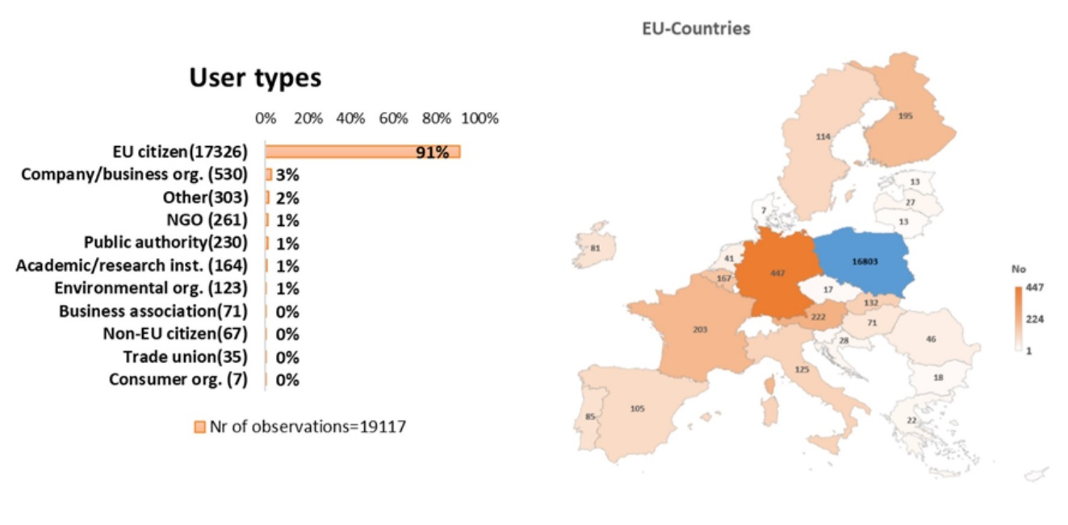
Figure 1 Respondent type & geographic distribution
Regarding respondents’ connection to forests, the most frequently chosen option was “visiting forests regularly, e.g. for health, well-being, nature observation” (63.22% of total, 14 204 replies, multiple options possible). 13.12% of total respondents (2 948 replies) indicated that they were a forest owner, a forest manager or a forest investor. 9.65% of total responses (2 169 replies) suggested that their livelihood is dependent on forests. Another 8.23% (1 848) indicated that they either work in a forest-based industry, with (peri-) urban green spaces or as a forest researcher.
Respondents were also asked to indicate which sectors they are active in to further detail their stakeholder type (up to three sectors could be selected). Amongst the organisations that provided a response, forestry was selected most frequently (29.54%, 1 056 replies), followed by biodiversity/environment (17.29%, 618 replies), and climate change (9.09%, 325 replies). EU citizens also selected forestry most frequently (14.41%, 3 790 replies), followed by a non-predefined sector (13.80%, 3 630 replies), and biodiversity/environment (9.10%, 2 392 replies).
  - Overview of results
The OPC included 16 questions on the new EU Forest Strategy for 2030, separated into two parts. The first three questions in Part I focussed on the roadmap published in October 2020, and the remaining 13 questions concerned various forest aspects and were not mandatory to fill in. All questions allowed for an additional open feedback and responses were systematically analysed and reported for the roadmap questions. As questions for Part II were optional, percentages presented for Part II refer to the respondents of the presented stakeholder group that answered the question concerned. Some questions allowed respondents to ‘rate’ options (from -2 to +2 or “not important at all” to “very important” or “not challenging” to “very challenging”). In Part II, questions 4, 5, 8, and 9 were more relevant for organisations, question 13 was primarily relevant for citizens, while the other questions were relevant for all groups. This is reflected in the reporting which focusses on the responses from the targeted groups per question. In the analysis of Part I and II, the replies for ‘important’ and ‘very important’ are jointly categorized as ‘important’.

  - Analysis of replies to Part I of the questionnaire: Views on potential objectives and actions of the new forest strategy
Nurturing forests
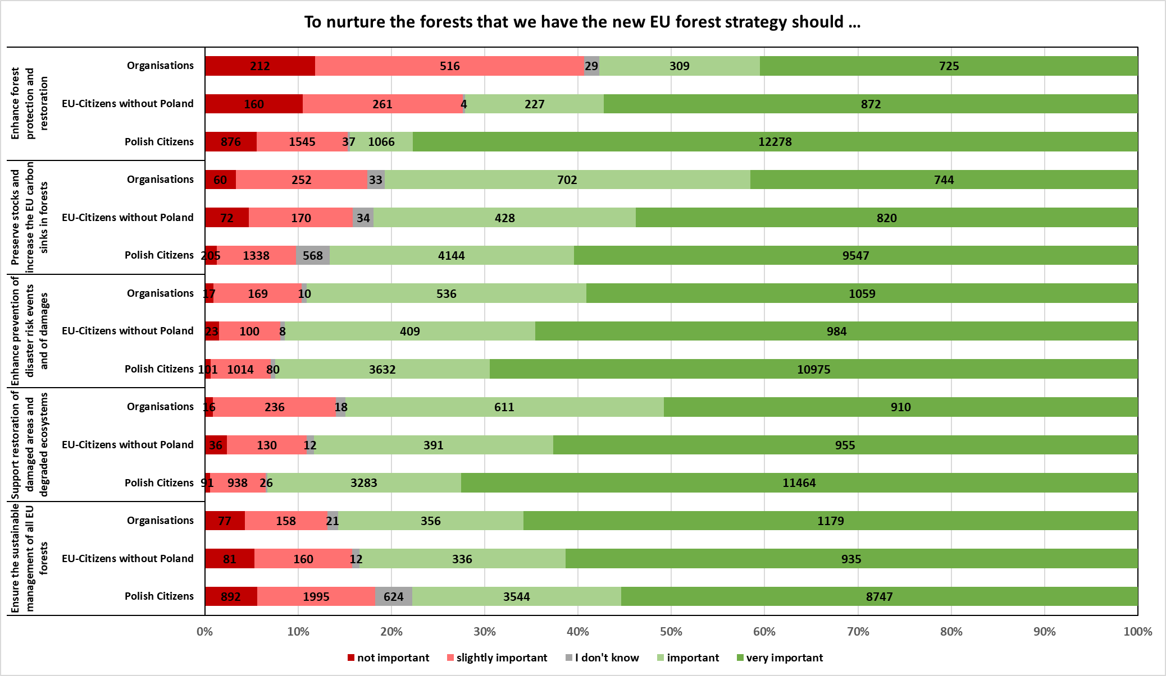
Figure 2 Responses to Roadmap Question 1 – Nurture
While all options could be rated, the objective selected most frequently by organisations (1 791) as ‘important’ for nurturing existing forests was to enhance prevention of disaster risk events and of damages, and secure forest resilience to incidence and extent of fires and other natural hazards, and secure forest health with a view to changing climatic conditions and environmental degradation (89.06%), followed by ensure the sustainable management of all EU forests, maximising the provision of their multiple functions while enhancing their productive capacity (85.71%) and support restoration of damaged areas and degraded ecosystems, taking into account projected climate conditions (84.92%).
There is agreement among public authorities, business associations, and NGOs that enhance prevention of disaster risk events and of damages, and secure forest resilience to incidence and extent of fires and other natural hazards, and secure forest health with a view to changing climatic conditions and environmental degradation (92.61%, 95.77%, 93.87%) are the most important measures. Representatives from trade unions most frequently selected ensure the sustainable management of all EU forests as ‘important’ (87.39%). Environmental organisations most frequently considered support restoration of damaged areas and degraded ecosystems, taking into account projected climate conditions as ‘important’ (97.56%)
Non-Polish EU citizens (1 524) selected most frequently as ‘important’ enhance prevention of disaster risk events and of damages, and secure forest resilience (91.40%), support restoration of damaged areas and degraded ecosystems, (88.32%), and ensure the sustainable management of all EU forests (83.40%).
Polish Citizens (15 802) selected most frequently as ‘important’ support restoration of damaged areas and degraded ecosystems (93.32%), enhance prevention of disaster risk events and of damages, and secure forest resilience (92.44%), and preserve stocks and increase the EU carbon sinks in forests, their soils and harvested wood products (86.64%).
In the open feedback, public authorities and business associations emphasised the need to define old-growth forest and primary forests, as well as strict protection and the need to further differentiate questions; some of them also prefer to deal in general with forest issues at the national level. Public authorities noted that the roadmap misses the objective to establish and elaborate protected and strictly protected areas and needs to better consider the balance between forests and hunting, forest planning to address climate change versus protection of seminatural habitats, and the multifunctionality of forests. Private sector organisations emphasised the need for a holistic approach to foster the competitiveness of the forest-based sector including bioenergy and harvested wood products (HWPs). Business associations also referred to the need to align with the EU biodiversity efforts. A large number of NGOs and environmental organisations frequently noted that forests should be left unmanaged, the forest policy should build on the EU biodiversity strategy, and climate efforts should not lead to monocultures or harm biodiversity. They also objected against biomass use & energy and considering HWPs as carbon sinks, and there was strong criticism concerning the term “sustainable forest management” because it is lacking a clear and widely shared definition and should be replaced with clear and quantifiable metrics. It was also frequently noted that the question-and-answer option design grouped too many opposing concepts together, reducing overall clarity for the respondents.
Planning for the forests of the future
While all options could be rated, the objective selected most frequently by organisations (1 791) as ‘important’ for planning for the forests of the future was adaptation of forests to climate change and strengthening their resilience to face future challenges, including through enhanced conservation and use of the genetic diversity of trees (91.79%), followed by rural development, including local enterprises and value chains, tapping on forests’ multiple functions (87.05%), and a strong research and innovation agenda to improve our knowledge of forests and to optimise their composition, structure, management and use, including for the bioeconomy (82.30%).
There is agreement among all organisations that adaptation of forests to climate change is the most important measure to plan for the forests of the future (business associations: 90.14%, public authorities: 92.61%, trade unions: 91.43%, environmental organisations and NGOs: 91.10%, business associations: 90.14%). Business associations also note a strong research and innovation agenda to improve our knowledge of forests with the same share.
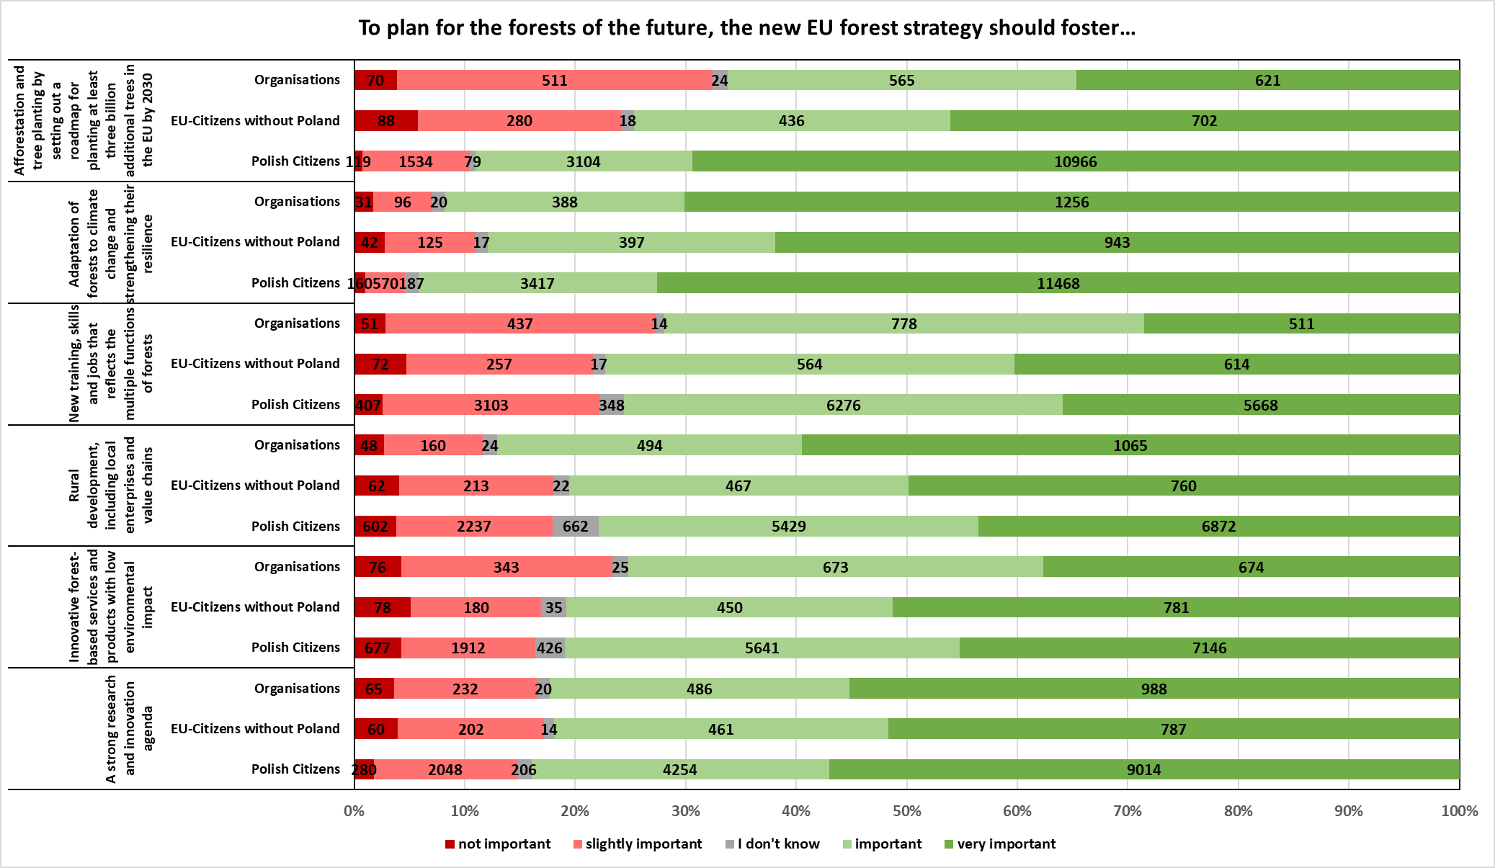
Figure 3 Responses for Roadmap Question 2 – Planning
Most frequently selected by Polish citizens (15 802) were adaptation of forests to climate change (94.20%), afforestation and tree planting by setting out a roadmap for planting at least three billion additional trees in the EU by 2030 (89.04%), and a strong research and innovation agenda to improve our knowledge of forests (83.96%).
In the additional open feedback, organisations primarily underlined the need of adaptation to climate change and shared different methods of achieving this objective. Afforestation also received significant attention, with respondents from multiple organisation types being largely supportive, but concerned about implementation. In particular business associations noted that tree planting could become a singular strategy and called for sustainable forest management to build adequate resilience against climate change. Around half of the public authorities indicated that their priority for planning new forests takes into account adaptation and building resilience to climate change, and one-third also noted that resilience to climate change should be underpinned by a strong research agenda. Multiple public authorities identified a strong research agenda as of particular importance for maintaining biodiversity and expressed the need for rural development, specifically requesting a ‘multi-functional plan’ which looks at the forest value chain. A few public authorities specified the need for training forest professional in both public and private domains. NGOs and environmental organisations also stated that the incorrect implementation of afforestation could result in detrimental impacts with regards to carbon emissions and biodiversity, especially if its purpose is to produce wood for energy. Public authorities, trade unions and business associations alike questioned the meaning of ‘enhanced conservation of the genetic diversity of trees’, stating that the wording was too vague to comment on, and therefore could not fully support the measures proposed.
Managing existing and new forests
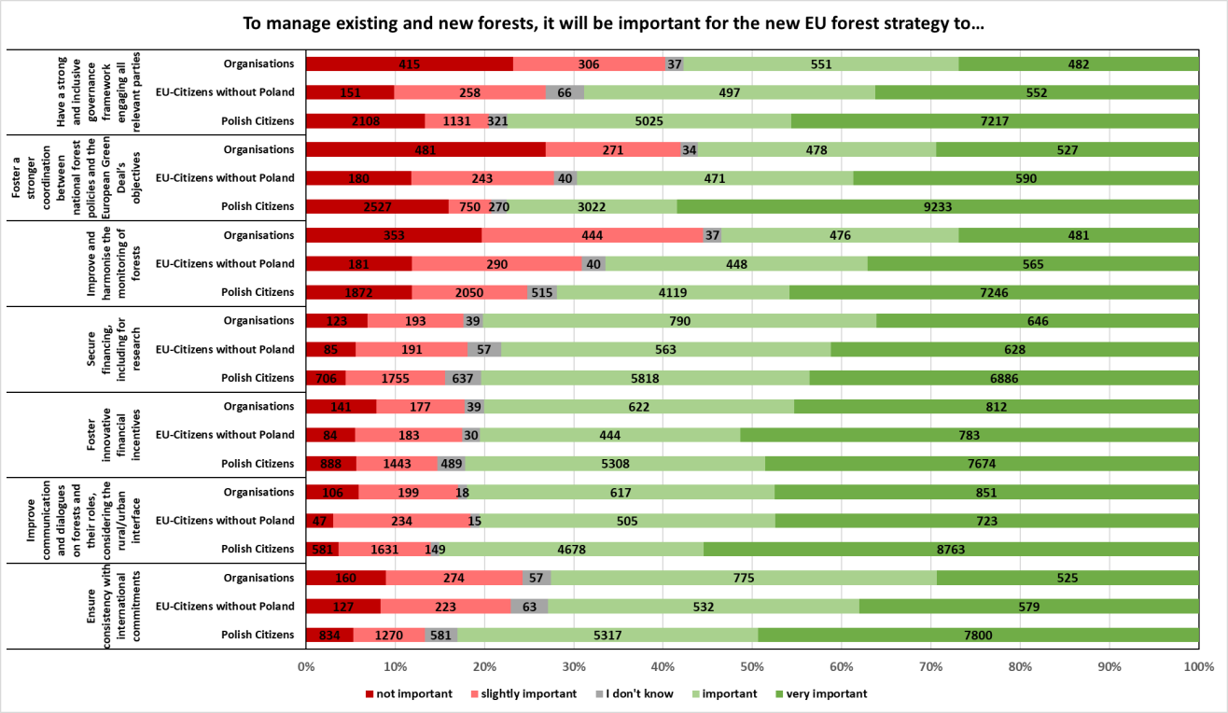
Figure 4 Responses for Roadmap Question 3 - Managing
While all options could be rated, the objective selected most frequently by organisations (1 791) as ‘important’ for managing existing and new forests was to improve communication and dialogues on forests and their roles, considering the rural/urban interface (81.97%), followed by secure financing, including for research, enhancing the use of EU and national budget, as well as private funds, ensuring a consistent approach among different funding instruments (80.18%), and foster innovative financial incentives, including payments for ecosystem services and result-based schemes (‘carbon farming’) for forest managers that provide public goods such as carbon sequestration or biodiversity benefits, including through protecting and restoring forests (80.07%). The most important measure for environmental organisations and NGOs was to ensure consistency with international commitments (84.42%).
The three options most frequently selected as ‘important’ by non-Polish EU citizens (1 524) were improve communication and dialogues on forests and their roles (80.58%), followed by foster innovative financial incentives (80.51%) and secure financing (78.15%).
Most frequently selected by Polish citizens (15 802) as ‘important’ were improve communication and dialogues on forests and their roles (85.06%), ensure consistency with international commitments (83.01%), and foster innovative financial incentive (82.15%).
In the open feedback, primarily Polish public authorities and one Swedish public authority noted that management and monitoring of new and existing forests should remain the responsibility of Member States, and a significant portion of them also expressed that it was “essential that the definition of forest was the same in all Member States”. Several local authorities stated that the new EU forest strategy should focus on “integration of other policies within the European Green Deal”. NGOs and environmental organisations alike shared concerns that the forestry agenda was still not science-driven; they also broadly supported fostering coordination between EU Green Deal objectives and national forest policies, as well as consistency of the new forest policy with international commitments. A few organisations expressed concern that financial incentives may be translated into purchasing carbon offsets in the land sector. In addition, some NGOs commented on how exchanges between citizens and forest authorities happen quite late in forest governance processes, and proposed an earlier engagement within the governance framework.
  - Analysis of replies to Part II of the questionnaire: Optional questions on various forest aspects
The report for Part II groups answers into themes. Since group sizes differ, the three most frequent options are reported by the percentage of responses which selected an option as ‘very important’ or ‘important’. Response option ‘other’ was hardly selected and excluded from the statistical analysis.
THREATS AND CHALLENGES FOR EU FORESTS
Q1 Respondents were asked to rate which potential obstacles posed a challenge or threat to forests. Organisations felt that climate change and extreme events posed the greatest threat (90.13%), biological threats such as diseases/invasive species/game (73.40%), followed by biodiversity loss, and ecosystem degradation and vulnerability of monocultures (65.76%). The three options most frequently selected as posing the greatest threat by non-Polish EU citizens were climate change and extreme events (84.79%), followed by direct human induced deforestation (74.02%), and biological threats" (e.g. diseases/invasive species/game) (73.87%). For Polish citizens they were climate change and extreme events (90.33%), followed by direct human induced deforestation (87.98%), and biodiversity loss, ecosystem degradation and vulnerability of monocultures) (84.73%).
FORESTS FOR SOCIAL AND ECONOMIC WELFARE IN RURAL AREAS
Q2 Regarding what should be done to ensure that forests continue to provide rural communities with livelihoods and income, organisations selected most frequently as ‘important’ direct economic/financial incentives (85.57%), followed by cooperation/partnership building (82.59%) as second priority, and improving forest management (e.g. digitalisation/infrastructure) (73.29%) as the third one. Non-Polish EU citizens most frequently selected as ‘important’ direct economic/financial incentives (84.65%), followed by cooperation/partnership building (79.06%), and technical support e.g. job creation/training/advisory services (78.11%). Polish citizens selected the same sequence of response options with 88.96%, 80.88%, and 74.90% respectively.
FORESTS FOR CLIMATE AND BIODIVERSITY
Q3 Concerning specific actions and measures that should be promoted to enhance forest biodiversity, adapt forests to climate change and strengthen carbon sequestration, organisations selected most frequently as ‘important’ increase forest species diversity & select native and better climate-suited species (81.41%). Next, they selected the promotion of long-living wood products and alignment of wood demand (73.24%), and improve forest management incl. improved biodiversity practices (67.79%). Non-Polish EU citizens selected the same sequence of response options with 82.25%, 80.90%, and 76.32% respectively. Polish citizens second most frequently selected as ‘important’ was afforestation / reforestation / forest & soil protection (85.22%); but the first and third response was the same as in the other two groups with 88.87% and 83.22% respectively.
EU/NATIONAL SUPPORT AND INSTRUMENTS
Q4 Regarding what should be done to facilitate access to, and improve the use of, EU and national funds for forest management and forest-related activities, organisations most frequently chose as ’important’ improve funding allocation (86.69%), followed by increasing EU co-funding rates (79.48%), and prioritisation of forests in budget allocation and expenditure (78.23%).
FOREST-RELATED CHALLENGES FACING FOREST-BASED INDUSTRIES
Q5 On the main forest-related challenges facing the forest-based industry sector in their respective countries and the EU as a whole, organisations most frequently selected lack of skilled labour force (66.28%), and with somewhat lower shares unclear forest policy objectives and regulatory framework (49.48%), and lack of price premium for sustainable products (47.98%).
PROMOTION OF WOOD PRODUCTS
Q6 Concerning what could be done to promote the wider use of sustainable wood-based products to boost recycling rates, organisations stated that the most important objective was to support research on new and innovative wood-based products (85.47%), followed by better information, communication and exchange of practices (81.86%), and economic incentives (79.47%). Non-Polish EU citizens most frequently selected as ‘important’ support research on new and innovative wood-based products (82.89%), followed by economic incentives (82.56%), and better information, communication and exchange of practices (81.82%). Polish citizens selected the same sequence of response options with 85.66%, 85.26%, and 84.38% respectively.
CERTIFICATION AND LABELLING
Q7 In regards to the extent to which stakeholders know or use tools that certify the sustainability of forest products (forest certification, product labelling), organisations selected in my purchasing decisions, I am more likely to trust certified products from EU forests most frequently (22.73%), followed by I do not trust the existing labelling and certification systems and I would like that the EU does something about it (19.26%), and certification/labelling is sometimes an important criterion driving my decision to buy a product (18.07%). Non-Polish EU citizens selected the same sequence of response options with 27.31%, 21.69%, 16.35%, respectively. Polish citizens most frequently selected I don’t know of any labelling or certifying systems for forest-based products (45.80%); but the second and third response was the same as for the other stakeholder groups with 19.87% and 11.11%, respectively.
FOREST INFORMATION AND MONITORING AT EU LEVEL
Q8 Respondents were asked what should be done to improve forest data, knowledge and monitoring of EU forests. Organisations selected most frequently monitoring climate risks and forest condition (84.50%), and next harmonise national forest inventories (71.58%), and increase use of remote sensing/satellite data (64.13%).
ENSURING CONSISTENCY WITH INTERNATIONAL AGREEMENTS AND SHOWING GLOBAL LEADERSHIP
Q9 Regarding the most important way the EU forest strategy should ensure consistency with international commitments and to support EU’s international leadership, the three preferred options for organisations were set out the EU’s positions, approaches and values in favour of sustainable forest in relevant fora (85.35%), closely followed by ensuring consistency between the EU’s domestic policies and trade agreements (84.03%) and promotion of experience and lessons learnt at EU level (82.95%).
PLANTING AT LEAST 3 BILLION ADDITIONAL TREES IN THE EU BY 2030
Q10 Respondents were asked where the 3 billion additional trees should be planted. The three most frequently selected options by organisations are, afforestation of degraded land (23.52%), tree planting as part of forest restoration (15.63%), and landscape features to foster connectivity (14.13%). Non-Polish EU citizens replied with the same sequence of response options and shares of 24.81%, 15.49%, and 13.18%. Polish citizens ranked highest afforestation of degraded land (23.05%), followed by tree planting for agroforestry, including orchards (17.82%), and tree planting as part of forest restoration (16.28%).
Q11 Respondents were asked what are the main challenges in terms of planting additional trees in their respective countries. Organisations identified Financial resources / loss of farmland value after conversion to forest land as the most challenging obstacle (62.88%), followed by barriers to transnational production/transfer (46.29%) and unfavourable climatic conditions (43.83%). Non-Polish EU citizens found financial resources / loss of farmland value after conversion to forest land (55.03%), local acceptance/administrative procedures (48.59%), and finding appropriate spaces (45.82%) most challenging. Polish citizens selected the same first and second options as non-Polish EU citizens most frequently with 61.18% and 59.82% respectively; but their third most frequently selected choice was unfavourable climatic conditions (41.79%).
Q12 Respondents were asked how the EU could encourage the wider use of forests for the health and well-being of all. Encouraging forest-related educational opportunities was selected most frequently by organisations (87.26%) followed by raise awareness of the health benefits of forests (83.68%) and promote the exchange of best practices and other communication efforts on the multiple roles of forests (77.42%). Non-Polish EU citizens ranked highest encourage forest-related educational opportunities (81.63%), promote the exchange of best practices (76.62%) and raise awareness of the health benefits of forests (73.62%). Polish citizens selected raise awareness of the health benefits of forests (91.45%), encourage forest-related educational opportunities (90.29%), and promote the exchange of best practices and other communication efforts on the multiple roles of forests (82.69%).
Q13 Respondents were further asked if they had ever paid to compensate for the CO2 emissions associated with their purchases through tree planting schemes. 26.48% of organisations, 29.54% of non-Polish EU citizens and 26.45% of Polish citizens responded that they had paid CO2 emissions compensation through tree planting schemes.
- Analysis of additional documents submitted to the public consultation
A total of 228 additional documents (e.g. position papers) were submitted as part of the roadmap consultation (86), open public consultation (133), and via direct submission to the Commission (9). This analysis covers sampling of 30 papers from a range of public and private stakeholders from within EU Member States and stakeholders with a pan-EU focus, 10 of these were submitted as part of the initial roadmap consultation and separately sampled after a review of the responses received to the roadmap consultation. All organisation types were included in the sample. Position papers were analysed based on the objectives of the roadmap and aligned with the roadmap questions of the OPC. Results are presented grouped by the three roadmap themes, nurture forests, plan for forests of the future, and manage new and existing forests.
To Nurture Forests

Business associations note that, while forest protection is important for biodiversity, protection objectives do not actually contradict production or sustainable forest management, with one business association suggesting that forest protection should be left to Member States. Similarly, companies largely want to protect and restore forests in an effort to combat climate change, though also consider that management and production could be integrated. Public authorities and non-governmental and environmental organisations want to increase protections and restrict industry measures, in particular the restriction of biomass use for energy in the renewable energy directive. Preservation of stocks and increasing carbon sinks was of interest to the majority of stakeholders. All stakeholders agree that forest protection must include initiatives to counter fires, pests and diseases. Suggestions of how to accomplish this objective included employing local initiatives to manage forests, mixed forests with natural regeneration, a higher proportion of deciduous trees, and active and timely management to contain disasters. One public authority referred to the importance of conserving and using forest tree genetic resources plays a key role in forest adaptation. All stakeholders support restoration of damaged areas and degraded ecosystem. Companies and business organisations pointed to the natural limitations of forests and suggested monitoring of restoration objectives at global scale. An environmental organisation and a research institute suggested that restoration measures should include biodiversity targets. A central theme of several position papers was that the EU Forest Strategy for 2030 should ensure sustainable management of EU forests. In this regard, NGOs and environmental organisations stress that current sustainable forest management practices are not sufficient. One NGO also mentions that sustainable forest management needs a clear widely adapted definition since for example currently clear cutting of forests would still be seen as sustainable. Another NGO stressed that the EU also needs to support sustainable forest management and forest conservation in non-EU countries and to ensure consistency with the EU Timber Regulation and Forest Law Enforcement, Governance and Trade Regulation. Other measures suggested to achieve this include the use of binding forest protection criteria in trade agreements.
To Plan for Forests of the Future

Several position papers commented on planning for forests of the future, specifically in terms of afforestation and tree planting. Out of three business associations which covered this topic, two stressed the importance that the areas for tree planting, including under the 3 billion trees initiative, should be determined by the Member States. All three companies/business associations included in the sample supported afforestation in particular by converting unused land, one company also mentioned the potential of using the offsetting emissions via afforestation. Environmental organisations and NGOs stressed the need to avoid monocultures and to enhance biodiversity, which also decreases vulnerability and fire risk, it was also stressed that binding nature restoration are necessary and proforestation should be promoted. One national forest ministry highlighted that it must be possible to determine the areas to be afforested at national level in order to maintain an understanding of the suitability and impacts of the sites on the environment e.g. that open habitats of cultural value should not be afforested but also that economic areas of importance should be considered. Regarding adaptation of forests to future climate change the two main suggestions by stakeholders are to foster adaptation via biodiversity and sustainable forest management, including the use of an ecosystem approach. The UN Office for Disaster Risk Reduction suggests to increase research into climate-resilient tree species, and a company suggested direct adaptation support could be financed via carbon offsetting by companies. One research institute noted that climate change adaptation requires increased attention on fire, pests and disease. Only five position papers mentioned training and jobs in the context of planning new forests with only one clear recommendation by an NGO that foresters should be trained on the consequences of climate change. In terms of rural development, several stakeholders felt that the strategy should emphasise the entire forest value chain which has a huge impact on rural development. Two business associations asked for the Common Agriculture Policy (CAP) to maintain and increase its focus on forests. One stressed the need to coordinate rural development policies with the forest strategy and one suggested that an ecosystem restoration fund levied through the CAP or Emission Trading Scheme (ETS) could boost rural development. The discussion surrounding the role of innovation with regards to forest-based services and products focussed on the substitution of wood biomass for fossil fuels but also for carbon-intensive building materials in the building sector. One NGO stressed the importance of keeping forests out of the ETS due to uncertainty in data around forest sinks and stocks, and one NGO and one environmental organisation strongly opposed using wood for bioenergy and expressed that it should be excluded from the Renewable Energy Directive. Stakeholders from all groups expressed the need for additional research to support an effective sustainable forest management strategy, including increasing forests’ resilience towards natural disasters, adapting to climate change and improving the sustainability of wood biomass. Less common suggestions includes improving resource efficiency and improving links between research and policy.
To Manage New and Existing Forests

Stakeholders have diverging views regarding the governance to manage new and existing forests. Business associations, a trade union, and one public authority prefer forest policy to be left to Member States, the business associations and the trade union go even further and prefer to use a bottom-up approach where forest owners are at the core of the forest strategy and forest governance. One public authority highlighted that including cities as part of the forest governance will support the management of forests, and it would make sense as city dwellers need near-by forests for recreation. NGOs had several suggestions to improve governance including establishing further guidelines on biodiversity-friendly reforestation and close-to-nature management and having regular checks on whether actions in Member States are implemented, and to ensure that local communities from forest areas have a voice in decision making. Stakeholders were in agreement that national forest strategies should have a strong coordination function with the EU Green Deal objectives and other EU Green Deal policies. Stakeholders were also in agreement that the new forest policy is pivotal to integrate existing forest policies into the Green Deal. Responses from public authorities, business associations, and NGOs highlight that the wood value chain could be a contributing factor in achieving the Green Deal objectives. NGOs and environmental organisations expressed the view that the forest strategy needs to align with a number of other policies such as the Biodiversity strategy for 2030 and the other policies under the Green Deal. Regarding improving and harmonising the monitoring of forests all stakeholders agree that this is a prerequisite for sustainable forest management. Suggestions included cooperation across the borders in the event of pests or fire, monitoring the enforcement of bans on commercial forestry, establishing a harmonised monitoring system, monitoring biodiversity, and improving the quality of forest data for monitoring. One public authority mentioned that the EU has to improve the knowledge base on forest biodiversity through harmonised reporting based on national forest inventories. Securing financing was identified as a challenge by multiple stakeholder groups. There was a wide range of suggestions in separate areas. One international organisations highlighted the current fragmentation in financing as a challenge where funding comes from smaller forest departments rather than from environment, health or social departments, which benefit of the forest regulatory services. Business associations stressed the importance of the forest policy to provide a stable and predictable policy framework to channel investments into the sector and making use of existing instruments such as the CAP. Stakeholders also agreed that innovative financial incentives will be positive, but views differed how these incentives should look like. The NGOs and environmental organisation which mentioned this topic highlighted that financial incentives should be provided through payments for ecosystem services which rewards forest owners for actions to protect forest areas. One NGO also mentioned that the polluter pays principle should be employed through a tax on forest products based on their ecological footprint to prioritise long-lived wood product. Lastly, all stakeholder groups were in agreement that improving the dialogue with the public would be a positive step in the new strategy. All stakeholder groups agree on ensuring consistency with international commitments.

- Sources of the evidence used in the preparation of the Forest Strategy
  - Forest area and cover, and their changes over the last 30 years
When looking into forest area and cover it is important to consider that the term ‘forest’ may have very different meanings depending on the context. As a result, different data sources may use different forest definitions or even concepts, typically linked to the assessment methods and criteria agreed in various international frameworks. Great care should thus be taken when using, comparing, or combining, forest area and forest cover estimates.
A fundamental distinction needs to be made between forest as land cover and forest as land use. Land cover describes the state of the land, often closely linked to the instant or short period an observation is made, e.g. using a sensor aboard a satellite or other forms of Earth Observation. Land use focuses on the function of a piece of land, recorded in cadastral information or land use or management plans, which may disregard the momentary state of the land. This has important implications for managed forest land that undergoes cycles of planting, growth, and harvest. When such land is recently harvested the area seizes to be forest in terms of land cover, until the trees regrow. In terms of land use, however, this land is considered forest throughout the management cycle, including when no trees are present.
Many forest land cover maps follow the Food and Agricultural Organization (FAO) modular-hierarchical Land Cover Classification System. At the regional scale, Forest Europe makes use of the FAO results under the Forest Resources Assessment (FRA), following a land use definition for reporting on the European forest area. Countries validate collected information before publishing and aligning forest definitions on forest cover and land use. At the European scale, data on forest is gathered by the CORINE Land Cover monitoring (CLC) combining land cover information from satellite with land use information from other sources.
The FAO-FRA definition of forest is “land spanning more than 0.5 hectares with trees higher than 5 meters and a canopy cover of more than 10 percent, or trees able to reach these thresholds in situ. It does not include land that is predominantly under agricultural or urban land use.” EUROSTAT and Forest Europe make use of the same definition. The FAO-FRA definition provides further explanations such as that forests are designated landholdings used as forests, regardless of their current vegetation. Regeneration sites after harvesting, understocked sites due to clear-cut and (natural) disasters, nurseries, forest roads and firebreaks, rubber-wood, cork oak and Christmas tree plantations, areas with bamboo and palms (if height and canopy cover criteria are met) etc. are included in the forest area. It excludes tree stands in agricultural production systems such as in fruit plantations and agro-forestry systems, and trees in urban parks and gardens.
The CORINE Land Cover (CLC) definition of forest is: “Areas occupied by forests and woodlands with a vegetation pattern composed of native or exotic coniferous and/or broad-leaved trees and which can be used for the production of timber or other forest products. The forest trees are under normal climatic conditions higher than 5 m with a canopy closure of 30% at least. In case of young plantation, the minimum cut-off-point is 500 subjects by ha.” This definition uses forest cover to refer to areas where trees dominate a vegetation type. ‘Forest cover’ is mainly used when assessments are based on remote sensing and legal designation of the land is unknown or not considered. This definition also uses criteria for minimum tree cover, minimum tree height and a minimum area below which the area it is not considered a forest. CLC information is limited by a minimum mapping unit of 25ha.
Besides the FAO and CLC assessments, which both have their own definition of forest, the EUROSTAT LUCAS and the UNFCCC-LULUCF are noteworthy. They both build on the FAO forest definition concept to collect and process data of the forest area but have their own specific criteria and thresholds set in their specific policy context.
The EUROSTAT LUCAS survey is a European-scale field survey. It generates harmonised forest land cover and land use data for European statistics through direct field observations every three years since 2006 (EUROSTAT-LUCAS). The LUCAS ‘Woodland’ land cover class equals the FAO Forest class and the ‘Shrubland’ cover’ class is equal to the FAO class ‘Other Wooded Land’. The share of forest area based on the LUCAS data is used as indicator for the Sustainable Development Goal Life on land (SDG 15).
Under the UN Framework Convention on Climate Change (UNFCCC), parties annually report on land use, land use change and forestry (LULUCF) to provide information on carbon greenhouse gas emissions and removals from land use including forests. The forest definition follows the 2006 IPCC Guidelines on national greenhouse gas inventories (vol. 4) which allows to set minimum thresholds for area, tree height and tree crown cover density according to national circumstances. Specific Member States implementations are reported in National Inventory Reports and listed in Annex II of the LULUCF Regulation.
Besides forest itself, there are other terms that are used in land classifications that may influence the forest area. The FAO forest assessment defines two classes similar to forests: ‘Other Wooded Land’ (OWL) and ‘Other land with tree cover’ (OLT). EUROSTAT and Forest Europe make use of the same categories. The FAO defines OWL as land with a canopy cover of 5-10 per-cent of trees able to reach a height of 5 m in situ, or a canopy cover of more than 10 percent when smaller trees, shrubs and bushes are included. Other Land with Tree cover (OLT) is defined as ‘Other land’ that is predominantly agricultural or urban land use and has patches of tree cover that span more than 0.5 hectares with a canopy cover of more than 10 percent of trees able to reach a height of 5 meters at maturity” and including both forest and non-forest tree species. Similarly to the FAO category ‘Other wooded land’, LUCAS also considers class ‘Other wooded land’, while the CORINE land cover classification includes a category called ‘Transitional woodland and shrub’. The IPCC guidelines do not foresee such a top level land use category but could allow for specific implementations at sub-category level.
The comparison of the forest area (including Other wooded land) from the different assessments shows that they result in a different forest area for Europe (Figure 5). This comparison is further complicated by the fact they have different assessment years. The difference between to FAO’s 2020 estimate for the EU27 forest area (159 million ha), and the LULUCF estimate from 2019 (163 million ha) is greater than 4 million hectares, or roughly the forest area of Latvia. The CORINE Land Cover reports the lowest forest area, even when the area for ‘Transitional woodland and shrub’ is included.
The forest area for the EU27 reported in the forest assessments of FAO-FRA, LULUCF, CLC, and LUCAS show large differences over the period 1990-2020 (Figure 6). The forest area according FAO-FRA (the sum of Forest and OWL) amounts to approximately 180 million ha in 2020, which is similar to the forest area reported by LUCAS (2018), but much higher than the area reported by CLC and LULUCF. FAO-FRA reported for 2020 a 10% higher forest area (ca. 17 million ha) than was reported by LULUCF, which could mainly be explained by the inclusion of the OWL class in the FAO-FRA forest area. Although the class Transitional woodlands and shrubs is included in the CLC forest area in the graph, which together with the CLC Forest class theoretically covers about the same land cover types as the FAO Forest and OWL classes, the area reported by CLC is 23 million ha lower than that reported by FAO-FRA.
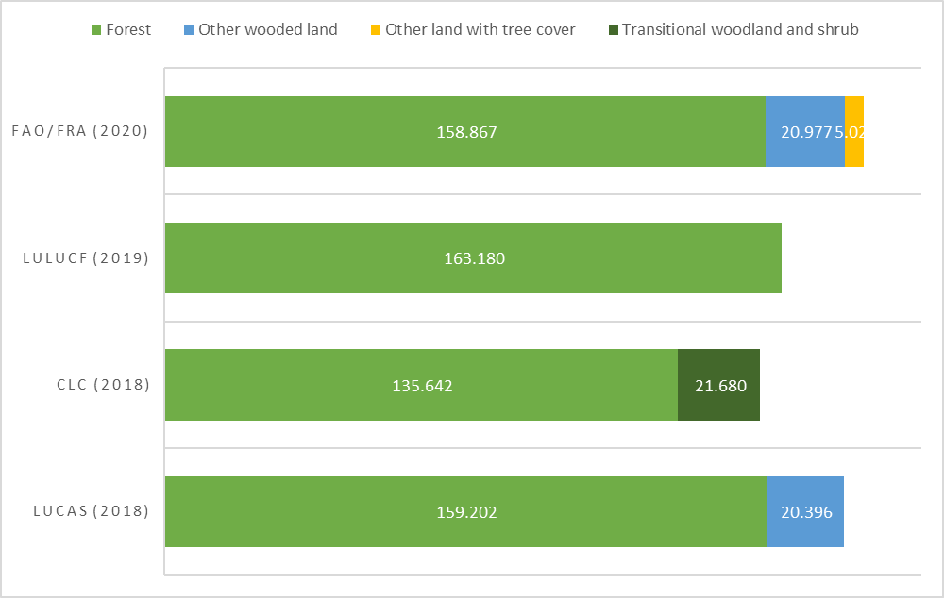
Figure 5 Forest area (1000 ha) for the EU27 according to different forest assessments of FAO-FRA, LUCAS, CORINE Land cover, and LULUCF (year of reporting for sources: FAO-FRA: 2020, LUCAS: 2018, CORINE-CLC: 2018, UNFCCC: 2019). LULUCF includes managed and unmanaged forests as defined by IPCC.
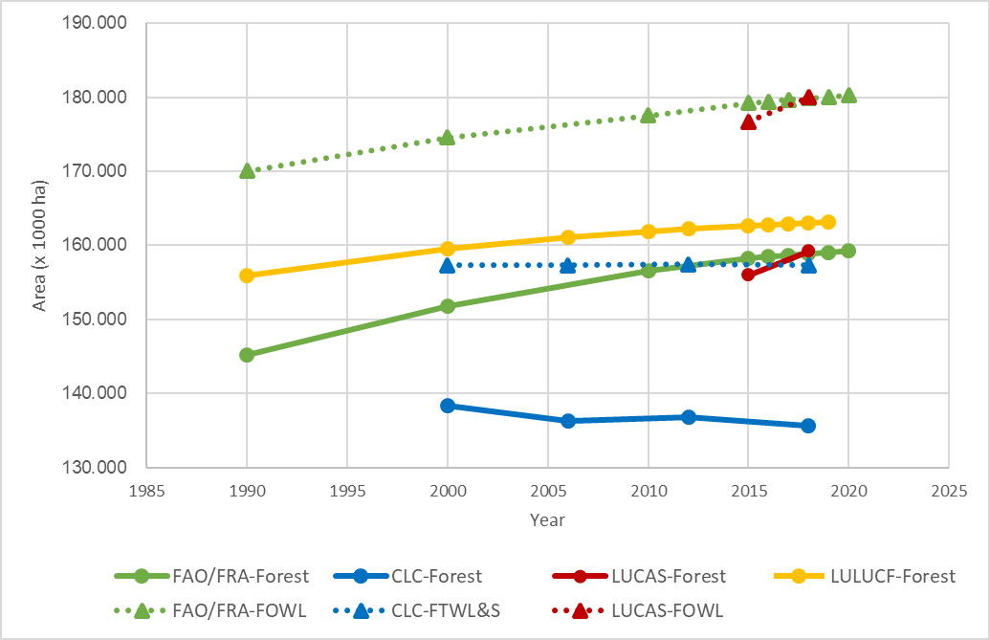
Figure 6 Forest area for the current EU27 Member States. FAO-FRA data is presented for both “forest area” and “forests and other wooded land” (FOWL), and LUCAS data is presented in a similar manner (“forest” area and “forest and other wooded land” – FOWL). ; CLC data is presented as “forest” area (including broadleaved forest, coniferous forest, mixed forest) and “forest and transitional woodland and shrub’ (FTWL&S). LULUCF includes managed and unmanaged forest as defined by IPCC.
All four assessments for the EU27 show an increase of the forest area for all periods considered, yet at a slower pace in the last 15 to 20 years. The hybrid land cover-land use CLC assessment even shows a slight decrease in forest area of 108.000 ha over the period 2012 to 2018.
These assessments combined lead to some important conclusions:1) the concept of forest and land cover, land use or a hybrid of both as well as their specific definitions and thresholds is a key consideration when assessing forest cover in the EU and Member States 2) several assessments point to an increase in forest area in the last 30 years; 3) growth in forest and tree-covered area has slowed in the last two decades;
To specifically assess the development of forest area gain and loss, Figure 7 depicts the annual time series for 1990-2019 of afforested and deforested land in the EU-27, extracted from Member States’ LULUCF greenhouse gas inventory submissions of 2021 (annual land conversion estimated in CRF Table 4.1). Afforested land (the stacked bar above the zero-line) shows the land converted to forest land by IPCC land use category; deforested land (the stacked bar below the zero line) indicates to which land category forest land was converted. The black solid line depicts the net area change in forest land; that is the difference between the total afforested and total deforested land.
Notably, grasslands and croplands were converted to forests. Annual variations are mainly driven by changes in the shares of cropland conversion and to a lesser extent by grassland conversions. Losses of forest land are predominantly due to the expansion of settlements and conversion to grasslands. The dynamics by total afforested area indicate a decline from approximately 500,000 ha at the end of the last millennium to below 300,000 ha in the last 10 years. Comparatively lower variations are shown for deforested land, in most years being around 100,000 ha of forest area loss except for the period 2004-2010 reaching almost 150,000 ha. The net area change reaffirms the net area gains of forest land for all years of this 30-year time series; yet, the net area increase of forest land diminished over the last 20 years from 400kha to approximately 150kha. According to greenhouse data reporting, the EU forest area increased by 7.2 Mio ha over the 30 years in this time series.
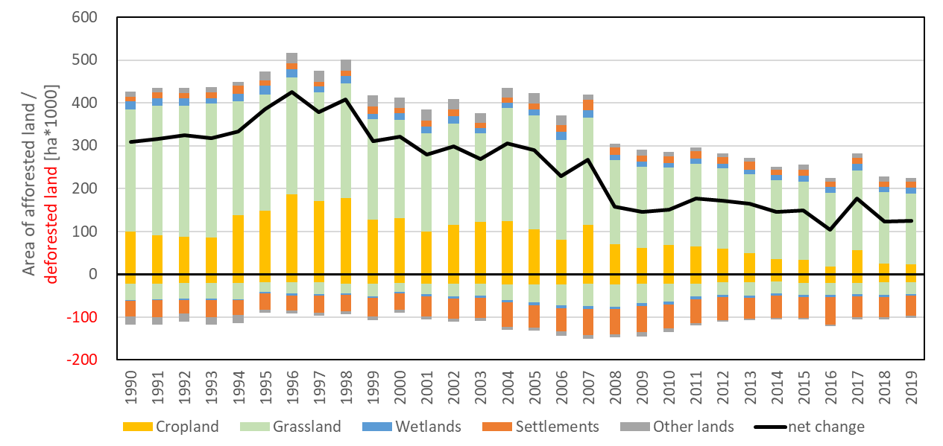
Figure 7. Area of annually afforested land deforested areas in the EU-27 for the period 1990-2019. Source: EU Member States’ GHG inventory submission of 2021, CRF Table 4.1. National Inventory Submissions 2021 | UNFCCC.
  - GHG data of the LULUCF sector including forest land
Land use in the EU is a net sink, removing more CO2 from the atmosphere than emitting greenhouse gases. Figure 8 shows in Mega tonnes of CO2 equivalents (Mt CO2-eq) the total LULUCF net removals (black line) and the net emissions or net removals by land use category as stacked bar plots (net removals have negative sign). At the EU level only forests and products from forests, so-called harvested wood products (HWP), are net removals; all other land use categories show net emissions. In recent years (2016-2018), forest land and HWPs have annually removed, on average, about -360 Mt CO2-eq and -40 Mt CO2-eq, respectively in the EU-27.Trends and variations in net removals of the land sink are predominantly driven by changes in the net removals by forest land and the associated forest products. Following an increase in removals by 70 Mt CO2-eq from 1992 and 1999, there is a plateau with some variability, which decreases by 70 Mt CO2-eq since 2013.
The vast majority of the net forest carbon sink is captured in the above and below ground living biomass, followed by sequestration mineral soils and small amounts in deadwood, which can however significantly increase after natural disturbances such as storms. It should be noted that organic soils are net emitters, which can lead to offsetting carbon sequestration by other pools and forests in such locations becoming net emitters.
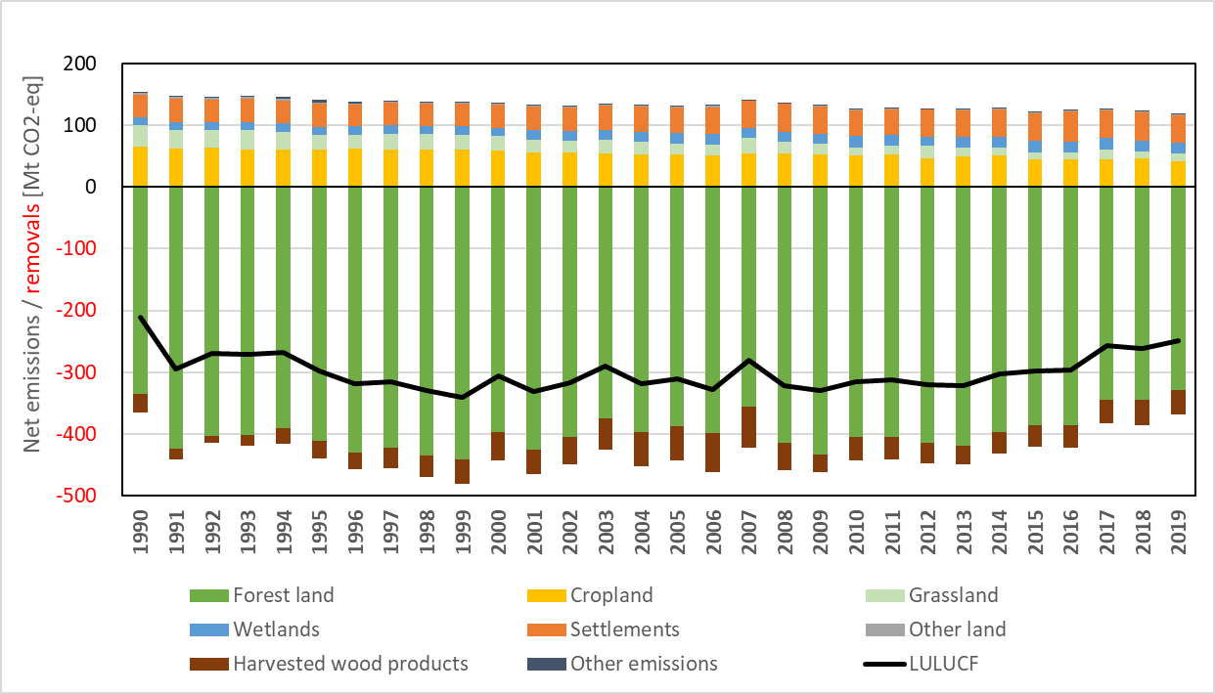
Figure 8 Net emission and removals by land use category and total LULUCF in the EU-27 for the period 1990-2019. Source: EU Member States’ GHG inventory submission of 2021, CRF Table 4. National Inventory Submissions 2021 | UNFCCC.
Figure 9 shows, by land use conversion category, net removals by afforested land (stacked bar plot below zero line) and emissions by deforested land (stacked bar plot above zero line); for land area conversions see also Figure 7. Total removals from afforested land decreased from almost 60Mt CO2-eq in 2010 to 40Mt CO2-eq in 2019, over the same period emissions from deforestation decreased from 36 Mt CO2-eq to 31 Mt CO2-eq. This reduces the net contribution of 20Mt of net forest removals by afforested land reported for the period 2000-2013 to just below 10Mt CO2-eq in most recent years. This demonstrates that the decreased rate in net forest area gain also contributed to the reduction in net removals over the last decade, yet at a lower level than other drivers.
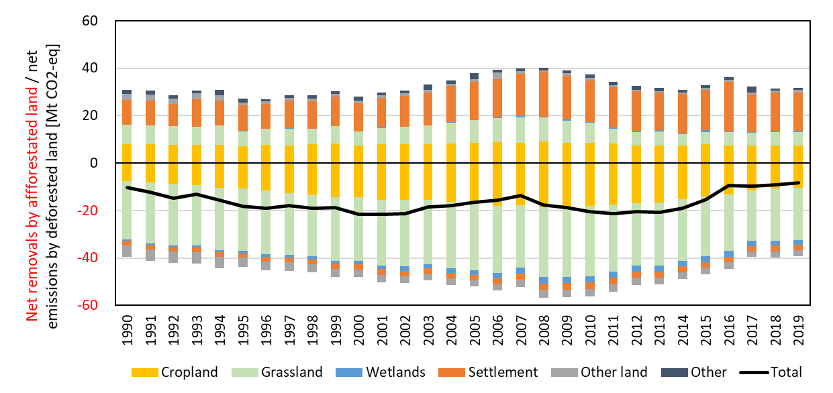
Figure 9 Net removals by afforested land and emissions by deforested land and their net total in the EU-27 for the period 1990-2019. Source: EU Member States’ GHG inventory submission of 2021, multiple CRF Tables. National Inventory Submissions 2021 | UNFCCC
  - Regime of EU’s forests
In 2020, 85% of the forest area and 88% of the growing stock was available for wood supply in the EU-27. Forest is considered available for wood supply (FAWS) when there are no environmental, social or economic restrictions that could have a significant impact on the current or potential supply of wood (Alberdi et al., 2016). A breakdown of the forest area available (FAWS) and non-available (FnWAS) for wood supply in 2020 by Member State is shown in Figure 10, based on the FAO Global Forest Resources Assessment 2020.
Given some differences in the national definitions of FAWS, the JRC worked with National Forest Inventories institutions to produce harmonized data on FAWS at sub-national scale and assess the restrictions to wood availability for 20 European countries. The results are described in a JRC Technical Report (see Figure 11 and Figure 12).
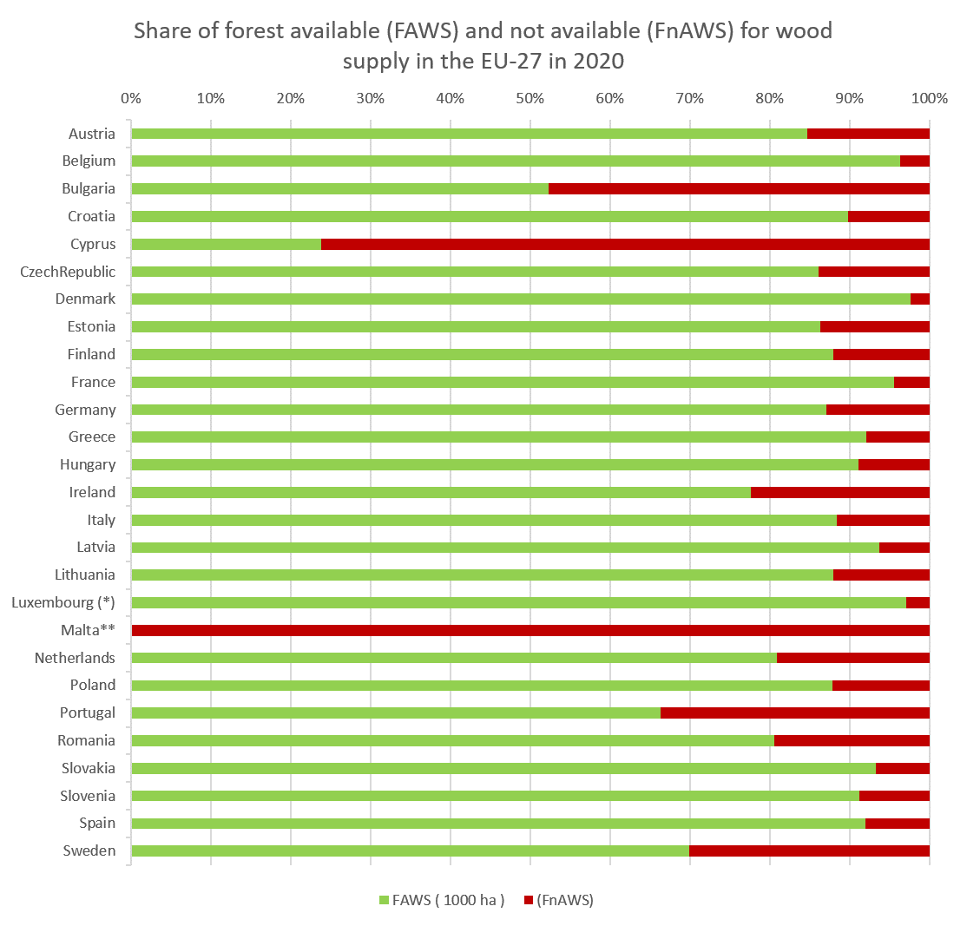
Figure 10 Share of forest land available for wood supply (FAWS) and non-available for wood supply (FnAWS) by Member state in 2020.
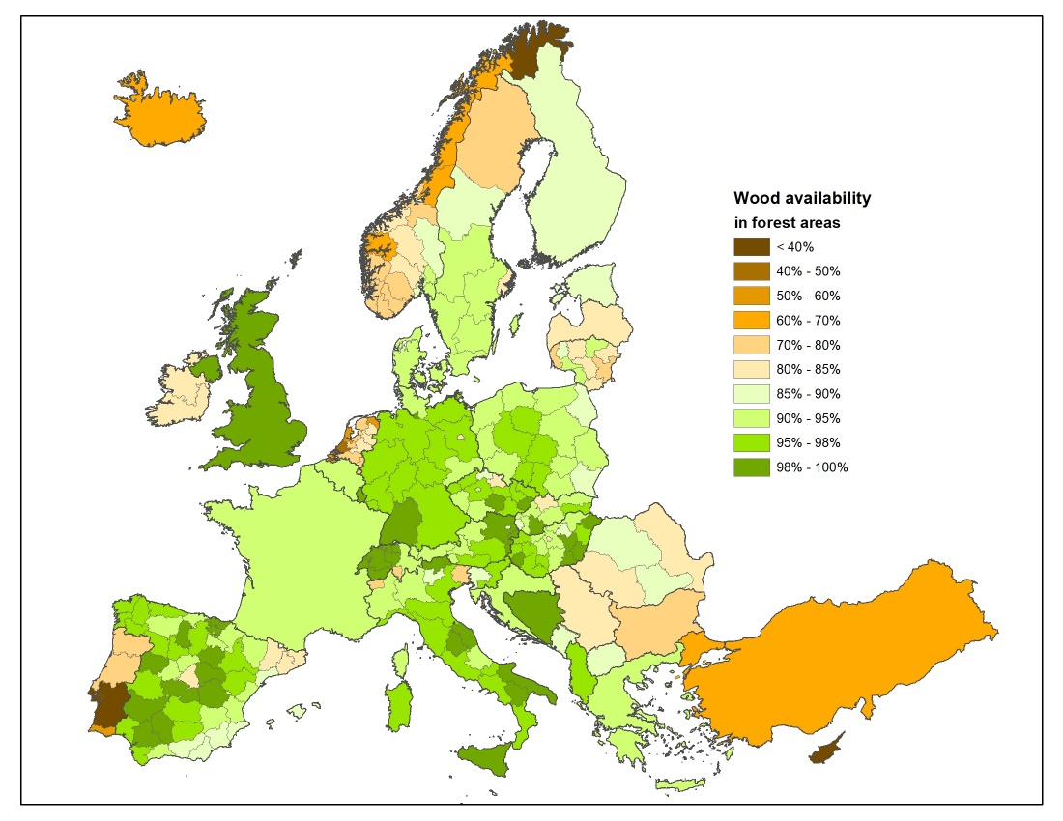
Figure 11 Percentage of wood available in European forests. The percent of wood is in unit of aboveground biomass for countries with data available at sub-national level (countries participating in the JRC study) and in unit of growing stock volume for countries
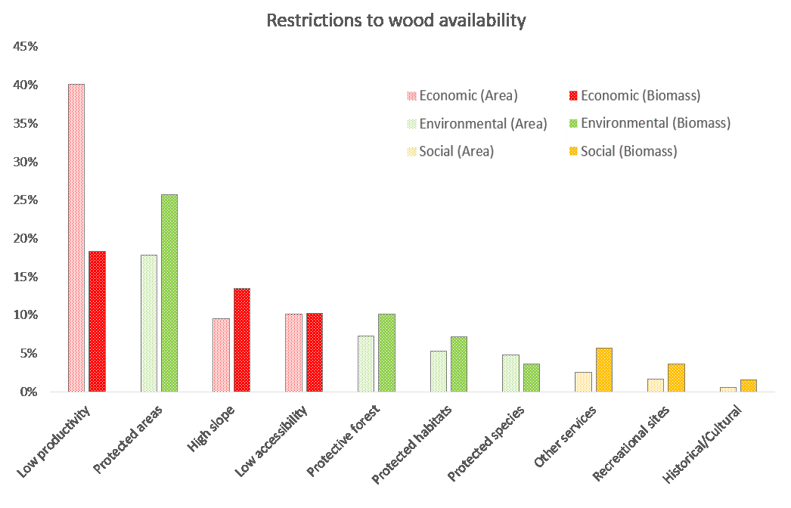
Figure 12 Percentage contribution of each restriction to the forest available for wood supply for 20 European countries in terms of area (left bars with light colours) and biomass (right bars with dark colours) . The restrictions are divided in three main categories categories: economic (red), environmental (green) and social (orange) restrictions. Source: Avitabile V., Pilli R., Camia A., The biomass of European forests, EUR 30462 EN, Publications Office of the European Union, Luxembourg, 2020, ISBN 978-92-76-26100-1, doi:10.2760/758855, JRC122635.
Primary and old-growth forests represent below 3% of the total EU forest extent. About 90% of the reported primary and old-growth forests in the EU is located in Sweden, Bulgaria, Finland and Romania. The mapped area of primary and old-growth forests in the EU is ~1.35 million hectares, however there is a pronounced mapping deficit estimated at ~4.4 million hectares. About 93% of the mapped primary and old-growth forests are part of the Natura 2000 Network, and 87% are strictly protected.
As regards forest ownership, 60 % of EU forests are privately owned (estimated at 16 million forest owners). Many different schemes of public ownership cover the other 40%, see Figure 13.
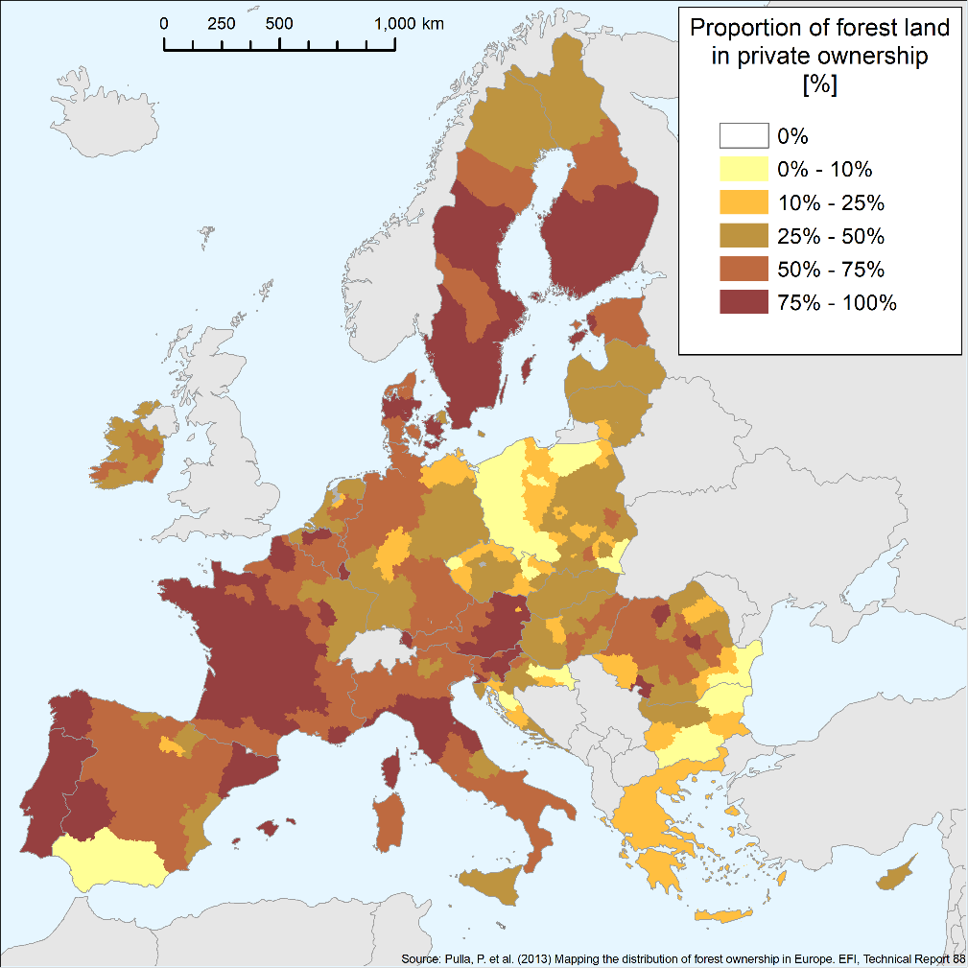
Figure 13 Proportion of forest land in private ownership. Source: Pulla, P., Schuck, A., Verkerk, P. J., Lasserre, B., Marchetti, M. and Green, T. 2013. Mapping the distribution of forest ownership in Europe. EFI Technical Report 88. 92 p.
  - Forests protected under the EU nature legislation
To preserve forests and the biodiversity that they host, specific species and habitats are protected by the Birds and Habitats Directives. The species and habitats protected under the nature legislation are to a large extent included in Natura 2000 sites. Nearly 25% of the total forest area (including transitional forest land) in the EU is part of Natura 2000 sites, according to information available in the Forest Information System for Europe – FISE (based on overlapping Corine landcover maps and Natura 2000 mapping). The same FISE data is used below for the overview of forests (in % and in ha) in Natura 2000 sites by Member State, see Figure 14 and Figure 15
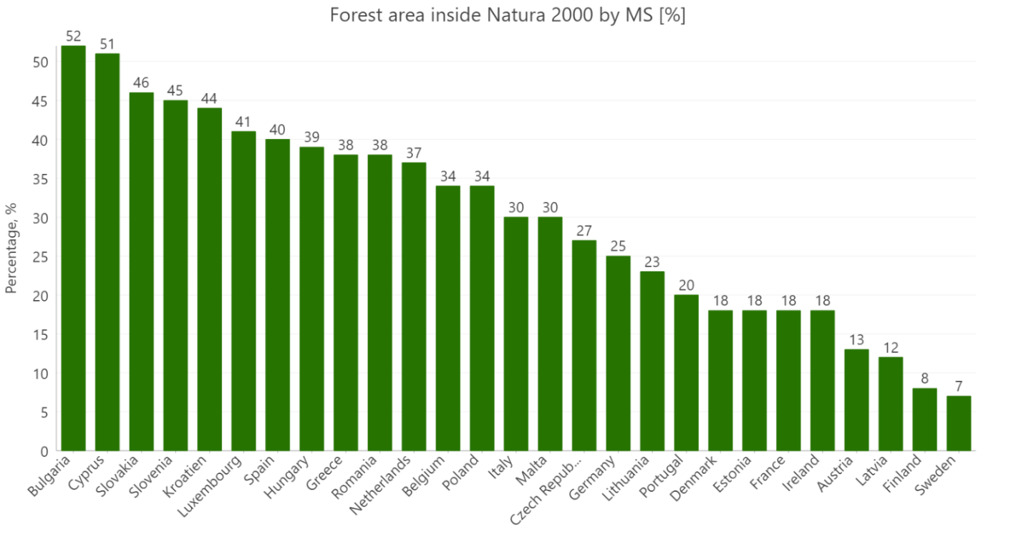
Figure 14 Percentage of forest area inside Natura 2000 (%). Forest area (CLC)= Broad-leaved forest (3.1.1) + Coniferous forest (3.1.2 ) + Mixed forest (3.1.3 )+ Transitional woodland/shrub (3.2.4 ); Corine Land Cover (CLC) Nomenclature Guideline
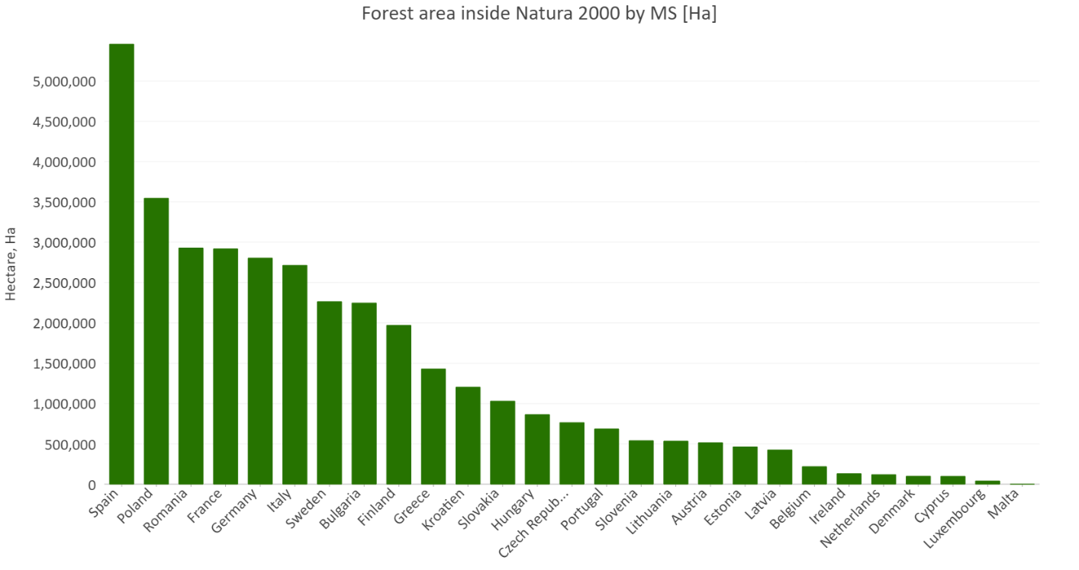
Figure 15 Forest area inside Natura 2000, by Member State in ha. Forest area (CLC)= Broad-leaved forest (3.1.1) + Coniferous forest (3.1.2 ) + Mixed forest (3.1.3 )+ Transitional woodland/shrub (3.2.4 ); Corine Land Cover (CLC) Nomenclature Guideline
  - Status of forest habitats protected under the Habitats and Birds Directives
The third edition of the report on the State of Nature in the EU was published in 2020, based on reports from Member States under the Birds (2009/147/EC) and the Habitats (92/43/EEC) Directives covering the period 2013-2018. Protected forest habitats make up almost one third of the area of habitats protected under the Habitats Directive (Annex I of the directive lists all protected habitats, including 81 forest habitat types), with over 500 000 km². Out of these, approximately 60% of which are temperate forests, and 25% are boreal and Mediterranean (overlap between the groups is possible). Around 35% of the Annex I forest area reported by Member States is included in Natura 2000.
The report includes data on the conservation status of Annex I forest habitats, indicating that over half of the assessments showed a poor conservation status (54 %) and 31% showed a bad conservation status, while only around 14 % of the assessments showed good conservation status, see Figure 16
These percentages refer to the number of assessments (for forests the total is 232), not the area of habitats. The conservation status is assessed based on four parameters: range, area, structure and functions and future prospects – hence area is only one of these. At regional level there are some notable differences in conservation status and trends.
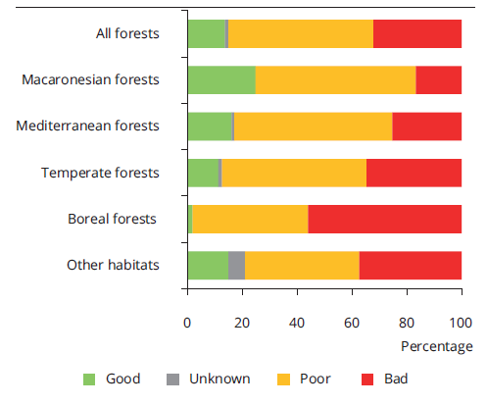
Figure 16 Conservation status of forests by region, State of Nature report
Over 90% of boreal forest habitat assessments show an unfavourable conservation status and worse trends than temperate and Mediterranean forests. Boreal forests had the highest rate of bad assessments (56%) and the highest percentage of habitats with deteriorating trends in conservation status (43%).
The conservation status is determined by four parameters (Habitat condition, Distribution range, Area covered, Future prospects) and is considered favourable only when all of them are favourable or three favourable and one unknown. Changes in the conservation status of all habitat types require major changes in the parameters and this explains why the status shows relatively stable patterns and trends. For forests in particular, which have far longer cycles than other habitats, the parameters might require time to improve. While the habitats condition is measured in terms of forest habitats area reported, the conservation status of habitats is aggregated at EU level and counted as number of assessments (one assessment may refer to e.g. beech forests in the Alpine biogeographical region), see Figure 17.
In order for a habitat type to be considered in favourable conservation status, the result of each assessment has to be favourable for all the four parameters or three favourable and one unknown. For example, if the specific structure and functions parameter is favourable this is not sufficient for the habitat type to be considered in a favourable status as the three other parameters –the area, the range and the ‘future prospects’- have to be favourable or two favourable and one unknown.
The habitat condition parameter shows that not-good condition is reported only for 21.1% of the forest habitats area, whereas nearly half of the area (49.5%) of forests under the Habitats Directive are in good condition, and for almost one third (29.4%) the condition is unknown. However, the total area of forests in good condition is limited to a very small number of ecosystems. The percentage of unknown conditions shows that the monitoring of conservation status of forest could be improved.
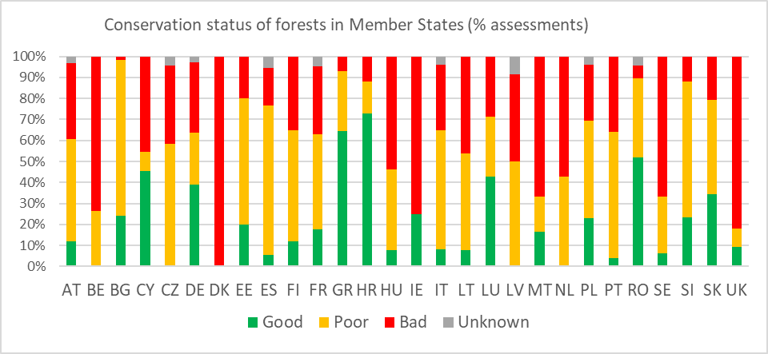
Figure 17 Conservation status of forests in Member States (% assessments)
The State of the Nature report shows that the conservation status of forest habitats protected under the Habitats Directive varies significantly among Member States, with more than 50% of assessments showing a bad conservation status in several countries (DK, UK, BE, IE, MT, NL, SE, HU), while more than 50% of assessments show a good status only in HR, GR, RO.
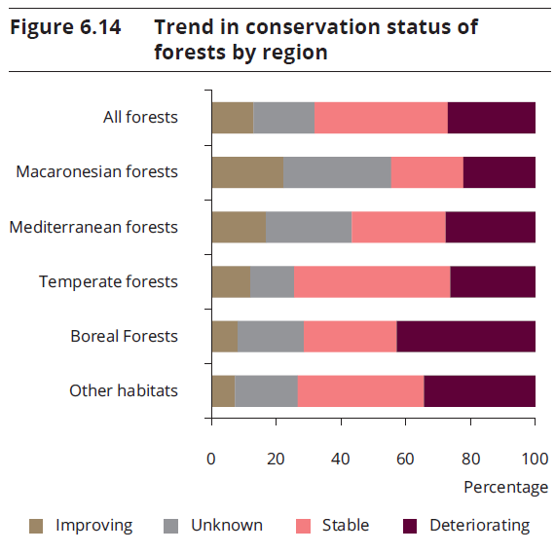
Figure 18 Trend in conservation status of forests by region, State of Nature report
Figure 18 does not show much progress, nevertheless, the trends in conservation status of forest are more favourable than those for other protected habitats with over 54% of all protected forest habitats assessed showing stable or improving trends. However, about one third (27%) of the forest assessments are deteriorating and 19% are unknown. Most of the improvements in diverse forest types were reported by Bulgaria (37 of 73 cases), e.g. for eastern white oak woods or beech forests. Apart from these, forests in Belgium and Greece also reportedly improved more than the average.
A high proportion, if not most changes in trends across reporting cycles are due to changes in the quality of Member States’ reports (as the SoN indicates in both its 2015 and 2020 editions). The 2015 report concluded that the reported changes were mostly an artefact and, most likely, the conservation status of forest and woodland habitats and species did not significantly change. The 2020 report refers to the genuine changes, and concludes that only around 1% of all (not only forests) habitat and species assessments show improving genuine changes in their conservation status, and 3% of habitats and 2% of species show a deterioration.
Another element reported under the State of Nature concerns the pressures and threats for protected habitats. For forests, the most reported pressures were: forestry (50 % of all pressures for mixed forests, broadleaved deciduous and coniferous forests), agriculture, alien species, natural processes, development / construction, and climate change. Among the forestry operations, those reported most often are: removal of dead and dying trees, clearcutting and removal of all trees, removal of old trees (excluding dead or dying), conversion to other types of forests including monocultures, and replanting with or introducing non-native or non-typical species.
Forest-dependent insects, mammals, non-vascular plants and breeding birds such as the Lesser Spotted Woodpecker (Dryobates minor) are most heavily affected by an excessive removal of dead and old trees or the reduction of old-growth forests. The clear-cutting of forested areas is considered to be the most relevant pressure for breeding birds in the context of forestry. Although new trees should be replanted or allowed to regrow after the forest stands have been clear-cut — as required by national forest acts in Europe — deforestation and clear-cutting without regrowth is occurring in Europe (EEA, 2016). Apart from breeding birds that depend on forest habitats, old trees are particularly valuable for some bats and small mammals, such as the Western Barbastelle (Barbastella barbastellus), the Caucasian Squirrel (Sciurus anomalus) or the Forest Dormouse (Dryomys nitedula). For species other than birds and for habitats, however, the most frequently reported forestry pressure is the removal of dead trees. Many insects, non-vascular plants, amphibians and reptiles depend on these for food, breeding places and shelter. Dead wood specialists such as the near-threatened Hermit Beetle (Osmoderma eremita) need dead, decaying wood for their life cycle. These structures thus represent integral features of healthy forest habitats; their removal can lead to changes in forest structure and diversity (Paillet et al., 2010; Vilén et al., 2015)
  - Composition of EU’s forests
Currently, 26 % of EU forests have one tree species (mainly conifers), 52 % have two to three tree species, and 6% of forests have six or more tree species reported (Figure 19). A further breakdown of area by number of tree occurring species is shown in Figure 20.
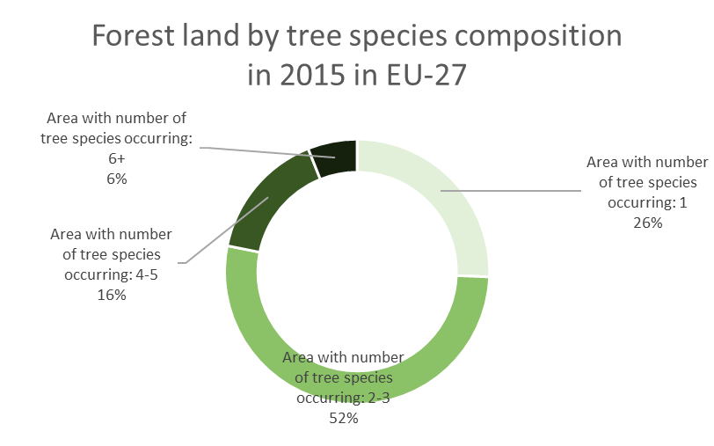
Figure 19 Forest area classified by a number of tree species occurring in the EU-27 in 20153
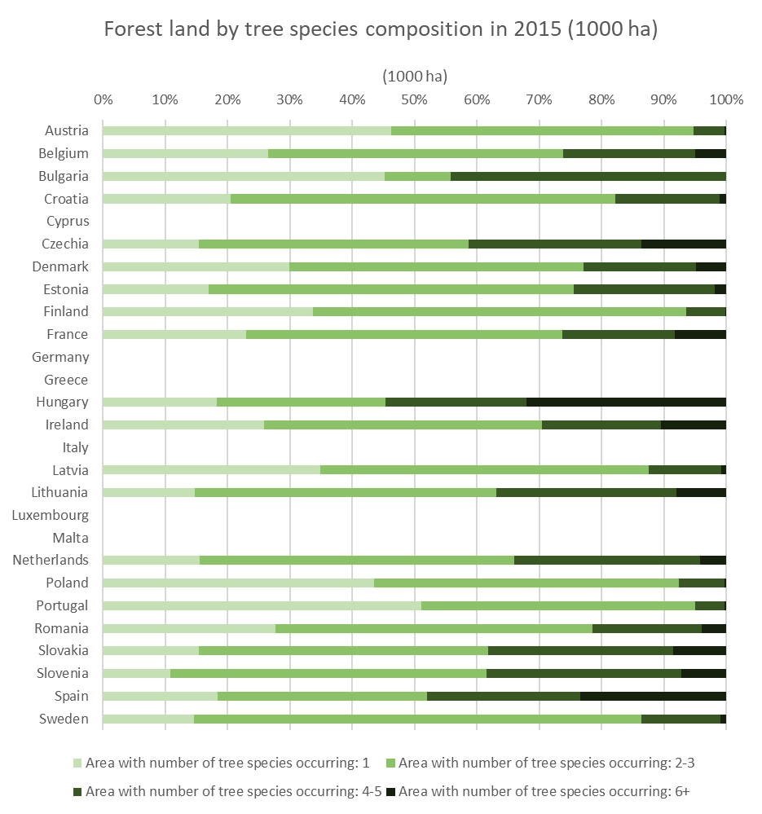
Figure 20 Forest area classified by a number of tree species occurring, by Member State in 2015
  - EU forests age overview
About three-quarters of forests in the EU reported as even-aged (Figure 21), of which about 53% are beyond the regeneration phase (forests between 0 and 20% of the recommended rotation age) and have not yet reached the mature phase (forests older than 90% of the recommended rotation age). Forests in their mature phase represent 14% of the even-aged total stands, while the remaining 7% is unspecified in the statistics or unknown. Nearly a quarter of European forests are uneven-aged, i.e. mostly managed through single-tree selection system.
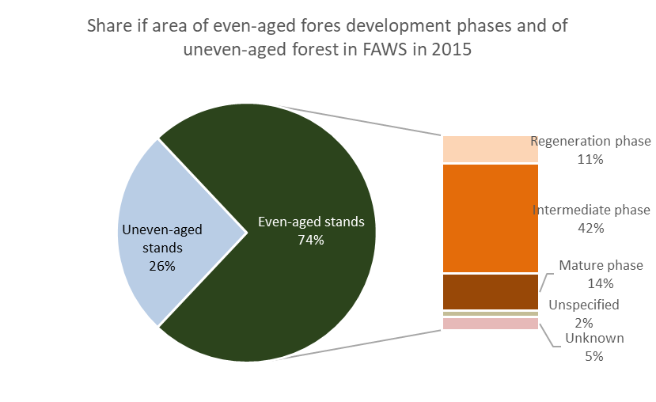
Figure 21 Share in the EU-27 of the area of even-aged forest development phases and of uneven-aged forest in FAWS in 2015
A breakdown of the FAWS by the age class distribution in 2015 in the EU-27 Member States is shown in Figure 22, based on the FAO Global Forest Resources Assessment 2020.
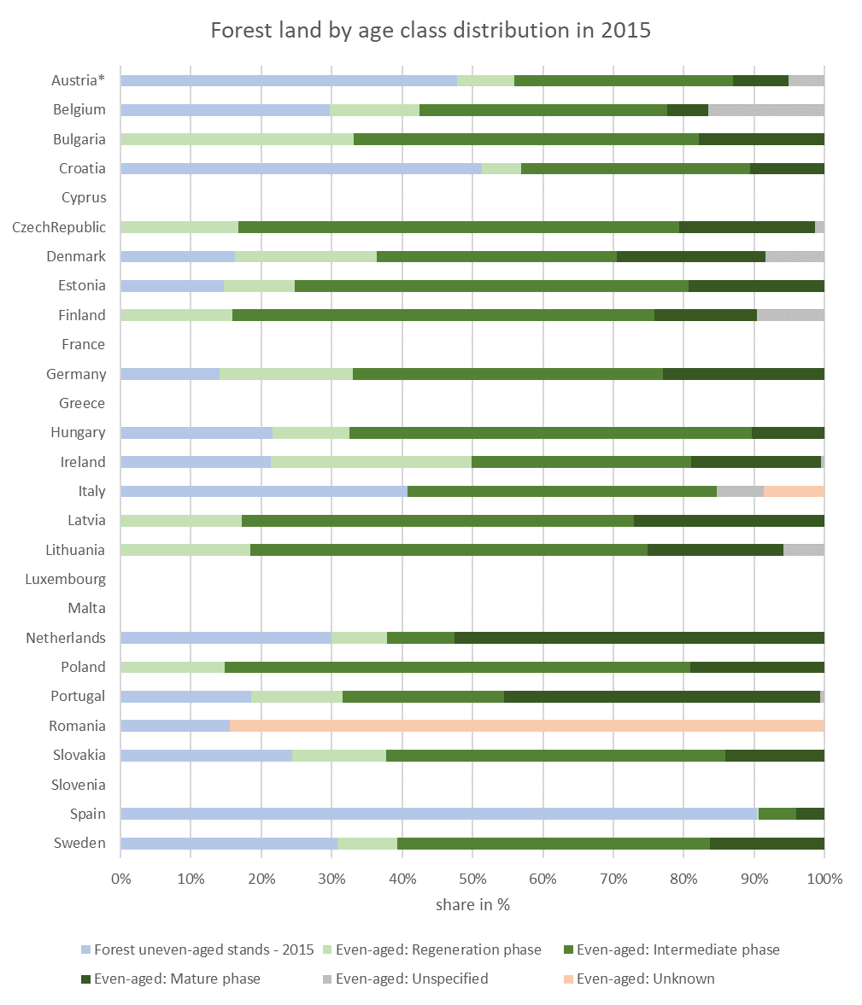
Figure 22 Share in the EU-27 of the area of even-aged forest development phases and of uneven-aged forest in FAWS in 2015 by Member state
Furthermore, Figure 23 represents the evolution of the age-class distribution of even-aged forests between 2000 and 2020, as estimated from the Carbon Budget Model used by the JRC, according to data reported from National Forest Inventories.
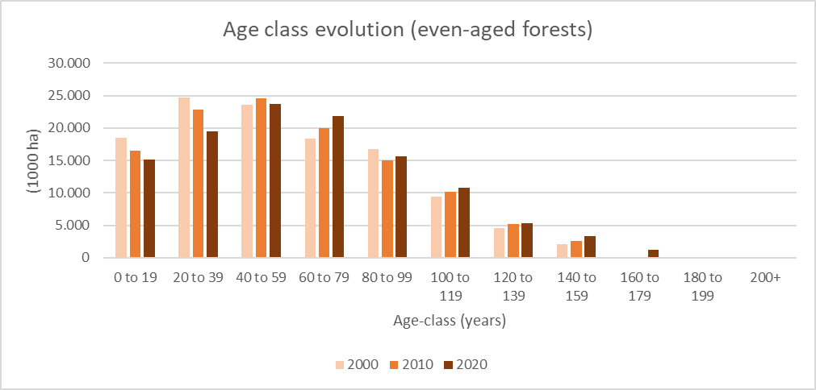
Figure 23 Age class evolution in even-aged forests. Source: Based on Pilli et al., 2016
  - Vulnerability to climate-driven disturbances in European forests
Ongoing changes of European climate are rapidly affecting the condition of forests in terms of temperature regime, water availability and nutrient cycles, ultimately impacting on the risk of natural disturbances. Multiple assessments have documented the increase of climate-driven risks in various regions of Europe from fires, windstorms and insect outbreaks. Analysis of both satellite retrievals and surface inventories of disturbance events are confirming the increasing frequency of the events and of the overall area affected by the various types of natural disturbances, with a relevant rise of wind disturbances and of bark-beetle infestations in central-European spruce forests. In 2017, when forest fires burnt more than 1 million ha and killed over 130 people – the worst EU fire season on record - Portugal was the country affected the most. Yet, beyond the ‘traditional’ Mediterranean countries, forest fires have also left their marks in central and northern European countries in recent years, especially in Sweden, which requested twice assistance through the Union Civil Protection Mechanism. The year 2019 stood out for an unusually high number of winter and spring fires, driving the total number of fires in the EU to the highest level for the preceding decade (almost 2000), and for an exceptional number of forest fires, significantly more than average and much earlier in the season, in the Arctic. Further analysis of climate drivers of these events combined with climate scenarios are pointing to a potential further increase of their impacts in future decades, with possible negative implications on the forest carbon budget.
In addition to an increase frequency of events, the results of a JRC study suggest that climate change has made Europe's forests also more vulnerable to hazards like fires, insect outbreaks, wind throws, or a combination of these three. Consistently to the IPCC risk assessment framework, 'vulnerability' is defined as the fraction of biomass that is potentially lost when a forest ecosystem is affected by a natural disturbance. More than 60% of the biomass in European forests is exposed to these risks - over 33 billion tonnes in total - putting the future role of forests for wood provision or carbon sequestration under growing uncertainty. The study is based on machine-learning models applied to disturbance records and satellite data from 1979-2018, to measure and map the vulnerability of Europe's forests to these hazards. The study shows that vulnerability is driven by a combination of climate parameters and forest structural, physiological and mechanical properties. Vulnerability to fires shows an increasing trend in the Mediterranean region, whereas vulnerability to insect outbreaks shows a generalized increase across Europe, with higher rates in Central and Northern (see Figure 24) . Quantifying the effects of natural disturbances to forests' resilience and productivity at large scales is a major challenge. The results of this study contribute to a better understanding of potential climate-driven natural disturbances on European forests, helping to guide forest management and define adaptation policies to address these vulnerabilities.
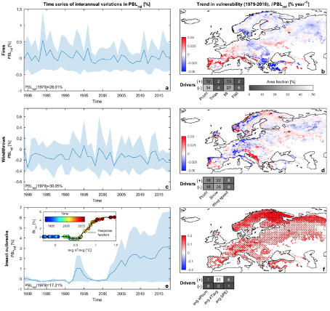
Figure 24 Temporal trends in forest vulnerability to (ab) forest fires, (cd) windstorms and (ef) insect outbreaks) over the 1979-2018 period. Shaded patterns reflect the 95% confidence interval; black dots in maps show pixels where trends are significant. Corresponding temporal drivers visualized in terms of area fraction (reported in colour and numbers) where the given driver (total precipitation, average temperature and standardised precipitation index, SPEI) is dominant. (Source: Forzieri G. et al., 2020)
The extraordinary drought conditions since 2015, which were unprecedented in the past 2110 years, also caused significant direct tree damage and dieback in certain parts of Europe. Available studies project more frequent, severe and longer lasting meteorological and hydrological droughts for most of Europe during the 21st century, except for parts of central-eastern and north-eastern Europe. The greatest increase in drought conditions is projected for southern Europe. These projections are very consequential for forests. The ability of trees to survive sustained drought is strongly related to their embolism resistance. However, 70% of 226 forest species from 81 sites worldwide operate with narrow hydraulic safety margins against injurious levels of drought stress. Many trees and forests, both in Europe and across the globe, are therefore highly vulnerable to drought, potentially resulting in long-term reductions in tree productivity, resilience and survival. Drought-induced forest decline is occurring not only in arid regions but also in wet forests not normally considered at drought risk, because tree’s hydraulic safety margins are largely independent of mean annual precipitation. By weakening trees, droughts will also increase the vulnerability of forests to other disturbances, like fires and bark beetle infestations, further amplifying the climate impacts on forests.
  - Forest type and tree range shifts under climate change
The onset of climate change means also forest change. Europe’s vegetation zones have already started to move upwards and northwards, triggering a transformation of forest ecosystems in many places.
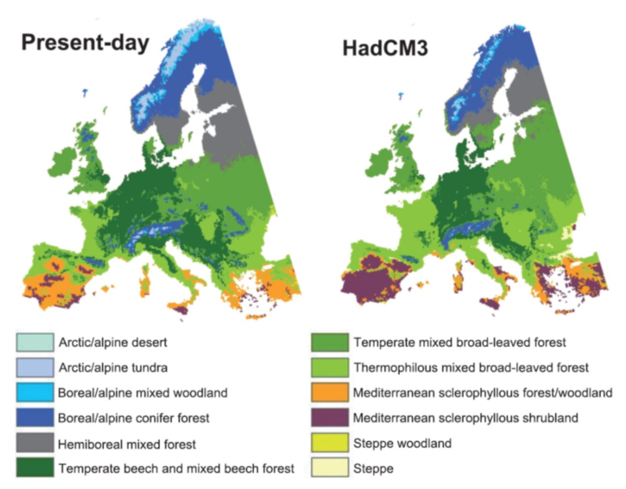
Figure 25 Modelled past (1961–90, left) and future (2071–2100, right) potential natural vegetation (PNV) in Europe, using a high greenhouse gas emission scenario
By the end of this century and under a high emissions scenario, trees may grow in many of today’s arctic and alpine tundra ecosystems; the transition zone between temperate broad‐leaved and boreal conifer forest may have moved several hundreds kilometres northwards; and shrub lands may be replacing the forests of Southern Spain. Altogether, 31 to 42 per cent of Europe’s land area could be belong to by a different ‘potential natural vegetation’ zone, depending on the emissions scenario and circulation model used (see Figure 25).
Along with such vegetation zone shifts, the potential range of Europe’s main tree species is expected to shift, too. Depending on the climate scenario used, between 21 and 60% of European forest lands may to suitable mostly for Mediterranean oak forest types by 2100 whilst Norway spruce - one of the major commercial tree species in Europe today – may be restricted to the higher elevations in central Europe and to areas in northern Sweden, Finland and Norway. Broadleaves such as oak and beech could experience range shifts from western Europe (France, Netherlands, Germany) and the lower elevations in central and eastern Europe more to central, northern and northeastern Europe (see Figure 26). Without effective countermeasures, these developments could have profound consequences for the economic value and the delivery of the various ecosystem services by forests.
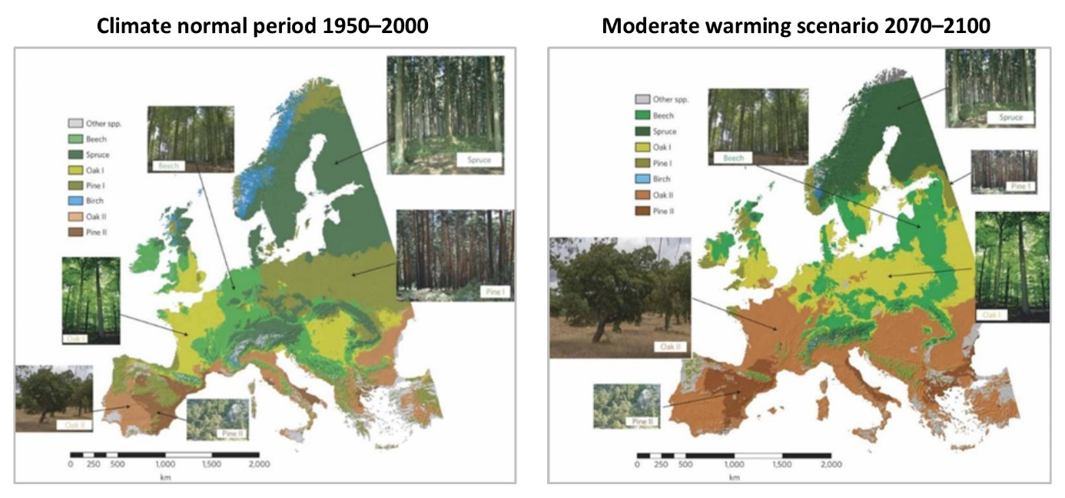
Figure 26 Potential range of major tree species in Europe under a moderate warming scenario in 2070-2100 (right) compared to the 1950–2000 period (left)
  - Forest defoliation
Crown defoliation of trees is an indication of poor forest health. In fact, an indicator on defoliation is collected periodically by the International Co-operative Programme on Assessment and Monitoring of Air Pollution Effects on Forests (ICP Forests; Michel et al. 2018) and reported in Forest Europe under Criterion 2 “forest Ecosystem Health and Vitality” of FOREST EUROPE. Defoliation is a parameter of tree vitality, which can be affected by a number of human and natural factors (abiotic and biotic). Therefore, defoliation is a natural bioindicator useful as warning sign on the fate of forest pressures i.e. insect’s infestations, fungi, deposition, abiotic factors such as heat and drought, frost, wind, snow/ice, or the action of man.
The defoliation survey from ICP in 2017 assessed 5496 plots in 26 European countries, in total 101,779 trees (Michel et al. 2018). Of the 26 countries assessed, 20 are MS of the EU, the other six countries are: Moldova, Montenegro, Norway, Serbia, Switzerland and Turkey. The seven MS of the EU not included in the 2017’s defoliation data are Malta, Portugal, Austria, Cyprus, Finland, Ireland and Netherlands.
The reporting from ICP indicates that 25.1% of all assessed trees had needle or leaf loss exceeding 25%, thus classified as damaged. The mean defoliation of all trees was 21.7%, indicating a 0.3% increase in relation to 2016. Broadleaved trees had a higher mean defoliation, 22.7%, than coniferous trees with 20.7%. Around 71% of all the plots assessed had a mean defoliation up to 25%, therefore 29% of plots had a mean defoliation above 25% i.e. the damage threshold.
The overall trend of mean plot defoliation from 1998 to 2017 per group of tree species indicates that all the 10 groups of tree species exhibited upward trends of defoliation, of which seven statistically significant trends. The groups exhibiting significant upward trends represent around 70% of all the trees of the survey (Table 1).
In summary, one out of four of all assessed trees showed defoliation levels suggesting damage. In addition, all the groups of the most abundant tree species exhibited upward trends of defoliation suggesting a degrading condition.
Table 1 Trend of mean annual plot defoliation (percentage) in the most abundant tree species groups across Level I plots (5057 plots) from 1998-2017 in 26 European countries. A positive trend indicates increasing defoliation. (*) Significant at 5% according to the Mann-Kendall test. Source of data: ICP Forests (Michel et al., 2018). Source of table: Maes et al. Annex (2020).
Tree species/groups [abundance of the species on Level I plots] | Trend 1998-2017 (percentage) | Statistical significance  (p-value)
Scots pine (Pinus sylvestris) [16.5%] | 0.064 | 0.381
Norway spruce (Picea abies) [12%] | 0.070 | 0.035*
Austrian pine (Pinus nigra) [5.1%] | 0.230 | 0.010*
Mediterranean lowland pines (Pinus brutia, P. halepensis, P. pinaster, P. pinea) [>7.3%] | 0.371 | < 0.001*
Other conifers | 0.081 | < 0.001*
Common beech (Fagus sylvatica) [11.7%] | 0.118 | < 0.012*
Deciduous temperate oaks (Quercus petraea and Q. robur) [8.5%] | 0.065 | 0.347
Deciduous sub-Mediterranean oaks (Quercus cerris, Q. frainetto, Q. pubescens, Q. pyrenaica) [>5.4%] | 0.003 | 0.871
Evergreen oaks (Quercus coccifera, Q. ilex, Q. rotundifolia, Q. suber) [>3.7%] | 0.329 | < 0.001*
Other broadleaves | 0.283 | < 0.001*

  - Fellings and net annual increment
Growing stocks of timber in EU-27's forests increased by 43 % in the period of 1990–2019. The largest increase was estimated for Denmark, Spain, Bulgaria and Poland (>80 % for each), while, at the other end of the spectrum, a much less moderate increase was estimated for Sweden and Greece (<20 % increase). None of the EU countries estimated a decrease in the growing stocks of timber in 2019 compared to 1990.
An indication of the pressures from forest management on forest ecosystems can be derived by comparing fellings to net annual increment (NAI). Roundwood removals are reported by countries in the Joint Wood Energy Enquiry (JFSQ) and can be converted to fellings.
These reported values in the JFSQ are compared using an alternative sources of data. In the alternative approach, fellings are derived from the amount of wood sourced in European forests, which is also available from country reporting. In this approach, there is the caveat that a significant amount of woody biomass is reported as ‘unspecified’ in the reported sources, meaning without specifying whether or not it is from primary or secondary sources. The JRC has therefore developed an approach, described in Jonsson et al (2021), whereby a range is reported on the presumed removals from EU forests. The ‘unspecified’ wood is either fully attributed to primary (= maximum); or to secondary, (= minimum). In this way, the fellings are estimated from the amount of wood that is reported as sourced as either ‘primary’, or ‘primary plus unspecified’.
The net annual increment (NAI) is the gross annual increment minus natural losses, where gross annual increment is the annual volume of increment of all trees and includes the increment of trees that have been felled or have died during the reference period.
As shown in Figure 27, the trends in NAI between 2009 and 2015 were slightly decreasing in Europe, while the trends in fellings were increasing.
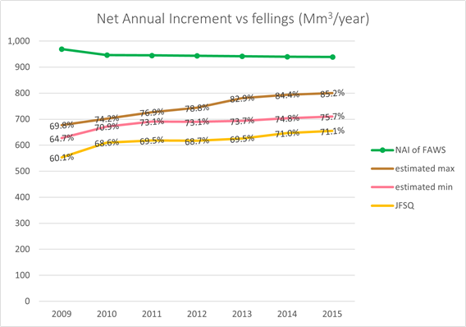
Figure 27 Fellings derived directly from the removals declared in the JFSQ (yellow line), compared with the fellings derived from the uses (JRC estimates, brown and pink lines), compared against the Net Annual Increment of Forest Available for Wood Supply (units: million m³ SWE o.b., figure taken from Jonsson et al 2021).
  - Salvage logging
Currently there is no common dataset on salvage forest loggings in the EU. The European Commission has therefore initiated a data-collection process on total harvest, salvage loggings and causes of salvage loggings in 2020, for the period 2004-2019. Data has been collected in 17 Member States by searching national datasets, Eurostat and/or consulting with national experts. The data found was presented to the Standing Forestry Committee for validation and/or for additional input. The following Member States validated data on salvage loggings and/or provided additional information: Austria, Bulgaria, Croatia, Cyprus, Czechia, Estonia, France, Finland, Germany, Hungary, Latvia, Lithuania, Romania, Poland, Slovakia, Slovenia and Sweden. These Member States represent 76% of total forest area in EU-27. It is important to note that the time series where annual data on salvage loggings are available varies among Member States. In some countries data are available for the entire period requested 2004-2019, but in some countries data are available for a shorter period. For the period 2014-2018, data are available in all 17 Member States that data was collected. Figure 28 shows the time series of salvage loggings, overlapped with the graphic of total removals in seventeen Member States for the period 2014-2018.
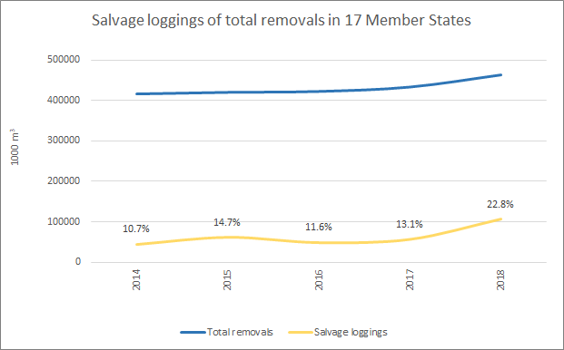
Figure 28 Salvage loggings of total removals (1000 m3, u.b.) in 17 Member States; for the period 2014-2018. Source: Camia A., Giuntoli, J., Jonsson, R., Robert, N., Cazzaniga, N.E., Jasinevičius, G., Avitabile, V., Grassi, G., Barredo, J.I., Mubareka, S., The use of woody biomass for energy purposes in the EU, EUR 30548 EN, Publications Office of the European Union, Luxembourg, 2021, ISBN 978-92-76-27867-2, doi:10.2760/831621, JRC1227190.
This Figure 28indicates that natural disturbances followed by salvage loggings have increased during the time period considered from 10.7% in 2014 to 22.8% in 2018 of total removals in 17 Member States. It is important to note that the magnitude of the recent rise in salvage loggings is varying largely between countries. For example, in Czechia in 2018, salvage loggings accounted for 90% of total removals, while in Sweden it accounted for only 3%. The time period considered in this analysis is rather short for analysing long term trend of natural disturbances. The recent rise in salvage loggings indicates a large pulse of bark beetle infestations in Central Europe. Further work is needed to acquire information on natural disturbances and salvage loggings.
  - Wood use in the EU
In 2015, considering both primary and secondary wood, 417 m3 of Solid Wood Equivalent (SWE) in the EU-27 were used for energy in 2015, while 76 m3 SWE and 181 m3 SWE were used for short-lived products (pulp for paper) and long-lived products (sawnwood, wood-based panels and dissolving pulp), respectively. This implies that about 62% of the available biomass is used for energy production, while 27% is stocked in long-lived products and 11% in short-lived products. Short-lived products here do not include recycled paper. Source: Sankey diagrams of woody biomass flows in the EU-27.
On the other hand, when double accounting the woody biomass is taken into account (because of cascading use of by-products), 52% of the wood in the EU-27 was used for the material production (i.e., including also the woody biomass that is not stocked in the product) and 48% for energy. The breakdown by Member State is show in Figure 29 and the underlying data available in the Bioeconomy Monitoring System from the Knowledge Centre for Bioeconomy.
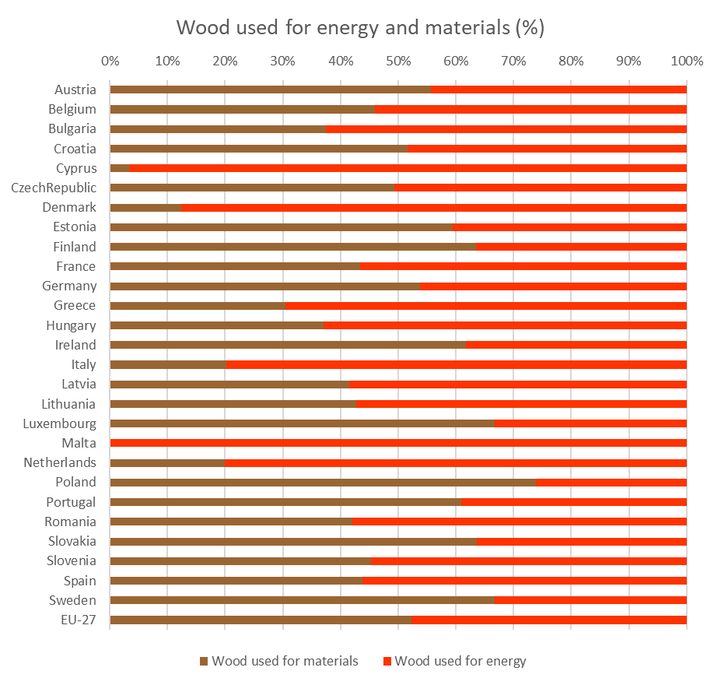
Figure 29 Share of woody biomass used for materials and energy in the EU-27 Member States in 2015 (incl. double accounting .

  - Cascading use of wood
The cascading factor represents multiple use of woody biomass in different sectors, first as logs and then as industrial by-products or post-consumer recovered resources. The higher the cascade factor, the more often by-products and recycled woody biomass are used. When only primary wood is used, the cascade factor is equal to 1.0. It is evaluated as “total cascade factor” according to the formula defined in Mantau (2015). Data for calculations are derived by the Joint Forest Sector Questionnaire, Eurostat, the Joint Wood Energy Enquiry, the National Renewable Energy Action Plan Progress reports of the Member States and the factors are consistent with the Wood Resource Balances (Cazzaniga et al 2019). The roundwood sources are estimated considering the total uses of WRB as described above in the section on Fellings to NAI comparison. This indicator has been computed for the EU Bioeconomy Monitoring System.
Figure 30 shows an increase in the cascading use of wood between 2009 and 2015. On this period, the overall cascade factor of the wood resource balance is above 1.50 and increasing. This means the wood resources from trees have been used more than one and a half time and increasing.
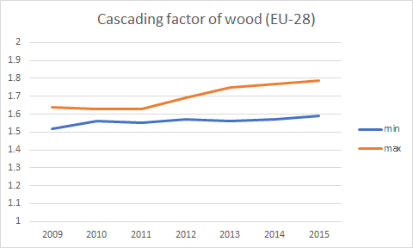
Figure 30 EU Bioeconomy indicator ‘cascading use of wood’, showing an increasing circularity of wood at EU-level between 2009-2015.
  - Size of and employment in different forest-based sectors in the EU
The gross value added of the forest-based sector –which includes forestry and logging, the manufacture of wood and of products of wood and cork, and the manufacture of paper and paper products– was 109,855 million euros in the EU-27 in 2018, about 0.9% of the total gross value added in the EU. The sector is particularly important in Baltic countries, Finland and Sweden (Figure 31). In addition, printing activities and the manufacturing of wood-based furniture cumulated 25 and 31 billion euros in 2018 in the EU-27. In total, the wood-based industries in the EU-27 generated a gross value added of EUR 139 billion in 2018, which corresponds to 7.1 % of the total manufacturing industry.
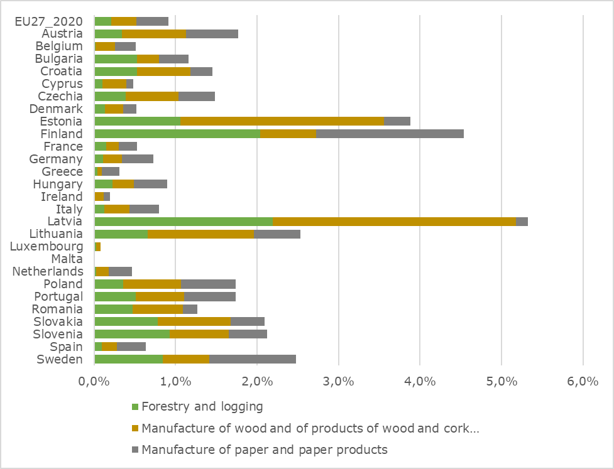
Figure 31 Share of gross value added in the forest-based sector in 2018 (source: Eurostat National accounts aggregates by industry [NAMA_10_A64])
In 2018, the number of people employed in the forest-based sector employed 2.1 million people in the EU-27 (see Figure 32 and Figure 33), corresponding to about 1.1% of the total employment in the EU. The other wood-related manufacturing activities employed an additional 1.2 million people (0.66 million in printing industries and 0.53 million people in of wood-based furniture). More generally, and considering other economic activities further transforming wood and wood-based products, heat and power from bioenergy, wood in construction and the publishing of printed books, newspapers, flyers…, the activity of more than 4 million people is related to forest or wood in the EU-27 (see Robert, et al., 2020). This does not account for retail activities and non-wood activities such as forest-related leisure activities, scientific work on forests, etc.
The number of jobs the forest-based sector was subject to important decline until 2013-2014, mainly related to gains in productivity and to increased international competitivity. With the conjunction of additional demand for renewable material and products as well as for ecosystem services, the number is currently stabilising.
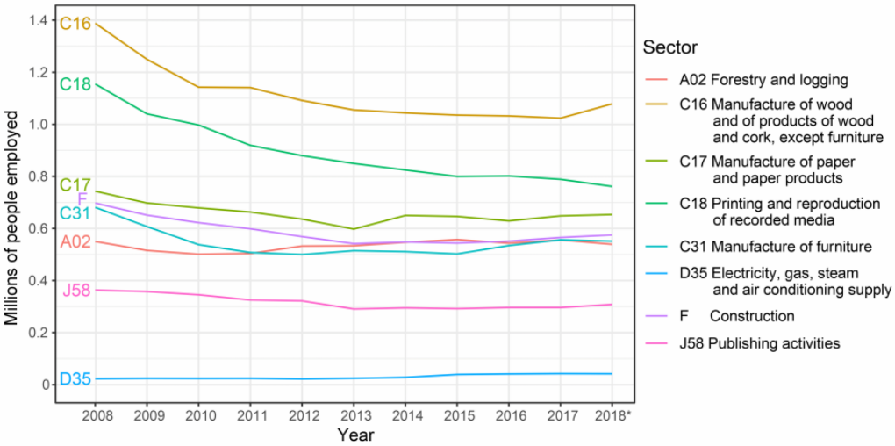
Figure 32 Change in employment in the forest-based sectors (source: Robert et al. 2020).
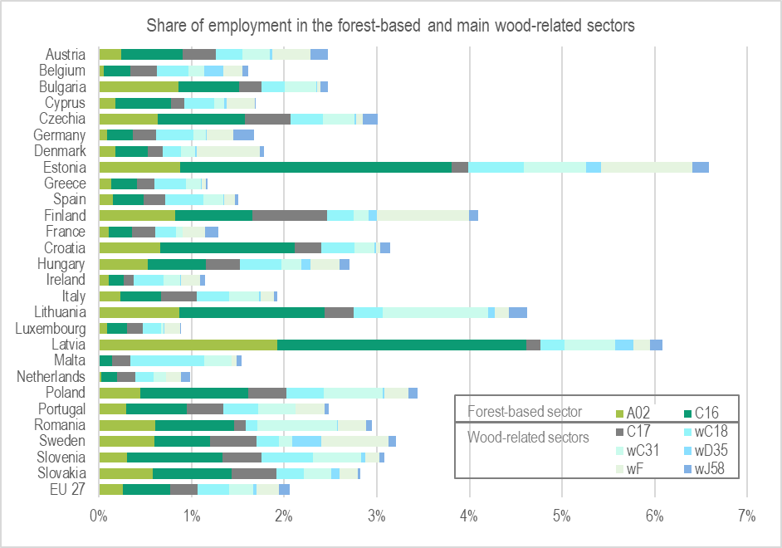
Figure 33 Share of employment by Member State in the forest-based and wood related sectors in 2018 out of total employment (data from Eurostat [LFSA_EGAN22D] and Robert et al. 2020); A02: Forestry and logging; C16: Manufacture of wood and of products of wood and cork, except furniture; manufacture of articles of straw and plaiting materials; C17: Manufacture of paper and paper products; wC18: Printing on paper and other wood products; wC31: Manufacture of wood-based furniture; wD35: Electricity, gas, steam and air conditioning supply from wood; wF: wood-based Construction; wJ58: Publishing activities related to printed material.
In the EU, most wood-based jobs are in manufacturing industries and in construction. However, in some countries, employment remains principally in primary and first transformation activities such as in Latvia, Croatia and Czechia whereas in other countries such as in the Netherlands, Germany and Denmark, jobs are mainly in the end of the value chain (production of final products such as pieces of furniture, books, buildings).
Although often undervalued, the total value of non-wood forest products (NWFP) collected each year may amount to 71% of the value of annual roundwood production according to Lovrić et al. 2020. However, in most cases, these products are not marketed and sometimes not marketable either (direct benefit to households often without payment). Activities related to NWFPs are therefore rather difficult to estimate since most of them are indirect (ongoing work at the JRC).
  - The value of forest ecosystem services
Ecosystem services are the contributions of ecosystems to benefits used in economic and other human activity. Forests provide us with timber, but they also regulate water flows, control soil erosion, clean the air we breathe and withdraw vast amounts of the carbon we emit into the atmosphere. The amount and quality of the services provided by forests depends on their size (extent) and on their ecological condition. Healthy forests provide more services than degraded forests and drivers of degradation, including climate change and natural and man-made disturbances, thus may compromise the ability of forests to provide ecosystem services. Figure 34 illustrates for a group of ecosystems including forest, the monetary value of several ecosystem services they provide, as estimated by the INCA project. While the INCA project aimed to cover the economically most important ecosystem services, this estimate still comprises only a subset of all ecosystem services.
The total supply of these seven ecosystem services in Europe amounts to EUR 172 billion/year, of which European forests deliver EUR 81 billion/year, or 48%. The value of these seven ecosystem services is more than 9 times higher for an area of forest, than for the same extent of urban area. Timber accounts for EUR 15 billion/year, or about 18%, of the value of the forest ecosystem services considered here. Which is, for example, about the same amount of the water purification service of forests.
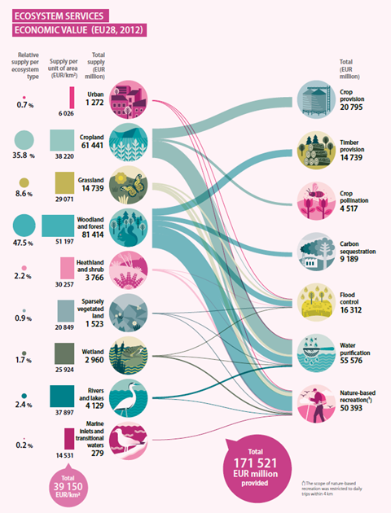
Figure 34 Annual economic value of ecosystem services in the EU-28 (in euros as of 2012). Source: Vysna, V., Maes, J., Petersen, J.E., La Notte, A., Vallecillo, S., Aizpurua, N., Ivits, E., Teller, A. (2021) Accounting for ecosystems and their services in the European Union (INCA). Final report from phase II of the INCA project aiming to develop a pilot for an integrated system of ecosystem accounts for the EU. Statistical report. Publications office of the European Union, Luxembourg.
  - Condition of EU forests
This section presents in short the conclusions of the summary for policymakers of the EU ecosystem assessment (Figure 35). Forests host a dominant part of Europe’s terrestrial biodiversity, and contributing significantly to climate change mitigation. After millennia of forest use, currently only between 2% and 4% of EU forests are primary or old-growth forests. Today, most forests are semi-natural (89%). The remaining share are plantations. There has been an increase in some structural indicators, for example forest area, biomass volume and deadwood. Forest area increased in Europe by 13 million hectares in the period between 1990 and 2015 due to both natural processes and to active afforestation. More forested area does not necessarily mean healthier and biodiverse forests. Climate change impacts are increasing. Tree cover loss from wildfires, storms and harvesting is increasing. This suggests that the harvested area of forests is likely increasing due to a higher demand for biomass. Pollutants remain a concern even if the trends point downwards. One out of four forest trees suffers leave damage and loss. The predominant drivers are not yet fully understood, whereas parasitic insects and abiotic factors, mostly drought, are recognized as factors exacerbating this negative trend. Increased evapotranspiration suggests functional changes in forests. Whereas a 3% decrease in the abundance of common forest birds has been reported since 1990, their status shows slightly improving trends in the last few years. Important knowledge gaps persist with respect to biodiversity in forests, forest management intensity, as well as forests health and resilience, pointing to the need for a reinforced forest monitoring framework.
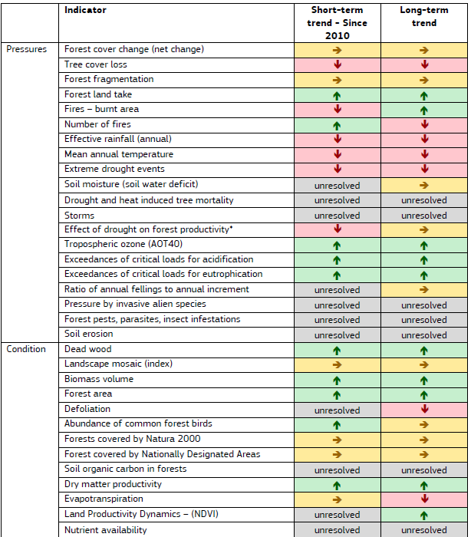
Figure 35 Summary of trends in pressure and condition of forests in the EU-28
  - Key sources of evidence
The key sources of evidence considered in the Communication include:
- Agriculture, forestry and fishery statistics — 2020 edition - Products Statistical Books - Eurostat
- Forest Europe State of Europe Forests 2020
https://foresteurope.org/wp-content/uploads/2016/08/SoEF_2020.pdf
- European forest ecosystems. State and trends (EEA Report No 5/2016)
https://www.eea.europa.eu/publications/european-forest-ecosystems
- Mapping and Assessment of Ecosystems and their Services: An EU ecosystem assessment - MAES (2020)
JRC Publications Repository - Mapping and Assessment of Ecosystems and their Services: An EU ecosystem assessment (europa.eu)
- EEA Report No 10/2020, State of Nature in the EU, Results from reporting under the nature directives 2013-1018
https://www.eea.europa.eu/publications/state-of-nature-in-the-eu-2020
- JRC study on Mapping and assessment of primary and old-growth forests in Europe (2021)
Earth Day : New report shows there are still pristine forests in Europe and calls for their mapping and strict protection | EU Science Hub (europa.eu)
- Forest Information System for Europe (FISE)
Forest Information System for Europe (europa.eu)
- Land cover and change statistics 2000-2018, EEA
https://www.eea.europa.eu/data-and-maps/dashboards/land-cover-and-change-statistics
- Greenhouse gas inventory submission 2020 (annual time series 1990-2018) of EU Member States to the UNFCCC
National Inventory Submissions 2020 | UNFCCC
- Forzieri G. et al (2020) Vulnerability of European forests to natural disturbances. JRC PESETA IV project – Task 12. Luxembourg: Publications Office of the European Union
https://op.europa.eu/s/pdwB
- Forzieri, G., Girardello, M., Ceccherini, G. et al. (2021) Emergent vulnerability to climate-driven disturbances in European forests. Nat Commun 12, 1081.
https://doi.org/10.1038/s41467-021-21399-7
- Thompson, I., Mackey, B., McNulty, S., Mosseler, A. (2009). Forest Resilience, Biodiversity, and Climate Change. A synthesis of the biodiversity/resilience/stability relationship in forest ecosystems. Secretariat of the Convention on Biological Diversity, Montreal. Technical Series no. 43, 67 pages.
- Vysna, V., Maes, J., Petersen, J.E., La Notte, A., Vallecillo, S., Aizpurua, N., Ivits, E., Teller, A. (2021) Accounting for ecosystems and their services in the European Union (INCA). Final report from phase II of the INCA project aiming to develop a pilot for an integrated system of ecosystem accounts for the EU. Statistical report. Publications office of the European Union, Luxembourg.
- Conclusions
The new EU Forest Strategy for 2030 covers the issues identified by stakeholders as important to be included in the strategy. The strategy also sets out different actions and all of them are to varying extend supported by the quantitative and qualitative inputs from the stakeholder consultations as well as the scientific evidence.
The Commission services have noted all key messages mentioned in the consultations and summarised in this document. Most of the recommendations made in the consultation were very helpful to gauge the expectations and positions of consulted parties and have been fully taken into account in the drafting process. Recommendations from the scientific literature were also examined and taken into account in the drafting process. Further engagement with the stakeholders and scientist will take place for during the implementation stage.
Although the results of the public consultations allowed the Commission to collect a very high number of views and opinions on the initiative, this may not be statistically representative, due to the relatively small number of answers from some stakeholder groups or Member States. Overall, the results of the consultation activities confirmed the proposed objectives and actions of the new EU forest strategy for 2030, even if there are differences among the stakeholder groups.

COM(2018) 811: https://eur-lex.europa.eu/legal-content/EN/TXT/PDF/?uri=CELEX:52018DC0811&from=EN
SWD(2019) 389: ext-study-forestry-measures-swp_2019_en.pdf (europa.eu)
This section was prepared by Technopolis Group & COWI under the framework contract No. CLIMA.A.4/FRA/2019/0011 led by COWI, as part of the specific contract No. 340201/2020/832904/ETU/CLIMA.C.3
Consultations outcomes are available here: https://ec.europa.eu/info/law/better-regulation/have-your-say/initiatives/12674-Forests-new-EU-strategy/public-consultation_en
This section was prepared by Technopolis Group & COWI under the framework contract No. CLIMA.A.4/FRA/2019/0011 led by COWI, as part of the specific contract No. 340201/2020/832904/ETU/CLIMA.C.3
Public authorities include state owned forest companies
i8661en.pdf (fao.org)
Eurostat collects information on the area of wooded land, including forest and other wooded land as defined in FAO FRA, through the European Forest Accounts (EFA). The methodology states that data on land reported through that questionnaire “must be coherent with other data provided at European and international level (national accounts, Forest Europe, FAO, and OECD)”. 14 Member States report data on forest area to Eurostat under the EFA, and in addition Eurostat gapfills EFA tables with FAO-FRA data on forest area. Data reported for the same variable are in general well aligned among EFA, FRA and Forest Europe.
National definition of forests however, could differ from the FAO definition.
https://land.copernicus.eu/user-corner/technical-library/corine-land-cover-nomenclature-guidelines/html/index.html
https://ec.europa.eu/eurostat/web/products-statistical-books/-/KS-03-21-096
National Inventory Submissions 2021 | UNFCCC
EUR-Lex - 32018R0841 - EN - EUR-Lex (europa.eu). In few cases there are differences between definitions in National inventory reports and the LULUCF Regulation which will require reconciliation for compliance.
Depending on the data sources the EU outermost territories may or may not be included.
Data sources fig. 5 and fig. 6: FAO/FRA; CLC: Land cover and land cover changes in European countries in 2000-2018 — Copernicus Land Monitoring Service); LULUCF; LUCAS (https://ec.europa.eu/eurostat/databrowser/view/LAN_LCV_FAO__custom_1066297/default/table & https://ec.europa.eu/eurostat/databrowser/view/for_area/default/table?lang=en)
For greenhouse gas reporting Member States follow specific definitions of forest land with regards to area, anticipated tree height and tree crown cover. Details may be obtained from Member States National Inventory Report and Regulation (EU) 2018/841.
Reporting of greenhouse gas (CO2, CH4 and N2O) emissions and removals in the Land Use, Land Use Change and Forestry (LULUCF) sector follows the IPCC 2006 guidelines for national greenhouse gas inventories. LULUCF distinguishes six main land use categories, including their conversion: Forest Land, Cropland, Grassland, Wetlands, Settlements and Other land. Changes in carbon stocks are estimated for carbon pools above and below-ground living biomass, dead organic matter (for forests divided in deadwood and litter), and soils with a separation between mineral and organic soils. Specific emissions, e.g. related to nitrogen application and leaching, drainage and rewetting or biomass burning are recorded separately. The harvested wood product category estimates the net balance between inputs and outputs of biomass for different wood product categories. Non-CO2 gases were converted to CO2 equivalents by applying global warming potentials from the IPCC 5 Assessment Report (CH4: 28, N2O: 265).
Average value for 2016-2018 in the EU-27, which includes forest remaining forest (315 Mt CO2-eq) and land to forest (45 Mt CO2-eq). Grassi, G., Fiorese, G., Pilli, R., Jonsson, K., Blujdea, V., Korosuo, A. and Vizzarri, M., Brief on the role of the forest-based bioeconomy in mitigating climate change through carbon storage and material substitution, Sanchez Lopez, J., Jasinevičius, G. and Avraamides, M. editor(s), European Commission, 2021, JRC124374.
Greenhouse gas reporting for “land converted to forest land”, here afforested land, or “forest land converted to cropland / grassland / wetland / settlement / other land”, here deforested land, remain in this transition category for 20 years. Emissions by CH4 and N2O from afforested land and deforested land are included under “Other”.
JRC study on Mapping and assessment of primary and old-growth forests in Europe (2021). https://publications.jrc.ec.europa.eu/repository/handle/JRC124671
Forest Nature and biodiversity https://forest.eea.europa.eu/topics/forest-nature-and-biodiversity. Data Sources: Corine Land Cover (CLC) 2018 provided by European Environment Agency (EEA) and Copernicus Land Monitoring Service & Extracted from Natura 2000 Barometer provided by European Environment Agency (EEA)
EEA Report No 10/2020, State of Nature in the EU, Results from reporting under the nature directives 2013-1018
State of Nature in the EU - Methodological paper Methodologies under the Nature Directives reporting 2013-2018 and analysis for the State of Natura 2000, page 19.
General evaluation matrix for habitat types (from the Report format for the period 2013- 2018: http://cdr.eionet.europa.eu/help/habitats_art17) Parameter Conservation Status
State of Nature Report. EEA 2015, page 166.
‘Limitations due to poor data quality or gaps in data completeness still exist. A noteworthy portion of the reported information comes from expert opinion and partial surveys, indicating the absence or incomplete monitoring schemes in Member States.’ ‘Compared with the previous reporting period, the share of habitats with bad conservation status has increased by 6 %. These differences largely relate to changes in the methods used or variations in data quality’ (State of Nature Report 2020. EAA. Executive summary. Page 5)
Genuine changes refer to real changes in nature, rather than changes that are due to improved data or knowledge, taxonomic rearrangements or the use of different monitoring methods
FAO Global Forest Resources Assessment 2020
In forest management planning average age can be used if the difference between the oldest and youngest trees are not significant. This may originate from the planting/regenerating phase when the difference between the seedlings/young trees could be e.g. 10 years. However, the inventories shows only the weighted average of the age.
Values for CY, FR, EL, LU, MT, and SI in the age development phases are not reported. AT FAWS only; IT data for 2010
Source: State of Europe’s Forests 2020 Report (SoEF). 2020. Available at: https://foresteurope.org/state-europes-forests-2020-report/.
Senf, C. and Seidl, R.: Storm and fire disturbances in Europe: Distribution and trends, Glob. Chang. Biol., (November 2020), 1–15, doi:10.1111/gcb.15679, 2021.
Sebald, J., Senf, C. and Seidl, R.: Human or natural? Landscape context improves the attribution of forest disturbances mapped from Landsat in Central Europe, Remote Sens. Environ., 262(May), 112502, doi:10.1016/j.rse.2021.112502, 2021.
DG ECHO Emergency Response Coordination Centre, JRC and the Situational Awareness Team: Analytical Brief ‘Forest Fires in Europe’, 14 May 2020 / DG ECHO A3 Situational Awareness Team: Analytical Brief ‘Increase of Arctic wildfires in 2019’, 25 July 2019.
Seidl, R., Schelhaas, M.-J., Rammer, W. and Verkerk, P. J.: Increasing forest disturbances in Europe and their impact on carbon storage, Nat. Clim. Chang., 4(9), 806–810, doi:10.1038/nclimate2318, 2014.
Forzieri G. et al (2020) Vulnerability of European forests to natural disturbances. JRC PESETA IV project – Task 12. Luxembourg: Publications Office of the European Union / Forzieri, G., Girardello, M., Ceccherini, G. et al. (2021) Emergent vulnerability to climate-driven disturbances in European forests. Nat Commun 12, 1081.
Büntgen, U., Urban, O., Krusic, P.J. et al. (2021) Recent European drought extremes beyond Common Era background variability. Nat. Geosci. 14, 190–196. https://doi.org/10.1038/s41561-021-00698-0
https://www.eea.europa.eu/data-and-maps/indicators/river-flow-drought-3/assessment
Choat, B., Jansen, S., Brodribb, T. et al. (2012) Global convergence in the vulnerability of forests to drought. Nature 491, 752–755. https://doi.org/10.1038/nature11688
Source: Hickler, T., Vohland, K., Feehan, J., Miller, P.A., Smith, B., Costa, L., Giesecke, T., Fronzek, S., Carter, T.R., Cramer, W., Kühn, I. and Sykes, M.T. (2012) Projecting the future distribution of European potential natural vegetation zones with a generalized, tree species-based dynamic vegetation model. Global Ecology and Biogeography, 21: 50-63. https://doi.org/10.1111/j.1466-8238.2010.00613.x
Source: Hanewinkel, M., Cullmann, D., Schelhaas, MJ. et al. (2013) Climate change may cause severe loss in the economic value of European forest land. Nature Clim Change 3, 203–207. https://doi.org/10.1038/nclimate1687
Summary sourced from the EU ecosystem assessment: https://publications.jrc.ec.europa.eu/repository/handle/JRC120383
Michel A, Seidling W, Prescher A-K, (Eds.). (2018). Forest Condition in Europe: 2018 Technical Report of ICP Forests. Report under the UNECE Convention on Long-range Transboundary Air Pollution (Air Convention). Vienna: BFW-Dokumentation 25/2018. BFW Austrian Research Centre for Forests.
https://ec.europa.eu/eurostat/databrowser/view/for_vol/default/table?lang=en
https://unece.org/forests/data-forest-products-production-and-trade
Jonsson R., Cazzaniga N.E., Camia A., Mubareka S., Analysis of wood resource balance gaps for the EU, EUR 30393 EN, Publications Office of the European Union, Luxembourg, 2021, ISBN 978-92-76-22970-4, ISSN 1831-9424, doi:10.2760/417678, JRC122037.
https://knowledge4policy.ec.europa.eu/bioeconomy/glossary/N_en
The original dataset is available at: https://data.jrc.ec.europa.eu/dataset/2100b612-a4b0-4897-829b-72b7b1e5782c
https://knowledge4policy.ec.europa.eu/bioeconomy/monitoring_en
Source: Knowledge Centre for Bioeconomy: https://knowledge4policy.ec.europa.eu/bioeconomy/monitoring_en
Mantau, U. (2015). Wood flow analysis: Quantification of resource potentials, cascades and carbon effects. Biomass and bioenergy, 79, 28-38.
Cazzaniga N.E., Jonsson R., Pilli R., Camia A.(2019).Wood Resource Balances of EU-28 and Member States. EC Joint Research Centre, Publications Office of the European Union, Luxembourg, doi:10.2760/020267, JRC114889.
https://knowledge4policy.ec.europa.eu/visualisation/eu-bioeconomy-monitoring-system-dashboards_en
Eurostat 2020: https://ec.europa.eu/eurostat/statistics-explained/index.php?title=Wood_products_-_production_and_trade#Wood_based_industries, accessed on 22.06.2021
Source: Robert, N., Jonsson, R., Chudy, R., Camia, A. 2020. The EU Bioeconomy: Supporting an Employment Shift Downstream in the Wood-Based Value Chains? Sustainability 2020, 12, 758. https://doi.org/10.3390/su12030758.
Lovrić M, Da Re R, Vidale E, Prokofieva I, Wong J, Pettenella D, et al. Non-wood forest products in Europe – A quantitative overview. Forest Policy and Economics 2020;116:102175. https://doi.org/10.1016/j.forpol.2020.102175.
https://ecosystem-accounts.jrc.ec.europa.eu/
https://publications.jrc.ec.europa.eu/repository/handle/JRC123783
https://publications.jrc.ec.europa.eu/repository/handle/JRC120383

