Executive summary 3
1. Economic situation and outlook 8
2. Progress with country-specific recommendations 14
3. Reform priorities 20
3.1. Public finances and taxation 20
3.2. Financial sector 25
3.3. Labour market, education and social policies 29
3.4. Competitiveness reforms and investment 41
3.5. Environmental sustainability 54
A. Overview Table 60
B. DSA statistical annex 66
C. Standard Tables 67
D. Investment Guidance on Just Transition Fund 2021-2027 for Latvia 73
E. Progress towards the Sustainable Development Goals (SDGs) 75
References 81

LIST OF Tables
1.1. Key economic and financial indicators - Latvia 13
2.1. Summary table of 2019 CSR assessment 16
C.1. Financial market indicators 67
C.2. Headline Social Scoreboard indicators 68
C.3. Labour market and education indicators 69
C.4. Social inclusion and health indicators 70
C.5. Product market performance and policy indicators 71
C.6. Green growth 72

LIST OF Graphs
1.1. GDP growth and contribution of components 8
1.2. Investment growth and contributions, % 9
1.3. HICP inflation and contributions, % 12-month average year-on-year change 9
1.4. Selected labour market indicators 10
1.5. Wages, productivity and unit labour costs, index 2000=100 10
1.6. Selected social inclusion indicators, % of population 11
1.7. Current account and its components, % of GDP 12
2.1. Overall multiannual implementation of 2012-2019 CSRs to date 14
3.1.1. The fiscal stance and the economic cycle 20
3.1.2. Expenditure growth and the discretionary fiscal effort 20
3.1.3. Estimated tax wedge on labour in 2020, compared to relatively high and relatively low levels in other EU countries 22
3.1.4. Effect on income distribution of the increase in the basic allowance presented in the budget for 2020 22
3.2.1. House prices / wages ratio, index, 2006=100 28
3.3.1. Unemployment rate by education attainment 30
3.3.2. At-risk-of-poverty rate by age groups 34
3.3.3. Density of practising doctors across regions of Latvia 38
3.4.1. Labour productivity growth, annual % change 41
3.4.2. Average productivity growth 2013 - 2018, % 41
3.4.3. Unit labour cost growth and its components, % 42
3.4.4. Average real investment growth 2013 - 2018, % 43
3.4.5. Control of Corruption indicator 52
3.5.1. Greenhouse gas emissions, index, 1990=100 54
3.5.2. Greenhouse gas emissions by sector, million tonnes of CO2 equivalent 55
3.5.3. Energy consumption by sector, million tonnes of oil equivalent 56

LIST OF Boxes
2.1. EU funds and programmes to address structural challenges and to foster growth and competitiveness in Latvia 17
3.3.1. Monitoring performance in light of the European Pillar of Social Rights 28
3.4.1. Administrative & territorial reform in Latvia 45
3.4.2. Investment challenges and reforms in Latvia 49

Economic activity remains robust despite slowing investment. Key reforms are progressing well, but ensuring that growth benefits all parts of society remains a challenge. While investment is set to slow, Latvia’s growth is expected to remain robust on the back of a strong labour market, which will support private consumption growth. From a longer-term perspective, Latvia is among the frontrunners of EU convergence; however, as the country becomes richer, its income growth will increasingly depend on investments in human capital and innovation, whose performance has been limited. Public finances have remained broadly sound with government debt decreasing. However, growth has not been fully inclusive, as inequality has remained high and peripheral regions have lagged behind the Riga region. Catching up with the EU average, decarbonising its economy and spreading the growth benefits more broadly while coping with a falling population will be Latvia’s main challenges over the coming decades.
GDP growth is moderating as investment slows down and exports face headwinds from a deteriorating external environment. GDP growth reached 2.1% in 2019, marking the end of the EU-fund fuelled investment boom, which had pushed GDP growth to above 4% over the previous two years. While investment growth declined from double-digits in 2017 and 2018 to around 4% in 2019, private consumption remained steady, supported by strong labour market and high wage growth. Declining financial and transport services weighed on export growth on the one hand, while a good harvest gave a boost to grain exports, on the other. Overall, though, slowing foreign demand reflected in Latvia’s export growth, which in 2019 was 2.7%, down from 4.0% the year before. Looking forward, growth is set to remain stable at around 2½ % over 2020 and 2021.
Labour market performance is strong. The employment rate continued its upward trend (76.8% in 2018), on the back of a declining labour force. The unemployment rate declined to 6.4% in 2019 from 7.4% in 2018. The long-term unemployed and young people also continue to benefit from the steady improvement in the labour market, but regional and skills level disparities persist. Unemployment is forecast to fall further over the coming years, mainly because the labour supply is expected to continue shrinking due to population decline.
Declining labour supply is driving rapid increase in labour cost, but risks remain limited. Over the past six years Latvia has had some of the highest increase in labour cost among the EU countries. They are primarily a result of declining labour supply stemming from population ageing and emigration. The growth in labour costs has far outpaced productivity growth in recent years, raising concern about Latvia’s cost competitiveness. Yet, so far Latvia has managed to expand its export market shares and with the current account broadly balanced and low credit growth, the risk of overheating is contained. On the positive side, the rising incomes may help stem the emigration, which has been the major driver of the population decline in the first place.
Latvia’s main economic objective remains steady income convergence with the EU average. Latvia’s income per capita has increased by 22% over the past five years with productivity growth being the main driver. Yet, in 2018 it stood at only 69% of EU average and income difference with the EU remains a powerful driver of emigration. Therefore, continued convergence remains Latvia’s key challenge both in terms of improving its population’s living standard and of halting emigration. Productivity growth has been solid throughout the post crisis period. However, concerns about sustained convergence with the EU average persist due to Latvia’s rising infrastructure costs resulting from declining population, poor innovation performance and underinvestment in human capital.
Inequality in income and opportunities remains significant. The income distribution is more unequal in Latvia than in the EU on average, and the situation worsened in 2018. The redistribution through taxes and social transfers has a lower impact on income inequality than in other Member States, due to the limited adequacy of social protection system and the limited progressivity of tax system. Notably, the elderly and people with disabilities experience high poverty rates. Moreover, access to healthcare is more difficult for low-income groups, and the quality of education remains unequal between larger urban and smaller rural schools. Furthermore, there are large regional disparities in income levels, with the poorest regions enjoying only around half of the income level enjoyed in Riga.
Skills shortages and mismatches are among the main obstacles to business investment and limit productivity growth. Limited labour supply has led to shortages of skilled workers. At the same time, low-skilled workers are less in demand and face higher unemployment. Strong growth in the construction sector absorbs some of the low and medium-skilled workforce, while upskilling and adult learning had little impact in reducing skills mismatches. The low level of digital skills among the labour force limits the use of digital technologies by businesses and the potential for innovation. Moreover, job opportunities are concentrated in urban centres while labour mobility from less dynamic areas is hampered by the availability of affordable housing and poor transport connections.
Public expenditure growth is being restrained following the recently enacted tax cuts. The labour and corporate tax cuts over 2018-2020 have only been partly compensated by revenue-increasing measures. As a result, both government revenue and expenditure shares in GDP are expected to decline between 2018 and 2020.
The size of the shadow economy has declined, but remains large relative to other EU countries. The large informal economy reduces government’s revenue and its spending capacity, as well as distorts competition and resource allocation. Firms involved in informal activity stay small and ready to close down once detected. Banks are reluctant to lend to such firms. While their share is decreasing, many employees are still partially or fully undeclared, facing lower social protection.
Latvia can boost its long-term growth potential by focusing private and public investments on innovation, human capital and regional development. Latvia remains a catching-up economy and its main national development focus is on increasing its GDP per capita. As evidenced by falling productivity growth rates, the easy gains of the early catch-up stage have been exhausted. This means that productivity growth will have to increasingly rely on knowledge-intensive activities. Latvia’s weakest point has been innovation, which requires investments in research and development, in developing people’s knowledge and skills, and in other intangible assets. Latvia would also benefit from boosting the economic potential of its peripheral regions - increasing their accessibility, and promoting energy efficiency, employment and investment opportunities. Finally, investments in social inclusion and healthcare are needed in order to tackle high inequality and uneven access to employment and public services. Additionally, identifying investment needs in green technologies, sustainable solutions, and securing adequate funding will be key to deliver on the climate and energy objectives and shape a new growth model.
Latvia has made some progress in addressing the 2019 country-specific recommendations.
Substantial progress has been made in strengthening the anti-money laundering system.
There has been some progress in the following areas:
- The tax wedge on labour has been reduced and is closer to the EU average.
- Taking steps to address social exclusion by improving the guaranteed minimum income, minimum pensions and income support for persons with disabilities in 2020. The adequacy of benefits, however, remains low.
- Improving the accountability and the efficiency of public administration. Latvia has launched a reform of territorial administration aiming to improve to the governance of municipalities.
- Efforts to improve accessibility, quality and cost-effectiveness of the health system continue. However, public financing for health is set to decline as a share of GDP in 2020.
- Measures to consolidate resources for education, including the large school network, while improving quality and efficiency have been delayed. Reforms to improve vocational education and training are ongoing, but their attractiveness remains low. There are no new measures to improve provision of adult learning. Plans to develop a comprehensive skills strategy are ongoing.
Latvia's performance on the indicators of the Social Scoreboard supporting the European Pillar of Social Rights point to a number of employment and social challenges, but also some positive outcomes. Latvia’s labour market performance has been solid in recent years. Employment levels have reached historic highs and the gender employment gap is among the lowest in the EU. Nevertheless, disparities in employment across regions and skills levels persist. In addition, growth has not been fully inclusive, as inequality remains high. The risk of poverty or social exclusion has slightly increased as the situation continues to worsen for people with disabilities, older people and the unemployed. Access to affordable healthcare is a challenge and, although self-reported unmet needs for medical care are decreasing, they remain high.
- Latvia is likely to meet most of its 2020 targets except investment in research and development. Regarding progress towards its national targets under the Europe 2020 strategy, Latvia has attained its employment rate target and renewable energy target. It met its targets on preventing early school leaving, tertiary education attainment in 2016, and is progressing well containing its greenhouse gas emission growth. At the same time, with its energy consumption continuing to increase, it is at moderate risk to miss its energy efficiency target. However, it is far from its public research and development investment target, which are unlikely to be met by 2020. Moreover, due to an increase in relative poverty, Latvia has moved away from its poverty target.
Latvia is progressing well on most United Nations’ Sustainable Development goals with slower progress in health, innovation and reducing inequalities ().
The main findings of the analysis in this report, and the related policy challenges, are as follows:
- Latvia’s tax revenue share in GDP has been reduced by tax cutting measures. The main sources of revenue are labour and consumption taxes, while the share of capital taxes is low and has been further reduced by the corporate tax reform. Property taxation remains based on outdated values, which reduces revenue from recurrent property taxation over time. The low government revenue share in GDP limits the capacity to finance public spending on social protection and healthcare, which are lower than in other Member States.
- While mortgage lending is boosted by state support, overall, credit growth remains low. While total credit growth has picked up over the past year or so, it follows a long period of negative growth. Measured over medium term, it has remained substantially below nominal GDP growth rate. State support for home buying to families has boosted the mortgage lending somewhat but it remains substantially below the mortgage growth in the other Baltics. Credit growth is constrained by the prevalence of the shadow economy and the legacy of the 2009 financial crisis, which damaged many households’ credit history. At the same time, Latvia’s banking sector remains financially sound.
- Latvia has reduced the flow of risky money through its banks and overhauled its anti-money laundering system. Latvia has taken a number of major steps to ensure its financial system is not used for money laundering and terrorist financing. By banning the servicing of non-resident shell companies, Latvia has substantially reduced the flow of risky money through its banks. Furthermore, it has amended a number of laws to improve the governance and clarify responsibilities of main stakeholders. Finally, it has strengthened the capacity of key supervisory, financial intelligence and law enforcement institutions.
- Latvia's labour market performance is positive overall, but upskilling of the labour force is weak. While overall unemployment is low, less skilled, older workers, ethnic minorities and those living in rural areas still face higher unemployment. Their participation in adult learning and in measures that facilitate return to employment is low. Digital skills are also below the EU average. Sectoral level bargaining is strengthened, but overall capacity of social partners remains limited.
- Latvia’s education system performs well in terms of basic skills proficiency, but improving efficiency and ensuring quality for all remains a challenge. Student outcomes are above the EU average, however, urban schools on average outperform rural schools. The government faces the twin challenges of streamlining the large and inefficient school network, and to renew the teaching workforce by improving the attractiveness of the teaching profession. Reforms in these areas have not yet brought about the desired improvements. The government has taken steps to consolidate and improve higher education, but the system remains fragmented and not sufficiently competitive at international level. While the tertiary education attainment rate is high, the proportion of science, technology, engineering and mathematics graduates is low. Vocational education and training are being modernised, but the share of students in this type of education is below the EU average.
- Measures to address the high risk of poverty or social exclusion are limited. Poverty is prevalent among the elderly, people with disabilities, and the unemployed. Tax and benefit policy changes over the period 2008-2018 have had made little difference. The minimum income level, minimum pensions and support for persons with disabilities have increased from 2020, but less than initially expected. Meanwhile, unemployment benefits have been reduced. Moreover, there are gaps in social protection for self-employed and non-standard workers. Low-income groups have poor housing conditions and access to social housing is limited.
- Low public spending for healthcare and unhealthy lifestyle choices constitute the main reasons for the population’s poor health. Reforms to boost efficiency and quality in healthcare have been initiated, but remain at early stages. Health workforce shortages, especially in regions outside Riga and in the nursing sector in general, hinder access to health services and pose risks to the implementation of health reforms. An increase in public financing in recent years has improved the availability of health services and reduced the waiting times. However, public spending for health is set to remain well below the EU average in the coming years. Investments would be needed in order to ameliorate access to and quality of healthcare, improve the geographical availability of health services and implement the planned reforms.
- Reducing energy consumption in transport and housing are Latvia’s key climate policy challenges. Latvia’s greenhouse gas emissions per capita are among the lowest in the EU. This is because its energy consumption per capita is lower than the EU average and the share of renewable energy is among the highest in the EU. However, in order to meet its 2030 target for greenhouse gas emissions, it will need to break the current trend of increasing energy consumption in transport and housing. Moreover, it will need to continue increasing the share of renewables, which it has successfully done in heating and power generation sectors, but has struggled to do in transport. In addition, it will need to boost its circular economy performance and improve the sustainability of its agricultural and forestry practices. The Commission’s proposal for a Just Transition Mechanism under the next multi-annual financial framework for the period 2021-2027, includes a Just Transition Fund, a dedicated just transition scheme under InvestEU, and a new public sector loan facility with the EIB. It is designed to ensure that the transition towards EU climate neutrality is fair by helping the most affected regions in Latvia to address the social and economic consequences. Key priorities for support by the Just Transition Fund, set up as part of the Just Transition Mechanism, are identified in Annex D, building on the analysis of the transition challenges outlined in this report.
- Latvia invests little in research and innovation and faces a shortage of researchers. In 2018, Latvia invested 0.64% of GDP in research and innovation, which was among the lowest in the EU. Moreover, the investment is highly dependent on EU funding and has not noticeably increased for more than a decade. The serious underfunding of the system hinders its effectiveness and its attractiveness to researchers, especially young researchers. Moreover, the system suffers from governance fragmentation. On the positive side, Latvia has a vibrant start-up community, which boosts its innovation output somewhat against a backdrop of rather weak performance on other fronts.
- Latvia is undertaking a major administrative territorial reform aiming to improve the functioning of municipalities. Latvia has begun work to consolidate its 119 municipalities to less than 40. The reform aims to increase the municipalities’ capacity to foster development and provide better quality services. The larger municipalities, however, will need to make infrastructure investments to ensure quality public services are accessible to citizens living further away from the centres of the new municipalities. A participatory approach with involvement and commitment of all stakeholders is important to ensure the sustainability and swift implementation of the reform.
- Latvia is taking steps to improve the effectiveness of its justice system and the fight against corruption. However, improving the quality of public procurement remains a challenge. The quality of the justice system is being improved, particularly by introducing a unified complaints portal and evening out workload. It is also progressing well on fighting corruption as evidenced by gradually improving corruption perception figures and a reinforced capacity to investigate corruption, including high profile cases. However, in European comparison corruption perception remains high. Shortcomings remain as regards the oversight of implementation of anti-corruption actions. Transparency in public procurement could be improved, considering that the negative perception among business of the fairness of procurement process remains high. This in turn could enhance competition.

GDP growth
In 2019, growth slowed as the investment cycle matured and external demand weakened. At the same time, continuously strong private consumption helped sustain a healthy growth rate. GDP growth is expected to have reached 2.1% in 2019. The growth rate of all components slowed compared to 2018, with investment seeing the sharpest decline. The slowdown of investment and construction, in particular, led to lower employment growth, which in turn had a knock-on effect on household consumption. While weakening external demand weighed on exports, they maintained solid growth thanks to dynamic services export. The falling labour supply ensured that the unemployment rate continued to decline despite less buoyant growth in employment. Inflation accelerated somewhat compared to 2018, notably due to an increase in food and utilities price growth.
Graph 1.1: GDP growth and contribution of components
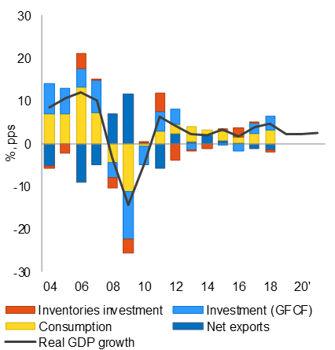
Source: European Commission
The Commission's Winter Forecast projects growth to remain broadly constant in 2020 and 2021 as slightly stronger domestic demand is expected to compensate for falling export growth. Private consumption is set to benefit from rapid wage growth and slowing inflation, thus being the main growth driver. Investment growth meanwhile is expected to decelerate further in 2020 before recovering somewhat in 2021. Export growth in 2020 is set to benefit slightly from the good harvest of 2019. However, this will not be enough to compensate for the drag on growth coming from weakening external demand. Overall, growth is forecast to reach 2.3% in 2020 and increase slightly to 2.4% in 2021.
Consumption
Despite the slowdown in 2019, private consumption is set to remain strong on the back of robust growth in real disposable income. In 2019, household consumption is forecast to have grown by 3.2%, somewhat lower than the 4.2% growth in 2018. The slowdown was primarily due to lower employment growth and higher inflation which both restrained disposable income growth. However, with the labour market set to remain tight, robust wage growth combined with abating inflation are expected to ensure solid growth of real income and by extension – private consumption. Consumer confidence remains high, providing further support for private consumption.
Investment
Investment is set to gradually slow as inflows of EU funds approach their peak in 2020. However, the beginning of the Rail Baltica project is expected to boost investments in 2021. In 2019, investment is forecast to have grown by 4.5% - notably less than the double-digit growth rates seen in 2017 and 2018. Due to EU fund inflows levelling off, public investment growth declined significantly while the momentum in private investment held up better. In 2020, public investment is expected to decline slightly while moderate growth in private investment should put the total growth rate in low positive territory. The construction related to the Rail Baltica project (see Section 3.4) is expected to begin at the end of 2020 and should boost the investment growth rate in 2021.
Graph 1.2: Investment growth and contributions, %
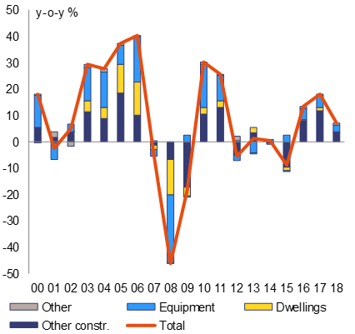
Source: European Commission
Trade
Exports slow amid weakening external demand while decelerating investment curbs import growth. In 2019, exports are forecast to have grown by 2.7%, down from 4.0% in 2018. The slowdown is partly due to a drop in re-exports. However, there was also a slowdown in growth in exports of domestically produced merchandise, most notably wood products, after the boost from high timber prices of previous years. On the positive side, services export growth improved compared to 2018 thanks to the especially strong performance of business and IT services exports, which outweighed the languishing transport sector — Latvia’s biggest services export sector. Over the coming years, export growth is unlikely to improve significantly given the weakening demand from the country’s main export markets.
Inflation
Inflation reaches its peak in 2019 as food and utility prices drove it past the 3 per cent mark. HICP inflation reached 3.1% in 2019, up from 2.6% in 2018. The pick-up in inflation was due to hikes in the prices of several utilities at the beginning of the year, a pick-up in inflation for industrial goods and a spike in the growth of food prices, which was partly the result of the previous year’s poor harvest. Services price growth at the same time remained stable, hovering around 3 per cent. It is expected that the acceleration in utility and food prices will have been temporary and will therefore slow inflation this year and next. Inflation is forecast at 2.5% in 2020 and at 2.3% in 2021.
Graph 1.3: HICP inflation and contributions, % 12-month average year-on-year change
Source: European Commission
Labour market
At 6.4% in 2019, the unemployment rate edges closer to its record low as wage growth remains high. In 2019 the unemployment rate dropped to 6.4% from 7.4% in 2018. The unemployment rate continued falling despite a forecast 0.4% decline in employment — this was due to the declining active population. Employment was down in trade, while in construction it continued to grow. However, with investment growth projected to slow, employment demand from the construction sector should also fall. Nonetheless, a continued decline of the labour force is expected to keep the unemployment rate constant despite falling employment — it is forecast to remain at 6.4% in 2020 and 2021. The continued decline of the working age population is set to ensure a dwindling active population. Altogether, this will ensure the labour market remains tight over the forecast horizon, exerting upward pressure on wages.
Graph 1.4: Selected labour market indicators
Source: European Commission
Labour supply is expected to continue falling and skills mismatches have emerged. The reduced labour supply – the outcome of natural population decline and emigration – has led to emerging labour shortages and a tightening labour market. In addition, skills mismatches prevail with large and increasing differences among the unemployment rates of different skills groups (Section 3.3.1).
Wages and productivity
Rapid wage growth drives unit labour cost appreciation. Nominal wages grew by 8.5% in 2019, up from 7.6% growth in 2018. Wages have been increasing at a brisk pace for some time now with the average wage growth over the past 5 years reaching 7.9%, substantially above the EU average of 1.6%. Productivity growth has also been fairly rapid with 3.0% growth in 2019, slightly higher than the 2.8% average growth rate over the past 5 years. Wage growth, however, has outpaced productivity growth by some margin, leading to a significant appreciation in unit labour costs, which grew by 5.3% in 2018 and the three-year growth of 14.7% is above the macroeconomic imbalance procedure threshold of 12%. In 2019, unit labour cost growth is expected to have slowed along with slowing wage growth. However, looking forward, the tight labour market is set to continue driving swift wage growth, which may lead to elevated unit labour cost growth.

Graph 1.5: Wages, productivity and unit labour costs, index 2000=100
Source: European Commission
Income level
In 2018, Latvia’s GDP per capita stood at nearly 70% of the EU average. In 2018, Latvia’s GDP per capita increased by 5.4% — among the highest growth rates in the EU. It was driven in equal parts by productivity growth, which increased by 3.0% and by growth in the share of the employed population, which increased by 2.4%. In purchasing power parity terms, it was 69.3% of the EU average, more than 3 percentage points higher than the year before. However, there are significant regional differences in GDP per capita within the country — in 2016, in Riga it stood at 165% of the national average, while in the other regions it was below the national average with the poorest region — Latgale — producing only 51% of the national average. The differences in wage levels are smaller, with the Riga region’s wages being 113% compared with Latgale’s 69% of the national average.
Social developments
While severe material deprivation has declined, relative poverty has worsened and both remain above the EU average. In line with the gradual improvement in labour market indicators, the share of people living in low-work intensity households has been falling for a number of years and reached 7.6 % in 2018, down from 10 % in 2013. This however, has not been sufficient to alleviate poverty, due to the presence of high in-work poverty in the low work intensity households. The at-risk-of-poverty rate, a measure of relative poverty, increased to 23.3 % in 2018 from 19.4 % in 2013, above the EU average of 17.1 %. Meanwhile, severe material deprivation showed a marked decline from 24% in 2013 to 9.5% in 2018, but remains somewhat above the EU average of 5.9% (see Graph 1.6). In 2018, the overall at-risk-of-poverty-or-social-exclusion rate of 28.4% also masked large differences between age groups, with the elderly (65+) facing a much higher risk compared to children or those of working age (49% as opposed to 22.5% and 23.5 % respectively) (Section 3.3.2).
Graph 1.6: Selected social inclusion indicators, % of population
Source: European Commission
Income inequality remains well above the EU average. While reducing inequality is one of the main goals of Latvia’s national development plan, Latvia is unlikely to achieve its national target to bring inequality down to the EU average by 2020. Income inequality as measured by the S80/S20 has risen in the post-crisis period and is among the highest in the EU. In 2018, the ratio stood at 6.8 compared with the EU average of 5.2. While income inequality before taxes and benefits is below the EU average, inequality after taxes and benefits, remains high, due to its relatively small role in redistributing income. A key driver is the low income of elderly households whose median income level is less than three quarters of that of the general population.
Unequal opportunities in access to education and healthcare persist. According to the OECD Programme for International Student Assessment (PISA), the education system is rather equitable, with socioeconomic background exerting a relatively limited influence on learning achievement in reading. At the same time, access to quality education remains dependent on the place of residence, and urban schools outperform rural ones (Section 3.3.4.). A similar urban-rural divide exists in access to healthcare. Moreover, low-income groups report significantly more unmet needs for medical services than high-income groups (Section 3.3.3.).
External position
The current account remains close to balance. In 2019, the current account is forecast to have recorded a deficit of 0.8% of GDP, similar to the previous year. The main forces at work in determining the current account balance are (i) EU fund inflows, which are partly spent on importing investment goods, and (ii) household savings growth in excess of domestic investments, which need to find an investment outlet outside of the country. Consequently, the net international investment position has continued to improve and stood at minus 50% of GDP at the end of 2018, from minus 83% of GDP in 2010. While still relatively high, the associated economic risks are limited, because this net investment position is mostly composed of foreign direct investment, while the investment position excluding equity was close to balance at the end of 2018.
Graph 1.7: Current account and its components, % of GDP
Source: European Commission
Public finances
The general government balance improved slightly in 2019. The general government deficit is forecast to have been 0.6% of GDP in 2019, slightly better than the 0.7% of GDP deficit in 2018. The government balance is set to remain broadly stable in 2020 and 2021, while the government debt is expected to continue falling to reach 32.9% of GDP in 2021. The Commission estimates that the output gap will remain positive but will be shrinking throughout 2019-2021.
Key sustainability challenges
Latvia progresses well on most United Nation’s Sustainable Development goals with slower progress in health, innovation and reducing inequalities. Latvia has among the highest shares of renewable energy among EU countries (SDG 7, see Section 3.5), it scores above EU average on most education and labour market indicators (SDGs 4 and 8, see Section 3.3.4). However, inequality in Latvia is high and has seen little progress over medium to long term (SDG10, see Section 3.3.3). This is also reflected in Latvia’s health outcomes (SDG 3, see Section 3.3.3) and social protection (SDG 1, see Section 3.3.2) remaining below EU average, as these sector have been significantly underfunded. Furthermore, breaking the trend of rapidly growing energy consumption and improving the recycling rates remain the key environmental sustainability challenges (SDG 12, see Section 3.5). Finally, while Latvia’s economic performance has overall been good, as its income per capita growth over the past decade has been remarkable (SDG 8, see Sections 1 and 3.4), its innovation performance is poor and has seen little progress in recent years (SDG 9, see Section 3.4).
Table 1.1: Key economic and financial indicators - Latvia
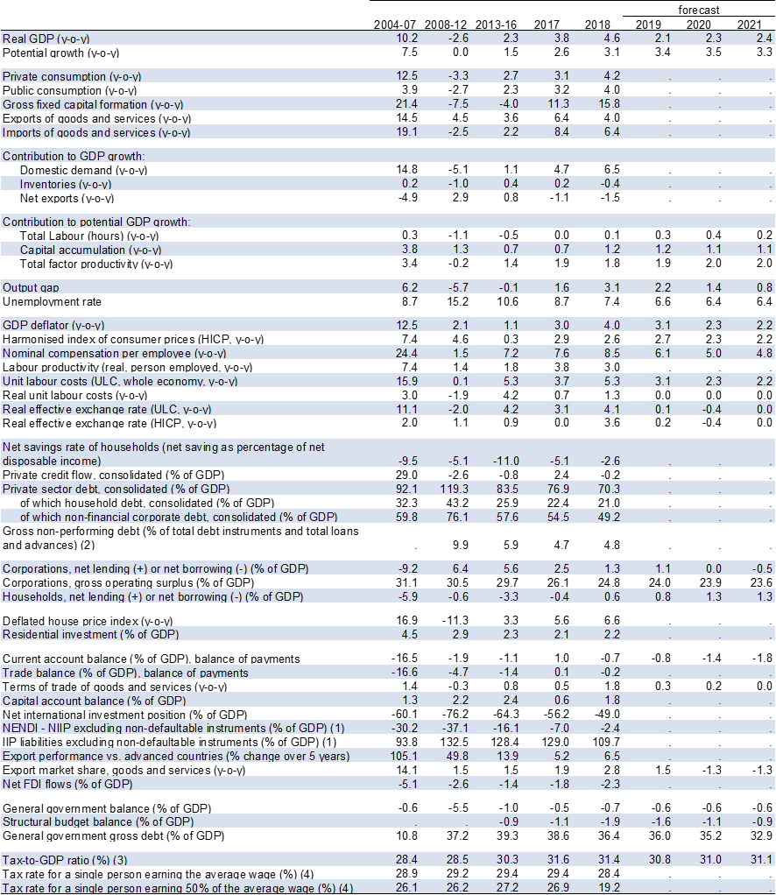
(1) NIIP excluding direct investment and portfolio equity shares.
(2) Domestic banking groups and stand-alone banks, EU and non-EU foreign-controlled subsidiaries and EU and non-EU foreign-controlled branches.
(3) The tax-to-GDP indicator includes imputed social contributions and hence differs from the tax-to-GDP indicator used in the section on taxation.
Source: Source: Eurostat and ECB as of 9-1-2020, where available; European Commission for forecast figures (Autumn forecast 2019)

Since the start of the European Semester in 2011, 95% of all country-specific recommendations addressed to Latvia have recorded at least ‘some progress’. In 2019, work advanced on some long-standing recommendations, with ‘some progress’ made in improving the adequacy of minimum social benefits and public administration reform has helped improve governance of municipalities. Moreover, the taxation of low wages (the tax wedge) has been notably reduced over the years past few, bringing it in line with the benchmark against other EU countries in 2020. However, this reduction in the tax on labour has been only partly compensated by other tax measures, showing ‘limited progress’ over time (Graph 2.1). Latvia has achieved ‘substantial progress’ and ‘full implementation’ in introducing a fiscal governance framework, reforming the pension system a few years ago and strengthening the anti-money laundering system more recently.
Graph 2.1: Overall multiannual implementation of 2012-2019 CSRs to date
(1) The overall assessment of the country-specific recommendations related toon fiscal policy exclude compliance with the Stability and Growth Pact.
(2) The multiannual CSR assessment of the country-specific recommendations looks at their implementation since from the CSRs time they were first adopted until the February 2020 Country report.
Source: European Commission
Latvia is committed to fiscal discipline and the tax wedge for low wages has been reduced. Latvia corrected its excessive government deficit in 2012 and since then has strived to maintain government borrowing within the limits set by the well-established fiscal governance framework. The increase in the income-dependent basic allowance in 2020 should reduce the tax wedge for low wages, thus showing a substantial progress in this respect. However, Latvia has not ensured revenue neutrality of the recent tax changes with the tax revenue from capital and property declining, contrary to what has been recommended. This limits its capacity to address the social reforms recommended to Latvia. Tax compliance is gradually improving, but more could still be done by closing tax policy loopholes, like the micro-enterprise tax regime, and by tackling more decisively shadow activity in several sectors of the economy.
Some progress has been made in carrying out social policy reforms, but their implementation is limited by the low level of public funding. Ambitious government plans to raise the minimum income level announced in 2014 have been shelved up to now due to a lack of funding. In 2020, the minimum social assistance benefits have been somewhat increased, but less than planned for 2020-2021, due to funding constraints. The adequacy of the minimum social benefit remains low and more effort is needed. The low level of public financing for health has limited people’s access to quality and timely care for years. Healthcare financing increased in 2017-2019, reaching an estimated 3.8% of GDP, but it is set to decline in 2020, as funding commitments are only partly satisfied. Efforts to increase the efficiency and quality of the health system continue, while major reforms of the hospital and primary care networks are still at an early stage, despite being on the reform agenda for some years now.
Education reforms have shown ‘some progress’ since 2012, but a greater effort could be done in order to improve the quality and efficiency of the education system, while expanding adult learning. Latvia made some progress in developing a quality-rewarding financing model for higher education and setting up an external quality assurance agency for higher education over 2012-2015. However, the amount of performance-based funding remains limited, and the higher education system remains fragmented, with too many study programmes and education institutions. The intentions of streamlining the school network, given the declining number of students, has not proceeded as planned in recent years, thus delaying gains in quality and efficiency in general education. Reforms to improve vocational education and training are ongoing, but the share of students in this type of education remains low. Participation in adult learning is low, especially for the low-skilled, due to personal reasons and insufficient non-financial and financial incentives for employers to invest and support adult learning for their employees.
Despite low national financing, ‘some progress’ has been achieved in investing in innovation, transport and digital infrastructure, while housing and environmentally minded policies have not yet been established. Since 2012, Latvia has been recommended to expand its investments in R&D, but funding plans have not materialised. Nevertheless, consolidation of the research institutions has been achieved and establishing a unified governance body planned. Transport and digital infrastructure have been developed with the EU’s support, but broadband coverage in rural areas remains low. Plans to develop an environmentally sustainable energy and transportation network have not yet been devised. However, the development of Rail Baltica should support the shift to transport that is less carbon intensive. Investments in housing are hampered by lengthy and cumbersome planning processes, as well as outdated rental laws, with no progress on proposed changes since 2018.
Public governance reforms, one of the reform priorities since 2012, have shown ‘some progress’ in recent years. The reduction in the length of court proceedings in general has been achieved, while the role of the Council for the Judiciary has been strengthened. Public oversight of insolvency administrators has been established. Public administration reform for the central government is being implemented over the period 2017-2020 and reform of local governments is set to be rolled out from 2021. Moreover, corporate governance of state and municipal companies already started to improve before the country’s accession to the OECD in 2016 and has continued to improve since then. ‘Some progress’ has been made in preventing conflict of interests over time, but certain shortcomings remain.
Latvia has made ‘some progress’ in addressing the 2019 country-specific recommendations (see Table 2.1). ‘Substantial progress’ has been made in strengthening the anti-money laundering system and reducing the flow of risky money through Latvia. The shifting of the tax burden from labour to other less detrimental tax sources has been partly achieved, as the measures were not revenue neutral. Social and healthcare plans for 2020 have had their financing restricted, resulting in ‘some progress’. Environmentally sustainable investment policies are still being designed. Public administration reforms have advanced, while the system to prevent conflict of interest showed mixed developments.
Upon request from a Member State, the Commission can provide tailor-made expertise via the Structural Reform Support Programme to help design and implement growth-enhancing reforms. Since 2017, Latvia has received support for a total of 32 projects. In 2019, several projects were implemented, including the development of a framework for assessing performance of the healthcare system and the provision of a methodology for innovative public service reform projects. Moreover, the Commission has supported the authorities in implementing the mid-term tax strategy by, among other things, supporting the development of VAT gap analysis methods and a compliance-risk management strategy. In 2019, work started on reviewing system for assessing disabilities and on enhancing the integration of people with disabilities in the labour market.
Table 2.1: Summary table of 2019 CSR assessment *
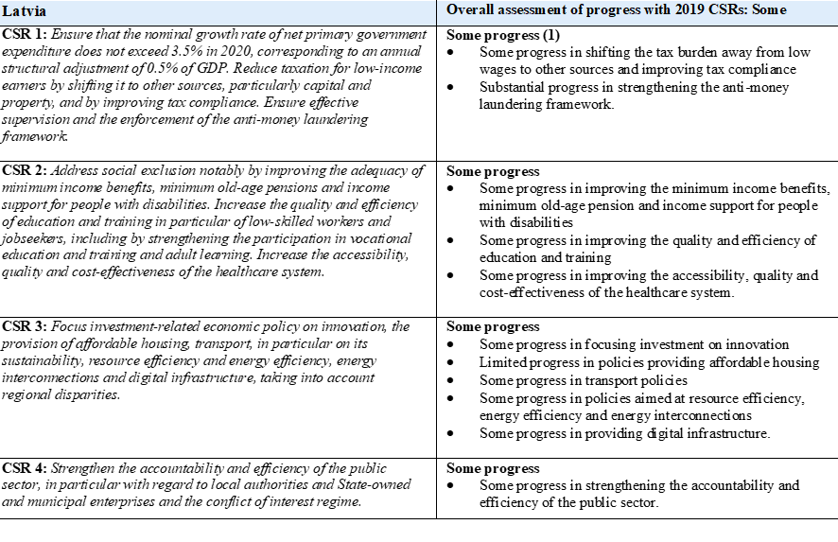
(1) The assessment of CSR1 does not include an assessment of compliance with the Stability and Growth Pact.
Source: European Commission
* The assessment of CSR3 does not take into account the contribution of the EU 2021-2027 cohesion policy funds. The regulatory framework underpinning the programming of the 2021-2027 EU cohesion policy funds has not yet been adopted by the co-legislators, pending inter alia an agreement on the multiannual financial framework (MFF)”.

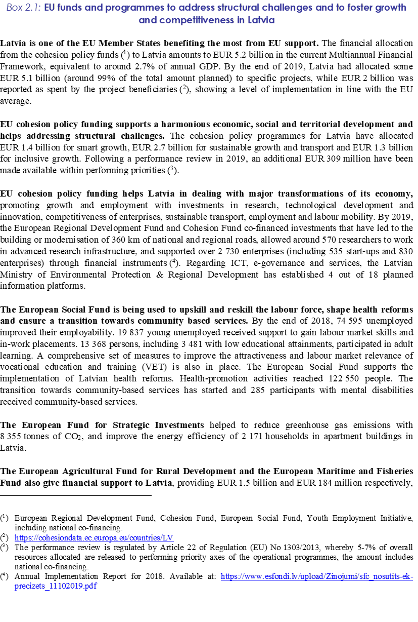
(Continued on the next page)

Box (continued)
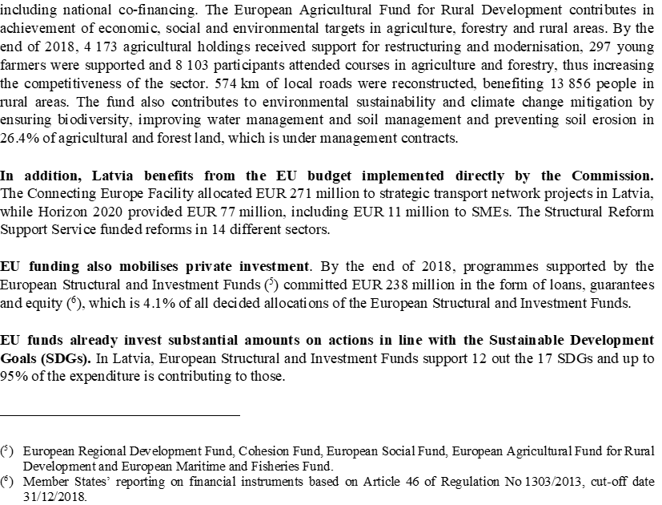

3.1. Public finances and taxation

3.1.1. Fiscal policy
Latvia’s fiscal stance is estimated to have tightened in 2019 and 2020. Latvia ran a fiscal expansion in 2017 and 2018 during a cyclical upturn in the economy. This was marked by an increase in government borrowing and annual expenditure growth rates of around 10%. It is projected that in 2019 and 2020, the structural deficit will be reduced in parallel with a slowdown in economic growth and a narrowing positive output gap (Graph 3.1.1). The expansionary revenue effort resulting from tax-cutting measures being implemented as of 2018 has been offset by a contractionary expenditure effort, as nominal expenditure growth is restrained at around 3.5% on average in 2019 and 2020 (Graph 3.1.2).
Graph 3.1.1: The fiscal stance and the economic cycle
Source: European Commission – Autumn 2019 forecast
The government revenue and expenditure share in GDP has declined due to tax-cutting measures. The cuts in effective tax on labour and corporate profits and dividends adopted in 2017 and being implemented from 2018 have only been partly compensated by revenue-increasing measures. It is estimated that the ratio of government revenue to GDP will decline by 1 percentage point of GDP between 2018 and 2020. This will lead to a contraction of the government expenditure ratio, while the government is committed to reducing government borrowing. Current expenditure is planned to decrease by 1 percentage point of GDP (mostly government purchases and transfers) and capital expenditure by 0.5 percentage points of GDP between 2018 and 2020. At the same time the government sector wage bill and social payments are expected to expand, in view of discretionary increases and indexation to wage and price developments in the economy.
Graph 3.1.2: Expenditure growth and the discretionary
fiscal effort
(1) Discretionary fiscal effort (DFE) consists of revenue and expenditure effort. (1)=(2)+(3)
(2) Revenue effort represents discretionary revenue measures. In this graph, positive revenue effort means expansionary fiscal stance (deficit-increasing).
(3) Expenditure effort shows the gap between the growth of public spending and smoothed potential growth over 10 years.
(4) Expenditure benchmark growth follows the notion of the expenditure benchmark in the EU fiscal framework (nominal smoothed potential growth adjusted for discretionary revenue effort). For further details on the methodology see Carnot, N. and F. de Castro (2015). ‘The Discretionary Fiscal Effort: an Assessment of Fiscal Policy and its Output Effect’. European Commission, Economic Papers 543, February.
Source: European Commission – 2019 Autumn Forecast

3.1.2. FISCAL FRAMEWORK AND EXPENDITURE REVIEW
The fiscal framework guides the fiscal targets with a margin of interpretation. Budgetary targets are set on the basis of the fiscal rules established in the Law on fiscal discipline and are monitored by the independent Fiscal Discipline Council. However, the Latvian budgetary authorities exercise interpretation when setting the targets, frequently resulting in higher structural balances than what is allowed by the national fiscal framework, as noted in the Surveillance Report by the Fiscal Discipline Council (2019). In particular, the authorities treat part of the tax reform costs as one-off measures, relaxing the structural balance requirement under the national fiscal framework, which is contested by the Fiscal Discipline Council. The Commission also does not recognise such one-off measures, and the authorities take that into account for compliance with the Stability and Growth Pact.
The expenditure review in 2019 analyses health and education expenditure, but does not re-evaluate spending priorities across government sectors. The review brought forward improvements in budget preparation, analysed spending on education and health and presented some savings for reallocation. However, the expenditure review does not assess the relevance of existing spending amounts. Any savings in one government sector are expected to be used in the same sector first, while reallocations among government functions are limited. Sectors with historically larger budgets and established indexation mechanisms are in a stronger negotiation position in the government discussions (defence, social protection). However, sectors relying on discretionary decisions need political support from other ministers to be agreed. For example, the baseline budgetary plans for the healthcare sector do not account for the underlying demographic and cost pressures, undermining its starting positon in the budget negotiations.

3.1.3. TAXATION
Latvia’s tax revenue share in GDP has been reduced by tax-cutting measures. The ratio of tax revenue to GDP is set to decline from 31½% in 2017 to 30½% in 2020, which is well below the EU average of 39%. The main sources of revenue are labour and consumption taxes. The share of capital taxes was already low compared to other Member States and has been further reduced by the corporate tax reform. The transition to the new corporate income tax regime, where only dividend withdrawals are taxed, resulted in higher temporary costs in 2019 and lower revenue in the medium-term, as companies appear to be retaining profits more than initially planned. Moreover, the decision to postpone the property value update for property tax from 2020 to 2022 limits revenue the potential of taxes on capital.
Latvia has moved towards a greener tax system and of all Member States now has one of the highest shares of environmental taxes. Taxes on energy, transport, pollution and use of resources amounted to 3.4% of GDP in 2018 (EU average 2.4%). Nevertheless, some tax exemption remain, decreasing tax effectiveness in changing environmentally harmful consumption patterns. Reduced VAT and excise duty rates on energy (heating and fuel used in agriculture) accounted for 0.3% of GDP in tax expenditure in 2017 (Ministry of Finance, 2018). Moreover, VAT deductibility for the purchase price and operating costs of company cars subsidises the private use of company cars. Latvia’s draft energy and climate plan intends to review and to reduce tax subsidies on fossil fuels, aligning taxation based on CO2 emissions, while household investments in energy efficiency could be incentivised by temporary VAT or property tax reliefs. Increasing environmental taxes can help in achieving environmental objectives. At the same time distributional effects and respective compensatory measures for the most vulnerable households should be taken into account (European Commission, 2019c).
The taxation of low wages has been brought in line with other Member States. The budget for 2020 further increased the monthly income-dependent basic allowance to EUR 300 and its minimum threshold to EUR 500, exceeding the previously adopted plans. As a result, the tax wedge for wages at 50% of average wage would decrease to 35% in 2020 — broadly in line with levels in other Member States (Graph 3.1.3). While the measure is targeted at low wage earners, it is estimated to benefit more middle income groups in the population-wide income distribution (Graph 3.1.4). This is explained by a low work intensity of lower income groups and already existing allowances that partly or fully exempt low wages from personal income tax. Social transfers generally considered to be better suited to reaching the poorest households (see Section 3.2.3). At a cost similar to the 2017 tax reform, a reform of the minimum income level, with a tapered transition to labour income, could close the gap with the EU average in terms of poverty and inequality while improving incentives to work (Ivaškaitė-Tamošiūnė et al., 2018).
Graph 3.1.3: Estimated tax wedge on labour in 2020, compared to relatively high and relatively low levels in other EU countries
Source: European Commission

Graph 3.1.4: Effect on income distribution of the increase in the basic allowance presented in the budget for 2020
Source: European Commission (Euromod)
Despite increased labour tax progressivity, the tax system could do more to reduce inequalities. Since 2018, Latvia has adopted a progressive tax schedule and has increased the income-dependent basic allowance, making personal income taxation more progressive. Nevertheless, tax progressivity in Latvia remains lower than in other EU Member States. Moreover, a strong reliance on consumption tax revenue, which typically contributes little to redistribution, and low capital taxation limit the distributional effect of the tax-benefit system and its effectiveness in reducing income inequalities.
Property taxation remains based on outdated values. Latvia has a potential to increase revenue from property taxation. Recurrent property tax accounted for 0.7% of GDP in 2019, below the EU average of 1.6% of GDP in 2017. While real estate cadastral values which are used to calculate property tax are meant to follow the market values, the Latvian government has consecutively postponed updating the cadastral values. The planned update in 2020 has been postponed to 2022, as increasing property taxation is highly unpopular. This postponement is estimated to cost around 0.1% of GDP on top of around 0.3% of GDP forgone in revenue due to the previous postponements of valuation updates.
Proposed changes to property taxation would narrow the tax base. The draft cadastral methodology presented in 2019 envisages to standardise site areas used for buildings and to cut a number of building classification types, thus addressing the valuation difficulties and sources of inconsistencies. However, the planned introduction of special values for taxation of individual housing sites would make their taxation more detached from the market values. Furthermore, a proposal to tax only primary residences valued more than EUR 100 000 would exempt a majority of households from paying the tax and would cost some 0.2% of GDP in tax revenue.
The share of the shadow economy still appears to be high. Based on surveys of company managers, Latvia’s shadow economy was estimated at 24% of GDP in 2018, exceeding estimates for Estonia (17%) and Lithuania (19%) (Sauka & Putnins, 2019). The under-reported business income in Latvia (35% of the shadow economy) and ‘envelope’ wages (22%) account for most of the difference with other Baltic states. Among sectors, construction (36%) and retail (25%) had the highest share of shadow activity in 2016-2018 on average. The VAT gap () in Latvia is estimated at 15% in 2017 exceeding the EU average of 11% (CASE, 2019). The State Revenue Service of Latvia shares similar VAT gap estimates and expects the gap have narrowed in 2018. However, VAT fraud remains widespread. The World Bank has prepared several recommendations on this to the Latvian authorities and organised training for the staff of the State Revenue Service in order to improve VAT collection ().
Tax compliance has gradually improved through variety of measures. In 2019, the authorities continued expanding use of data-driven risk assessments, increasing communication with the taxpayers through the electronic declaration system and implementing sector specific measures. In the construction sector, the implementation of the collective agreement (see Section 3.3.1) and tightening of electronic employee registration on large construction sites are expected to reduce the high share of shadow activity in the sector. Illegal online gambling has been restricted by more efficient blocking of access to unlicensed gambling sites and by involving payment service providers in policing unlicensed activities. The State Revenue Service is also improving its analytical capacity in using large data sets and in identifying suspicious operations. Tax revenue gains from these measures can be expected in the medium term, but it requires a continuous effort to monitor tax compliance and to react to the signs of evasion.

3.1.4. DEBT SUSTAINABILITY ANALYSIS AND FISCAL RISKS
The risk to Latvia’s fiscal sustainability is assessed to be low in the medium and long term, assuming current policies continue. The low risks to fiscal sustainability are assessed on the basis of the low initial debt level and on the assumption that the costs related to the ageing population will be contained (see Annex B). Under the baseline scenario of the 2018 Ageing Report (European Commission, 2018a), total ageing-related expenditure is projected to decline by 1.3 percentage points of GDP between 2018 and 2070, assuming a fall in pension spending and a limited increase in healthcare spending. The average public pension benefit is projected to decline relative to the average wage, though this would be partly compensated by the increasing size of the mandatory private pension schemes. The health expenditure-to-GDP ratio is expected to increase from 3.7% in 2016 to 4.3% in 2070, in view of the projected demographic changes. This would still be one of the lowest in the EU. These assumptions might be politically and socially unsustainable, thought, in view of the currently low adequacy of pensions (see Section 3.3.2) and underfunding of public healthcare (see Section 3.3.3).
If Latvia converges with the EU average indicators for pension adequacy and health spending, risks to fiscal sustainability appear higher. Assuming that healthcare costs converge with the EU average, Latvia’s healthcare and long-term care spending is projected to increase by some 3% of GDP by 2070. Maintaining the current levels of the pension benefit ratio up to 2070 would cost around 2% of GDP annually. Moreover, raising the pension benefit ratio to the EU average would cost 10% of GDP. Such assumptions would lead to higher risks to fiscal sustainability in the medium and long run than current policies suggest.

Financial stability
The Latvian banking sector remains profitable, well-capitalised and overall sound despite the decline of the non-resident segment. Average profitability has remained relatively stable despite the shrinking of non-resident banks’ operations. Return on equity increased slightly to 10.1% in the first half of 2019 while the return on assets was 1.1% at the end of the first half of 2019. As a result, banks are on average well capitalised with a total capital ratio of 22.6, which is well above the EU average and the prudential minimum set by the regulator. According to a stress test done by the Bank of Latvia, the shock absorption capacity at a systemic level is good. Local deposits are still outpacing credit growth, contributing to a falling loan-to-deposit ratio, which reached 74% at the end of Q2 of 2019. The liquidity risk of credit institutions is limited, as liquid assets make up a large share of total assets (30%).
Table 3.2.1: Financial soundness indicators
(1) * ECB aggregated balance sheet: loans excluding to government and monetary financial institutions / deposits excluding from government and MFI
** For comparability only annual values are presented
Source: European Central Bank CBD2
The banks formerly servicing non-resident clients are in the process of finding a viable alternative for their former business model. Non-resident banks () have substantially downsized their operations on the back of tightened anti-money laundering rules (see below) and transformed their business models. As a result, their business volumes and deposits shrunk notably. A part of the credit institutions servicing foreign customers has started to offer new financial products and collect household deposits via web platforms. While this improves the maturity composition of their financing, it may pose refinancing and liquidity risks in the medium term, given the likely outflow at maturity. Other credit institutions have seen the quality of their foreign loan portfolio deteriorate, a large part of which consists of unlikely-to-pay loans (NPL) not past due. The average non-performing loan ratio for households and non-financial corporations amounted to 7.5% in Q2 2019, but trends in the NPL-ratio of credit institutions servicing domestic customers and foreign customers considerably differ (4.2% and 31.4% respectively).
The main risks to financial stability are associated with housing market developments in the Nordic countries and anti-money laundering in Latvia. Although, the significance of Nordic parent bank funding for their subsidiaries in Latvia has shrunk considerably, risks related to the housing market in Sweden could impact Latvia via trade and confidence channels. Moreover, following the transformation of Luminor Bank from a subsidiary into a branch of the Estonian entity, the transmission of shocks coming from other Baltic states to Latvia could be accelerated. While measures have already been put in place to mitigate the risks of money laundering and terrorist financing, potential ramifications in the financial sector could be wide and uncertain in case of adverse events.
Anti-money laundering
Latvia has reaffirmed its commitment to fighting money laundering and terrorism financing as key to preserve trust and stability of its financial system. Following the ABLV case (), Latvia took immediate steps to reduce the flow of risky assets through its financial system (European Commission, 2019a) In July 2018, Moneyval concluded that the effectiveness of Latvia’s anti-money laundering (AML) system was only moderate and put it under enhanced monitoring by the Financial Action Task Force () (FATF). The FATF will assess the progress made by Latvia at its next plenary meeting in February 2020. Following Moneyval’s report, Latvia has declared shoring up its AML system a priority and has worked on many fronts to strengthen its anti-money laundering system. In January 2020, Moneyval has taken stock of Latvia’s progress and improved the country’s ratings on 11 recommendations, and Latvia is now “compliant” or “largely compliant” with all FATF’s recommendations. Measures to improve the fight against money laundering would contribute to advancing towards SDG 16.
Latvia has updated its anti-money laundering legal framework and strengthened the supervisory and law enforcement institutions. Latvia updated its anti-money laundering law, the law on credit institutions and the law governing Latvia’s financial supervisory agency – the Financial and Capital Markets commission (FCMC). The list of authorities with competence to enforce sanctions was also expanded. Implementation of international sanctions is among the FCMC’s top priorities for the coming years. As of 29 June 2019, the Financial Intelligence Unit (FIU) is the chief authority responsible for AML/CFT issues. Its staff was increased and its independence and autonomy were bolstered. The extent to which the Financial Intelligence Unit (FIU) of Latvia can effectively execute and leverage its new powers will be essential given its central role in AML/CFT framework.
Latvia has increased the financial supervisor’s staff and invested in its analytical capacity. The number of staff dealing with AML supervision increased markedly. FCMC developed new tools to better identify beneficial owner groups and transaction connections. The FCMC also increased the number of on-site inspections and strengthened its supervision of money services providers, which have emerged in the wake of shell companies closing down. Over 2019, the FCMC has imposed enforcement actions (monetary and other) on four banks and four administrative investigations are ongoing. A new supervisors’ coordination platform allows a common understanding of money laundering and terrorist financing risks and is used to share knowledge and supervisory practices. All supervisors have now developed sectoral risk assessments and guidelines for risk-based supervision. However, Latvia should continue its efforts to implement risk based supervision in practice.
De-risking and rebuilding the reputation of Latvia’s financial sector has been a critical part of Latvia’s anti-money laundering strategy. One of the FCMC's main objectives is to closely monitor the change of business model of the banks (formerly) servicing foreign clients. Due to de-risking measures taken by banks, amplified by the ban on servicing particular type of shell companies, the share of non-EU deposits has decreased from 35.6% in 2015 to 6.6% in September 2019. The value of non-resident deposits has shrunk from €8.1 bn in 2017 to €3.2 bn in September 2019 (39.7% to 19.5% in total deposits). De-risking actions taken in respect of other high-risk areas (e.g. foreign-owned companies) include improved transparency of legal persons (). Nevertheless, Latvia should increase its understanding of underlying risks of money laundering and terrorist financing, in particular in relation to accountants, lawyers, tax advisors and other professionals involved in company formation.
The government has also strengthened the dialogue between the financial sector, the supervisor and the law enforcement bodies. In 2018 a coordination group led by the FIU was set up and helped improved the stakeholders’ understanding of money laundering risks. Moreover, thanks to the feedback by the Financial Intelligence Unit to obliged entities, the quality of suspicious transaction reports has improved and its quantity reduced, although it remains rather high. Cross-border dissemination of suspicious transaction reports has improved. Latvia should continue its efforts on the cross border dissemination of suspicious transaction reports.
The law enforcement authorities’ capacity to handle money laundering cases still needs to be strengthened. Guidelines on investigation have been updated and training has been provided to all judicial stakeholders to improve the quality and effectiveness of prosecuting money laundering cases. Data show that the number of prosecutions and criminal proceedings has increased and that assets are being confiscated (). However, efforts could continue to ensure that money laundering investigations are prioritised and effective and dissuasive sanctions for persons convicted of money laundering.
Credit growth
Mortgage lending has been boosted by a state support programme, but credit growth remains sluggish overall. After prolonged deleveraging, the annual growth rate of mortgage loans turned positive in 2018, reaching 1.9% (year-on-year) in August 2019. The growth in mortgages is underpinned by an improvement in the financial situation of households, low interest rates and the state programme to support house purchases. The increase in lending to non-financial corporations (3.5% growth year-on-year in the first half of 2019) is to a large extent linked to a few large long-term loans. At the end of 2018 bank lending to the domestic non-financial sector stood at 34% of GDP, remaining among the lowest in the EU. At the same time, the role of non-bank financial institutions in domestic lending continues to strengthen. At the same time, the role of non-bank financial institutions () in domestic lending continues to grow. At the end of 2019, non-bank lenders accounted for 17% of all loans granted to households and non-financial corporations. The growth in household leasing provided by the non-bank financial sector, in particular, accelerated from 5.9% in 2018 to 8.2% in Q2-2019. By contrast, growth in leases to non-financial companies decreased from 10% in Q4-2018 to 3.2% in Q2-2019. This can be explained by the deferral of corporate income tax tax for reinvested profits, which was introduced from 2018.
Slow credit growth is due to both demand and supply factors. Banks’ standards for lending to small and medium-sized enterprises remain tight. High credit risk (bad track records, weak borrower collateral and equity), shortcomings in the legal framework, and the shadow economy are important supply-side constraints to corporate lending. On the demand side, the share of finance-constrained firms appears to be higher in Latvia than in other Member States (EIB Investment Survey 2019). Rejected loan application rates remain high — according to SAFE survey data, the percentage of rejected loan applications by small and medium-sized enterprises (SMEs) has further increased, reaching the fourth highest share in the EU. At the same time, the availability of bank loans for large corporates with sound financial indicators is good. However, their demand is low and volatile. Smaller investments are often financed with internal resources.
Additional macro-prudential measures aimed at limiting the growth of loan-to-value ratios are under way. Bank of Latvia has expressed concern about the loan-to-value ratios which are rising because of the state guarantee programme helping families buy their first property by guaranteeing part of their down-payment. About half of all mortgages are granted under the state support programme. In the first half of 2019, new loans with a loan-to-value ratio exceeding 90% accounted for one third of all new mortgages. Besides the lower down payment, a discount on stamp duties for loans granted through the state support programme provides an additional incentive to apply for support. Bank of Latvia wishes to make the 90% ceiling on the loan-to-value ratio, which is already effective for banks, also binding for non-bank lenders.
Alternative financing
There has been a steady increase in the availability of venture capital in recent years and this trend is expected to continue. Access to finance is supported by the national development institution Altum, which plays a major role by supplementing bank and other market-based financing to mainly small and medium-sized enterprises. It provides loan guarantees to established companies and direct funding to start-ups for seed, acceleration and expansion phases. The sectoral distribution of venture capital investments is diversified, but ICT and manufacturing stand out. There is a strong concentration of venture capital in the Riga region, where most high-growth enterprises are located. According to the start-up ecosystem mapping completed in 2019, between 2012 and 2018 the amount of venture capital attracted by 178 Latvian start-ups totalled €122.2 million. Venture capital constitutes the main form of financing for start-ups or 46%. Other investors like banks and financial institutions represent 23% of the total investment, with financing also coming from business angels (6%), enterprises (5%) and crowdfunding (1%). Despite increasingly positive trends, the venture capital market in Latvia is still developing relatively slowly. It is focused on the rather early stages of financing and remains dependent on public co-funding (European Commission, 2019e). In August, the continuation of the Baltic Innovation Fund initiative was ensured with the signature of the Baltic Innovation Fund 2 Agreement by the European Investment Fund and the three Baltic states. Over the next 5 years, the Baltic Innovation Fund 2 (€156 million) will invest in private equity and venture capital funds that focus on the Baltic states, with the goal of further developing equity investments in SMEs to boost growth in the region.
Housing market
The growth in residential real estate prices does not pose systemic risks to financial stability. Nominal house prices have grown on average by 8-9% annually in recent years. The increase in house prices has been supported by the steady wage growth of recent years and the state support programme for house purchase that was introduced at the beginning of 2015 and expanded in 2018. Since the burst of the housing bubble in 2009 when house prices fell by 45%, their recovery has not exceeded wage growth. In fact, since 2010 when house prices were at their most depressed level, wage growth has exceeded house price growth by some 10 percentage points, as evidenced in the continuously declining house price wage ratio (see Graph 3.2.1). A housing affordability index compiled by one of the Baltics’ leading commercial banks shows that, of the three Baltic capitals, house prices remain most affordable in Riga (Swedbank, 2019). The volatility of construction demand has fuelled rapidly rising labour costs. Moreover, lengthy and cumbersome processes for obtaining planning and building permits have also contributed to the high cost of construction. As a result, the market for new dwellings is concentrated mainly in Riga and the surrounding area, because lower purchasing power in places further away makes new housing commercially unviable (European Commission, 2019a). Streamlining building regulations is essential to remove a range of supply-side factors that impede the ability of the construction sector to respond to a growing demand for affordable housing.
Graph 3.2.1: House prices / wages ratio, index, 2006=100
Source: European Commission
Shortages of skilled workers are a major bottleneck in the construction sector. There is a particular need for construction managers, water and wastewater engineers and roofers. Latvia adopted a construction industry development strategy for 2017-2024 to address industry issues, which include ensuring a qualified workforce; increasing productivity; reducing administrative barriers; and improving the quality of construction services. In addition, the volatility of investment demand exacerbates the capacity constraints and price pressures in the construction sector (European Construction Observatory 2019).

3.3.1. Labour market
Labour market performance is overall positive; however, labour shortages and skills mismatches have emerged. The employment rate continues its upward trend (77.4% in Q3-2019; 76.8% in 2018), on the back of declining unemployment (6.2% in Q3-2019; 7.4% in 2018) and a growing activity rate (77.7% in 2018). The long-term unemployed and young people also continue to benefit from the steady improvement in the labour market. Nonetheless, unemployment rates continue to differ depending on the region and level of skills, highlighting the need for significant investment. Unemployment is forecast to fall further over the coming years, mainly because the labour supply is expected to continue falling due to a natural decline in the population and emigration (see Section 1). Between 2000 and 2016, Latvia lost about 287 000 people (12.1% of the initial population) to net migration, with skilled labour accounting for more than two thirds of this loss (Hazans M., 2018). The limited labour supply has led to emerging labour shortages and exposed skills mismatches. In Q2-2019, vacancies reached a historic peak of 30 500, with an increase of almost 24% compared to the same period in 2018 (CSB, 2019). Compared to other Member States, Latvia still faces relatively low labour shortages with 15.5% of the firms facing difficulties finding suitable workers (EU-BCS, 2019). However, the indicator has increased substantially since 2013 (by around 7.7 pps).
Conditions are improving with return migration and immigration from other non-EU countries on the rise. In 2018, international long-term net migration was still negative at 4.9 thousand people. However, this is the lowest level recorded in the past 20 years. The ongoing income convergence and moderate labour shortages provide positive conditions for return migration. Coupled with more flexible immigration regulations, they have also led to an increase in immigration from non-EU countries. In 2018, about 4 000 work permits were issued, mostly for workers from Ukraine and the Commonwealth of Independent States (CIS), which is comparable with the number of return migrants (Krasnopjorovs, 2019). Nevertheless, assessing the full extent of non-EU workers in the Latvian labour market remains a challenge due to the multiple entry channels, absence of proper monitoring tools and fragmented oversight. While increasing, the limited size of return migration and immigration cannot compensate for the shortage of skilled labour caused by emigration over the past years (Hazans M., 2018). It could, however, alleviate some short-term labour market pressures.
A large share of the unemployed are low-skilled, while there is a shortage of high-skilled labour. In the short term, the strong growth in the construction sector absorbs low and medium-skilled workers, with little effort for upskilling and adult learning (). Nevertheless, unemployment rates continue to differ by skill level: the unemployment rates of high, medium and low-skilled workers stood at 3.7%, 8.5% and 16.5%, respectively (2018) (Graph 3.3.1). Labour market shortages have emerged for high-skilled labour in particular. At the same time, the supply of low-skilled workers exceeds their declining demand, leading to a high unemployment rate for this group, with the gap expected to continue widening over the medium and long term (Ministry of Economics, 2019a). Increasing training of low-skilled and unemployed could help to progress on European Pillar of Social Rights principle 1, thereby also contributing to advancing towards the United Nations’ Sustainable Development Goal 4 and 8.
Graph 3.3.1: Unemployment rate by education attainment
Source: European Commission

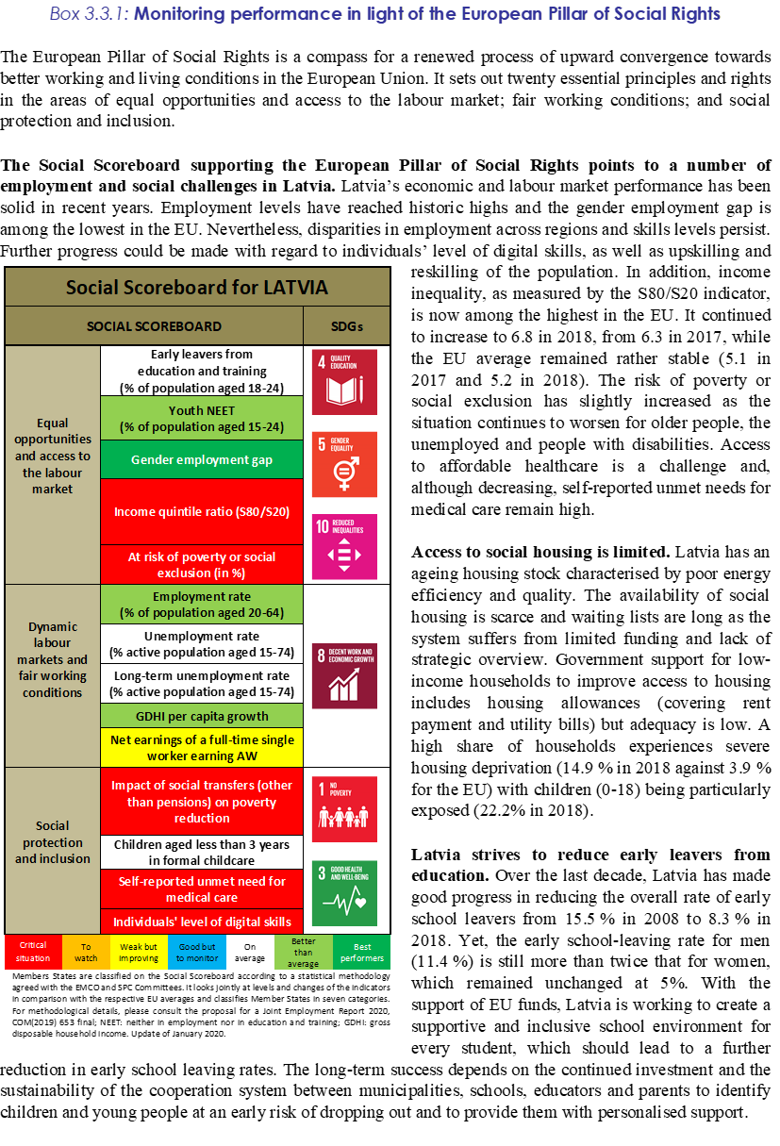
Low-skilled, older workers and ethnic minorities have limited access to the labour market. While youth unemployment has decreased, unemployed young people often lack work experience and basic skills, and youth employment (33.1% for young people aged 15-24) is lower than the EU average (35.4%, 2018). As many as half of the registered unemployed aged 15-29 are low skilled, which reflects the overall high unemployment of the low-skilled in the country (Graph 3.3.1). Unemployment among older workers (aged 55-74) is decreasing at a slower rate than for other age groups, which can be linked to their poor health and low participation in adult learning (3% in 2018) (CSB, 2019). The employment rate for ethnic minorities is some 12 pps lower than for the ethnic majority, and unemployment among non-EU nationals is consistently higher than among nationals in every age group. This is partly linked to the insufficient public supply of general and professionally oriented Latvian language courses for the adult population (OECD, 2019a). Improving labour market access for these groups and unlocking the internal labour market reserves, could ease some of the tensions in the labour market.
Employment conditions differ across regions and internal mobility remains a challenge. The unemployment rate, youth unemployment rate and share of long-term unemployed vary considerably across regions. While densely populated Riga and the surrounding Pieriga region exhibits the lowest levels of unemployment (6.7% and 4.7% in 2018 respectively), Latgale has both the highest unemployment rate (11.8% in 2018) and lowest activity rate among Latvia's NUTS-3 regions (CSB, 2019). A regional mobility support scheme reimbursing transport or housing costs for 4 months (capped at EUR 600) is having a positive effect on job uptake and has the potential to be scaled up in a targeted way (OECD, 2019b). However, rental costs relative to incomes are high in Riga and the surrounding region of Pieriga, thus discouraging regional mobility. The absence of a national housing policy also limits the provision of housing to more vulnerable groups (see Section 3.3.2.).
Spending on and participation in active labour market policies remain low, limiting the activation of those furthest away from the labour market. While Latvia has low public spending 0.6% in 2017 on active labour market policies, the list of such policies has expanded and diversified in recent years. Training for the unemployed has had a positive effect on labour market outcomes; effectiveness has been further boosted when combined with other measures, such as support for regional mobility. However, the role of these measures is limited by the low registration of jobseekers with the public employment service, with only around half of all unemployed registered, and relatively low participation rates (6.8 per 100 persons wanting to work, 2017). Many unemployed persons therefore cannot be reached to help them search for a job or participate in activation measures (OECD, 2019b). Cooperation between public employment services, social services and educational institutions is insufficient, resulting in poor monitoring of school-to-work transitions and limited integration in the labour market.
While the employment rate of women is high, imbalances in the labour market persist. Latvia has one of the lowest gender employment gaps (4.2 pps in Latvia, 11.6 pps EU average, 2018) and a gender pay gap around EU average (15.7% versus 16.0% in the EU, 2017). While women have higher educational attainment (see Section 3.3.4), they are also more likely to study social sciences and humanities and work in sectors with lower wages, such as healthcare, social care, education and tourism. Around 21.8% of women and 19.4% of men earn minimum wages or lower (CSB, 2019). Access to flexible working arrangements is lower in Latvia than in the EU as a whole and around two thirds of women (68%) and men (63%) are unable to change their working time arrangements (EIGE, 2019). Latvia is taking steps to progress on European Pillar of Social Rights principle 2, thereby also contributing to advancing towards the Sustainable Development Goal 5, to achieve gender equality also through national planning documents, such as the Plan for Stimulating Equal Rights and Opportunities for Women and Men 2018-2020.
The prevalence of completely or partially informal employment is high. While the share of undeclared earnings is slowly decreasing, estimated 41% of all employees had an undeclared earning share of at least 10% in 2016. More than 4% of employees were working entirely in the informal economy, with the highest incidence among skilled agricultural and manual workers as well as the low-skilled. Moreover, a typical ‘envelope’ wage receiver had low or middle income and faced difficulties in making ends meet (estimates based on EU-SILC microdata). According to a special Eurobarometer survey carried out in September 2019, 36% of Latvians know someone who worked without declaring all or part of their income. One in five Latvians also said they have purchased goods or services that could involve undeclared work in the past year. The high prevalence of the informal economy has adverse effects on the social protection of the affected workers. It further contributes to the under-reporting of accidents at work and heightens occupational risks (European Commission, 2019b). Several measures are being implemented to improve the compliance (see Section 3.1.3.); at the same time the capacity of the State Labour Inspectorate to tackle undeclared work remains limited, due to the high staff turnover and unfilled vacancies, especially in Riga (State Labour Inspectorate, 2019).
Wages are catching up with the EU average, but the share of low-wage earners remains high. The average monthly wage (reflected in nominal compensation per employee) grew by 6.2% in 2019 (8.4% in 2018), reaching 67% of the EU average (in purchasing power standards). At the same time, some 27% of employees earned wages up to two thirds of the median wage in 2018, which is a higher share than in other Member States. The national monthly minimum wage stood at EUR 430 in 2019 — at 47% of the median wage. When comparing the net disposable household income of minimum wage earners to the at-risk-of-poverty threshold in 2018, the minimum wage did not provide sufficient income to be out of poverty for a single worker working full-time, for single parents with a child, nor for dual-earners couple with two children (all earning the minimum wage). The net earnings in purchasing power standards for a single person are among the lowest in the EU and reported as ‘weak but improving’ in the Social Scoreboard (Box 3.3.1). Furthermore, Latvia faces a risk of in-work poverty, at 8.1% in 2018 (7.6% for men and 8.5% for women). This risk is particularly high for older workers (aged 55+) with 10.5% at risk of in-work poverty in 2018 and significantly higher for temporary and part-time workers (30.9% and 22.7% in 2018, respectively).
While sectoral collective bargaining has been strengthened, the social partners’ limited capacity restricts their role in social dialogue. As of November 2019, the collective agreement in the construction sector entered into force, setting a minimum wage for the sector at EUR 780 and reducing a surcharge for overtime work to 50%. This agreement is a novelty for Latvian industrial relations and a step towards strengthening sectoral collective bargaining, which is currently weak. While EU funds provide financial support to extend sectoral bargaining, collective bargaining coverage remains low and it takes place mainly at company level (Müller T. et al., 2019). The national setting for involving social partners in reforms and policy formation is well established; however, the social partners’ limited capacity restricts their meaningful and timely involvement.

3.3.2. Social policies
Poverty remains high and is increasing, while spending on social protection is low. The risk of poverty and social exclusion slightly increased (28.4%, 2018), driven by an increase in monetary poverty (23.3%, 2018), and is reported as ‘critical’ in the Social Scoreboard (Box 3.3.1). Elderly people and people with disabilities are particularly affected (Graph 3.3.2). The share of people who are currently poor and were poor during two out of the three previous years is high and increasing. This indicates that people live with a low income for long periods, as opposed to people who face transitory poverty. In 2018, 1 in 5 Latvians experienced material and social deprivation. In 2018, Latvia spent 11.6% of GDP on social payments, well below the EU average of 20.4%. The budget for 2020 targets an increase in social expenditure to 11.7% of GDP (). This mostly reflects the annual indexation of pensions, as well as discretionary increases in minimum social benefits. However, significant investment needs remain to address Sustainable Development Goal 1 to end poverty and foster the active inclusion and social integration of vulnerable groups, which includes providing these groups with supporting social services.
Graph 3.3.2: At-risk-of-poverty rate by age groups
(1) The at-risk-of-poverty rate is the share of people with an equivalised disposable income below the at-risk-of-poverty threshold, which is set at 60% of the national median equivalised disposable income.
Source: European Commission
Poverty rates are markedly different among age groups, and tax and benefit policies have not changed significantly the situation of the poorest households. In 2018, the overall at-risk-of–poverty-or-social-exclusion rate of 28.4% masked large differences between different age groups, with older people (aged 65+) facing a more than double risk compared to children or those of working age (49% versus 23%, respectively). According to EUROMOD estimates, the tax and benefit policy changes between 2008 and 2018 increased, on average, disposable income and reduced income inequality (the Gini coefficient fell by about 1%) (European Commission, 2019b). Middle-income groups and the poorest 10% are estimated to have benefited the most. However, the overall poverty rate has remained broadly unchanged, as the poverty line of 60% of median income has increased, covering a similar share of people as before. Policy changes have been more targeted at reducing child poverty (by 2.9 pps), while the poverty rate for older people has increased (by 4.1 pps).
The adequacy of social assistance benefits slightly improved, but remains low and contributes little to alleviating poverty. The adequacy and the coverage of the minimum income scheme are very low (). From 2020, the guaranteed minimum income tops up monthly income to EUR 64 (from EUR 53 in 2019). The amount of the benefit is still well below the costs of living and the poverty threshold, which stood at EUR 409 in 2018. In 2018, around 1% of the population (20 878 persons) were guaranteed minimum income recipients, out of which 20% were children, 16% people with disabilities and 14% older people. The increase will result in less than 5 000 additional people eligible for the benefit. The effect of the guaranteed minimum income on poverty reduction is very small (1 pp in 2017), and the effect of the housing benefits is equally low, underlining the poor adequacy of Latvia’s social safety nets (European Commission, 2019b).
Minimum pensions have been slightly increased, but the adequacy of pensions remains low. In 2018, the aggregate replacement ratio for pensions in Latvia stood at only 40 %, among the lowest in the EU. In 2018, 11.5 % of newly allocated pensions were minimum pensions at an average amount of EUR 83 per month. The average monthly pension stood at around EUR 360 in 2019, which is below the poverty threshold. The gap between pensions and wages in the economy has widened. The average inflation-adjusted gross wage increased by 33% between 2014 and 2019, while, the average inflation-adjusted old-age pension increased only by 15%over the same period. To improve the situation for pensioners, the income tax allowance was increased in 2019 and more favourable indexation rules have been applied to cover inflation and for those with longer service periods. On 1 January 2020, the government also raised the minimum pension base rate from EUR 64 to EUR 80 with higher rates applied for more years worked. Those who have worked less than 15 years will not benefit from the increase, as they are only entitled to a state social security old-age allowance that has remained unchanged at EUR 64 since 2006. Consequently, the adequacy improvements are limited and a large proportion of older people (46%, 2018, EU-SILC) remains below the poverty threshold.
The unemployed are at high risk of poverty, in particular when the duration of unemployment increases. The at-risk-of-poverty rate of unemployed persons is high, at 60% (2018), and rising. Despite this, as of 2020, unemployment benefits are paid only for the first 8 months of unemployment (previously 9 months) and are gradually reduced during these months. This change is expected to have a limited impact on the incentive to seek work, as there is already low benefit dependency and about half of the recipients exited the benefit scheme within 6 months (OECD, 2019b). Moreover, low social insurance contributions result in low unemployment benefits. As there is no minimum level of unemployment benefits, vulnerable groups may require social assistance. Therefore cooperation between public employment and social services could be enhanced. The average unemployment benefit stood at EUR 356 per month (September 2019, national data), below the poverty threshold of EUR 409 (2018). Moreover, seasonal workers and the self-employed are not covered by insurance against unemployment and have limited social protection coverage.
Measures are being taken to improve the weak social protection for persons with disabilities. The share of persons with disabilities at risk of poverty or social exclusion in Latvia is 43.6 %, one of the highest in the EU (EU average 28.7 %; 2018). In 2018, Latvia had one of the highest gaps in the EU between the at-risk-of poverty–and-social-exclusion rate for persons with and without disabilities (22.4 pps vs. the EU average of 9.5 pps). On 1 January 2020, the state social security benefit, which serves as a basis for calculating the invalidity pension, was raised from EUR 64 to 80 EUR. But for persons with a disability since childhood, the amount has been increased from EUR 106.72 to EUR 122.69 and will be further indexed depending on the severity of the disability. Furthermore, the special care allowance for children and adults with severe disability since childhood was increased on 1 July 2019, by EUR 100, amounting to EUR 313.43 per month. While the measure increases the disposable income of this group, the amounts are still below the poverty threshold, and more could be achieved by providing community-based services.
The transition from institutional to community-based care has started, but only covers a part of overall needs. Despite improvements, Latvia still has a high number of people living in institutional settings (5 010 in 2019). With a delay of 2 years, the transition from institutional to community-based care started in 2018 for three priority groups: adults with mental disorders, children with functional disorders and children in out-of-family care. As a result, the number of children in institutions is decreasing. Prejudices towards adults with mental disabilities remain a challenge though, and continuous communication efforts are needed. The EU funds support community-based care services as well as infrastructure, such as day care centres and group apartments, but these funds succeed in covering only a part of the overall needs. The capacity of municipalities to develop community-based services has been strengthened, but shortages of social workers pose a risk to the successful implementation and sustainability of the programme. In 2018, 36% of the country’s municipal social services did not comply with the minimum requirement set by law to provide one social work specialist per 1 000 inhabitants.
Access to childcare facilities is low and the provision of services and support measures is unequal. In 2018, 27% of all 0-3-year-olds were enrolled in formal childcare, which is below the Barcelona targets of 33% and below the EU average of 35% (EU-SILC). While Latvia guarantees a free public early education and care place for every child from as early as one and a half years, around 17% of women and men in Latvia report unmet needs for formal childcare services. Lone mothers are more likely to report higher unmet needs for formal childcare services (24%), compared to couples with children (17%) (EIGE, 2019). The number of public and private care facilities has increased mainly in Riga and the surrounding area, but decreased in other regions. Nevertheless, the availability of the legally entitled place in a public pre-school is a challenge in Riga and other larger cities. Available support measures, eligibility criteria as well as the amount of co-financing for children in private pre-schools due to the absence of publicly funded places varies among the municipalities, thus increasing the inequalities in access to early childhood education and care.
Access to adequate housing, particularly for low-income groups, is a challenge, and homelessness is not addressed at national level. In 2018, 14.9% of the population and every fifth person at risk of poverty experienced severe housing deprivation, significantly above the EU average of 3.9% and 9.4% respectively. The proportion of people who found it difficult to adequately warm their homes decreased to 7.5% (2018), while the proportion of those with arrears in utility bills remains high (11.6%, 2018) (see Section 3.5). The lack of a common approach for providing housing benefits in municipalities creates unequal access to the service. The social housing stock is low and often not fit for living, while the waiting period can reach up to 25 years (BISS, 2019). Between 2009 and 2017, the number of homeless people using shelter/night shelter services in Latvia increased almost fourfold reaching 6 877 persons, of whom 80% are men. The service provision for the homeless remains underdeveloped and differs across various municipalities (Lāce T., 2019). Moreover, there is no national strategy in Latvia to address homelessness and housing exclusion specifically nor has any social housing policy been developed in general.
The social economy is still a new concept with a potential for growth. There were 75 registered social enterprises by the end of 2019 (MoW data, 2019 ()). However, it is estimated that up to 200 social enterprises operate in Latvia. Most are relatively new and usually do not employ more than 10 people. While there is a Law on Social Enterprises (2018) and a grant programme, limited recognition by the market and society, as well as poor entrepreneurial skills constrain the creation and growth of the social economy in Latvia. (European Commission, 2018b). Furthermore, while civil society organisations have many opportunities for participation in policy making, their impact is moderate due to their limited capacity.

3.3.3. Healthcare
Unhealthy lifestyles constitute one of the main reasons for poor health outcomes. The rate of preventable mortality in Latvia was the second highest in the EU in 2017. Lifestyle-related risk factors (including tobacco smoking, dietary habits, alcohol consumption and low levels of physical activity) are responsible for around 51% of all deaths in Latvia, far above the EU average of 39%. The authorities are putting increasing emphasis on promoting health and a series of measures have been taken in recent years. Nonetheless, the spending on public health and prevention in Latvia remained at 2.4% of the health budget in 2017, below the EU average of 3.1% (OECD/European Observatory on Health Systems and Policies, 2019).
Low public financing for health limits access to quality and timely care, negatively affecting health outcomes. Health coverage is nominally universal, but coverage gaps exist. Restricted access to state-paid health services leads to long waiting times, high unmet needs for care with significant disparities between income groups (12.8% for the poorest 20% of the population versus 1.7% for the richest 20% of the population), high levels of out-of-pocket payments for health services (41.8% of the total health spending in 2017) and financial hardship for vulnerable groups such as pensioners and low-income households (European Commission, 2019a). In 2017, the rate of treatable mortality in Latvia was the third highest in the EU, pointing to a need and scope to invest in improving access to and the quality of healthcare. Public financing for healthcare increased from 3.4% of GDP in 2017 to around 3.8% in 2019 (). This increased the availability of some health services and innovative medicines and reduced the waiting times in some areas. Moreover, the rise in health spending is expected to have a positive effect on GDP and public finances in the long run by increasing the size of the working age population.
Nevertheless, spending on health in Latvia remains among the lowest in the EU. Health expenditure in Latvia, both in terms of per capita and as a proportion of GDP, remains well below the EU average (OECD/European Observatory on Health Systems and Policies, 2019). Latvia's public spending on health stood at 3.4% of GDP in 2017, well below the EU average of 7.8%. The spending share increased in 2018 and 2019, but is estimated to decline to 3.5% of GDP in 2020, as discretionary spending increases lag behind GDP growth (see Section 3.1.2). Significant investments are required in a number of specific areas in order to enhance the quality of healthcare and improve access in the context of Pillar principle 10 and Sustainable Development Goal 3.8: for the implementation of the planned reforms, improvement of the geographical availability of health services, disease prevention, strengthening of primary care, eHealth, integration of care, and for the health workforce.
A new health insurance system will replace the two-basket system, which posed risks for access to healthcare for part of the population. The government decided to postpone until 2021 the introduction of the two-basket health insurance system, which was meant to come into effect in January 2019. In the meantime, the authorities plan to develop and launch a new health financing model based on compulsory national health insurance. It is expected that this new model will be based on the principle of a single basket of health services for all Latvian residents. The authorities aim to present this new model to the Parliament in the spring of 2020.
Latvia has taken a number of measures to improve the quality and efficiency of the health system and increase access to it. Actions taken in the domain of cancer care have resulted in improved outcomes, such as five-year survival rates after diagnosis, comparable to those in most EU countries. On the other hand, progress in certain areas, such as reducing the high mortality rate following hospital admission for acute myocardial infarction and stroke is contingent on completing the restructuring of the hospital sector and enhancing the collaboration among hospitals. The government approved an action plan to combat anti-microbial resistance and promote a prudent use of antibiotics by medical practitioners, veterinary professionals and animal farmers. The authorities also plan to offer screening programmes and diagnostic services for mental disorders in children at primary care settings, in order to increase access to such services, given the lack of child psychiatrists. Furthermore, patient pathways are being designed and will be implemented for diseases of high prevalence and for cases where long waiting times exist.
Plans to restructure the hospital and primary care sectors are still at an early stage. A 5-level system is introduced in the hospital sector. The authorities are assessing whether the hospitals have enough resources to provide services in accordance with their assigned level. The results of the assessment may lead to revisions of the hospitals’ levels. A hospital collaboration model has been developed, with technical support from the European Commission’s Structural Reform Support Programme, and will be piloted in one region to test aspects such as the rotation of specialists and the use of telemedicine tools. The pilots of multi-disciplinary health centres for the primary care reform have not been launched yet. This will take place in 2020 with five pilots. The pilot cases will help to detail plans for the primary care reform, such as the number and location of health centres across the country and the related investments needs.
Access to long-term care provision is limited. Public expenditure on long-term care was 0.4% of GDP in 2016 — significantly lower than the EU average (1.6%). The coverage of the long-term care system in Latvia is moderate: in 2013, 20% of the potentially dependent population was covered and only 1% of the total population were long-term care recipients. In 2016, 38% of households in need were affected by an unmet need for homecare services due to financial reasons (the EU average was 32%). Out-of-pocket payments are estimated to be particularly high — 100% of care user’s disposable income in case of moderate needs and more than 200% in case of severe needs (OECD, 2019c). The demand for long-term care and integrated services is estimated to be on the rise in Latvia, and access to these services is particularly important for older people.
Workforce shortages are hindering access to healthcare and challenging the implementation of health reforms. The situation is more pronounced in areas outside Riga, where the density of practising doctors is much lower (see Graph 3.3.3), resulting in an urban-rural divide for access to healthcare. Low remuneration has been a deterrent for young health workers and nurses in particular. The authorities are taking measures to improve the recruitment and retention of health workers, including a commitment to increase the wages of medical practitioners by 20% each year over 2019-2021 (European Commission, 2019a). However, the increase in the budget for 2020 only results in a wage rise of some 10% on average.
Graph 3.3.3: Density of practising doctors across regions of Latvia
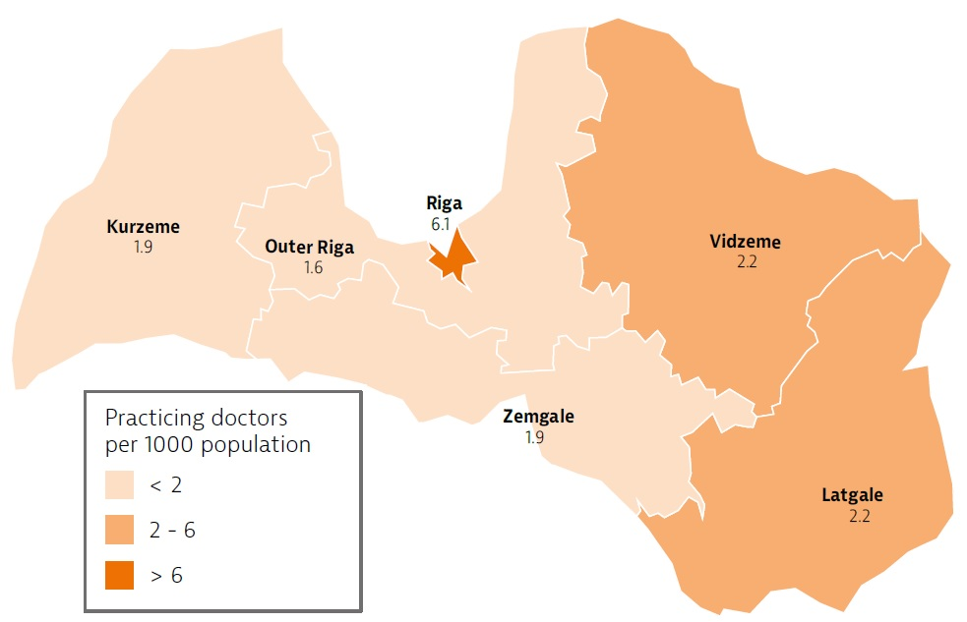
Source: Statistical yearbook of health care in Latvia, 2018
Policies pursued for the healthcare workforce have not achieved the expected results, so far. The issues, which have long been identified, have not changed since 2006, according to a recent report on human resources in healthcare (State Audit Office, 2019). The report concludes that (i) the number of health professionals employed in the health sector is declining; (ii) there is a shortage of certain specialist doctors and (iii) regions are experiencing a shortage of medical practitioners in almost all specialties. It also estimates that the sector requires at least 3 598 additional nurses. The report recommends that the planning and forecasting methodology for human resources in healthcare needs to be improved and complemented by actions to boost the number of healthcare professionals; ensure the capacity of educational institutions to offer appropriate training programmes and support continuous professional education. The Ministry of Health has prepared a time plan to implement the recommendations in the State Audit Report by 2022. Measures include the creation of new educational programmes for nurses. Specifically, a concept for the nursing profession is being developed, which will propose wider competencies for nurses and the establishment of a new nursing role responsible for general care from 2022. In addition, the current two-tier system for education of nurses will be replaced by a new unified four-year university programme.

3.3.4. Education and skills
Latvia’s education system performs well in terms of learning achievements, but faces the challenge of streamlining the school network, while improving the quality and efficiency of the system and aligning it to labour market needs. The higher education sector has benefited from a gradual increase in investment and incremental changes in quality assurance, but remains fragmented and not sufficiently competitive at international level. Vocational education and training is being modernised, but the share of students in this type of education is below the EU average. The low level of digital skills among the labour force limits the use of digital technologies by businesses and the potential for innovation.
School education in Latvia produces good results in terms of proficiency in basic skills, while urban schools outperform rural schools on average. In 2018, Latvian student performance was broadly stable in science but worsened in reading compared to 2015, although it remains above the level observed in 2000, while performance in maths increased (OECD PISA, 2019d). Overall, the proportion of low achievers in all three domains is lower than the EU average (9.2% vs 12.6%). Female students outperform males in reading (by 33 score points) and to a lesser extent in science (8 points), but are outperformed by boys in maths by 7 points. Urban schools performed better than rural schools, with a difference of 52 score points in reading (roughly equivalent to 1 year of schooling). The system is rather equitable, with a pupil’s socioeconomic background exerting a relatively limited influence on learning achievement in reading. The difference between the most advantaged and the most disadvantaged students was 65 score points, as compared to the EU average of 95.
As the number of school children decreases, the consolidation of Latvia’s large and inefficient school network is a priority for the government. Streamlining of the school network has been planned from 2017 by setting the minimum criteria for the quality and the number of students per class in general upper-secondary education institutions. This has also been linked with changes to teachers’ pay and reform of the education content. The minimum criteria is set to be effective from August 2020, however their actual definition is still being discussed (Box 3.4.1).
Low statutory salaries and long working hours contribute to making teaching unattractive and reforms have not yet resulted in the desired improvements. The proportion of Latvian teachers who believe that teaching is a valued profession in society is higher than the EU average (23% vs. 18%) (OECD TALIS, 2019e). However, only 65% of teachers say that if they could decide again, they would still choose to become a teacher (78% in the EU on average). Income reliability and job security appear to be strong influencing factors in choosing teaching as a profession. The new teacher remuneration scheme introduced in 2016 has gradually increased the minimum monthly salary rate from EUR 680 on 1 September 2016 to EUR 750 on 1 September 2019. However, this monthly salary rate is still less than half of the EU average monthly salary for teachers (European Commission/EACEA/ Eurydice, 2018c).
Renewing the teaching workforce is a challenge, as young graduates are not attracted to the profession and teacher shortages are becoming apparent, especially in science and maths. In 2015, less than 1% of 15-year-olds aspired to work as a teacher (only 0.2% among boys) (European Commission, 2018c). According to the Ministry of Education and Science, out of approximately 1 000 education graduates per year, currently only about 350-400 actually start working as teachers. The Ministry has updated regulations on the financing of higher education institutions, to ensure they receive performance-based funding according to how many of their education graduates enter the teaching profession. Teacher shortages are increasingly being reported. In September 2018, a survey of 200 school leaders conducted by the Society for Independent Education found that 65% of schools had a shortage of teachers. In 2018, the plans were set out to redesign teacher study programmes matching the new competency-based learning standards in schools. Along with the changes to the full-time pedagogical study programmes, a one-year work-based study programme for professionals with academic degree in other fields has been launched in 2020.
The new standard curriculum for all levels of general education has been adopted and will be phased in over the period 2019-2023. The competence-based learning standards for pre-school and basic education were adopted in 2018 and those for general secondary education were passed in September 2019. The new curriculum in upper secondary education reduces the number of subjects, compared to the previous one, and allows students to dedicate 30% of school time to specialised in-depth learning of selected subjects. The implementation of the new curriculum will be gradual starting with pre-school level in 2019/2020 and ending with upper grades in 2022/2023.The share of young adults with tertiary education decreased in 2018 compared to the previous year, but remains above the EU average. 42.7% of 30-34 year-olds had a tertiary qualification in 2018, down from 43.8% in 2017. The decrease was more pronounced for men (from 32% to 30.6%), further widening an already significant gender gap (24.6 pp). Graduates in science, technology, engineering and mathematics represented 21% of all graduates in 2017, well below the EU average of 26%. In addition, the proportion of graduates in natural sciences, mathematics and statistics was the lowest in the EU (3.1% against an EU average of 7.6% in 2016). On a positive note, the employment rate for graduates in the 20-34 age group rose sharply in 2018 (84.1%, up from 78% in 2017) and now exceeds the EU average of 81.6%. Graduate tracking is being implemented, with the first data from the Register of Students and Graduates expected at the end of 2019.
New measures to reduce fragmentation of the higher education system and to develop higher quality study programmes are being planned, with support from EU funds. While this is a step in the right direction, it remains to be seen whether Latvia’s higher education institutions can be motivated to reduce the scope and number of programmes as they compete for students. Overall, available research funding in the country is still low, and the amount of performance-based funding for higher education institutions is limited. The success of these measures will largely depend on more resources for academic research being made available, on better governance of higher education institutions and on the ability of the government agency responsible for quality assurance and accreditation of study programmes to conduct a rigorous evaluation of the quality offered by higher education institutions. Several factors will play a key role, including the quality of the new higher education programmes to be developed and the availability of qualified academic staff.
Despite the ongoing reform efforts, participation in vocational education and training (VET) remains low. Latvia has undertaken several reforms to strengthen the VET system, such as curriculum reform, development of education standards and qualifications, modular programmes, teacher training and closer co-operation with employers. Labour market outcomes for VET students have improved, but the employment rate of recent VET graduates remains below the EU average (75.8% vs. 79.5% in the EU in 2018). Despite these efforts, the participation in VET remains stagnant with less than 40% students opting for this form (48% in the EU in 2018). Measures supported by the European Social Fund to reduce the high drop-out rate of students in vocational education and training (19% in upper secondary vocational education in 2017/2018) are in place. Graduate tracking is organised only at school level and the development of a centralised approach should be finalised by the end of 2020.
During 2019, Latvia continued to support implementation of work-based learning via a number of projects. These projects included cross-border mobility for VET students, continuous professional development for teachers of vocational education and training and in-company trainers, and support to businesses in implementing work-based learning and practices. With the Employers’ Confederation in the lead, the work-based learning approach is being introduced. By October 2019, 29 out of 38 vocational education and training schools and 469 companies were implementing at least one work-based learning programme with 2 011 students participating. There is scope to further strengthen the implementation of work-based learning and increase the participation of schools and employers, as well as better align the work-based learning offer with labour market needs.
The level of adult participation in learning remains relatively low and further steps to raise awareness and reduce barriers are planned. In 2018, 6.7% of adults participated in learning, which is below the EU average of 11% and the national target of 15%. The adult learning participation rate for the low-skilled in 2018 was even lower at only 2.5% (4.3% in the EU on average). This is partially explained by the low awareness and barriers in access — in 2016 more than 35% of adults neither participated nor wanted to participate in adult learning. The main barriers to participation were reported to be the costs, conflict with working schedule or family responsibilities (CSB, 2018). Insufficient non-financial and financial incentives for employers to invest and support adult learning for their employees also limit the provision of the adult learning (OECD, 2019a).
Latvians are lacking digital skills at all levels, from basic to advanced, and the low share of ICT specialists in the workforce hampers digitisation and productivity. No significant progress has been made to improve the level of digital skills that are below the EU average (see Box 3.3.1). Only 43% of Latvians between 16 and 74 years old have basic digital skills (58% in the EU as a whole), an indicator recorded as ‘critical’ on the Social Scoreboard (Box 3.3.1), and ICT specialists represent a low share of the workforce (1.7% compared to 3.9% in the EU). Bridging the gender gap in digital is an important element, since women ICT specialists account for a mere 0.5% of women’s employment, below the EU average of 1.4%. However, Latvia is successful in producing ICT graduates: there has been a constant increase, well above the EU average (to 5% of all graduates, compared to 3.6% in the EU).
Measures to improve access to adult learning are being supported with EU funds and there are plans for state-financed adult learning after 2022. Latvia lacks a clear framework or agreement on how to sustainably share the costs of funding lifelong learning between government, employers and individuals (OECD, 2019a). State funding of adult learning has been postponed until 2022 and currently mainly EU funds are being used to improve access to adult learning. So far 16 800 adult employees, including 3 481 employed with a low level of education, were involved in adult learning. Work is planned to develop a regulatory framework for state funding for adult learning that is to enter into force by the end of 2022. The National Skills Strategy project, which is receiving OECD support, is in its action phase, and it is during this phase that Latvia’s national strategy for education and skills for 2021-2027 will be developed and approved.

3.4.1. investment and productivity
Labour productivity and unit labour costs
Labour productivity growth more than halved in Latvia in 2018 compared to 2017, but remains well above the EU average. In 2018, hourly labour productivity growth slowed to 2.3%, compared with 4.7% the previous year. Despite the slowdown, it still grows substantially above the EU average – over the past five years Latvia’s average productivity growth was 3.1%, while EU’s average growth was only 1.0%. Over the medium term, however, the appreciation of unit labour costs may hurt Latvia’s export competitiveness and therefore hurt its productivity growth. Moreover, the declining population is set to continue putting strain on the efficiency of Latvia’s infrastructure thus potentially being a drag on the overall productivity growth. Following the 2016 Council Recommendation, Latvia has appointed the University of Latvia think tank LV PEAK as National Productivity Board in October 2019. Measures to ensure continued convergence with the EU average would contribute to advancing towards SDGs 8 and 9.
Graph 3.4.1: Labour productivity growth, annual % change
Source:
Productivity growth in manufacturing has been roughly twice as fast as in market services in Latvia. Slow productivity growth in non-tradable services is partly due to Latvia’s small domestic market, which limits economies of scale that can be achieved. Also, the decline in the population has put an additional strain on the productivity of domestically focused sectors. Compared to the other Baltic States, Latvia’s productivity growth in industry has been the fastest over the past 5 years, but in level terms it remains some 20% below that of Estonia and Lithuania. In market services, Latvia’s productivity growth falls between the other Baltics (Graph 3.4.2).
Graph 3.4.2: Average productivity growth 2013 - 2018, %
Source: European Commission
Cost competitiveness
Unit labour cost growth remains among the highest in the EU, raising concern about Latvia’s cost competitiveness. In 2018, unit labour cost growth accelerated again to 5.3%, bringing the three-year growth rate to 14.7%, considerably above the macroeconomic imbalances scoreboard threshold of 9%. The growth in unit labour costs in Latvia has considerably exceeded the euro-area average and Latvia’s real effective exchange rate based on unit labour costs has appreciated by 7.1% between 2015 and 2018. However, the unit labour cost growth has been slow to pass on to prices as evidenced by the mere 1.3% increase in the real effective exchange rate based on the harmonised index of consumer prices over the past 3 years. The rise in wage costs relative to Latvia’s trading partners carries the risk of making the country’s exports too expensive to compete in foreign markets. However, the growth of export market share has remained healthy so far — over the past 5 years it has increased by 8.6%. This is notably below other catching-up economies at a similar income level, like Poland or Romania whose market shares have increased by more than 20% over the past 5 years. However, Latvia’s export market share growth rate is highest among the Baltics — in Lithuania it was below 5%, and in Estonia it barely changed at all.
Wage growth spurred by labour market tightening is the primary driver of unit labour cost growth. The breakdown of the growth in unit labour costs shows that the average productivity growth over the past 3 years has been among the fastest in the EU. However, Latvia’s annual wage growth of around 7.9% in the past 5 years has been much higher than the EU average of 1.6%, therefore driving the relative increase in unit labour costs. The driver of the recent fast wage growth is the falling labour supply and an investment-led increase in labour demand. Labour supply is set to continue declining due to the demographic situation. Conversely, rapid wage growth may alleviate the pressure of a falling labour supply if the country manages to stem outward migration. Further relief to the shortage of workers could come from policies facilitating better internal mobility, increasing adult participation in learning, improving the labour market relevance of training of the low-skilled and improving health outcomes.
Graph 3.4.3: Unit labour cost growth and its components, %
Source: European Commission
Investment
Despite a recent surge, investment levels remain only somewhat above the EU average. Investment growth slowed in 2019, ending a spurt, which saw real increase in investment of nearly 35% between 2016 and 2019. The spurt was driven primarily by EU-funded public investment, helped also by private sector investments in retail spaces and office buildings to accommodate the rapidly growing business and IT services industry. Over the longer term, however, real investment growth in Latvia has been meagre — over the past 5 years it has increased at roughly the same pace as the EU average. Moreover, it has mostly been driven by non-residential construction and machinery, while the growth in other asset types has been significantly lower than in the other Baltics or the EU average. EU-funded infrastructure projects form a significant part of non-residential construction and have therefore been instrumental in carrying Latvia’s investment growth. Lacklustre residential investment growth is linked to a number of factors — relatively high construction costs due to lengthy and cumbersome administrative procedures, slow mortgage lending and a declining population. Finally, poor investment in intellectual property is linked to a relatively weak digitalisation drive across economic sectors (see graph 3.4.4).
Graph 3.4.4: Average real investment growth 2013 - 2018, %
Source: European Commission
Firm surveys show that uncertainty about demand holds back investment. Private investment remains subdued, largely driven by uncertainty regarding external demand conditions, but to some extent also by structural barriers. One quarter of Latvian firms consider they had invested too little over the last few years, which is among the highest rates in the EU. At the same time, only 29% of firms in Latvia report operating at or above full capacity, which is the lowest value in the EU (EIB Investment Survey 2019). The cost and availability of external financing and the stability and complexity of tax legislation are also cited as possible obstacles to investment (Flash Eurobarometer 459 ‘Investment in the EU’).
Research and innovation
Investment in research and innovation in Latvia recently increased, supported by EU funds, but remains low overall. In 2018, research and development expenditure relative to GDP was up 0.64% (0.51% in 2017). More than half of this is public spending. European funds constitute 41.5% of all public investment in research and innovation. Despite the increase in spending, it is insufficient to tackle the significant underfunding of the entire research and innovation system. The share of investment in research and development is considerably below the EU average (2.1% of GDP in 2018) and is also far below Latvia’s target of 1.5% of GDP for 2020. The underfunding hinders the effectiveness of the research and development system, its attractiveness to researchers, especially young researchers, and is limiting its added value for the economy. Moreover, the coverage of sustainability-related research and innovation topics is limited. The share of publications in top journals has slightly increased but remains relatively low in international comparison.
Latvia boasts a vibrant start-up community, but the supply of IT specialists is limited and research-industry links are weak. While the employment share of high growth enterprises is slightly above the EU average, the country performs below the EU average in terms of access to finance and other framework conditions (e. g. human capital, regulation and innovation), with the notable exception of entrepreneurial skills, reflected in the steadily growing start-up community. The highest share of high-growth enterprises is found in knowledge-intensive and medium-high tech manufacturing industries, particularly in ICT and machinery and equipment, but also in some medium-low tech sectors such as rubber and plastic products. The development of a technology-oriented start-up ecosystem is promising. However, skills shortages and having still relatively few research-industry and intra-industry links remain key challenges (European Commission, High Growth Enterprises Factsheet Latvia). Latvian start-ups and SMEs also lag in innovation capacity compared to other EU Member States. To address this, in 2018 Latvia’s technology transfer programme was amended to improve innovation voucher support for the innovation activities of SMEs.
Human capital imbalances are holding back the development of the Latvian research and innovation system. Demographic trends and underfunding make it difficult for Latvia to keep up with the EU average in terms of numbers of researchers, PhD students and graduates in science, technology, engineering and mathematics. Even if the situation is advancing, there is still ample scope for further improvement, e.g. for reaching the national goal of 7 000 researchers in 2020. Several changes are underway, including changes to the academic career system, study programmes, and higher education governance. In cooperation with the European Commission, a Horizon 2020 Policy Support Facility activity is aiming to develop recommendations on policies for attracting and retaining talents in scientific and technological careers as well as in the business sector.
The fragmentation of the governance of the research & innovation system still represents a challenge for Latvia but is being addressed. Following the recommendations from the European Commission’s Horizon 2020 Policy Support Facility activity (), in 2019 the government approved a new strategy for the institutional consolidation of the Latvian science policy system. A unified science policy enforcement body in Latvia should start its activities in 2020. This reform has the potential of reinforcing the research and innovation system and increasing administrative capacity.
Digitalisation
Latvia has made substantial improvements in digital public services and is well above the EU average in this area. Progress has been driven by the use of e-government, the availability of pre-filled forms and the availability of open data further to the launch of the national data portal, making it possible to access public administration data sets and metadata directly and to link to other data sets. The country is slightly less advanced in e-government services for business. Further efforts are being made to increase the effectiveness of public administration through the efficient use of cloud computing services in order to reduce administrative burden and create a more favourable business environment for entrepreneurs and SMEs.
Latvia continues to invest in getting more people to use e-government services. 83% of internet users (compared to 67% in the EU) used e-government services. Results have been achieved thanks to an extensive communication and training programme called — ‘My Latvija.lv! Do it digitally!’ that involves training for at least 6,000 national and local government officials, teachers, librarians and journalists, to improve their knowledge of digital solutions, so they can help people make the transition from on-site services to digital services. The programme provides information and video tutorials of more than 500 e-services and brings together over 30 government institutions in a cooperative effort.
Latvian business does not fully exploit its digitisation potential. Latvia is lagging behind the EU average and has not made any significant progress in integrating digital technologies. Latvian enterprises continue to underexploit the potential of online selling of goods and services, remaining considerably below the EU average in e-commerce among SMEs and related levels of turnover. Only 11% of SMEs sell online, below the EU average of 17.5%. The percentage of SMEs selling cross border remains below the EU average (only 6.6% of total SMEs, against 8.4% in the EU as a whole) and only an average of 5.3% of SME turnover comes from the online segment. Businesses make only limited use of electronic information sharing, e-cloud services and social media and only 7.7% of companies use big data.
Improvements in the integration of digital services by businesses is limited by the shortage of high-skilled professionals. Almost half of all Latvian enterprises that want to recruit ICT specialists report difficulties in filling their vacancies. Additionally, 17.7% of enterprises provide staff with training to develop and upgrade their ICT skills, a figure that is significantly below the EU average of 23.9%. The shortage of ICT specialists is also evident in employment figures, as their share of total employment is significantly below the EU average — 1.7% compared with 3.9% (see Section 3.3). This is potentially an obstacle to investment and innovation and might also limit the spread of productivity-enhancing digital solutions among businesses. The shortage is likely to become worse in the future due to rapidly growing demand.
Several initiatives aim to boost digital innovations and promote the use of digital technologies. Eight Competence Centres, set up in the areas of Latvia’s smart specialisation strategy for an overall investment of €67 million, cover 175 projects and 138 enterprises and are EU-funded. They promote innovation in Latvia through the joint development of products and processes by companies and scientific institutions. Latvia also set a Single Technology Transfer Centre, as part of the Investment and Development Agency of Latvia, to foster industry-science cooperation and the commercialisation of public research.
Business environment and entrepreneurship
Latvia has a favourable business environment, but the shadow economy remains a challenge. Latvia ranked 19th out of 190 in the 2019 World Bank Doing Business Review, unchanged compared to the previous year. Latvia ranks high in most of the sub-indicators, except for getting electricity, which is still a relatively lengthy and costly process. Insolvency cases and dealing with construction permits also score low. According to the European Commission’s SME Policy Review, the biggest challenge for Latvia in creating a favourable environment for entrepreneurship is the lack of skills and innovation. In addition, while Latvia is among the leaders in the EU in terms of the time needed to start a business (1 day) and greatly reducing the related costs, the bureaucracy and payments related to closing a company create a burden that may discourage entrepreneurs from starting another business in the future. Moreover, the shadow economy remains a structural constraint, but several measures are being implemented to improve tax compliance (see Section 3.1).
Latvia’s start-up environment is dynamic and rapidly growing. Latvia’s start-up ecosystem consists of more than 400 registered start-ups, a pool of institutional investors and business angels, a diverse range of modern co-working spaces, dozens of business incubators funded by the government, academia and private individuals, as well as numerous events. The capital city Riga hosts important conferences, such as The Digital Freedom Festival, iNovuss, Deep Tech Atelier and TechChill. A unique Start-up Law and a Start-up Visa (‘temporary residence permit’) aim to provide targeted support to help start-ups face their main initial challenges, namely employee wages and taxes. The criteria for support under the Start-up Law were further simplified in 2019 to make it easier for start-ups to apply and reduce the time it takes to receive support to develop their business.
Public procurement
Transparency and competition in procurement procedures remain problematic. According to the 2019 Flash Eurobarometer, 71% of Latvia’s businesses believe that competition-excluding specifications is a widespread practice in their country (compared to the EU average of 58%) and 80% believe that favouritism and corruption hamper business competition (compared to the EU average of 71%). The share of single-bidder contracts remains high (around 30% in 2018, EU average of 24%), with most of these contracts being in the healthcare area, due to limitations of the market and restrictions imposed by manufacturers. Moreover, the percentage of directly negotiated procedures was 12% in 2018 (EU average 4%). The Procurement Supervision Bureau intends to increase transparency by publishing information on low-value procurement, as well as on the real value of the contracts (versus the initial ones) in their electronic procurement system. To professionalise the staff involved in procurement, more than 500 persons have been trained in various topics, including fraud and corruption. The bureau carries out preliminary controls to check the quality of tendering documentation and investigations based on a risk matrix. Information received from whistleblowers or complainants constitute an important source of information for the bureau.

3.4.2. single market integration
Single market for goods and services
Latvia is a very open economy and well integrated in EU markets. Overall Latvia scores well in the Single Market Scoreboard. With goods trade comprising 94.5% of GDP and services trade comprising 28.3% of GDP, Latvia’s trade integration is above the EU average. About two thirds of exports of goods are going to other EU Member States. Latvia’s main export markets are Lithuania, Estonia, Germany and Sweden. Regulatory restrictions in the services sector are overall lower than the EU average. Latvia has an efficient customs system and is among the best EU performers for information availability and advanced rulings on customs (European Commission, 2019e). The use of e-commerce and e-business is increasing, but there still seems to be further scope for improvement. The percentage of SMEs intra-EU online exporters remains well below the average with only 4.7%. Most Latvian producers (65%) are still concentrated in low-technology industries, such as basic wood and metal processing. A higher number of notifications of draft technical regulations under the Single Market Transparency Directive could help prevent potential barriers in the internal market for goods and information society services.
Digital single market
Most urban areas in Latvia have excellent digital infrastructure, and lack of fixed broadband access in rural areas is compensated by mobile broadband. The country’s main strengths are the broad coverage of fast and ultra-fast broadband (with 93% and 88% of households covered, respectively), both of which are among the best in the EU. Also, the take-up of fast internet subscriptions is above the EU average and growing rapidly (44% and 38% of homes subscribe to fast and ultrafast broadband respectively). However, the overall subscription to fixed broadband services is stagnating at 60% and remains below the EU average. This is largely due to low fixed broadband coverage in rural areas. Although, extensive EU-funded investments in extending fixed broadband to rural areas have been made, investments in last-mile connections have not followed due to lack of commercial viability. However, the missing progress in fixed broadband coverage is partially compensated by a rapid increase in mobile broadband, thanks to data bundles being widely available at affordable prices and high 4G coverage. Latvia is prepared for early 5G deployment in the 3.4-3.8 GHz band. However, in the medium to long term, access to and the renting of property in order to install the many base stations required for 5G might hinder 5G deployment.
Transport
The Rail Baltica project is crucial to integrating the Baltics with the core European rail network. Currently, Latvia is well connected with its eastern neighbours via wide gauge rail, but it does not have any standard gauge rail lines, limiting it international accessibility from the rest of the EU. . The construction of the Rail Baltica project, linking the three Baltic countries to Poland and therefore the rest of the European rail network, is crucial to address that shortcoming. The project is not progressing as planned. The State Audit Offices of the Baltic countries have estimated Rail Baltica is experiencing delays of more than 2 years. This is due to the fact that an agreement on technical specifications for interoperability between the participating EU Member States has been delayed, the project is facing management challenges, and in Latvia due to the fact that the scope of works has increased, higher- than-planned costs may occur. Going forward, the outcome of the decision-making process on the future model of infrastructure management will be decisive for realising the full market potential of Rail Baltica.
Improving transport infrastructure within and around Riga would both facilitate labour mobility and help curb growing energy consumption from passenger cars. As the main generator of GDP, Riga is a crucial transport hub for both passengers and cargo. Enhancing mobility presumes an integrated approach to transport. Improving regional rail connections and transit points would facilitate more environmentally friendly commutes. The growing use of passenger cars is among the chief reasons for growing carbon emissions in the transport sector (see Section 3.5). Therefore, switching commuters from cars to public transport is an essential part of the effort to curb energy consumption and emissions in the transport sector. Two major investment projects are expected to help this cause. Firstly, a major EU-funded rail electrification project is planned to begin in 2020. In its first phase, which is planned to be completed by 2023, 314 km of track would be electrified, increasing the share of electrified track from 14% to 30%. Secondly, Latvia is investing in new trains, which will increase the attractiveness of rail commutes and therefore help increase the share of public transport usage for commuting. Moreover, Latvia is currently developing a new transport model that it hopes will help direct public investments where they can have the most impact. Finally, Rail Baltica is also expected to support the modal shift to rail from more carbon intensive modes of transport.
Despite recent improvements, the quality of the road infrastructure remains well below the EU average. Road transport performance, measured as a ratio between accessibility and distance (Dijkstra et al, 2019) is below the EU average in all regions except Riga, where it is close to the EU average (80.4 versus 81.9). Moreover, Latvia is among the few EU countries without motorways. Lack of suitable ring-roads has led to heavy lorry traffic passing through major inhabited areas, adding to congestion and air pollution. To address that, Latvia has launched its first public-private partnership project to design and construct the Kekava bypass on the European Route E67. This project is expected to move lorry traffic away from residential areas and increase traffic flow.
Energy
Latvia, together with the other Baltic countries, is progressing well towards synchronisation with continental Europe’s electricity grids, a key priority for the coming years. The ongoing Baltic Synchronisation Project, scheduled for completion by the end of 2025, is key to ensuring security of supply of the whole Baltic region. The June 2019 implementation roadmap includes the following milestones — building the necessary infrastructure to reinforce the internal grids of the three Baltic states, establishing a high-voltage direct current line between Lithuania and Poland, and carrying out optimisation measures. All of the above actions will require significant investments in the coming years.
Latvia continues to implement the key electricity infrastructure projects that form part of the implementation of the Baltic energy market interconnection plan. In September 2019, the third and last phase of the ‘Kurzeme ring’ was commissioned, strengthening the western part of Latvia’s grid and allowing for a further integration of renewables and robustness of the grid in view of synchronisation. Key projects, such as the construction of an internal 330 kV power-line ‘Riga TEC-2 — Riga HES’ and the third interconnector between Latvia and Estonia, are expected to be finalised by 2020 and alleviate congestion at the border between these two Member States.
Work on developing the common gas market is complete and it is operational since 1 January 2020. It is the first bidding area in Europe to encompass three countries. Gas transmission system operators from Latvia, Estonia and Finland signed a memorandum of understanding on 12 October 2018 to pave the way towards integrating the natural gas markets of the three countries in 2020. On 14 February 2019, all three gas transmission system operators signed the inter-transmission system operator compensation agreement which sets the rules for the common market area between the three countries as of January 2020. In practice, the agreement removes gas transmission tariffs on the borders between Finland, Estonia and Latvia and imposes an equal entry fee on all the import points. Discussions are ongoing to enlarge the regional gas market to include Lithuania as well.
Latvia is expected to achieve full unbundling of its domestic gas market by early 2020. Following the opening of the gas market in April 2017, Latvia still needs to finalise the unbundling of its transmission system operator Conexus. Certification of the transmission system operator was conditionally granted by the Regulator (in September 2018), and needs to be accomplished by January 2020.

3.4.3. REGIONAL DISPARITIES
Important economic and social differences persist in the country, mainly between the capital region and the rest. Disparities between the capital and the other regions remain among the highest in EU. While the capital region of Riga has a GDP per head higher than the EU average (), rising from 60% in 2000 to 106% in 2016, the growth in the regions has been much more modest. For example, GDP per head in the Latgale region rose only 13%, from 20% in 2000 to 33% in the same period. In terms of wages, Latgale region has the lowest average gross salary of €701 per month, while the average monthly salary in Riga was €1,129. The pay gap between the capital region and the rest is around 1.6 times. Finally, the poorest regions have also experienced more rapid depopulation — while the population in Riga and its suburbs has increased, the population in Latgale has declined by 29% since 2001.
The competitiveness of other regions than Riga is low (). There are almost 93 entities () registered per 1,000 persons in Riga while only 61 in Latgale. Riga region is also increasingly more engaged in business services where added value per employee tends to be higher, while manufacturing remains much more significant in the regions. These differences are mainly linked to the ability to attract investments. The capital region has a better economic performance. Therefore it can offer higher wages and better employment and career opportunities, while the other regions are not able to provide sufficiently well paid and attractive jobs. The share of the employed population to total population was 68% in Riga while only 56% in Latgale in 2018, with corresponding differences also in other areas such as levels of unemployment and poverty.
A balanced development of all regions is essential for the sustainable growth and social cohesion of Latvia. However, the continuing negative trend of depopulation will have major consequences for the long-term sustainability and quality of public services to the population in the more rural, more sparsely populated areas in Latvia. The average size of a municipality in 2018 was 8,460, in 2040 it is expected to be 7,200 (-15%). The per capita cost of public services like education, social services, and administration are higher in small municipalities than in large ones (Bank of Latvia, 2019). Their small size also limits their capacity to attract investments and manage large-scale projects due to lack of available specialists.
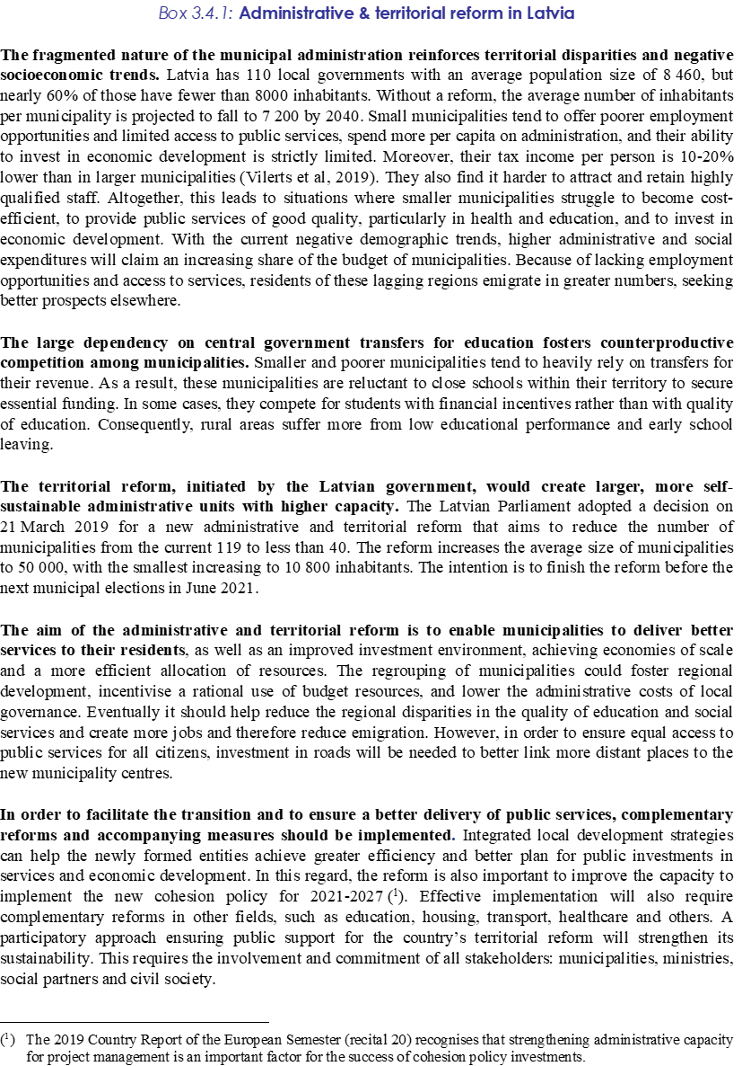

3.4.4. QUALITY OF GOVERNANCE
State-owned enterprises
Latvia is taking steps to improve the governance of municipality-owned enterprises. While common corporate governance principles have applied to state-owned enterprises since 2014, municipality enterprises had so far been exempt from these requirements. However, as of 2020, the municipality enterprises will have their management separated from the elected officials of municipalities and they will be required to establish supervisory boards comprised of independent members. Moreover, enhanced transparency and reporting standards will apply. This is expected to improve the enterprises’ economic performance and accountability.
Justice system
The quality and independence of the justice system are being further strengthened. In order to improve the quality of the justice system, all complaints concerning the justice system received through different channels have been grouped together under a new unified portal under the control of the judiciary (Judicial Qualification Board). This portal provides information on the examination of the complaints and their follow-up. Moreover, Latvia’s Council for the Judiciary is discussing a new framework for selecting candidate judges, with the objective of strengthening the independence of the appointment process. The new framework would increase the profession’s role in selecting new judges. It would also reduce the influence of individual assessors by making use of commissions composed of several judges. While the perception of judicial independence increased among businesses, it decreased among judges (2020 EU Justice Scoreboard, forthcoming). However, the Council for the Judiciary faces capacity constraints in its efforts to improve the quality of the justice system, while the Court Administration, with almost one hundred employees, remains under the authority of the Ministry of Justice. The Council issued an opinion that the draft law on the remuneration of judges does not adequately implement the relevant Constitutional Court decision.
Discussions are ongoing on the appropriate ways to increase the quality and efficiency of handling financial crime cases. The Ministry of Justice has proposed creating a special court for economic crimes. However, the Council for the Judiciary issued two opinions against establishing a separate ‘economic court’, stating lack of evidence it would bring improvements in quality and efficiency, and calling for criminal procedure reform instead, among other things. State Control has launched an audit of the factors affecting the effective investigation and adjudication of criminal cases for economic and financial offences and it will cover a two-year period. An examination of the data in different courts is envisaged, with the objective of finding solutions to even out the workload and reduce the need for transfers of cases. The Insolvency Control Service is continuously supervising insolvency administrators, including through appropriate sanctions. It reported a number of irregularities, such as the failure to observe auction procedures, the delay of payments to creditors, the racking up of unreasonable costs, as well as the failure to submit reports.
Corruption and conflict of interest prevention
Latvia’s score on corruption control indicators is slowly improving. In the 2019 Worldwide Governance indicator for control of corruption, Latvia ranks 20th among EU countries (Latvia ranked 21st in 2018). However, Latvia’s score has tended to slowly improve over time (see Graph 3.4.5). According to the 2019 Flash Eurobarometer, 77% of businesses in Latvia believe that corruption is widespread in their country (14% more than the EU average, but 9% less than in 2017). However, only 19% consider corruption to be a problem when doing business (compared to the 37% EU average, the same as last year).

Graph 3.4.5: Control of Corruption indicator
(1) The indicator is a composite of different indicators from various sources. Worldwide mean is set at zero with higher score meaning better control of corruption.
Source: World Bank
The Corruption Prevention and Combatting Bureau (KNAB) has been effective in opening up investigations. KNAB’s effectiveness has increased since its current head was appointed in 2017. As of 31 December 2019, the Bureau operates at near its full capacity, with 135 out of 150 posts filled. Its reorganisation led to an improved cooperation between the departments in charge of prevention and repression of corruption. Forty-seven new criminal proceedings were started in 2019, with several high-profile investigations in vulnerable sectors such as procurement at municipal level or cartels in the construction industry. However, court proceedings remain lengthy, in many cases pending in court for several years. The implementation of certain measures in the anti-corruption plan has been delayed. Gaps are more frequent at local and municipal level, where KNAB’s prevention efforts need to be stepped up. Moreover, KNAB’s monitoring on the implementation of the anti-corruption action plan needs to be strengthened.
The law on the prevention of conflict of interest has been strengthened over the past years, but certain categories of officials remain exempted. The amendments proposed last year, which would have exempted approximately 14,000 civil servants with control and supervision functions from declaring their assets have been currently put on hold in Parliament. However, in November 2019, the Parliament approved another set of amendments allowing certain categories of public servants to combine their functions with outside activities as long as they are not remunerated. These amendments may complicate the implementation of the law. Special attention should be given to political advisors (both paid and non-paid), whose statute is uncertain, an issue which has also been flagged up by the Council of Europe’s Group of States against Corruption.
The verification of asset declarations still present some shortcomings. Approximately 68,000 asset and interest declarations are submitted annually by all public officials in Latvia. Their verification is carried out by KNAB and the State Revenue Service, based on a risk-based approach. In 2018 KNAB has found irregularities in more than one third of the verified declarations (783 declarations inspected out of 878 assessed), which is a relatively high percentage. According to civil society representatives, administrative fines for irregularities in the declarations are quite low, which may not be dissuasive enough to prevent further misstatements. Declarations are not published in open data format, which may hinder the control exercised by civil society and the media, and assets of spouses are not declared.
The anti-corruption legal framework has been strengthened, but a law regulating lobbying activities is still missing. The Whistleblowing Law entered into force in May 2019. According to the State Chancellery, public bodies are in the process of setting up internal reporting mechanisms for whistleblowers. Moreover, a website providing all relevant information and form for submitting complaints has been set up. In the space of only a few months, the Chancellery, the State Revenue Service and KNAB each have received more than 40 complaints. A working group has been set up by a parliamentary committee to issue provisions regulating the lobbying activities of members of Parliament. A code of ethics for politically appointed persons is still missing, this has also been flagged up by the Group of States against Corruption.

Key climate and environmental challenges
Latvia is among EU’s top performers in renewable energy but more effort is needed to improve its energy efficiency. Latvia’s share of renewable energy is among the highest in the EU, contributing to some of the lowest greenhouse gas emissions per capita in the Union. However, Latvia’s energy consumption continues to increase driven primarily by the transport and residential sectors. While around half of energy consumption in the residential sector comes from renewable sources, the share of renewables in transport is still low. Therefore, investment in public transport, energy efficiency of buildings and infrastructure for electric cars could help alleviate Latvia’s growing emissions. Furthermore, Latvia’s share of recycled waste is low and stagnating leading to high landfilling rates. To address this, investment in sorting facilities and a better alignment of incentives of stakeholders are needed.
European climate action
Under the Paris Climate Agreement, the EU and its Member States have committed to a significant reduction in greenhouse gas emissions (). The strategy to achieve those goals relies on two main instruments - European-wide carbon pricing through Emissions Trading System (EU-ETS) () and binding targets for individual Member States. In the EU-ETS sectors, a limited and declining amount of emission allowances ensure that the emissions reduction is driven by market forces. Meanwhile, emissions reduction in the remaining greenhouse gas-emitting sectors (buildings, transport, agriculture and waste) falls under the responsibility of individual Member States who have committed themselves to binding targets. In 2010, Latvia committed to not let its greenhouse gas emissions from non-ETS sectors increase by more than 17% by 2020 compared to their 2005 level. For 2030, Latvia has agreed to reduce greenhouse gas emissions from non-ETS sector by 6% compared to their 2005 level.
Greenhouse gas emissions
Latvia is about to achieve its 2020 emission reduction target but additional measures will be necessary to achieve its 2030 target. In 2018, overall emissions have more than halved compared with their 1990 levels and remained about the same compared with 2005. However, the decline since 1990 has come mainly from the ETS sectors, notably energy production. Meanwhile, greenhouse gas emissions in non-ETS sectors has increased by 7.5% compared with their 2005 level. Therefore, Latvia will very likely meet its 2020 target, however, to reach its 2030 target Latvia will have to break the current trend of increasing emissions (see graph 3.5.1). Latvia's target for emissions reduction of 6% is considerably below the EU's target of 30% reduction. However, this is because Latvia's emissions per capita were less than half of the EU average (), to begin with.
Graph 3.5.1: Greenhouse gas emissions, index, 1990=100
Source: European Commission
The increase in greenhouse gas emissions in non-ETS sectors is driven mainly by increasing use of passenger cars. According to estimates of Latvia’s Ministry of Economics (2019b) estimates, in 2017, emissions from non-ETS sectors accounted for roughly 4/5 of all greenhouse emissions. Among those, transport and agriculture were the largest contributors to total greenhouse gas (GHG) emissions and, responsible for 30% and 25% of all emissions, respectively. Moreover, over the past 5 years the transport sector has seen the fastest increase in energy consumption. Given that it relies almost exclusively on fossil energy, its contributions to the increase of GHG emission is broadly proportional to its increase in energy consumption. Conversely, improving transport sector’s energy efficiency has the largest potential to reduce greenhouse gas emissions among all sectors. In the agricultural sector, investing in drainage systems and emissions capture for animal farming as well as improving the efficiency of fertiliser usage offer the best rewards for reducing the emissions. Improving the energy efficiency of heating also offers potentially significant cuts in greenhouse gas emissions. Finally, while Latvia landfills most of its waste, waste sector’s contribution to greenhouse gas emissions is only about 5% (see graph 3.5.2). However, improvements in recycling rates would contribute to other important environmental sustainability objectives.
Graph 3.5.2: Greenhouse gas emissions by sector, million tonnes of CO2 equivalent
Source: European Commission
Renewable energy
Latvia boasts among the highest shares of renewables in the EU and is on track to achieve its renewable energy target of 40% for 2020. In 2017, the share of renewable energy in Latvia’s final energy consumption was 39%. Latvia has achieved good progress in electricity and heating sectors, with a share of renewables close to 55%, some of the highest in Europe. At the same time, the share of renewables in transport is low at 2.5% Overall, Latvia is on track to achieve its 2020 renewable energy objective of 40%. However, the existing support scheme for renewable energy has proved to be expensive (European Commission, 2018d). The government is working on modernising the scheme to ensure that Latvia achieves its 2030 renewable energy target of 50% in a sustainable and cost-effective manner (European Commission, 2019a). Latvia aims to boost its renewable energy production in energy by tapping the potential of both on-shore and off-shore wind energy and solar energy. In heating, it plans to increase the use of biomass and solar energy and further modernise district heating. In the transport sector, it is set to focus on boosting the use of advanced biofuels and electric mobility. These investments are expected to increase Latvia’s share of renewables to 50% by 2030.
Energy efficiency
Latvia is on track to achieve its 2020 energy efficiency target, however, its energy consumption is on the rise, driven by the transport and residential sectors. Latvia has put in place a number of energy efficiency measures, but they have mainly focused on the residential sector, while there have been few initiatives to reduce energy consumption in the transport sector. As a result, energy consumption is on the rise, driven by the transport sector (see graph 3.5.3) Currently, the investment in energy efficiency measures mainly comes from European Structural and Investment fund-financed programmes, with private investment opportunities being underdeveloped. The government plans to renovate 2000 apartment buildings by 2030, which is too low to achieve the ambitious energy saving objective. Additional financial instruments would be needed to attract private investments in addition to public funding. Latvia’ Long Term Renovation Strategy, which is due by March 2020, will set out the strategy to improve the energy performance of its building stock.
Graph 3.5.3: Energy consumption by sector, million tonnes of oil equivalent
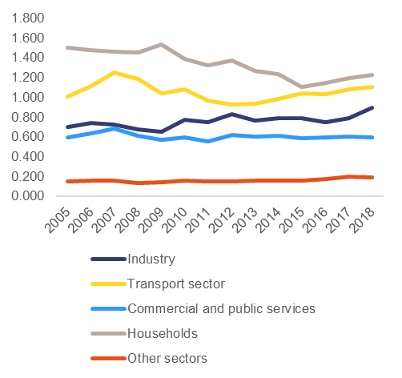
Source: European Commission
Energy poverty in Latvia has decreased overall, but remains a challenge for vulnerable groups. The overall share of people who found it difficult to keep their homes warm decreased to 7.5% (2018), below the EU average. However, as recently as 2016, 22.7% of households at risk of poverty could not afford to keep their homes warm. Moreover, 11.6% of the population in Latvia had outstanding debts and delayed payments for their utility bills, which are typically paid as monthly instalments. Targeted measures such as introduction of lower electricity tariffs for most vulnerable groups have had a positive impact on increasing indirect income for these groups (Baltic Institute of Social Sciences (BISS), 2019). Still, other measures could be considered to alleviate the financial burden for vulnerable groups. While the state has defined the income level for granting a poor family status (€128 per person per month), the income level for granting a low-income status varies among municipalities. These differences create an unequal access to the support measures, such as lower tariffs for electricity and housing benefits. Furthermore, housing conditions for low-income households are poor (Section 3.3.2.). Measures targeting renovation of multi-apartment buildings can also help alleviating energy poverty.
Transport
The transport sector is the largest consumer of energy in Latvia with 30% in 2017 and accounts for the biggest contribution of greenhouse gas emissions from non-ETS sectors with 36.3% in 2017. Further measures and policies are needed to reduce emissions from transport (European Commission, 2019f). In order to act on the transport area, the Latvian government is drafting a new law – Transport Energy Law. It will include regulatory measures to ensure that Latvia achieves the 2020 target of 10% renewable energy share in the transport sector. Electric mobility is picking up slowly as the development of charging infrastructure picks up pace.
The growing use of passenger cars is a major driver of increasing energy consumption. At about 80% of all trips made, the share of passenger car usage for transport is among the highest in Europe. Over the past four years the car-kilometres driven by passenger cars have increased by nearly 30%. At the same time, the number of cars per inhabitant and car kilometres per capita remain relatively low. The share of renewable energy used in road transport is only 3.5% and even lower among passenger cars. The number of electric cars is negligible.
Agriculture
The agriculture sector accounts for almost a quarter of greenhouse gas emission in Latvia. In 2017, emissions from agriculture accounted for 24.6% of total greenhouse gas emissions with 60% of emissions coming from agricultural soils (Ministry of Economics, 2019b). Emissions related to livestock account for the remaining 40% of emissions. With only 7% of utilised agricultural area managed by high-intensity farms, Latvia is among the EU countries with the least fertiliser-intensive agricultural practices in the EU. Moreover, the share of agricultural area used for organic farming is among the highest in the EU (). However, the low share of drained farmlands contributes to lower crop yields and higher emission gas leakage. Latvia’s National Energy and Climate Plan foresees improving the fertilising efficiency, investment in drainage systems, and better animal feed as chief means of reducing the greenhouse gas emissions in the agriculture sector.
Land use and forestry
Emission absorption from forestry is declining due to forests’ increasing age. In 2017, changes in land use subtracted around 15% from Latvia’s emissions balance, the sector’s contribution has been highly volatile (see graph 3.5.2). Over the long term, however, the sector’s negative contributions to Latvian emissions have declined primarily due to the doubling of the logging volumes. The ageing of the forests is the primary driver of the rapid growth in logging volumes. To a lesser extent, deforestation has also contributed to the decline in sectors’ declining negative emissions contribution. Latvia’s National Energy and Climate Plan foresees investment in drainage systems and improving the forest quality as the main means to improve their productivity and therefore increase their emissions absorptive capacity.
Circular economy
Latvia falls significantly behind its re-use and recycling targets as the lack of incentives for municipalities holds back investment in separate collection. In 2018, the rate of Latvia’s municipal waste recycling (including composting) reported to Eurostat was only 25%, while its landfilling rate was 59%. Latvia will miss the 2020 recycling target of 50 %. Substantial stepping up in effort will be necessary to meet the 55% recycling target for 2025. Investment in sorting and recycling, as well as, in waste prevention is needed to increase the recycling rate substantially. However, while the landfill tax has been rising steadily, it has not ensured investment in separate collection infrastructure by the municipalities. This is largely due to the fact that municipalities are not in charge of reaching national recycling targets. Infrastructure for separate collection is particularly poor in the capital Riga, where around half of country’s waste is generated. Therefore, it could be especially worthwhile to align municipalities’ incentives with national targets. The planned administrative and territorial reform is an opportunity to draw municipalities more closely into sound waste administration. Furthermore, the waste data quality could be improved.
The adoption of the circular economy strategy and action plan could help Latvia bring about the necessary systemic change. Latvia is currently discussing a circular economy strategy with its adoption planned later in 2020. An overarching circular economy strategy will help Latvia bring about the necessary systemic change and identify specific needs for strategic investments on circular economy in the country. Green Public Procurement has a key role in delivering circular economy objectives. In 2018, Green public procurement in financial terms reached 18.3 % from all public procurements in Latvia, up from 12 % in 2017. However, the proportion of Green public procurement is highly dependent on projects financed by EU funds. Furthermore, many public procurers still hesitate to introduce green requirements in their tender specifications due to perceived complexity and higher costs. Although Latvia is one of the countries with most complete national action plans on Green public procurement, the practical implementation of green aspects in public procurement can be further improved.
Biodiversity
Latvia could benefit from a comprehensive approach to ecosystem services to better preserve its natural habitats. According to the report recently submitted by Latvia on the conservation status of habitats and species covered by the Habitats Directive for the period 2013-2018 (EEA, 2020), the share of habitats in good conservation status in 2018 was only of 10% and it has decreased compared to the previous reporting period (2007-2012). According to this report, 5 out of 12 forest habitats of EU importance have bad conservation status. As indicated by Latvia, the main pressures are agricultural, industrial and urban pollution and changes in land use. In addition, the intensified urban sprawl reduces the extent of natural areas and causes landscape fragmentation. Latvia would benefit from the mainstreaming of biodiversity conservation and sustainable use in other areas, notably forestry, agriculture, fishery and tourism.
Climate investment needs
The green transition in Latvia would require investments in transport, buildings, renewable energy, and related education and skills. Latvia’s has high potential for wind energy deployment, especially off-shore wind energy, providing a cost-efficient path to further increase its share of renewable energy. In order to curb the rapid growth of fossil energy consumption in the transport sector, investments in public transit systems and infrastructure for electric vehicles would be required. Further efforts to increase the energy efficiency of buildings and district heating systems are needed to address the growing energy consumption in heating. Finally, investments in research and innovation would be important to support the clean transition in Latvia. In its National Energy and Climate Plan Latvia estimates that the total investment needs up to 2030 amount to EUR 550 million for energy efficiency and renewable energy measures in heating, around EUR 1.7 billion for renovation of buildings, EUR 1 billion to decarbonise the transport sector, and EUR 130 million to bio methane (Ministry of Economy, 2019). Overall, investments needed to reach the emission reduction targets in Latvia correspond to about 2% of GDP (European Commission, 2019d).
Labour market and skills
Going forward, the transition to a climate neutral economy will create further need for investment in skills. In Latvia, climate action is expected to support mid- and high-skilled job creation, indicating future needs for reskilling and upskilling. Supply of jobs related to installation of clean technologies, industrial production, different infrastructure aspects and energy production services will increase. Therefore, education and adult learning policies may need to be adapted. In particular, the workforce for the building sector needs appropriate training to ensure they have the necessary skills to perform these new jobs (European Commission, 2019c). A special focus on the gender dimension of a just transition might be needed to ensure that women equally benefit from arising opportunities. Since new green jobs are expected in sectors with traditionally limited female representation (see Section 3.3.1), education and skills need to be strengthened to mitigate pre-existing gender inequalities. Social partners can have a key role through all forms of social dialogue, including collective bargaining, in ensuring decent work and in forecasting skills needs and employment challenges, and in designing adequate and continuous training, among others.
Just transition analysis
Greenhouse gas emissions from wetlands and peat extraction constitute 14.5% of total greenhouse gas emissions (LEGM, 2019). Bog areas cover 645 100 ha or 10% of Latvia's territory. Peat extraction takes place in 4% of the total bog area. On average, 1800 workers are employed in peat extraction, increasing to 2500 during the season. The transition to a climate neutral economy could impact two regions the most – Vidzeme, where most peat extraction takes place, and Latgale due to the region’s disadvantaged socio-economic situation (see section 3.4.3). Approximately 50 000 hectares of land in Latvia can be identified as peatlands that have been degraded by peat extraction. Ensuring the sustainable production of peat, innovative ways of using and restoring wetlands would reduce the overall greenhouse gas emissions of Latvia, as they are efficient carbon storage systems.
Adapting the peat industry to a climate friendly and carbon neutral economy would require investments in SMEs, innovation and human capital. For sustainable land use and management, testing and implementing innovative approaches will be necessary. Diversifying regional economic activities and creating new business opportunities within the framework of a smart specialisation strategy will be essential for making the shift towards a more diversified, competitive and green economy. This transition would also lead to changing employment patterns, inducing needs for re- and upskilling.
The Just Transition Fund, as proposed by the European Commission, could contribute to the development of new and innovative solutions for the reclamation of peatlands and wetlands, the reskilling of employees, etc., thus limiting the potential impact of energy transition on local communities. Dedicated investment guidance for the Fund is in Annex D.

Commitments | Summary assessment ()
2019 country-specific recommendations (CSRs)
CSR 1: Ensure that the nominal growth rate of net primary government expenditure does not exceed 3.5% in 2020, corresponding to an annual structural adjustment of 0.5% of GDP. Reduce taxation for low-income earners by shifting it to other sources, particularly capital and property, and by improving tax compliance. Ensure effective supervision and the enforcement of the anti-money laundering framework. | Latvia has made some progress in addressing CSR 1:
Ensure that the nominal growth rate of net primary government expenditure does not exceed 3.5% in 2020, corresponding to an annual structural adjustment of 0.5% of GDP. | The assessment of compliance with the Stability and Growth Pact will be included in the spring when final data for 2019 will be available.
Reduce taxation for low-income earners by shifting it to other sources, particularly capital and property, and by improving tax compliance. | Some progress: The tax wedge for low wages in 2020 is estimated to have been reduced in line with the benchmark against other Member States. However, this reduction is not offset by other tax revenue sources, in particular capital and property. Tax compliance is improving in some areas, but policy and compliance gaps remain high.
Ensure effective supervision and the enforcement of the anti-money laundering framework. | Substantial progress: Latvia has strengthened its anti-money laundering system and the flow of risky money through the country has been reduced. Latvia has increased the capability of supervisory and law enforcement institutions and has established information sharing and a cooperation group involving competent authorities. A number of sanctions have been applied in 2019. The number of investigations and amount of funds frozen increased in 2019, but a large amount of deposits in ABLV bank still needs to be scrutinised during its liquidation. Latvia should continue its efforts to ensure effective supervision and enforcement of its anti-money laundering framework.
CSR 2: Address social exclusion notably by improving the adequacy of minimum income benefits, minimum old-age pensions and income support for people with disabilities. Increase the quality and efficiency of education and training in particular of low-skilled workers and jobseekers, including by strengthening the participation in vocational education and training and adult learning. Increase the accessibility, quality and cost-effectiveness of the healthcare system. | Latvia has made some progress in addressing CSR 2:
Address social exclusion notably by improving the adequacy of minimum income benefits, minimum old-age pensions and income support for people with disabilities. | Some progress: Minimum social benefits have been increased for 2020, except for those who have worked less than 15 years. The increases are lower than planned, leading to partial implementation, and the adequacy of benefits remains low. Further action would be required to address the high risk of poverty or social exclusion as well as income inequality.
Increase the quality and efficiency of education and training in particular of low-skilled workers and jobseekers, including by strengthening the participation in vocational education and training and adult learning. | Some progress: While improving quality and efficiency, measures to consolidate resources, including the large school network, have been delayed. At the same time, reforms to improve vocational education and training are ongoing and are planned to be finalised by the end of 2021, but the share of students in vocational education and training remains low. An EU-funded adult learning project is ongoing, but overall participation in adult learning remains low, especially for the low-skilled, and measures to increase uptake have been adopted. Work on a national skills agenda with support from the OECD is ongoing and in 2020 Latvia’s national strategy for education and skills for 2021-2027 will be developed and approved.
Increase the accessibility, quality and cost-effectiveness of the healthcare system. | Some progress: Public spending for healthcare is set to decline as a share of GDP in 2020. The level of unmet needs for medical care and the level of out-of-pocket payments remain high. The introduction of the two-basket health insurance system, which posed risks for access to healthcare, has been postponed. Healthcare network reforms initiated in previous years continue, but are still at an early stage. In particular, the pilots of the multi-disciplinary health centres for the primary care reform have not been launched yet. Efforts have been made to combat anti- microbial resistance, to improve mental healthcare and to support the nursing profession. However, workforce shortages persist and access to affordable healthcare remains a challenge for parts of the population.
CSR 3: Focus investment-related economic policy on innovation, the provision of affordable housing, transport, in particular on its sustainability, resource efficiency and energy efficiency, energy interconnections and digital infrastructure, taking into account regional disparities. | Latvia has made some progress in addressing CSR 3:
Focus investment-related economic policy on innovation. | Some progress. Latvia will not meet its national target for investments in R&D by 2020, as national financing has not been increased as initially planned. Latvia relies on the support from the Horizon 2020 Policy Support Facility and has advanced in creating a unified coordination body in 2020 to tackle currently fragmented governance.
the provision of affordable housing. | Limited progress: Affordable housing in the centres of economic activity is a bottleneck for labour mobility and economic growth. Lengthy and cumbersome processes for obtaining planning and building permits are hampering new housing construction. The weak protection of landlords discourages more investment into rental housing. The draft rental law has not made any progress in the Parliament since 2018. The plans for energy-efficiency renovation of apartment buildings are unambitious.
transport, in particular on its sustainability. | Some progress: Transit and major transport connections are the authorities’ first priority, while a large share of local roads are of poor quality. The use of passenger cars is growing, while the share of passenger transport by bus or train is declining. The transport sector is a major source of greenhouse gas emissions, while renewable energy use in road transport is low. Regulatory changes and a better organisation of public transport to improve environmental sustainability are at an early stage. However, the development of Rail Baltica should support the shift to less carbon intensive rail transport once finished.
resource efficiency and energy efficiency, energy interconnections | Some progress: Regional gas market with Finland and Estonia became operational on 1 January 2020. The Baltic grid synchronisation project, the internal electricity grid reinforcement project and construction of the third interconnector with Estonia are all well on track. However, the final National Energy and Climate Plan detailing the investment plan aimed at increasing the resource and energy efficiency is still to be submitted by Latvia. The government has adopted its 2030 Strategy on Latvia’s adaptation to Climate Change with a view to develop infrastructure and buildings, taking into consideration the potential climate risks. The Strategy for the Low-Carbon Development until 2050 is expected to be approved in 2020.
and digital infrastructure, taking into account regional disparities. | Some progress: Latvia is among the EU’s front-runners for the deployment of very high-speed internet infrastructure. However, last mile connections are an issue in rural areas.
CSR 4: Strengthen the accountability and efficiency of the public sector, in particular with regard to local authorities and State-owned and municipal enterprises and the conflict of interest regime. | Latvia has made some progress in addressing CSR 4:  Public administration reform for the central government is being implemented. Administrative-territorial reform for consolidating local authorities and improving their services was presented in 2019 and is expected to be adopted in mid-2020. Corporate governance of state and municipal companies has been improved by requiring disclosure of company reports to the same extent as for listed companies. Moreover, the uncompetitive behaviour of municipal companies and entities is prohibited and the Competition Council is charged with monitoring the situation. The capacity to investigate corruption cases has been strengthened, but shortcomings remain as regards the oversight of implementation of anti-corruption actions, a lack of clarity as regards the applicable regime on conflicts of interests, the application of sanctions for asset disclosure irregularities and the lack of a legal framework regulating lobbying activities.
Europe 2020 (national targets and progress)
Employment rate: 73% | The employment rate (for the 20-64 age group) increased further to 76.8% in 2018 from 74.8% in 2017.
R&D: 1.5 % of GDP | R&D expenditure was 0.64% of GDP in 2018, up from 0.51% of GDP in 2017. Latvia is not on track to meet its target.
Greenhouse gas emissions: increase by 17% between 2005 and 2020 (in non-ETS sectors) | According to the latest national projections and taking into account existing measures, the target is expected to be achieved: 8% in 2020 compared to 2005 (with a margin of 9 pps).  Furthermore, while the target for 2016 was an increase of no more than 12% compared to 2005, the preliminary figures show that the non-ETS emissions increased by 4%. The interim target has therefore been achieved.
Renewable energy target: 40% | In 2018, Latvia’s share of renewable energy was 40.3%, thus reaching its 2020 target. However, maintaining the renewables share at this level will remain a challenge.
Energy efficiency: 5.4 Mtoe expressed in primary energy consumption (4.5 Mtoe expressed in final energy consumption) | In 2018, Latvia’s primary energy consumption increased to 4.7 from 4.5 Mtoe in 2017. Final energy consumption also increased from 4.0 Mtoe to 4.2 Mtoe. Given the current trend, Latvia is at some risk of missing its 2020 energy efficiency target, particularly for final energy consumption.
Early school leaving: 10% | The share of early school leavers from education and training decreased from 8.6% in 2017 to 8.3% in 2018.
Tertiary education: 34% attainment rate for age group 30-34 | The already high tertiary attainment rate decreased slightly in 2018 reaching 42.7% from 43.8% in 2017. Gender disparities remain strong, with the tertiary attainment rate at 30.6% for men and 55.2% for women.
Poverty/social exclusion: reduction of the number of people at risk of poverty and/or living in jobless households by 121 000 compared to 2008. | After having reached its target in 2017, Latvia has again fallen below it in 2018. The number of people living at risk of poverty and/or living in jobless households reached 471 000 in 2018, resulting in a reduction of 104 000 compared to 2008, less than the target.

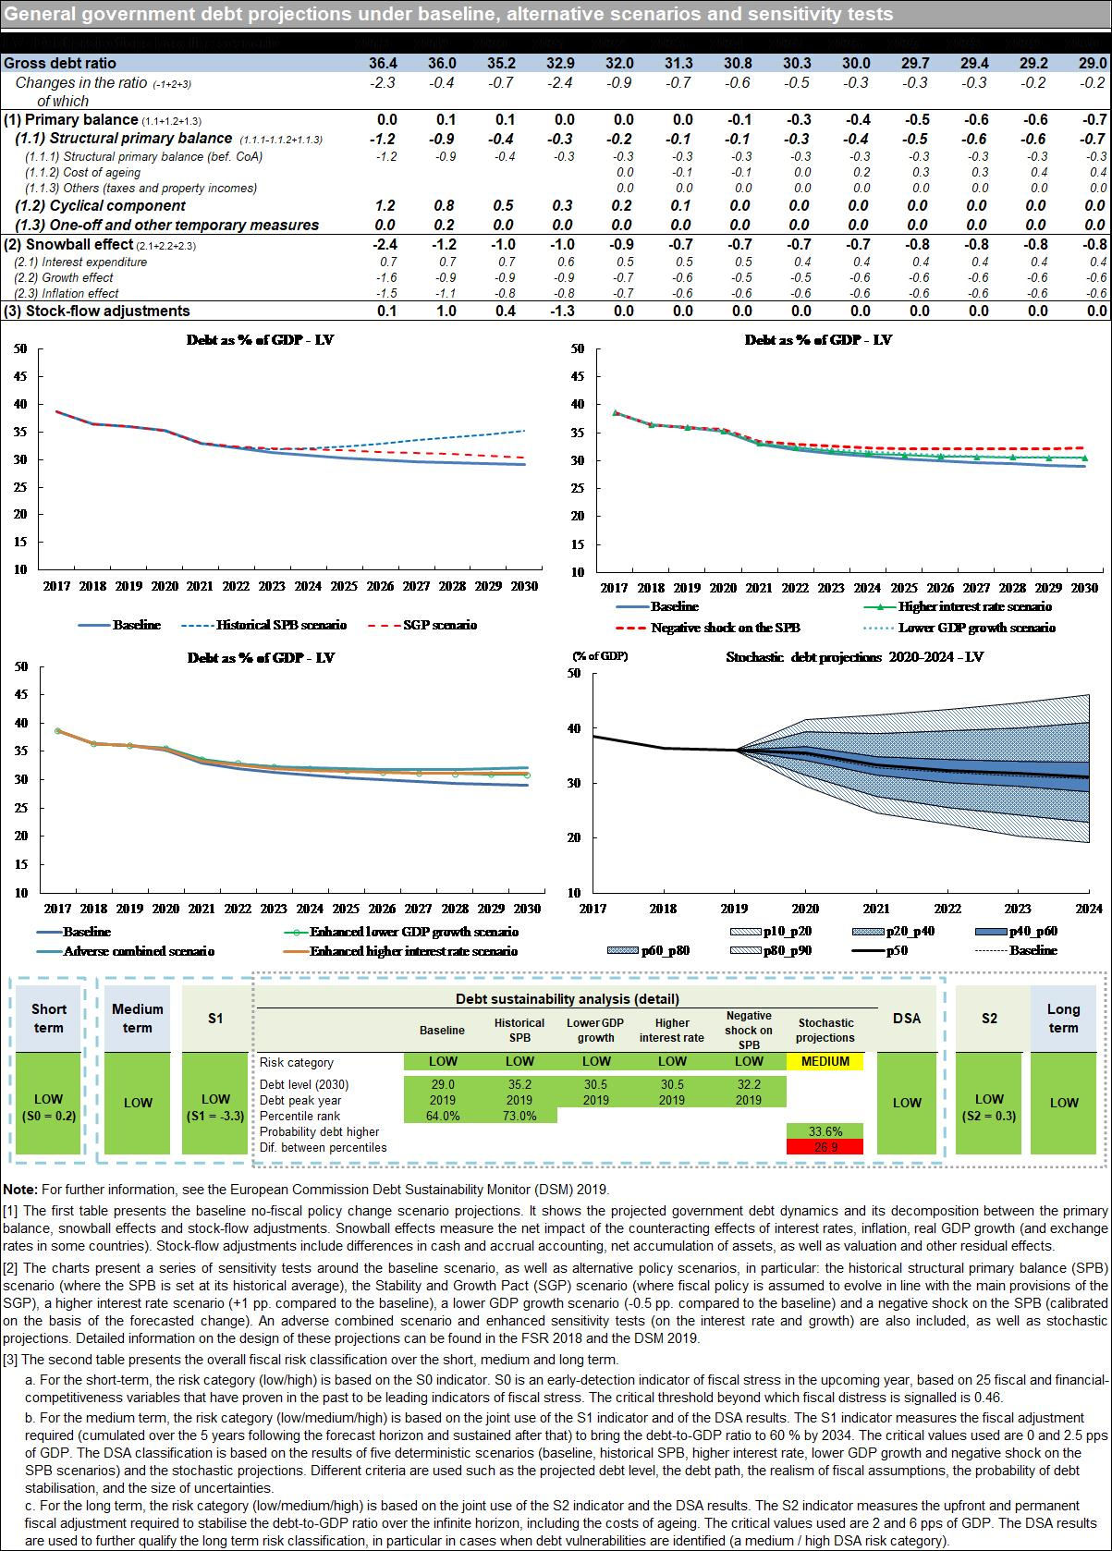
Table C.1: Financial market indicators
(1) Latest data Q3 2019. Includes not only banks but all monetary financial institutions excluding central banks.
(2) Latest data Q2 2019.
(3) Quarterly values are annualised
* Measured in basis points..
Source: European Commission (long-term interest rates); World Bank (gross external debt); Eurostat (private debt); ECB (all other indicators).

Table C.2: Headline Social Scoreboard indicators
(1) People at risk of poverty or social exclusion (AROPE): individuals who are at risk of poverty (AROP) and/or suffering from severe material deprivation and/or living in households with zero or very low work intensity.
(2) Unemployed persons are all those who were not employed but had actively sought work and were ready to begin working immediately or within two weeks.
(3) Gross disposable household income is defined in unadjusted terms, according to the draft 2019 joint employment report.
(4) Reduction in percentage of the risk-of-poverty rate, due to social transfers (calculated comparing at-risk-of-poverty rates before social transfers with those after transfers; pensions are not considered as social transfers in the calculation).
(5) Average of first three quarters of 2019 for the employment rate, unemployment rate and gender employment gap.
Source: Eurostat

Table C.3: Labour market and education indicators
* Non-scoreboard indicator
(1) Long-term unemployed are people who have been unemployed for at least 12 months.
(2) Difference between the average gross hourly earnings of male paid employees and of female paid employees as a percentage of average gross hourly earnings of male paid employees. It is defined as "unadjusted", as it does not correct for the distribution of individual characteristics (and thus gives an overall picture of gender inequalities in terms of pay). All employees working in firms with 10 or more employees, without restrictions for age and hours worked, are included.
(3) PISA (OECD) results for low achievement in mathematics for 15 year-olds.
(4) Impact of socio-economic and cultural status on PISA (OECD) scores.
(5) Average of first three quarters of 2019. Data for youth unemployment rate is seasonally adjusted.
Source: Eurostat, OECD

Table C.4: Social inclusion and health indicators
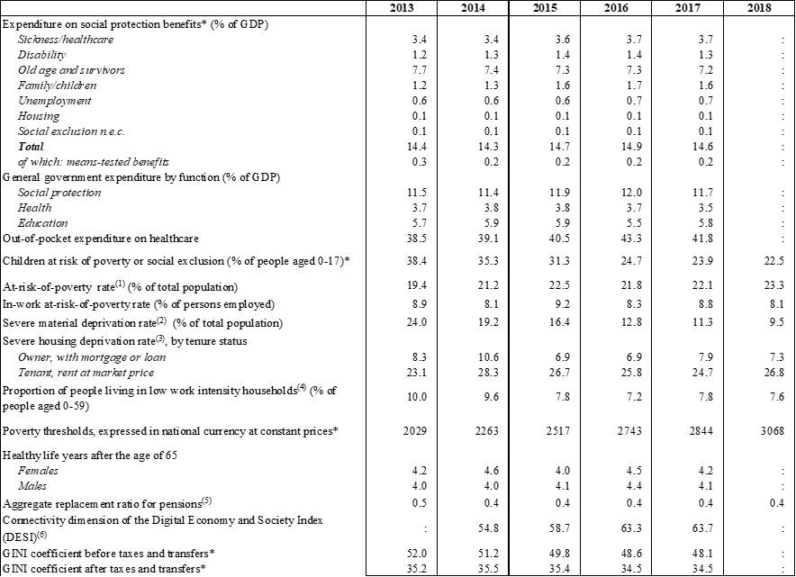
* Non-scoreboard indicator
(1) At-risk-of-poverty rate (AROP): proportion of people with an equivalised disposable income below 60 % of the national equivalised median income.
(2) Proportion of people who experience at least four of the following forms of deprivation: not being able to afford to i) pay their rent or utility bills, ii) keep their home adequately warm, iii) face unexpected expenses, iv) eat meat, fish or a protein equivalent every second day, v) enjoy a week of holiday away from home once a year, vi) have a car, vii) have a washing machine, viii) have a colour TV, or ix) have a telephone.
(3) Percentage of total population living in overcrowded dwellings and exhibiting housing deprivation.
(4) People living in households with very low work intensity: proportion of people aged 0-59 living in households where the adults (excluding dependent children) worked less than 20 % of their total work-time potential in the previous 12 months.
(5) Ratio of the median individual gross pensions of people aged 65-74 relative to the median individual gross earnings of people aged 50-59.
(6) Fixed broadband take up (33%), mobile broadband take up (22%), speed (33%) and affordability (11%), from the Digital Scoreboard.
Source: Eurostat, OECD

Table C.5: Product market performance and policy indicators
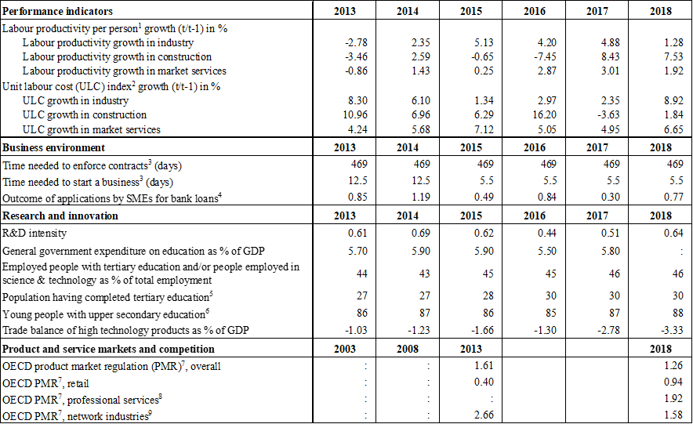
1 Value added in constant prices divided by the number of persons employed.
2 Compensation of employees in current prices divided by value added in constant prices.
3 The methodologies, including the assumptions, for this indicator are shown in detail here: http://www.doingbusiness.org/methodology.
4 Average of the answer to question Q7B_a. "[Bank loan]: If you applied and tried to negotiate for this type of financing over the past six months, what was the outcome?". Answers were codified as follows: zero if received everything, one if received 75% and above, two if received below 75%, three if refused or rejected and treated as missing values if the application is still pending or don't know.
5 Percentage population aged 15-64 having completed tertiary education.
6 Percentage population aged 20-24 having attained at least upper secondary education.
7 Index: 0 = not regulated; 6 = most regulated. The methodologies of the OECD product market regulation indicators are shown in detail here: http://www.oecd.org/competition/reform/indicatorsofproductmarketregulationhomepage.htm
Please be aware that the indicator values from 2003 to 2013 are comparable, however the methodology has considerably changed in 2018 and therefore past vintages cannot be compared with the 2018 PMR indicators!
8 Simple average of the indicators of regulation for lawyers, accountants, architects and engineers.
9 Aggregate OECD indicators of regulation in energy, transport and communications (ETCR).
Source: European Commission; World Bank — Doing Business (for enforcing contracts and time to start a business); OECD (for the product market regulation indicators); SAFE (for outcome of SMEs' applications for bank loans).

Table C.6: Green growth
All macro intensity indicators are expressed as a ratio of a physical quantity to GDP (in 2010 prices)
Energy intensity: gross inland energy consumption (in kgoe) divided by GDP (in EUR)
Carbon intensity: greenhouse gas emissions (in kg CO2 equivalents) divided by GDP (in EUR)
Resource intensity: domestic material consumption (in kg) divided by GDP (in EUR)
Waste intensity: waste (in kg) divided by GDP (in EUR)
Energy balance of trade: the balance of energy exports and imports, expressed as % of GDP.
Weighting of energy in HICP: the proportion of 'energy' items in the consumption basket used for the construction of the HICP.
Difference between energy price change and inflation: energy component of HICP, and total HICP inflation (annual % change).
Real unit energy cost: real energy costs as % of total value added for the economy.
Industry energy intensity: final energy consumption of industry (in kgoe) divided by gross value added of industry (in 2010 EUR).
Real unit energy costs for manufacturing industry excluding refining: real costs as % of value added for manufacturing sectors.
Share of energy-intensive industries in the economy: share of gross value added of the energy-intensive industries in GDP.
Electricity and gas prices for medium-sized industrial users: consumption band 500–20 00MWh and 10 000 -100 000 GJ; figures excl. VAT.
Recycling rate of municipal waste: ratio of recycled and composted municipal waste to total municipal waste.
Public R&D for energy or for the environment: government spending on R&D for these categories as % of GDP.
Proportion of GHG emissions covered by EU emissions trading system (ETS) (excluding aviation): based on GHG emissions.
(excl. land use, land use change and forestry) as reported by Member States to the European Environment Agency.
Transport energy intensity: final energy consumption of transport activity including international aviation (kgoe) divided by gross value added in transportation and storage sector (in 2010 EUR).
Transport carbon intensity: GHG emissions in transportation and storage sector divided by gross value added in transportation and storage sector (in 2010 EUR).
Energy import dependency: net energy imports divided by gross inland energy consumption incl. consumption of international bunker fuels.
Aggregated supplier concentration index: Herfindahl index covering oil, gas and coal. Smaller values indicate larger diversification and hence lower risk.
Diversification of the energy mix: Herfindahl index covering natural gas, total petrol products, nuclear heat, renewable energies and solid fuels. Smaller values indicate arger diversification.
* European Commission and European Environment Agency - 2018 provisional data.
Source: European Commission and European Environment Agency (Share of GHG emissions covered by ETS); European Commission (Environmental taxes over labour taxes and GDP); Eurostat (all other indicators).

Building on the Commission proposal, this Annex () presents the preliminary Commission services’ views on priority investment areas and framework conditions for effective delivery for the 2021-2027 Just Transition Fund investments in Latvia. These priority investment areas are derived from the broader analysis of territories facing serious socio-economic challenges deriving from the transition process towards a climate-neutral economy of the Union by 2050 in Latvia, assessed in the report. This Annex provides the basis for a dialogue between Latvia and the Commission services as well as the relevant guidance for the Member States in preparing their territorial just transition plans, which will form the basis for programming the Just Transition Fund. The Just Transition Fund investments complement those under Cohesion Policy funding for which guidance in the form of Annex D was given in the 2019 Country Report for Latvia ().
In Latvia, greenhouse gas (GHG) emissions from wetlands and peat extraction constitute around 14.5% of total GHG emissions (). Peat extraction leads to the degradation of wetlands, which are efficient carbon storage systems. Ensuring sustainable production of peat and restoring peatlands and wetlands can significantly reduce emissions. On average 1,800 workers are employed in peat extraction (), increasing to 2,500 during the season. Vidzeme and Latgale are two regions where the transition to a climate neutral economy would have a significant socio-economic impact. Based on this preliminary assessment, it appears warranted that the Just Transition Fund concentrates its intervention on these regions.
In line with ambitious climate goals and transition to a carbon neutral economy, the emissions from the GHG-intensive industries in the priority regions would need to be reduced as much as technologically feasible, and potential negative social and economic impacts resulting from this transition mitigated. For example, adapting the peat industry to become more environmentally sustainable, climate friendly and carbon neutral would lead to employment shifts in the affected regions. The smart specialisation strategies () provide an important framework to set priorities for innovation in support of economic transformation. Diversifying regional economic activities and creating new business opportunities would therefore be essential for making the transition towards a more diversified, competitive and green economy. This also implies the need for new skills of those people currently employed in the peat sector and its value chain.
In order to tackle these transition challenges, priority investment needs have been identified for diversifying and making the regional economies more modern and competitive, and for alleviating the socio-economic costs of the transition. Key actions of the Just Transition Fund could target in particular:
- productive investments in SMEs, including start-ups, leading to economic diversification and reconversion;
- investments in the creation of new firms, including through business incubators and consulting services;
- investments in research and innovation activities and fostering the transfer of advanced technologies;
- investments in the deployment of technology and infrastructures for affordable clean energy, in greenhouse gas emission reduction, energy efficiency and renewable energy.
- upskilling and reskilling of workers.
In order to increase the resilience of the affected regions, investment needs have also been identified for improving the attractiveness of the local economy. Key actions of the Just Transition Fund could target in particular:
- investments in regeneration and decontamination of sites, land restoration and repurposing projects.

Assessment of Latvia’s short-term progress towards the SDGs ()
Table E.1: Indicators measuring Latvia’s progress towards the SDGs
(Continued on the next page)
Table E.1 shows the data for Latvia and the EU-28 for the indicators included in the EU SDG indicator set used by Eurostat for monitoring progress towards the SDGs in an EU context (). As the short-term trend at EU-level is assessed over a 5-year period, both the value at the beginning of the period and the latest available value is presented. The indicators are regularly updated on the SDI dedicated section of the Eurostat website. 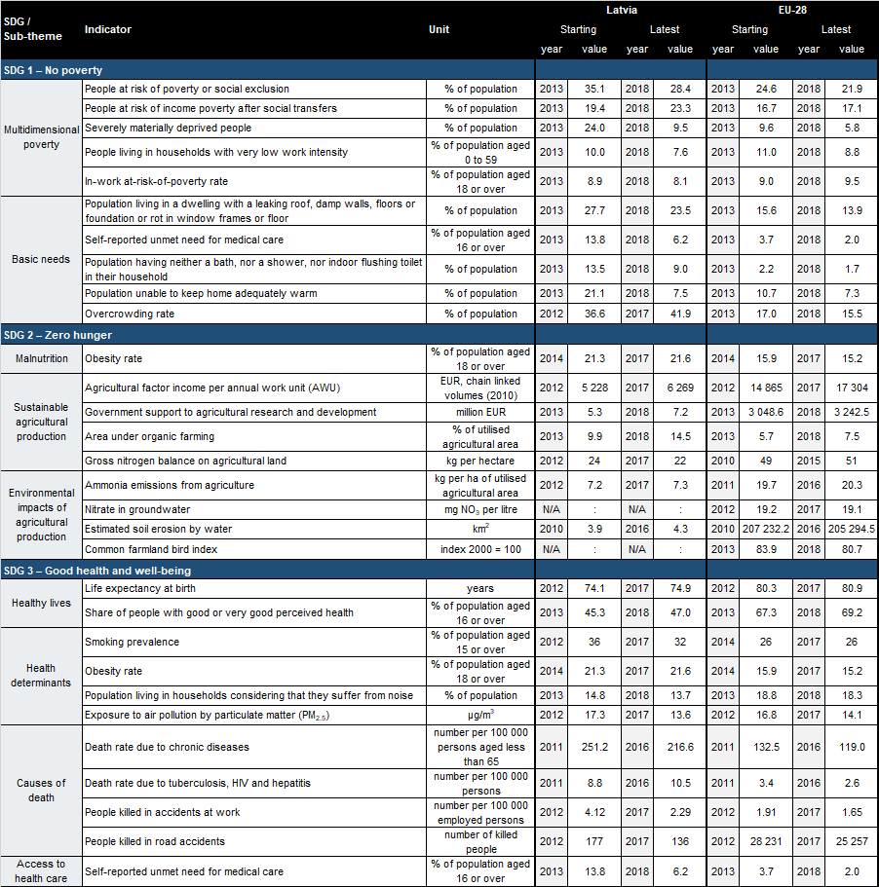
Table (continued)
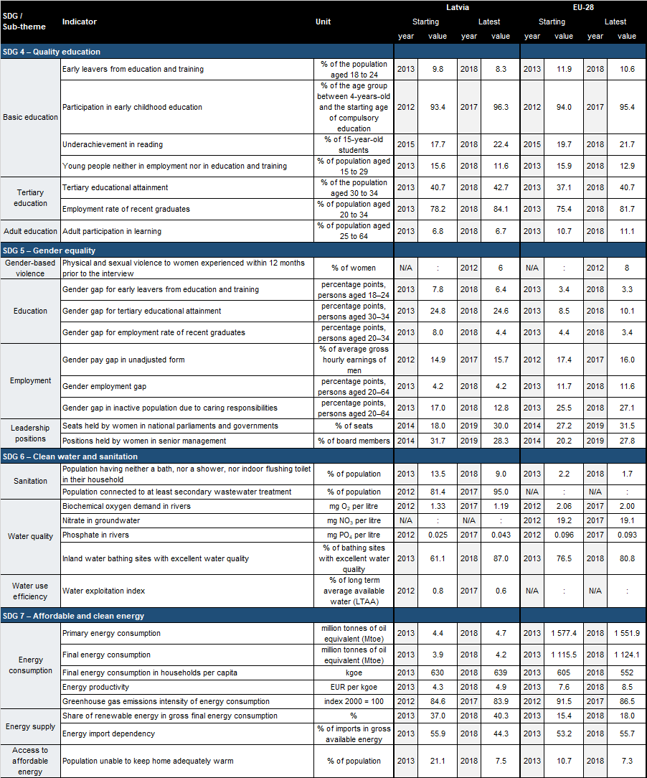
(Continued on the next page)

Table (continued)
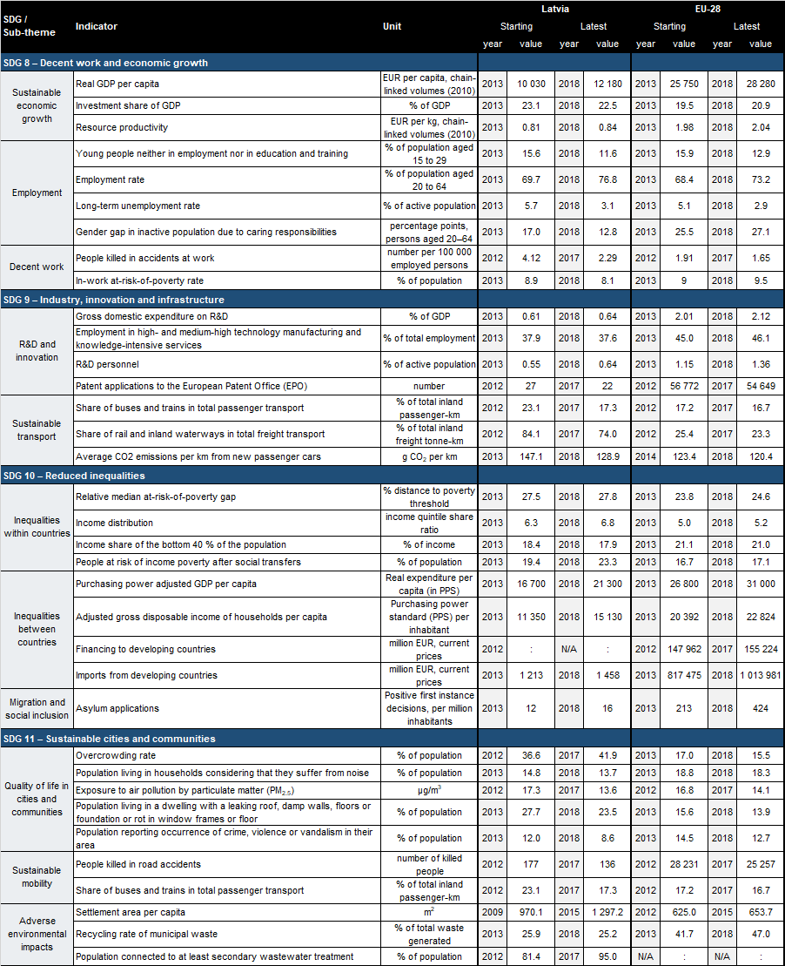
(Continued on the next page)

Table (continued)
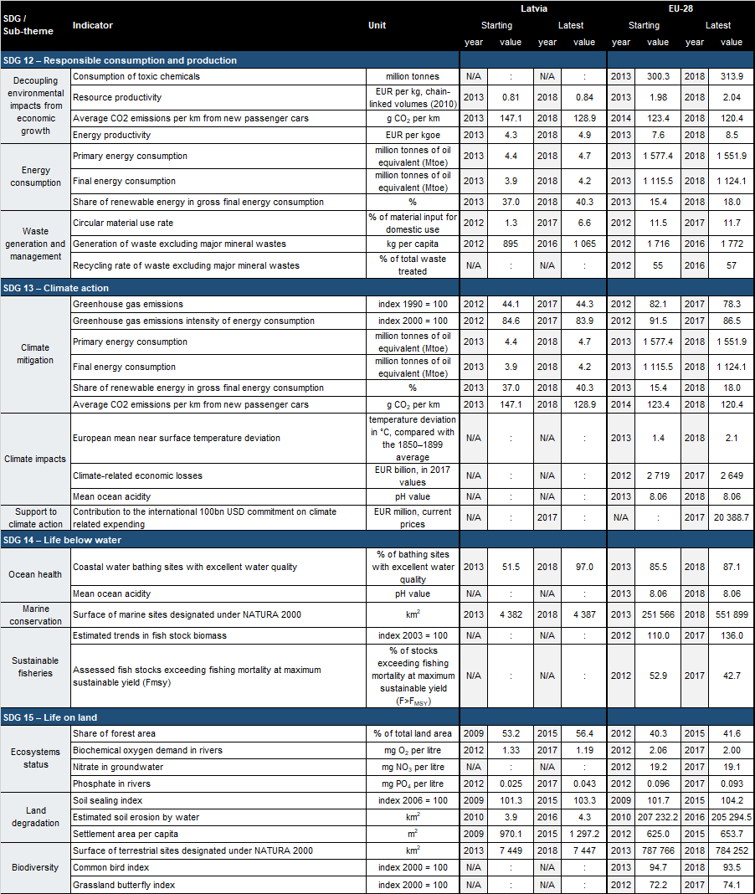
(Continued on the next page)

Table (continued)
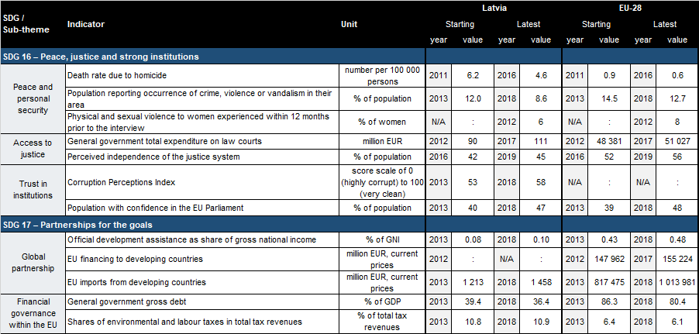
Source: Eurostat

Baltic Institute of Social Sciences (BISS). (2019). Ikgadējs nabadzības un sociālās atstumtības mazināšanas rīcībpolitikas izvērtējums (t.sk. izvērtējums par nevienlīdzību veselības aprūpē un nevienlīdzību mājokļa pieejamības jomā). [The annual assessment of policies to reduce poverty and social exclusion (including the assessment of health inequalities and inequality in access to housing).] Retrieved from: http://petijumi.mk.gov.lv/sites/default/files/title_file/Nabadz_soc_atstumt_mazin_ricibpol_izvertejums_Zinojums.pdf
Center for Social and Economic Research (CASE). (2019). Study and Reports on the VAT Gap in the EU-28 Member States: 2019 Final Report. Retrieved from: https://ec.europa.eu/taxation_customs/sites/taxation/files/vat-gap-full-report-2019_en.pdf
Central Statistical Bureau of Latvia (CSB). (2018). Results of Adult Education Survey. Retrieved from: https://www.csb.gov.lv/lv/statistika/statistikas-temas/socialie-procesi/izglitiba/meklet-tema/303-apsekojuma-pieauguso-izglitiba-rezultati-2018
Central Statistical Bureau of Latvia (CSB). (2019). Labour Force Survey: Key Indicators in 2018. Retrieved from: https://www.csb.gov.lv/lv/statistika/statistikas-temas/socialie-procesi/nodarbinatiba/meklet-tema/380-darbaspeka-apsekojuma-galvenie-raditaji
Dijkstra et al. (2019). Road transport performance in Europe. Retrieved from: https://ec.europa.eu/regional_policy/sources/docgener/work/2019_02_road_transport.pdf
European Business and Consumer Survey (EU-BCS). (2019). Retrieved from: https://ec.europa.eu/info/business-economy-euro/indicators-statistics/economic-databases/business-and-consumer-surveys/latest-business-and-consumer-surveys_en
European Commission. (2018a). The 2018 Ageing report. Retrieved from: https://ec.europa.eu/info/sites/info/files/economy-finance/ip079_en.pdf
European Commission. (2018b). Social enterprises and their ecosystems in Europe. Updated country report: Latvia. Available at https://europa.eu/!Qq64ny
European Commission/EACEA/Eurydice. (2018c). Teachers’ and School Heads’ Salaries and Allowances in Europe – 2016/17. Retrieved from: https://eacea.ec.europa.eu/national-policies/eurydice/sites/eurydice/files/teacher_and_school_head_salaries_2016_17.pdf
European Commission. (2018d). Country Report – Latvia. Retrieved from: https://ec.europa.eu/info/sites/info/files/2018-european-semester-country-report-latvia-en_1.pdf
European Commission. (2019a). Country Report – Latvia. Retrieved from: https://ec.europa.eu/info/sites/info/files/file_import/2019-european-semester-country-report-latvia_en.pdf
European Commission. (2019b). Labour Market and Wage Developments in Europe. Retrieved from: https://ec.europa.eu/social/BlobServlet?docId=21904&langId=en
European Commission. (2019c). Employment and Social Developments in Europe: Sustainable growth for all: choices for the future of social Europe. Available at: https://ec.europa.eu/social/main.jsp?catId=738&langId=en&pubId=8219
European Commission. (2019d). NECP factsheet Latvia. Retrieved from: https://ec.europa.eu/energy/sites/ener/files/documents/necp_factsheet_lv_final.pdf
European Commission. (2019e). 2019 SBA Fact Sheet Latvia. Retrieved from: https://ec.europa.eu/docsroom/documents/38662/attachments/17/translations/en/renditions/native
European Commission. (2019f). Commission recommendation on the draft integrated National Energy and Climate Plan of Latvia covering the period 2021-2030. Retrieved from: https://ec.europa.eu/energy/sites/ener/files/documents/lv_rec_en.pdf
European Construction sector observatory. (2019). Country profile Latvia. Retrieved from: https://ec.europa.eu/docsroom/documents/37022/attachments/1/translations/en/renditions/native
European Environment Agency (EEA). (2020). Article 17 web tool on Habitat assessments at Member State level. Retrieved from: https://nature-art17.eionet.europa.eu/article17/reports2012/habitat/report/?period=5&group=Forests&country=LV&region
European Institute for Gender Equality (EIGE). (2019). Gender Equality Index 2019: Latvia. Retrieved from: https://eige.europa.eu/publications/gender-equality-index-2019-latvia
European Investment bank (EIB). (2019). EIB Investment Survey. Country overview: Latvia. Retrieved from: https://doi.org/10.2867/93527
Fiscal Discipline Council. (2019). Fiscal discipline surveillance report on Latvia’s Medium Term Budgetary Framework 2020/2022. Retrieved from: https://fiscalcouncil.lv/files/uploaded/Surveillance_report_2020_final_3.docx.pdf
Hazans M., European Centre of Expertise in the field of labour law, employment and labour market policy. (2018). Labour Market Policy Thematic Review 2018: An in depth analysis of the emigration of skilled labour. Latvia. Retrieved from: https://ec.europa.eu/social/main.jsp?catId=738&langId=en&pubId=8132&furtherPubs=yes
Ivaškaitė-Tamošiūnė et al. (2018). The Effect of Taxes and Benefits Reforms on Poverty and Inequality in Latvia. Directorate-General for Economic and Financial – Economic brief, 39. doi:10.2765/830917. Retrieved from: https://ec.europa.eu/info/sites/info/files/economy-finance/eb039_en_0.pdf
Krasnopjorovs O. (2019). Anatomy of labour reserves in the Baltic countries: a snapshot 15 years after the EU accession. Bank of Latvia. Retrieved from: https://datnes.latvijasbanka.lv/papers/discussion/dp_2_2019-en.pdf
Lāce T. (2019), European Social Policy Network (ESPN). National strategies to fight homelessness and housing exclusion. Latvia. Retrieved from: https://ec.europa.eu/social/BlobServlet?docId=21621&langId=en
Latvian Environment, Geology and Meteorology Centre (LEGM). (2019). 2019. gada iesniegtās SEG inventarizācijas kopsavilkums. Retrieved from: https://www.meteo.lv/fs/CKFinderJava/userfiles/files/Vide/Klimats/Majas_lapai_LVGMC_2019_seginvkopsavilkums.pdf
Ministry of Economics. (2019a). Mazkvalificētais darbaspēks Latvijā. Retrieved from: https://www.em.gov.lv/files/tautsaimniecibas_attistiba/dsp/Mazkvalificetais%20darbaspeks%20Latvija%202019.pdf
Ministry of Economics. (2019b). Nacionālais Enerģētikas un klimata plans. Retrieved from: https://em.gov.lv/lv/nozares_politika/nacionalais_energetikas_un_klimata_plans/
Ministry of Finance. (2018). Nodokļu atvieglojumu ziņojums par 2017.gadu. Retrieved from: https://fm.gov.lv/files/nodoklupolitika/NA_novertejums_2017_FINAL.docx
Ministry of Welfare. (2019). Publiskais gada pārskats par 2018.gadu. Retrieved from: www.lm.gov.lv/upload/PP_2018_Final.pdf
Müller T., Vandaele K. and Waddington J., European Trade Union Institute (ETUI). (2019). Collective bargaining in Europe: towards an endgame. Volume I, II, III and IV. Retrieved from: https://www.etui.org/Publications2/Books/Collective-bargaining-in-Europe-towards-an-endgame.-Volume-I-II-III-and-IV
OECD. (2019a). OECD Skills Strategy Latvia: Assessment and Recommendations, OECD Skills Studies, OECD Publishing, Paris, https://doi.org/10.1787/74fe3bf8-en
OECD. (2019b). Evaluating Latvia's Active Labour Market Policies, Connecting People with Jobs, OECD Publishing, Paris. Retrieved from: https://doi.org/10.1787/6037200a-en.
OECD. (2019c). Measuring social protection for long-term care in old age, Final Report, June 2019. OECD Publishing, Paris.
OECD. (2019d). Programme for International Student Assessment (PISA) 2018. Paris. https://doi.org/10.1787/19963777
OECD. (2019e). TALIS 2018 Results (Volume I): Teachers and School Leaders as Lifelong Learners, TALIS, OECD Publishing, Paris. Retrieved from: https://doi.org/10.1787/1d0bc92a-en
OECD/European Observatory on Health Systems and Policies. (2019). Latvia: Country Health Profile 2019, State of Health in the EU, OECD Publishing, Paris/European Observatory on Health Systems and Policies, Brussels. Retrieved from: https://ec.europa.eu/health/state/country_profiles_en
Sauka, A., & Putnins. T. (2019). Shadow Economy Index for the Baltic Countries 2009-2018. Stockholm School of Economics in Riga. Retrieved from: http://www.sseriga.edu/shadow-economy-index-baltic-countries
State Audit Office. (2019). Human Resources for Health Care. Retrieved from: http://www.lrvk.gov.lv/revizija/cilvekresursi-veselibas-aprupe/
State Employment Agency of Latvia. (2019). Pārskats par bezdarba situāciju valstī (jūnijs). Retrieved from: http://www.nva.gov.lv/docs/31_5d399d6d2f8563.07502318.pdf
State Labour Inspectorate of Latvia. (2019). Performance review 2018. Retrieved from: http://www.vdi.gov.lv/files/2018_gada_darbibas_parskats.pdf
Swedbank. (2019). Baltic Housing Affordability index. Retrieved from: https://www.swedbank-research.com/english/baltic_housing_affordability_index/2019_q2/hai_q2_2019.pdf
Vilerts K., Zutis K. and Beņkovskis K. (2019). Factors Determining Municipal Spending Differences in Latvia. Discussion Paper 1/2019. Bank of Latvia. Retrieved from: https://datnes.latvijasbanka.lv/papers/discussion/DP_1_2019_en.pdf

() Within the scope of its legal basis, the European Semester can help drive national economic and employment policies towards the achievement of the United Nations’ Sustainable Development Goals (SDGs) by monitoring progress and ensuring closer coordination of national efforts. The present report contains analysis of Latvia’s progress towards the SDGs. Annex E presents a set of SDG indicators for Latvia.
() The VAT gap represents the difference between expected VAT revenue based on the tax law and respective tax bases and the VAT revenue actually collected.
() Project of the European Commission and the World Bank "Technical Assistance: Supporting the Implementation of the Mid-Term Tax Strategy of the Government of Latvia".
() The banking sector is composed of two segments – banks servicing residents or “domestically active banks” (80% of total assets) and banks servicing non-residents or foreign clients (20% of total assets). The latter’s share has been falling.
() In early 2018, the United States financial crime enforcement network (FinCen) implicated Latvia's then third biggest bank ABLV to conducting large scale money laundering. The European Central bank revoked its licence and the ABLV bank went into self-liquidation.
() Financial Action Task Force is an inter-governmental body established by members of OECD in 1989. The objectives of the FATF are to set standards and promote effective implementation of legal, regulatory and operational measures for combating money laundering, terrorist financing and other related threats to the integrity of the international financial system.
() Around 97% of companies (or some 135000) established in Latvia have disclosed their beneficial owners since the introduction of the Enterprise Register. The remaining 3% have had their rights to trade terminated because of non-compliance with the UBO reporting requirements. Around 86% of all legal persons have revealed their beneficial owners. Since December 2017, there is no possibility to register a new legal person without disclosure of beneficial owner information.
() The number of criminal proceedings for money laundering has risen from 93 in 2018 to 164 in 2019.
() In Q2-2019, the non-bank financial sector represented roughly 30% of the financial sector in Latvia (40% compared to banking sector assets). The bulk (50%) of the non-bank financial sector is composed of pension funds, 25% leasing companies and the rest is fragmented among insurance, investment funds, alternative investment funds and other non-bank intermediaries.
() According to the benchmarking on adult skills and adult learning systems in the EU conducted within the Employment Committee.
() Draft Budgetary Plan of Latvia, 2020. Retrieved from: https://ec.europa.eu/info/sites/info/files/economy-finance/2020_dbp_lv_en.pdf
() According to the EU benchmarking exercise in the Social Protection Committee. See the draft Joint Employment Report 2020 for details.
() Statistics, Ministry of Welfare, 2019 http://lm.gov.lv/upload/Stat-SU-05112019.pdf
() Financing from the government schemes based on the System of Health Accounts.
() See the Final Report of this Policy Support Facility — https://rio.jrc.ec.europa.eu/en/library/specific-support-latvia-final-report-–-latvian-research-funding-system-0.
() The EU average is set to 100.
() Annoni, P., and Dijkstra, L. (2019) The EU Regional Competitiveness Index, DG REGIO Working Paper Series. The index varies between 0 and 100 (best performing EU region). .
() Number of economically active statistical units per 1,000 population in the market sector (number, RAIM apr.) https://raim.gov.lv/lv/node/38.
() The European Union has set out to reduce its greenhouse gas emissions by 40% by 2030 compared to 1990. The European Commission’s Green Deal initiative presented in December 2019 has proposed to increase the emissions reduction target to at least 50% and set an ambition to reach carbon neutrality by 2050. This has yet to be agreed by Member States.
() Carbon pricing through emissions trading system (ETS) applies to power and heat generation, energy-intensive industry, and commercial aviation sectors.
() In 2005, Latvia emitted 5.2 tonnes of greenhouse gases per capita compared with the European Union average of 10.8 tonnes of greenhouse gases per capita. In 2018, the number had risen to 6.4 tonnes greenhouse gas emissions per capita in Latvia compared to a European Union average of 8.6 tonnes per capita.
() Share of organic farming is one of the key indicators for sustainable development goal 2 on sustainable food production systems and implementation of resilient agricultural practices.
The Commission will assess, in the course of 2020, the final National Energy and Climate Plan submitted by Latvia on 3 February 2020.
() The following categories are used to assess progress in implementing the 2017 country-specific recommendations (CSRs): No progress: The Member State has not credibly announced nor adopted any measures to address the CSR. This category covers a number of typical situations, to be interpreted on a case-by-case basis taking into account country-specific conditions. They include the following: no legal, administrative, or budgetary measures have been announced in the national reform programme, in any other official communication to the national Parliament/relevant parliamentary committees or the European Commission, publicly (e.g. in a press statement or on the government's website); no non-legislative acts have been presented by the governing or legislative body; the Member State has taken initial steps in addressing the CSR, such as commissioning a study or setting up a study group to analyse possible measures to be taken (unless the CSR explicitly asks for orientations or exploratory actions). However, it has not proposed any clearly-specified measure(s) to address the CSR. Limited progress: The Member State has: announced certain measures but these address the CSR only to a limited extent; and/or presented legislative acts in the governing or legislative body but these have not been adopted yet and substantial further, non-legislative work is needed before the CSR is implemented; presented non-legislative acts, but has not followed these up with the implementation needed to address the CSR. Some progress: The Member State has adopted measures that partly address the CSR; and/or that address the CSR, but a fair amount of work is still needed to address the CSR fully as only a few of the measures have been implemented. For instance, a measure or measures have been adopted by the national Parliament or by ministerial decision, but no implementing decisions are in place. Substantial progress: The Member State has adopted measures that go a long way towards addressing the CSR and most of them have been implemented. Full implementation: The Member State has implemented all measures needed to address the CSR appropriately.
() This Annex is to be considered in conjunction with the EC proposal for a Regulation of the European Parliament and of the Council on the Just Transition Fund 2021-2027 (COM(2020) 22) and the EC proposal for a Regulation of the European Parliament and of the Council laying down common provisions on the European Regional Development Fund, the European Social Fund Plus, the Cohesion Fund, and the European Maritime and Fisheries Fund and financial rules for those and for the Asylum and Migration Fund, the Internal Security Fund and the Border Management and Visa Instrument (COM(2020) 23)
() SWD(2019) 1013 final
() GHG emissions inventory, Latvian Center for Environment, Geology & Meteorology, https://www.meteo.lv/fs/CKFinderJava/userfiles/files/Vide/Klimats/Majas_lapai_LVGMC_2019_seginvkopsavilkums.pdf
() Source: Latvian Peat Association
() As defined in Article 2(3) of Regulation EU1303/2013 (CPR)
() Data extracted on 9 February 2020 from the Eurostat database (official EU SDG indicator set; see https://ec.europa.eu/eurostat/web/sdi/main-tables).
() The EU SDG indicator set is aligned as far as appropriate with the UN list of global indicators, noting that the UN indicators are selected for global level reporting and are therefore not always relevant in an EU context. The EU SDG indicators have strong links with EU policy initiatives.

