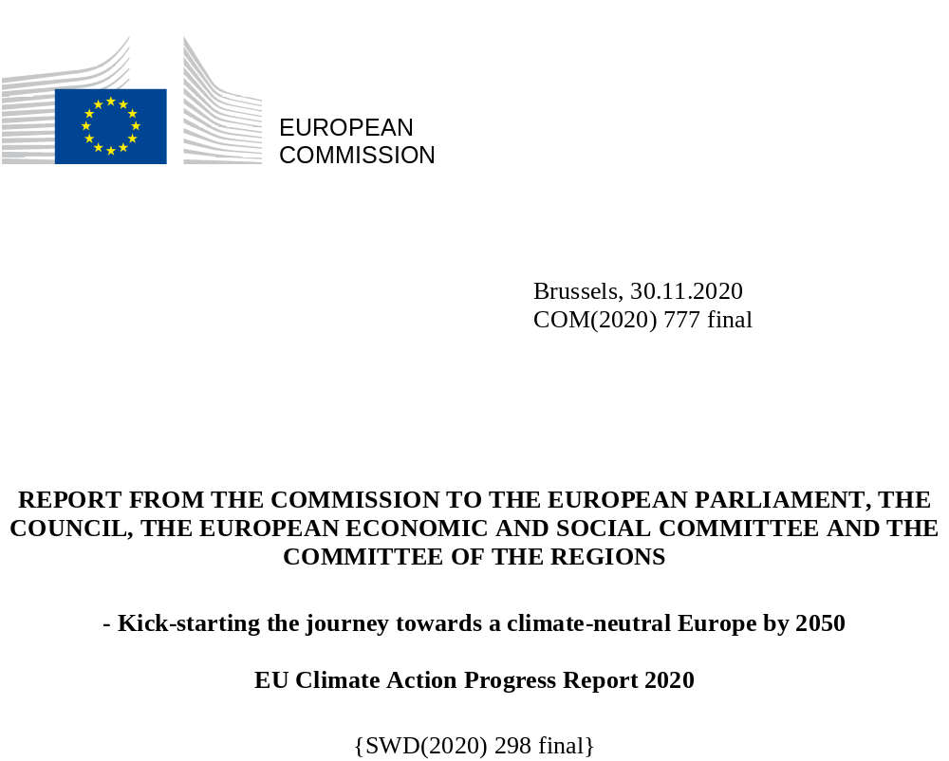

“We can be confident in our progress, but this is no time to rest on our laurels. We need to step up our efforts across all sectors of the economy. The European Green Deal’s policies will drive our green transition and allow us to cut greenhouse gas emissions faster, with a goal of reaching 55% below 1990 levels by 2030. The transition is feasible if we stick to our commitment and seize the opportunities of the recovery to reboot our economy in a greener, more resilient way and create a healthy, sustainable future for all.”

Frans Timmermans, Executive Vice-President for the European Green Deal

MEETING THE EU’S INTERNATIONAL COMMITMENTS

In 2019, greenhouse gas (GHG) emissions decreased by 3.7% while the EU economy continued to grow
In 2019, EU-27 greenhouse gas emissions (including international aviation) were down by 24% from 1990 levels, according to the approximated GHG inventory. Including emissions and removals from land use, land use change and forestry this results in a net emission reduction of 25%.The EU thus remains well on track to achieve its target under the UN Framework Convention on Climate Change of reducing GHG emissions by 20% by 2020. Emissions in 2019 fell by 3.7% compared to 2018. EU GHG emissions therefore reached their lowest level since 1990. Between 1990 and 2019, the EU’s combined GDP grew by about 60%. The GHG emission intensity of the economy, defined as the ratio between emissions and GDP fell to 282 g CO₂eq/€₂₀₁₅, which is less than half of the 1990 level.

Figure 1: Total EU 27 GHG emissions (including international aviation) and removals 1990-2019, current 2030 Target and proposed step-up, projected emissions 2020 – 2050 with existing (‘baseline’) and with additional measures necessary to achieve climate neutrality (‘net zero’) by 2050

The COVID-19 crisis is expected to lead to an unprecedented fall in emissions in 2020. The IEA estimates a drop of 8% in 2020 for global CO2 emissions. The carbon monitor, run by an international research consortium, estimates that EU-27 emissions in the first half of the year 2020 have dropped by 11% compared to the same period of the previous year. However, as experienced in the past, a swift economic recovery may lead to a strong and rapid rebound in emissions, unless policy gears stimulus measures toward the green transition. First reliable data on the impacts of COVID-19 on EU emissions will be available in next year’s report.
Even before the pandemic, emissions from stationary installations in all countries covered by the EU emissions trading system (EU ETS), fell strongly by 9.1 % from 2018 to 2019. Emissions not covered by the ETS (such as emissions from non-ETS industry, transport, buildings, agriculture and waste) remained unchanged from 2018 to 2019. The year before these had seen a slight drop, however, overall, emissions from this aggregate of economic sectors have been stable for several years. According to preliminary accounting under the Kyoto Protocol, decreasing net credits from land use, land use change and forestry (LULUCF) between 2013 and 2017 stabilized in 2018.
CO₂ emissions from international aviation continued to increase in 2019, rising by 3% compared to the previous year, continuing the increasing trend. Aviation emissions are covered by the ETS, but for the moment only for flights within the European Economic Area (EEA). Regarding emissions from extra-EEA international aviation, i.e. both from incoming flights from and outbound to non-EEA countries, are currently not priced under the EU ETS, in accordance with the ‘stop the clock’ provision in the Directive. This was intended to provide momentum for a global market-based mechanism, the Carbon Offsetting and Reduction Scheme for international aviation (CORSIA). Aviation's overall impact on the global climate, including through non-CO₂ emissions or effects, is considerably higher than the CO₂ component alone. It has been estimated that the non-CO₂ radiative forcing effects were 2-4 times those of CO₂, which gives a range of 136-272 million tonnes CO₂-equivalent for aviation’s total impacts from intra-EEA activities. This range results from the varying degrees of uncertainty that still prevail as to the exact magnitude of the various non-CO₂ effects and trade-offs between them.

European climate action to be stepped up towards net zero emissions in 2050 despite the COVID-19 pandemic
The year 2019 was a significant milestone for European climate action. The European Council agreed in December on the EU becoming climate-neutral by 2050 in line with the Paris Agreement. The European Parliament had already endorsed the objective in its resolution on climate change of March. To ensure climate neutrality by 2050, the Commission presented the European Green Deal as a comprehensive multi-sectoral roadmap toward a green and just transition. In principle, all EU actions and policies should pull together to help the EU achieve a successful and just transition towards a sustainable future.
A new proposal for a European Climate Law was subsequently adopted by the Commission in March 2020, in order to make the climate neutrality target legally binding in the EU. The proposal was amended in September to include a new target for 2030 and support the increasing of the EU’s nationally determined contribution under the Paris Agreement from the previous at least 40% reduction target to at least 55% compared to 1990. Figure 1 illustrates where EU emissions are projected to land with currently existing and planned policies and measures (‘baseline’) on the one hand, and with a plausible path towards climate neutrality with additional measures to achieve -55% net emissions as set out in the Climate Target Plan (‘net zero’), on the other.
Following the outbreak of the COVID-19 pandemic in spring 2020, a recovery package and the 2021-2027 budget have been designed with the purpose of helping the EU to rebuild after the pandemic and supporting investment in the twin green and digital transitions. The European Council agreed in July 2020 that 30% of the funds amounting to € 1.8 trillion should be targeted at advancing the climate transition helping EU Member States address their sustainability challenges and boosting green jobs and competitiveness. The biggest potential to create a quick economic stimulus in the area of climate and energy policy has been identified in the areas of building renovation, renewable energy, renewable hydrogen, and infrastructure, as well as clean mobility such as electric vehicles and charging points, smart grids and energy sector integration.
To ensure consistency, the proposed Recovery and Resilience Facility (RRF) Regulation fixes criteria with which national Recovery and Resilience Plans for 2021-2023 should comply. The plans need to be consistent with country-specific recommendations identified in the 2019 and 2020 European Semester cycles, the integrated National Energy and Climate Plans (NECPs), including on just transition. The plans need to include both investments and reforms that contribute to the green transition, corresponding to the climate objective for the RRF of 37% of the allocated spending. The RRF links policies with financing, complemented by the key financial resources delivering the European Green Deal, namely InvestEU, cohesion funds, the Just Transition Fund, Innovation Fund, and Modernisation Fund. The Digital Europe Programme will support the twin green and digital transitions.

This report provides illustrative examples on how EU funds contribute to climate friendly innovation.
Member States identify additional policies and measures to reach 2030 objectives
In 2019, all Member States prepared their final integrated National Energy and Climate Plans. These show that while Member States have made significant progress in defining their respective paths to reaching the current 2030 climate and energy targets, further efforts are still needed.
With existing national policies and measures implemented, EU-27 total emissions are projected to be reduced by 30% in 2030 according to aggregated national GHG projections. With the implementation of the planned measures or stated ambitions in the final NECPs, the overall GHG reduction of the EU is estimated at 41%, thus reaching the current at least 40% reduction target.

Cooperation with Norway and Iceland to reach the 2030 target
Norway and Iceland have agreed to cooperate with the EU in order to reach their 2030 targets of reducing GHG emissions by at least 40% compared to 1990 levels. In the context of the EEA Agreement, Norway and Iceland will as of 2021 implement the Effort Sharing Regulation (ESR) and the LULUCF Regulation. Norway and Iceland have already taken part in the EU ETS since 2008.

EMISSIONS IN THE EU EMISSIONS TRADING SYSTEM (ETS)
The Emissions Trading System (ETS) covers emissions from approximately 11,000 power stations and manufacturing plants, as well as aviation within and between the participating countries.
In 2019, emissions from installations in all countries participating in the ETS are estimated to have decreased by 9.1% compared to 2018. This decrease was mainly driven by changes within the electricity and heat production sectors, where emissions fell by about 15% compared to 2018. The trend of strongly decreasing emissions over the past years thus continues. The decrease was mainly driven by the the power sector, where emissions fell by close to 15% as a result of coal being replaced by electricity from renewables and gas-fired power production. Emissions from industry decreased by close to 2%.
Verified aviation emissions grew modestly in 2019, by 1% compared to 2018.
Figure 2 shows the historical and projected development with existing measures of ETS emissions, together with the cap and the accumulated surplus of ETS allowances.

Figure 2: Verified ETS emissions 2005-2019, Member States projections with existing measures 2020-2030, ETS cap phases 2, 3 and 4, and accumulated surplus of ETS allowances 2008-2019, (Mt CO₂eq)
As of end June 2020, the total number of international credits used or exchanged amounts to around 1.54 billion, accounting for over 96% of the estimate for the allowed maximum of 1.6 billion. In phase 3 alone (2013-2020), 480.94 million international credits have been exchanged up to the end of June 2020. For the Market Stability Reserve (MSR), operational since 2019, the Commission publishes annually the surplus for the preceding year. In 2019, the surplus was 1.39 billion allowances. On the basis of the revised ETS legislation for phase 4 (2021-2030), the auction volumes for 2020 were reduced by nearly 40%, or close to 375 million allowances. Auction volumes in 2021 will see a similar reduction. In 2021, the Commission will review the MSR in the context of the planned ETS revision.
The agreement on linking the EU ETS with Switzerland’s ETS entered into force on 1 January 2020 and is currently being operationalised.
After more than doubling in the previous year, revenues from the auctioning of allowances on the European carbon market grew slightly in 2019. The total revenues generated by Member States, the UK and EEA countries from the auctions between 2012 and 30 June 2020 exceeded € 57 billion, with more than half of this amount generated in 2018 and 2019. In the year 2019, total revenues exceeded € 14.1 billion and around 77% of the revenues were used, or are planned to be used, for climate and energy purposes, thereby supporting the green transition.
Example 1. Improved technology enhances energy performance of intermittent kilns in Italy
*The project is an example of how EU funds contribute to climate-friendly innovation in sectors covered by the ETS. It was funded by LIFE in 2016-2019.

The LIFE ECONOMICK project in Italy demonstrated the technical and economic viability of applying a new technology to intermittent (or shuttle) kiln for the ceramic sanitary ware industry. Its solutions, which reduce heat losses and optimise combustion conditions, can greatly improve the energy performance of a shuttle kiln and its lifecycle impacts, while maintaining competitiveness on the market and improving working conditions.
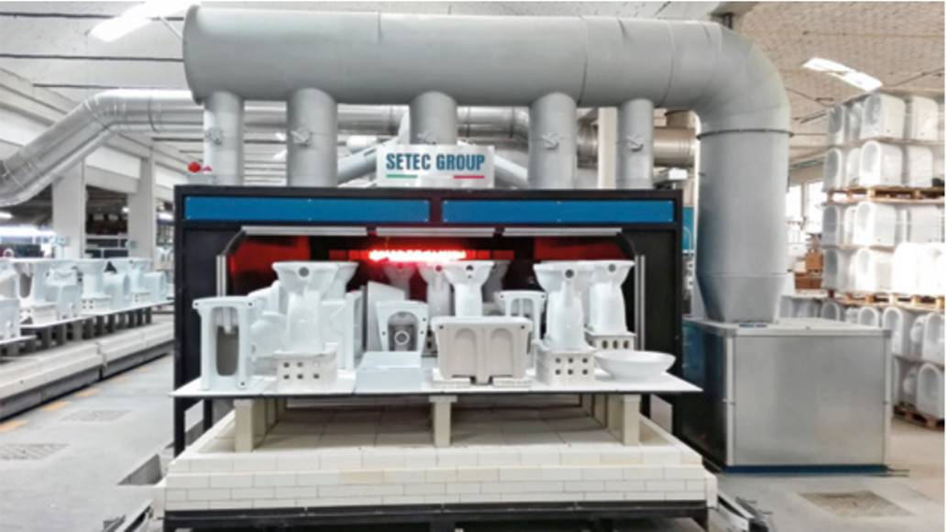
©SE.TE.C.SRL
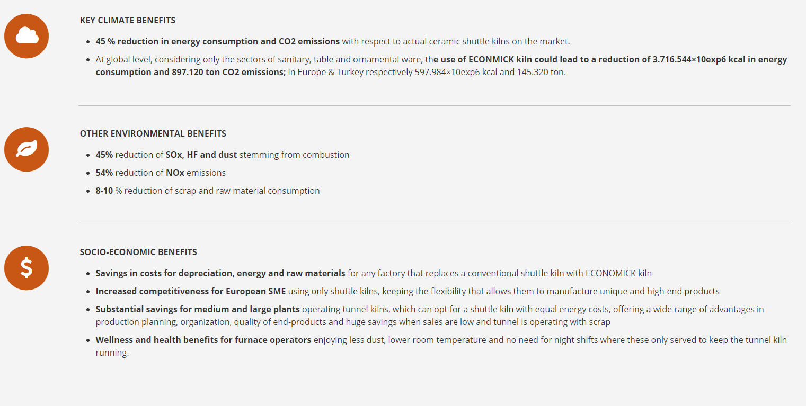

EFFORT SHARING EMISSIONS
Emissions from sectors not included in the ETS, except for emissions and/or removals from LULUCF, such as transport, buildings, agriculture and waste, are covered by the EU effort sharing legislation. The Effort Sharing Decision (ESD) sets national emissions targets for 2020, expressed as percentage changes from 2005 levels. On this basis, Member States must respect annual emissions limits. Similarily, the Effort Sharing Regulation (ESR) sets national emissions targets for 2030. The Commission is currently determining the annual emissions allocations (AEAs) for each country for the years 2021 - 2030 under the current ESR, based on a comprehensive review of GHG inventories.

Progress towards the effort sharing targets
Member States are planning, adopting and implementing policies and measures to achieve their current 2030 effort sharing targets. If currently implemented national policies are aggregated, the EU-27 would reduce effort sharing emissions by 19% by 2030 compared to 2005. This is well below the 30% overall emissions reduction target under the ESR by 2030 compared to 2005. However, with the implementation of additional policies Member States have outlined in the final NECPs how a reduction of 32% can be achieved. This is clear progress in comparison to currently implemented national policies. Figure 3 shows the distance between Member States’ existing 2030 targets under the ESR and their own ‘with existing measures’ projections and with planned measures.
However, to achieve the current EU-level emissions reduction target of 30%, Member States will need to fully implement the planned measures, all the more so as it is currently proposed to increase the EU’s 2030 climate ambition to 55 % greenhouse gas emissions reductions on the way to climate neutrality by 2050.

Figure 3: Gaps between 2030 ESR targets and projected emissions with existing measures, and with measures planned in the NECPs in percentage of 2005 base year emissions. Positive values indicate overachievement of targets; negative values indicate targets are projected not to be met.

As shown in Figure 4 below, since the effort sharing system was launched in 2013, EU-wide emissions have been below the overall limit each year. EU-27 emissions covered by the ESD were 10% lower in 2019 in comparison to 2005. The 2020 target of a 10% reduction will thus most likely be over-achieved, even without considering the impacts of the COVID-19 crisis.

Figure 4: Emissions in sectors covered by effort sharing legislation 2005-2030 and Annual Emission Allocations (AEAs), EU-27 (Mt CO₂eq)

Member States compliance with the Effort-Sharing Decision (ESD)
All Member States complied with their ESD obligations in 2013-2017. Malta exceeded its annual emissions allocations (AEAs) in each of these years, but covered the deficit by purchasing AEAs from Bulgaria. In 2017, Austria, Bulgaria, Cyprus, Estonia, Germany. Ireland, Lithuania, Luxembourg, and Poland exceeded their AEAs. France, Sweden and the UK cancelled surplus AEAs from 2013 to 2017 to enhance the environmental integrity of the system. As for previous years, Sweden deleted its surplus AEAs for that year (5.3 Mt). For 2017, it was joined by France and the UK, which, for the first time, deleted surplus AEAs accumulated over previous years. France deleted 100 Mt – most, but not all - of its accumulated surplus, while the UK deleted all its accumulated surplus amounting to 112.4 Mt. This means a total of 244 Mt surplus AEAs – corresponding to one fifth of the theoretical total - will have been deleted for the period until 2017 by these three countries. All other Member States (except Malta) banked surplus allocations for possible use in later years. No international credits from the clean development mechanism (CDM) or joint implementation were used to comply with ESD obligations.
The compliance cycle for 2018 is ongoing. In 2018, Malta’s emissions exceeded its AEA by 18% and it will therefore again need to purchase AEAs. Emissions in ten further Member States exceeded the AEAs of 2018 by up to 14%. These Member States have a surplus of AEAs banked from previous years that can be used to ensure compliance. The cumulative surplus of AEAs per Member State for 2013-2018 is shown in Figure 5.

Figure 5: Cumulative surplus of Annual Emission Allocations (AEAs) as percentage of 2005 base year emissions, 2013-2018
Preliminary data for 2019 show a similar picture as for 2018. Malta exceeded its AEA by 18%, Ireland 15% and Luxembourg by 11% followed by Estonia with 9%. Czechia is expected to join the group of Member States that already had higher emissions than their AEA in 2018. In case of a net deficit, Member States use the flexibility mechanisms in the Effort Sharing Decision (beyond banking and borrowing AEAs).
More than one third of effort sharing emissions come from transport. After a decrease in emissions between 2007 and 2013, emissions from transport have increased in each of the years since then, and are now only marginally lower (-2%) than in 2005. Towards 2030, Member States project, with existing measures, only a slight further reduction (-5% in 2030 compared to 2005). However, with implementation of planned policies and measures, transport emissions are projected to be reduced by 20% by 2030, compared to 2005. These trends underpin the strong need to focus recovery measures on this particular sector in the short run and underline the importance of reinforced policy instruments reducing transport emissions within a more ambitious 2030 target in the medium term.
The CO₂ emissions standards for new cars and vans and heavy duty vehicles are key drivers for road transport emissions reduction. By 2025 and 2030, respectively, average emissions from new cars will have to be 15% and 37.5% lower than in 2021, and average emissions from vans will have to be 15% and 31% lower than in 2021. Emissions from new lorries will have to be 15% and 30% lower than in 2019. The standards include a mechanism to incentivise the uptake of zero and low-emission vehicles based on benchmarks values from 2025 onwards. They also introduce new provisions to ensure the real-world representativeness of the monitored emissions. Figure 6 shows that, while average CO₂ emissions per kilometre of new cars and vans remained below the targets set for 2019, provisional data for 2019 indicate an increase in emissions as compared to 2018. According to provisional data, in 2019 average emissions were 122.4 g CO₂/km for cars (1.6g above 2018) and 158.4 g CO₂/km for vans (0.5g above 2018). This confirms the trend seen in previous years. Therefore, vehicle manufacturers will have to significantly reduce emissions of their fleet to meet the stricter targets applying from 2020 onwards.

Figure 6: Average CO₂ emissions (g/km) for newly sold cars and vans compared to current fleet-wide targets until 2040
The Fuel Quality Directive contributes to decreasing GHG emissions from transport. It mandates to reduce life-cycle GHG emissions intensity of fuels by 6% by 2020, compared to 2010. The average GHG intensity of the fuels supplied in 2018 was 3.7% lower than 2010 based on data from the 28 reporting Member States (Figure 7). The progress achieved varies greatly across Member States, but almost all need to swiftly take further action to ensure that the 2020 target will be met.

Figure 7: Reductions in GHG intensity of fuels achieved by EU fuel suppliers in the 27 reporting Member States and UK, 2010-2018
Emissions from energy use in buildings show some year-to-year variation due to weather-related fluctuations in heating demand. Over the longer term, emissions have shown a downward trend since 2005, which is projected to continue towards 2030. The projected emissions decrease reflects the availability of economically attractive technologies reducing energy demand and integrating renewables. In order to achieve climate neutrality by 2050 and the 2030 milestone along the way – as well as for a swift economic recovery towards a green transition - this sector is key, as outlined in ‘A Renovation Wave for Europe’. More measures and funds will be needed to accelerate deep renovations including in upskilling and reskilling of the workforce.
Non-CO₂ emissions from agriculture were at a similar level in 2019 as in 2005 and with existing policies are projected to decline only slightly.
Emissions from waste management decreased by 12% between 2005 and 2019, and this downward trend is projected to continue.
Example 2. New technique reduces costs of biological oxidation of methane from landfills
The LIFE RE MIDA project tested - for the first time in a Mediterranean climate- an innovative technique to reduce methane emissions using microbial oxidation. The project developed full scale biofilter and biowindows in two pilot landfill sites in Italy. Key achievements include:
Reduction of more than 2,700 t CO₂eq of emissions through the biological oxidation of about 150,000 Nm³ of CH₄, corresponding to -37% of the current yearly GHGs emitted by the two pilot landfill sites.
Demonstration that costs of treating residual biogas with low methane concentration can be significantly reduced. This is particularly important for closed landfills for which waste management companies have not allocated sufficient financial resources to take care of continuing methane emissions.
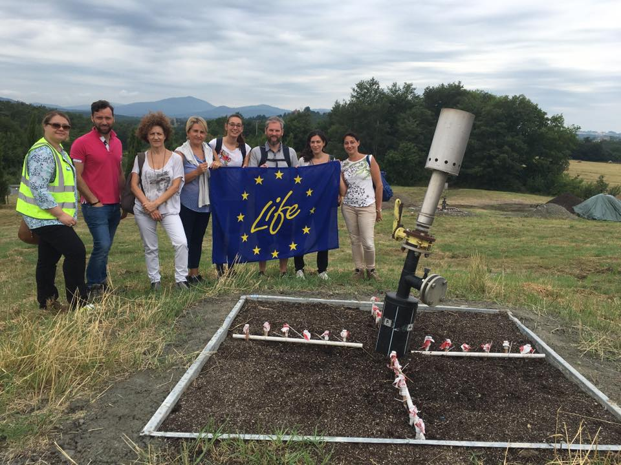
©Isabella Pecorini
*The project is an example of how EU funds contribute to climate-friendly innovation covered by the effort sharing legislation
As part of ESD emissions from industry and other sectors, many ozone-depleting substances (ODS) are potent greenhouse gases. With the exception of 2012, EU ODS consumption as counted under the Montreal Protocol has been negative since 2010. Thus, the EU will meet its obligations to phase out ODS consumption by 2020 as required under the Protocol. The Commission ozone team was presented the global Montreal Protocol award for customs and enforcement officers recognising their crucial role in implementing trade restrictions and bans for ODS.
The Commission evaluated the Regulation on substances that deplete the ozone layer in 2019. The evaluation shows that while the Regulation is very effective in reaching its objectives, it may be possible to achieve these results in a more efficient manner. A new proposal to improve the Regulation taking into account these findings is planned in 2021.
Fluorinated gases (F-gases) are a group of gases often used as substitutes for ozone-depleting substances. However, many F-gases are very powerful greenhouse gases. The Regulation on F-gases provides for an EU-wide phase-down of hydrofluorocarbons (HFC) from 2015 and other measures targeting emissions from F-gases, with the aim of cutting emissions by two thirds by 2030 compared to 2014. HFCs are also covered by the Kigali Amendment to the Montreal Protocol, which entered into force on 1 January 2019.
Example 3. Industry expertise brought together around resources on alternative refrigerants
The European F-Gases Regulation encourages the adoption of alternatives to HFC refrigerants with a high global warming potential. Industry groups are joining hands providing information on the safe use of alternatives such as ammonia, hydrocarbon, carbon dioxide and other low GWP refrigerants through the “Refrigerants, Emissons And Leakage” (REAL) Alternatives 4 LIFE learning programme. Resources developed as part of the project offer an innovative mix of e-learning, face-to-face training materials, practical exercises, assessments and an e-library of learning resources.
REAL Alternatives 4 LIFE has built on the successful REAL Skills Europe & REAL Zero containment approaches. It was prepared by a consortium of Partners from across Europe, co-funded by the EU, included training and professional institutes as well as employer representative bodies.
The emissions of F-gases almost doubled from 1990 to 2014 in contrast to emissions of all other greenhouse gases, which were reduced. However, thanks to the EU F-gas legislation emissions have been falling since 2015, mainly due to a reduction of HFC emissions. Data for 2019 show that the supply of F-gases decreased by 20% in terms of climate impact, and by 17% in terms of volume compared to 2018. In 2019, the total placing on the market under the EU quota system was 2% below the maximum quantity allowed. This reflects a shift towards gases with lower global warming potential and indicates that the Regulation effectively reduces F-gases emissions.
The Commission is planning a review of the F-gases Regulation in 2021 to improve EU rules taking into account the findings of three Commission reports adopted in 2020 on alternatives to fluorinated gases in specific equipment and the availability of HFCs on the EU market. Moreover, throughout 2020 the Commission has continued its focus on preventing illegal imports of hydrofluorocarbons that are not covered by the quota system.

LAND USE, LAND USE CHANGE AND FORESTRY
LULUCF can generate both emissions and removals of CO₂ from the atmosphere. From 2013 to 2020, EU Member States are committed to ensuring that greenhouse gas emissions and removals from additional action in this sector are accounted towards their reduction target under the Kyoto Protocol. Additional action is determined through the application of accounting rules on gross emissions and removals data, associated with an activity such as afforestation, reported annually in a specific inventory by each Member State.
Figure 8 shows that the EU’s ‘reported’ emissions and removals per activity for 2013-2018 produced an average sink of -396 Mt CO₂eq, i.e. a net removal. The reported net removals decrease from -440 Mt CO₂eq. to -319 Mt CO₂eq from 2013 to 2018. Applying the specific accounting rules for the Kyoto Protocol, the EU’s ‘accounted’ balance for 2013-2018 produced an average annual sink (or credit) of -114.1 Mt CO₂eq. The accounted net credits decreased from -150.3 to -79.3 Mt CO₂eq from 2013 to 2017 and slightly recovered to -94.6 in 2018. These quantities for the EU include both ‘mandatory’, i.e. afforestation/reforestation, deforestation and forest management, and ‘elected’ activities under the Kyoto Protocol.

Figure 8: Reported (R) and preliminary accounted (A) emissions and removals under the Kyoto Protocol, second commitment period, EU-27.
The decrease in net credits described above mainly resulted from decreasing credits or credits turning into debits for forest management as for example in Croatia, Czechia, Denmark, France, Lithuania, Luxembourg and Slovenia. The main reason is the increase in harvesting rates.
The LIFE Peat Restore project aims to rewet degraded peatlands in Poland, Germany, Estonia, Latvia and Lithuania covering an area of 5,300 hectares to restore the natural function as carbon sinks. In the project, the emissions and storage of greenhouse gases, the water level as well as the wildlife (flora and fauna) will be documented, analysed and compared. In addition, the potential climate effects of the rewetting in terms of estimated avoided emissions will be calculated.

©Agnese Priede
Total budget: € 6 million, EU-contribution 60%.

Example 4. Rewetting of degraded peatlands reduces emissions
Natural disturbances also contributed to increased emissions. Bark beetle significantly attacked forests in Czechia causing a dramatic increase in salvage logging. Singular disturbances such as wildfires, that affected forests in Cyprus in 2016, and Italy and Portugal in 2017, resulting in debits for that year, returned to ‘normal conditions’ in 2018.
Yet, in the context of climate change, natural disturbance events are expected to become more frequent. Market behaviour will mainly depend on the economic context. Material substitution and wood for energy initiatives along with afforestation and reforestation programmes are expected to increase as they are driven by policies that will enter into force in 2021. Care must be taken to ensure that these are carried out in accordance with appropriate ecological management principles that increase the future resilience of forests to fires, droughts and other climate-related disturbances, as well as help reversing declining biodiversity trends.
According to preliminary estimates using accounting rules for the Kyoto Protocol second commitment period Cyprus, Finland, Lithuania and the Netherlands have net LULUCF debits smaller than 1Mt CO₂eq per year. Higher levels of debits are forecast for Czechia, Latvia and Slovenia (1.5, 2.4 and 3.2 Mt CO_{2eq} per year, respectively).
The EU’s 2030 Climate and Energy Framework integrates emissions and removals from the land sector from 2021 using a set of accounting rules adapted from the Kyoto Protocol. The LULUCF Regulation requires each Member State to ensure that accounted emissions from land use are entirely compensated by an equivalent removal of CO₂ from the atmosphere through action in the sector. For making this regulation operational, Member States have submitted revised National Forestry Accounting Plans, including proposed Forest Reference Levels. The Commission analysed revised proposals, consulted the LULUCF Expert Group and the general public, and addressed issues through corrections by Member States or recalculations by the Commission. The Delegated Regulation setting out the Forest Reference Levels of the Member States for the period 2021-2025 was adopted by the Commission on 28 October 2020.

FINANCING CLIMATE ACTION

Mainstreaming climate policies into the EU budget
Meeting the objectives of the European Green Deal will require a significant increase in investments and will inevitably rely on private sector engagement, shifting large-scale investment to climate mitigation and climate adaptation. New policy instruments and financial mechanisms, disruptive business models and services, and societal innovation will all be required to provide correct investment signals and predictability for investors, to turn research into investable opportunities and innovative businesses, and bring necessary climate action solutions to market.
Achieving the current EU 2030 climate and energy targets is estimated to require increases of annual investments related to energy production and use in 2021-2030 by just over 1 percentage points of GDP on average compared to the previous decade, namely an increase of around € 260 billion per year. For an increased greenhouse gas emissions reduction target of at least 55% this figure would increase to around € 350 billion per year. Around one third of these additional investments is needed in the transport and residential sectors. Public and private sectors will need to mobilise this additional investment. As part of the Green Deal, the Commission has proposed the European Green Deal Investment Plan to support Member States. The agreement reached in the July European Council foresees that at least 30% of the next EU's long-term budget (MFF and Next Generation EU) should be dedicated to climate action to increase the current level of 20% set for 2014-2020. The latest available data in Figure 9 show that such expenditure accounted for 21% of the budget in 2020, and in total around € 210 billion over the whole period.
The Plan also helps mobilise private investments through targeted financial instruments such as EU guarantees and equity finance to the European Investment Bank. Moreover, a Just Transition Fund will be set up to support those regions that rely heavily on carbon intensive activities by providing access to reskilling programmes and employment opportunities in new economic sectors for example.

Figure 9: Climate-relevant spending in the EU budget, 2014-2020 (€ million and percentage of the EU budget)

Sustainable finance
A fundamental shift in investment patterns in the medium to long-term will be essential for achieving a climate-neutral EU. As part of the legislative environment, the EU is aligning its financial and capital markets framework to climate challenges.
The EU has continued to implement the 2018 action plan to integrate sustainability in capital markets:
- The amended Benchmark Regulation introduces a new category, so-called EU climate benchmarks, i.e. the EU Climate Transition Benchmark and EU Paris-aligned Benchmark, and sustainability-related disclosures for all benchmarks;
- the Taxonomy Regulation establishes a framework to facilitate sustainable investment;
- The Disclosure regulation on sustainability‐related disclosures in the financial services sector;
- Changes to the existing delegated acts under AIFMD, UCITS, Solvency II, MiFID II and IDD to integrate sustainability factors, sustainability risks and sustainability preferences into the organisation requirements and operating conditions for the relevant financial sector entities as well as the product oversight and governance processes.
As part of the European Green Deal, the Commission has launched and accelerated the preparatory processes for a renewed Sustainable Finance Strategy seeking to strengthen the foundations for sustainable investment, increase green investment opportunities, and fully manage climate and environmental risks.

Research and Innovation (Horizon Europe)
Research and innovation (R&I) are crucial for climate action. Hence, it is important to ensure adequate finance and trigger the required investment for R&I that support the breakthrough technologies, market uptake and large-scale deployment of transformational solutions, needed to achieve the EU’s climate goals.
Under the Horizon 2020 R&I programme, the European Green Deal call with a budget of € 1 billion aims to kick-start urgent climate action in support of the Green Deal objectives. In addition, the European Innovation Council has awarded over € 307 million to 64 game-changing start-ups and SMEs contributing to the objectives of the European Green Deal Strategy and the Recovery Plan for Europe.
From 2021, the Horizon Europe R&I programme will contribute to inclusive recovery and develop solutions for climate action. At least 35% of its budget will be devoted to climate action.

Member States’ use of revenues from the auctioning of EU ETS allowances
In 2019, the EU-28 Member States earned € 14.1 billion from auctioning revenues. Steadily increasing carbon prices have resulted in a continued increase in revenues from the auctioning of EU ETS allowances in the past. Contrary to this, Figure 10 below shows a slight decrease in total EU ETS revenues from 2018 to 2019. This decrease results from the fact that no auctioning took place in the UK in 2019 due to safeguard measures following Brexit. Auctioning resumed in the UK in 2020.
In 2019, a total of 77% of the revenues were used, or are planned to be used, for climate and energy purposes. This is a significant increase compared to the share of 70% in 2018.
During the years 2013-2019, almost 78% of revenues went to climate and energy expenditure with a share of 4% of total revenues or € 1.9 billion being directed to international climate and energy expenditure.

Figure 10: Use of revenues from the auctioning of ETS allowances 2013-2019 (€ billion), EU-28
Over the years, Figure 11 shows that most revenues from the auctioning of EU ETS allowances that are used domestically were spent on renewable energy, energy efficiency and sustainable transport. In 2019 €3.7, €2.9 and €0.7 billion of domestic revenues were respectively spent on these purposes.

Figure 11: Domestic use of revenues from auctioning of ETS allowances 2013-2019 (€ billion), EU-28

New Entrants Reserve (NER 300) under the ETS
The NER 300 is a large-scale funding programme for innovative low-carbon energy demonstration projects. It is aimed at demonstrating innovative renewable energy (RES) technologies and environmentally safe carbon capture and storage (CCS) on a commercial scale within the EU. The NER 300 has been funded from the monetisation of 300 million emission allowances from the New Entrants Reserve. The funds were awarded to projects selected through two rounds of calls for proposals in December 2012 and July 2014. As a result, 38 renewable energy projects and one carbon capture and storage project amounting to €2.1 billion have been awarded funding in 20 EU Member States. Nine projects are now operational, and another three projects from the second call are expected to become operational by 30 June 2021. One project is considered as completed and four further projects are at various stages of development.
Given the challenging economic and policy context since the NER 300 programme was designed, 22 projects that had been selected for funding found it difficult to raise sufficient equity or to attract additional financial support and were withdrawn by July 2020. The withdrawals from the two calls for proposals have released a total of almost €1.5 billion. The amended NER 300 Decision allowed the re-investment of the unused funds of €708.7 million from the cancelled projects of the first call through existing financial instruments. Under the InnovFin Energy Demonstration Projects (InnovFin EDP) and the Connecting Europe Facility Debt Instrument (CEF DI), so far, eight projects were allocated almost €201 million from the available funding (see Example 5). The unused funds from the cancelled projects of the second call (presently €746 million) will be added to the resources available for the Innovation Fund.
Example 5. NER 300 funds re-invested in projects for fuel production from steel-making waste gas and electrification of public transport
The unused funds from the first call for proposals (€709 million) are re-invested in the InnovFin EDP and the CEF DI, both managed by the European Investment Bank.
Since the last progress report two new projects, Voltalis from France improving the energy efficiency and Steelanol on decarbonising the steel sector in Belgium (see below), have been selected to benefit from the NER 300 unspent funds of up to €95 million under InnovFin EDP.
NER 300 support of some €34 million was awarded under the CEF DI to three innovative clean transport projects located in Italy and Germany.
Three further renewable energy projects have benefitted from project development assistance by NER 300 unspent funds. These projects from Sweden, Italy and the Netherlands address climate change by developing innovative, first-of-a-kind demonstration plants.
InnovFin EDP: Steelanol - fuel production from waste gas from the steel-making
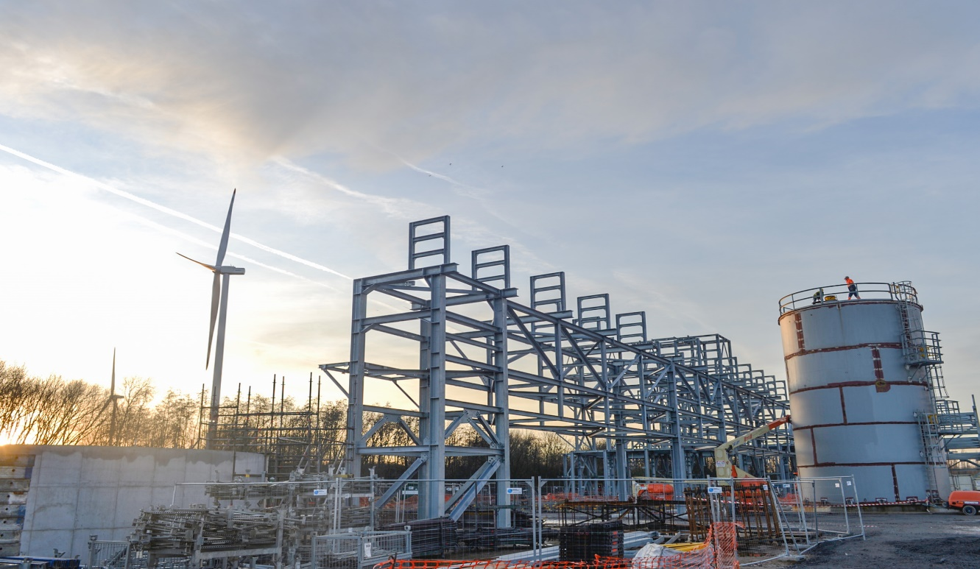
©Jeroen Op De Beeck, ArcelorMittal
The Steelanol project, valued at €225 million, received a €75 million loan fully backed by NER 300 resources. This first-of-a-kind project aims to demonstrate a pathway for producing ethanol from waste gas fully integrated into a large-scale steel mill, a major breakthrough toward low-carbon steel-making.
Example 5. cont.

CEF DI: Hamburger Hochbahn e-mobility programme

The project by Hamburger Hochbahn, a public transport operator, aims to renew and electrify Hamburg’s urban public transport fleet. It will replace diesel buses by 100 e-buses and deploy the charging infrastructure. The project uses 100% certified renewable electricity for its e-buses. The company expects that the charging infrastructure will be modular and scalable, easy to maintain, and highly energy- and cost-efficient.
The project is supported by the CEF DI with NER 300 contribution amounting to €4.7 million.

Innovation Fund
The Innovation Fund is a low-carbon fund created by the revised EU ETS Directive for phase four. It supports, on a competitive basis, first-time market development and commercial scale demonstration of innovative technologies and breakthrough innovation in sectors covered by the EU ETS. This includes innovative renewables, energy-intensive industries, carbon capture, utilisation and storage, energy storage, as well as substitute products and cross-sectoral projects. It is funded by the auctioning of 450 million allowances and undisbursed revenues from the second call of the NER 300 programme. By the end of September 2020, 31 auctions were executed, providing more than €590 million. An additional €746 million of NER 300 undisbursed revenues will be added in 2020. The fund’s implementing structure has been established and the grants will be managed by Innovation and Networks Executive Agency (INEA) while the European Investment Bank will provide the Project Development Assistance to eligible projects.
A first call for proposals, amounting to €1 billion and addressing large-scale projects was launched in July 2020. This will be followed by regular calls until 2030, helping companies to bring the breakthrough of clean technology solutions needed for achieving climate neutrality by 2050. The call is open for projects in eligible sectors from EU Member States, Norway and Iceland while also enabling co-financing from other public funding initiatives, such as State aid or other EU funding programmes. A first call for small-scale projects with capital expenditure below €7.5 million is planned towards the end of 2020.

Modernisation Fund
The Modernisation Fund will support low-carbon investments in the power sector and wider energy systems of ten Central and Eastern European Member States listed in the ETS Directive. Moreover, five eligible Member States decided to transfer additional allowances to the Modernisation Fund. As a result, 643 million allowances will be available from 2021 to 2030. The shares of eligible Member States resulting after these transfers are shown in Figure 12. The Modernisation Fund will follow a lean administrative procedure. Beneficiary Member States are responsible for the selection, financing and reporting of investments, and must comply with applicable State aid rules. The Commission will be responsible for the disbursement decisions following a technical and financial assessment of the EIB. The fund will be operational as of 2021.

Figure 12: Shares of eligible Member States in the Modernisation Fund

LIFE – Climate Action
The LIFE programme is the EU’s funding instrument for the environment and climate action, co-financing projects with European added value. The total budget for funding projects in 2014 to 2020 amounts to € 2.5 billion under the sub-programme for environment and € 0.86 billion under the sub-programme for climate action. Most LIFE Environment projects also bring climate co-benefits.
LIFE Climate Action supports mitigation and adaptation projects, climate governance and information. The number of proposals submitted under the 2019 LIFE call were higher than in previous years. Under the 2019 LIFE call for traditional projects, proposals involving coordinating beneficiaries from 13 Member States were recommended for funding, with Spain, Italy and the Netherlands attracting the most. In addition, LIFE Integrated Projects implement regional, multi-regional or national environmental and climate plans and strategies required by EU environmental or climate legislation, with more funding per proposal than for traditional projects.
The multiannual financial framework for 2021-2027 includes an increased budget of € 5.43 billion for the LIFE programme for Environment and Climate Action with the thematic breakdown in the pie chart in Figure 13 below.

Figure 13: Proposed budget allocation for LIFE 2021-2027

Structural Reform Support Programme (SRSP)
Since 2016, the Commission has provided Member States with extensive technical support and expertise in a large portfolio of projects related to the green transition and climate neutrality. Support to green projects, has expanded significantly during the implementation of the SRSP. Under the 2020 SRSP, about one in four projects contributed to the goals of the European Green Deal, including climate action. In 2020, there was also a special call launched to provide technical assistance to Member States who requested it in preparation for the territorial just transition plans, in the context of the Just Transition Mechanism. Overall, the SRSP 2019 and 2020 supported 104 (at least partially) green projects in 25 Member States. SRSP 2020 is also supporting 18 Member States in the preparation of their respective territorial just transition plans. At the same time, the SRSP 2019 continued to support the transition away from coal with two projects. Under SRSP 2020, two additional assignments were approved, providing expertise to Member States to help achieve coal phase-out. From 2020 onwards, the revamped Technical Support Instrument (TSI) will also cover aspects of the just transition. The TSI budget can provide tailored expertise to support design and implementation of climate policies, including relevant training aimed at building capacity among national and regional authorities.

ADAPTING TO CLIMATE CHANGE
The impacts of climate change are increasingly felt across Europe and the wider world. The last five years were the hottest on record, and heatwaves, droughts and wildfires are becoming increasingly common across Europe. This highlights the urgent need to adapt to the adverse effects of climate change.
The European Green Deal sets out an increased focus on adaptation, building on the achievements of the current EU Adaptation Strategy, which was adopted in 2013 to prepare Member States for current and future climate impacts:
- All EU Member States now have a national adaptation strategy or plan
- More than 2,700 cities and towns in Europe have committed through the Covenant of Mayors initiative to enhancing their climate resilience reflecting an increase of some 800 since 2019
- Several National Energy and Climate Plans contain adaptation goals and consider climate risks to the energy sector
- A new version of the Climate-ADAPT platform was deployed in January 2019 alongside the publication of the Climate-ADAPT Strategy 2019-2021
- The European Commission has published the fourth edition of its PESETA report on a range of climate impact projections and adaptation in the EU and beyond
- The LIFE programme continues to fund adaptation projects in crucial areas such as agriculture, forestry, water management, buildings or protected areas

Example 6. Preventing forest fires in Catalonia through sustainable forest management
Catalonia began developing its ORGEST silvicultural models in 2004 as a means of sustainably managing forests and protecting them from large fires, while enabling them to continue to produce wood, cork, pine nuts and other goods. The resulting ORGEST guidelines are a set of benchmarks for forest management, for the various tree formations in the region. Just under 60% of the forest management plans approved in the region between January 2014 and June 2017 use the ORGEST silvicultural models. Over half of those have a combined production-prevention objective.
The LIFE+ DEMORGEST project (together with a complementary LIFE Nature project called Life+ Pinassa) provided an opportunity to apply the ORGEST models at landscape scale in two pilot areas with high fire risk, and on another seven demonstration plots where 10 of the ORGEST models were tested. The project could show that investments in forest fire prevention methods in accordance with the ORGEST guidelines can generate 2.5 times the invested amount in terms of returns from ecosystem services. For example, the plots following the advice from the ORGEST models have an annual CO₂ absorption rate that is 60% higher than in non-management scenarios, while water use efficiency increased by up to 40%.
As one of the initiatives announced under the European Green Deal, the Commission is currently working on a new, more ambitious EU strategy on adaptation to climate change to be adopted in early 2021. An extensive stakeholder consultation was carried out for the new strategy between May and August 2020. The new strategy will build on the 2013 EU Adaptation Strategy, which was positively evaluated in 2018, including several areas for improvement and the need for the EU to:
- align its adaptation action with the Paris Agreement, the Sendai Framework for Disaster Risk Reduction and the UN sustainable development goals;
- support increased citizen climate action through the new European Climate Pact;
- strengthen infrastructure against extreme weather and climate change impacts;
- embed ecosystem-based approaches in the assessment and choice of adaptation options;
- increase the attention on public health issues in adaptation policy and planning.
Under Horizon 2020’s successor Horizon Europe, an ambitious Mission on Adaptation to climate change including societal transformation will be launched in 2021. Horizon Europe missions will focus on research and scale-up innovation in areas of great impact for the EU, and will engage citizens, industry and public support through coordinated efforts to achieve ambitious targets.
Member States report regularly under the Union Civil Protection Mechanism. Based on these reports and additional evidence, the Commission regularly publishes ‘An overview of natural and man-made risks the EU may face’. The report maps, and therefore improves awareness of, and preparedness to, risks relating to forest fires, floods, droughts and other extreme weather events.

INTERNATIONAL CLIMATE COOPERATION

Aviation
In October 2019, ICAO’s 40th Assembly reaffirmed its support for the global market-based measure Carbon Offsetting and Reduction Scheme for International Aviation (CORSIA) and decided to start working on a long-term goal for emission reductions from international aviation, in view of its adoption at the next Assembly in 2022. So far 88 countries have volunteered to join from 2021, there are uncertainties related to the final coverage and robustness of the scheme in light of reservations of countries with important aviation activity. In March 2019, the ICAO Council approved the first set of six programmes which may provide units for offsetting of emissions during the CORSIA pilot phase from 2021 to 2023. A new application period has been opened in 2020 for a second wave of eligible units which are currently being assessed, with an ICAO decision planned by the end of the year. The June 2020 ICAO Council also agreed on the change of baseline for CORSIA, now being based only on 2019 emissions during the pilot phase.
The EU Member States notified ICAO of the existing differences between the features of the EU ETS for aviation and the legally-binding features of CORSIA contained in the Standards and Recommended Practices (SARPs) to protect the EU’s interests. The EU also issued a declaration at ICAO’s 40th Assembly stating that, while the EU strongly supported CORSIA and remained fully committed to implement it from the start of the pilot phase, it maintains its right to increase the climate ambition level in tackling aviation emissions not discriminating according to the nationality of operators.
The EU already has an integrated monitoring, reporting and verification framework for the EU ETS and CORSIA in place. In addition, the Commission is assessing different policy options for a legislative proposal by June 2021 to implement further aspects of CORSIA in the EU, through amending the EU ETS Directive.

Maritime
International shipping carries 80% of the world’s trade volume and is responsible for 2-3% of all GHG emissions. In the future, these emissions are projected to increase significantly if mitigation measures are not swiftly put in place.
After the adoption of the initial GHG emissions reduction strategy by the International Maritime Organization (IMO) in 2018, the European Commission has been closely involved in the ongoing negotiations around its implementation. So far, discussions have focused in particular on short-term measures that can deliver further emissions reductions before 2023, also building on existing IMO measures, such as the Energy Efficiency Design Index and the Ship Energy Efficiency Management Plan.
In addition, in 2019, the EU system for the monitoring, reporting and verification of CO₂ emissions from maritime transport confirmed the substantial impact of shipping with over 138 million tonnes of CO₂ released into the atmosphere in 2018. It also confirmed the significant carbon footprint of EU’s external seaborne trade, with around two-thirds of the CO₂ emissions reported coming from voyages to or from a port outside the European Economic Area. Overall, these CO₂ emissions represent around 3.7% of total CO₂ emissions reported by the European Union in 2018. The Commission published in May 2020 its first annual report on CO₂ emissions from maritime transport. This report enables a comprehensive and granular understanding of CO₂ emissions from ships calling at ports inside the European Economic Area. It also provides valuable analysis on the characteristics and energy efficiency of ships, helping identify the various factors influencing CO₂ emissions. As such, the EU monitoring, reporting and verification (MRV) system provides valuable information for policymakers to address GHG emissions from shipping and could constitute the basis for any such measures that will be adopted under the European Green Deal. A review is currently underway as to whether the EU MRV system can be aligned, where appropriate, to the IMO data collection system.
In 2019, the European Green Deal announced a basket of measures to ensure that shipping contributes to the EU climate effort, including a proposal to extend European emissions trading to the maritime sector to ensure that the price of transport reflects its climate impact and a specific initiative to ramp-up the production and deployment of sustainable alternative fuels for ships.

Supporting developing countries
The EU and its Member States remain the world’s biggest providers of official development assistance to developing countries, delivering €75.2 billion in 2019. The EU, its Member States and the European Investment Bank are also the largest providers of public climate finance with a contribution of €23.2 billion in 2019, a 6.9% increase compared to 2018.
The Commission will provide at least €14 billion (or an average of €2 billion a year) to support climate activities in developing countries in 2014-2020. In addition, the European Investment Bank provided €3 billion in climate finance to developing countries in 2018. It finances, for example, energy efficiency and renewable energy projects in Africa and other regions.
The Global Climate Change Alliance Plus (GCCA+) initiative, with a budget of € 750 million from 2007-2020, contributes towards the 20 % climate mainstreaming objective for the 2014-2020 period. The GCCA+ EU flagship initiative helps the world’s most vulnerable countries to address climate change. It focuses on building climate resilience in Least Developed Countries (LDCs) and Small Island Developing States (SIDS). In 2015, the GCCA+ expanded to include middle-income countries in support of the implementation of their Nationally Determined Contributions (NDCs) under the Paris Agreement. So far, it has funded over 80 projects in Africa, Asia, the Caribbean and the Pacific. In addition, in 2018, the Commission pledged € 10 million to the UNFCCC’s adaptation fund.
Furthermore, a technical assistance facility will be set up to provide technical assistance and policy advice to support the upgrade and implementation of the Nationally Determined Contributions under the Paris Agreement climate strategies and action plans. The facility will also support formulating and implementing National Adaptation Plans, land policies and practices, disaster risk reduction strategies and low-carbon or carbon-neutral development strategies. At the regional level, the EU supports the Africa Adaptation Initiative to promote climate change adaptation across the continent.
The EU and its Member States are the world’s leading humanitarian aid donor, including helping those people that are most vulnerable to the impacts of climate change. Preparedness to disasters – including to those caused by climate change - is increasingly embedded in humanitarian aid programmes and projects.

Technical notes

‘EU-27’ means the current EU
EEA (2020), Approximated EU greenhouse gas inventory - Proxy GHG emission estimates for 2019, forthcoming
No estimate is made for LULUCF emissions and removals in the approximated EU greenhouse gas inventory for 2019. Using 2018 LULUCF data as proxy for 2019, net emission reductions (including LULUCF) compared to 1990 were 25%.
In addition to the target under the UNFCCC, the EU-27, together with Iceland and the UK, also committed to a binding emission reduction for the second commitment period of the Kyoto Protocol (2013-2020). The target is to reduce emissions by 20%. For more detailed information see SWD [xyz] which contains additional information as annex to this document.
Ratio given for illustration, statistically imprecise as GDP (national accounting) and emissions (territory) have different scopes.
Due to different scopes used in the quantification of the scenarios ‘baseline’ and ‘net zero’ (where international aviation is not in the scope, SWD(2020) 176) the two time series presented here as ‘baseline’ and ‘net zero’ were calibrated to the EU’s current target scope using the historical emissions incl. international aviation in 2019. Furthermore, the 2020 and 2030 reduction targets for the EU (expressed in percent) have been converted into approximate emission limits for the EU-27.
IEA (2020), Sustainable Recovery, IEA, Paris. https://www.iea.org/reports/sustainable-recovery
Carbon Monitor: Data update 20 August 2020. https://carbonmonitor.org/
Directive 2008/101/EC, recital 19, https://eur-lex.europa.eu/legal- content/EN/TXT/?uri=celex%3A32008L0101
EU Multi-Annual Financing Framework 2021-2027 € 1074.3 billion and Next Generation EU € 750 billion, the main instrument for implementing the recovery package
SWD(2020) 205 final
Due to ETS scope changes, time-series are not consistent before 2013. The figure includes all countries participating in the EU ETS in the respective years. Cap phase 4 with existing 40% target. Aviation is included in the cap for 2012-2019.
C(2020) 2835 final, https://ec.europa.eu/clima/sites/clima/files/ets/reform/docs/c_2020_2835_en.pdf
Agreement between the European Union and the Swiss Confederation on the linking of their greenhouse gas emissions trading systems, OJ L 322, 7.12.2017, p.3.
Auctioning for the UK, suspended temporarily in 2019, resumed in 2020.
According to the Withdrawal Agreement, the UK continues to apply key ESD provisions.
Regulation (EU) 2018/842 on binding annual greenhouse gas emission reductions by Member States from 2021 to 2030 contributing to climate action to meet commitments under the Paris Agreement.
Due to Brexit, the aggregated targets (AEAs) for the 27 Member States do no longer exactly reach the EU-level reduction targets expressed in percent as contained in the ESD and ESR. The difference for 2030 is about 1 percentage point.
Stepping up Europe’s 2030 climate ambition, COM(2020) 562 final.
In 2019 and 2020, Member States have submitted projections in the context of the NECPs and of the Monitoring Mechanism Regulation (EU) No. 525/2013 (MMR) as part of the effort sharing legislation. The aggregated “with existing measures” projections for effort sharing sectors are based on the GHG projection submissions under the MMR Monitoring Mechanism Regulation (EU) No. 525/2013 or the NECPs, whichever is more recent. 13 Member States reported updated GHG projections in 2020 (AT, BE, CY, DK, EE, EL, HU, IE, LV, LT, LU, PL and SI). The aggregated planned measures are based on the 2030 greenhouse gas projections “with additional measures” for effort sharing sectors that were included in the NECPs. If Member States provided projections in March 2020 under the MMR calibrated to more recent inventory data these were used. For the few Member States for which projections of planned measures for effort sharing sectors are not available (DK, NL, PT, RO, SE, SK), the following gap-fillers were applied: ESR targets for DK, NL and RO, as the targets set in the NECPs imply fulfilling the ESR targets domestically, national domestic ESR targets (SK), with additional measures projections submitted under the MMR in 2019 (PT). For SE with existing measures projections submitted in March 2019 are presented; certain measures have been implemented or planned to achieve the domestic target for ESR sectors of at least -50% reductions since then which will only be reflected in updated projections in March 2021. For Bulgaria it is noted that the WEM projection has lower emissions than the WAM projection. One reason is that they stem from different modelling exercises, WEM from the 2019 MMR submission and WAM from the final NECP. The 2005 base year values as used under the Effort Sharing Decision and published in the accompanying Staff Working Document e.g. in SWD(2018) 453 have been used unless Member State updates thereof based on more recent inventories are available from the NECPs.
Austria, Belgium, Bulgaria, Cyprus, Estonia,Finland,Germany, Ireland, Luxembourg, Poland.
Targets for 2021-2024 to be calculated in WLTP
COM(2020) 662 final
Employment and Social Developments in Europe 2019, Chapter 5
Regulation (EC) No 1005/2009 on substances that deplete the ozone layer. The evaluation: https://ec.europa.eu/clima/sites/clima/files/ozone/docs/swd_2019_406_en.pdf
https://ec.europa.eu/info/law/better-regulation/have-your-say/initiatives/12310-Ozone-layer-protection-revision-of-EU-rules
Regulation (EU) No 517/2014 on fluorinated greenhouse gases
F-Gases report 2020, EEA, forthcoming.
https://ec.europa.eu/info/law/better-regulation/have-your-say/initiatives/12479-Review-of-EU-rules-on-fluorinated-greenhouse-gases
https://ec.europa.eu/clima/news/more-climate-friendly-alternatives-harmful-greenhouse-gases-used-air-conditioning-and_en
The trend in reported emissions and removals for the EU differs from accounting due to a marked drop by 65 Mt CO₂-eq of net removals by Forest Management in Romania in 2018. This is noted as an error in the 2020 EU National Inventory Report (Table 11.6, p 896). In accounting, credits by Forest Management in Romania are capped to 3.5% of the emissions in the base year.
Denmark, Germany, Ireland, Italy, Portugal and Spain elected to include in their accounts Cropland Management; Denmark, Germany, Ireland, Italy and Portugal also elected Grazing Land Management; Romania elected Revegetation.
Reported emissions and removals from LULUCF under the Kyoto Protocol as shown in Figure 8 are based on specific activities and are not the same as land-based reported emissions and removals from LULUCF under the UNFCCC Convention inventory as included in Figure 1.
Regulation (EU) 2018/841 on the inclusion of greenhouse gas emissions and removals from land use, land use change and forestry in the 2030 climate and energy framework.
Alternative Investment Fund Manager Directive 2011/61/EU
Directive 2009/65/EC of the European Parliament and of the Council of 13 July 2009 on the coordination of laws, regulations and administrative provisions relating to undertakings for collective investment in transferable securities (UCITS)
Directive 2014/65/EU of the European Parliament and of the Council of 15 May 2014 on markets in financial instruments and amending Directive 2002/92/EC and Directive 2011/61/EU
Directive (EU) 2016/97 of the European Parliament and of the Council of 20 January 2016 on insurance distribution (recast)
The European Commission has launched the European Innovation Council (EIC) as a flagship initiative aimed at supporting European innovators in the scaling-up of breakthrough, disruptive innovation. The proposal for Horizon Europe has earmarked € 10 billion for the EIC.
Czechia, Croatia, Lithuania, Romania, Slovakia
https://ec.europa.eu/clima/policies/budget/modernisation-fund_en
Because of the national transfers, these shares deviate from the ones listed in Annex IIb of the ETS Directive.
Allocation based on European Council conclusions
https://ec.europa.eu/jrc/en/peseta-iv
https://ec.europa.eu/clima/policies/adaptation/what_en
https://ec.europa.eu/echo/sites/echo-site/files/swd_2017_176_overview_of_risks_2.pdf. Next report due in November 2020.
https://eur-lex.europa.eu/legal-content/EN/TXT/?uri=CELEX:32018D2027
https://www.icao.int/Meetings/a40/Documents/10132_en.pdf (see p. 79)
IMO targets: reduce total annual GHG emissions from international shipping by at least 50% by 2050 compared to 2008 (to be reviewed in 2023) and full decarbonisation as early as possible before the end of the century, and 40 % carbon intensity improvements by 2030.
On air quality, in 2016 the IMO confirmed the entry into force of the stricter 0.5% global sulphur limit (down from 3.5%) in marine fuels from 1 January 2020.
https://eur-lex.europa.eu/legal-content/EN/TXT/?qid=1598194010804&uri=CELEX:52019PC0038
2019 Annual Report from the European Commission on CO2 Emissions from Maritime, https://ec.europa.eu/clima/sites/clima/files/transport/shipping/docs/swd_2020_82_en.pdf
https://ec.europa.eu/clima/sites/clima/files/transport/shipping/docs/swd_2020_82_en.pdf

