1 Introduction
The production and sourcing of plant proteins for the agri-food sector has repeatedly stimulated political debate at EU level. This Report is intended to meet the Commission’s commitment taken during the adoption process for Regulation (EU) 2017/2393, to review the supply and demand situation for plant proteins in the EU and to explore possibilities to further develop their production in an economically and environmentally sound way.
In addition, the European Parliament adopted a Report in April 2018 calling for a European strategy to promote European protein crops.
This Report summarises the work carried out by the Commission in response to this commitment, by analysing the protein sector in the EU. This process involved stakeholders and representatives of Member States by means of a survey; 4 expert workshops in Belgium, Romania, France and the Netherlands; bilateral discussions in Member States as well as an external study on the market potential for EU-grown plant proteins.

2 Supply and demand of plant proteins in the EU
The report focuses on protein rich plants with a crude protein content of more than 15 % (oilseeds: rapeseed, sunflower seeds and soya beans; pulses: beans, peas, lentils, lupins etc.; and fodder legumes: mainly alfalfa and clover), accounting for about 1/4 of the total crude plant protein supply in the EU.
Although cereals and grassland significantly contribute to the total EU plant protein supply, they are not covered in this report because of a low protein content and low market relevance, respectively.
In 2016/17, the EU demand for plant proteins amounted to around 27 million tonnes of crude protein (Graph 1). The feed market is by far the most important outlet (93 % in volume) and mainly supplied by oilseed meals.
- 2016/17 EU use of proteins and their sources (in million tonnes of crude protein)
Depending on the protein source, the EU’s self-sufficiency rate varies substantially (rapeseed 79 %, sunflower 42 %, soya 5 %). As a consequence, the EU imports annually around 17 million tonnes of crude proteins (of which 13 million tonnes are soya based and equal to 30 million tonnes of soya bean equivalent); mainly from Brazil, Argentina and the USA. The EU also imports 1.5 million tonnes of crude protein from sunflower and up to one million tonnes of rapeseed, both mostly from the Ukraine.
The soya area in the EU has doubled to almost one million ha since the Common Agricultural Policy (CAP) reform in 2013, with an EU production of 2.8 million tonnes in 2018. The main soya producers are Italy, France and Romania.
Pulses show a similar positive trend: since 2013 production has almost tripled in the EU and reached 6 million tonnes (2.6 million ha) in 2018. The main pulses are field peas and faba beans, whereas lentils and chickpeas are only grown on limited areas. France, Spain and Lithuania are the main field pea producers; the UK and France grow faba beans.
For rapeseed — the main EU-grown oilseed — the area has increased by 66 %, from 4.1 to 6.8 million ha between 2003 and 2018. EU production has reached 20 million tonnes ˗ mainly driven by the demand for biodiesel (Renewable Energy Directive). Its by-product (rapeseed meal) is an important source of protein-rich feed. The main rapeseed producers are, France, Germany and Poland.
- Member States’ area shares for protein crops in 2017
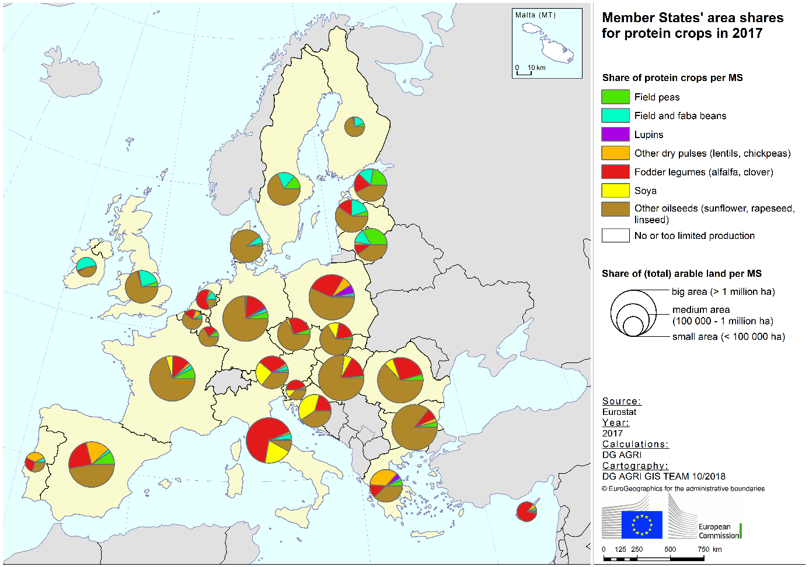Source: Eurostat
The food market for plant proteins is smaller (7 % in volume), but potentially considerably profitable. In 2017, almost 3 million tonnes were consumed in the EU: peas, faba beans, lentils, chickpeas, other pulses, and soya beans. The EU imports around one million tonnes of pulses for food, in particular chickpeas and lentils. For field peas and faba beans, the EU is a net exporter.

3 Development of Market Segments in the EU
The market for plant proteins has three different segments: conventional feed, high-value feed, and food – each with their own economic, social and environmental features.

3.1 Conventional compound feed
The compound feed market is by far the largest market for plant proteins. Two thirds of this market is for poultry (35 %) and pigs (33 %), while ruminants (cattle, sheep, goats) account for 28 %. Poultry and dairy feed are the main drivers for the annual growth of 1 % (Graph 3), while pig feed has been stagnating.
The growth rate is expected to remain positive until 2030, although only at 0.3 % per year.
- Compound feed use in the EU (2004-17)
The conventional compound feed market is highly price driven. Livestock farmers focus on ‘value for money’ to meet the nutritional needs of their animals (protein & amino acid content).
Soya meal is a privileged ingredient in compound feed formulation, because of its high protein content (over 40 %), amino acid content and year-round availability, which limits the need for frequent reformulation. Growth prospects for EU-grown plant proteins are limited in the conventional compound feed market.

- Expected annual growth rates for animal products in the EU 2017-30, in total and by region
Another important trend is the relative shift of conventional livestock production to Eastern Europe: Poland (poultry in particular) and to some extent Hungary and Romania (Graph 4), where production costs are lower.
This shift could stimulate the demand for EU-grown plant pro-teins, as these regions coincide with their major production areas.

3.2 Premium feed
Consumers in the EU have become increasingly conscious about the way animal products are produced. They demand higher standards as regards animal welfare, environmental impact (climate change/deforestation), type of production (based on organic or non-genetically modified (non-GM) feed, regional supply chains).
In response, different premium market segments for feed have emerged in the EU.
- Share of non-GM feed in selected Member States (2012)
This trend is most visible for non-GM-fed animal products: For example, in Germany in 2012, 9 % of cattle feed was non-GM (Table 1), while in 2017 VLOG-certified milk reached a market share of more than 40 %. In Austria, developments are similar for various livestock sectors.
Unfortunately, at this stage a fuller analysis of these developments is challenging, due to the lack of comprehensive data on premium feed segments at EU level.
- Austrian market situation
This creates economic opportunities for EU-grown feed, which is by definition non-GM. The price premium for non-GM soya is around EUR 80-100 per tonne, partly to cover the lower yield and higher costs, but also in response to limited availability. Only 9 million tonnes are traded globally as non-GM, representing 6 % of global trade in soya beans.
Organic production also displays high growth rates in EU animal production, thanks to a growing demand of over 10 % per year on average.

- Annual growth rate of organic EU animal production
In 2016, 3 % of EU milk was organic. This is expected to grow to 10 % by 2030. In 5 Member States (Austria, Sweden, Denmark, Latvia and Greece), market shares have already surpassed 10 % (Table 2).

- Organic dairy production 2017 (*2016)
Growth in organic animal production directly impacts the production of organic dry pulses and other protein crops for feed, with a rate of 11 % per year (Table 3). This trend is likely to continue and may even increase further.
For ruminants, growth in organic production also favours grass-fed systems and on-farm feed production, to meet minimum on-farm feed shares.

- Area of organic dry pulses and protein crops (2016)
The strong development of premium feed chains is an important driver for EU-grown plant proteins.
The increasing non-GM feed demand provides EU soya bean farmers with opportunities, as availability outside Europe is currently limited.

3.3 Food segment
Human plant protein intake is on the rise in many EU regions, especially in western and northern Europe. Particularly promising is the market for meat and dairy alternatives, with annual growth rates of 14 % and 11 % respectively (Graph 7).
This segment is no longer a niche market, as major food companies enter the market, and major retailers under their own brands. Around 90 % of meat alternatives are consumed by flexitarians. Retailers often promote plant-protein-based products on the same shelves as traditional meat and dairy products.
- Turnover in meat and dairy alternatives in the EU (2013-17)
The market for pulses for food in the EU is benefitting from innovations in pre-cooking processes, inclusion of pulses in prepared convenience foods and the development of new pulses such as ‘edamame’.
Pulses are likewise benefiting from increasing consumer interest in regional products. Local names of pulses with characteristics linked to their place of production can be eligible for registration as Protected Geographical Indications or Protected Designations of Origin.
Close to 40 pulses are recognised to date from 8 different Member States: Spain (e.g. Armuña lentils), Italy, France (e.g. Le Puy green lentils), Greece (e.g. Santorini faba bean), Sweden, Latvia, Austria and Poland. These products are generally sold at higher prices than regular products.
The food market for plant proteins is seeing double-digit growth. But to have a better overview, more data is needed to follow these developments.
In two of the workshops held to provide input to this report (on supply chains and market segments), the importance of well-functioning supply chains in the food segment was highlighted.

- Summary – Features of the three segments

4 Agronomic, environmental and climate benefits of Legumes
Legumes (pulses, soya and leguminous fodder (alfalfa, clover)) are plants that contribute to nitrogen fixation, containing symbiotic bacteria called Rhizobia within nodules in their root systems, producing nitrogen compounds.
Nitrogen is a major component of protein and a required nutrient for plants. Legumes in the crop rotation usually lead to lower needs for mineral and organic nitrogen fertilisers, which contribute to 25 % of the total direct greenhouse gas emissions by agriculture in the EU.
Incorporating legumes into long-term crop rotation systems provides some positive effects on soil conditions. Soil carbon plays a key role in the carbon cycle, soil fertility, plant development and is thus important in global climate models and agricultural systems.
Higher yields are therefore observed for selected crops following legumes e.g. yields of wheat, maize or rapeseed can be up by 10 % compared to following a cereal. The quality of cereals is also improved (e.g. higher protein contents or lower mycotoxins contamination) when following a legume.
Including legumes in crop rotation also lowers pest pressure by constituting a break in several pest cycles affecting cereals. However, legumes are themselves also subject to specific pests.
Most legumes are very attractive to bees and often play the role of refuge for other wildlife, and can therefore have a positive effect on biodiversity in low-input agricultural systems. Alfalfa and clover also have a beneficial effect on weed management for subsequent crops and can therefore lead to reduced or zero use of herbicides.
To realise these environmental benefits, sound agronomic practices are a precondition. Production systems of many legumes are comparatively demanding and legumes suffer from yield gaps and higher yield variability compared to cereals or rapeseed.
The latter is a major obstacle in further expansion and a main target for improving protein crop production. A lack of breeding resources and knowledge gaps (low agronomic expertise, insufficient cooperation between farmers and other actors, etc.) are responsible for the fact that only 3 % of EU arable land is currently used for legumes, despite their agronomic and environmental benefits.

5 Research and Innovation at EU Level
The current EU Research and Innovation (R&I) framework supports innovation through the agricultural European Innovation Partnership (EIP-AGRI) supported through two sources of funding: the European research Programme Horizon2020 (H2020) and the Rural Development Programmes (RDP) supporting Operational Groups (OGs) and Innovation Support Services (see Graph 8).
- Agricultural European Innovation Partnership – linking H2020 to the CAP
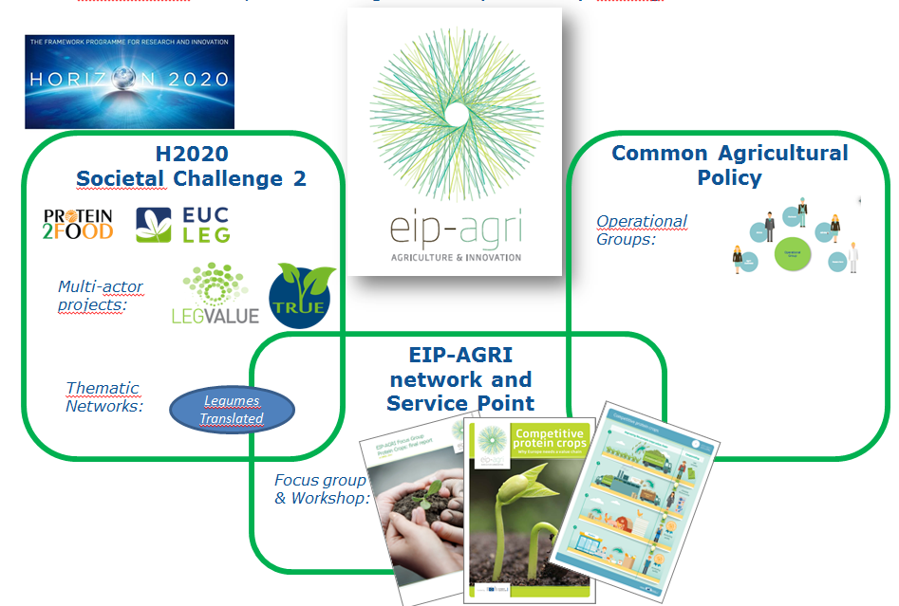
Legumes have benefitted from research projects at different scales. Building on previous projects tackling breeding issues related to biotic/abiotic stresses, food/feed uses and environmental assets of legumes, the on-going H2020 projects are looking at transition paths to sustainable and competitive legume-based production systems and value chains in the EU, as well as breeding strategies and food characteristics.
In 2018 the thematic network 'Legumes Translated' started to collect existing knowledge and best practices on sustainable legume cropping systems and value chains. EIP-AGRI organised a focus group on protein crops, which produced a report.
To answer to more local issues, most Member States fund OGs within their rural development programmes. Several of these cover protein plants (ecosystem services provided by legumes, crop production, feed and food uses), for instance the groups titled:
- Secure and increase the production of peas, lupins and faba beans in Britany (France);
- Improve forage systems (incl. alfalfa) for the production of PDO Parmigiano Reggiano cheese (Italy).
Legumes play a key role in cross-cutting issues related to crop diversification, sustainable soil management and nutrient cycles also tackled by R&I. Through all those activities, multi-actor approaches and systems approaches have guided and will guide R&I activities in the proposals for ‘Horizon Europe’ and the future of the CAP. R&I can help make these crops more competitive, and for this it is essential to simultaneously develop market outlets, coordinate supply chains and improve production techniques.

6 EU policy instruments and Member State initiatives

6.1 Main CAP instruments supporting protein plants
The current CAP provides several instruments that directly or indirectly recognise legume benefits from an environmental point of view or maintain and support the production of protein crops in the EU, such as:
- greening – through the possibility to grow certain nitrogen-fixing crops that are beneficial for biodiversity on Ecological Focus Areas (EFA), and a crop diversification requirement
- rural development programmes e.g. through Agri-Environment-Climate Measures (AECM), knowledge transfer, advisory services, cooperation and innovation, and investment instruments
- voluntary coupled support (VCS), – which can be provided to sectors undergoing certain difficulties and to maintain current level of production
These measures, together with a positive market environment, have contributed to a positive trend in recent years and to increased EU production of protein crops.
All Member States (except Denmark) allow farmers to fulfil their EFA obligation by cultivating nitrogen-fixing crops (8.3 million ha, i.e. 15 % of arable land in 2017). Nitrogen-fixing crops have been the most declared EFA type (37 % of total EFA).
Several Member States add requirements on previous and subsequent crops to nitrogen-fixing crops in EFA to ensure biodiversity benefits. The biodiversity effects are currently subject to an evaluation.
The possibilities of using measures under rural development programmes to support protein crops are widespread. Given their nature and the large number of such programmes, this report does not attempt to quantify their use but demonstrates through examples how some of them are suitable to support protein crops.
Protein crops are included in some AECM. Member States may give farmers support for introducing protein crops in rotation or maintaining green cover to improve soil and water quality in defined areas.
In the 2014-20 programming period, over 3 million ha have been under practices of crop rotation and crop diversification. For example, in Wallonia, rotation with mixtures of cereals and at least 20 % legumes is eligible for support, provided that no fertilisers and pesticides are used.
Germany has an AECM measure to support crop rotation in arable farming, on condition that at least 10 % of legumes are included.
- Member State notifications on the use of VCS (X) and EFA (green field)
for different protein crops in 2019
Support for organic farming within rural development programmes is likely to have a significant impact on the development of protein crops in the EU, since organic farming relies on legumes for nitrogen and on-farm produced feed.
Knowledge transfer and advisory measures can be used to raise awareness on the agronomic and environmental benefits of rotation systems, and provide advice to farmers. Cooperation measures promote interaction between farmers and other actors, e.g. to establish and develop short supply chains and local markets.
Member States may also use other measures under these programmes which provide support for investment in physical assets, to change their production orientation e.g. towards protein crops.
Under the direct payment scheme, Member States may grant VCS to sectors that are experiencing difficulties, to maintain current levels of production. Oilseeds, grain legumes and other protein crops are eligible under this scheme.
In 2019, 16 Member States will support protein crops with VCS. Almost 12 % of the VCS budget is allocated to ‘protein’ crops. Aid levels vary from EUR 35 to 660 per ha (on average EUR 79 per ha).
In 2017, in 222 cases recognised producer organisations had protein crops included in their activity. Most of these organisations are improving the supply chain and market access, using the exemptions from EU competition rules for joint marketing.
13 Member States are planning to distribute pulses to children through the EU school scheme in the coming years (based on national strategies they have submitted).

6.2 Examples of Member State initiatives
Partly using EU policy instruments, Germany, France (in cooperation with an Interbranch Organisation), and Poland have set up national plans to support the cultivation of protein crops.
Germany | France | Poland
Network of demonstration farms, AECM and stakeholder dialogue | Reinforcing supply chains, creating value through certification, research | Increasing use of domestically sourced protein for animal feed
R&I programme together with demonstration networks for soya (over 100 farms), peas and beans (over 75 farms) and lupins (over 50 farms), both organic and conventional.  These networks test varieties and transfer knowledge between organic and conventional farmers.  AECM measure for crop rotation with legumes.  A dialogue platform for stakeholders about more sustainable protein feed. | A focus on creating and reinforcing supply chains, both for feed and food.  Targets for production (500 000 ha of protein crops by 2022, with 10-20 % better return), and environment (20-30 % less pesticide use and greenhouse gas emissions).  Main elements are: R&I, improving the exploitation of whole product types, and certification schemes. | Multiannual R&D programmes to increase the production of domestically grown plant protein through research (breeding, varieties adaptation, agronomics practices, supply chain developments, improving protein use in animal feed).  The main objective is to decrease dependency on soya imports.
Denmark, Austria, and the Netherlands have introduced initiatives to promote plant proteins. In Denmark, the National Bioeconomy Panel published its recommendations on the Future of Proteins in spring 2018. These are closely linked to reaching environmental objectives for the Water Framework Directive, reducing greenhouse gas emissions and pesticide use. There is a focus on R&D, from the extraction of proteins from grasses, faba beans and other protein sources (insects and marine proteins) to the application of these proteins in feed, food and bio-based materials, with the aim of commercially producing sustainable protein-based raw materials.
Despite the absence of a national plan, Austria focuses on locally-sourced plant proteins and has significantly increased its area of protein crops over recent years. Supported by strong demand for local non-GM feed production and a focus on farm advisory systems, soya has become the fourth arable crop and could surpass maize in the coming years.
Dutch food policy includes a target to rebalance the ratio between animal and plant proteins in human consumption. One focus is public information and education on nutrition, to improve awareness among consumers. The Dutch dairy sector has introduced a plan that, by 2025, 65 % of the proteins used at dairy farms must come from the farm itself or within a radius of 20 km. This target will stimulate regional production of protein crops and grass-clover mixtures.
At supranational level, in July 2017, 14 Member States signed the ‘European Soya Declaration’, committing to promote sustainable soya production in suitable areas of Europe, include it in various crop rotations and develop sustainable soya and other legume markets in Europe. The signatories have pledged to undertake measures such as promoting healthy sustainable diets using plant protein, encouraging more precise livestock feeding, reducing the dependency of imported soya through more effective use of European protein sources and strengthening support for certification of sustainably-produced soya beans.

7 Conclusions
With the help of a positive market environment and existing policy measures, the EU plant protein sector has grown dynamically in recent years, in particular for the premium feed and food segments.
With currently available data, it is not easy to quantify how dynamic these segments will grow in future. Nevertheless, development will continue to be influenced by the following drivers:
- The growth in relative competitiveness of EU-grown protein crops versus other crops and non-EU plant proteins, e.g. through the availability of better varieties and better knowledge of specific agronomic practices and other aspects of the production cycle
- The development of organised supply chains and producer organisations in the sector, allowing economies of scale, quality improvements and labelling to promote EU-grown protein crops
- Greater recognition of how legumes contribute to environmental and climate objectives, through agro-ecological practices such as extended crop rotation
- Changing consumer behaviour and preferences, including rebalancing plant versus animal protein in human consumption and eco-friendly agriculture
- Influence of other policies and debates in society on the production of protein crops (e.g. halting tropical deforestation, to contribute to the Paris climate agreement, the UN's Sustainable Development Goals, the Renewable Energy Directive and the European sustainability and bioeconomy strategy)

A number of existing policy instruments, and the policy proposals under the new EU multi-year budget (multi-annual financial framework), in particular for agriculture and research, provide options for further strengthening the development of EU-grown plant proteins:
- Support farmers growing plant proteins via the proposed future CAP, by including them in national CAP strategic plans
Developing protein crops could help achieve most of the 9 CAP objectives (economic, environment, climate and socio-economic, including healthier diets).
To support Member States identifying targeted measures, in line with their own needs analysis the Commission will provide advice on ways to include plant proteins in national strategic plans, including:
- setting up sectoral programmes, with a direct or indirect benefit for protein, to strengthen supply chains, unlock the market potential of plant proteins and make farmers more resilient
- rewarding the benefits of legumes for environment and climate objectives (such as green cover or crop rotation) through Eco-schemes and environmental/-climate management commitments under rural development programmes. Both would offer possibilities to help producers convert to more sustainable types of farming, including sustainable intensification, conservation agriculture, and agro-ecological practices
- Mobilising rural development support for on-farm investment, supporting farm advice, knowledge transfer, setting up producer organisations, and cooperation along the food chain
- Dedicating appropriate amounts to coupled income support for plant proteins facing difficulties in their development, to make them more competitive/sustainable or improve quality (not limiting themselves to the additional 2 %)
- Continue to boost competitiveness through R&I
R&I is a key driver for improving the competitiveness of EU-grown protein plants. Continued support from EU and Member States’ research programmes will help close gaps in breeding, to offset low investment from the private sector in ‘smaller’ protein crops and focus on eco-friendly crop protection, sustainable soil management and supply chains.
The proposal for ‘Horizon Europe’ – with a doubling of the agri-food budget – will allow us to address these challenges, including, if relevant, through calls for research/innovation projects specific to protein crops.
The EIP-AGRI, supported by both Horizon Europe and the rural development programmes, helps implement innovation at farm level and in supply chains.
Under EIP-AGRI, thematic networks and operational groups will continue to gather best practice and harness research results by sharing them across the EU.
- Improve market analysis and transparency, through better monitoring tools for plant proteins
Better data collection of prices, trade flows and production/consumption figures will be help us better understand market dynamics.
DG AGRI will systematically incorporate protein crops in the work of the Crops Market Observatory and initiate a discussion with Member States and stakeholders on regular data collection and exchange.
By favouring a more transparent market for plant proteins throughout the value chain, operators will be able to better tailor their production and investment decisions. In the medium term, this could contribute to developing possibilities for risk management tools, including future markets for soya and other protein crops expressed in EUR.
- Promote the benefits of plant protein for nutrition, health, climate and environment
Member States and stakeholders are invited to use the various possibilities to proactively communicate and promote protein plants for agriculture, feed and food. One option is to use upcoming calls under the EU promotion programme for agri/food products, such as:
  - ‘Programmes on EU quality schemes, organic’
  - ‘Programmes highlighting specific agricultural production systems’, e.g. traceability, authenticity, labelling, nutritional and health aspects, environment and sustainability.
In 2019, EUR 200 million will be available to co-finance promotion programmes.
The Commission also commits to widely communicate the benefits of plant proteins (e.g. in fairs, social media) and further interact with children via the school schemes.
- Increase sharing of knowledge/best practice in supply chain management and sustainable agronomic practices and bundle information on research activities in breeding, technical innovation and processing, e.g. on a dedicated knowledge platform

The Commission calls for a continued debate – with Member States, the European Parliament and other stakeholders – on how best to stimulate regional and national approaches and so unlock the economic potential of plant proteins, using current and future policy instruments for a further growth of plant protein production in the EU.

2017/2116(INI).
Based on expert estimations (Agrosynergy 2018, forthcoming).
2016/17 EU Protein Balance Sheet
FEFAC (2017): statistical yearbook.
2018 EU agricultural medium-term outlook, forthcoming (Dec 18).
VLOG (Verband Lebensmittel Ohne Gentechnik) is a German association certifying and issuing the ‘Ohne Gentechnik’ (GM-free) label.
Rabobank: Decommoditising Soy, Report May 2018.
EU expert workshop "Market Segments in Plant Proteins"
Pérez Domínguez, I. et al (2016): An economic assessment of GHG mitigation policy options for EU agriculture (EcAMPA 2). JRC Science for Policy Report.
https://ec.europa.eu/eip/agriculture/en/publications/eip-agri-focus-group-protein-crops-final-report
Evaluation of the impact of the CAP on habitats, landscapes and biodiversity (forthcoming).
Ecorys (2018): Study on Producer Organisations and their activities in the olive oil, beef and veal and arable crops sectors.
Germany: Beans, Peas & Co. BMEL’s Protein-Crop Strategy for promoting the cultivation of pulses in Germany, since 2012 France: Plan de filière 2018-22 Poland: Increase the use of domestically sourced plant protein for animal feed and produce high quality animal products within the framework of sustainable development- 2016-20.
National Bioeconomy Panel: Proteins for the future, 2018.
http://www.donausoja.org/fileadmin/user_upload/Activity/Media/European_Soya_signed_declaration.pdf

