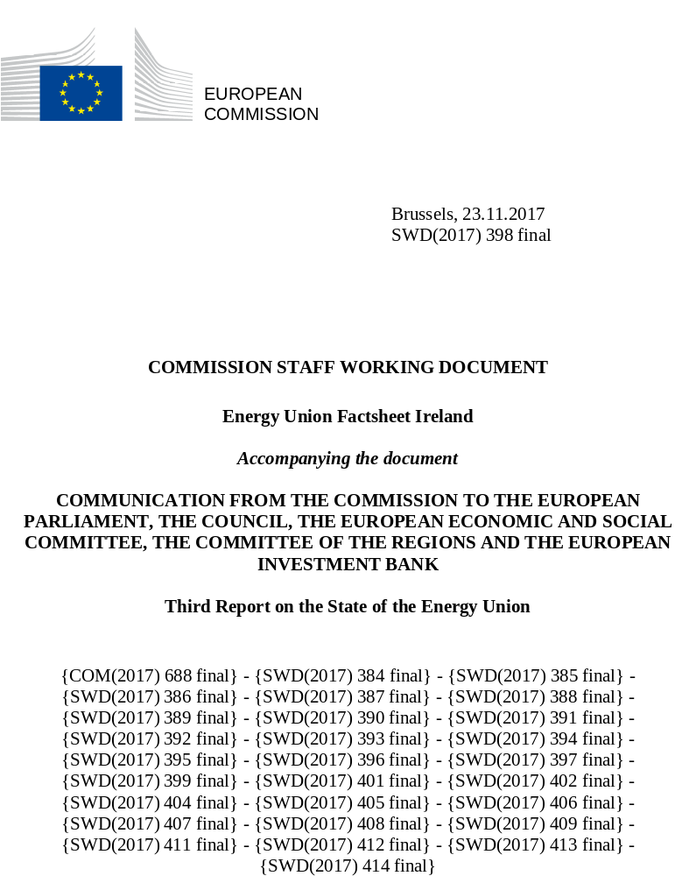

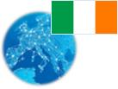 Ireland
Energy Union factsheet

- Macroeconomic implications of energy activities
Energy and transport are key sectors for the overall functioning of the economy as they provide an important input and service to the other sectors of the economy. Together, these two sectors accounted for on average 4.1% of the total value added of Ireland. Similarly, their share in total employment was 4.9% in 2015.
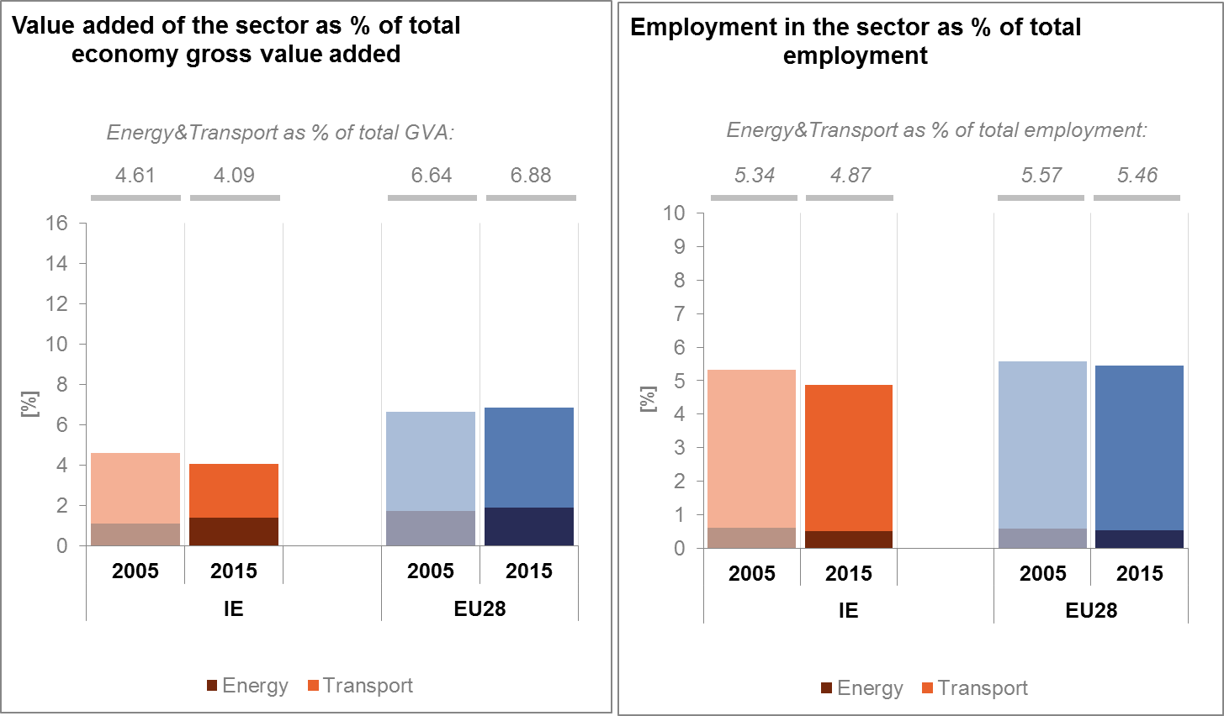
(source: Eurostat)
The decarbonisation of the energy and transport sectors will require significant investments and economic activity beyond the remit of these sectors themselves. The energy transition implies a structural shift in economic activity. Energy-related investment and jobs will in part migrate from traditional fossil fuel based activities towards construction, equipment manufacturing and other services related to the deployment of low carbon and clean energy technologies. At the moment, the efforts related to the low-carbon and clean energy transition in sectors beyond energy can only be partially quantified and are therefore not included in this analysis.
In the case of the renewable energy sector, both the direct and the indirect effects on employment are being estimated. According to EurObserv'ER, in 2015, the share of direct and indirect renewable energy related employment in total employment of the economy in Ireland was at about 0.25%, well below the EU average of 0.54%. The turnover of the renewable energy industry in the same year was estimated at around EUR 665 million, the biggest part being attributed to wind, followed by bioenergy.
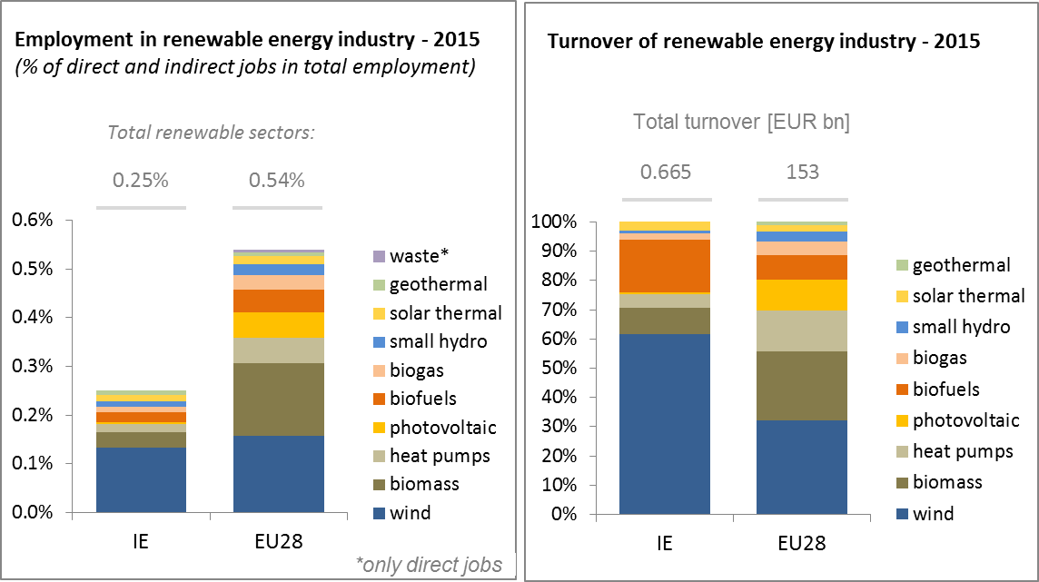
(source: EC based on Eurobserv'Er and Eurostat)
An indication of the level of efforts and challenges encountered by Ireland in the energy sector is given by the Gross fixed capital formation (GFCF). After the year 2010, and taking the electricity and gas sectors as reference sectors, the share of investments in GDP has fallen significantly. It represented around 0.4% of the country's GDP in 2015, much lower than in the pre-crisis period when it varied around 0.7 to 0.8% of GDP.
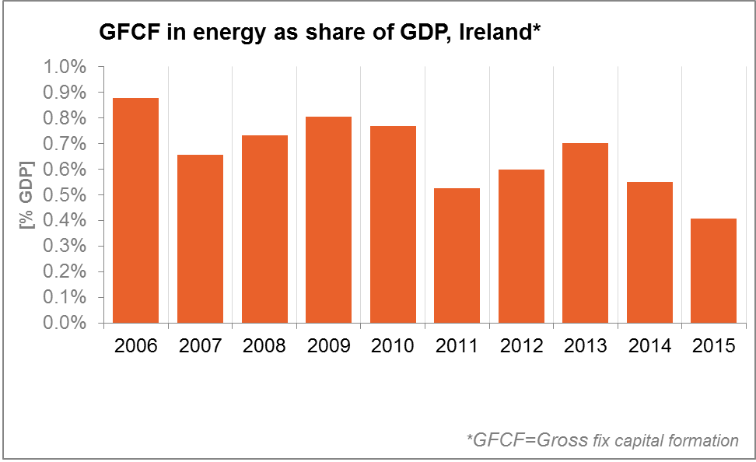
(source: Eurostat)
In terms of trade, Ireland is a net importer of fossil fuels. The trade deficit in energy products has fallen from about 2% of GDP in 2006 to 1.6% in 2015, influenced by improvements in energy efficiency, domestic renewable energy production and by the decrease in the prices of energy commodities. The decrease is almost completely accounted for by petroleum products. The trade deficit for gas has hardly changed whereas the trade deficits for electricity and coal are negligible.
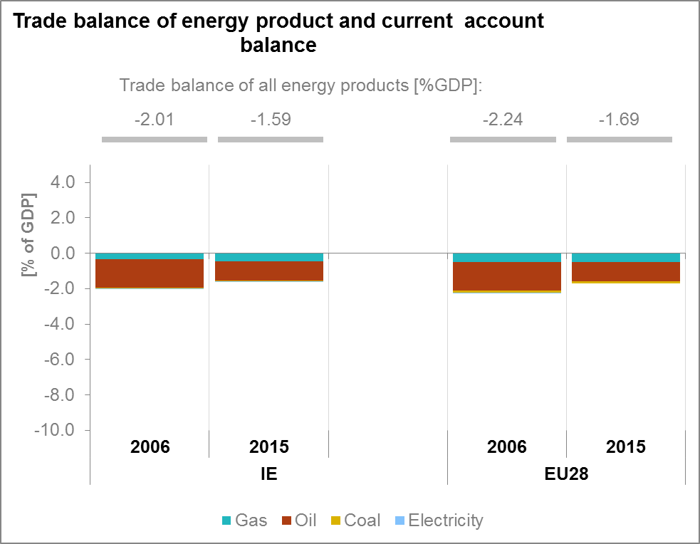
(source: Eurostat)
- Energy security, solidarity and trust
  - Energy Mix
Ireland's share of oil in its energy mix is far above the EU average (49.9 % vs 34.4%). The Irish share of solid fuels (15.5%) and natural gas (26.6%) in the energy mix is closer to the EU averages (16.2% and 22% respectively), but the country is below average in the renewable share (7.6% vs 13%).
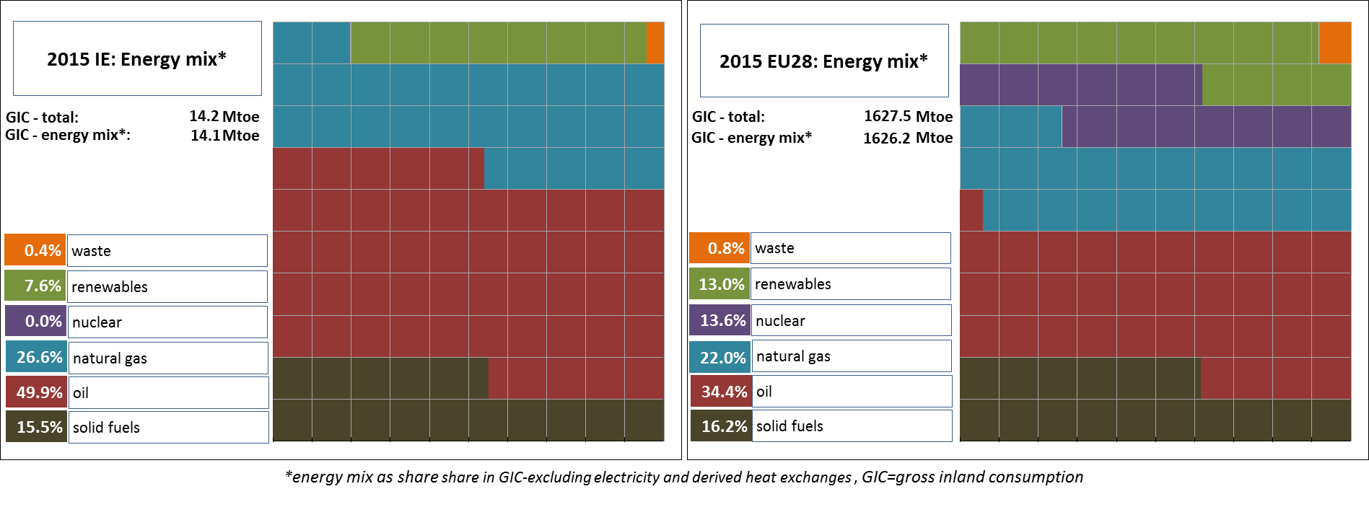
(Source: Eurostat)
2.2. Import dependency and security of supply
Import dependency is a key issue for Ireland given its geographical location. In 2015, 88.7% of Ireland's energy consumption is coming from imports, almost 30 p.p. more than the EU average. This is due to the high share of crude oil and hard coal in the energy mix which are respectively imported from Norway at 70.9% and from Colombia at 84.1%. However, this situation is expected to have changed in 2016. According to national figures, the production of natural gas from the Corrib field reduced gas imports to 41% in 2016, and therefore the overall import dependency of the country. The balance of gas demand is imported from or through the United Kingdom. Inland-produced renewable energy would have large potential to reduce the energy dependency of Ireland.
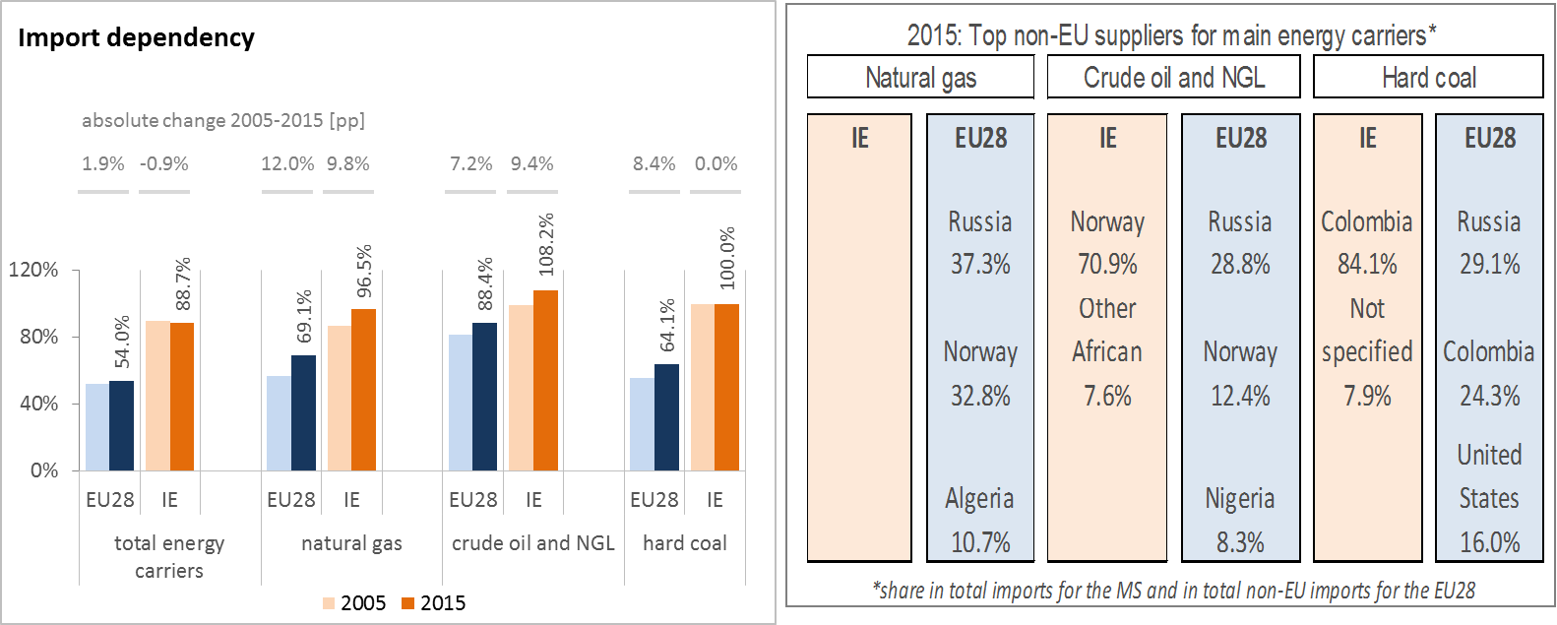
(source: Eurostat. An import dependency ratio above 100% means that the country processes some petroleum and coal products before exporting them.)
The overall import dependency of Ireland recorded a slight decrease of about 0.9 p.p. between 2005 and 2015, whilst at the EU level, import dependency increased by 1.9p.p. over the same period. Still, Ireland imported, in absolute terms, 96.5 % of its natural gas and 108.2% of its oil needs in 2015 (meaning oil was then refined and exported again); import dependency on hard coal was near 92%.
The aggregate supplier concentration index (SCI) increased considerably (by 10%) between 2005 and 2014, in particular as regards hard coal (38.9% increase) for which Colombia became the dominant supplier in 2015 providing 84.1% of third country supplies. Norway was the dominant supplier of crude oil (70.9%) in that same year.
The EU Gas Security of Supply Regulation (GSSR) requires that, if the single largest gas infrastructure fails in one Member State, the capacity of the remaining infrastructure is able to satisfy total gas demand during a day of exceptionally high gas demand.
Ireland cooperates with the UK on issues of gas security of supply. The two countries have adopted a regional approach towards the obligations under the EU GSSR. As a result, Ireland complies with the N-1 rule at regional level (UK-IE), reaching an N-1 value of 134%. Furthermore, the UK and Ireland produce a Joint Risk Assessment and a Joint Preventative Action Plan.
The UK is either the source or the conduit for the majority of Ireland’s 88% dependency on imported energy, and of 97% of natural gas supplies prior to the commencement of production from the Corrib gas field (2015 figures).
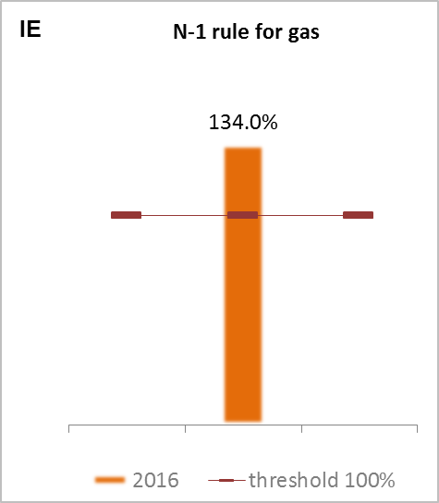
(source: gas coordination group)

- Internal market
  - Interconnections and wholesale market functioning
    - Electricity
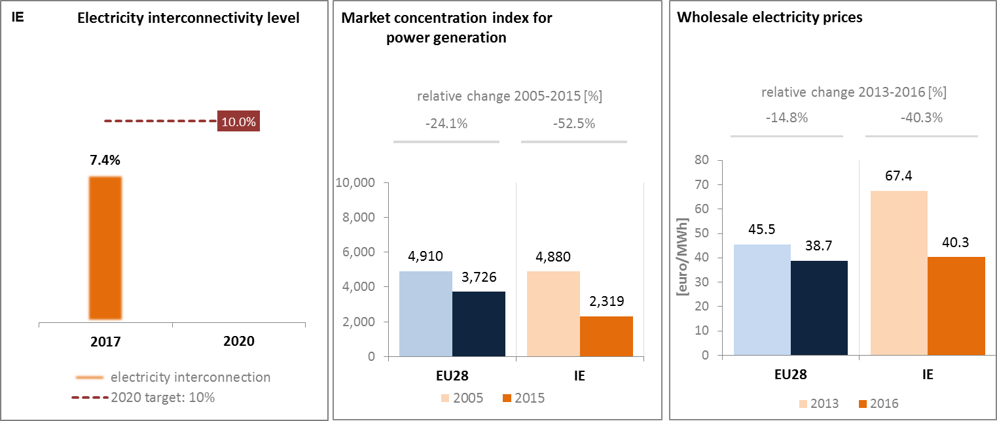
(source: EC based on ENTSO-E scenario outlook and adequacy forecast 2014) | (sources: EC services based on Eurostat for the left graph and based on Platts and European power exchanges for the right graph)
Due to its geographical location, Ireland is somewhat isolated from the EU electricity market. In 2017 its level of interconnectionwas at 7.4% of installed generation capacity. Nevertheless, the country is on the path to reach the 10% target by 2020 through the completion of PCIs currently under way. There are several electricity PCIs in the pipeline involving Ireland; AC interconnector to Northern Ireland (commissioning date 2021, capacity 1500 MVA); a second AC interconnector to Northern Ireland (commissioning date 2027, capacity 710 MVA); the DC Greenlink project to Wales (commissioning date 2021, capacity 700MW); the DC Celtic interconnector to France (commissioning date 2025, capacity 700 MW).
The currently operational East-West interconnector has a maximum capacity of 500 MW and is connected to the GB electricity grid in Wales. Furthermore, there is currently an on-going study into the feasibility of an interconnector between Ireland and France (the Celtic interconnector) which, if the project goes ahead, could also allow the Irish grid direct access to electricity from France.
Concentration of the power generation market is well below EU average and there is also significant diversification in fuel supply. Indeed, in 1990 fossil fuels accounted for around 93% of gross electricity generation. Following the establishment of renewable schemes in 2001, renewable penetration has resulted in the shares from peat and coal dropping almost in half. In 2015 fossil fuels inputs fell to around 71% of electricity generation (Natural Gas 44%, solid fuels 26%). Renewables accounted for around 29%, mainly through wind energy (23%).
Wholesale electricity prices are slightly above EU average, even if they recorded a very important decrease (-40%) in recent years, which brought them closer to the EU average in 2016. Various factors could explain this trend: the influence of gas prices on electricity price formation; the higher transmission costs paid by customers due to the population dispersal across the island; or the cost implications of market imperfections associated with the curtailment of generation (including wind).
    - Gas
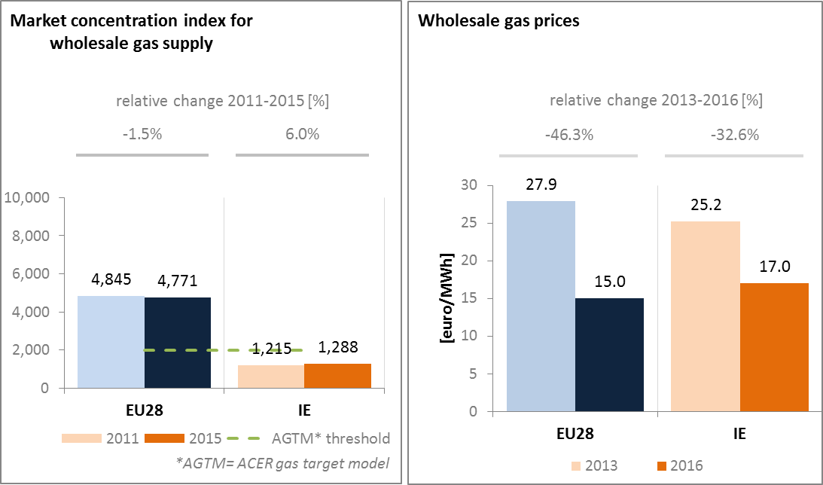
(source: ACER for the left graph and EC services based on on Platts, gas hubs, Eurostat for the right graph)
Wholesale gas prices are slightly above EU average, and they went down 33% between 2013 and 2016. These drops can be attributed to on-going healthy supply, decreased demand year on year, and the drop in international gas prices.
Ireland is well connected to the UK gas market via two sub-sea interconnectors between the UK and Ireland and another via Northern Ireland which is connected to Scotland. It has also planned for some time to develop an LNG regasification terminal at Shannon on the south west coast. This project is a PCI with a planned commissioning date of 2019.
As regards market concentration, according to ACER, the threshold for a well-functioning market is 2000. In 2015, Ireland was one of the five Member States (together with Belgium, Luxembourg, Sweden and the UK) which had a concentration index under this threshold. This is due to Ireland's largely reliance on gas from the North Sea, a region characterized by a high number of gas producers, some of which can also source LNG. In 2016, indigenous gas production from the Corrib gas field came on stream and met over 55% of Ireland’s gas demand. The majority of the balance of Ireland’s natural gas requirement is imported via the UK.
  - Retail electricity and gas markets
    - Electricity
In 2016, household electricity prices in Ireland were above the EU average. Between 2013 and 2016, average band retail electricity prices for households decreased by 3%, still a much lower decrease than for wholesale prices. The share of taxes and levies in household electricity prices is much lower in Ireland than in the rest of the EU.
Smart metering has not yet started and it is scheduled to begin in 2019. However, annual switching rates are far above EU average (14% in Ireland v. 6.2% in the EU in 2015).
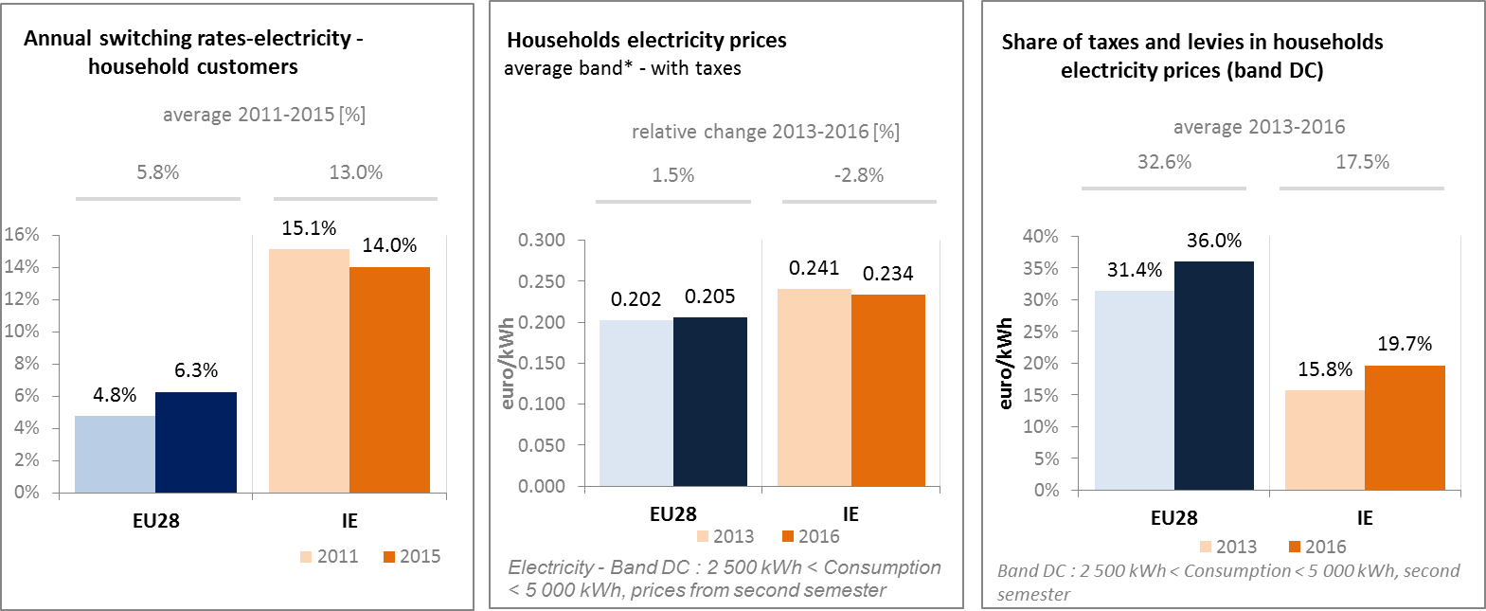
(source: ACER) (source: Eurostat) (source: Eurostat)
    - Gas
In 2016, household gas prices in Ireland were close to the EU average. Between 2013 and 2016, average band retail gas prices for households decreased by 6%, still below the decrease of wholesale prices.
Annual switching rates were far above EU average (15.1 % in Ireland v. 7 % in the EU in 2015. The Commission for Energy Regulation (CER) is active in promoting switching as a means for consumers to help increase competition. CER's Energy Customers Team acts as single contact point providing a free dispute resolution service. CER has also implemented measures to ensure that disconnections are a last resort including offering customers a free Pay-As-You-Go meter. Low switching costs may also contribute to this high switching level.
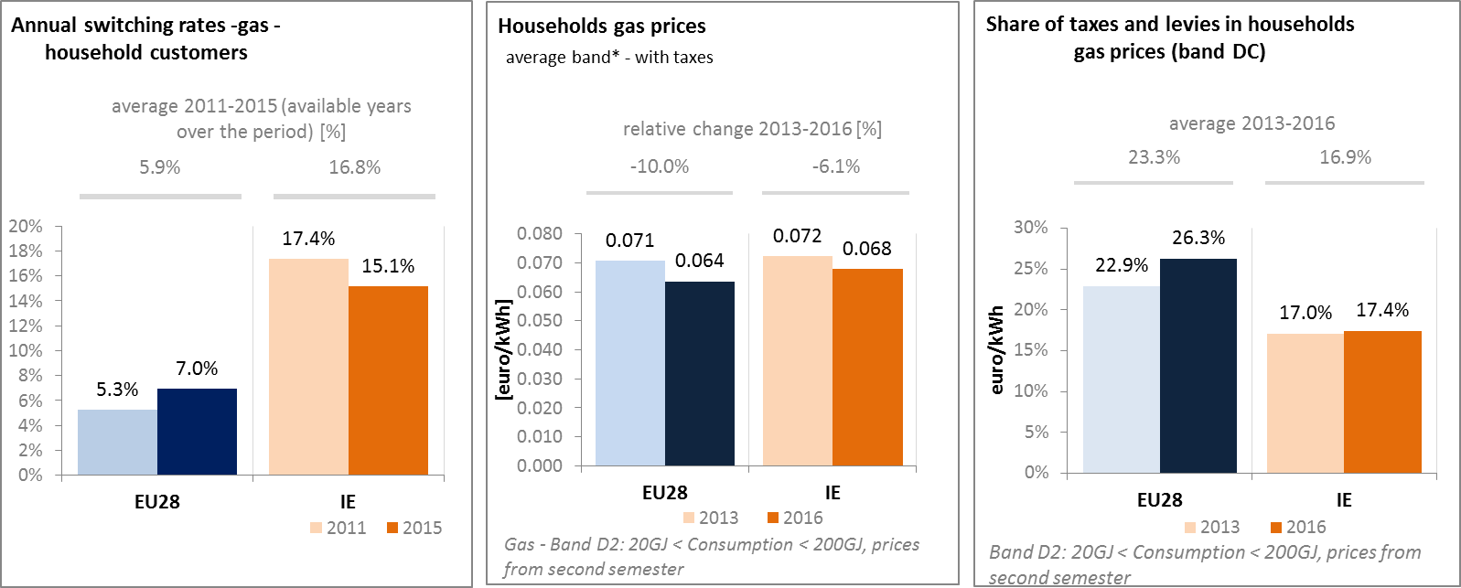
(source: ACER) (source: Eurostat) (source: Eurostat)
    - Market performance indicators
According to the periodical survey of the European Commission, the Irish consumers are more satisfied than the EU average about the services received on electricity retail markets. On gas retail markets, the level of satisfactions is close to the EU average.
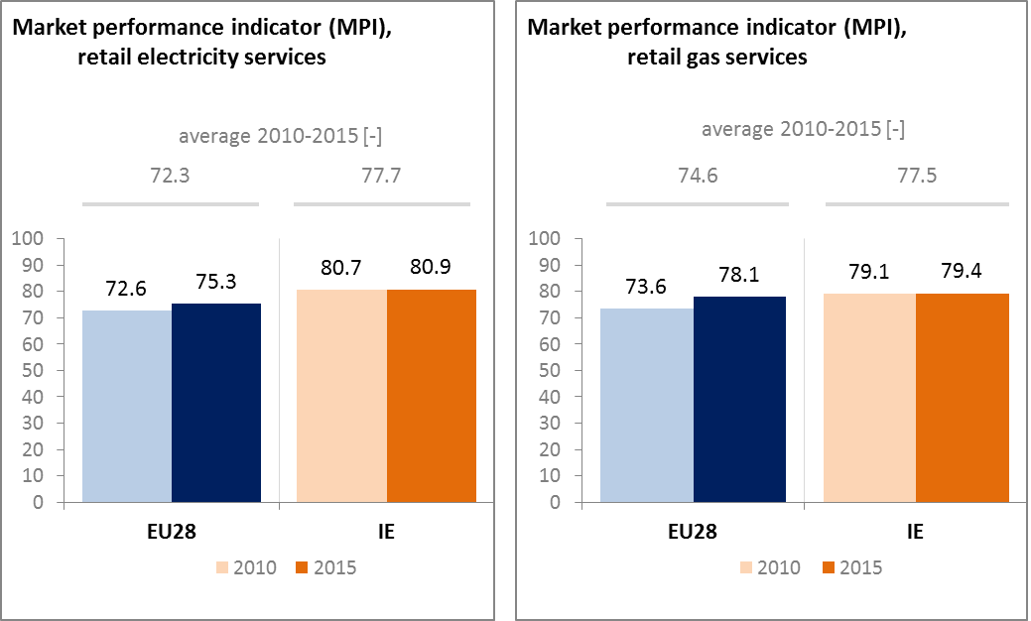
(source: DG JUST survey)
  - Energy affordability
The share of energy in total household expenditures of the lowest quintile of population is relatively close to the EU average (8.1% for Ireland v. 8.6% for the EU). The percentage of citizens below the at-risk-of poverty threshold unable to keep their home adequately warm increased by 7.7 percentage points between 2005 and 2015. This increase could be explained by the economic difficulties faced by Ireland over the period that can have generally impacted purchasing power of households. In addition, the households most affected by energy poverty are typically those in which the energy efficiency of homes is the poorest (old, insufficiently insulated homes). This leads to a greater sensitivity to domestic consumer energy prices.
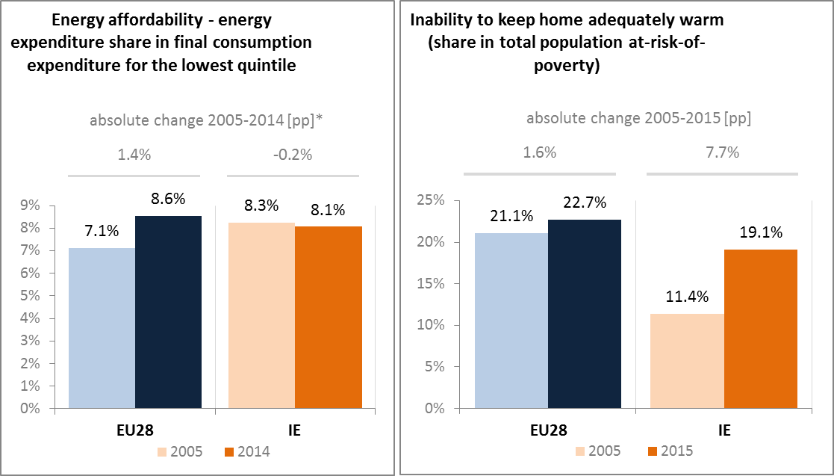
(source: ad-hoc data collection of DG ENER based on HBS with the support of Eurostat and national statistics)
- Energy efficiency and moderation of demand
Since 2005, Ireland has decreased its primary energy consumption by 5.3% to 13.96 Mtoe in 2015. Over the same period, final energy consumption has also decreased by 11% to 11.21 Mtoe in 2015. Ireland has already achieved levels of primary and final energy consumption below the indicative national 2020 targets (13.9 Mtoe in primary energy consumption and 11.7 Mtoe in final energy consumption). However, the latest projections suggest that Ireland might not achieve its 2020 target. It is therefore important that Ireland intensifies its efforts, especially as the Irish economy picks up. This issue has been acknowledged by the Irish Authorities and several initiatives have been introduced to correct the trajectory.
Primary energy intensity decreased by 3.7% on annual average over the last 10 years, a faster rate than the EU as a whole.
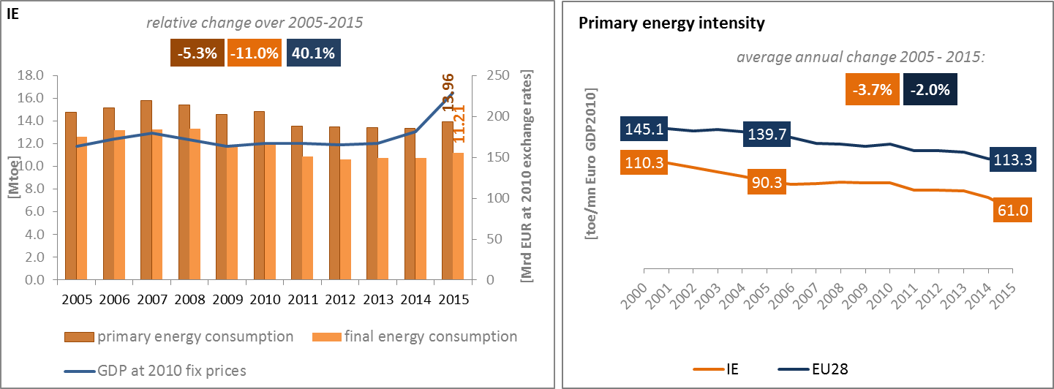
(source: Eurostat)
In 2015 in Ireland, transport was the largest final energy consuming sector representing a 41.2% share in the total final energy consumption, which is above than the EU average (i.e. 33.1%). On the contrary, in all other sectors, the energy consumption of Ireland was in 2015 below the EU average, although it is quite close to it in the agricultural and residential sectors.
In the residential sector, the improvement of home energy efficiency is recognized as a priority issue. Several initiatives have been launched to promote energy efficiency renovations in homes with promising results. The "Warmer Homes Better Energy" scheme for instance fully funds energy efficiency improvements for the most vulnerable households, to combat energy poverty. Another example is the "Better Energy Homes" energy efficiency grants scheme that offers financial support for targeted energy efficiency measures. A number of pilot schemes are also underway, one testing the multiple benefits of energy efficiency as well as a scheme aimed at deeper energy efficiency upgrades. 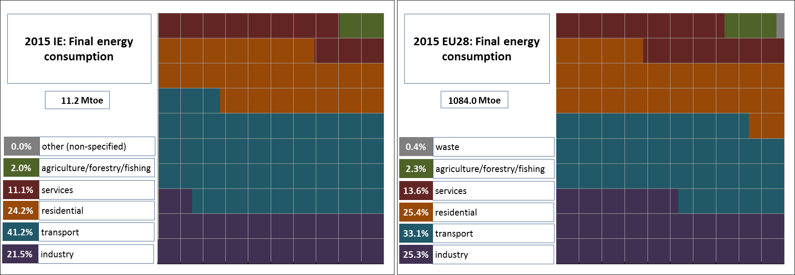
(source: Eurostat)
In Ireland, final energy intensity decreased considerably over the 2005-2015 period, staying well below EU average, and decreasing at a faster pace. A detailed sectoral assessment can illustrate these trends. The energy intensity of Irish's industry is the lowest in the EU together with Denmark, and has been decreasing over the last ten years. Ireland has also improved its energy intensity in the services and household sector.
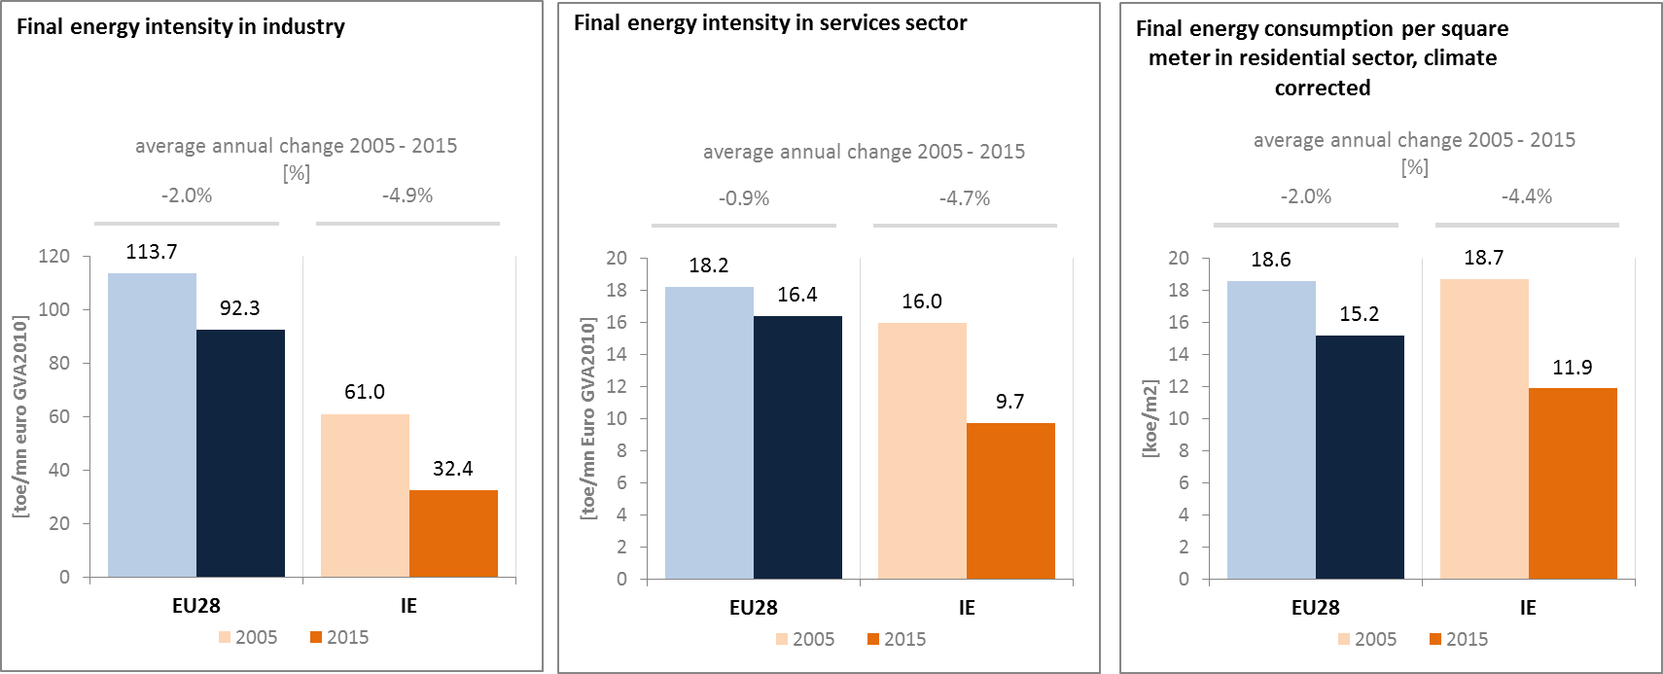
(source: Eurostat) (source: Eurostat) (source: Odyssee database)
Between 2005 and 2015 in Ireland, the final energy consumption in transport recorded an average annual decrease of 0.7%. This may have been largely driven by the dramatic decrease in freight transport activity, consequence of the worsening of the economic context.
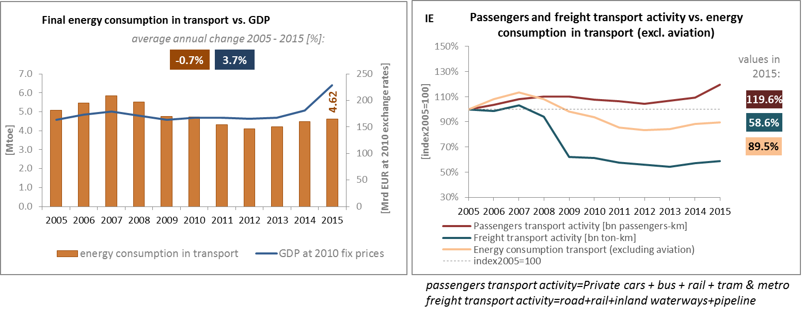
(source: Eurostat) (source: Eurostat and DG MOVE pocketbook)
The share of collective passengers’ land transport into total passengers' transport increased between 2005 and 2015 by 1.7 percentage points indicating a lower use of private transport means in Ireland.
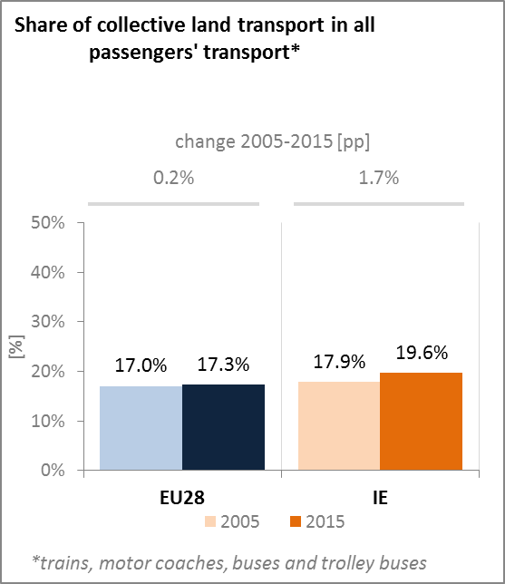
(source: Eurostat)
The Irish National Reform Programme 2016 has announced that for the seven years 2016 to 2022, the government will invest EUR 10 billion in transport. This transport capital allocation is largely framed by the recommendations and priorities set out in the Strategic Investment Framework for Land Transport. The priorities are to maintain and renew the strategically important elements of the existing land transport system, to address urban congestion and to improve the efficiency and safety of existing transport networks. In addition, getting people out of cars and onto public transport has a key role to play in reducing Ireland’s carbon emissions, by providing a viable, less polluting alternative to car and road transport for many journeys. The largest single project will be a new metro link in Dublin, planned to be in operation by 2026/2027.
The strong rebound of the Irish economy that started in 2014 has broadened and gained further momentum. The Capital Plan is a national programme for infrastructure investments across Ireland over the period 2016 to 2021, and prioritises spending on those areas of greatest need as the economy continues its strong recovery.
- Decarbonisation of economy
  - GHG emissions
Under the 2009 EU Effort Sharing Decision (No 406/2009/EC), Ireland has an emissions reduction target for each year between 2013 and 2020. For the year 2020 itself, the target set for Ireland is that emissions should be 20% below their level in 2005.
The latest national projections of greenhouse gas emissions indicated that emissions from those sectors of the economy not covered by the EU Emissions Trading System (ETS) could be 3% below 2005 levels by 2020 against a -20% target. The 2020 target is consequently expected to be missed by around 17 pps.
The actual reduction in greenhouse gas emissions to date was driven largely by an economic and financial crisis, with emissions increasing in recent years as the recovery gathered momentum. Emissions in the non-ETS sectors fell consistently between 2008 and 2014, in large part as a result of the economic downturn.
In 2016, emissions in the non-ETS sectors increased by 3.2% compared to 2015, and according to preliminary data, Ireland will miss its 2016 interim target under the Effort Sharing Decision by a margin of 2.2 pps. Ireland's own projections indicate that it would cumulatively exceed its non-ETS emissions obligations by 13.7 Mt of CO₂ equivalent over the period 2013-2020 under existing measures.
The implementation of additional measures identified in the National Renewable Energy Action Plan and the National Energy Efficiency Action Plan would still generate an excess of emissions of 11.5 Mt of CO₂ equivalent over the period 2013-2020. Ireland also published its first statutory National Mitigation Plan in July 2017. This Plan marks the first step in the process of developing the medium- to long-term options to ensure that Ireland is well positioned to take the necessary actions to drive its National Transition Objective and comply with its international commitments.
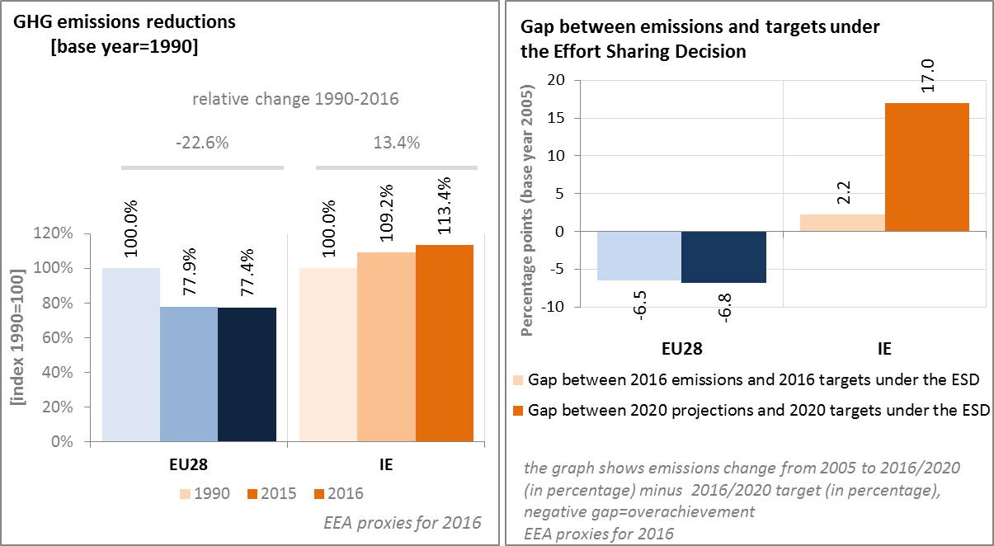
(source: EC and EEA)
On a sectorial basis, agriculture, transport and energy industries are by far the largest emitters of GHG, representing respectively 33.1%, 19.8% and 19.7% of the total in 2015. In the absence of large-scale heavy industry, the next largest emitter is the residential sector with 13% of total emissions in 2015. Emissions from agriculture (mainly methane and nitrous oxide) fell consistently between 1999 and 2011, but have since risen again. In 2015, they were 2.7% below 2005 levels. In transport, strong output growth and rising vehicle ownership between 1990 and 2007 led to strong growth in emissions in that period. The economic and financial crisis, together with a number of measures to reduce CO₂ intensity (including the introduction of a carbon tax on fuels in 2010) reversed the trend between 2008 and 2012. Since 2013, however, emissions in transport have resumed a rising trend.
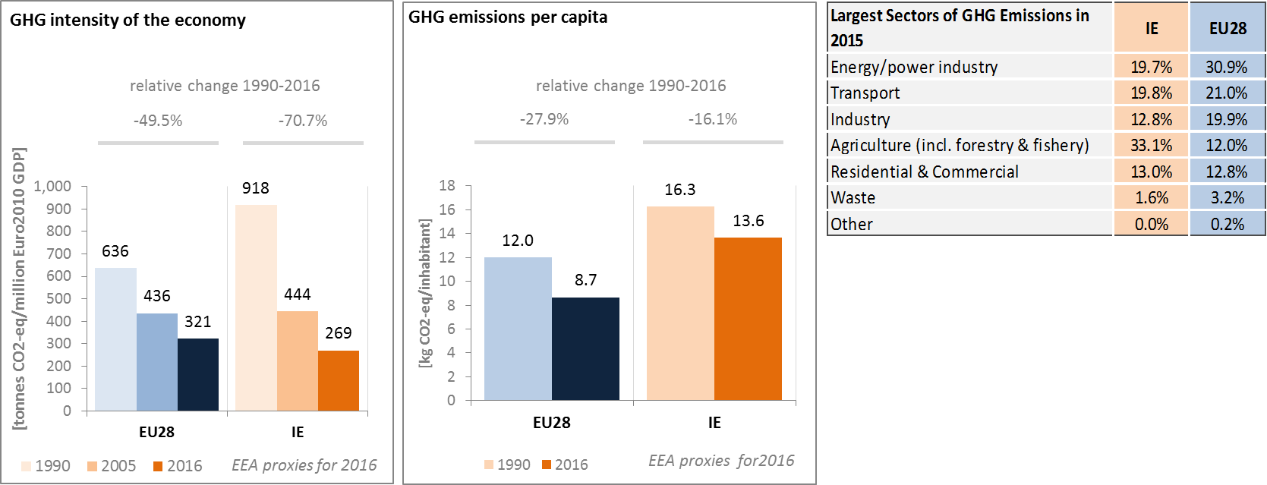
(source: EC and EEA)
Preliminary accounts under the Kyoto Protocol for Ireland show overall removals of -4.4 Mt CO₂-eq. as an annual average in the period 2013-2015. For comparison, the annual average of the EU-28 accounted for removals of -119.0 Mt CO₂-eq. Notable are Forest Management accounts showing emissions; Ireland is one of only three EU Member States with this accounting issue.
Removals by Afforestation are clearly higher than emissions by Deforestation and Forest Management and both being smaller than removals by Grassland Management. The accounted contribution by Cropland Management, changing from a source to a sink in 2015, is negligible. Overall, there is a varying, slightly increasing trend in removals due to a complex interaction between various activities. Removals by Afforestation and Grassland Management show increasing values in 2015. Emissions by Deforestation depict an increasing trend over the course of the three-year period, overtaking emission by Forest Management in 2015.
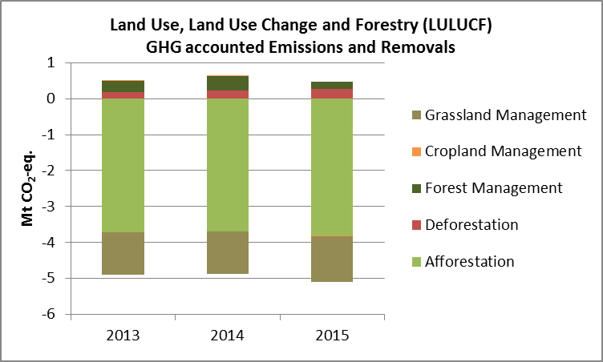
Note: Forest Management credits are capped and presented as yearly averages when the total Forest Management credits of the considered period exceed the simulated cap over the same period.
(source: EC and EEA)

CO₂ emissions in transport and alternative fuelled vehicles
Although average CO₂ emissions of new cars in Ireland were below the EU average in 2016 and consistently declining (by 32.9% compared to 2005), including as a result of changes to the vehicle registration tax, in 2015, emissions from road transport were higher than in the previous year and 139% higher than in 1990, though down from 2005.
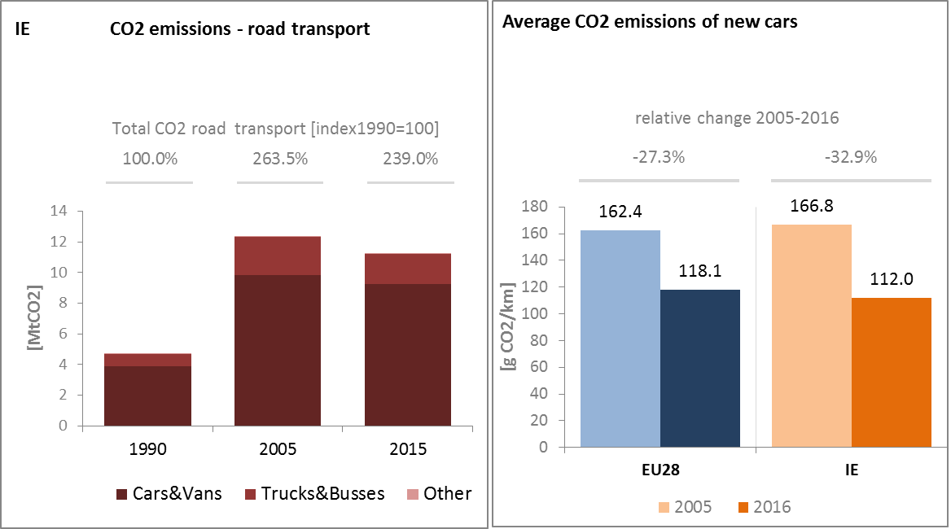
(source: European Environment Agency)
From 2013 to 2016, the number of electric charging points in Ireland has almost doubled, from 551 to 993 units.
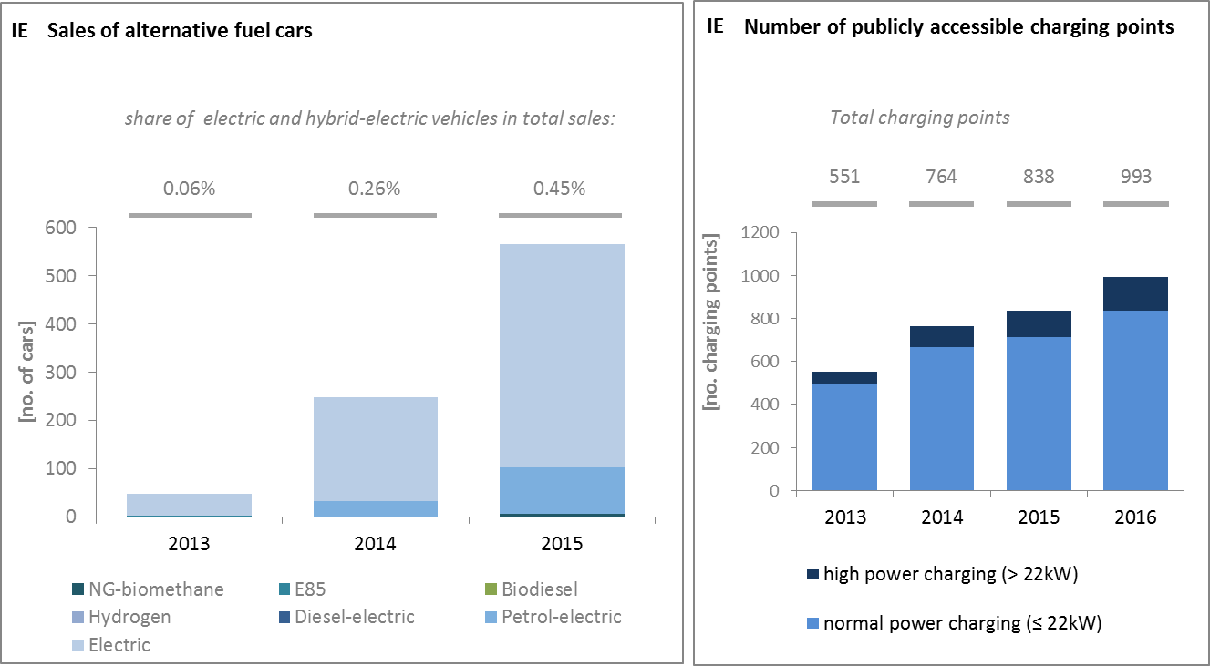
(European Environment Agency) (European Alternative Fuels Observatory)
National Policy Frameworks under Directive 2014/94/EU on alternative fuels infrastructure have to establish targets, objective and measures for the development of the market of alternative fuels in the transport sector and the deployment of the relevant infrastructure. Ireland has submitted its National Policy Framework as requested under article 3 of the Directive 2014/94/EU.
A detailed assessment of the Irish National Policy Framework in terms of its compliance with the requirements of Directive 2014/94/EU on alternative fuels infrastructure, its contribution to achievement of long-term energy and climate objectives of the Union and coherence of its targets and objectives in terms of cross-border continuity has been published as part of the Communication on Alternative Fuels Action Plans (COM(2017)652) and the related staff working document SWD(2017)365.
  - Adaptation to climate change
A non-statutory National Climate Change Adaptation Framework (NCCAF) was published in 2012. The Irish Climate Action and Low Carbon Development Act (2015) obliges the competent ministry to submit to Government for approval a statutory National Adaptation Framework (NAF) by 10 December 2017. This framework is to be reviewed every five years and will identify the sectors and lead Departments that will be required to prepare sectoral adaptation plans in line with legislative requirements in addition to requiring local authorities to develop local and/or regional adaption strategies. The statutory NAF will also provide for a regime to increase coordination between sectors and the further integration of climate adaptation within all relevant national policy and legislation.
  - Taxes on energy and transport and fossil fuel subsidies
Ireland uses taxation as part of their climate policy, and has a carbon tax in place. It was introduced in December 2009 as a component of Ireland's excise duties on energy products. The tax, called the "Mineral Oil Tax", was extended to all other liquid fuels from May 2010, and applied to solid fuels in May 2013. It was introduced at a rate of €15/tCO₂, and it was increased in 2012 by 5€/tCO₂ to 20€/tCO_{2.}
Ireland's overall tax burden on energy and transport (including carbon taxation) amounts to 2.4% of GDP, in line with the EU average. However, the composition of this tax burden in Ireland differs from the one in the EU. The Irish tax burden on energy products ranks among the lowest in the EU. In 2014 it was 0.4 p.p. lower than the EU average, with lower transport fuel tax revenue accounting for about half of this gap. Despite an above average increase, the GDP-ratio of the taxation of heat and electricity remains below the EU average. In contrast, the tax burden on transport vehicles in Ireland is among the highest in the EU. Both the circulation and registration tax for vehicles have a CO₂ emission component.
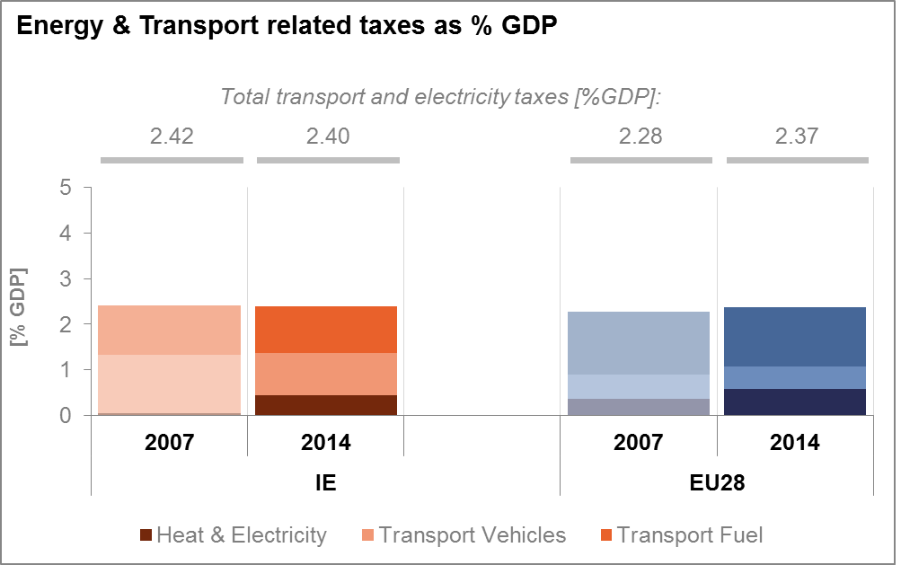
(source: Eurostat)
The main form of public support to fossil fuel energy consumption in Ireland (for which data is available) is the compensation scheme for electricity produced from peat (shown below as subsidies to coal). This has been increasing over the last decade; however the support for peat will expire at the end of 2019.
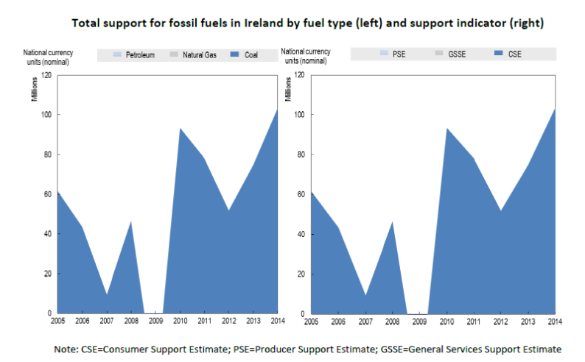
(source: OECD Inventory of Support Measures for Fossil Fuels 2015)
  - Renewable energy
Ireland met the 2013/2014 indicative trajectory and is currently in line with the 2015/2016 indicative trajectory on the RES share in gross final energy consumption. However, as the indicative trajectory becomes steeper towards 2020, reaching the 2020 target remains challenging.
The renewable energy share in the overall gross final energy consumption was 9.2% in 2015 (2015/2016 indicative trajectory is 8.9 %). In 2015, the renewable energy share was 6.5% in the transport sector, 6.4% in the heating and cooling sector and 25.2% in the electricity sector.
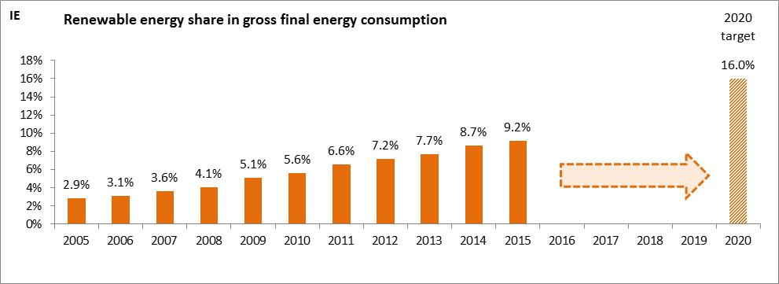
(source: Eurostat-SHARES)
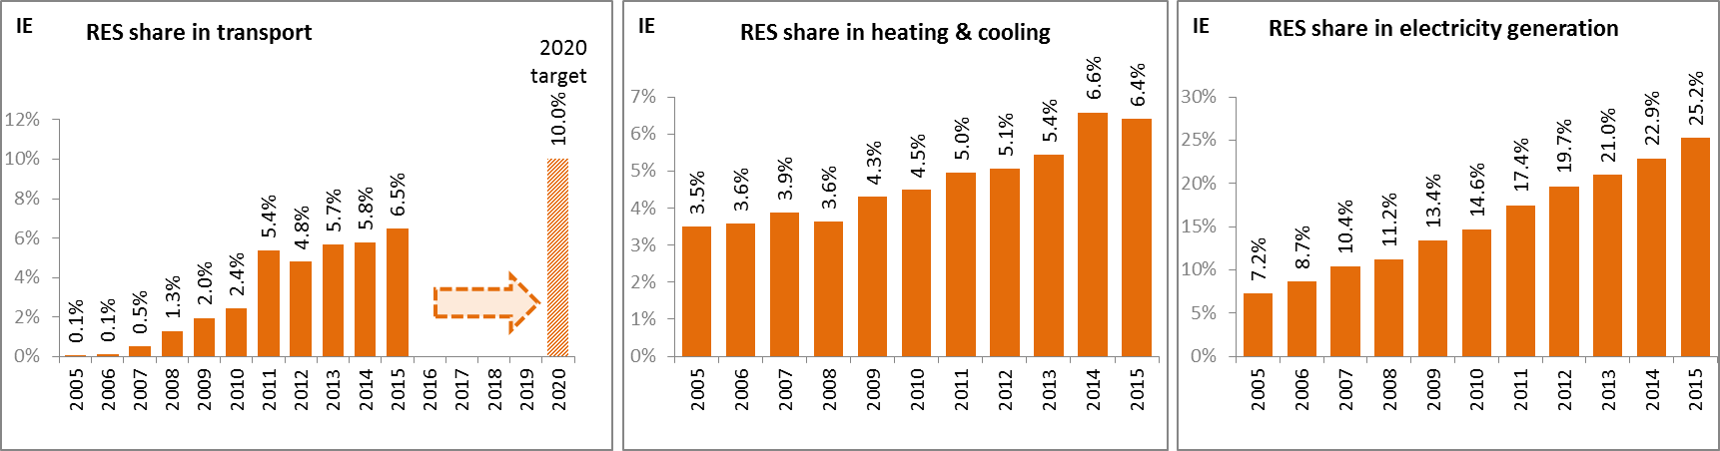
(source: Eurostat-SHARES)
Fossil fuels avoidance and GHG avoided emissions due to penetration of renewable energy sources remains below EU average, in particular as regards greenhouse gas emissions.
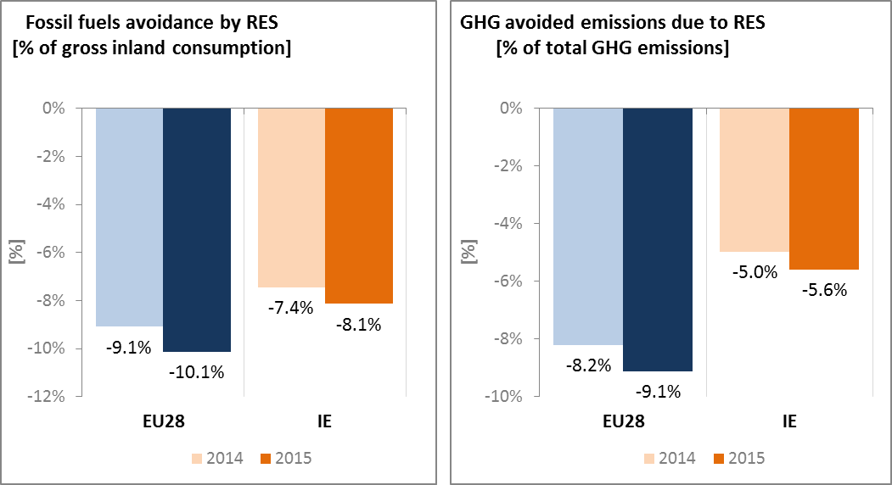
(source: EEA)
In Ireland, electricity from renewable sources is mainly promoted through a feed-in-tariff scheme (REFIT), though the scheme is now closed for new projects and there is at present no support scheme available for new investments in the production of electricity from renewable energy sources. Renewable energy sources for heating purposes are promoted through a grant and a tax return. Renewable energy in the transport sector is promoted through a biofuels obligation scheme, while there is also a subsidy and two tax regulation mechanisms for the purchase of electric and (plug-in) hybrid electric vehicles.
As part of its National Reform Programme 2017 Ireland sets out plans to develop a new electricity support scheme (RESS) and a new renewable heat incentive scheme (RHI) in order to meet its renewables targets. The introduction of any new scheme will be subject to government approval and state aid approval from the European Commission.
Access of electricity from renewable sources to the grid is granted according to the principle of non-discrimination and renewable energy plants are connected under the so-called Group Processing Approach (GPA). Regarding the use of the grid, operators are obliged to provide an offer for use to every operator of an (renewable) energy plant. Grid operators are generally obliged to develop the grid system. However, individual plant operators do not have the right to demand grid expansion. In addition, there are also a number of transitional provisions concerning grid connections that aim to facilitate the correlation of grid connection with the new RES support scheme.

  - Contribution of the Energy Union to better air quality
Air quality in Ireland is reported to be generally good, with exceptions. For the year 2013, the European Environment Agency estimated that about 1,520 premature deaths were attributable to fine particulate matter (PM_{2.5}) concentrations and 30 to nitrogen dioxide (NO₂) concentrations.
In 2015, Ireland reported no exceedances of the binding EU air quality standards, as shown in the figure below.
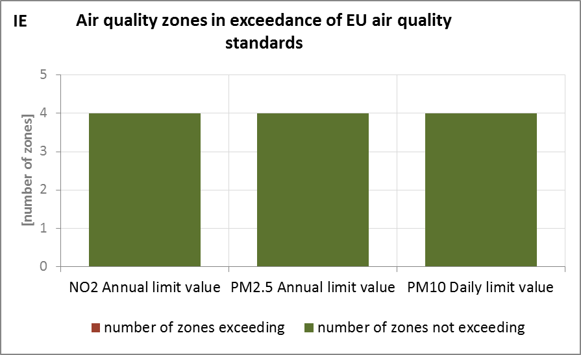
(source: EEA)
The health-related external costs from air pollution in Ireland have been estimated to be more than EUR 2 billion/year (income adjusted, 2010), which includes the intrinsic value of living a healthy life without premature death as well as the direct costs to the economy such as healthcare costs and lost working days due to sickness caused by air pollution.
The Energy Union can substantially contribute to further improve air quality through measures reducing emissions of both GHG and air pollutants such as PM and nitrogen oxides (NO_{x}) from major contributing sectors such as (road) transport, energy production, industry and residential heating (e.g. stoves and boilers) as shown below.
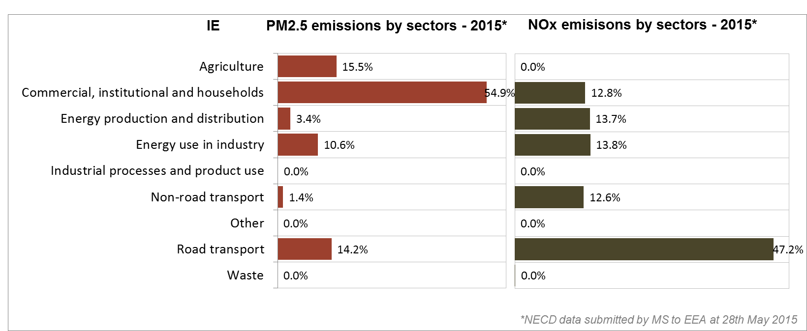
(Source: EEA. This table reflects only sources of primary PM_{2,5} emissions.)
- Research, innovation and competitiveness
  - Research and innovation policy
In March 2016, a national strategy and roadmap for energy research was prepared in Ireland by a dedicated Energy Research Strategy Group. The Strategy aims to develop world-class and world-scale energy research capability. It is also the responsibility of this Group to ensure the implementation of this Strategy.
The Irish Energy Research Council (IERC) is a key element of the Strategy. Its focus is on the demand side of energy management and generation, which includes distributed generation and micro-grids. The current priority areas for research projects funded by the IERC are: (a) Smart Cities and Sustainable Communities; (b) Low Carbon Heating and Cooling; (c) Monitoring, Measurement and Analysis of Energy; and (d) Embedded and Distributed Generation Systems.
Ireland is an active contributor to the on-going work of the Strategic Energy Technology (SET) Plan. It participates in five (out of fourteen) temporary working groups for the implementation of the integrated SET Plan, and it leads the group on ocean energy.
Regarding the Horizon 2020 programme, Ireland has so far received 1.6% of the EU contribution devoted to the 'secure, clean and efficient energy' part of the programme. As of September 2017, 76 participations from Irish organisations have been awarded EUR 29.4 million in Horizon 2020 energy projects. This includes a grant of almost EUR 2.5 million to Exergyn Ltd for its participation in project Exergyn Drive (recycled low grade waste heat) and six grants totalling over EUR 7 million to Irish beneficiaries participating in project RealValue (smart electric thermal storage).

  - Investments and patents in the Energy Union R&I priorities
In 2015, public (national) investments in the Energy Union R&I priorities reached EUR 60 million, twice the value reported for 2014. This is the highest annual public investment during the period 2007-2015. The largest share of investments (53%) was attracted by the Smart System R&I priority of the Energy Union, followed by Renewables (27%) and Sustainable Transport (18%). In 2014, the most recent year for which data from most Member States are available, public investment per GDP in Ireland was lower than the EU average.
Private investment in the Energy Union R&I priorities in 2013 was estimated at EUR 61 million (0.4% of the private R&I investment in Energy Union R&I priorities in the EU). The focus was on Smart System, which received 42% of these investments, followed by Renewables with a share of 32%.
In 2013, the most recent year for which complete patent statistics are available, 18 companies and research organisations based in Ireland filed 25 patents in low-carbon energy technologies (0.4% of the EU total). The focus was on Renewables (34%), followed by Sustainable Transport (31%) and the Smart System priority (24%).
In 2013, both private R&I investments and patents in Energy Union R&I priorities were lower than the EU average when normalised by GDP and by population respectively. In the period 2007-2013 private R&I investments have decreased on average by 1% per year, contrary to the EU average value that increased by 6% on average. For the same period, the number of patents in the Energy Union R&I priorities has increased on average by 10% per year, a slower increase compared to the respective EU rate (15%).
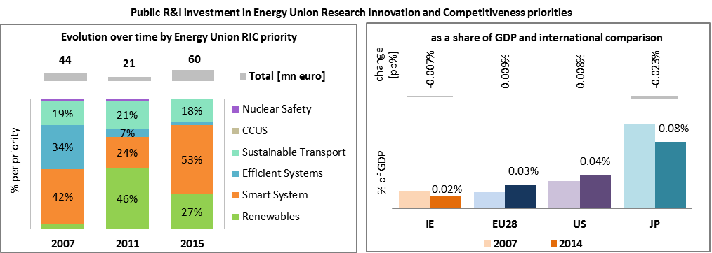 Note: The international comparison (right) is shown for 2014 (Ireland had reported EUR 29.4 million). Reporting at EU level for 2015 is not as complete, and very few countries have reported for 2016.

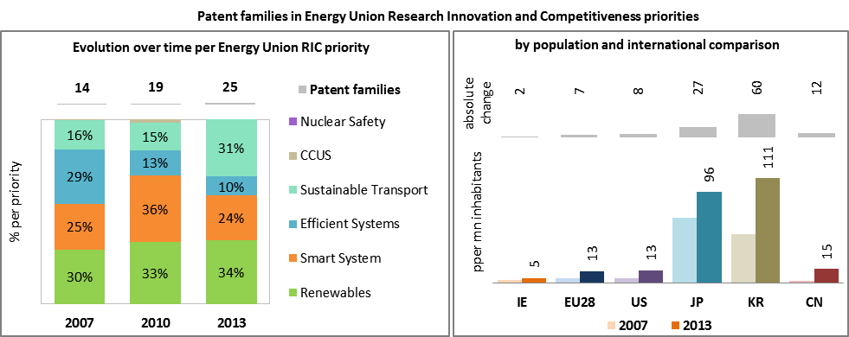
(Data sources: Public investment as available in the International Energy Agency RD&D Statistics database for codes relevant to Energy Union RIC priorities. Patent data based on the European Patent Office PATSTAT database. Private investment as estimated by JRC SETIS. Detailed methodology available from the JRC.)
  - Competitiveness
In 2014, the real unit energy costs (RUEC) in Ireland (8.5%) was almost half those at the EU average (15.3%). This is still above those in the US but below those in Japan and China. Electricity prices paid by industrial customers in Ireland are close to EU and OECD averages; gas prices for industrial consumers are slightly above EU averages.
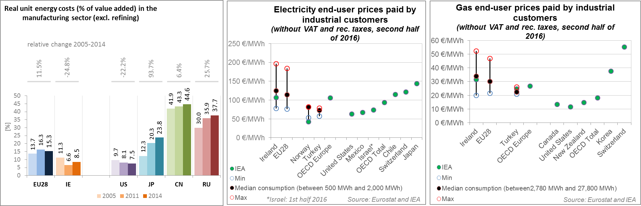
(source: ECFIN)
Ireland appears to have a very weak competitiveness performance in wind and solar energy technology, in both absolute terms and vis-à-vis the EU as a whole. As indicated by the revealed comparative advantage indicator being close to zero and thus far under the level for the EU, the Irish economy is neither specialised in solar PV nor in wind turbine technologies. The relative trade balance confirms that Ireland is a net importer of solar and wind components, relying more on foreign supply than the EU average.
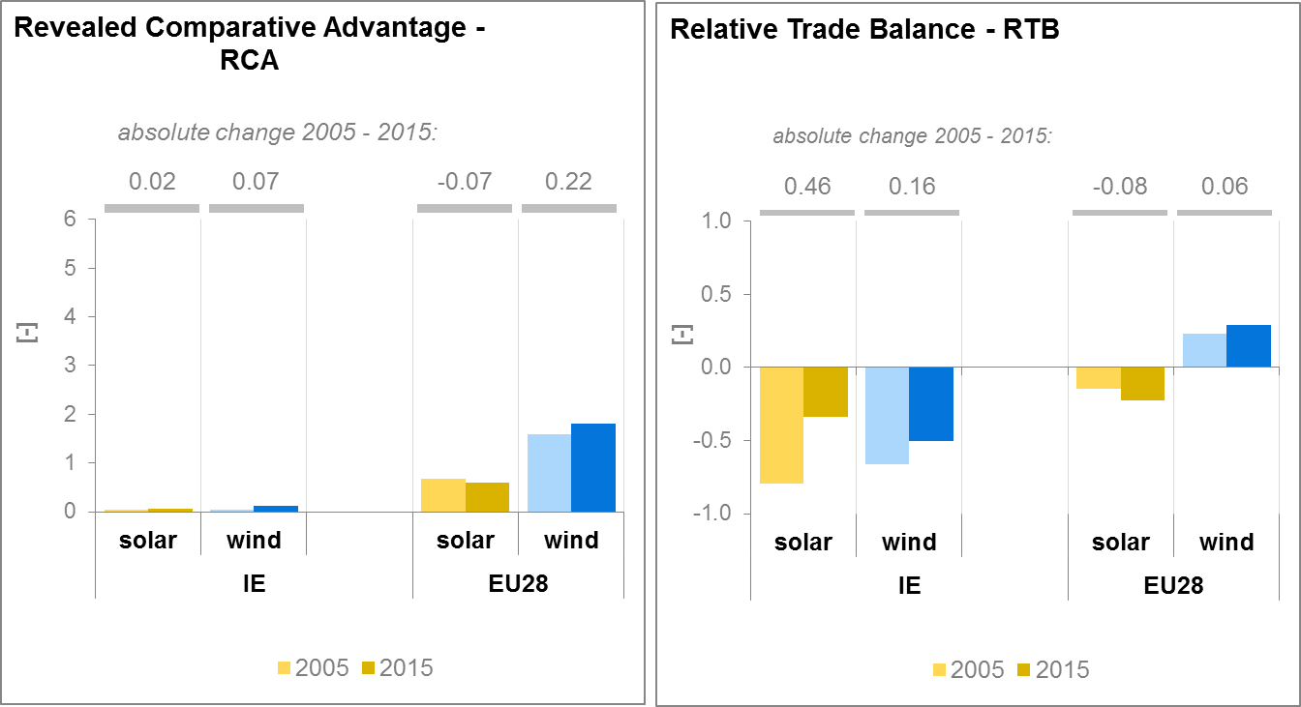
(source: UN comtrade)
- Regional and local cooperation
Since its establishment in 2009, Ireland has been a part of the North Seas Countries’ Offshore Grid Initiative (NSCOGI), whose aim is to facilitate the cost-effective deployment of offshore renewable energy, in particular wind, and to promote interconnection between the countries in the Region and integration between wholesale electricity markets. In 2016, the countries in the North Seas region signed a political declaration to reaffirm their commitment to (voluntary) cooperation, with the aim of securing a sustainable, secure and affordable energy supply for the Northern Seas countries. This initiative includes a work plan with sector specific working groups to develop concrete cooperation between Member States. The development of an offshore grid linking the ten countries in the North Seas region (Belgium, Denmark, France, Germany, Ireland, Luxembourg, the Netherlands, Norway, Sweden and the UK) is a long-standing energy policy priority for the EU.
Since November 2007 there has been a regulatory cooperation arrangement in place for all wholesale electricity matters between Ireland and Northern Ireland, which provides for joint decision making between the Commission for Energy Regulation (CER) in Ireland and the Utility Regulator in Northern Ireland (UREGNI) via the Single Electricity Market Committee (SEMC). The SEMC works on implementation of the EU Target Model and development of the design of revised energy and capacity markets under the aegis of the new Integrated Single Electricity Market (I-SEM). The SEMC is also responsible for the cooperation with Ofgem and regional partners on implementation of the 3rd Package requirements through the France-UK-Ireland region, and cross border congestion management arrangements.
European Territorial Cooperation – 'Interreg' – under EU cohesion policy provides further opportunities for cross-border, transnational and interregional cooperation, including in the Energy Union areas.
Cities and urban areas have a key role in the energy and climate challenge. The Urban Agenda for the EU, established by the Pact of Amsterdam in May 2016, better involves cities in the design and implementation of policies, including those related to the Energy Union. It is implemented through Partnerships, in which the Commission, Member States, cities and stakeholders work together on a number of important areas, including on Energy Transition, Urban Mobility, Air Quality, Climate Adaptation and Housing.
By 2016, in the context of the Covenant of Mayors, the sustainable energy action plans delivered by 5 Irish municipalities had been assessed. Overall, these 5 municipalities cover about 1.4 million inhabitants. These municipalities committed to reducing GHG emissions by 20.4% by 2020 (as compared to 1990 baseline), a lower percentage reduction than at EU level. In addition, 3 cities (covering 1.16 million inhabitants) have committed to conduct vulnerability and risk assessment and develop and implement adaptation plans.
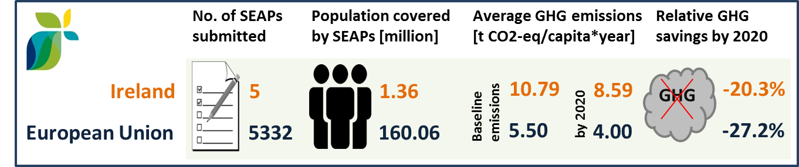
(source: JRC 2016. Notes: SEAP=sustainable energy action plan, GHG=greenhouse gas emissions)
- Cohesion policy and EU-supported clean energy investments
EU cohesion policy makes a key contribution to delivering the Energy Union objectives on the ground, including investment possibilities to implement energy policy objectives in Ireland which are complemented by national public and private co-financing, aiming at optimal leverage. It also ensures integrated territorial solutions to energy and climate challenges, supports capacity building and provides technical assistance.
Over 2014-2020, cohesion policy is investing some EUR 85 million in energy efficiency improvements in residential buildings in Ireland. Cohesion policy is also investing significantly in R&I and in SME competitiveness in Ireland, based on the national strategy for smart specialisation. For Ireland, the strategy includes a focus on 14 research priorities, one of which is marine renewable energy. At this stage, the allocations foreseen for investments in R&I and adoption of low-carbon technologies in Ireland are not specified, but should become available in line with the evolving content of the smart specialisation strategy. A further estimated EUR 3 million is invested in supporting the move towards an energy-efficient, decarbonised transport sector.
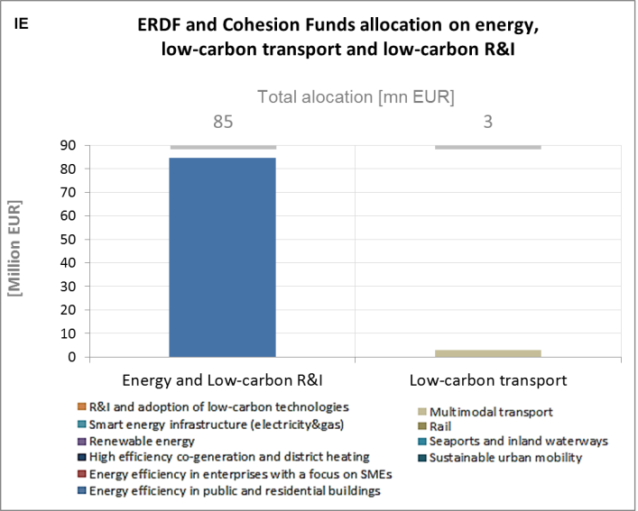
(source: DG REGIO)
These investments are expected to contribute to around 30,000 households with improved energy consumption classification. Overall, the cohesion policy investments in Ireland over 2014-2020 are expected to contribute to an estimated annual decrease of GHG emissions of around 14,000 tonnes of CO2eq.
For example, a key objective of the Social Housing Retrofit (SHRS) initiative, managed by Department of Housing, Planning, & Local Government, is to provide funding to those local authorities that have the greatest social housing targets and who can return the maximum number of units to a lettable, energy efficient condition at reasonable cost and to meet Ireland’s commitments in relation to carbon emissions reduction and energy reduction targets for 2020. There are two separate elements under the SHRS: the Energy Efficiency (EE) Programme and the Voids Programme. Minimising voids is a targeted measure that focuses exclusively on vacant properties with the objective of returning these to productive use as quickly as possible. The scheme focuses on the retrofitting of the fabric of the dwelling (insulation of walls/roofs, window/door replacement, heating system improvement) and applies to all local authorities. In the Border Midland and Western region energy efficiency works were carried out on over 1,400 units since 2014. In 2016, the number of vacant units retrofitted decreased to 597. The average energy efficient work cost per unit in 2014 was EUR 3,352, EUR 2,919 in 2015 and EUR 4,220 in 2016. In the Southern and Eastern Region, 5 475 vacant units were retrofitted by the end of 2016 with total expenditure of EUR 26.85 million reported under the scheme. The average energy efficient work cost per unit in 2014 was EUR 5,543, EUR 5,929 in 2015, and EUR 6,034 in 2016.
Another example is the Better Energy Warmer Homes Scheme, managed by the Sustainable Energy Authority of Ireland (SEAI) and the Department of Communications, Climate Action and Environment, commenced operations in March 2014 with an extension of an existing framework panel. A new tender and framework panel was appointed in January 2015 and operations under this new panel commenced in March 2015. It targets low-income households at risk of energy poverty. The scheme aims at improving the energy efficiency of the household at risk and in the process reduce the amount of expenditure that is required to be spent on energy. In the Border Midland and Western region the scheme continued operations throughout 2016 and the number of households with improved energy consumption classification by the end of 2016 was 7,670. In the Southern and Eastern region, 11 376 low-income households have had their energy efficiency improved by the end of 2016. This was funded with EUR 40 million through the scheme.
Through its support to sustainable transport systems, the Connecting Europe Facility (CEF) also contributes to the goals of the Energy Union. Following Irish participation in the CEF – Transport 2014-2015 Calls, the Irish action portfolio comprises 16 signed grant agreements, allocating EUR 78.5 million of actual CEF Transport Funding to Irish beneficiaries (state-of-play February 2017). The transport mode which receives the highest share of funding is maritime (49% of actual funding). As an island nation Ireland is heavily dependent on its ports. The country is investing in its State owned commercial ports, upgrading their operational capacities and consecutively contributing to a better integration of the maritime transport into the North Sea – Mediterranean corridor. Ireland is also involved in a maritime transportation action, aiming at developing Sea Traffic Management technologies.
Ireland is an active partner in several multi-country road actions encompassing studies on the harmonisation of interoperable intelligent transport systems (ITS) and cooperative Intelligent transport systems (C-ITS). In addition, one innovation action addresses the introduction of a national network of CNG refuelling facilities, allowing end user uptake and higher levels of CNG deployment.
Within the rail portfolio, the CEF programme contributes to removing the capacity cross-border bottlenecks, and an upgrading of the existing signalling system. Ireland is also involved through multi-beneficiary air actions covering both studies and works. These actions contribute firstly to the deployment of the Single European Sky ATM Research (SESAR), and secondly to the modernisation of the air traffic management (ATM) system.

The indicators used in this country factsheet largely build on indicators developed for the Commission Staff Working Document "Monitoring progress towards the Energy Union objectives – key indicators" (SWD(2017) 32 final) https://ec.europa.eu/commission/sites/beta-political/files/swd-energy-union-key-indicators_en.pdf
Gross value added and employment in NACE sectors D-Electricity, gas, steam and air conditioning supply and H-Transportation and storage
The year 2015 records a lower share of only 4.1% because of the extraordinary headline GDP growth of 26.3% due to the accounting of a bigger share of multinational company's global value added to their affiliates in Ireland.
National accounts, Eurostat
Gross fixed capital formation consists of resident producers´ acquisitions, less disposals, of fixed tangible or intangible assets. This covers, in particular, machinery and equipment, vehicles, dwellings and other buildings. It also includes foreign direct investment (FDI). Steam and air conditioning supply are also included in the figures mentioned above as Eurostat reports electricity, gas, steam and air conditioning supply together.
This also represents a continuous decrease from the record high of 2011 at 3.2 % GDP deficit. In 2014, the deficit was 2.7%.
As discussed above, these numbers are expected to have changed in 2016
Source: SWD(2017) 32 final, 1.2.2017, Second report on the State of the Energy Union, p.38.
Regulation (EU) No 994/2010 of the European Parliament and of the Council of 20 October 2010 concerning measures to safeguard security of gas supply and repealing Council Directive 2004/67/EC Text with EEA relevance.
See Ibid.
The interconnectivity level is calculated as a ratio between import interconnection and net generation capacities of the country (i.e. the 2017 value is the ratio between simultaneous import interconnection capacity [GW] and net generating capacity [GW] in the country at 11 January 2017, 19:00 pm as resulted from ENTSO-E Winter Outlook 2016/2017)
SWD(2017) 32 final, 1.2.2017, Second report on the State of the Energy Union, p.62
National Energy Efficiency Action Plan for Ireland #4 2017-2020, http://www.dccae.gov.ie/documents/NEEAP%204.pdf (accessed September 2017).
http://www.seai.ie/Grants/Warmer_Homes_Scheme/About_the_BEWH.html (accessed May 2017).
https://www.seai.ie/grants/home-grants/better-energy-homes/
https://www.seai.ie/grants/home-grants/warmth-and-wellbeing/; https://www.seai.ie/grants/home-grants/deep-retrofit-programme/
Avoided GHG emissions mentioned here have a theoretical character as these contributions do not necessarily represent 'net GHG savings per se' nor are they based on life-cycle assessment or full carbon accounting.
http://www.res-legal.eu/
European Environment Agency, 2016, Air Quality in Europe – 2016 Report, table 10.2. The report also includes details as regards the underpinning methodology for calculating premature deaths.
Directive 2008/50/EC of the European Parliament and of the Council of 21 May 2008 on ambient air quality and cleaner air for Europe, OJ L 152, 11.6.2008, p.1-44
Compliance data as reported by the Member States as part of their official annual air quality report for the calender year 2015 (available on the European Environment Agency's (EEA) Eionet/Central Data Repository), http://cdr.eionet.europa.eu/ie/eu/aqd
See also the EU Environmental Implementation Review Country Report for Ireland, SWD(2017)60 final of 3.2.2017
National emission data as reported by the Member States to the EEA (available on the EEA's Eionet/Central Data Repository), http://cdr.eionet.europa.eu/ie/eu/nec_revised
In the context of this document, the term 'patent' refers to patent families, rather than applications, as a measure of innovative activity. Patent families include all documents relevant to a distinct invention (e.g. applications to multiple authorities), thus preventing multiple counting. A fraction of the family is allocated to each applicant and relevant technology.
http://www.iea.org/statistics/RDDonlinedataservice/
https://www.epo.org/searching-for-patents/business/patstat.html#tab1
https://setis.ec.europa.eu/related-jrc-activities/jrc-setis-reports/monitoring-ri-low-carbon-energy-technologies
This indicator measures the amount of money spent on energy sources needed to obtain one unit of value added.
The RCA index for product "i" is defined as follows: ${RCA}_{i}=\frac{\frac{X_{j,i}}{\sum_{i}{X_{j,i}}}}{\frac{X_{w,i}}{\sum_{i}{X_{w,i}}}}$ where $X$ is the value of exports, and j is the country and w is the reference group, the World economy. 2005 refers in the text to the indicator average over the 2000-2009 period, while 2015 represents the average over the 2010-2016 period. The same applies for the RTB indicator - see below.
The RTB indicator for product "i" is defined as follows: ${RTB}_{i}=\frac{X_{i}-M_{i}}{X_{i}+M_{i}}$ where $X_{i}$ is the value of product's "i" exports and $M_{i}$ imports.
Note that European Economic Interest Groups and International Organisations are excluded from the analysis.
Source: INEA

