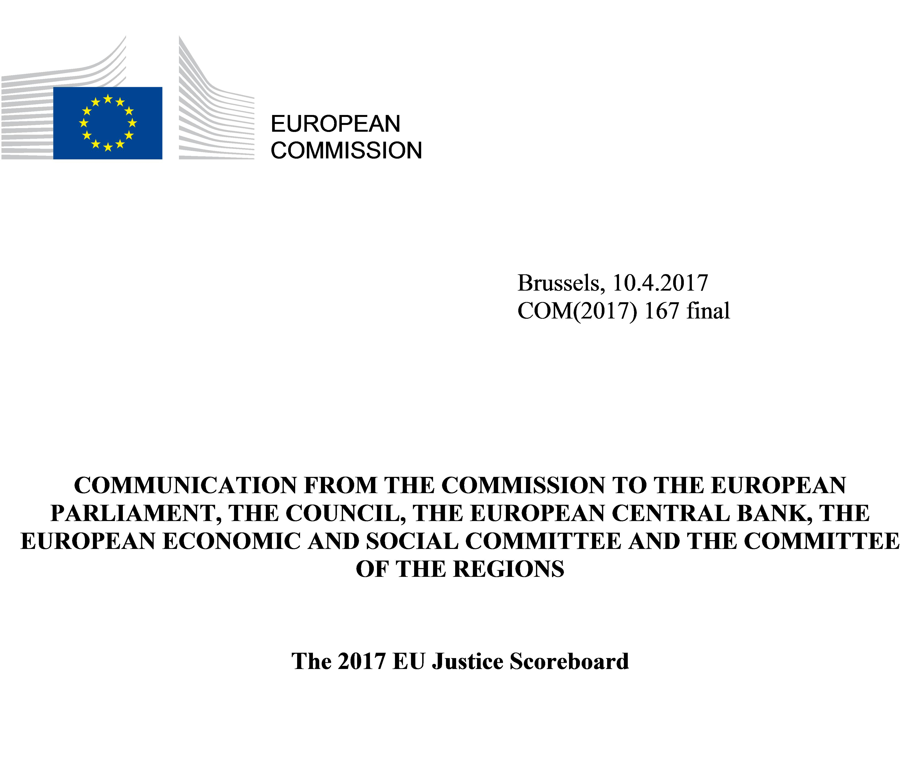

1. INTRODUCTION
‘Effective justice systems support economic growth and defend fundamental rights. That is why Europe promotes and defends the rule of law.’ This role of Member States’ justice systems underlined by Jean-Claude Juncker, President of the European Commission, is crucial for ensuring that individuals and businesses can fully enjoy their rights, for strengthening mutual trust and for building a business and investment-friendly environment in the single market. Moreover, as underlined by Frans Timmermans, First Vice-President of the European Commission, effective justice systems also underpin the application of EU law: ‘The European Union is built on a common set of values, enshrined in the Treaty. These values include respect for the rule of law. That is how this organisation functions, that is how our Member States ensure the equal application of EU law across the European Union.’
For these reasons, improving the effectiveness of national justice systems is a well-established priority of the European semester — the EU’s annual cycle of economic policy coordination. Independence, quality and efficiency are the key elements of an effective justice system. The 2017 EU Justice Scoreboard (‘the Scoreboard’) helps Member States to achieve this priority by providing an annual comparative overview of the independence, quality and efficiency of national justice systems. Such a comparative overview assists Member States in identifying potential shortcomings, improvements and good practices as well as trends in the functioning of national justice systems over time. It is also crucial for the effectiveness of EU law. When applying EU law, national courts act as EU courts and ensure that the rights and obligations provided under EU law are enforced effectively. For this reason, the Scoreboard looks closely at the functioning of courts when applying EU law in specific areas.
The 2017 edition further develops this overview and examines new aspects of the functioning of justice systems:
- to better understand how consumers access the justice system, it examines which channels they use to submit complaints against companies (e.g. courts, out of court methods), how legal aid and court fees influence access to justice, particularly for persons at-risk-of-poverty, the length of court proceedings and before consumer authorities and how many consumers are using the online dispute resolution (ODR) platform which became operational in 2016.
- to keep track of the situation of judicial independence in Member States, this edition presents the result of a new survey on the perception of citizens and companies; it shows new data on safeguards for protecting judicial independence.
- this edition continues to examine how national justice systems function in specific areas of EU law relevant for the single market and for an investment-friendly environment. It presents a first overview of the functioning of national justice systems when applying EU anti-money laundering legislation in criminal justice. It also examines the length of proceedings for provisional measures to prevent imminent damages in certain areas of law.
- in order to have a clearer picture of the current use of information and communication technologies (ICT) in justice systems, this edition presents the results from a survey of lawyers on how they communicate with courts and for which reasons they use ICT.
- as standards on the functioning of courts can drive up the quality of justice systems, this edition examines in more detail standards aiming to improve the court management and the information given to parties on progress of their case.
As this is the fifth edition, the Scoreboard also takes stock of the progress achieved over time.
Although data are still lacking for certain Member States, the data gap continues to decrease, in particular for indicators on the efficiency of justice systems. The fruitful cooperation with Member States’ contact points on national justice systems and various committees and European judicial networks have enriched the data significantly. The remaining difficulties in gathering data are often due to insufficient statistical capacity or to the fact that the national categories for which data are collected do not exactly correspond to the ones used for the Scoreboard. In very few cases, the data gap is due to the lack of willingness of certain national authorities to contribute. The Commission will continue to encourage Member States to further reduce this data gap.

What is the EU Justice Scoreboard?
The EU Justice Scoreboard is a comparative information tool that aims to assist the EU and Member States to improve the effectiveness of their national justice systems by providing objective, reliable and comparable data on the quality, independence and efficiency of justice systems in all Member States. The Scoreboard does not present an overall single ranking but an overview of how all the justice systems function, based on various indicators that are of common interest for all Member States.
The Scoreboard does not promote any particular type of justice system and treats all Member States on an equal footing.
Timeliness, independence, affordability and user-friendly access are some of the essential parameters of an effective justice system, whatever the model of the national justice system or the legal tradition in which it is anchored.
The Scoreboard mainly focuses on litigious civil and commercial cases as well as administrative cases in order to assist Member States in their efforts to pave the way for a more investment, business and citizen-friendly environment. The Scoreboard is a comparative tool which evolves in dialogue with Member States and the European Parliament, with the objective of identifying the essential parameters of an effective justice system.
What is the methodology of the EU Justice Scoreboard?
The Scoreboard uses various sources of information. Large parts of the quantitative data are provided by the Council of Europe Commission for the Evaluation of the Efficiency of Justice (CEPEJ) with which the Commission has concluded a contract to carry out a specific annual study. These data range from 2010 to 2015, and have been provided by Member States according to CEPEJ’s methodology. The study also provides detailed comments and country specific information sheets that give more context. They should be read together with the figures.
Data on the length of proceedings collected by CEPEJ show the ‘disposition time’ which is a calculated length of court proceedings (based on a ratio between pending and resolved cases). Data on courts’ efficiency in applying EU law in specific areas show the average length of proceedings derived from actual length of court cases. It should be noted that the length of court proceedings may differ substantially geographically within a Member State, particularly in urban centres where commercial activities may lead to a higher caseload.
The other sources of data are: the group of contact persons on national justice systems, the European Network of Councils for the Judiciary (ENCJ), the Network of the Presidents of the Supreme Judicial Courts of the EU (NPSJC), Association of the Councils of State and Supreme Administrative Jurisdictions of the EU (ACA-Europe), the European Competition Network (ECN), the Communications Committee (COCOM), the European Observatory on infringements of intellectual property rights, the Consumer Protection Cooperation Network (CPC), the Expert Group on Money Laundering and Terrorist Financing (EGMLTF), Eurostat, the European Judicial Training Network (EJTN), the Council of Bars and Law Societies of Europe (CCBE) and the World Economic Forum (WEF). The methodology for the Scoreboard has been further developed in close cooperation with the group of contact persons on national justice systems, particularly through a questionnaire and collecting data on certain aspects of the functioning of justice systems.
The Scoreboard contains figures on all three main elements of an effective justice system: quality, independence and efficiency.
These should be read together, as all three elements are necessary for the effectiveness of a justice system and are often interlinked (initiatives aimed at improving one of them may have an influence on the other).
How does the EU Justice Scoreboard feed into the European semester?
The Scoreboard provides a comparative overview of the quality, independence and efficiency of national justice systems and helps Member States to improve the effectiveness of their national justice systems. This makes it easier to identify shortcoming and best practices and to keep track of challenges and progress. In the context of the European semester, country-specific assessments are carried out through bilateral dialogue with the national authorities and stakeholders concerned. This assessment takes into account the particularities of the legal system and the context of the Member States concerned. It may lead to the Commission proposing to the Council to adopt country-specific recommendations on the improvement of national justice systems.

2. CONTEXT: JUSTICE REFORMS REMAIN HIGH ON THE AGENDA
– Developments at national and EU level –
In 2016, a large number of Member States pursued their efforts to improve the effectiveness of their national justice system. Justice reforms take time, sometimes several years from the first announcement of new reforms, over the adoption of legislative and regulatory measures, to the actual implementation of the adopted measures. Figure 1 presents an overview of adopted and envisaged justice reforms. It is a factual presentation of ‘who does what,’ without any qualitative evaluation. In that respect, it is important to underline that any justice reform should uphold the rule of law and comply with European standards on judicial independence. Figure 1 shows that procedural law remains an area of particular attention in a number of Member States and that a significant amount of new reforms have been announced for legal aid, alternative dispute resolution methods (ADR), court specialisation and judicial maps. A comparison with the 2015 Scoreboard shows that the level of activity generally remained stable, both on the announced reforms and measures under negotiation.

Figure 1: Legislative and regulatory activity concerning justice systems in 2016 (adopted measures/initiatives under negotiation per Member State) (source: European Commission)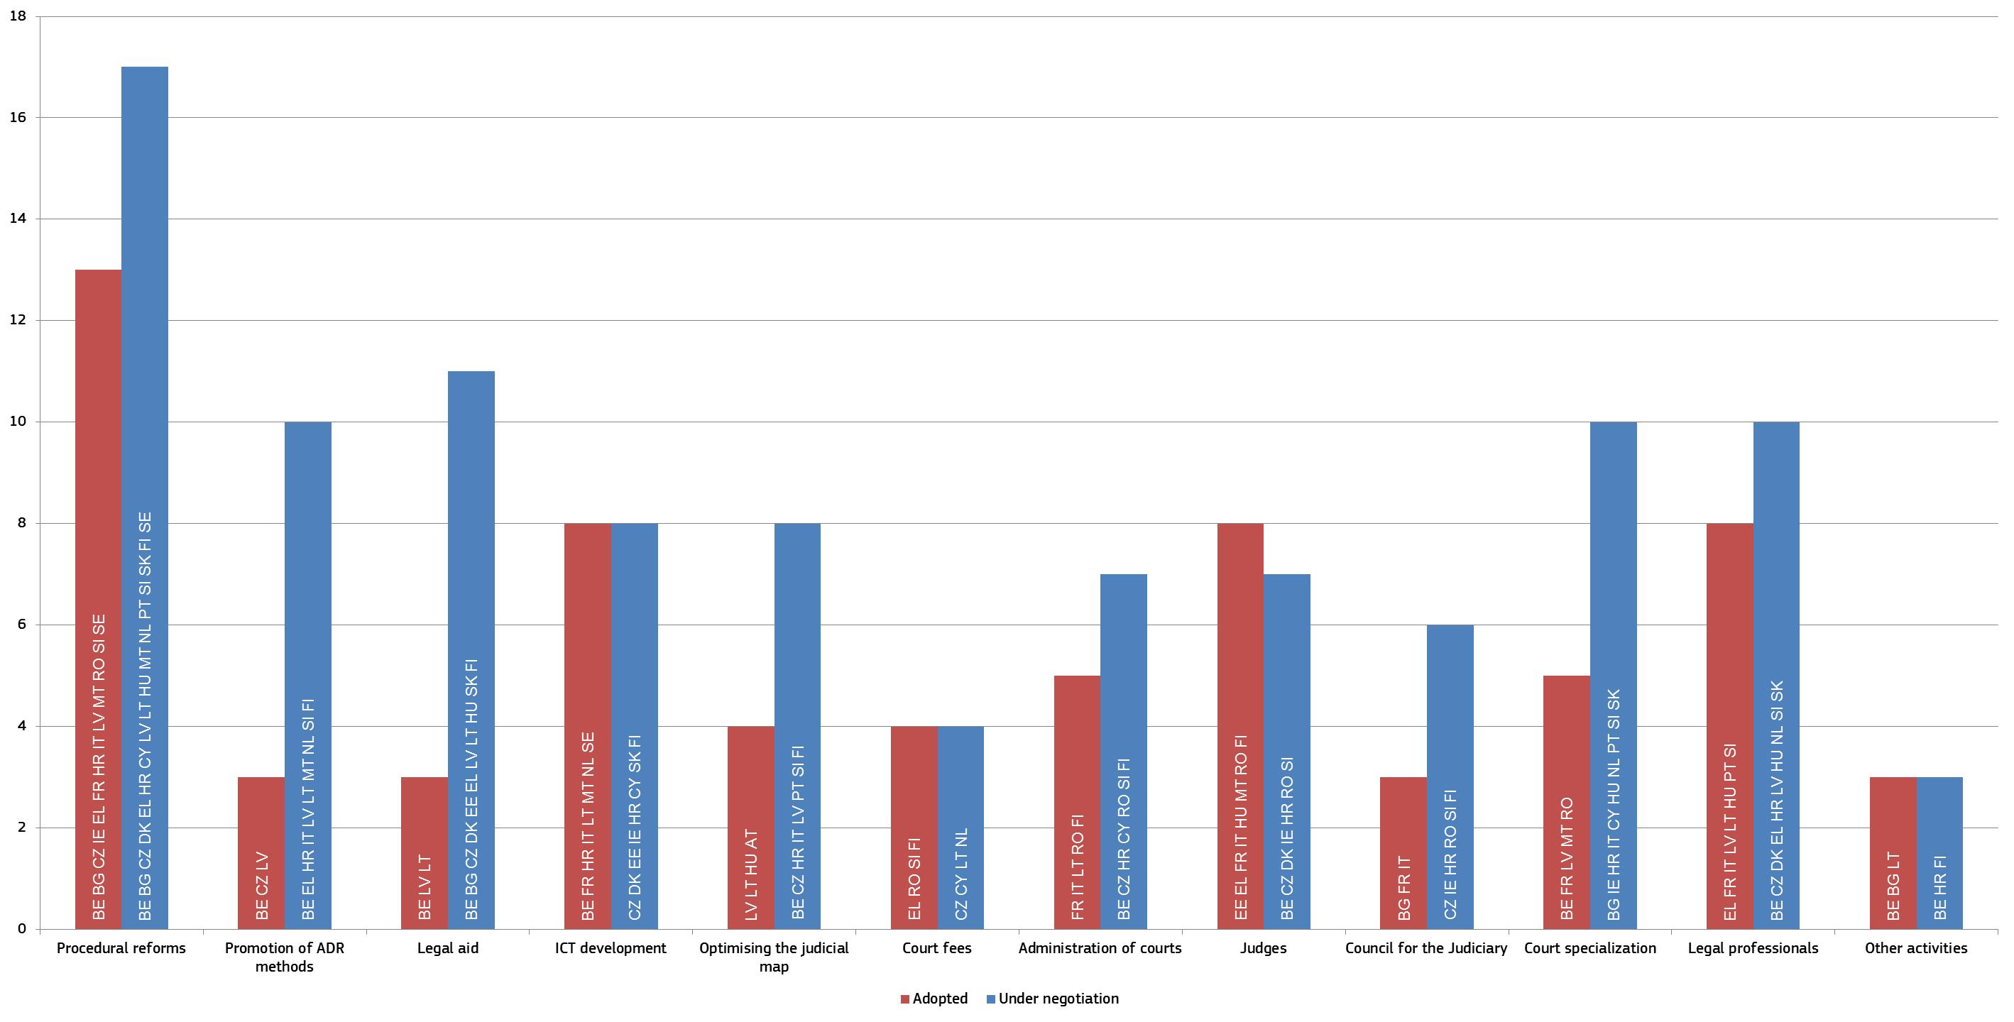
The EU is encouraging certain Member States to improve the effectiveness of their justice system. In the 2016 European semester, based on a proposal from the Commission, the Council addressed country specific recommendations to six Member States in this area. Two of the Member States which were subject to a country specific recommendation in 2015 did not receive a recommendation in 2016 due to the progress they had achieved. In addition to those Member States subject to country specific recommendations, a further eight Member States are still facing particular challenges and are being closely monitored by the Commission through the European semester and economic adjustment programmes. The Commission further assists justice reforms in Romania and Bulgaria through the cooperation and verification mechanism.
In 2016, the Commission adopted, under the EU Rule of Law Framework, two recommendations regarding the rule of law in Poland, setting out the Commission’s concerns and recommending how these concerns can be addressed. The Commission considers it necessary that Poland’s Constitutional Tribunal is able to fully carry out its responsibilities under the Constitution, in particular to ensure an effective constitutional review of legislative acts.
The Commission continues to support justice reforms through the European Structural and Investment Funds (ESI Funds). During the current programming period 2014 – 2020, ESI Funds will provide up to EUR 4.2 billion to support Member States’ efforts to enhance the capacity of their public administration, including justice. 14 Member States have identified justice as a priority area for support by the ESI Funds. The Commission emphasises the importance of taking a result-oriented approach when implementing these priorities and calls upon Member States to evaluate the impact of ESI Funds support. In 2016, five Member States requested technical assistance from the Structural Reform Support Service of the Commission, for example on sharing national experiences regarding judicial map reforms.
The positive economic impact of the good functioning of justice system deserves these efforts. A 2017 study by the Joint Research Centre identifies correlations between improvement of court efficiency and the growth rate of the economy and between businesses’ perception of judicial independence and the growth in productivity. Where judicial systems guarantee the enforcement of rights, creditors are more likely to lend, firms are dissuaded from opportunistic behaviour, transaction costs are reduced and innovative businesses are more likely to invest. This positive impact is also underlined in further research, including from the International Monetary Fund, European Central Bank, OECD, World Economic Forum, and World Bank.
– Developments in caseload –
The general context is characterised by a rather stable but high level of caseload of Member States’ justice systems, even if the level varies considerably between Member States (Figure 2). This shows the importance of continuing efforts to ensure the effectiveness of justice system.
Figure 2: Number of incoming civil, commercial, administrative and other cases* (1st instance/per 100 inhabitants) (source: CEPEJ study)
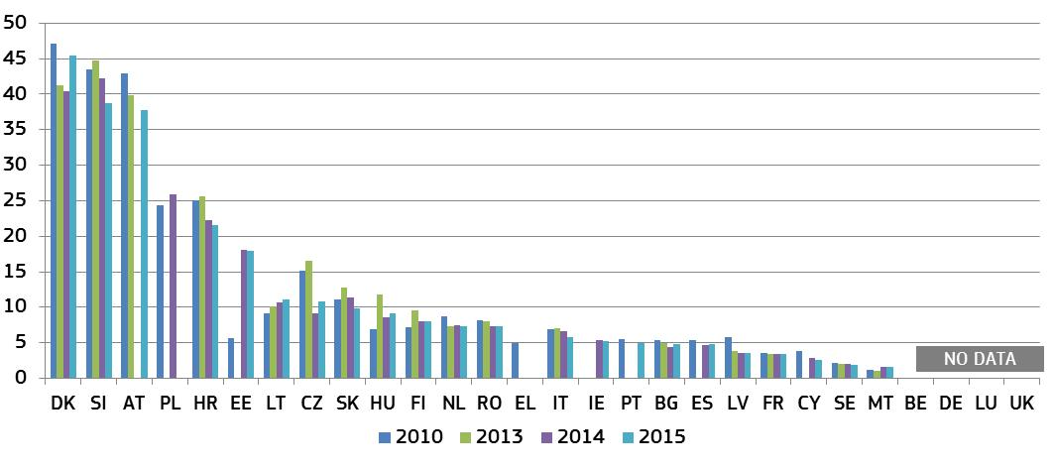* Under the CEPEJ methodology, this category includes all civil and commercial litigious and non-litigious cases, non-litigious land and business registry cases, other registry cases, other non-litigious cases, administrative law cases and other non-criminal cases. Methodology changes in CZ, HR, MT, and FI.
Figure 3: Number of incoming civil and commercial litigious cases* (1st instance/per 100 inhabitants) (source: CEPEJ study)
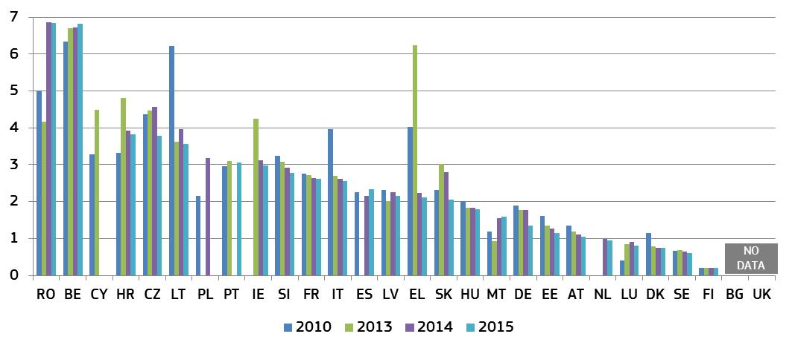* Under the CEPEJ methodology, litigious civil/commercial cases concern disputes between parties, e.g. disputes regarding contracts. Non-litigious civil/commercial cases concern uncontested proceedings, e.g. uncontested payment orders. Methodology changes in CZ, HR, IT, and FI. Data for NL include non-litigious cases. DE: data solely based on the statistics on the administration of justice published by the German Federal Statistical Office.

3. Key findings of the 2017 EU Justice Scoreboard
Efficiency, quality and independence are the main parameters of an effective justice system, and the Scoreboard presents indicators on all three.

3.1 Efficiency of justice systems
The Scoreboard examines the efficiency of proceedings in the broad areas of civil, commercial and administrative cases and in specific areas where courts apply EU law.

3.1.1 General data on efficiency
The indicators related to the efficiency of proceedings in the broad areas of civil, commercial and administrative cases are: length of proceedings (disposition time); clearance rate; and number of pending cases.

3.1.1.1 Length of proceedings
The length of proceedings indicates the estimated time (in days) needed to resolve a case in court, meaning the time taken by the court to reach a decision at first instance. The ‘disposition time’ indicator is the number of unresolved cases divided by the number of resolved cases at the end of a year multiplied by 365 (days). All figures concern proceedings at first instance and compare, where available, data for 2010, 2013, 2014 and 2015.
Figure 4: Time needed to resolve civil, commercial, administrative and other cases*
(1st instance/in days) (source: CEPEJ study)
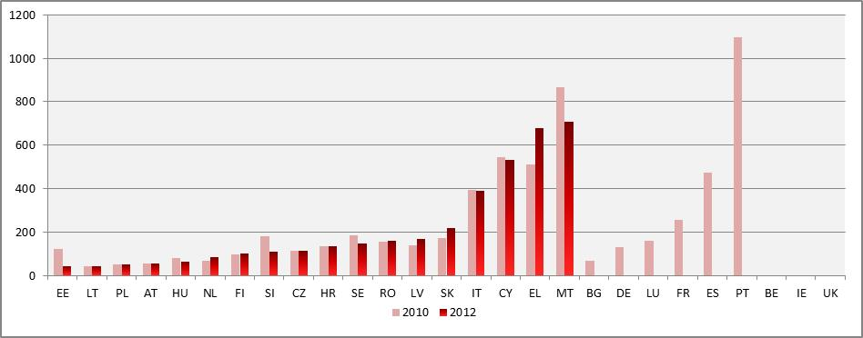
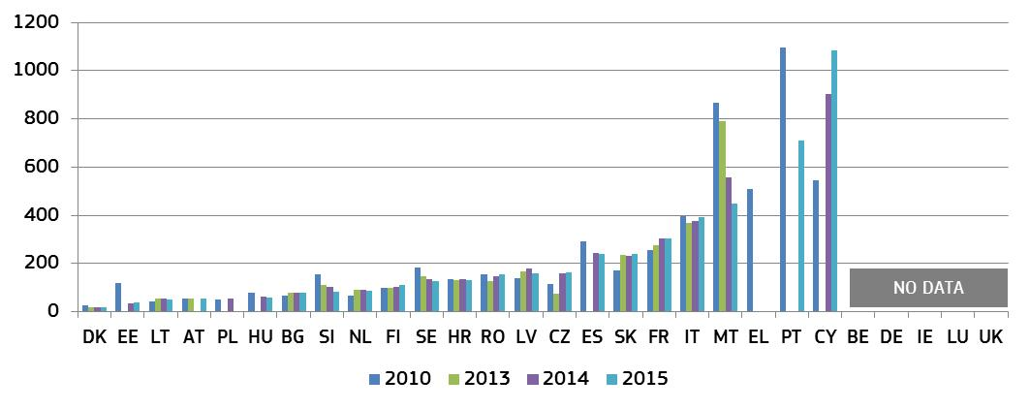* Under the CEPEJ methodology, this category includes all civil and commercial litigious and non-litigious cases, non-litigious land and business registry cases, other registry cases, other non-litigious cases, administrative law cases and other non-criminal cases. Methodology changes in CZ, HR, IT, HU, MT, PT, and FI. Pending cases include all instances in CZ and SK.
Figure 5: Time needed to resolve litigious civil and commercial cases*
(1st instance/in days) (source: CEPEJ study)
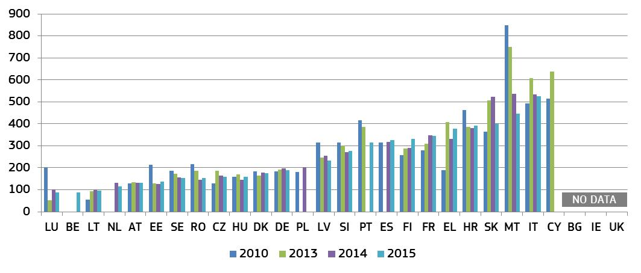* Under the CEPEJ methodology, litigious civil/commercial cases concern disputes between parties, e.g. disputes regarding contracts. Non-litigious civil/commercial cases concern uncontested proceedings, e.g. uncontested payment orders. Methodology changes in CZ, HR, IT, HU, MT, PT, and FI. Pending cases include all instances in CZ and SK. Data for NL include non-litigious cases. DE: Data solely based on the statistics on the administration of justice published by the German Federal Statistical Office.
Figure 6: Time needed to resolve administrative cases* (1st instance/in days) (source: CEPEJ study)
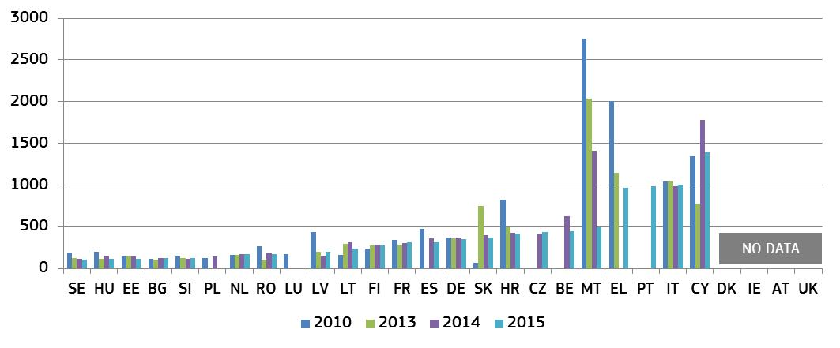* Administrative law cases concern disputes between citizens and local, regional or national authorities, under the CEPEJ methodology. Methodology changes in HR, HU and FI. Pending cases include all instances in CZ and SK. DK, IE and AT do not record administrative cases separately. DE: Data solely based on the statistics on the administration of justice published by the German Federal Statistical Office.

3.1.1.2 Clearance rate
The clearance rate is the ratio of the number of resolved cases over the number of incoming cases. It measures whether a court is keeping up with its incoming caseload. When the clearance rate is about 100 % or higher, it means the judicial system is able to resolve at least as many cases as come in. When the clearance rate is below 100 %, it means that the courts are resolving fewer cases than the number of incoming cases.
Figure 7: Rate of resolving civil, commercial, administrative and other cases*
(1st instance/in % — values higher than 100 % indicate that more cases are resolved than come in, while values below 100 % indicate that fewer cases are resolved than come in) (source: CEPEJ study)
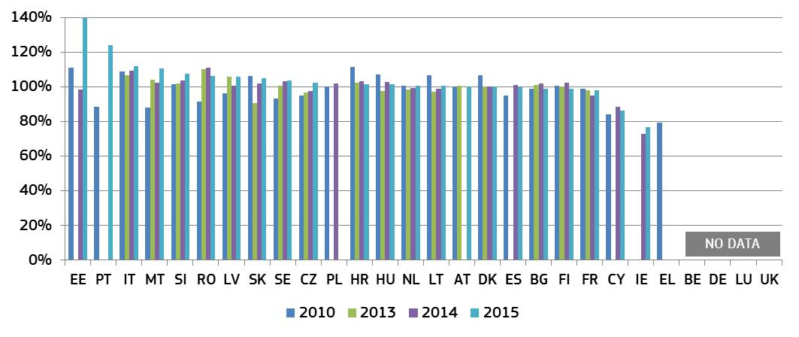* Methodology changes in CZ, HR, IT, HU, MT, PT, and FI. The data of EE reflect a 50 % increase in resolved registry cases. IE: the number of resolved cases is expected to be underreported due to the methodology.
Figure 8: Rate of resolving litigious civil and commercial cases* (1st instance/in %) (source: CEPEJ study)
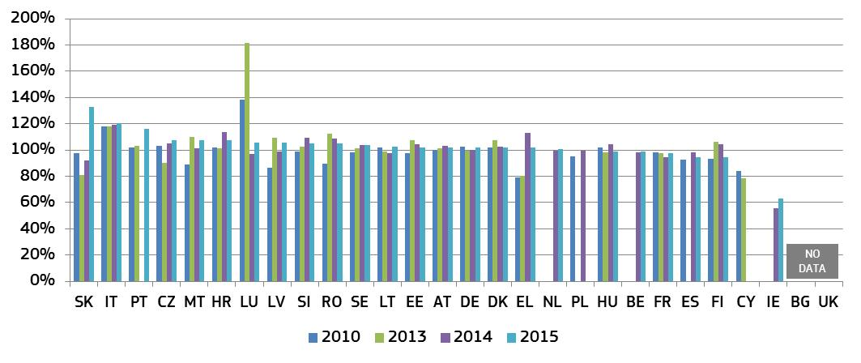* Methodology changes in CZ, HR, IT, HU, MT, PT, and FI. IE: the number of resolved cases is expected to be underreported due to the methodology. Data for NL include non-litigious cases. DE: data solely based on the statistics on the administration of justice published by the German Federal Statistical Office.
Figure 9: Rate of resolving administrative cases* (1st instance/in %) (source: CEPEJ study)
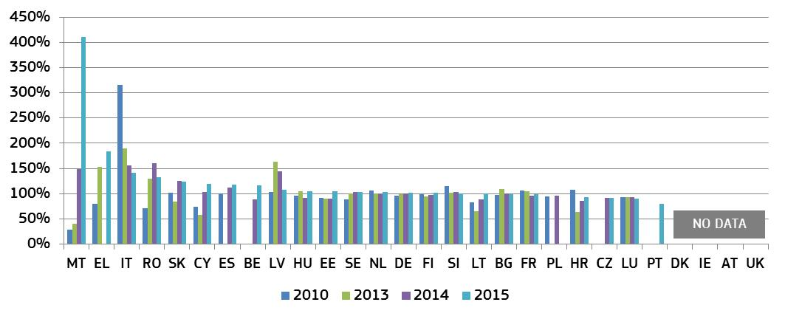* Methodology changes in HU and FI. Reorganisation of the administrative court system in HR. Pending cases include all instances in CZ and SK. DK, IE and AT do not record administrative cases separately. DE: Data solely based on the statistics on the administration of justice published by the German Federal Statistical Office.

3.1.1.3 Pending cases
The number of pending cases expresses the number of cases that remains to be dealt with at the end of the year in question. It also influences the disposition time.
Figure 10: Number of other pending civil, commercial and administrative cases* (1st instance/per 100 inhabitants) (source: CEPEJ study)
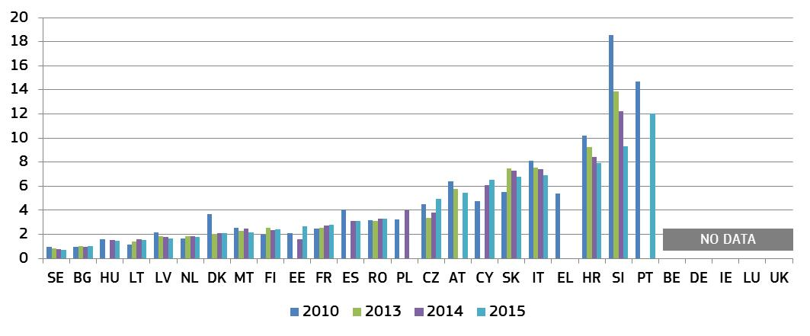* Methodology changes in CZ, HR, IT, HU, MT, PT, and FI. Pending cases include all instances in CZ and SK.
Figure 11: Number of pending litigious civil and commercial cases* (1st instance/per 100 inhabitants) (source: CEPEJ study)
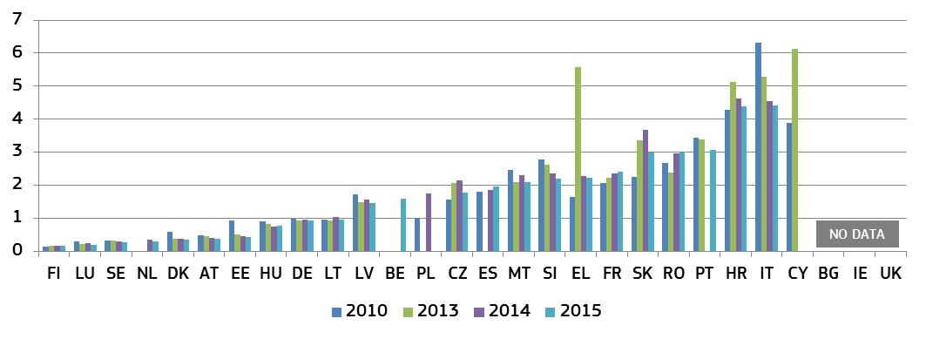* Methodology changes in CZ, HR, IT, HU, MT, PT, and FI. Pending cases include all instances in CZ and SK. Data for NL include non-litigious cases. DE: data solely based on the statistics on the administration of justice published by the German Federal Statistical Office.
Figure 12: Number of pending administrative cases* (1st instance/per 100 inhabitants) (source: CEPEJ study)
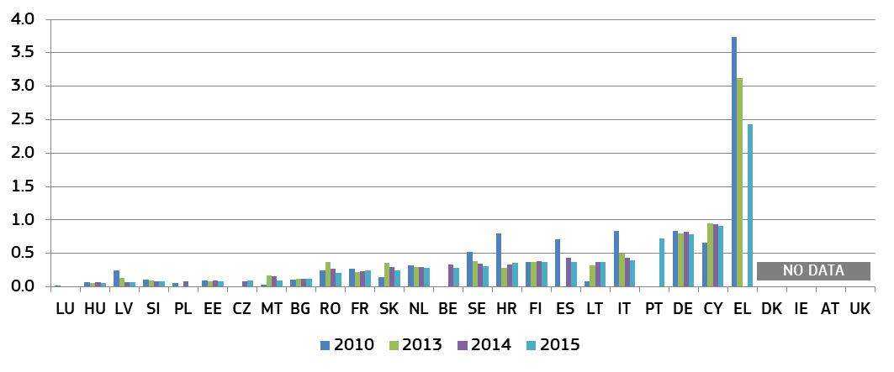* Methodology changes in HR, HU and FI. Pending cases include all instances in CZ and SK. DK, IE and AT do not record administrative cases separately. DE: data solely based on the statistics on the administration of justice published by the German Federal Statistical Office.

3.1.2 Efficiency in specific areas of EU law
This section complements the general data on the efficiency of justice systems and presents the average length of proceedings in specific fields when EU law is involved. The 2017 Scoreboard builds on previous data in the areas of competition, electronic communications, EU trademark, consumer protection and also provides data on anti-money laundering. The areas are selected in view of their relevance for the single market and the business environment. In general, long delays in judicial proceedings may have negative consequences on rights stemming from EU law, e.g. when appropriate remedies are no longer available or serious financial damages become irrecoverable.
– Competition –
Effective enforcement of competition law ensures a level playing field for businesses and is therefore essential for an attractive business environment. The figure below presents the average length of cases against decisions of national competition authorities applying Articles 101 and 102 of the Treaty on the Functioning of the European Union (TFEU).
Figure 13 Competition: Average length of judicial review* (1st instance/in days) (source: European Commission with the European Competition Network)
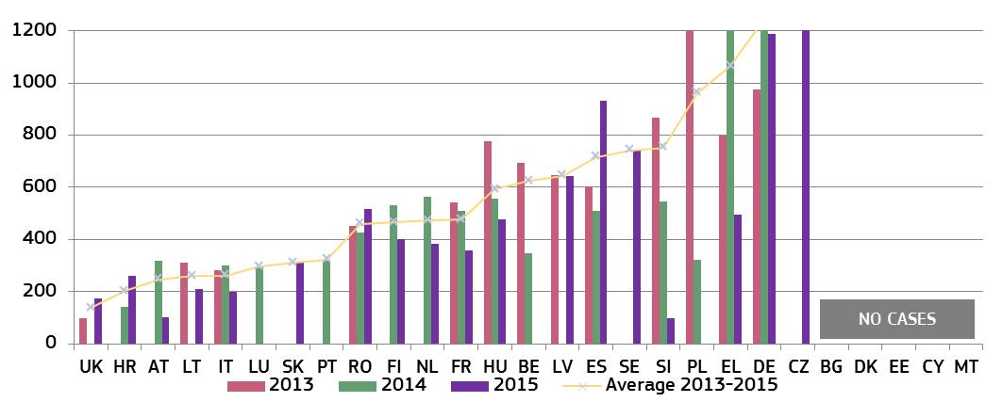
* IE and AT: scenario is not applicable as the authorities do not have powers to take respective decisions. AT: data not based on appeals against the national competition authority. The number of cases was limited (below 5 per year) in some years for the majority of Member States, which can make the annual data dependent on one exceptionally long or short case and result in large variations from one year to the other. DE: data refer to fines cases, where the ‘1st instance’ court issues its own judgment, with the competition authority decision functioning as an indictment. FR: data include 2 cases concerning the review of decisions granting interim measures and therefore handled with particular speed. An empty column in respective year means no cases reported by BE, CZ, HR, LV, LT, LU, NL, PL, SK, FI, SE and UK and not data available for AT. In Member States where no cases occurred, this could be because no decisions of the competition authority were challenged in court (e.g. in LU). DE: average is 1 246 days; CZ: average is 2 091 days.

– Electronic communications –
EU electronic communications legislation aims to make the related markets more competitive, contribute to the development of the internal market and to generate investment, innovation and growth. The effective enforcement of this legislation is also essential to achieve lower prices for consumers and better quality services. The figure below presents the average length of judicial review cases against decisions of national regulatory authorities applying EU law on electronic communications. It covers a broad spectrum of cases, ranging from more complex ‘market analysis’ reviews to consumer-focused issues.
Figure 14 Electronic communications: Average length of judicial review cases* (1st instance/in days) (source: European Commission with the Communications Committee)
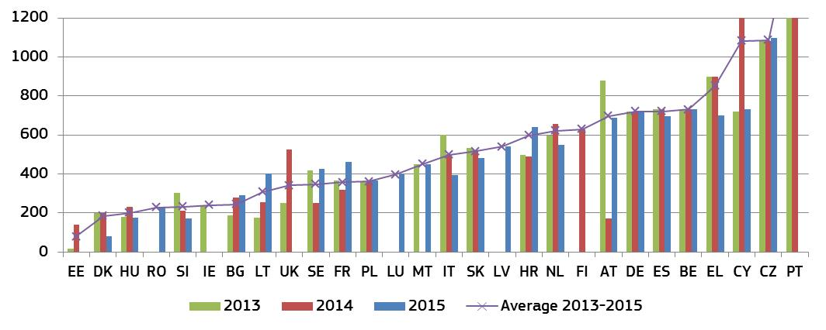* The number of cases varies by Member State. An empty column indicates that the Member State reported no cases for the year. In some instances, the limited number of relevant cases (BE, EE, IE, CY, LT, and UK) can make the annual data dependent on one exceptionally long or short case and result in large variations from one year to the other. DK: quasi-judicial body in charge of 1st instance appeals. ES, AT, and PL: different courts in charge depending on the subject matter. PT: average is 1706 days.
– EU trademark –
Effective enforcement of intellectual property rights is essential to stimulate investment into innovation. The EU trademark is the most common EU intellectual property title. EU legislation on EU trademarks gives a significant role to the national courts, which act as EU courts and take decisions affecting the single market. Figure 15 below shows average length of EU trademark infringement cases in litigation among private parties.
Figure 15 EU trademark: Average length of EU trademark infringement cases* (1st instance/in days) (source: European Commission with the European Observatory on infringements of intellectual property rights)
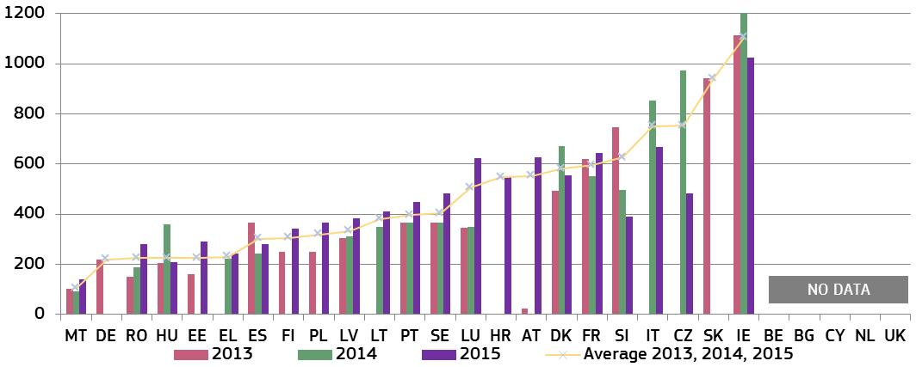
* FR, IT and LT: a sample of cases used. PL: estimations by courts used for 2015. The number of relevant cases was in some years limited (below 5 per year) in EE, IE, HR, HU, LU and FI, which can make the annual data dependent on one exceptionally long or short case and result in large variations from one year to the other. IE: one particularly difficult case of 2 326 days significantly influenced the average length. MT: the data refers to cross-border cases in customs enforcement. DK: data cover both EU and national trademark cases in the Maritime and Commercial Court. AT: methodology changed compared to 2013. An empty column in respective year means no cases reported by EE, HR and FI and no data available for CZ, DE, EL, IT, AT, PL, and SK.
– Consumer protection –
Effective enforcement of consumer law ensures that consumers benefit from their rights and that companies infringing consumer rules do not gain unfair advantage. Consumer authorities and courts play a key role in the enforcement of EU consumer law within the various national enforcement systems. Figure 16 illustrates the average length of judicial review cases against decisions of consumer protection authorities applying EU law.
For consumers or companies, effective enforcement can involve a chain of players, not only courts but also administrative authorities. To better examine this enforcement chain, this edition looks at the length of proceedings by consumer authorities in addition to the length of judicial review of such decisions. Figure 17 shows the average length of administrative decisions by national consumer protection authorities in 2014 and 2015 from the moment a case is opened. Relevant decisions include declaring infringements of substantive rules, interim measures, cease and desist orders, initiation of court proceedings or case closure.
Figure 16 Consumer protection: Average length of judicial review* (1st instance/in days) (source: European Commission with the Consumer Protection Cooperation Network)
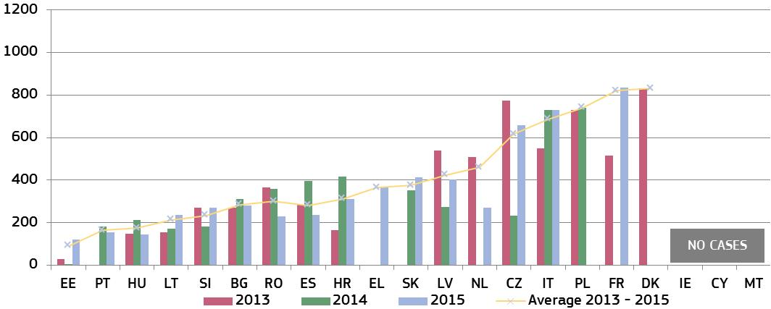

* BE, LU, AT, FI, SE and UK: scenario is not applicable as consumer authorities not empowered to decide on infringements of relevant consumer rules. In some of these Member States (e.g. FI and SE) consumer authorities can initiate actions in court, or contact the public prosecutor (BE). DE: administrative authorities can adopt decisions in cross-border cases only, but no relevant cases occurred as the Federal Ministry of Justice and Consumer Protection instructed other qualified entities to take enforcement measures. Some Member States have mixed systems (BG, DK, EE, IE, ES and LT) where consumer authorities have to bring court actions on some rules (e.g. unfair contract terms in BG and CY). DE, AT: Mostly civil enforcement in consumer law through consumers or private/semi-private bodies. ES: Data covers 4 Autonomous Communities. In some years the number of relevant cases was limited (below 5 per year) in DK, EE, EL, FR, HR and NL. This can make the annual data dependent on one exceptionally long or short case and result in large variations from one year to the other. IT, PL and RO provided an estimate. An empty column in respective year means no cases reported by DK and NL and no data available for EL FR, PT and SK. The powers of some authorities include only parts of the relevant EU consumer law.

Figure 17 Consumer protection: Average length of administrative decisions by consumer protection authorities* (in days) (source: European Commission with the Consumer Protection Cooperation Network)
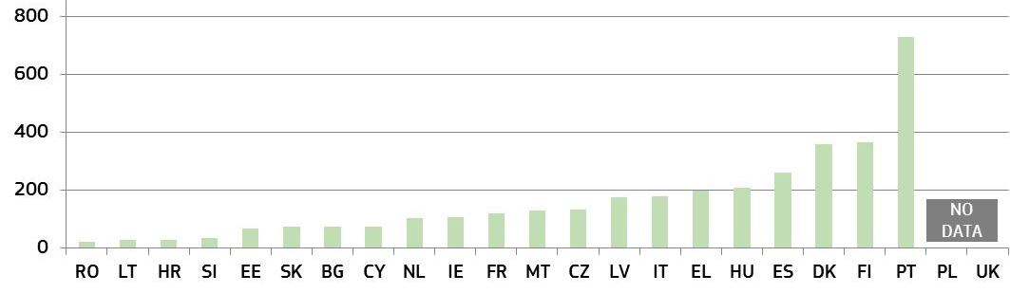

* BE, DE, LU, AT, and SE: scenario is not applicable. The figure presents a weighted average on administrative proceedings initiated by consumer authorities in 2014 and 2015. DK, EL, CY, and LT: provided estimates. IE, FI: data show the average of the ranges, where length could vary depending on the complexity of the breach. NL: data covers decisions imposing administrative fines for infringement of substantive rules. PT: the length can be due to complex procedures and in some cases, lack of ICT tools to digitalise some processes. Some Member States also indicated use of informal instruments for enforcement, generally successfully (LU and NL). Some authorities are competent for only parts of relevant EU law.
– Provisional measures –
Provisional measures decided by courts are fast-track procedures which include for instance temporary injunctions and seizure of goods aimed at deterring or preventing an imminent infringement before the final resolution of a case. Efficiency of proceedings for provisional measures is particularly important, as they are often used in cases of urgency where delays could lead to irreparable harm for the claimant. Figure 18 illustrates the average time needed to obtain a decision of a national court on a request for the application of provisional or interim measures to stop infringements of EU trademarks and of electronic communications rules.

Figure 18 Provisional measures — Average length of provisional measures in 2015* (1st instance/in days) (source: European Commission with the European Observatory on infringements of intellectual property rights and the Communications Committee)
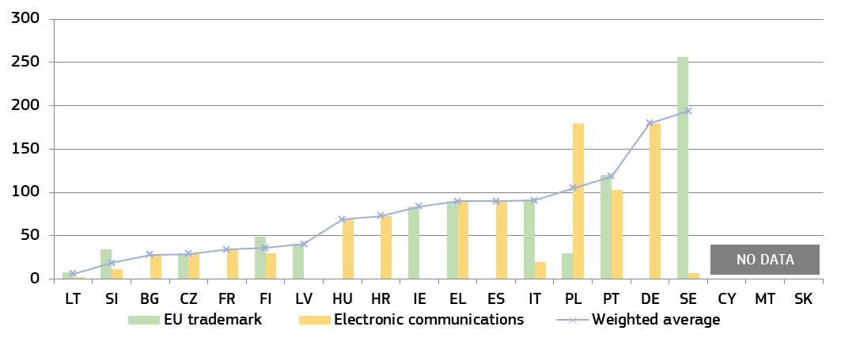
* EU trademark: LU, HU and RO reported no cases; BE, BG, DK, DE, EE, ES, FR, HR, NL, AT, and UK provided no data on provisional measures in this area. Electronic Communications: BE, DK, EE, IE, LV, NL, AT and UK reported no cases; LU and RO provided no data on provisional measures in this area. The number of cases is low (below 5 per year) for the majority of Member States in each area, which can make the annual data dependent on one exceptionally long or short case.
– Money Laundering –
In addition to contributing to the fight against crime, the effectiveness of the fight against money laundering is crucial for the soundness, integrity and stability of the financial sector, the confidence in the financial system and fair competition in the single market. As underlined by the International Monetary Fund, money laundering offences can discourage foreign investment, distort international capital flows and have negative consequences for a country’s macroeconomic performance, resulting in welfare losses, draining resources from more productive economic activities, and even have destabilising spill over effects on the economies of other countries. The anti-money laundering Directive requires Member States to maintain statistics on the effectiveness of systems to combat money laundering or terrorist financing. In cooperation with Member States, a pilot questionnaire was developed, which collected data on the functioning of various national bodies, including criminal courts dealing with money laundering offences. Figure 19 shows the average length of first instance court cases when dealing with money laundering criminal offences.
Figure 19: Money laundering: Average length of court cases* (1st instance/in days) (source: European Commission with the Expert Group on Money Laundering and Financing of Terrorism)
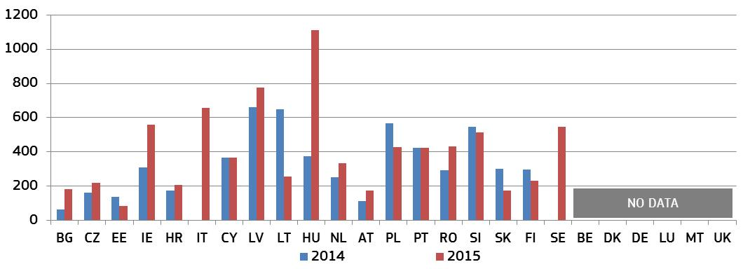
* EL, ES, and FR: data only for number of cases, not case length. IT: calculation based on a sample of judgments delivered in 2015 and 2016. SE: result is a theoretical maximum case length, not an average. CY, RO and SE: data for convictions only.

3.1.3 Summary on the efficiency of justice systems
Timeliness of judicial decisions is essential to ensure the smooth functioning of the justice system. The main parameters used by the Scoreboard for examining the efficiency of justice systems are the length of proceedings (estimated time in days needed to resolve a case), the clearance rate (the ratio of the number of resolved cases over the number of incoming cases) and the number of pending cases (that remains to be dealt with at the end of the year).
General data on efficiency
Looking at the broad areas of civil, commercial and administrative cases, the 2017 Scoreboard shows that the positive development already noted last year continues. It also shows where data are available, that since the first edition of the Scoreboard in 2013, overall there are more Member States in which efficiency has progressed than in which it has deteriorated.
- It is encouraging to observe positive developments in particular in the Member States which have been identified in the context of the European semester or economic adjustment programme as facing challenges:
  - The length of litigious civil and commercial cases has improved significantly in a number of these Member States (Figure 5). This improvement is clearer in a five years perspective (i.e. since 2010) than in the short-term. However, the category ‘all cases’ (Figure 4) and, even more, the category ‘administrative cases’ (Figure 6), show a positive picture also compared to last year, i.e. stability or improvement.
  - In most Member States clearance rates for litigious civil and commercial cases have improved over the five years (Figure 8). With a few exceptions, the same is true in the short-term for administrative cases (Figure 9), a major improvement compared to last year, and also for the broad ‘all cases’ category (Figure 7). This means that in general Member States are able to deal with incoming cases in the analysed areas.
  - On pending cases, even if progress is less clear over the five years period, certain improvements can be noted in the last two years, regardless of the category analysed. While there is overall stability in the ‘all cases’ category (Figure 10), there are clear improvements both as regards litigious civil and commercial pending cases (Figure 11) and administrative cases (Figure 12). However, despite these improvements, the level of pending cases remains high in a number of Member States.
  - Justice reforms take time to show their effect. However, certain reforms engaged seem to already contribute to an improvement in efficiency. For instance, one Member State reported a large improvement in the number of cases being cleared and a consequential reduction in pending cases mainly due to the fact that administrative cases are being dealt with by a single court.
Efficiency in specific areas of EU law
Figures on proceedings in specific areas (Figures 13-19) aim at better reflecting the functioning of justice systems in concrete types of business-related disputes covered by EU law. For citizens or companies, effective enforcement can involve a chain of players, not only courts but also administrative authorities. To better examine this enforcement chain, this edition looks at the length of proceedings by consumer authorities in addition to the length of judicial review of such decisions. It also shows the length of interim measures to prevent imminent infringements or damages in the areas of electronic communication and intellectual property rights. The figures indicate that:
- Competition and electronic communications cases are on average at least several months longer than the cases in the specific areas of EU trademark and consumer law. This can be explained by the complexity and economic importance of cases in competition and electronic communications, and possibly by the procedural rules in some EU countries. The length of cases in one Member State may vary considerably depending on the area of law.
- The importance of the different players in the enforcement chain is presented in the consumer field. Figures 16-17 illustrate the length of both administrative proceedings and judicial review. When these two parts of the chain come into play, combined proceedings could range for instance between about 160 and 1 200 days depending on the Member States. However, data suggest that in many Member States a large proportion of administrative decisions are not challenged in court, pointing to the conclusion that many infringements are resolved solely by the administration.
- A court may decide on provisional or interim measures to deter or prevent an infringement on a temporary basis. The data in the EU trademark and electronic communication fields show that the duration of the underlying court proceedings may vary between several days up to eight months across Member States (Figure 20), as well as per type of case in the same country. The lack of cases on provisional measures in some Member States may also be due to procedural rules which make their use more difficult.
- The effective fight against money laundering is crucial in protecting the financial system, fair competition and preventing negative economic consequences. This edition presents the results of a pilot data collection of the length of judicial proceedings dealing with money laundering offences under the anti-money laundering Directive. For Member States where data are available, there appear to be notable variations in case length — from less than half a year up to almost three years (Figure 19). The data collection is expected to improve with the implementation of the Directive in June 2017.

3.2 Quality of justice systems
Effective justice systems do not only require timely but also high quality decisions. Quality is a driver for citizens’ and businesses’ trust in the justice system. Although there is no single agreed way of measuring the quality of justice systems, the EU Justice Scoreboard focuses on certain factors that are generally accepted as relevant to improve the quality of justice. They are grouped into four categories:
1) accessibility of justice for citizens and businesses;
2) adequate material and human resources;
3) putting in place assessment tools; and
4) using quality standards.

3.2.1 Accessibility
Accessibility is required throughout the entire justice chain to facilitate obtaining relevant information – about the justice system, how to initiate a claim and the related financial aspects, the state of play of proceedings up until their end – so that the judgment can be swiftly accessed online.

– Giving information about the justice system –
As a pre-requisite, access to justice requires that citizens and businesses are well informed in a user-friendly manner about various aspects of the justice system. Figure 20 shows the availability of online information about the judicial system for the general public.
Figure 20: Availability of online information about the judicial system for the general public* (source: European Commission)
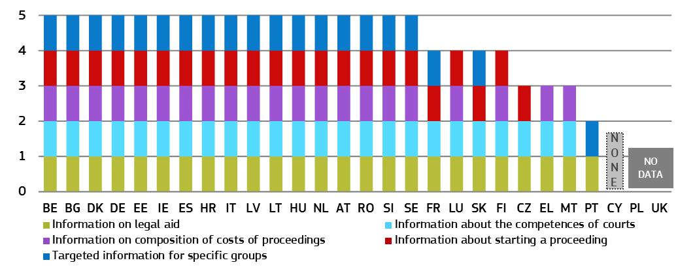* DE: Each federal state and the federal level decide which information to provide online.

– Legal aid and court fees –
Access to legal aid is a fundamental right enshrined in the Charter of Fundamental Rights (‘the Charter’). In order to collect comparable data on the different legal aid and court fee systems, two specific scenarios on a consumer dispute have been set out in the context of each Member State’s income and living conditions. The data in Figure 21 show availability of legal aid for these two scenarios. They are based on two different values of the claim: a high value claim (i.e. EUR 6 000) and a low value claim (i.e. each Member State’s respective Eurostat poverty threshold converted to monthly income ).
Most Member States grant legal aid on the basis of the applicant’s income. Figure 21 compares in % the income thresholds for granting legal aid in a specific consumer case with the Eurostat poverty threshold in each Member State. For example, if eligibility for legal aid appears at 20 %, it means that an applicant with an income 20 % higher than the respective Eurostat poverty threshold can receive legal aid. On the contrary, if eligibility for legal aid appears at -20 %, it means that the income threshold for legal aid is 20 % lower than the Eurostat poverty threshold. Some Member States operate a legal aid system that provides for coverage of 100 % of the costs linked to litigation (full legal aid), complemented by a system covering parts of the costs (partial legal aid). Other Member States operate either only a full or only a partial legal aid system.
Figure 21: Income threshold for legal aid in a specific consumer case* (differences in % from Eurostat poverty threshold) (source: European Commission with the CCBE)
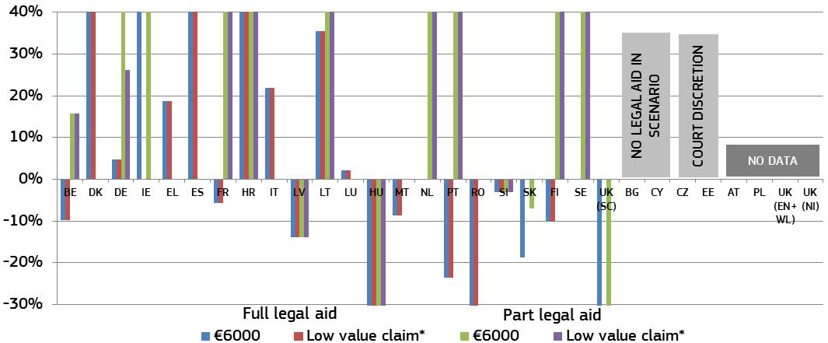
* The figure presents thresholds for legal aid ranging from 40 % to -30 %. DK, DE, IE, FR, HR, LT, NL, PT, FI, and SE grant legal aid at an income threshold which ranges between 40 % and 154 %. HU, RO, and UK(SC) grant legal aid at an income threshold which ranges between -30 % and -68 %. ‘Low value claim’ means a claim which corresponds to the Eurostat poverty threshold for a single person in each Member State, converted to monthly income (e.g. in 2014, this value ranged between €110 in RO and €1716 in LU). Most Member States use disposable income for calculating legal aid eligibility, except DK, LU, and NL which use gross income. In IE, SK, and UK (SC) no legal aid is available for a value of the claim at the respective AROP threshold as the amount would be too small. DE: the income threshold is based on the Prozesskostenhilfebekanntmachung 2016 and average annual housing costs (SILC). LV: a range of income between €128.06 and €320 depending on the place of residence of the applicant. The rate is based on the arithmetic mean.

Most Member States require parties to pay a court fee when starting a judicial proceeding. Figure 22 compares for the two scenarios the level of the court fee presented as a share of the value of the claim. If, for example, the court fee appears at 10 % of a EUR 6 000 claim in the figure below, the consumer will have to pay a EUR 600 court fee to start a judicial proceeding. The low value claim is based on the Eurostat poverty threshold for each Member State.

Figure 22: Court fee to start a judicial proceeding in a specific consumer case (level of court fee as a share of the value of the claim) (source: European Commission with the CCBE)
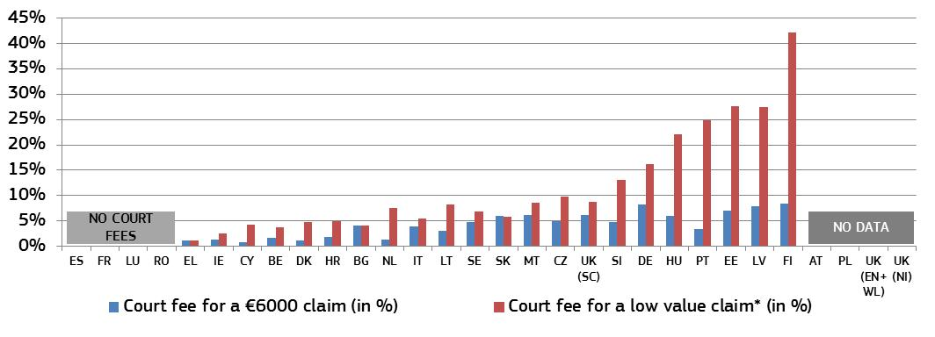
* ‘Low value claim’ see below Figure 21.

– Submitting and following a claim online –
Electronic submission of claims, the possibility to monitor and advance a proceeding online as well as electronic communication between courts and lawyers also ease access to justice and reduce delays and costs. ICT systems in courts also play an increasingly important role in cross-border cooperation between judicial authorities and also ease the implementation of EU legislation.
Figure 23: Availability of electronic means* (0 = available in 0 % of courts, 4 = available in 100 % of courts) (source: CEPEJ study)
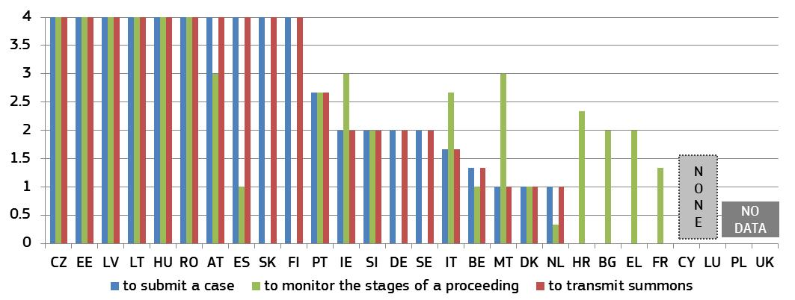
* DK: electronic forms are available on website, but can currently only be submitted by email. LT: certain documents may be submitted via the courts’ electronic services portal. PL: the possibility to bring a case to the court by electronic means only exists for writ of payment cases. RO: a case may be submitted to courts via email. SK: the e-submission is possible in certain civil procedures. Citizen has access to information about court proceedings via courts websites. SI: in specific types of cases the monitoring of procedural acts is possible.

– Exchanges between courts and lawyers –

The frequency of using various ICT techniques in exchanges between courts and lawyers as well as the underlying reasons for the use and non-use differ significantly between Member States. In order to have a clearer picture of the actual use of ICT, Figure 24 presents the results from a survey of lawyers on how they communicate with courts and for which reasons they use ICT.
Figure 24: Use of ICT between courts and lawyers* (source: CCBE survey)
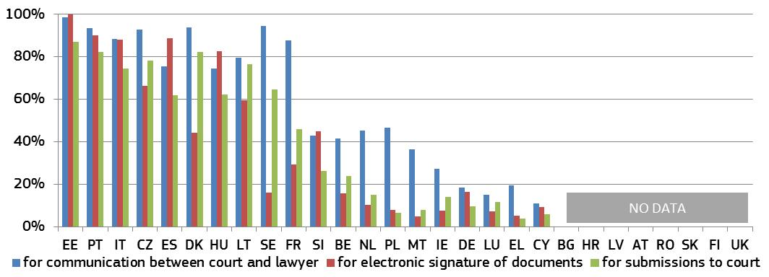
* Submissions to court covers the following answer options:’ electronic submission of a claim’, ‘electronic submission of summons to appear in court’, ‘electronic submission of evidence/supporting documents’.
Figure 25: Reasons for the (non-)use of ICT between courts and lawyers* (source: CCBE survey)
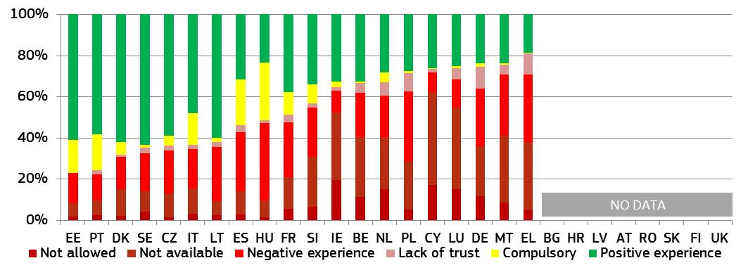
* Positive experience covers the following answer options: ‘very practical’, ‘user-friendly’ and ‘other advantages’. Negative experience covers the following answer options: ‘not sufficiently user friendly’, ‘technical problems’ and ‘other obstacles’. Respondents could give indicate a maximum of two reasons for the (non-)use of ICT.

– Communicating with the media –
For the general public, the media serves as a channel that contributes to the accessibility of justice systems and judicial work.
Figure 26: Relations between courts and the press/media* (source: European Commission)
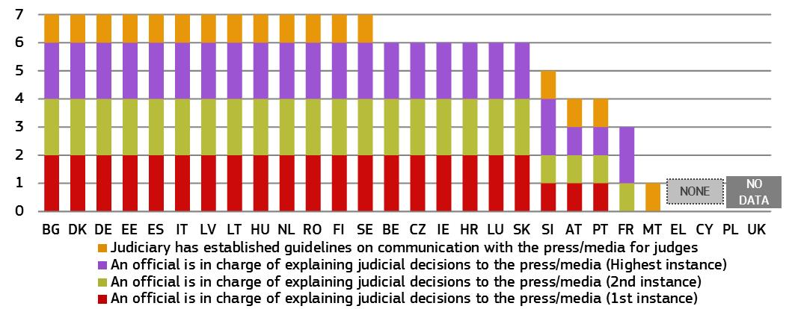* For each of the three instances two points can be given if civil/commercial cases and administrative cases are covered. If only one of the two categories of cases is covered only one point is given. Maximum possible: 7 points. DE: each federal state has own guidelines for judges on communicating with the press and media. FI: in all courts there is a person who can be in contact with the press when necessary, but not as his/her main duties.

– Accessing judgments –
Providing judgments online advances transparency and understanding of the justice system. It helps citizens and businesses to take informed decisions when accessing justice. It could also contribute to increasing consistency of case law.
Figure 27: Access to published judgments online to the general public* (civil/commercial and administrative cases, all instances) (source: European Commission)
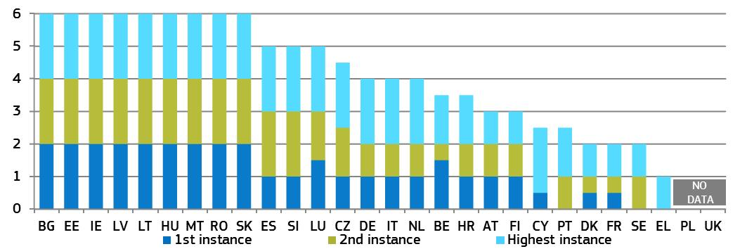
* For each instance, one point was given if all judgments are available for civil/commercial and administrative cases respectively (0.5 points when some judgments are available). For Member States with only two instances, points have been given for three instances by mirroring the respective higher instance of the non-existing instance. For those Member States that do not distinguish between the two areas of law, the same number of points has been given for both areas. Maximum possible: 6 points. DK: most administrative cases are adjudicated by independent collegial quasi-judicial administrative bodies outside courts. SE: courts do not publish judgments regularly online (only landmark cases). According to the principle of public access to information, citizens are entitled to read all judgments or decisions. DE: each federal state decides on online availability of 1st instance judgments.

Figure 28: Arrangements for online publication of judgments in all instances* (civil/commercial and administrative cases, all instances) (source: European Commission)
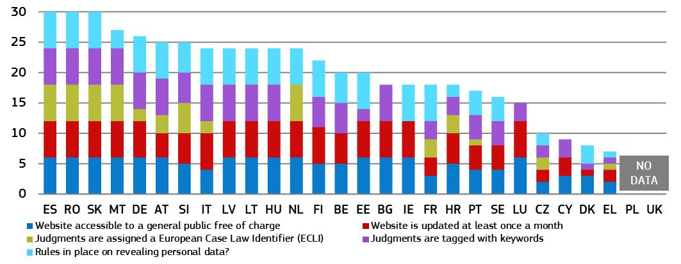
* For each of the three instances, two points can be given if civil/commercial cases and administrative cases are covered. If only one of the two categories of cases is covered only one point per instance is given. Maximum possible: 30 points. DK: most administrative cases are adjudicated by independent collegial quasi-judicial administrative bodies outside Danish courts. NL: no keywords, but a table of contents is added to every published judgment.

– Complaining to companies –
Access to justice includes avenues outside courts. Figure 29 is based on a survey on retailers’ attitudes towards cross-border trade and consumer protection. Companies were asked to indicate if they received complaints from consumers located in their own country and through which channel.

Figure 29: Consumer complaints channels outside companies* (source: Survey on retailers attitudes towards cross-border trade and consumer protection 2016 )
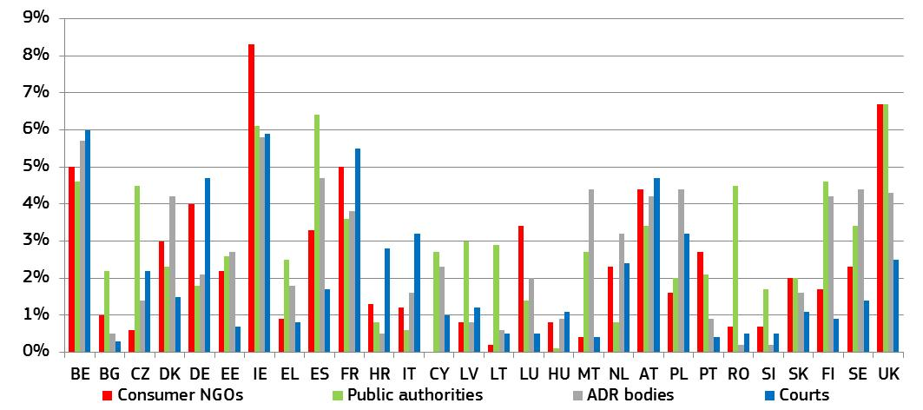
* Share of businesses having received consumer complaints through the respective channels. Original question also contained answer options ‘In-house complaint channels’ and ‘Other channels’, which in most Member States are the two main channels used. Public authorities are in this context those which are dealing with consumer related issues.

– Accessing alternative dispute resolution methods –
Figure 30 shows Member States’ efforts to promote and incentivise the voluntary use of alternative dispute resolution methods. Figure 31 shows the number of complaints submitted through the European online dispute resolution (ODR) platform. This web-based multilingual tool has been available to the public since 15 February 2016. Consumers and traders who have a contractual dispute over a product or service bought online and wish to find a solution out of court can submit their contractual disputes about online on the platform.
Figure 30: Promotion of and incentives for using ADR methods* (source: European Commission)
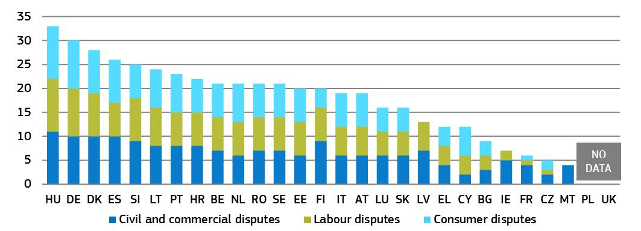
* Aggregated data based on the following indicators: website providing information on ADR; publicity campaigns in media; brochures to the general public; court provides specific information sessions on ADR upon request; ADR/mediation coordinator at courts; publication of evaluations on the use of ADR; publication of statistics on the use of ADR; legal aid covers costs (in part or in full) incurred with ADR; full or partial refund of court fees; including stamp duties; if ADR is successful; no lawyer for ADR procedure required; judge can act as mediator; others. For each of these 12 indicators, one point was given for each area of law. IE: promotion and incentives in civil and commercial disputes relate only to family proceedings. PT: for civil/commercial disputes, court fees are refunded only in case of justices for peace. LV: no court fees charged in labour disputes.
Figure 31: Number of consumer complaints to the ODR platform (per 100 000 inhabitants) (source: ODR platform — extracted 24 March 2017)
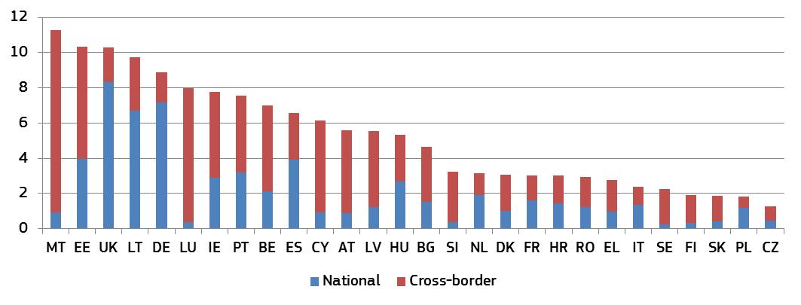

* The Figure shows the number of complaints submitted to the ODR platform, not the number of disputes received by ADR entities via the ODR platform. A number of cases submitted to the ODR platform are subsequently solved bilaterally between the parties outside the platform, without any further involvement of an ADR entity.

3.2.2 Resources
Adequate resources, the right conditions in courts and well-qualified staff are necessary for the good functioning of the justice system. Without a sufficient number of staff with the required qualifications, skills and access to continuous training, the quality of proceedings and decisions are at stake.
– Financial resources –
The figures below show the budget actually spent on courts, first by inhabitant (Figure 32) and second as a share of gross domestic product (GDP) (Figure 33).
Figure 32: General government total expenditure on law courts* (in EUR per inhabitant) (source: Eurostat)
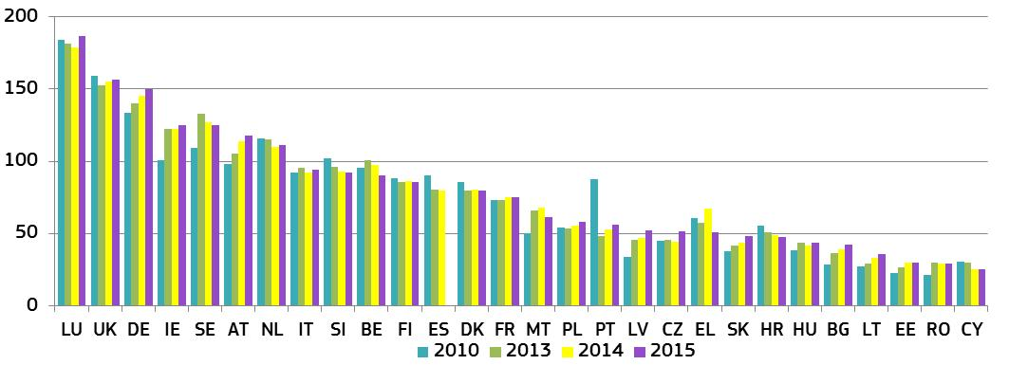* Data for NL, SK are provisional.
Figure 33: General government total expenditure on law courts* (as a percentage of GDP) (source: Eurostat)
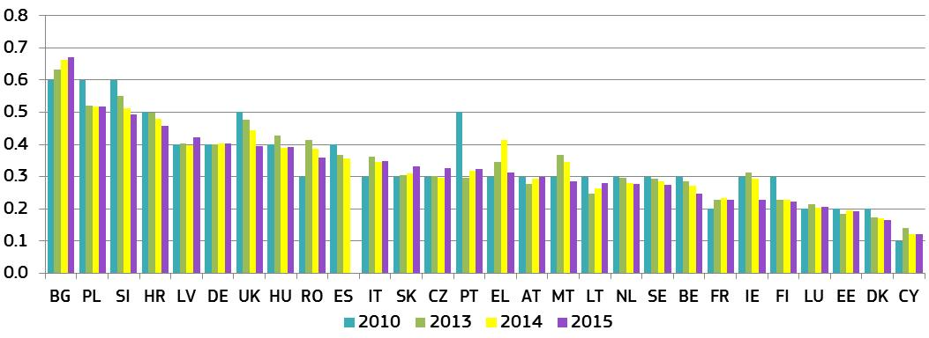* Data for NL, SK are provisional.
Figure 34 shows which state power (judiciary, legislature or executive) sets the criteria for determining financial resources for the judiciary, and what criteria are used.
Figure 34: Criteria for determining financial resources for the judiciary*
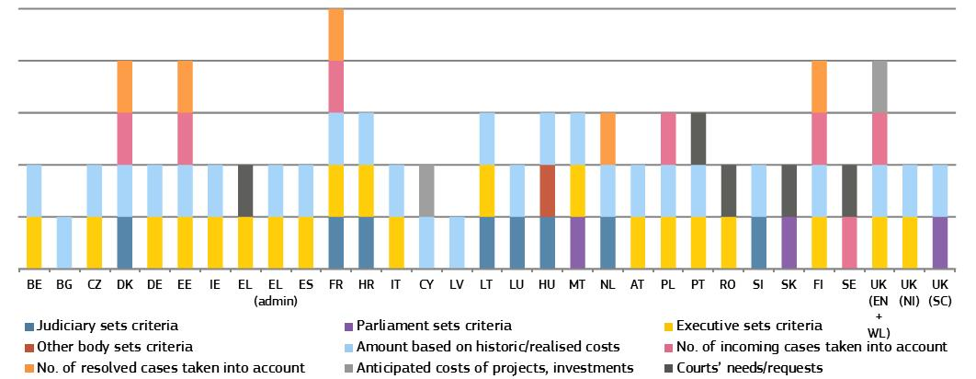
* DK: number of incoming and resolved cases at courts of 1st instance are taken into account; DE: only for the Supreme Federal Court’s budget — as regards courts of 1st and 2nd instance; judicial systems vary between the federal states; EE: number of incoming and resolved cases for courts of 1st and 2nd instance; FR: number of incoming and resolved cases for courts of all instances; IT: the Ministry of Justice defines criteria for civil and criminal courts, while the Council for the Judiciary (CPGA) defines criteria for administrative courts; HU: law states that the salaries of judges must be determined in the act on the central budget in such a way that the amount shall not be lower than it had been in the previous year; NL: the number of resolved cases based on an evaluation of the costs for courts is taken into account.
– Human resources –
Adequate human resources are essential for the quality of a justice system. Diversity among judges, including gender balance, adds complementary knowledge, skills and experience and reflects the reality of society.
Figure 35: Number of judges* (per 100 000 inhabitants) (source: CEPEJ study)
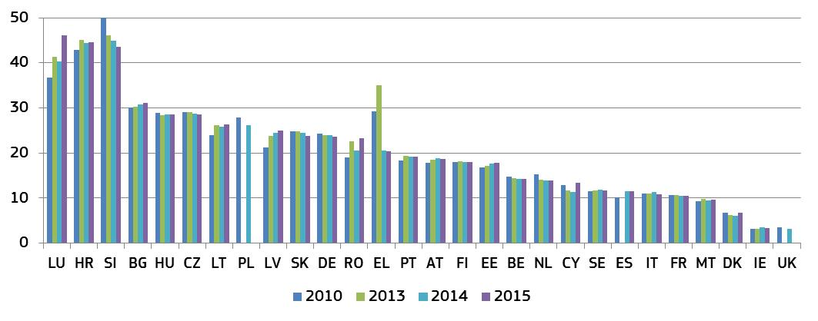* This category consists of judges working full-time, under the CEPEJ methodology. It does not include the Rechtspfleger/court clerks that exist in some Member States. EL: the total number of professional judges includes different categories over the years shown above, which partly explains their variation. UK: weighted average of the three jurisdictions; data for 2010 contains 2012 data for UK (NI).

Figure 36: Proportion of female professional judges at 1st and 2nd instance and Supreme Courts (source: European Commission (Supreme Courts) and CEPEJ study (1st and 2nd instance))
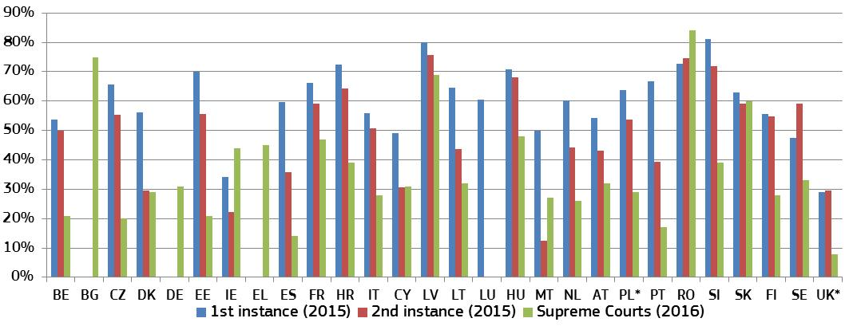
* PL and UK data for 2014 for 1st and 2nd instance.

Figure 37: Developments in the proportion of female professional judges at 1st and 2nd instance 2010-2015, at Supreme Courts 2010-2016* (difference in percentage points) (source: European Commission (Supreme Courts) and CEPEJ study (1st and 2nd instance))
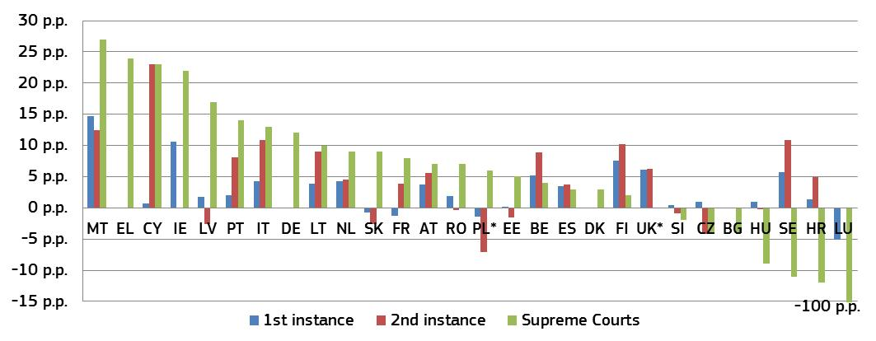* LU: the proportion of female professional judges in the Supreme Court declined from 100 % in 2010 to 0 % in 2016. UK: for England & Wales the average of 1st and 2nd instance is used. PL and UK: data compare 2010 with 2014.
Figure 38: Number of lawyers* (per 100 000 inhabitants) (source: CEPEJ study)
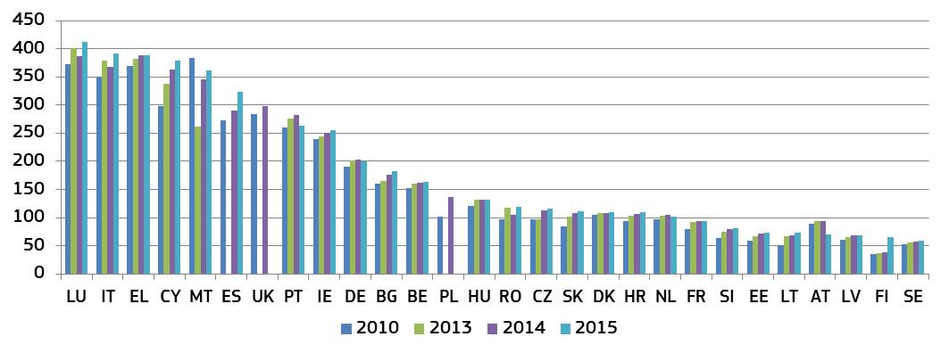
* Under CEPEJ methodology a lawyer is a person qualified and authorised according to national law to plead and act on behalf of his or her clients, to engage in the practice of law, to appear before the courts or advise and represent his or her clients in legal matters (Recommendation Rec (2000)21 of the Committee of Ministers of the Council of Europe on the freedom of exercise of the profession of lawyer).

– Training –
Judicial training is important in contributing to the quality of judicial decisions and the justice service delivered to citizens. The data set out below cover judicial training in a broad range of areas, including communication with parties and the press and on judicial skills.
Figure 39: Compulsory training for judges* (source: CEPEJ study)
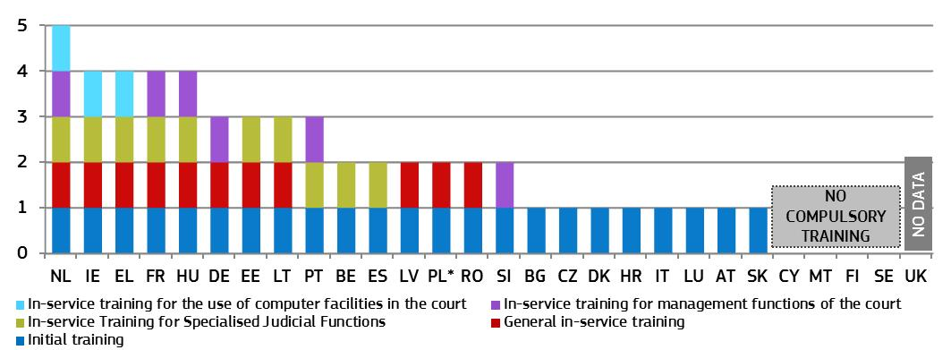
* Some Member States do not offer compulsory training in certain categories but may offer optional training.
Figure 40: Judges participating in continuous training activities in EU law or in the law of another Member State* (as a percentage of total number of judges) (source: European Commission, European judicial training report 2016)
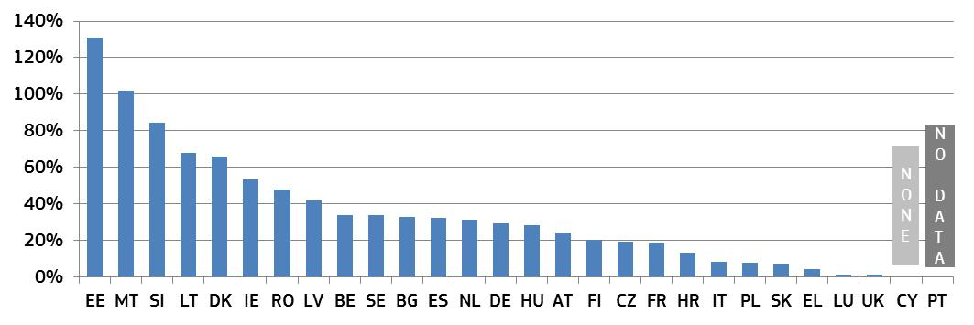* In a few Member States the ratio of participants exceeds 100 %, meaning that some participants attended more than one training activity. AT data includes prosecutors, DK includes court staff.
Figure 41: Share of continuous training of judges on various types of skills* (as a percentage of total number of judges receiving training) (source: European Commission)
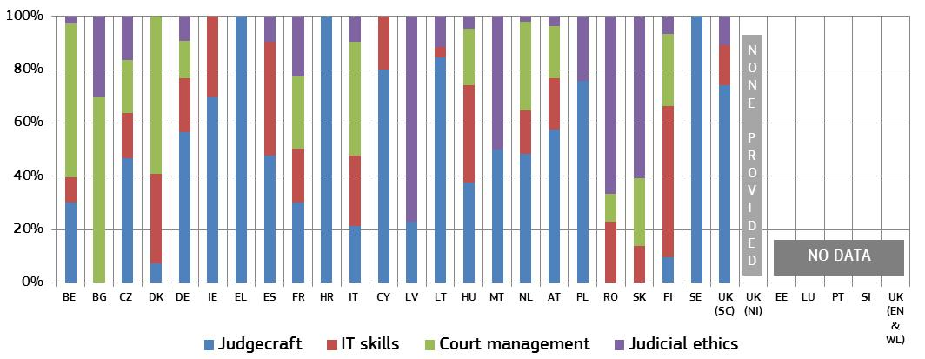* The table shows the distribution of judges participating in continuous training activities (i.e. those taking place after the initial training period to become a judge) in each of the four identified areas as a percentage of the total number of judges trained. Legal training activities are not taken into account. Judicial training authorities in UK(NI) did not provide specific training activities on the selected skills.
Figure 42: Availability of training for judges on communication with parties and the press (source: European Commission)
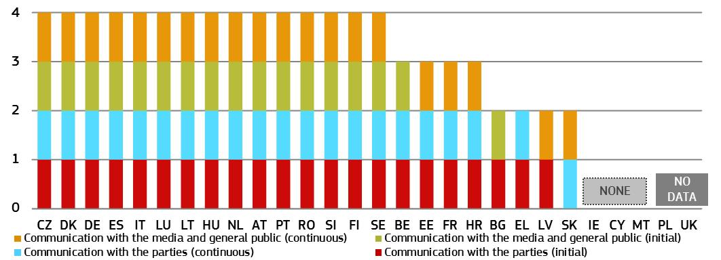

3.2.3 Assessment tools
Monitoring and evaluation of court activities are conducive to detecting deficiencies and needs, and thereby help the justice system to be more responsive to current and future challenges. Adequate ICT tools can provide real-time case management systems and can help to provide nationwide standardised court statistics. In addition, they could be used for the management of backlogs and automated early-warning systems. Surveys are essential to assess how justice systems operate from the perspective of legal professionals and court users. An adequate follow-up of surveys is a pre-requisite to improve quality of justice systems.
Figure 43: Availability of monitoring and evaluation of court activities* (source: CEPEJ study)
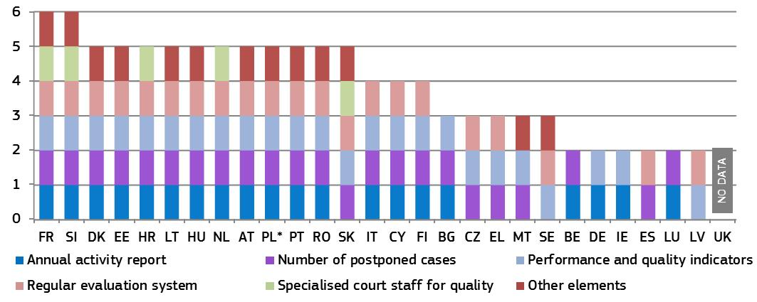
* The evaluation system refers to the performance of court systems, using indicators and targets. In 2015, all Member States, except LV, reported having a system that allows them to monitor the number of incoming cases, the length of proceedings and the number of decisions handed down, making these categories irrelevant. Similarly, the more in-depth work on quality standards has superseded its use as an evaluation category. Data on ‘other elements’ include e.g. appealed cases (EE, ES, and LV), hearings (SE), or the number of cases solved within certain timeframes (DK).
Figure 44: Availability of ICT for case management and court activity statistics*
(0 = available in 0 % of courts, 4 = available in 100 % of courts) (source: CEPEJ study)
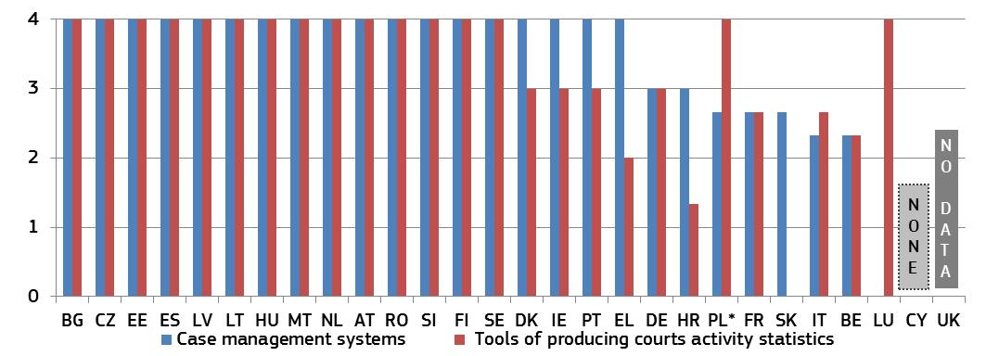
Figure 45: Topics of surveys conducted among court users or legal professionals* (source: European Commission)
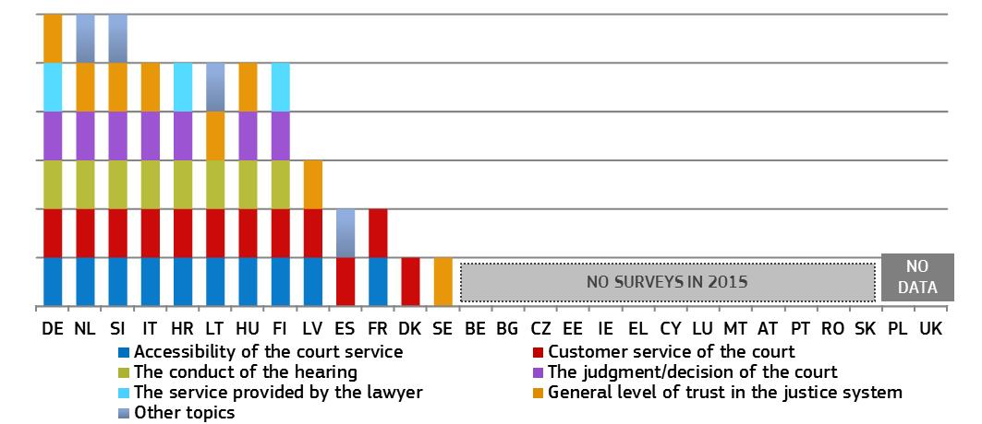* Member States were given one point per survey topic indicated regardless of the level they were performed at.
Figure 46: Follow-up of surveys conducted among court users or legal professionals (source: European Commission)
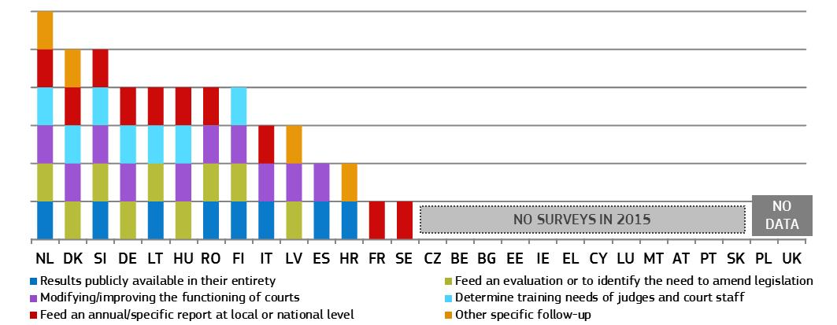

3.2.4 Standards
Standards can drive up the quality of justice systems. Following the mapping of quality standards in the 2016 Scoreboard, this edition examines certain standards on timing and information to parties in more detail. Figures 47-49 present the use of standards on time limits, timeframes and backlogs, and an overview of which Member States use these standards. Time limits are quantitative deadlines, e.g. for the time from the registration of a case until the first hearing. Timeframes are measurable targets/practices e.g. specifying a pre-defined share of cases to be completed within a certain time. Backlogs are cases that are pending after a certain pre-defined amount of time, e.g. three months or even ten years. Figure 48 presents in how many areas of law standards on timing exist.
Figure 47: Standards on timing* (source: European Commission)
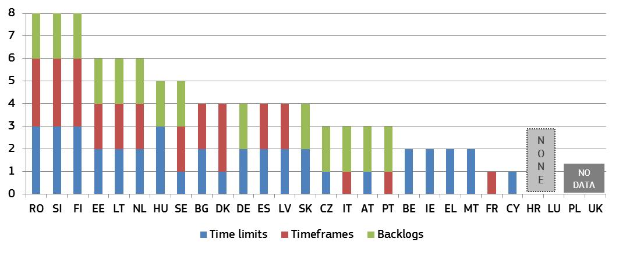
* Member States were given 1 point per area of law (civil/commercial, administrative, or other) that has standards defined.
Figure 48 shows the competences of the different powers of state to set and monitor the standards on timing.
Figure 48: Setting and monitoring standards* (source: European Commission)
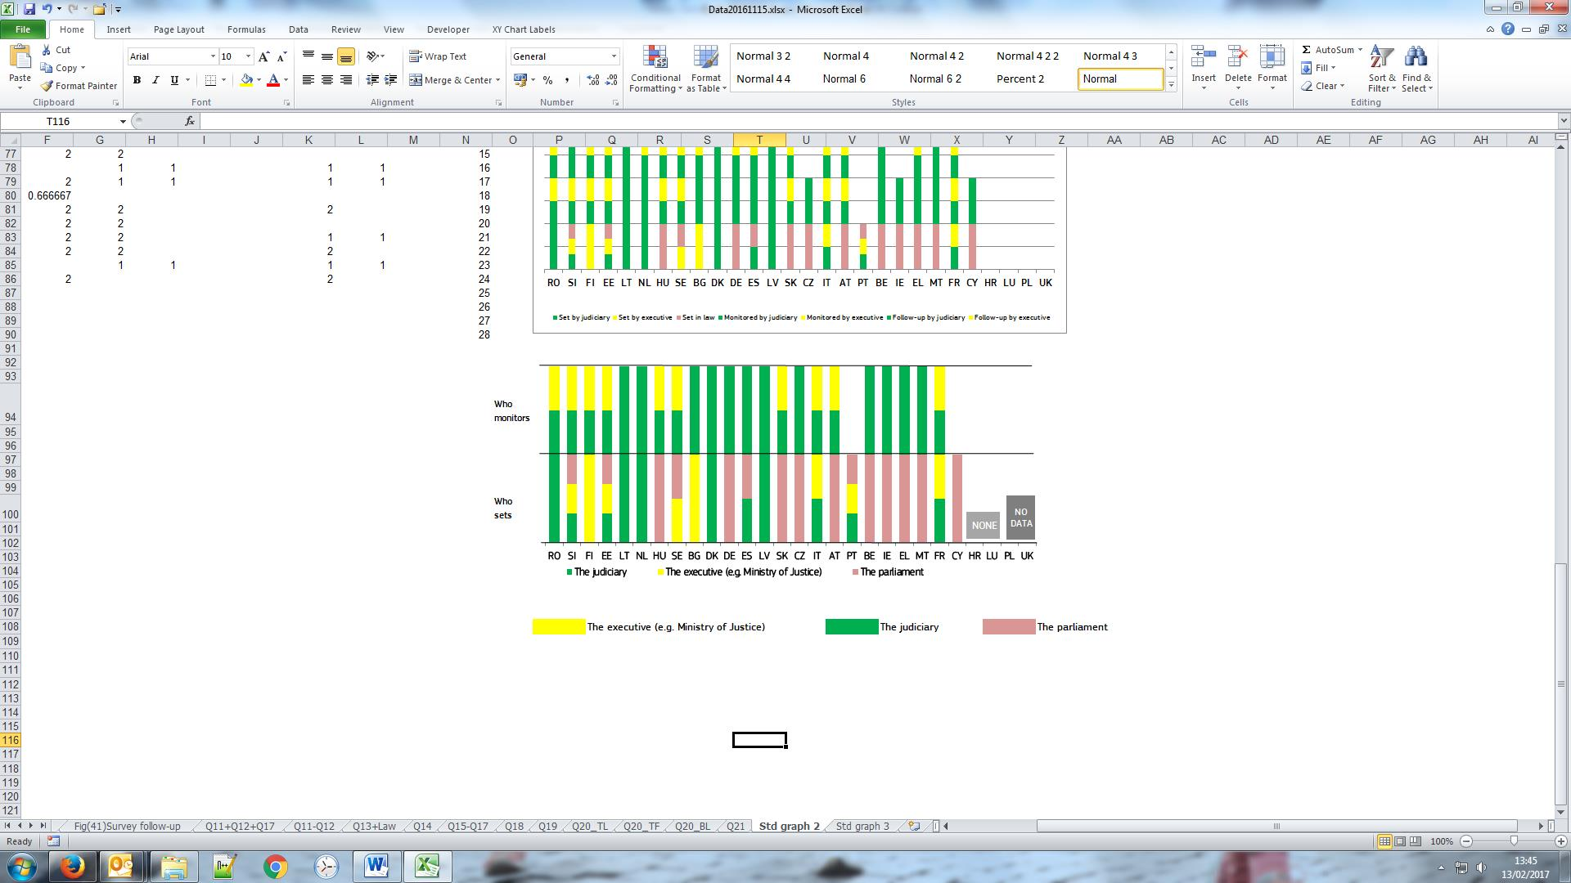 * Member States are ordered according to the order in Figure 47. Note that the definition ‘by the parliament (standards set in law)’ here indicates that a certain standard is set only in law. Even when more than one power is shown for setting/monitoring timing related standards, each power could be fully responsible for one type of standard. The ‘executive’ encompasses institutions under direct or indirect control by the government. The ‘judiciary’ includes bodies such as court presidents, councils for the judiciary, judges’ bodies, etc. CY and PT: No information on monitoring.
Figure 49 shows which measures are used when standards on timing (Figure 48) are not complied with. For example, in certain Member States non-compliance triggers a special meeting between the judge in question and the court president to discuss the situation. If it is an entire court which is not complying, the meeting could be between the president of the court in question and the president of the higher court.
Figure 49: Follow-up to non-compliance with standards (source: European Commission)
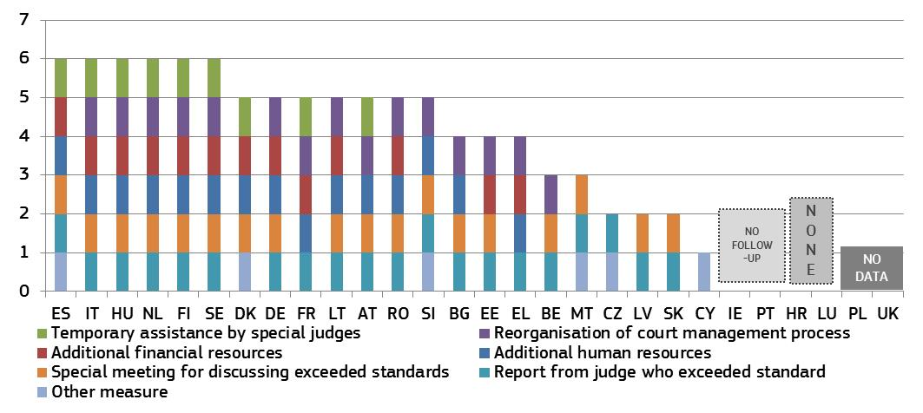
– Information to parties –
Figure 50 presents standards on the way parties are informed and the type of information they receive about the progress of their case. Certain Member States have a system with automatic notification by e-mail or SMS providing information about delays, timetables or general case progress. Others simply give online access to the information during the case, while some also leave it at the discretion of the courts.
Figure 50: Standards on information about case progress * (source: European Commission)
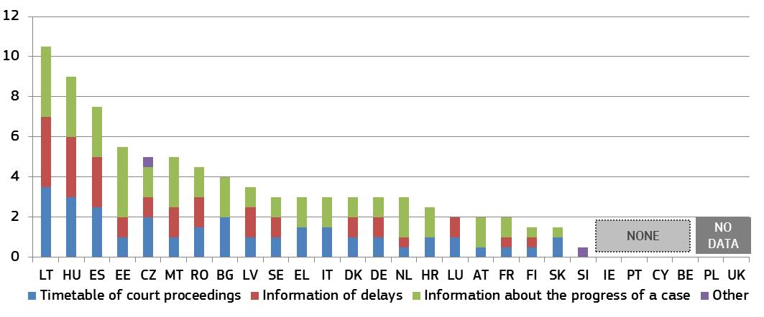
* Member States were given points depending on the method used to provide each type of information. 1.5 points for automatic notification by e-mail or SMS, 1 point for online access throughout the case, 0.5 points each for information upon request by parties, court discretion or any other method used.

3.2.5 Summary on the quality of justice systems
The 2017 Justice Scoreboard examines the factors that contribute to the quality of justice systems: easy access, adequate resources, effective assessment tools and appropriate standards.
Accessibility
This edition looks in more detail at how justice systems are accessible from the perspective of the court users, i.e. citizens, consumers or businesses.
- Most Member States provide online information about their justice system (Figure 20). However, room for improvement exists regarding the user-friendliness of this information, for example web pages which are accessible for the visually impaired or which provide interactive tools enabling citizens to find out whether they are eligible for legal aid. Also, online availability of court judgments for civil/commercial and administrative cases could be improved across all instances (Figure 27). Only 17 Member States publish all civil/commercial and administrative judgments of the highest courts.
- The availability of legal aid and the level of court fees have a key impact on access to justice, in particular for citizens in poverty. This edition examines how far legal aid systems support consumers in a dispute with a company of a high value (i.e. EUR 6 000) or a low value (i.e. claim corresponding to the Eurostat poverty threshold). Figure 21 shows that in some Member States, consumers whose income is below the Eurostat poverty threshold would not receive legal aid. The difficulty to benefit from legal aid could be particularly dissuasive when the court fees represent a significant share of the value of the claim (Figure 22).
- Proper use of ICT in courts contributes to speed up proceedings and to reduce cost. For example, a reform enabling courts in a Member State to deliver documents electronically to parties, and to deliver the remaining paper mail through a centralised postal system, saved more than EUR 4.5 million in 2016 (more than 2 % of the courts’ budget). The Scoreboard shows that electronic submission of claims is not in place in all Member States (Figure 23) nor are ways to follow online the progress in a court proceeding. A survey on the actual use of ICT between courts and lawyers shows that ICT tools are widely used in 10 out of the 20 Member States covered by the survey (Figure 24). They are most frequently used for general communication with courts, while signatures of documents and submissions of claims, summons and evidence are slightly less frequently done by electronic means. In 8 out of 10 Member States where lawyers report significantly less ICT use, the most frequent reason indicated is that the tools are not available and to a lesser degree bad experience with using ICT.
- Looking more closely at the channels used by consumers for complaining against a company (i.e. whether the complaint arrives through courts, public authorities, out of court mechanisms or consumer NGOs), it appears that the most frequent channel is the public authorities followed by the courts and the out of court mechanisms (Figure 29).
- In comparison to previous years, the voluntary use of alternative dispute resolution methods is increasingly promoted and incentivised in all Member States (Figure 30). The significant number of complaints submitted through the newly established online dispute resolution (ODR) platform shows the willingness of consumers to use alternative dispute resolution methods. In most Member States cross-border disputes represent a significant share of all disputes submitted to the ODR platform (Figure 31).
Resources
High-quality justice requires an adequate level of financial and human resources, appropriate training and diversity among judges, including gender balance. The Scoreboard shows the following:
- In terms of financial resources, data show that, in general, over half of the Member States increased expenditure on the judicial system per inhabitant in 2015 (Figure 32). However, few Member States facing particular challenges have decreased their budget. Member States mostly use historical or actual cost for determining financial resources for the judiciary instead of relying on the actual workload or court requests (Figure 34).
- The level of gender balance among judges in first and/or second instance courts continues overall to be good or appears to be moving towards a balance (Figure 36). In Supreme Courts however, even if most Member States are moving towards a gender balance, some Member States are moving in the opposite direction. (Figure 37).
- On the training of judges, while most Member States appear to recognise the importance of continuous training (Figures 39 and 40), efforts are needed to diversify the scope of the training offered. Continuous training on judicial skills (judgecraft), IT skills, court management and judicial ethics does not exist in all Member States (Figure 41). Furthermore, certain Member States do not provide any training on communicating with parties and with the press (Figure 42). In 2016, the European Judicial Training Network set up a short-term exchange programme for court presidents and heads of prosecution services focusing for example on change management and ICT.
Assessment tools
- Monitoring and evaluation tools for court activities exist in all Member States (Figure 43) however, not all Member States have the full range of such tools. The full potential of ICT case management systems still need to be improved in many Member States (Figure 44) to ensure that they can serve various purposes, including generating statistics, and that they are implemented consistently across the whole justice system. For example, in some Member States, ICT tools do not provide for the management of backlogs, including the identification of particularly old cases. By contrast, certain Member States have early-warning systems to detect malfunctions or non-compliance with case processing standards, which facilitates the finding of timely solutions. In some Member States, it is still not possible to ensure nationwide data collection across all justice areas.
- The regular use of surveys remains a central source for understanding the views that users and professionals have on the justice system. Around half of Member States undertook surveys in 2015 (Figure 45). Although all Member States undertaking surveys have also ensured follow-up, the extent of it differs greatly between them. The most common practice is to feed survey results into an annual report at local or national level (Figure 46). In several Member States, client-satisfaction surveys are published by the courts.
Standards
Standards can drive up the quality of justice systems. This edition examines in more detail certain standards aiming to improve the timing of proceedings and the information to the parties.
- Most Member States use standards on timing. However, certain Member States facing particular challenges on efficiency are currently not using such standards. Standards fixing time limits (e.g. for the time from the registration of a case until the first hearing) are most widespread, while those on timeframes (e.g. specifying a pre-defined share of cases to be completed within a certain time) and backlogs are used less (Figure 47). The monitoring of the respect of the standards is mainly under the responsibility of the judiciary (Figure 48). The non-compliance with the standards can trigger various type of follow-up. Most commonly, the judge concerned is asked to report and/or to discuss the issue, but other consequences can be the increase of human or financial resources of a certain court, the provision of temporary assistance by special judges or the reorganisation of the court management process (Figure 49).
- Most Member States have standards on how to inform the parties about the progress of their case, the court timetable or potential delays (Figure 50). The differences between Member States relate mainly to the methods used. Certain Member States have a system with automatic notification by e-mail or SMS providing information about delays, timetables or general case progress. Others simply give online access to the information during the case, while some also leave it at the discretion of the courts. From the perspective of citizen-friendliness, automated information by the court is preferable to one which requires action from the parties.

3.3 Independence
Judicial independence is a requirement stemming from the right to an effective remedy before a tribunal enshrined in the Charter (Article 47). It guarantees the fairness, predictability and certainty of the legal system, which are important elements for an attractive investment environment. In addition to information about perceived judicial independence from various sources, the Scoreboard shows how justice systems are organised to protect judicial independence in certain types of situations where independence could be at risk. Having continued its cooperation with European judicial networks, particularly the European Network of Councils for the Judiciary (ENCJ), the 2017 Scoreboard shows up-to-date figures on structural independence and presents new figures on the appointment and evaluation of judges.

3.3.1 Perceived judicial independence
Figure 51: Perceived independence of courts and judges among the general public (source: Eurobarometer– light colours: 2016, dark colours: 2017)
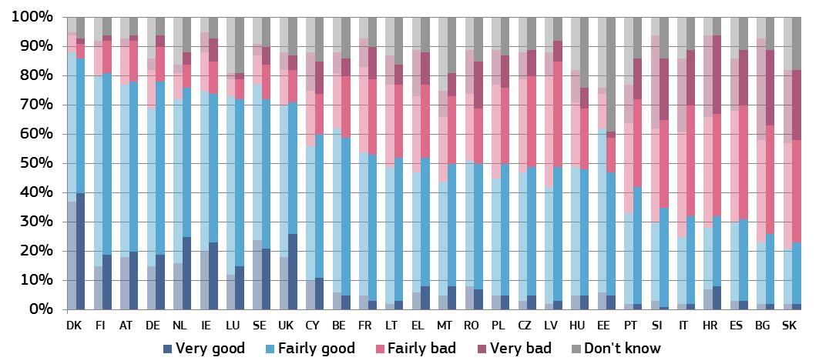
Figure 52 shows the main reasons for the perceived lack of independence of courts and judges. The respondents among the general public, who rated the independence of the justice system as being ‘fairly bad’ or ‘very bad’, could choose among three reasons to explain their rating. The Member States are in the same order as in Figure 51.
Figure 52: Main reasons among the general public for the perceived lack of independence (share of all respondents — higher value means more influence) (source: Eurobarometer)
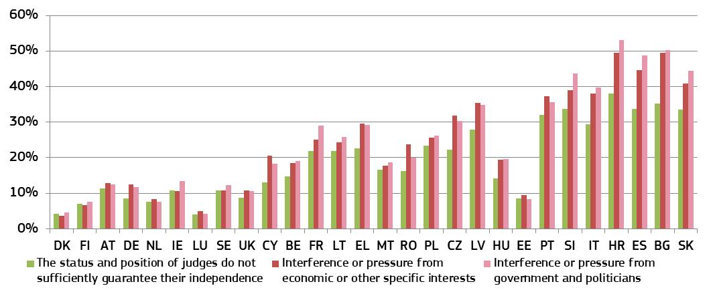
Figure 53: Perceived independence of courts and judges among companies (source: Eurobarometer– light colours: 2016, dark colours: 2017)
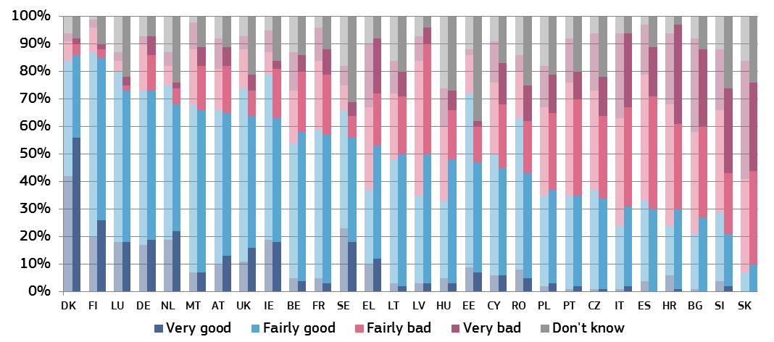
Figure 54 shows the main reasons for the perceived lack of independence of courts and judges. The respondents among companies, who rated the independence of the justice system as being ‘fairly bad’ or ‘very bad’, could choose among three reasons to explain their rating. The Member States are in the same order as in Figure 53.
Figure 54: Main reasons among companies for the perceived lack of independence (rate of all respondents — higher value means more influence) (source: Eurobarometer)
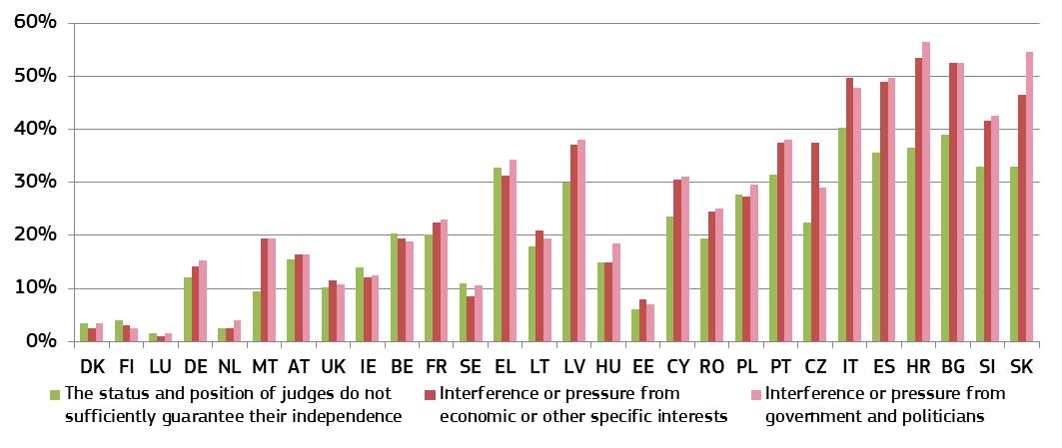
Figure 55: WEF: businesses’ perception of judicial independence (perception — higher value means better perception) (source: World Economic Forum)
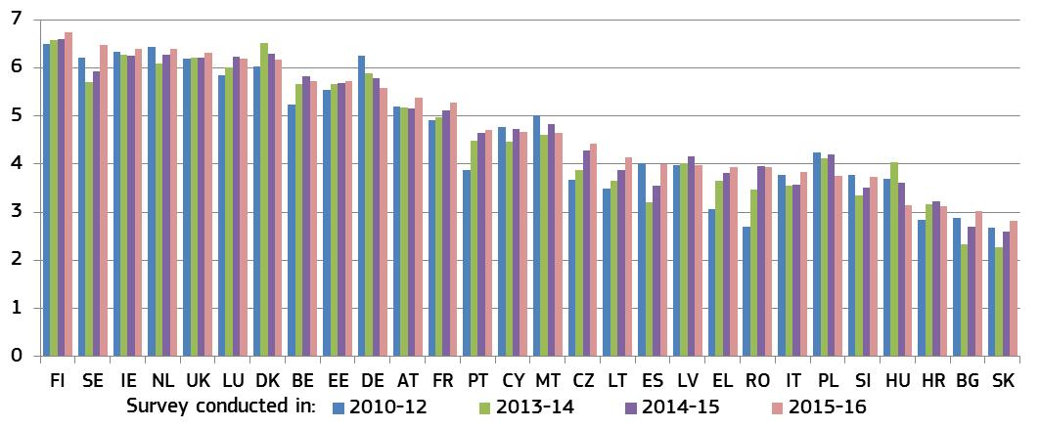

3.3.2 Structural independence
The Scoreboard presents an overview of how justice systems are organised to safeguard judicial independence in certain types of situations where independence may be at risk. This edition focuses on some of the main aspects of the judges’ status: the appointment of judges (Figures 56 and 57), the evaluation of judges (Figure 58), the transfer of judges without their consent (Figure 59), and the dismissal of judges (Figure 60).
The 2010 Council of Europe Recommendation on judges: independence, efficiency and responsibilities (‘the Recommendation’) sets out standards designed to preserve the independence of the judiciary in such situations. The figures presented in the Scoreboard do not provide an assessment or present quantitative data on the effectiveness of the safeguards. They are not intended to reflect the complexity and details of the safeguards. Having more safeguards does not, in itself, ensure the effectiveness of a justice system. It should also be noted that implementing policies and practices to promote integrity and prevent corruption within the judiciary is also essential to guarantee judicial independence.
– Safeguards relating to judges –
The guarantees of structural independence require rules, including those on the appointment of judges. Figure 56 presents the bodies and authorities which propose judges for their first appointment at first instance courts and the authorities that appoint them. It also shows whether the recruitment of judges is done through a specific exam or a competition for judges, or through a vacancy notice without a specific exam.
Figure 56: Appointment of judges: proposing and appointing authorities*
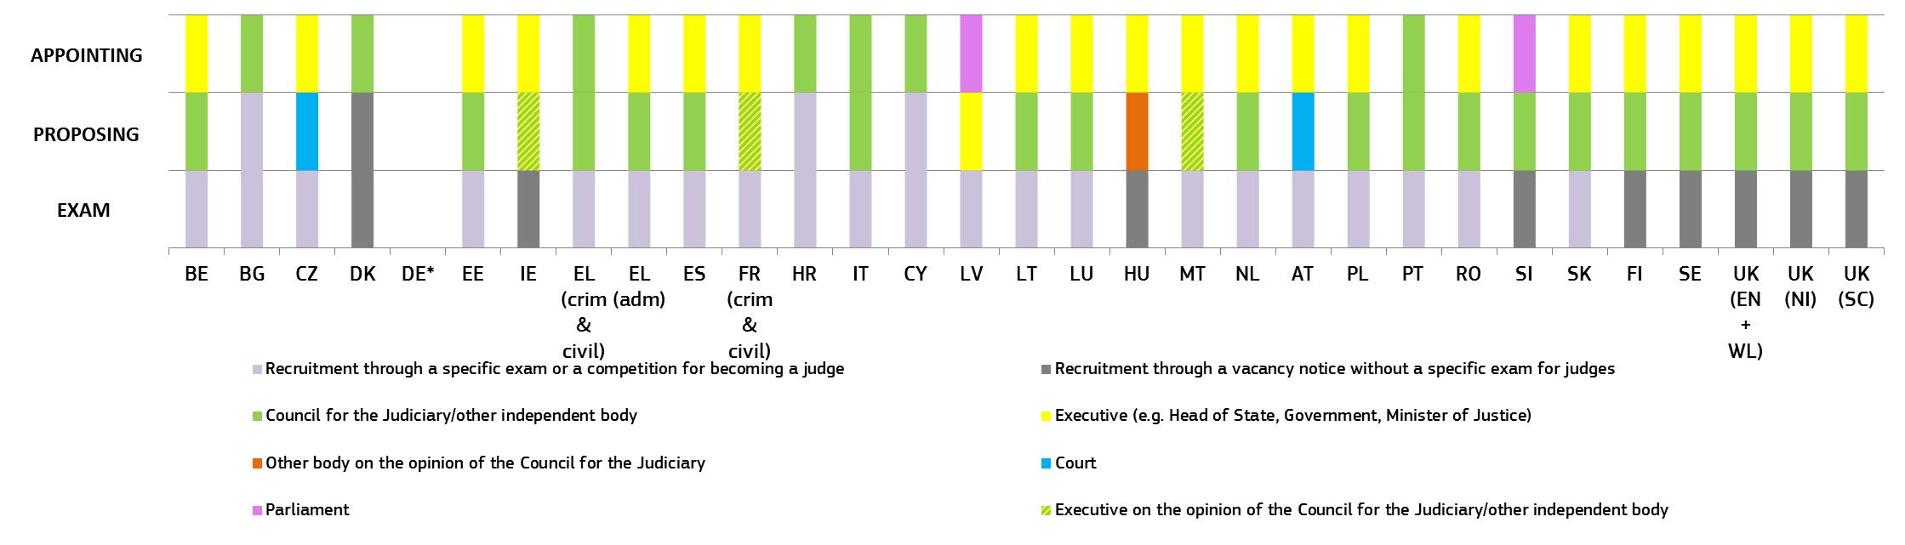
* In several countries other authorities or bodies (e.g. court presidents, judges) may or should deliberate or be consulted on the candidate judges (e.g. in BE, CZ, DE, EE, LT, HU, NL, AT, UK (EN+WL), and UK (SC)); In some countries (e.g. LT and PL) certain candidates are exempt from taking the special exam for judges because of their previous qualifications or experience; CZ: the president formally appoints judges, the Minister of Justice decides on the assignment of a judge to the particular court. In practice, the candidate judges for appointment are nominated by presidents of regional courts. Afterwards, the list of candidates is forwarded to the Ministry of Justice that forwards the list of candidates (after considering all circumstances) to the Head of State; DE: proceedings at the level of the federal states differ greatly. In half of the 16 federal states, judicial electoral committees participate in the recruitment. In some of the federal states, this matter is dealt with completely by their state Ministry of Justice, whereas in other federal states the authority to decide on recruitment and on the (first) appointment has been transferred to the presidents of the higher regional courts. Some federal states provide for mandatory participation of a council of judges. Others require a joint appointment by the competent minister and a conciliation committee if the council of judges objects. In some federal states, judges are elected by the state parliaments and have to be appointed by the state executive; IE: the Judicial Appointments Advisory Board recommends at least seven candidates to the government for appointment. Following the government’s decision, the president formally appoints the judge and cannot refuse to appoint the proposed candidate; FR: candidate judges are selected through a specific exam for becoming a judge and are ranked according to their results. Following a discussion between the candidate and the Ministry of Justice on assignment to a particular court, the Conseil Supérieur de la Magistrature must issue an opinion on the first appointment of these candidates and the Minister of justice then forwards the list of candidates to the President of the Republic, who must formally appoint the candidate judges through a decree without having discretion on the matter; LV: after three years, the Judicial Qualification Board, composed of and elected by judges, provides an opinion in the evaluation of the professional work of a judge; NL: the decision to propose a judge for appointment is formally made by a court president, relying on the recommendation by the Independent Selection Committee; RO: The figure relates to the appointment of senior judges; UK (EN+WL): Different procedures apply for the first appointment of the senior judiciary (High Court Judges and above), which are presented above, and for the appointment of the junior judiciary (Circuit Judges and below).
Figure 57 presents the possible discretion that the executive power (e.g. president of the republic, government) or the parliament have when they are appointing judges for their first appointment at first instance courts upon submission from the proposing authorities (e.g. Council for the Judiciary, court). The height of the column depends on whether the executive can reject a candidate judge at all, whether it can choose only among the proposed candidates, or whether it can choose and appoint any other candidate, even if she or he is not proposed by the competent authority. An important safeguard in case of non-appointment is the obligation to provide reasons and the possibility of a judicial review. The figure is a factual presentation of the legal system and does not make a qualitative assessment of the effectiveness of the safeguards. For example, it should be noted that in several countries where the executive or the parliament has the power to reject a candidate judge, such an event has never happened (e.g. in NL, AT, SK, SE, UK (EN+WL) and UK (SC)), or has happened only in very few cases (e.g. in LV, SI and FI).
Figure 57: Appointment of judges: competence of the executive and the parliament* (higher value means more possible discretion)
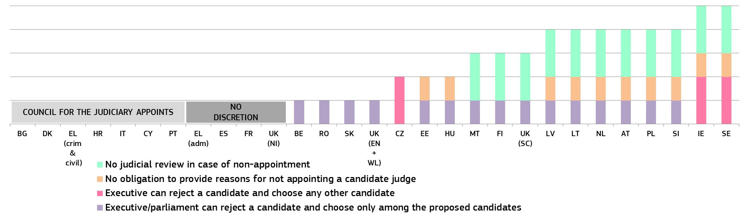
* For each Member State, one point was given if the executive/parliament can reject a proposed candidate and choose another candidate among those proposed; one point was given if there is no obligation by the executive/parliament to state reasons for not appointing a candidate judge; two points were given if the executive can reject a candidate and choose any other candidate; and two points were given if there is no judicial review in case of non-appointment. DE: no data; IE: the government may appoint a person who is not on the list sent by the Judicial Appointments Advisory Board but in practice does not do so. The final appointment is made by the president, who cannot refuse; EL (admin): the final appointment is made by the president, who cannot refuse; LT: without advice from the Judicial Council, the President cannot appoint a judge; if the Judicial Council gives positive advice to the president, the president is free to adopt the final decision; If the Judicial Council gives negative advice to the president, then the president must follow this advice when adopting the final decision; LU: there is no binding text on this issue, but until now, the appointing authority has never rejected a candidate judge proposed for appointment by the Commission du recrutement et de la formation des attaches de justice; PL: whether the President has to give reasons and whether there is judicial review in case of non-appointment of judges is currently being examined by the Supreme Administrative Court; RO: the president can refuse the appointment of a senior judge or prosecutor only once. The reasoned refusal is sent to the Superior Council of Magistracy; SK: The president could possibly refuse to appoint a candidate judge but it has never happened; FI: if the president does not appoint the proposed candidate, he/she cannot choose another candidate but remit only once the appointment for further preparation; SE: if the government wants to appoint a candidate that the Judges Proposals Board did not submit, it is legally obliged seek a new opinion by the Board on that other candidate; UK(EN+WL) and UK(NI): the appointing authority referred is the Lord Chancellor (UK Minister of Justice), who recommends a candidate judge for formal appointment by the Queen; UK(SC): the appointing authority referred is the First Minister of Scotland, who recommends a candidate judge for formal appointment by the Queen. If the First Minister of Scotland were to reject a candidate judge, the proposing authority (Judicial Appointments Board for Scotland) may propose this candidate judge again to the First Minister.
Figure 58 presents who decides on the evaluation of judges and what criteria are used (e.g. quantitative, qualitative). The Recommendation provides that where judicial authorities establish systems for the assessment of judges, such systems should be based on objective criteria.
Figure 58: Individual evaluation of judges*
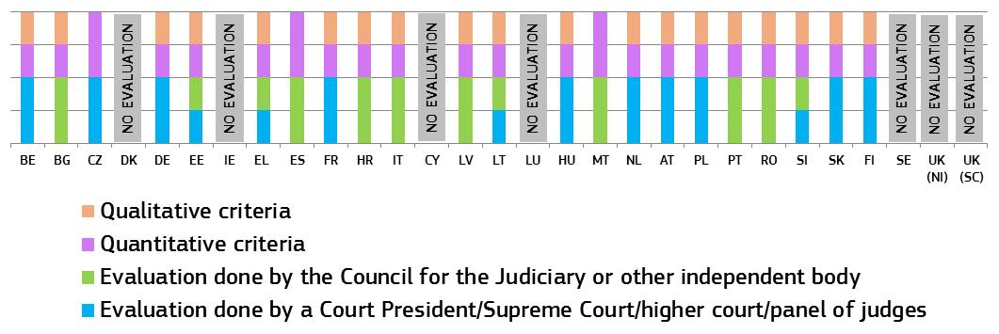
* For each Member State, two points were given if the evaluation was done by one authority or body and one point was given if this is a competence shared by two authorities/bodies. One point was given if a country uses quantitative and qualitative criteria, and two points were given if only quantitative criteria are used. UK (EN+WL): no data; EL: evaluation of criminal and civil judges is conducted by the Council for the Judiciary, and the evaluation of administrative judges is conducted by the judicial inspection body; IT: criminal and civil judges-qualitative and quantitative criteria are evaluated; administrative judges-quantitative criteria are evaluated.
Figure 59 shows whether the transfer of judges without their consent is allowed, if so, which authorities take the decision, the reasons for such transfers and whether it is possible to appeal against such a decision. The numbers indicate how many judges were transferred without consent in 2015 for organisational, disciplinary or other reasons, and how many appealed (if no number is given, there are no data available).
Figure 59: Transfer of judges without their consent* (irremovability of judges)
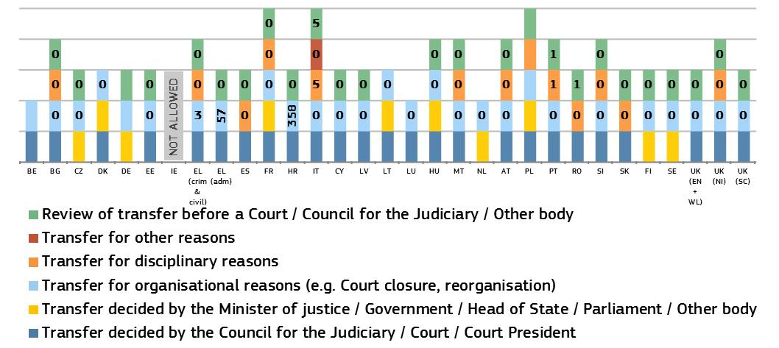
* BE: transfer for organisational reasons only within a court; CZ: a judge can be transferred only to the court of the same instance, the court one instance higher or lower (all within the same judicial district); DE: transfer for a maximum of three months and only in cases of representation; FR: Minister of Justice can transfer a judge for organisational reasons in the rare event such as the closure of a court or for legal reasons such as fixed-term appointments (for a court’s president or for specialised functions); HR: judges were transferred due to implementation of the judicial map reform; IT: three judges and two magistrates were transferred for disciplinary reasons by the CSM (civil and criminal courts’ council), who all appealed against the transfer; the CPGA (administrative courts' council) can transfer for disciplinary reasons only and did not transfer any judges; LT: temporary transfer in the event of an urgent need to ensure the proper functioning of the court; RO: only temporary transfers of up to a year, for disciplinary sanctions; FI: transfer in case of reorganisation of functions of public administration.
Figure 60 shows the authorities with the power to propose and take decision on the dismissal of judges at courts of first and second instance. The upper part of each column indicates which authority takes the final decision and the lower part shows – where relevant – which authority proposes dismissal or who must be consulted before a decision is taken. The numbers show how many judges (from all court instances) were dismissed in 2015 by a given body and how many appealed against dismissal (if no number is given, there are no data available).
Figure 60: Dismissal of judges at courts of 1st and 2nd instance*
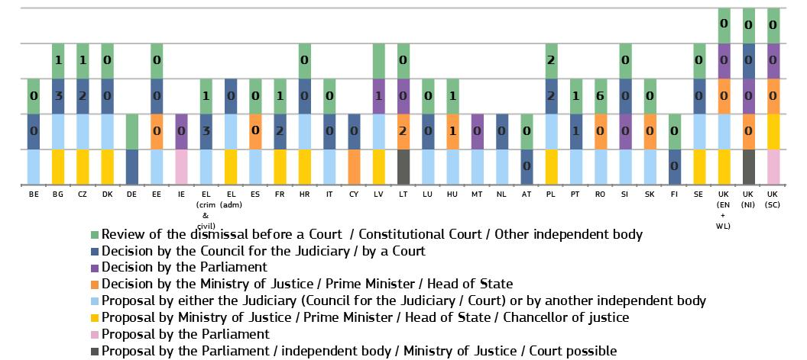
* The numbers indicate how many judges were dismissed in 2015 by particular body and how many appealed dismissal (no number indicates no data available). UK (EN+WL): no full-time salaried judges were dismissed. Only one part-time (fee-paid) tribunal judge was dismissed and fifteen non-salaried lay magistrates; In some countries, the executive has an obligation, either by law or practice, to follow the proposal of the Council for the Judiciary to dismiss a judge (e.g. ES and LT).
– Work of judicial networks –
European judicial networks have continued with their examination on the legal safeguards for protecting judicial independence. In September 2016, a joint brainstorming on the quality and independence of justice systems with members of the ENCJ, NPSC and ACA-Europe took place during which the Commission encouraged these networks to develop the examination of the effectiveness of the safeguards for judicial independence. The ENCJ has advanced in this examination (e.g. on non-transferability of judges, on funding of the judiciary) and has carried out a new survey of judges (e.g. on judges’ perception of judicial independence, judges’ perception on whether appointments and promotions were based on the ability and experience of the judges). The results of this work will be presented later in 2017 and could feed future editions of the Scoreboard.

3.3.4 Summary on judicial independence
Judicial independence is a fundamental element of an effective justice system. It is vital for upholding the rule of law, the fairness of judicial proceedings and the trust of citizens and businesses in the legal system. For this reason, any justice reform should uphold the rule of law and comply with European standards on judicial independence. The Scoreboard shows trends in perceived judicial independence and information on legal safeguards to protect judges in certain situations where their independence may be at risk.
- The 2017 Scoreboard presents the developments in perceived independence from surveys of citizens (Eurobarometer) and companies (Eurobarometer and World Economic Forum):
  - All surveys generally show similar results, particularly among the Member States with the lowest and the highest perceived judicial independence.
  - The WEF survey, presented for the fifth time, shows that the businesses’ perception of independence has improved or remained stable in more than two-thirds of Member States, both when compared with the previous year or since 2010. Compared to 2010, there were improvements in several Member States with a low level of perceived independence (Figure 55).
  - Among the reasons for the perceived lack of independence of courts and judges, the interference or pressure from government and politicians was the most stated reason, followed by the pressure from economic or other specific interests. Both reasons are still notable for several Member States where perceived independence is very low (Figures 54 and 56).
  - Among the reasons for good perception of independence of courts and judges, more than three-quarter of companies and of citizens (equivalent to 38 % or 44 % of all respondents, respectively) named the guarantees provided by the status and position of judges.
- The Scoreboard focuses on certain safeguards relating to the status of judges, from their appointment, their evaluation and possible transfer without consent, to their potential dismissal:
- On the first appointment of judges at first instance courts, it appears that in a majority of Member States, the Council for the Judiciary or another independent body proposes the candidate judges for the appointment (Figure 56). In a majority of Member States, the executive power (e.g. the President of the Republic or other Head of State, Government, Minister of Justice) appoints judges and its discretion varies (Figure 57).
- On the individual evaluation of judges (Figure 59), in all Member States, the evaluation is carried out either by the Council for the Judiciary, or by the court presidents (or other judges). While several Member States do not evaluate judges individually, the countries that do usually use both quantitative and qualitative criteria.
- On the transfer of judges without their consent and the dismissal of judges at first and second instance courts, in nearly all Member States, judges transferred or dismissed can appeal or request a judicial review of the decision. The figures show that in nearly all Member States a low number of judges were dismissed or transferred without their consent and that most transfers were for organisational reasons (Figures 59 and 60).

4. CONCLUSIONS
After five editions, the 2017 EU Justice Scoreboard shows progress: the effectiveness of justice systems has generally improved, a number of Member States have shown determination in engaging in justice reforms, the Council every year addressed recommendations to certain Member States, the judiciary has actively cooperated with the Commission and the European Parliament has supported EU actions in this area since the very beginning. Challenges remain and further efforts must be made to reap sustainable rewards for citizens. The rule of law and the future of Europe deserve these efforts.

2016 State of the Union Speech delivered before the European Parliament on 14 September 2016: https://ec.europa.eu/priorities/state-union-2016_en
http://europa.eu/rapid/press-release_SPEECH-16-2023_en.htm
See also Communication from the Commission — EU law: Better results through better application, 13 December 2016, 2017/C 18/02.
In view of the preparation of the EU Justice Scoreboard and to promote the exchange of best practices on the effectiveness of justice systems, the Commission asked Member States to designate two contact persons, one from the judiciary and one from the ministry of justice. Regular meetings of this informal group are taking place.
http://ec.europa.eu/justice/effective-justice/scoreboard/index_en.htm
In view of the preparation of the EU Justice Scoreboard and to promote the exchange of best practices on the effectiveness of justice systems, the Commission asked Member States to designate two contact persons, one from the judiciary and one from the ministry of justice. Regular meetings of this informal group are taking place.
ENCJ unites the national institutions in the EU Member States which are independent of the executive and legislature, and which are responsible for the support of the Judiciaries in the independent delivery of justice: https://www.encj.eu/
NPSJC provides a forum through which European institutions are given an opportunity to request the opinions of Supreme Courts and to bring them closer by encouraging discussion and the exchange of ideas: http://network-presidents.eu/
ACA-Europe is composed of the Court of Justice of the EU and the Councils of State or the Supreme administrative jurisdictions of each EU Member State: http://www.juradmin.eu/index.php/en/
ECN has been established as a forum for discussion and cooperation of European competition authorities in cases where Articles 101 and 102 of the TFEU are applied. The ECN is the framework for the close cooperation mechanisms of Council Regulation 1/2003. Through the European Competition Network, the Commission and the national competition authorities in all EU Member States cooperate with each other: http://ec.europa.eu/competition/ecn/index_en.html
COCOM is composed of representatives of EU Member States. Its main role is to provide an opinion on the draft measures that the Commission intends to adopt: https://ec.europa.eu/digital-single-market/en/communications-committee
The European Observatory on Infringements of Intellectual Property Rights is a network of experts and specialist stakeholders. It is composed of public- and private-sector representatives, who collaborate in active working groups. https://euipo.europa.eu/ohimportal/en/web/observatory/home
CPC is a network of national authorities responsible for enforcing EU consumer protection laws in EU and EEA countries: http://ec.europa.eu/internal_market/scoreboard/performance_by_governance_tool/consumer_protection_cooperation_network/index_en.htm
EGMLTF meets regularly to share views and help the Commission define policy and draft new legislation: http://ec.europa.eu/justice/civil/financial-crime/index_en.htm
Eurostat is the statistical office of the EU: http://ec.europa.eu/eurostat/about/overview
EJTN is the principal platform and promoter for the training and exchange of knowledge of the European judiciary. It develops training standards and curricula, coordinates judicial training exchanges and programmes, disseminates training expertise and promotes cooperation between EU judicial training institutions. EJTN has some 34 members representing EU states as well as EU transnational bodies. http://www.ejtn.eu/ .
CCBE is an international non-profit association which represents European bars and law societies. CCBE membership includes the bars and law societies of 45 countries from the EU, the EEA, and wider Europe: http://www.ccbe.eu/
WEF is an International Organisation for Public-Private Cooperation, whose members are companies: https://www.weforum.org/
The reasons for country-specific recommendations and the progress on the implementation of such recommendations are presented on an annual basis by the Commission in individual country reports in the form of Staff Working Documents: https://ec.europa.eu/info/publications/2017-european-semester-country-reports_en
The information has been collected in cooperation with the group of contact persons on national justice systems for 25 Member States. PL and UK did not submit information. DE explained that a number of reforms are under way as regards judiciary, where the scope and scale of the reform process can vary within the 16 federal states.
BG, HR, IT, CY, PT, SK; see Council Recommendation of 12 July 2016 on the 2016 National Reform Programme of Bulgaria and delivering a Council opinion on the 2016 Convergence Programme of Bulgaria, (2016/C 299/08); Council Recommendation of 12 July 2016 on the 2016 National Reform Programme of Croatia and delivering a Council opinion on the 2016 Convergence Programme of Croatia (2016/C 299/23); Council Recommendation of 12 July 2016 on the 2016 National Reform Programme of Italy and delivering a Council opinion on the 2016 Stability Programme of Italy, (2016/C 299/01); Council Recommendation of 12 July 2016 on the 2016 National Reform Programme of Cyprus and delivering a Council opinion on the 2016 Stability Programme of Cyprus, (2016/C 299/07); Council Recommendation of 12 July 2016 on the 2016 National Reform Programme of Portugal and delivering a Council opinion on the 2016 Stability Programme of Portugal, (2016/C 299/26); Council Recommendation of 12 July 2016 on the 2016 National Reform Programme of Slovakia and delivering a Council opinion on the 2016 Stability Programme of Slovakia, (2016/C 299/15).
LV and SI.
BE, ES, LV, MT, PL, RO, SI. These challenges have been reflected in the recitals of the Country-Specific Recommendations and the country reports relating to these Member States. The country reports are available at: https://ec.europa.eu/info/publications/2017-european-semester-country-reports_en. Furthermore, justice reforms in EL are closely being monitored in the context of the Economic Adjustment Programme for Greece.
Report on progress in Bulgaria under the Cooperation and Verification Mechanism, COM(2017) 43 final; Report on progress in Romania under the Cooperation and Verification Mechanism COM(2017) 44 final.
COM(2014) 158 final/2.
Commission Recommendation (EU) 2016/1374 of 27 July 2016 regarding the rule of law in Poland, OJ L 217, 12.8.2016, p. 53; Commission Recommendation (EU) 2017/146 of 21 December 2016 regarding the rule of law in Poland, OJ L 22, 27.1.2017, p. 65. See also IP/16/2643 and IP/16/4476.
BG, EL, HR, CY, SI.
‘The judicial system and economic development across EU Member States’, JRC (forthcoming).
See references in the 2016 EU Justice Scoreboard.
2016 Study on the functioning of judicial systems in the EU Member States, carried out by the CEPEJ Secretariat for the Commission: http://ec.europa.eu/justice/effective-justice/scoreboard/index_en.htm
The enforcement of court proceedings is also important for the efficiency of a justice system. However, comparable data are not available in most Member States.
Length of proceedings, clearance rate and number of pending cases are standard indicators defined by CEPEJ: http://www.coe.int/t/dghl/cooperation/cepej/evaluation/default_en.asp
CEPEJ data on second instance and Supreme Court proceedings and on specific categories of cases (e.g. insolvency) are not available for a sufficient number of Member States.
The years were chosen to keep the five-year perspective with 2010 as a baseline, while at the same time not overcrowding the figures. 2012 is available in the CEPEJ report.
The length of proceedings in specific areas is calculated in calendar days, counting from the day when an action or appeal was lodged before the court (or the indictment became final) and the day on which the court adopted its decision (figures 13-16, 18 and 20). Values are ranked based on a weighted average of data for 2013, 2014 and 2015 for figures 13-16 and 2014 and 2015 for figures 17-18. Where data was not available for all years, the average reflects the available data, calculated based on all cases, a sample of cases or estimations.
See http://eur-lex.europa.eu/legal-content/EN/TXT/PDF/?uri=CELEX:12012E/TXT&from=EN
The calculation has been made based on the length of cases of appeal against national regulatory authority decisions applying national laws that implement the Regulatory Framework for Electronic Communications (Directives 2002/19/EC (Access Directive), Directive 2002/20/EC (Authorisation Directive), Directive 2002/21/EC (Framework Directive), Directive 2002/22/EC (Universal Service Directive), and other relevant EU law such as the Radio Spectrum Policy Programme, Commission Spectrum Decisions, excluding Directive 2002/58/EC on privacy and electronic communications.
Community Trade Mark Regulation (207/2009/EC).
Figures 16 and 17 relate to the enforcement of the Unfair Contract Terms Directive (93/13/EEC), Consumer Sales and Guarantees Directive (1999/44/EC), Unfair Commercial Practices Directive (2005/29/EC), Consumer Rights Directive (2011/83/EC) and their national implementing provisions.
Based on Article 9 of Directive 2004/48/EC (IPRED).
The legal framework is the same as referred to in footnote 38.
Recital 2 of Directive (EU) 2015/849 of the European Parliament and of the Council of 20 May 2015 on the prevention of the use of the financial system for the purposes of money laundering or terrorist financing.
IMF Factsheet, 6 October 2016, http://www.imf.org/en/About/Factsheets/Sheets/2016/08/01/16/31/Fight-Against-Money-Laundering-the-Financing-of-Terrorism
Article 44(1) of the Directive (EU) 2015/849 (the implementation deadline for the Directive is in June 2017).
Reading of developments should be done with care as changes can have methodological explanations (as explained below the figures).
See section 2. Variance in the results over the five years analysed may be explained by contextual factors (variations of more than 10 % of incoming cases are not unusual) or systemic deficiencies (lack of flexibility and responsiveness or inconsistencies in the process of reform).
All civil and commercial litigious and non-litigious cases, non-litigious land and business registry cases, other registry cases, other non-litigious cases, administrative law cases and other non-criminal cases, under the CEPEJ methodology.
To be noted that the Association of the Councils of State and Supreme Administrative jurisdictions (ACA) has published a transversal study on ‘Access to administrative supreme courts and to their decisions’: http://www.juradmin.eu/images/media_kit/aca_surveys/Transversal-Analysis---Annex-1.pdf
2016 data collected in cooperation with the group of contact persons on national justice systems.
Charter of Fundamental Rights of the EU, Article 47(3).
The at-risk-of-poverty (AROP) threshold is set at 60 % of the national median equivalised disposable household income. European Survey on Income and Living Conditions, Eurostat table ilc_li01, http://ec.europa.eu/eurostat/web/income-and-living-conditions/data/database
Member States use different methods to establish the eligibility threshold, e.g. different reference periods (monthly/annual income). About half of the Member States also have a threshold related to the personal capital of the applicant. This is not taken into account for this figure. In BG, ES, FR, HU, HR, LV, LU, NL, PT, UK (SC), certain categories of persons (e.g. individuals who receive certain benefits) are automatically entitled to receive legal aid in civil/commercial disputes. Individuals who receive some type of social benefits are automatically entitled to legal aid in civil/commercial disputes. Additional criteria that Member States may use such as the merit of the case are not reflected in this figure.
2016 data collected through replies by CCBE members to a questionnaire based on the following specific scenario: a dispute of a consumer with a company (two different values of the claim have been indicated: €6000 and the Eurostat poverty threshold in each Member State). Given that conditions for legal aid depend on the applicant’s situation, the following scenario was used: a single 35-year-old employed applicant without any dependant and legal expenses insurance, with a regular income and a rented apartment.
The data refer to income thresholds valid in 2016 and have been collected through replies by CCBE members to a questionnaire based on the following specific scenario: a dispute of a consumer with a company (two different values of the claim have been indicated: €6000 and the Eurostat poverty threshold in each Member State).
Data concern 2015. Equipment rate from 100 % (device completely deployed) to 0 % (device non-existing) indicates the functional presence in courts of the device covered by the graph, according to the following scale: (100 % = 4 points if applicable to all matters / 1.33 points per specific matter; 50-99 % = 3 points if applicable to all matters / 1 point per specific matter; 10-49 % = 2 points if applicable to all matters / 0.66 point per specific matter; 1-9 % = 1 point if applicable to all matters / 0.33 points per specific matter. Matter relates to the type of litigation handled (civil/commercial, criminal, administrative or other).
Figures 24 and 25 are based on a CCBE survey conducted among lawyers.
2016 data collected in cooperation with the group of contact persons on national justice systems.
2016 data collected in cooperation with the group of contact persons on national justice systems.
2016 data collected in cooperation with the group of contact persons on national justice systems.
To be published in the framework of the Consumer Conditions Scoreboard 2017 (3rd quarter of 2017).
The methods to promote and incentivise the use of ADR do not cover compulsory requirements to use ADR before going to court, as such requirements raise concerns about their compatibility with the right to an effective remedy before a tribunal enshrined in the EU Charter of Fundamental Rights.
2016 data collected in cooperation with the group of contact persons on national justice systems.
General government total (actual) expenditure on administration, operation or support of administrative, civil and criminal law courts and the judicial system, including enforcement of fines and legal settlements imposed by the courts and operation of parole probation systems, and legal aid — legal representation and advice on behalf of government or on behalf of others provided by government in cash or in services; excluding prison administrations (National Accounts Data, Classification of the Functions of Government (COFOG), group 03.3), Eurostat table gov_10a_exp, http://ec.europa.eu/eurostat/data/database
Data collected through an updated questionnaire drawn up by the Commission in close association with the ENCJ. Responses from Member States without Councils for the Judiciary were obtained through cooperation with the Network of the Presidents of the Supreme Judicial Courts of the EU.
Database on women and men in decision-making: http://ec.europa.eu/justice/gender-equality/gender-decision-making/database/index_en.htm
Database on women and men in decision-making: http://ec.europa.eu/justice/gender-equality/gender-decision-making/database/index_en.htm
2015 data, 2014 for PL.
2015 data. In 2011 the Commission set the target that, by 2020, half of all legal practitioners in the EU should have attended training in European law or in the law of another Member State. The 2016 European judicial training report: http://ec.europa.eu/justice/criminal/files/final_report_2015_en.pdf
2015 data collected in cooperation with the EJTN. ‘Judgecraft’ includes activities such as conducting hearings, writing decisions or rhetoric.
2016 data collected in cooperation with the group of contact persons on national justice systems.
2015 data, 2014 for PL.
2015 data (2014 for PL). Equipment rate from 100 % (device completely deployed) to 0 % (device non-existing) indicates the functional presence in courts of the device covered by the graph, according to the following scale: 100 % = 4 points if applicable to all matters / 1.33 points per specific matter; 50-99 % = 3 points if applicable to all matters / 1 point per specific matter; 10-49 % = 2 points if applicable to all matters / 0.66 point per specific matter; 1-9 % = 1 point if applicable to all matters / 0.33 points per specific matter. Matter relates to the type of litigation handled (civil/commercial, criminal, administrative or other).
2015 data collected in cooperation with the group of contact persons on national justice systems.
2015 data collected in cooperation with the group of contact persons on national justice systems.
In the EU Justice Scoreboard, the standards on time limits and timeframes go beyond the requirements stemming from the right to a hearing within a reasonable time as enshrined in Article 47 of the Charter of Fundamental Rights of the EU and in Article 6 of the European Convention on Human Rights.
2016 data collected in cooperation with the group of contact persons on national justice systems.
2016 data collected in cooperation with the group of contact persons on national justice systems.
2016 data collected in cooperation with the group of contact persons on national justice systems.
2016 data collected in cooperation with the group of contact persons on national justice systems.
http://eur-lex.europa.eu/legal-content/EN/TXT/PDF/?uri=CELEX:12012P/TXT&from=EN
The figures are based on the responses to an updated questionnaire drawn up by the Commission in close association with the ENCJ. Responses to the updated questionnaire from Member States that have no Councils for the Judiciary or are not ENCJ members (CZ, DE, EE, CY, LU, AT and FI) were obtained through cooperation with the Network of the Presidents of the Supreme Judicial Courts of the European Union.
Eurobarometer survey FL447, conducted between 25 and 26 January 2017; replies to the question: ‘From what you know, how would you rate the justice system in (our country) in terms of the independence of courts and judges? Would you say it is very good, fairly good, fairly bad or very bad?’: http://ec.europa.eu/justice/effective-justice/scoreboard/index_en.htm
Eurobarometer survey FL447, replies to the question: ‘Could you tell me to what extent each of the following reasons explains your rating of the independence of the justice system in (our country): very much, somewhat, not really, not at all?’.
Eurobarometer survey FL448, conducted between 25 January and 3 February 2017; replies to the question: ‘From what you know, how would you rate the justice system in (our country) in terms of the independence of courts and judges? Would you say it is very good, fairly good, fairly bad or very bad?’: http://ec.europa.eu/justice/effective-justice/scoreboard/index_en.htm
Eurobarometer survey FL448; replies to the question: ‘Could you tell me to what extent each of the following reasons explains your rating of the independence of the justice system in (our country): very much, somewhat, not really, not at all?’.
The WEF indicator is based on survey answers to the question: ‘In your country, how independent is the judicial system from influences of the government, individuals, or companies? [1 = not independent at all; 7 = entirely independent]’. Responses to the survey came from a representative sample of businesses representing the main sectors of the economy (agriculture, manufacturing industry, non-manufacturing industry, and services) in all the countries concerned. The survey is administered in a variety of formats, including face-to-face or telephone interviews with business executives, mailed paper forms, and online surveys: https://www.weforum.org/reports/the-global-competitiveness-report-2016-2017-1
Recommendation CM/Rec(2010)12 of the Committee of Ministers to member states on judges: independence, efficiency and responsibilities.
Paragraph 46 and 47 of the Recommendation provides that the authority taking decisions on the selection and career of judges should be independent of the executive and legislative powers. With a view to guaranteeing its independence, at least half of the members of the authority should be judges chosen by their peers. However, where the constitutional or other legal provisions prescribe that the head of state, the government or the legislative power take decisions concerning the selection and career of judges, an independent and competent authority drawn in substantial part from the judiciary (without prejudice to the rules applicable to councils for the judiciary contained in Chapter IV) should be authorised to make recommendations or express opinions which the relevant appointing authority follows in practice.
Data collected through an updated questionnaire drawn up by the Commission in close association with the ENCJ. Responses from Member States that have no Councils for the Judiciary or are not ENCJ members were obtained through cooperation with the Network of the Presidents of the Supreme Judicial Courts of the EU.
Paragraph 44 of the Recommendation provides that decisions concerning the selection and career of judges should be based on objective criteria pre-established by law or by the competent authorities. Such decisions should be based on merit, having regard to the qualifications, skills and capacity required to adjudicate cases by applying the law while respecting human dignity. Paragraph 48 provides that an unsuccessful candidate should have the right to challenge the decision, or at least the procedure under which the decision was made.
Data collected through an updated questionnaire drawn up by the Commission in close association with the ENCJ. Responses from Member States that have no Councils for the Judiciary or are not ENCJ members were obtained through cooperation with the Network of the Presidents of the Supreme Judicial Courts of the EU.
Paragraph 58 of the Recommendation provides that where judicial authorities establish systems for the assessment of judges, such systems should be based on objective criteria. These should be published by the competent judicial authority. The procedure should enable judges to express their view on their own activities and on the assessment of these activities, as well as to challenge assessments before an independent authority or a court.
Data collected through an updated questionnaire drawn up by the Commission in close association with the ENCJ. Responses from Member States that have no Councils for the Judiciary or are not ENCJ members were obtained through cooperation with the Network of the Presidents of the Supreme Judicial Courts of the EU.
Paragraph 52 of the Recommendation contains guarantees on the irremovability of judges. Judges should not be moved to another judicial office without consent, except in cases of disciplinary sanctions or reform of the organisation of the judicial system.
Data collected through an updated questionnaire drawn up by the Commission in close association with the ENCJ. Responses from Member States that have no Councils for the Judiciary or are not ENCJ members were obtained through cooperation with the Network of the Presidents of the Supreme Judicial Courts of the EU. The Member States appear in the alphabetical order of their geographical names in the original language. The height of the columns does not necessarily reflect the effectiveness of the safeguards.
Paragraphs 46 and 47 of the Recommendation require that national systems provide for safeguards regarding the dismissal of judges.
It can be one or two different bodies depending on the reason for dismissal or the type of judge (e.g. president).
Data collected through an updated questionnaire drawn up by the Commission in close association with the ENCJ. Responses from Member States that have no Councils for the Judiciary or are not ENCJ members were obtained through cooperation with the Network of the Presidents of the Supreme Judicial Courts of the EU. The Member States appear in the alphabetical order of their geographical names in the original language. The height of the columns does not necessarily reflect the effectiveness of the safeguards.
In particular, the European Network of Councils for the Judiciary (ENCJ), the Network of the Presidents of the Supreme Judicial Courts of the EU (NPSC), Association of the Councils of State and Supreme Administrative Jurisdictions of the EU (ACA-Europe).

