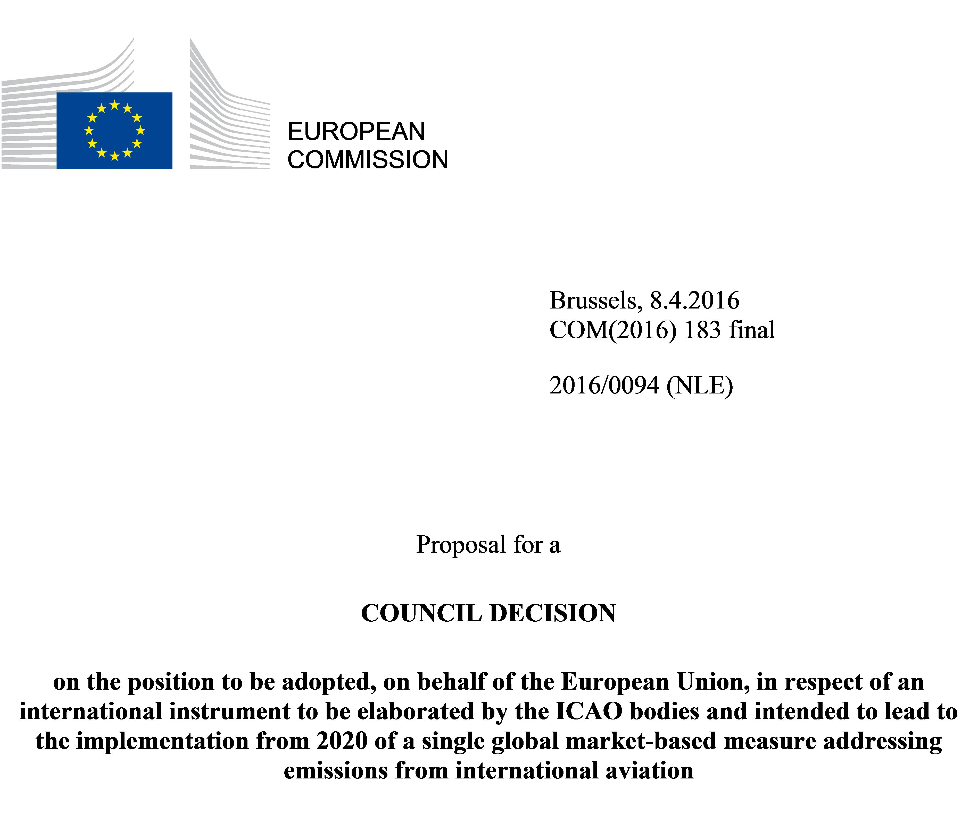

EXPLANATORY MEMORANDUM

1. CONTEXT OF THE PROPOSAL

• Reasons for and objectives of the proposal
The 21th Conference of the Parties to the UN Convention on Climate change successfully adopted the Paris Agreement whose objective is to limit global temperature increase well below 2°C compared to pre-industrial levels, and to pursue efforts to limit temperature increase to 1.5°. By 2050, global greenhouse gas emissions should be reduced by at least 50% below their 1990 levels. All sectors of the economy should contribute to achieving these emission reductions, including international aviation.
Greenhouse gas emissions from international aviation represent more than 2% of global emissions and are growing exponentially, with projections for 2050 indicating that, under a 'business as usual' scenario, such emissions from aviation activities could grow above 200% compared to current levels. The Commission Communication to the European Parliament and the Council on 'The Paris Protocol – A blueprint for tackling global climate change beyond 2020' underlines that ICAO should act to effectively regulate emissions from international aviation before the end of 2016. Despite the technological improvements, the potential for reduction of the overall emissions is limited in the aviation sector and market-based measures have therefore been recognised as a suitable measure to allow aviation to contribute to overall emission reductions. At the 38th Session of the ICAO Assembly (2013), it was decided to develop a single global market-based measure addressing international aviation emissions with a view to taking a decision by the 39th Session of the ICAO Assembly in 2016 (27th September to 7th October) for the implementation of the scheme from 2020.
It is therefore necessary to adopt, as soon as possible and well ahead of the next ICAO Assembly, the position that Member States, acting jointly in the interest of the EU, should abide by with regard to the decision to be taken by ICAO.
The position taken by the Union shall be expressed by the Commission and the Member States in ICAO bodies. The development of a proposal for such a instrument involves multiple ICAO bodies, including the ICAO Council. It is also necessary to adopt an EU position to ensure consistency with existing EU law.

• Consistency with existing policy provisions in the policy area
Decision 1600/2002/EC of the European Parliament and of the Council called for the Union to identify and undertake specific actions to reduce greenhouse gas emissions from aviation if no such action were agreed within ICAO by 2002. Following a decision by the 33rd Session of the ICAO Assembly (2001) to endorse an open emissions trading system for international aviation and by the 35th Session of the ICAO Assembly (2004) to develop guidance on the incorporation of emissions from international aviation into ICAO Contracting States' emissions trading schemes, the European Parliament and the Council adopted Directive 2008/101/EC which amended Directive 2003/87/EC establishing a system for greenhouse gas emission allowance trading so as to include aviation activities.
In addition to deciding to develop a global market-based measure, the 38th Session of the ICAO Assembly (2013) resolved that ICAO and its member States, with relevant organisations, would work together to strive to achieve a collective medium term global aspirational goal of keeping the global net carbon emissions from international aviation from 2020 at the same level. International aviation emissions are projected to be around 70% higher in 2020 than in 2005 and the Union and its Member States have consistently advocated that the global reduction target for greenhouse gas emissions from international aviation should be a 10% reduction by 2020 compared to 2005 levels. However, it appears expedient for the Union to seize the opportunity to promote the development, within a rather short time frame, of a global market-based measure to limit greenhouse gas emissions from international aviation to their levels in 2020, bearing in mind the possibility to review the targets over time, as appropriate.
In order to facilitate progress at the 39th Session of the ICAO Assembly (2016) towards an appropriate instrument, the Union legislators decided to temporarily consider the requirements of Directive 2003/87/EC to be satisfied in respect of flights to and from aerodromes in countries outside the European Economic Area (EEA). Following the 39th Session of the ICAO Assembly (2016) the Commission shall report to the European Parliament and to the Council on actions to implement an international instrument on a global market-based measure from 2020 that will reduce greenhouse gas emissions from international aviation in a non-discriminatory manner. In this report, the Commission shall consider, and, if appropriate, include proposals in reaction to, those developments on the appropriate scope for coverage of emissions from activity to and from aerodromes located in countries outside the EEA from 1 January 2017 onwards.

• Consistency with other Union policies
The proposed Decision is consistent with and complements other policies of the Union, notably energy, environmental and transport policies.
A global clean energy transition will require changes in business and investment behaviour and incentives across the entire policy spectrum.

2. LEGAL BASIS, SUBSIDIARITY AND PROPORTIONALITY

• Legal basis
The proposal is made under Article 192(1), together with Article 218(9) TFEU.
Article 218(9) TFEU lays down the procedure for the establishment of positions on the Union's behalf in a body set up by an agreement, when that body is called upon to adopt acts having legal effects.
In this case, the act expected to be adopted by the ICAO Assembly will have the legal effects indicated in Article 28a of Directive 2003/87/EC.
In accordance with Article 192(1) and 191 TFEU, the European Union shall contribute to the pursuit, inter alia, of the following objectives: preserving, protecting and improving the quality of the environment; promoting measures at international level to deal with regional or worldwide environmental problems, and in particular combating climate change.

• Choice of the instrument
Article 218(9) TFEU provides for a Council Decision as the applicable instrument.

3. RESULTS OF EX-POST EVALUATIONS, STAKEHOLDER CONSULTATIONS AND IMPACT ASSESSMENTS
Not applicable

4. BUDGETARY IMPLICATIONS
The proposal has no implication for the European Union budget.

5. OTHER ELEMENTS
Not applicable.

2016/0094 (NLE)
Proposal for a
COUNCIL DECISION
on the position to be adopted, on behalf of the European Union, in respect of an international instrument to be elaborated by the ICAO bodies and intended to lead to the implementation from 2020 of a single global market-based measure addressing emissions from international aviation
THE COUNCIL OF THE EUROPEAN UNION,
Having regard to the Treaty on the Functioning of the European Union, and in particular Article 192(1), in conjunction with Article 218(9) thereof,
Having regard to the proposal from the European Commission,
Whereas:
(1) Greenhouse gas emissions from international aviation represent more than 2% of global emissions and are growing exponentially, with projections for 2050 indicating that, under a 'business as usual' scenario, such emissions from aviation activities could grow above 200% compared to current levels. By 2050, global greenhouse gas emissions should be reduced by at least 50% below their 1990 levels. All sectors of the economy should contribute to achieving these emission reductions, including international aviation.
The 21st Conference of the Parties to the UN Convention on Climate change was successfully concluded in December 2015 by the adoption of the Paris Agreement whose objective is to limit global temperature increase well below 2°C compared to pre-industrial levels, and to pursue efforts to limit temperature increase to 1,5°.
(2) The International Civil Aviation Organisation (ICAO) was established by the 1944 Chicago Convention on International Civil Aviation. All Member States are Contracting Parties to that Convention and members of the ICAO, while the Union has Observer status in certain ICAO meetings, including the triennial ICAO Assembly. The Union and all its Member States are Parties to the 1997 Kyoto Protocol, which requires them to pursue limitation of emissions of greenhouse gases from international aviation through ICAO. Decision 1600/2002/EC of the European Parliament and of the Council called for the Union to identify and undertake specific actions to reduce greenhouse gas emissions from aviation if no such action were agreed within ICAO by 2002.
(3) The 33nd Session of the ICAO Assembly (2001) endorsed an open emissions trading system for international aviation. The ICAO Committee on Aviation Environmental Protection recommended in 2004 that an aviation-specific emissions trading system based on a new legal instrument under ICAO auspices should not be pursued further. The 35th Session of the ICAO Assembly (2004) endorsed open emissions trading and the possibility for States to incoporate emissions from international aviation into their emissions trading schemes, but the 36th Session of the ICAO Assembly (2007) urged exemption of aircraft operators based in other States unless it were bilaterally agreed. The Union, its Member States and other European States have consistently reserved the right to apply market-based measures (MBMs) on a non-discriminatory basis to all aircraft operators providing services to, from or within their territory, recalling that the Chicago Convention recognises Parties' rights to apply its own air laws and regulations to the aircraft of all States on a non-discriminatory basis providing services to, from or within their territory.
(4) Considering that the limitation of greenhouse gas emissions from aviation is an essential contribution in line with overall emission reduction commitments, the European Parliament and the Council adopted Directive 2008/101/EC which amended Directive 2003/87/EC of the European Parliament and of the Council of 13 October 2003 establishing a system for greenhouse gas emission allowance trading so as to include aviation activities and amending Council Directive 96/61/EC. The fifth recital of Directive 2008/101/EC states that the EU should seek to ensure that such a global agreement intended to contain global temparature increase includes measures to reduce greenhouse gas emissions from international aviation and, in this event, the Commission should consider which amendments to Directive 2003/87/EC as it applies to aircraft operators are necessary.
(5) The Commission Communication to the European Parliament and the Council on 'The Paris Protocol – A blueprint for tackling global climate change beyond 2020' underlines that the International Civil Aviation Organisation (ICAO), should act to effectively regulate emissions from international aviation before the end of 2016. The next meeting of the ICAO Assembly will take place in 2016, and should agree on an international instrument that will lead to the implementation by 2020 of a single global market-based measure to international aviation emissions.
(6) The 38th Session of the ICAO Assembly (2013) resolved that ICAO and its member States, with relevant organisations, would work together to strive to achieve a collective medium term global aspirational goal of keeping the global net carbon emissions from international aviation from 2020 at the same level ('the ICAO goal"), and decided to develop a global market based measure for international aviation and to report the results of its work for decision at 39th Session of the ICAO Assembly (2016). International aviation emissions are projected to be around 70% higher in 2020 than in 2005 and the Union and its Member States have consistently advocated that the global reduction target for greenhouse gas emissions from international aviation should be a 10% reduction by 2020 compared to 2005 levels. However, it appears expedient for the Union to seize the opportunity to promote the development, within a rather short time frame, of a global market-based measure to limit greenhouse gas emissions from international aviation to their levels in 2020, bearing in mind the review of the objective over time, as appropriate.
(7) In order to facilitate progress at the 2016 ICAO Assembly towards an appropriate instrument, Union legislator decided to temporarily consider the requirements of Directive 2003/87/EC to be satisfied in respect of flights to and from aerodromes in countries outside the European Economic Area (EEA). In doing so, the Union emphasised that legal requirements can be applied in respect of flights to and from aerodromes in EEA States, in the same manner as legal requirements can be applied in respect of the emissions from flights between such aerodromes.
(8) Directive 2003/87/EC as amended sets out certain obligations incumbent upon the Commission following the 39th Session of the ICAO Assembly (2016). The Commission shall report to the European Parliament and to the Council on actions to implement an international instrument on a global market-based measure from 2020 that will reduce greenhouse gas emissions from international aviation in a non-discriminatory manner. In this report, the Commission shall consider, and, if appropriate, include proposals in reaction to, those developments on the appropriate scope for coverage of emissions from activity to and from aerodromes located in countries outside the EEA from 1 January 2017 onwards.
(9) The position of the Union to be taken with regard to the international instrument to be developed in ICAO that will lead to the implementation from 2020 of a single global market-based measure to international aviation emissions should be established.
(10) It is necessary to adopt a Union position well ahead of the next ICAO Assembly,

HAS ADOPTED THIS DECISION:
Article 1
The position to be taken on behalf of the European Union leading to an instrument on a global market based measure at ICAO, shall be in accordance with the Annex to this Decision and shall be expressed by the Commission and the Member States acting jointly, in the interest of the Union, in the bodies of ICAO.
Article 2
The Commission shall keep the relevant Council bodies fully informed about the on-going discussions. In order for the Commission to be fully appraised of the Council's views on the proper application of the terms of the annex, the Commission shall consult those bodies throughout the process, whenever this is necessary, in view of the developments in the ICAO bodies.
Done at Brussels,
For the Council
The President

COM(2015)81, 4 March 2015
ICAO Resolution A38-18 (2013)
ICAO Resolution A33-7 (2001)
ICAO Resolution A35-5 (2004)
OJ L 275, 25.10.2003, p. 32.
See reservations to the 2013 ICAO Resolution, under footnote 4 above
Regulation 421/2014 of the European Parliament and of the Council
COM(2016) 110 final
ICAO Resolution A33-7
ICAO Resolution A35-5
Appendix L to Resolution A36-22
Reservations to the 2007 ICAO Resolution, 2010 ICAO Resolution, 2012 ICAO Council Decision endorsing the 'Delhi Declaration and 2013 ICAO Resolution, see http://ec.europa.eu/clima/policies/transport/aviation/documentation_en.htm
OJ L 8, 13.1.2009, p. 3
OJ L 275, 25.10.2003, p. 32
COM(2015)81, 4 March 2015
See reservations to the 2013 ICAO Resolution, under footnote 4 above
Regulation 421/2014 of the European Parliament and of the Council of 16 April 2014 amending Directive 2003/87/EC establishing a scheme for greenhouse gas emission allowance trading within the Community, in view of the implementation by 2020 of an international agreement applying a single global market-based measure to international aviation emissions, OJ L 129, 30.4.2014, p. 1.

