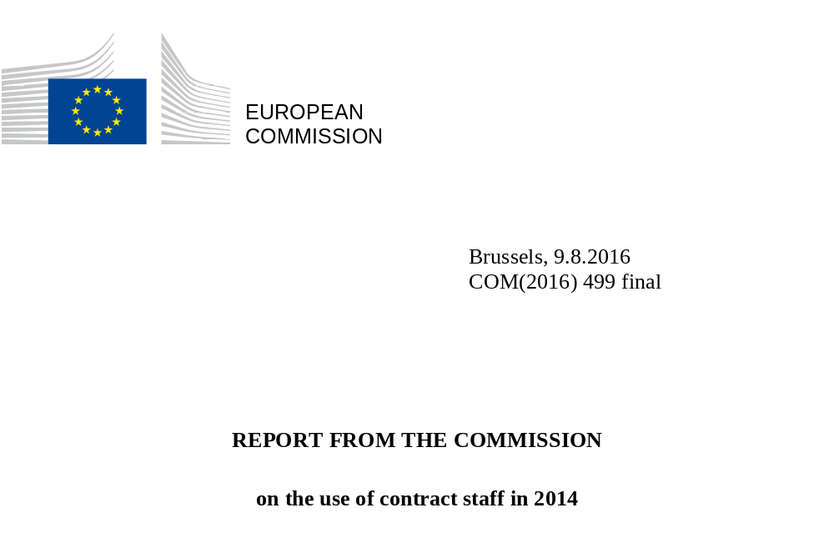

TABLE OF CONTENTS

1. Introduction 3
2. Trend in contract staff numbers in the Commission since 2004 4
3. Breakdown of Commission contract staff by gender and by function group 6
4. Breakdown of Commission contract staff by nationality 7
5. Breakdown of Commission contract staff by DG 14
5.1. Breakdown by gender and by DG 15
5.2.1 3a contract staff 16
5.2.2 3b auxiliary contract staff 17
6. Breakdown of contract staff in the other institutions and agencies 18
6.1. Breakdown of contract staff in the other institutions 19
6.1.1 Breakdown by gender and by function group in the other institutions 20
6.1.2 Breakdown by nationality in the other institutions 20
6.2. Breakdown of contract staff in the agencies 21
6.2.1 Breakdown by gender and by function group in the agencies 22
6.2.2 Breakdown by nationality in the agencies 24

1. Introduction
This report fulfils the obligation arising from Article 79(3) of the Conditions of Employment of Other Servants of the European Union (CEOS), which provides that ‘the Commission shall provide a yearly report on the use of contract staff including numbers of staff, level and type of posts, geographical balance and budgetary resources per function group’. It offers a detailed snapshot of the contract staff employed at 31 December 2014.
The budgetary data (sent each year with the draft budget to the Budgetary Authority - Working Document, parts II and III) show contract staff numbers at the time when the draft budget is presented (including contract staff recruited using assigned revenue), i.e.: a statement of the position at 1 April of year N-1 (where N is the year of the draft budget), budgetary implementation in year N-2 and requests for appropriations with estimates of full-time equivalents (FTE) for year N. That is why there are sometimes differences in the number of contract staff, depending on the data source.
This report includes data for all the European institutions (including the European External Action Service (EEAS), in operation since 1 January 2011) and agencies as defined in Article 1(a) of the Staff Regulations. The data for the Commission are more detailed and include staff financed from operational and research lines, plus staff working in administrative offices, delegations, representations and the Joint Research Centre (JRC).
Article 80 of the CEOS establishes a link between each function group (FG) and the duties that contract staff may perform:
Function group | Grade | Tasks
IV | 13 to 18 | Administrative, advisory, linguistic and equivalent technical tasks, performed under the supervision of officials or temporary staff
III | 8 to 12 | Executive tasks, drafting, accountancy and other equivalent technical tasks, performed under the supervision of officials or temporary staff
II | 4 to 7 | Clerical and secretarial tasks, office management and other equivalent tasks, performed under the supervision of officials or temporary staff
I | 1 to 3 | Manual and administrative support service tasks, performed under the supervision of officials or temporary staff.

The category of contract staff was created in 2004 as part of the reform of the Staff Regulations. Since then contract staff have made a useful contribution to the work of the institutions by carrying out administrative support activities at a lower cost and by bringing in skills which were not always available within the institution.
This is particularly true of FG I staff, who have replaced Category D officials since 2004. Since then no competitions have been organised to recruit officials for work as messengers or drivers or for any other typical FGI duties (except for the Parliament).

2. Trend in contract staff numbers in the Commission since 2004
At the end of 2014, the total number of contract staff across all the institutions and agencies stood at some 11 100. About 58 % of them are employed by the Commission, against 60 % in 2012. Given that the number of contract staff at the Commission remained relatively stable until 2013, followed by an increase in 2014, this relative drop in the share of Commission contract staff is attributable to the increased numbers in other institutions and agencies.
The breakdown between institutions and agencies is examined later in this report.
The trend within the Commission since 2004 is as follows:
Table 1

The rise in contract staff numbers at the Commission, which stood at around 6 400 in 2014, is attributable in part to the gradual replacement of auxiliary staff (who numbered nearly 3 000 in 2003) by auxiliary contract staff (Article 3b of the CEOS), to the replacement of the former Category D by contract staff (Article 3a of the CEOS) and to the conversion of permanent official posts into appropriations for contract staff in the administrative offices. Contract staff were also taken on as temporary replacements for permanent staff, as provided for in Article 3b of the CEOS.
Contract staff numbers grew each year up to 2009 before dipping slightly in 2010. This reduction is largely explained by the delay in obtaining the results of the new CAST selection procedures in 2010.
The Commission's figures appeared to show a stabilisation in 2011, but this is in fact the result of two contrasting events. On the one hand, the creation of the EEAS led to the transfer of 277 contract staff from the Commission’s staff (working for DG RELEX in delegations and at headquarters), while on the other, the Commission recruited 275 contract staff between 2010 and 2011. Without the departure of contract staff to the EEAS, there would have been a 4.6 % increase between 2010 and 2011, matching the average rate of increase recorded in 2008 and 2009.
In 2012 and 2013 the number of contract staff fell slightly (-1 % and -2 % respectively), mainly as a result of overall staff reductions and the fact that new staff regulations were due to come into force in January 2014.
The issuing of a call for expressions of interest (CEI) addressed to 3b contract staff in September 2013 created a pool of new candidates for the Directorates-General (hereinafter DGs). Given the timescales for selection and recruitment, the real impact of this CEI was felt above all in 2014.
Furthermore, the entry into force of the new Staff Regulations on 1 January 2014 extended the term of employment of 3b contract staff to a maximum of six years. This means that many contract staff who had already completed 3 years of service and were continuing to work for the Commission as agency staff have been able to be rehired for a further contractual period, allowing the Commission to benefit from contract staff who are already trained and operational immediately, while reducing the number of agency staff.

3. Breakdown of Commission contract staff by gender and by function group
The breakdown of contract staff by FG is shown in the table below.
Breakdown by gender and by function group in 2014
Table 2

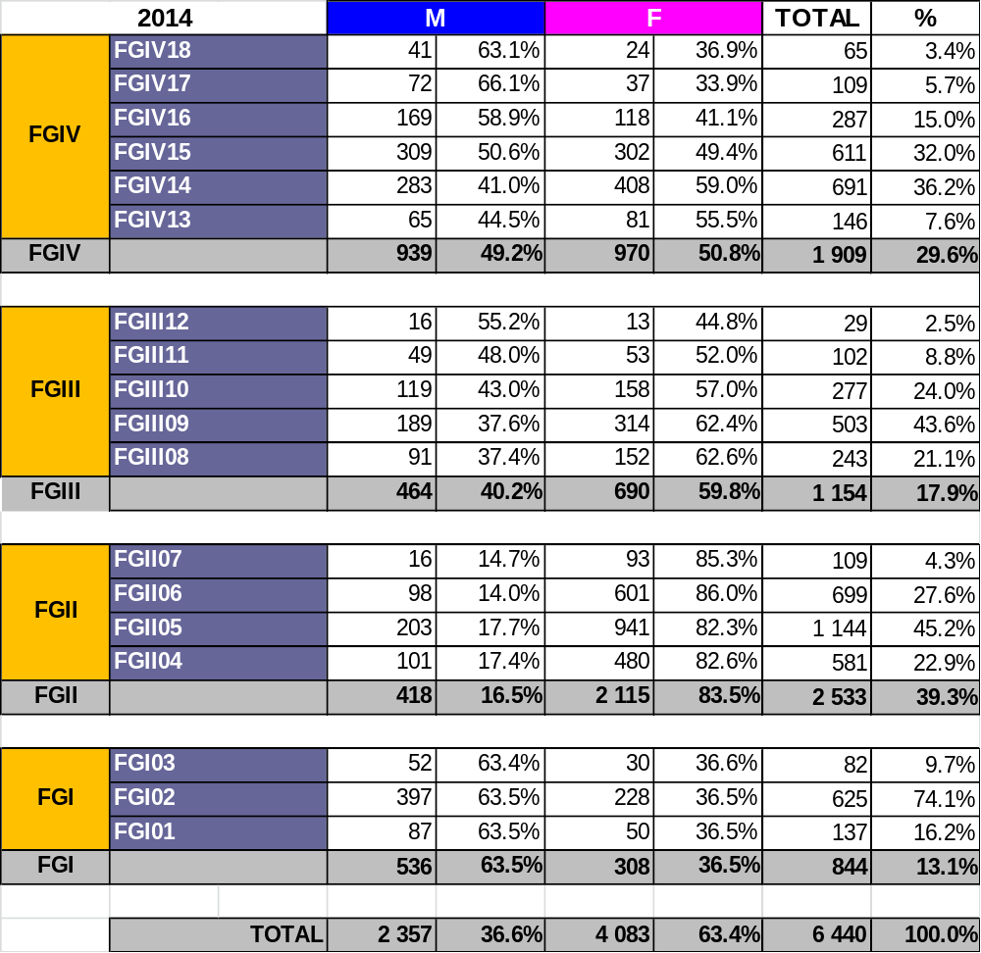
At 31 December 2014, 6 440 contract staff were serving in the Commission. The largest function group is FG II, accounting for almost 40 % of contract staff in 2014 - an increase on previous years. Staff in this group carry out secretarial or similar duties, while others are responsible for childcare. Next come contract staff in FG IV and FG III.
Overall, the balance between men and women has remained stable: women made up 62.8 % of all contract staff in 2013, against 63.4 % in 2014.
Gender balance was almost achieved in FG IV in 2014. The gender breakdown in the other FGs has remained stable since 2011. We find a much larger proportion of women in FG II (83.5 % in 2014) and, to a lesser extent, in FG III (59.8 % in 2014). In FG I, in contrast, men predominate (63.5 % in 2014).
This reflects the traditional breakdown by type of duties performed: FG IIs are mainly secretaries or childcare workers, while the majority of FG Is work as messengers or drivers.

4. Breakdown of Commission contract staff by nationality
The nationalities best represented among the contract staff were, in descending order, Belgians, Italians, French, Spaniards and Romanians, followed by Poles and Greeks. The representation of the first four nationalities has been the same since 2005. The UK and Germany, like Poland and the Netherlands, are rather under-represented in relation to their population. Conversely, Belgium and Italy have a high representation in relation to their population.
Following the accession of Croatia to the European Union on 1 July 2013, 59 Croatian contract staff worked at the Commission at 31 December 2014.

Breakdown of Commission contract staff by nationality and by gender in 2014

Table 3

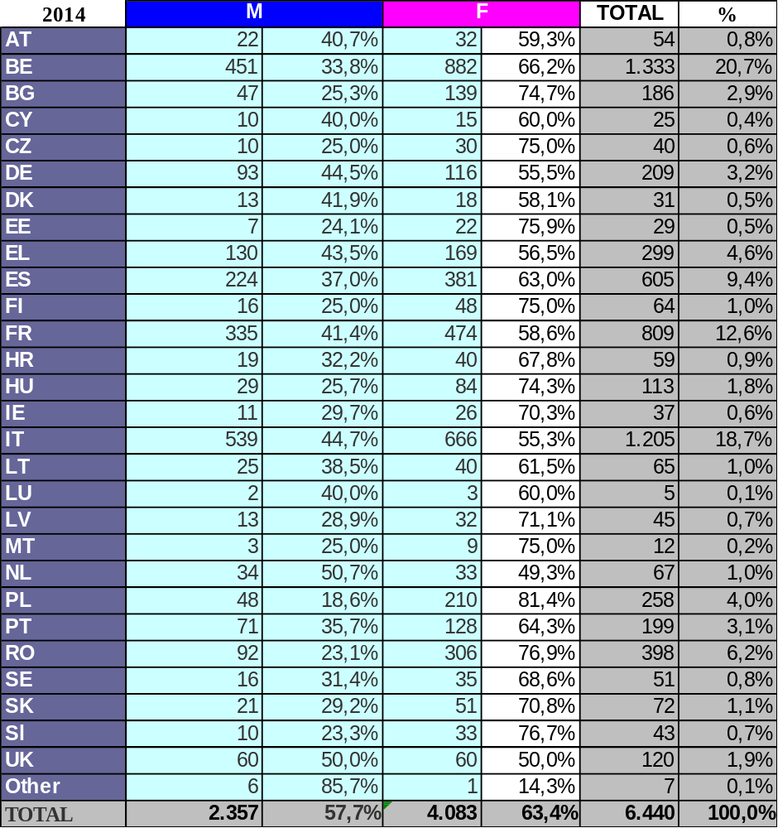

The breakdown of Commission contract staff by nationality is influenced by a combination of factors, including the location of the European institutions and duration of the proposed contracts.
As most recruitments are for a limited duration, candidates are more likely to accept a post if they are resident at or near the site of the institution offering them a job. On the other hand, it can be hard for candidates with families to leave their countries of origin and set up home at the institution’s headquarters for what is a relatively short period of time.
Contract staff are recruited to the Commission on the basis of Article 3b of the CEOS for an initial period of one year, followed by a two-year extension. Following the entry into force of the new Staff Regulations in 2014, the duration of these contracts is now set at a maximum of six years.
This role played by geographical proximity is also reflected in the composition of the lists of candidates that the Commission can draw on. We should stress, however, that there is no quota per nationality: recruitment is carried out on the basis of the required profile and the applicants' abilities and language knowledge.
The same trend of linkage to the place of residence is apparent in the table showing the breakdown by nationality in the other institutions and agencies.

Breakdown of contract staff by gender and by function group
These tables give an analytical breakdown by FG, nationality and gender. In 2014, as in previous years, all Member States are represented in FG IV and FG II. However there are no Luxembourgers in FG III and no Austrians in FG I.

Table 4

FGIV

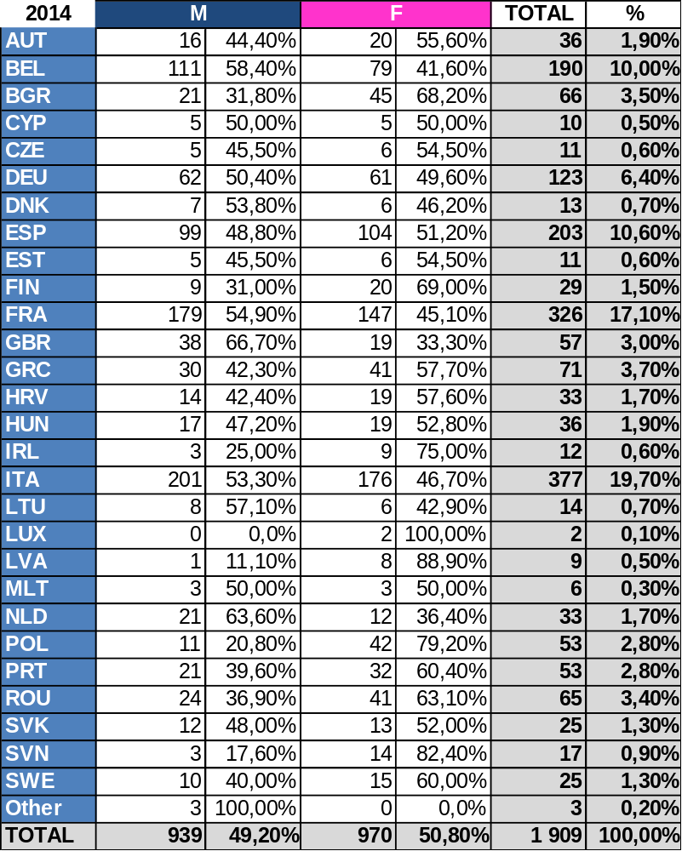

FGIII

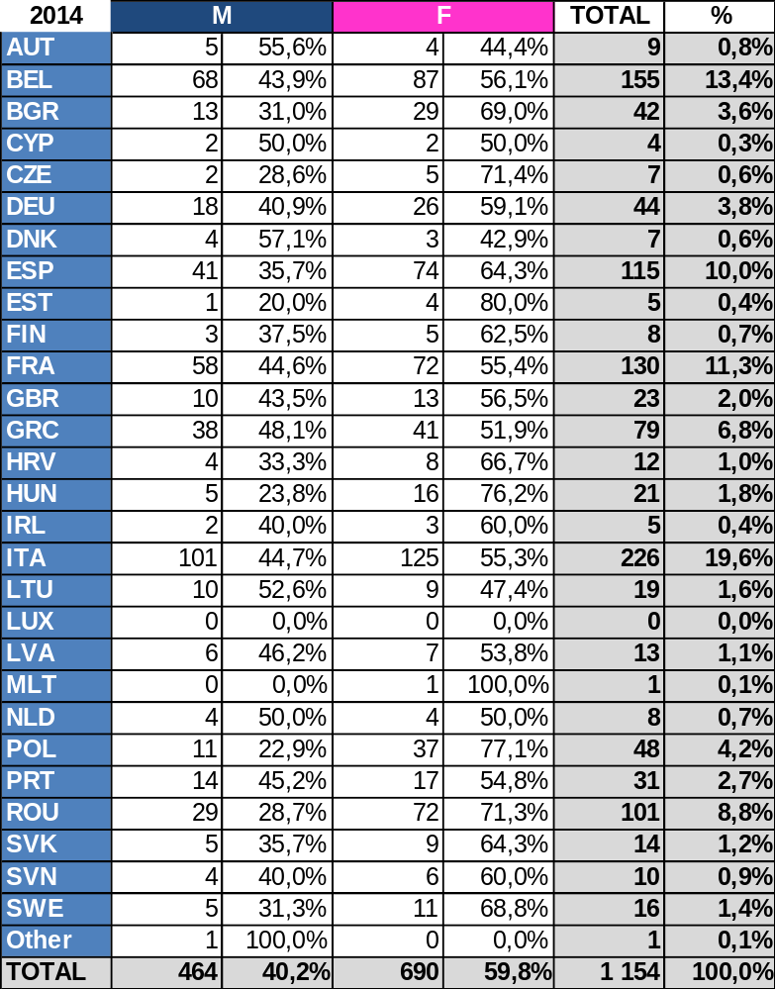

FGII

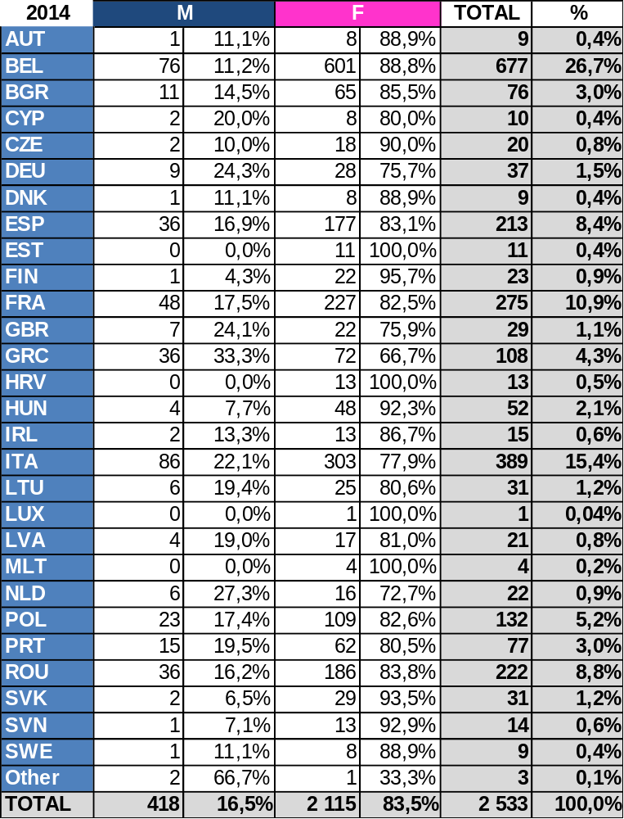

FGI

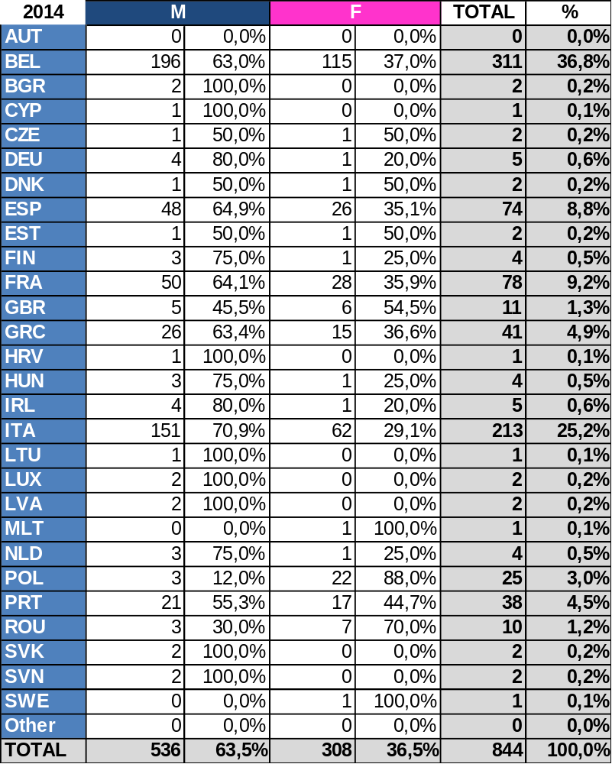

5. Breakdown of Commission contract staff by DG
In the following section the data on contract staff have been broken down by DG. There are differences between the DGs, largely because of the different nature of their work. DG DEVCO, for example, employs mostly FG IVs responsible for aid and international cooperation or working as programme managers both at headquarters and in the delegations, while the OIB employs mostly administrative assistants and childcare workers in FG II.
The appropriations allocated for the policy of replacing absent staff allow for a continuity of service that would not be as satisfactory without such temporary replacements.

5.1. Breakdown by gender and by DG
Table 5
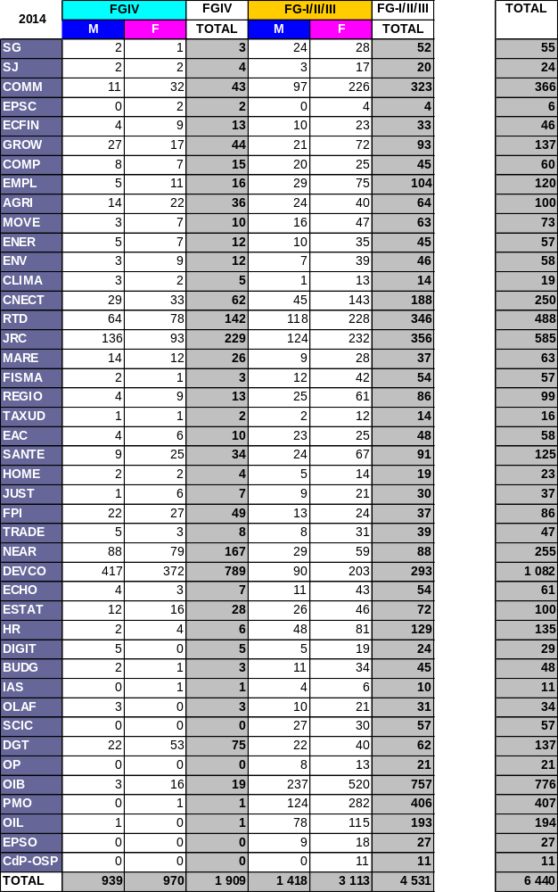

5.2. Breakdown by contract type

5.2.1 3a contract staff

Table 6
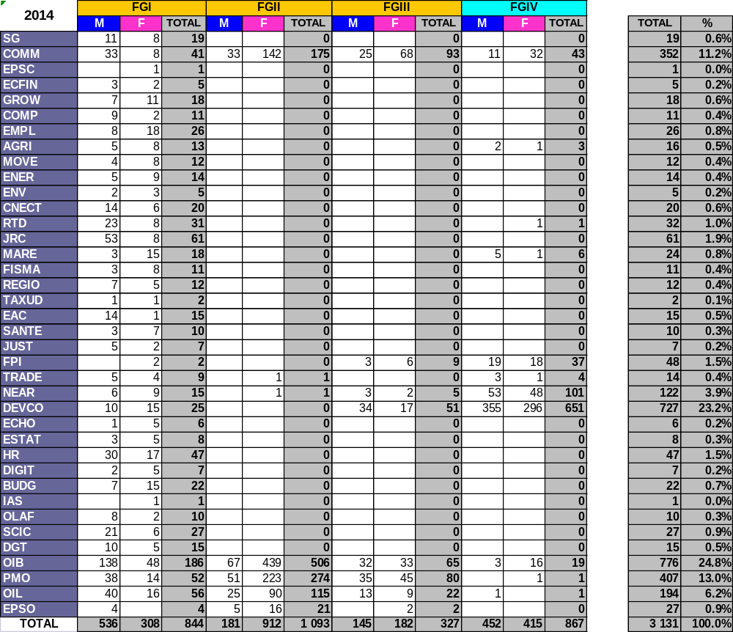

5.2.2 Auxiliary contract staff 3b

Table 7
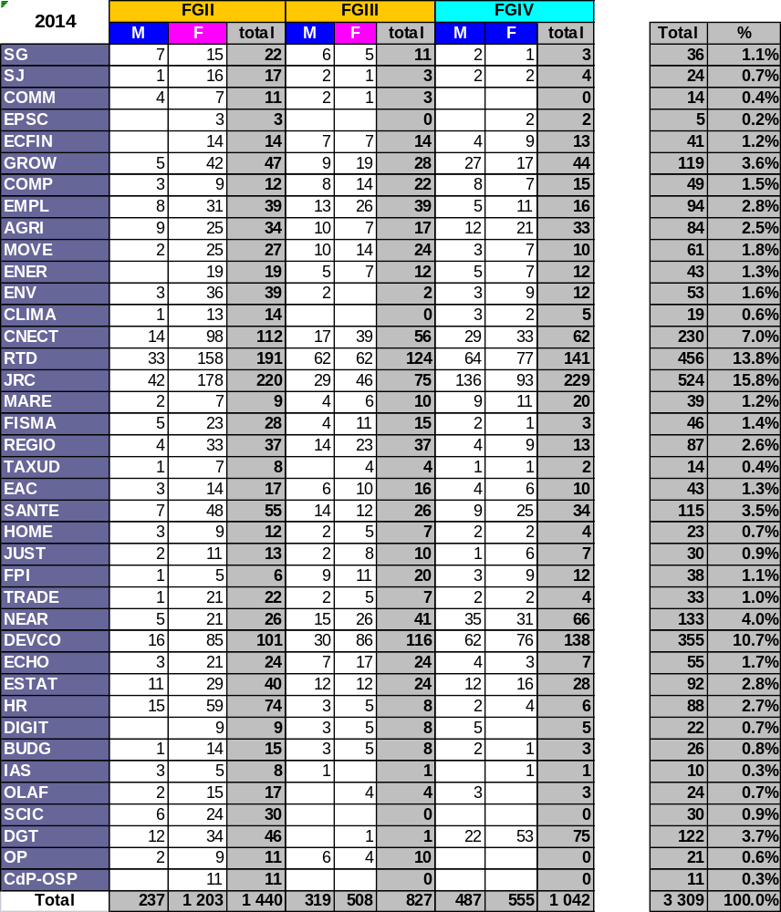

6. Breakdown of contract staff in the other institutions and agencies
The total number of contract staff in the other institutions and agencies was 4 624 in 2014 and 4 179 in 2013. This represents an increase of 10.6 % between 2013 and 2014.
Table 8
Trends in the breakdown of contract staff
in the other institutions and agencies since 2010

*The creation of the EEAS on 1 January 2011 and the transfer of 313 Commission staff to the EEAS on that date largely explains the significant rise in the number of contract staff between 2010 and 2011. More details can be found in the Commission's report to the Council on the use of contract staff in 2011.

6.1. Breakdown of contract staff in the other institutions
The number of contract staff in the other institutions rose by 17.7 % between 2013 and 2014. This increase is largely explained by a rise in the number of contract staff in Parliament between 2013 and 2014 (from 874 to 1210 contract staff), an increase of 38.4 % in that institution. The increase in the number of contract staff in Parliament in 2014 is the result of a decision to internalise security and the recruitment of contract staff in FG I to perform those tasks.
Table 9
Breakdown of contract staff in the other institutions in 2014

6.1.1 Breakdown by gender and by function group in the other institutions
Table 10

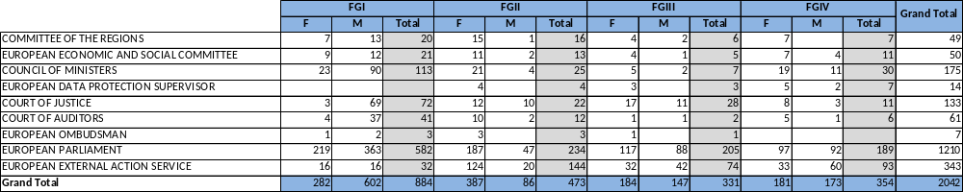

6.1.2 Breakdown by nationality in the other institutions
Table 11
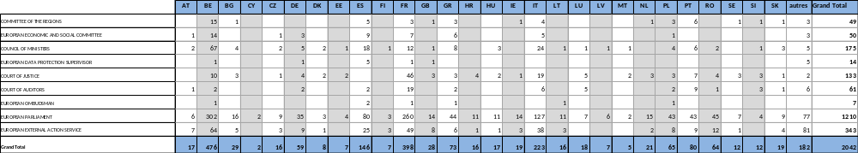

6.2. Breakdown of contract staff in the agencies
There has been a steady increase in the number of contract staff in the agencies. The numbers are as follows: 1 933 in 2010, 2 214 in 2011, 2 408 in 2012, 2 522 in 2013 and 2 582 in 2014.
Based on the classification established by DG BUDG, the available information is grouped into three categories of agency: decentralised agencies, joint undertakings and the European Institute of Innovation and Technology, and executive agencies.
Breakdown of contract staff in the agencies
Table 12

45 % of contract staff are employed by the executive agencies and 48 % by the decentralised agencies. The remainder (7 %) are employed by Joint Undertakings and the European Institute of Innovation and Technology.
The increase in the number of contract staff between 2010 and 2014 reflects the increase in the number of agencies and their tasks.
A number of new Joint Undertakings were also set up in 2014: 1) ECSEL (Electronic Components and Systems for European Leadership), which has taken over the activities of the ARTEMIS and ENIAC Joint Undertakings, 2) Bio-Based Industries Joint Undertaking (BBI), and 3) Shift2Rail (S2R).

6.2.1 Breakdown by gender and by function group in the agencies
The breakdown by function group is relatively uniform across the 3 categories of agency and has remained stable since 2012.
Breakdown by function group in the agencies in 2014
Table 13

Table 14
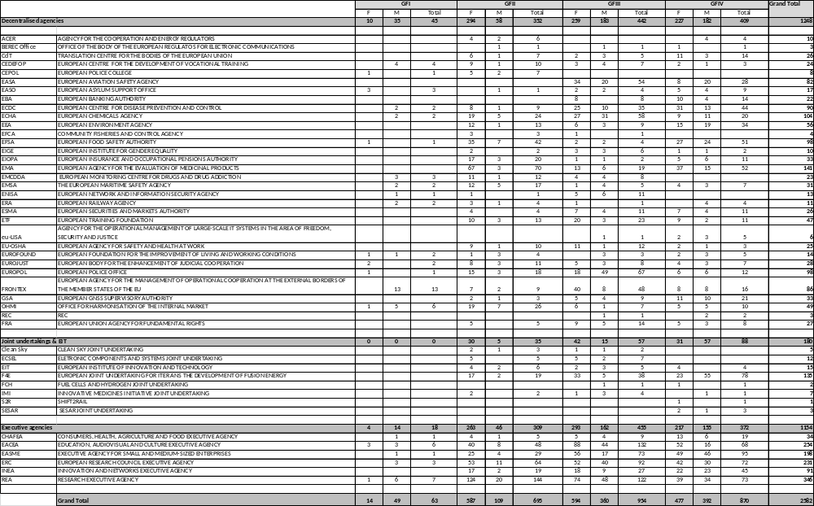

6.2.2 Breakdown by nationality in the agencies
The location of the agency plays a major role in determining the nationality of its contract staff.
Accordingly, the geographical breakdown in the executive agencies, which are located on the same sites as the Commission, reflects the same trends as the Commission, and the most represented nationalities are Belgians, Italians, French and Spanish.
Similarly, the location of other agencies and joint ventures is reflected in the breakdown by nationality of their contract staff.
Breakdown by nationality in the agencies in 2014

Table 15

Table 16

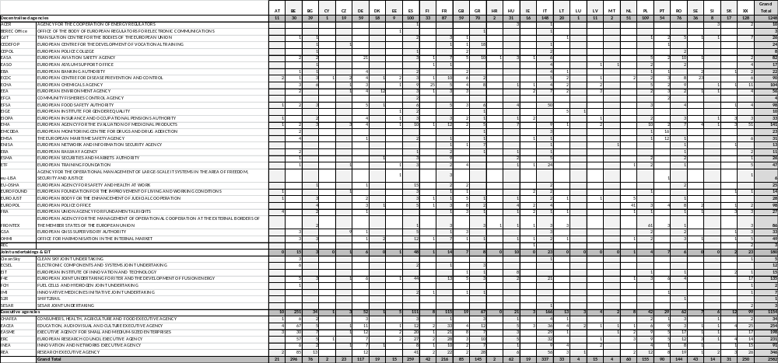

Source: Commission HR analytics platform
In 2013 it was difficult for the DGs to use the databases of existing candidates and there was a shortage affecting some profiles.
In particular, the number of agency staff fell from 415 on 1 July 2013 to 188 on 1 July 2014.
Source: Commission HR analytics platform
Source: Commission HR analytics platform
Source: Commission HR analytics platform
Source: Commission HR analytics platform
Source: Commission HR analytics platform
Source: Eurostat
Source: Eurostat
Source: Eurostat
Source: Eurostat
Source: Eurostat
Source: Eurostat
Source: Eurostat

