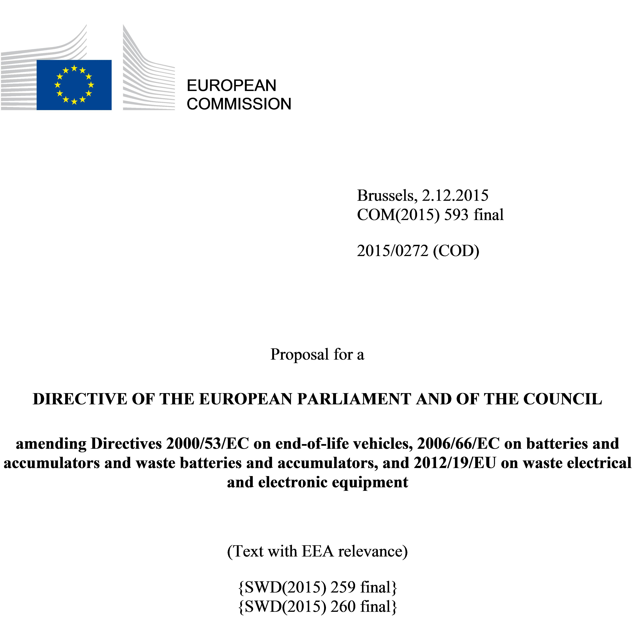

EXPLANATORY MEMORANDUM

1. CONTEXT OF THE PROPOSAL

1.1 General Context
The Union’s economy currently loses a significant amount of potential secondary raw materials which are found in waste streams. In 2013, total waste generation in the EU amounted to approximately 2.5 billion tons of which 1.6 billion tons were not reused or recycled and therefore lost for the European economy. It is estimated that an additional 600 million tons could be recycled or reused. By way of example, only a limited share (43%) of the municipal waste generated in the Union was recycled, with the rest being landfilled (31%) or incinerated (26%). The Union thus misses out on significant opportunities to improve resource efficiency and create a more circular economy.
With respect to waste management, the Union also faces large differences amongst its Member States. In 2011, while six Member States landfilled less than 3% of their municipal waste, 18 landfilled over 50%, with some exceeding 90%. This uneven situation needs to be redressed as a matter of urgency.
The proposals to amend Directive 2008/98/EC on waste, Directive 94/62/EC on packaging and packaging waste, Directive 1999/31/EC on the landfill of waste, Directive 2000/53/EC on end-of-life vehicles, Directive 2006/66/EC on batteries and accumulators and waste batteries and accumulators and Directive 2012/19/EU on waste electrical and electronic equipment form part of a Circular Economy Package which also includes a Commission Communication "Closing the loop – An EU action plan for the Circular Economy".

1.2 Grounds for and objectives of the proposal
Recent trends suggest that further progress on resource efficiency is possible and that it can bring major economic, environmental and social benefits. Turning waste into a resource is an essential part of increasing resource efficiency and closing the loop in a circular economy.
The legally binding targets in EU waste legislation have been a key driver to improve waste management practices, stimulate innovation in recycling, limit the use of landfilling, and create incentives to change consumer behaviour. Taking waste policy further can bring significant benefits: sustainable growth and job creation, reduced greenhouse gas emissions, direct savings linked with better waste management practices, and a better environment.
The proposal to amend Directive 2008/98/EC responds to the legal obligation to review the waste management targets in that Directive. The proposals which form part of the Circular Economy Package and amend the six Directives mentioned above build in part on the proposal that the Commission tabled in July 2014 and subsequently withdrew in February 2015. They are in line with the objectives of the Resource Efficiency Roadmap and the 7th Environment Action Programme, including full implementation of the waste hierarchy in all Member States, decline in absolute and per capita waste generation, ensuring high quality recycling and the use of recycled waste as a major, reliable source of raw materials for the Union. They also contribute to the implementation of the EU Raw Materials Initiative and address the need to prevent food waste. In addition, these proposals simplify the reporting requirements included in all six Directives.

2. RESULTS OF CONSULTATIONS WITH INTERESTED PARTIES AND IMPACT ASSESSMENT

2.1 Studies
The proposals and the accompanying impact assessment assess technological, socio-economic and cost-benefit aspects related to the implementation and further development of EU waste legislation. A supplement to the Impact Assessment was produced to analyse the potential effects of additional variants of the main policy options defined in the Impact Assessment.

2.2 Internal consultation
Within the Commission an Impact Assessment Steering Group composed of various Commission services (SG, ECFIN, GROW, CLIMA, JRC, and ESTAT) followed the preparation of the legislative proposals.

2.3 External consultation
An indicative list of issues to be tackled was developed by the Commission and the first interviews with key stakeholders started in February 2013. An online public consultation in line with the minimum standards for consultation was launched in June 2013, closing in September 2013. 670 responses were submitted, reflecting high public concern about the waste management situation in the EU and high expectations for EU action in this area. A specific consultation of Member States was held between June and September 2015 as well as a broader consultation on the circular economy.

2.4 Impact assessment
An impact assessment report and an executive summary were published together with the proposal adopted in July 2014. The impact assessment, which remains valid as the main analytical basis for the revised legislative proposals, evaluates the main environmental, social and economic impacts of various policy options to improve waste management in the EU. Various levels of ambition are assessed and compared to a "baseline scenario" in order to identify the most appropriate instruments and targets while minimizing costs and maximizing benefits.
The Commission’s Impact Assessment Board delivered a positive opinion on the impact assessment on 8 April 2014, while making a number of recommendations to fine-tune the report. The Board requested to further clarify the problem definition and the need for new mid-term targets, strengthen the arguments in favour of a landfill ban from a subsidiarity and proportionality point of view and of uniform targets for all Member States, and explain in more detail how the varying performances of Member States are taken into account in the proposal.
The impact assessment led to the conclusion that a combination of Options will bring the following benefits:
- Administrative burden reduction in particular for small establishments or undertakings, simplification and better implementation including by keeping targets ‘fit for purpose’;
- Job creation – more than 170.000 direct jobs could be created by 2035, most of them impossible to delocalize outside the EU;
- GHG emission reduction – more than 600 millions of tons of green house gas could be avoided between 2015 and 2035;
- Positive effects on the competitiveness of the EU waste management and recycling sectors as well as on the EU manufacturing sector (better extended producer responsibility schemes, reduced risks associated with raw material access);
- Reinjection into the EU economy of secondary raw materials which in turn will reduce the dependency of the EU on raw materials imports.
An analytical note supplementing the impact assessment was issued together with the legislative proposal. In this note, a number of additional options and variants were analysed with the aim to better take into account the different starting positions of each Member State.

3. LEGAL ELEMENTS OF THE PROPOSALS

3.1 Summary of the proposed action
The main elements of the proposals to amend EU waste legislation are:
- Alignment of definitions;
- Increase of the preparing for re-use and recycling target for municipal waste to 65% by 2030;
- Increase of the preparing for reuse and recycling targets for packaging waste and the simplification of the set of targets;
- Gradual limitation of the landfilling of municipal waste to 10% by 2030;
- Greater harmonisation and simplification of the legal framework on by-products and end-of-waste status;
- New measures to promote prevention, including for food waste, and re-use;
- Introduction of minimum operating conditions for Extended Producer Responsibility;
- Introduction of an Early Warning System for monitoring compliance with the recycling targets;
- Simplification and streamlining of reporting obligations;
- Alignment to Articles 290 and 291 TFEU on delegated and implementing acts.

3.2 Legal basis and right to act
The proposals amend six Directives addressing the management of different wastes. The proposals to amend Directive 2008/98/EC, Directive 1999/31/EC, Directive 2000/53/EC, Directive 2006/66/EC and Directive 2012/19/EU are based on Article 192(1) TFEU, whilst the proposal to amend Directive 94/62/EC is based on Article 114 TFEU.
Article 11(2) of Directive 2008/98/EC sets down a 50% target for preparing for re-use and recycling of household and similar waste and a 70% target for preparing for re-use, recycling and other material recovery of non-hazardous construction and demolition waste by 2020. Pursuant to Article 11(4), by 31 December 2014 at the latest, the Commission had to examine those targets with a view to, if necessary, reinforcing them and considering the setting of targets for other waste streams, taking into account the relevant environmental, economic and social impacts of setting the targets. According to Article 9(c), the Commission had to set, by the end of 2014, waste prevention and decoupling objectives for 2020, based on best available practices including, if necessary, a revision of the indicators referred to in Article 29(4). Finally, pursuant to Article 37(4), in the first report that intervenes by 12 December 2014, the Commission had to assess a number of measures including producer responsibility schemes for specific waste streams, targets, indicators and measures related to recycling, as well as material and energy recovery operations that may contribute to fulfilling the objectives set in Articles 1 and 4 more effectively.
Article 5(2) of Directive 1999/31/EC sets down three targets for the diversion of biodegradable municipal waste from landfills and bans the landfilling of certain waste streams. The last target for the diversion of biodegradable municipal waste from landfills has to be met by the Member States by 16 July 2016. Pursuant to Article 5(2), it shall be re-examined by 16 July 2014 with a view to confirming or amending it in order to ensure a high level of environmental protection and in light of the practical experience gained by Member States in the pursuance of the two previous targets.
Article 6(1) of Directive 94/62/EC sets down targets for the recovery and recycling of packaging waste which, pursuant to Article 6(5), shall be fixed every five years based on the practical experience gained in Member States and the findings of scientific research and evaluation techniques such as life-cycle assessments and cost-benefit analysis.

3.3 Subsidiarity and proportionality principle
The proposals are in conformity with the subsidiarity and proportionality principles set out in Article 5 of the Treaty on the European Union. They are limited to amending the abovementioned Directives by providing a framework establishing shared objectives, while leaving Member States free to decide about precise implementation methods.

3.4 Explanatory documents
The Commission considers that documents explaining Member States' measures transposing the Directives are necessary in order to improve the quality of information on the transposition of the Directives.
Waste legislation is often transposed in a highly decentralised manner in the Member States, including on the regional or local level and in multiple legal acts, depending on the administrative structure of a Member State. As a result, in transposing the amended Directives Member States may have to amend a wide variety of legislative acts at national, regional and local levels.
The proposals amend six different waste Directives and affects an important number of legally binding obligations, including a comprehensive amendment of the targets contained in Directive 2008/98/EC, Directive 1999/31/EC and Directive 94/62/EC and a simplification of Directive 2000/53/EC, Directive 2006/66/EC and Directive 2012/19/EU. This is a complex review of waste legislation that will potentially affect a number of pieces of national legislation.
The revised targets for waste management contained in the amended Directives are inter-connected, and should be carefully transposed into national legislation and later on incorporated into national waste management systems.
The proposed provisions will affect a wide range of private and public stakeholders in the Member States and will have an important impact on future investments in waste management infrastructure. The complete and correct transposition of the new legislation is essential to guarantee that their objectives (i.e. protecting human health and the environment, increased resource efficiency, and ensuring the functioning of the internal market and avoiding obstacles to trade and restriction of competition within the EU) are achieved.
The requirement to provide explanatory documents may create an additional administrative burden on some Member States. However, explanatory documents are necessary to allow effective verification of complete and correct transposition, which is essential for the reasons mentioned above, and there are no less burdensome measures to allow efficient verification. Moreover, explanatory documents can contribute significantly to reducing the administrative burden of compliance monitoring by the Commission; without them, considerable resources and numerous contacts with national authorities would be required to track the methods of transposition in all Member States.
In view of the above it is appropriate to ask Member States to accompany the notification of their transposition measures with one or more documents explaining the relationship between the provisions of the Directives amending EU waste legislation and the corresponding parts of national transposition instruments.

3.5 Delegated and implementing powers of the Commission
The delegated and implementing powers of the Commission are identified and the corresponding procedures for adoption of these acts are established in paragraphs 4, 5, 6, 9, 11, 14, 15, 18, 19, 21, 22 of Article 1 of the proposal concerning Directive 2008/98/EC, paragraphs 4, 6, 7, 9, 10 of Article 1 of the proposal concerning Directive 94/62/EC, paragraphs 6 and 7 of Article 1 of the proposal concerning Directive 1999/31/EC and the amendments proposed in Articles 1 and 3 of the proposal concerning Directives 2000/53/EC and 2012/19/EU.

4. BUDGETARY IMPLICATION
The proposals will not have an impact on the European Union budget and is therefore not accompanied by the financial statement provided for under Article 31 of the Financial Regulation (Regulation (EU, Euratom) No 966/2012 of the European Parliament and of the Council of 25 October 2012 on the financial rules applicable to the general budget of the Union and repealing Council Regulation (EC, Euratom) No1605/2002).

2015/0272 (COD)
Proposal for a
DIRECTIVE OF THE EUROPEAN PARLIAMENT AND OF THE COUNCIL
amending Directives 2000/53/EC on end-of-life vehicles, 2006/66/EC on batteries and accumulators and waste batteries and accumulators, and 2012/19/EU on waste electrical and electronic equipment
(Text with EEA relevance)
THE EUROPEAN PARLIAMENT AND THE COUNCIL OF THE EUROPEAN UNION,
Having regard to the Treaty on the Functioning of the European Union, and in particular Article 192(1) thereof,
Having regard to the proposal from the European Commission,
After transmission of the draft legislative act to the national parliaments,
Having regard to the opinion of the European Economic and Social Committee,
Having regard to the opinion of the Committee of the Regions,
Acting in accordance with the ordinary legislative procedure,
Whereas:
(1) Waste management in the Union should be improved, with a view to protecting, preserving and improving the quality of the environment, protecting human health, ensuring prudent and rational utilisation of natural resources and promoting a more circular economy.
(2) To reduce regulatory burden on small establishments or undertakings, simplification of the permitting and registration requirements for small establishments or undertakings should be introduced.
(2) Implementation reports prepared by Member States every three years have not proved to be an effective tool for verifying compliance and ensuring correct implementation, and are generating unnecessary administrative burden. It is therefore appropriate to repeal provisions obliging Member States to produce such reports and for compliance monitoring purposes use exclusively the statistical data which Member States report every year to the Commission.
(3) Statistical data reported by Member States are essential for the Commission to assess compliance with waste legislation across the Member States. The quality, reliability and comparability of statistics should be improved by introducing a single entry point for all waste data, deleting obsolete reporting requirements, benchmarking national reporting methodologies and introducing a data quality check report.
(4) Reliable reporting of statistical data concerning waste management is paramount to efficient implementation and to ensuring comparability of data among a level playing field between Member States. Therefore, when preparing the reports on compliance with the targets set out in these Directives, Member States should be required to use the most recent methodology developed by the Commission and the national statistical offices of the Member States.
(5) Directives 2000/53/EC, 2006/66/EC and 2012/19/EU should therefore be amended accordingly.
(6) In accordance with the Joint Political Declaration of 28 September 2011 of Member States and the Commission on explanatory documents, Member States have undertaken to accompany, in justified cases, the notification of their transposition measures with one or more documents explaining the relationship between the components of a directive and the corresponding parts of national transposition instruments. With regard to this Directive, the legislator considers the transmission of such documents to be justified.
(7) Since the objectives of this Directive, namely to improve the management of waste in the Union, and thereby contributing to the protection, preservation and improvement of the quality of the environment and to the prudent and rational utilisation of natural resources, cannot be sufficiently achieved by the Member States, but can rather, by reason of the scale or effects of the measures, be better achieved at Union level, the Union may adopt measures, in accordance with the principle of subsidiarity as set out in Article 5 of the Treaty on European Union. In accordance with the principle of proportionality, as set out in that Article, this Directive does not go beyond what is necessary in order to achieve those objectives,
HAVE ADOPTED THIS DIRECTIVE:
Article 1
Amendment of Directive 2000/53/EC
Article 9 of Directive 2000/53/EC is amended as follows:
(1) paragraph 1 is deleted;
(2) the following paragraphs 1a, 1b, 1c and 1d are inserted:
'1a. Member States shall report the data concerning the implementation of Article 7(2) for each calendar year to the Commission. They shall report this data electronically within 18 months of the end of the reporting year for which the data are collected. The data shall be reported in the format established by the Commission in accordance with paragraph 1d. The first report shall cover the data for the period from 1 January [enter year of transposition of this Directive + 1 year] to 31 December [enter year of transposition of this Directive + 1 year].
1b. The data reported by the Member State in accordance with this Article shall be accompanied by a quality check report.
1c. The Commission shall review the data reported in accordance with this Article and publish a report on the results of its review. The report shall assess of the organisation of the data collection, the sources of data and the methodology used in Member States as well as the completeness, reliability, timeliness and consistency of that data. The assessment may include specific recommendations for improvement. The report shall be drawn up every three years.
1d. The Commission shall adopt implementing acts laying down the format for reporting data in accordance with paragraph 1a. Those implementing acts shall be adopted in accordance with the procedure referred to in Article 11(2).'.
Article 2
Amendment of Directive 2006/66/EC
Directive 2006/66/EC is amended as follows:
(1) Article 22 is deleted;
(2) Article 23 is amended as follows:
(a) paragraph 1 is replaced by the following:
'The Commission shall draw up a report on the implementation of this Directive and its impact on the environment and the functioning of the internal market by the end of 2016 at the latest.';
(b) in paragraph 2, the introductory phrase is replaced by the following:
'In its report, the Commission shall include an evaluation on the following aspects of this Directive:'.
Article 3
Amendment of Directive 2012/19/EU
Directive 2012/19/EU is amended as follows:
(1) Article 16 is amended as follows:
(a) paragraph 5 is deleted;
(b) the following paragraphs 5a, 5b, 5c and 5d are inserted:
'5a. Member States shall report the data concerning the implementation of Article 16(4) for each calendar year to the Commission. They shall report this data electronically within 18 months of the end of the reporting year for which the data are collected. The data shall be reported in the format established by the Commission in accordance with paragraph 5d. The first report shall cover the data for the period from 1 January [enter year of transposition of this Directive + 1 year] to 31 December [enter year of transposition of this Directive + 1 year].
5b. The data reported by the Member State in accordance with this Article shall be accompanied by a quality check report.
5c. The Commission shall review the data reported in accordance with this Article and publish a report on the results of its review. The report shall cover an assessment of the organisation of the data collection, the sources of data and the methodology used in Member States as well as the completeness, reliability, timeliness and consistency of that data. The assessment may include specific recommendations for improvement. The report shall be drawn up every three years.
5d. The Commission shall adopt implementing acts laying down the format for reporting data in accordance with paragraph 5a. Those implementing acts shall be adopted in accordance with the procedure referred to in Article 21(2).';
(2) Article 21 is replaced by the following:
'Article 21
Committee procedure
1. The Commission shall be assisted by the Committee established by Article 39 of Directive 2008/98/EC. That committee shall be a committee within the meaning of Regulation (EU) No 182/2011(*).
2. Where reference is made to this paragraph, Article 5 of Regulation (EU) No 182/2011 shall apply.
3. Where the Committee delivers no opinion, the Commission shall not adopt the draft implementing act and the third subparagraph of Article 5(4) of Regulation (EU) No 182/2011 shall apply.

(*) Regulation (EU) No 182/2011 of the European Parliament and of the Council of 16 February 2011 laying down the rules and general principles concerning mechanisms for control by Member States of the Commission’s exercise of implementing powers (OJ L 55, 28.2.2011, p. 13).'.
Article 4
Transposition
1. Member States shall bring into force the laws, regulations and administrative provisions necessary to comply with this Directive by [insert date eighteen months after the entry into force of this Directive] at the latest. They shall forthwith communicate to the Commission the text of those provisions.
When Member States adopt those provisions, they shall contain a reference to this Directive or be accompanied by such a reference on the occasion of their official publication. Member States shall determine how such reference is to be made.
2. Member States shall communicate to the Commission the text of the main provisions of national law which they adopt in the field covered by this Directive.
Article 5
Entry into force
This Directive shall enter into force on the twentieth day following that of its publication in the Official Journal of the European Union.
Article 6
Addressees
This Directive is addressed to the Member States.
Done at Brussels,
For the European Parliament For the Council
The President The President

Directive 2008/98/EC of the European Parliament and of the Council of 19 November 2008 on waste and repealing certain Directives (OJ L 312, 22.11.2008, p. 3).
Directive 94/62/EC of European Parliament and Council of 20 December 1994 on packaging and packaging waste (OJ L 365, 31.12.1994, p. 10).
Council Directive 1999/31/EC of 26 April 1999 on the landfill of waste (OJ L 182, 16.07.1999, p. 1).
Directive 2000/53/EC of the European Parliament and of the Council of 18 September 2000 on end of life vehicles (OJ L 269, 21.10.2000, p. 34-43).
Directive 2006/66/EC of the European Parliament and of the Council of 6 September 2006 on batteries and accumulators and waste batteries and accumulators and repealing Directive 91/157/EEC (OJ L 266, 26.09.2006, p. 1-14).
Directive 2012/19/EU of the European Parliament and of the Council of 4 July 2012 on waste electrical and electronic equipment (OJ L 197, 24.7.2012, p. 38-71).
COM(2011) 571.
Decision No 1386/2013/EU of the European Parliament and of the Council of 20 November 2013 on a General Union Environment Action Programme to 2020 ‘Living well, within the limits of our planet’ (OJ L 354, 28.12.2013, p. 171).
The waste hierarchy gives the preference to prevention first followed by reuse, recycling before energy recovery and disposal which includes landfilling and incineration without energy recovery.
COM(2008) 699 and COM(2014)297.
COM(2014)397.
OJ C , , p. .
OJ C , , p. .
OJ C 369, 17.12.2011, p. 14.

