EN
EUROPEAN COMMISSION
Brussels, 19.4.2011
SEC(2011) 504 final

COMMISSION STAFF WORKING DOCUMENT
EU Accountability Report 2011 on Financing for Development
Review of progress of the EU and its Member States
Accompanying document to the
COMMUNICATION FROM THE COMMISSION TO THE EUROPEAN PARLIAMENT, THE COUNCIL, THE EUROPEAN ECONOMIC AND SOCIAL COMMITTEE AND THE COMMITTEE OF THE REGIONS
Enhancing EU Accountability on Financing for Development
towards the EU Official Development Assistance Peer Review
VOL V
{COM(2011) 218 final}
{SEC(2011) 500 final}
{SEC(2011) 501 final}
{SEC(2011) 502 final}
{SEC(2011) 503 final}
{SEC(2011) 505 final}
Annex 7 Donor Profiles

AUSTRIA 
AT A GLANCE
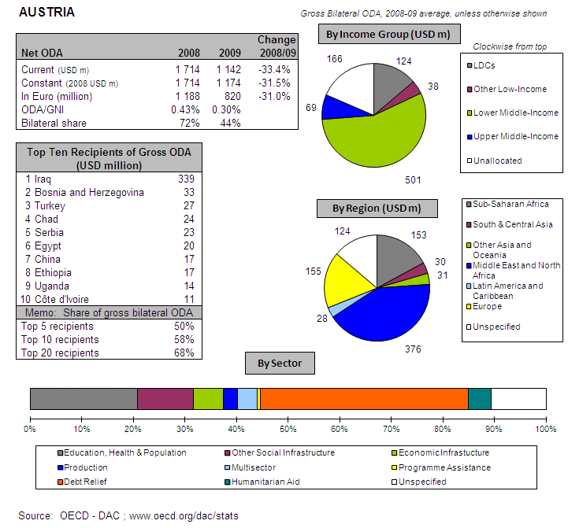
POLICY FRAMEWORK
Austria's development cooperation is based on the Federal Act on Development Cooperation of 2002 (amended in 2003) and the current Three Year Programme on Austrian Development Policy 2009-2011, which is focussed on the MDGs and aid effectiveness. The Federal Ministry for European and International Affairs is responsible for development policy, Austria's Development Agency (ADA) and the Austrian Development Bank (OeEB) for aid implementation. The introduction of a five year budget cycle (2009-2013) has made overall aid flows more predictable. The Federal Financial Framework Act 2010–2013 sets the financial parameters for medium-term ODA levels.
I. INCREASING FINANCIAL RESOURCES FOR DEVELOPMENT AND GLOBAL CHALLENGES
- IMPROVING DOMESTIC RESOURCE MOBILISATION
- Support to reform programmes for capacity development of customs, judiciary and tax administrations in developing countries: Austria provides aid in these fields to EU candidate countries, EU Neighbourhood Policy countries (through EU Twinning projects on customs and tax administration) and ACP countries administrations (support to: Customs, Semi-autonomous Revenue Authorities and Ministries of Finance).
- Support to promote good governance in tax matters: Yes
- Bilateral Tax Information Exchange Agreements and Double Taxation Conventions since 2010: (i) Double Taxation Conventions signed with Bosnia and Herzegovina, Hong Kong, Libya, Serbia, and Qatar; (ii) under negotiation with Argentina, Bahamas, Cayman Islands, Chile, Isle of Man, Iceland, Jersey, Guernsey, Sri Lanka, Tajikistan, and Turkmenistan
- State of ratification of/adherence to international conventions/initiatives on tax issues:
- United Nations Convention against Corruption (Merida): Yes
- OECD Convention on Combating Bribery of Foreign Officials
in International Business Transactions: Yes
- Stolen Assets Recovery initiative (STAR): No
- Extractive Industry Transparency Initiative (EITI): No
- IMF Regional Technical Assistance Centres: Yes
- International Tax Dialogue: Yes
- International Tax Compact: No
- African Tax Administration Forum (ATAF): No
- Centro Inter-Americano de Administraciones Tributarias (CIAT): No
- IMF Topical Trust Fund on Tax policy and administration: No

- SCALING UP ODA
ODA individual commitments /gap to agreed targets (total ODA, Africa, LDCs)
- According to its present estimates (until 2014) Austria is set to miss the 2015 0.7% ODA/ GNI target by a wide margin and will – on current forecasts – even remain below the EU collective ODA/GNI target of 0.39% in 2006 set by EU leaders in Barcelona .
- In 2010, Austria spent EUR 905 million as ODA (preliminary), 0.32% of its GNI. This was a slight recovery on 2009, when fewer debt relief measures reduced ODA volume, but it remains 0.11 percentage points below the 2008 ratio.
- Debt relief made up 50% of Austria’s ODA during the period 2005 - 2007 and more than 40% in 2008, which is higher than any other DAC member. With the decline in debt relief, Austria must sharply increase its aid to meet its agreed 2015 target.
Source: OECD/ DAC data for 1995 – 2010; Commission simulation based on information provided by EU Member States or based on agreed EU commitments for 2015. ODA in current prices.
Austria Share of debt relief in ODA volumes
Source: OECD/DAC data
- "Realistic, verifiable actions for meeting individual ODA commitments until 2015" taken in 2010: Although the Council of Ministers confirmed the ODA goals in November 2010, Austria projects ODA levels substantially below the 2005 – 2010 average.
- No measure taken nor planned to contribute to the EU27 target to channel at least 50% of EU collective ODA increase to Africa.
- Austria will reach the target of 0.15%-0.20% ODA/GNI to LDCs by 2010 and onwards.
- SUPPORT FOR / USE OF INNOVATIVE SOURCES AND MECHANISMS OF FINANCING DEVELOPMENT
- Austria intends to step up efforts for innovative financing mechanisms with significant revenue generation potential, with a view to ensuring predictable financing for sustainable development. Austria's budget for fiscal year 2011 does not allocate revenues from an agreed increase of the tax for private foundations to development cooperation. However, the concept of earmarking these revenues for development cooperation might be discussed again during the next budget negotiations.
- Austria did not use innovative financing mechanisms for development, but introduced an airline ticket tax (from January 2011) without earmarking its revenues for development.
- LEVERAGING PRIVATE FLOWS FOR DEVELOPMENT
- Support to private investment in developing countries:
Foreign Direct Investment
Source: OECD/ DAC
- Financial tools to support private investment
- Investment guarantees: Yes
- Improvement of the overall banking system: No
- Microfinance/ access to financial services: Yes
- Risk management initiatives: No
- Blending: Yes
- Private public partnerships: Yes
- Business and investment climate: Yes
- Investment facilities: Yes
- Export credits: No
- Austria promotes the adoption of internationally agreed principles and standards on Corporate Social and Environmental Responsibility by European companies. ADA offers Business Partnerships to Austrian/European companies on a co-financing basis. CSR oriented activities play a particular role in this type of projects. Health, education and compliance with social and ecological standards are the most frequent topics. One typical example is the hepatitis vaccination programme of OMV, the leading Austrian oil and gas corporation. The project, implemented in Pakistan, focuses on vaccination and medical education and is part of a comprehensive development programme including water and infrastructure.
- No new initiatives were started in 2010 to include social and environmental clauses in ODA-financed public procurement.
- Austria did not implement solutions internally or in cooperation with third countries to overcome barriers to migrants and their families' access to financial services.

- AID FOR TRADE
Source: OECD CRS Database (latest update)
- REDUCING THE DEBT BURDEN OF DEVELOPING COUNTRIES
- Austria delivered on its HIPC/ MDRI commitments (including vis-à-vis IDA/ AfDB)
- Actions/steps taken in 2010 to help restore and preserve debt sustainability in low-income countries: contribution to DeMFLIC (Debt Management Facilitation for Low Income Countries) a World Bank Multi-Donor Trust Fund.
- Austria favours reform of the international architecture for restructuring of sovereign debts in order to deal with potential future cases of debt distress in low-income countries (through the Paris Club with a role for International Financial Institutions).
- No specific intervention to prevent aggressive litigation against HIPCs (in particular to prevent the actions of "vulture funds").
II. IMPROVED EFFECTIVENESS OF SUPPORT TO DEVELOPING COUNTRIES
- MORE EFFECTIVE EU AID
- On Ownership. In 2010, Austria supported ownership through consultations and coordination with partner countries and through partner capacity development.
- On Conditionality. In 2010, Austria progressed by harmonising conditionalities with other donors.
- On Transparency and Predictability. Austria publicly discloses information on aid volumes through the Austrian Development Agency (ADA) web site.
- On Alignment. Austria partially integrated the principles of the Code of Conduct on Complementarity and Division of Labour in its development strategy.
- On Harmonisation. In 2010, ADA was authorised to manage EU funds. Delegated cooperation agreements with the European Commission and other Member States can now be concluded where appropriate.
- On Mutual Accountability. Austria established a joint framework for monitoring joint commitments with some of its priority countries (i.e. Bhutan, Burkina Faso, Ethiopia, Mozambique, Nicaragua and Uganda).
- On Managing for Development Results. Austria provides capacity building support for this.

- SUPPORTING BETTER GLOBAL GOVERNANCE
- Position on improving the voice of the EU and its Member States within International Financial Institutions. Austria supports a single EU Chair for the IMF in order for the EU27 to speak with one voice. In the case of Multilateral Development Banks, the rationale for a single constituency is considered less evident, but could be a long-term goal. A consolidation process requires fair terms of representation of smaller countries and efficient coordination mechanisms, including better EU coordination on MDB boards, among the EU27 capitals and common positions in the subcommittee on IMF matters—“SCIMF”— of the Economic and Financial Committee, or equivalent forum on WB/MDBs issues. These discussions should precede deliberations and decision making at G8/G20 level.
- Austria favours stronger Brussels based coordination on issues related to the World Bank and MDBs.
BELGIUM 
AT A GLANCE
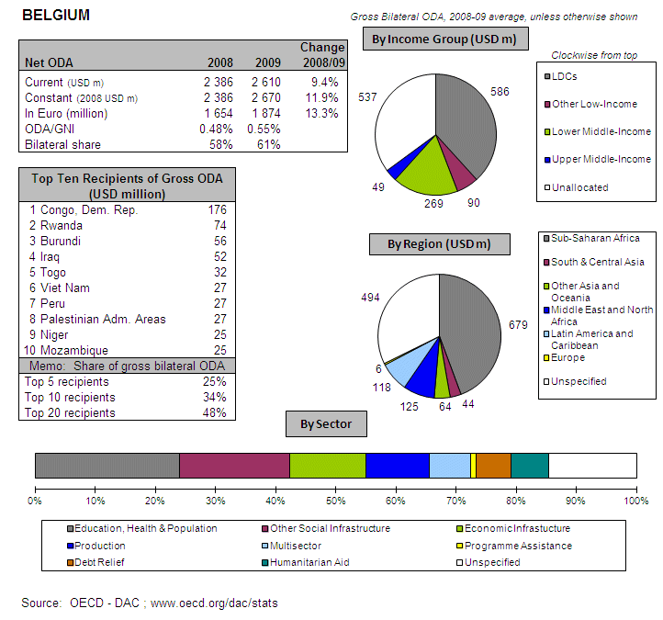
POLICY FRAMEWORK
The strategic framework that guides Belgian development co-operation actors includes the 1999 Law on International Cooperation, laws governing specific actors of Belgian development cooperation, various royal decrees, strategies of actors related to the federal level, and separate strategies by federated entities. Belgium’s development cooperation has gained new momentum over the last two years, driven by international commitments and a process of self-reflection. New policies have been issued, aid management reforms have advanced, and a new law on development cooperation has been prepared in 2010 in parallel with the government’s programme for 2008-2011.
I. INCREASING FINANCIAL RESOURCES FOR DEVELOPMENT AND GLOBAL CHALLENGES
  - IMPROVING DOMESTIC RESOURCE MOBILISATION
- Support to reform programmes for capacity development of customs, judiciary and tax administrations in developing countries: Belgium provides aid in these fields to ACP country administrations (support to: Semi-autonomous Revenue Authorities and Ministries of Finance).
- Support to promote good governance in tax matters: Yes
- Bilateral Tax Information Exchange Agreements and Double Taxation Conventions since 2010: (i) Double Taxation Conventions signed with Anguilla, Congo, Czech Republic, Dominican Republic, Granada, Japan, Korea, Macedonia, Malta, Montserrat, Rwanda, ; (ii) under negotiation with Barbados, Botswana, Colombia, Israel, Panama, Poland, Uruguay, (iii) planned with India, South Korea, Kyrgyzstan, Netherlands, Serbia, Turkmenistan
- State of ratification of/adherence to international conventions/initiatives on tax issues:
- United Nations Convention against Corruption (Merida): Yes
- OECD Convention on Combating Bribery of Foreign Officials
in International Business Transactions: Yes
- Stolen Assets Recovery initiative (STAR): No
- Extractive Industry Transparency Initiative (EITI): Yes
- IMF Regional Technical Assistance Centres: NC
- International Tax Dialogue: NC
- International Tax Compact: NC
- African Tax Administration Forum (ATAF): NC
- Centro Inter-Americano de Administraciones Tributarias (CIAT): NC
- IMF Topical Trust Fund on Tax policy and administration: NC
  - SCALING UP ODA
ODA Individual commitments and gap to target
- Belgium planned to meet the 0.7% target by 2010, but remained below it, reaching ODA level of 0.64% of GNI by spending EUR 2265 million (preliminary). Belgium has a legally binding commitment to the 0.7% target for 2010 and beyond.
- Debt relief makes up a particularly high share of Belgium’s ODA increase. This share, however, is expected to decline in 2011 and Belgium needs to make sure to sustain the 0.7% target in the medium and long term.
Source: OECD/ DAC data for 1995 – 2010; Commission simulation based on information provided by EU Member States or based on agreed EU commitments for 2010 and 2015. ODA in current prices.

Belgium Share of debt relief in ODA volumes

Source: OECD/DAC data for 2002-2010
- "Realistic, verifiable actions for meeting individual ODA commitments until 2015" taken in 2010: The official directorate of Development and Cooperation is currently drafting a mid-term budget plan to ensure required new ODA will be available to maintain ODA/GNI around 0.7% after 2010.
- 50% of new resources for bi-lateral Belgian development cooperation in 2010 and 2011 went to African partner countries, mostly in Sub-Saharan Africa
- Will you reach the target of 0.15%-0.20% ODA/GNI to LDCs by 2010 and onwards: Already achieved

  - Support for/ use of innovative sources and mechanisms of financing development
- Belgium did not use innovative financing mechanisms for development except net receipts from the Belgian Lottery “which should be regarded as innovative financing”.
- Belgium intends to step up efforts for innovative financing mechanisms with significant revenue generation potential. Belgium is ready to implement a Currency Transactions Tax (CTT) if consensus is reached at Euro-level. A law in this regard was voted in parliament in 2004.
  - LEVERAGING PRIVATE FLOWS FOR DEVELOPMENT
Support to private investment in developing countries:
Foreign Direct Investment
Source: OECD/ DAC
Financial tools to support private investment
- Investment guarantees: Yes
- Improvement of the overall banking system: Yes
- Microfinance/ access to financial services: Yes
- Risk management initiatives: No
- Blending: Yes
- Private public partnerships: No
- Business and investment climate: Yes
- Investment facilities: No
- Export credits: Yes
- Belgium promotes the adoption of internationally agreed principles and standards on Corporate Social and Environmental Responsibility by European companies. The Belgian Development Cooperation supports several activities within the framework of Fair Trade: the Trade for Development Centre within the Belgian Technical Cooperation (BTC) and several NGOs (Max Havelaar, Oxfam Wereldwinkels, Oxfam Magasins du Monde, etc.). The Belgian Development Cooperation organised a seminar on corporate governance together with the World Bank at the beginning of December 2010
- Belgium supports the Kimberley process and the FAO Code of Conduct for Responsible Fisheries
- No new initiatives were started in 2010 to include social and environmental clauses in ODA-financed public procurement (the Belgian law on public procurement of 24 December 1993 has not changed during 2010)
- Belgium implemented the "General Principles for International Remittances Services" agreed by the Committee on Payments and Settlements Systems (CPSS). Meanwhile, Belgium has robust and reliable data concerning the amounts and destination of remittances from Belgium.
  - AID FOR TRADE
Belgium AfT Commitments (in EUR thousands)
Source: OECD CRS Database (latest update)

  - REDUCING THE DEBT BURDEN OF DEVELOPING COUNTRIES
- Belgium delivered on its HIPC/ MDRI commitments (including vis-à-vis IDA/ AfDB) without delay.
- Actions/steps taken in 2010 to help restore and preserve debt sustainability in low-income countries: financially supporting the World Bank Debt Management Facility and also participating in the African Legal Support Facility.
- Belgium does not favour reform of the international architecture for restructuring of sovereign debts
- Specific interventions to prevent aggressive litigation against HIPCs (in particular to prevent the actions of "vulture funds"): Yes. On April 6, 2008, Belgium passed a bill to prevent the seizure or transfer of public funds for international cooperation, in particular related to the methods of the Vulture Funds.

II. IMPROVED EFFECTIVENESS OF SUPPORT TO DEVELOPING COUNTRIES
  - MORE EFFECTIVE EU AID
- On Ownership. In 2010, Belgium supported ownership through consultations and coordination with partner countries, through guidance and incentives for staff in partner countries, and through partner capacity development.
- On Conditionality. In 2010, Belgium progressed by harmonising conditionalities with other donors.
- On Transparency and Predictability. Belgium publicly discloses information on aid volumes through the Belgium Development Cooperation web site and through the websites of field offices.
- On Alignment. Belgium partially integrated the principles of the Code of Conduct on Complementarity and Division of Labour in its development strategy.
- On Harmonisation. Belgium signed a general arrangement on delegated cooperation with the Netherlands in 2011.
- On Mutual Accountability. Belgium established a joint framework for monitoring joint commitments with some of its priority countries (i.e. Mozambique, Tanzania, Uganda).
- On Managing for Development Results. Belgium provides capacity building support for this.

  - SUPPORTING BETTER GLOBAL GOVERNANCE
- Position on improving the voice of the EU and its Member States within International Financial Institutions. Belgium supports a single EU Chair at the IMF in order for the EU27 to speak with one voice. Notably in the IMF, preferably by a single seat for the euro area. As for the MDBs, this can best be done by an informal coordination mechanism among Executive Directors (e.g. World Bank), and, for important matters, among representatives from the capitals (e.g. Voice reforms, Development Committee).
- Belgium does not favour stronger Brussels based coordination on issues related to the World Bank and MDBs.

BULGARIA
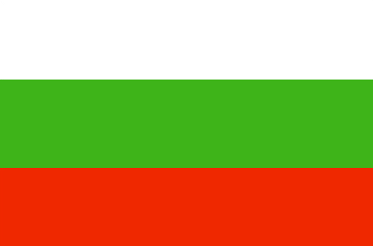
POLICY FRAMEWORK
Bulgaria’s international development cooperation activities are guided by the ‘Concept on the Policy of Bulgaria for participation in the international development cooperation’ adopted by the Council of Ministers (2007). The Ministry of Foreign Affairs manages Bulgaria’s development cooperation activities. The Ministry of Finance plays a role in ODA programming and planning and determines the selection of financial mechanisms and instruments. Bulgaria has stated that it will strive to reach the ODA targets set for the newly acceded Member States at 0.17% of GNI in 2010 and 0.33% of GNI in 2015, depending on its economic status and possibilities. A bilateral development strategy is awaiting adoption.
I. INCREASING FINANCIAL RESOURCES FOR DEVELOPMENT AND GLOBAL CHALLENGES
- IMPROVING DOMESTIC RESOURCE MOBILISATION
- Support to reform programmes for capacity development of custom, judiciary and tax administrations in developing countries: Bulgaria provides support to the General Department of National Taxation of Mongolia in the field of taxation and collection of mandatory social security contributions, including laws, regulations, manuals and training materials.
- Promotes the principles of good governance in tax matter: Yes
- New Bilateral Tax Information Exchange Agreements and Double Taxation Conventions of 2010: i) Agreements under negotiation: Venezuela; ii) Agreements planned: Yemen.
- Support/ratification of/adherence to international conventions/initiatives on tax issues:
- IMF Regional Technical Assistance Centres: Yes
- International Tax Dialogue: Yes
- International Tax Compact: Yes
- African Tax Administration Forum (ATAF): Yes
- Centro Inter-Americano de Administraciones Tributarias (CIAT): Yes
- IMF Topical Trust Fund on Tax policy and administration: Yes
- United Nations Convention against Corruption (Merida): Yes
- OECD Convention on Combating Bribery of Foreign Officials in International Business Transactions: Yes
- Stolen Assets Recovery initiative (STAR): No
- Extractive Industry Transparency Initiative (EITI): No

- SCALING UP ODA
ODA individual commitments/gap to agreed targets
- Bulgaria spent EUR 31 million on ODA in 2010 (preliminary), a nominal 250% increase compared to 2009 (partly due to improved ODA reporting); this corresponds to 0.09% ODA/ GNI, compared to 0.04% in 2009.
- Share of debt relief in ODA: N/A
Source: OECD/ DAC data for 1995 – 2010; Commission simulation based on information provided by EU Member States or based on agreed EU commitments for 2010 and 2015. ODA in current prices.

- "Realistic, verifiable actions for meeting your individual ODA commitments until 2015" taken in 2010: The multi-annual indicative timetable/minimum aid level commitment will be established after the adoption of the Ordinance of the Council of Ministers on the objectives, principles and mechanisms of participation of the Republic of Bulgaria in international development cooperation and a medium-term programme.
- Have you taken or do you plan to take measures to ensure that at least 50% of EU collective aid increases of ODA resources are channelled to Africa? N/A
- Bulgaria will not reach the target of 0.15%-0.20% ODA/GNI to LDCs by 2010

- SUPPORT FOR/ USE OF INNOVATIVE SOURCES AND MECHANISMS OF FINANCING DEVELOPMENT
- Bulgaria has not implemented any innovative financing sources and mechanisms and has no plan to step up efforts in the area.
- LEVERAGING PRIVATE FLOWS FOR DEVELOPMENT
Support to private investment in developing countries:
- Financial tools to support private investment:
- Investment guarantees: No
- Improvement of the overall banking system: No
- Microfinance/ access to financial services: No
- Risk management initiatives: No
- Blending: No
- Private public partnerships: No
- Business and investment climate: No
- Investment facilities: No
- Export credits: No
- Promoting Corporate Social and Environmental Responsibility: N/A
- New initiatives in relation to including social and environmental clauses in ODA-financed public procurements: N/A
- Bulgaria has implemented the "General Principles for International Remittances Services" agreed by the Committee on Payments and Settlements Systems (CPSS).
- AID FOR TRADE
Bulgaria AfT Commitments (in EUR thousands)
Source: OECD CRS Database (latest update)
- REDUCING THE DEBT BURDEN OF DEVELOPING COUNTRIES
- Bulgaria has delivered on its commitments to the HIPC and MDRI initiatives, including commitments towards IDA and the African Development Bank
- Bulgaria sees no need for reform of the international architecture for the restructuring of sovereign debts.
- Bulgaria has not planned any specific measure to prevent aggressive litigation against HIPCs.
II. IMPROVED EFFECTIVENESS OF SUPPORT TO DEVELOPING COUNTRIES
- MORE EFFECTIVE EU AID
- On Ownership. N/A
- On Conditionality. N/A.
- On Transparency and Predictability. N/A.
- On Alignment. Bulgaria has not integrated the principles of the Code of Conduct on Complementarity and Division of Labour in strategies, staff guidance and programming processes/guidelines.
- On Harmonisation. Bulgaria has no arrangements in place for delegated cooperation.
- On Mutual Accountability. Bulgaria has not established joint frameworks for monitoring joint commitments.
- On Managing for Development Results. Bulgaria does not provide capacity support for Managing for Development Results.

- SUPPORTING BETTER GLOBAL GOVERNANCE
- Bulgaria believes there are reasonable assumptions for an enhanced level of agreement among EU member states on major issues of common interest on the agenda of the IMF, the World Bank, and other MDB-s. It should be taken in account, though, that each EU member state is a separate shareholder in the respective IFI with its inherent rights and obligations.
CYPRUS
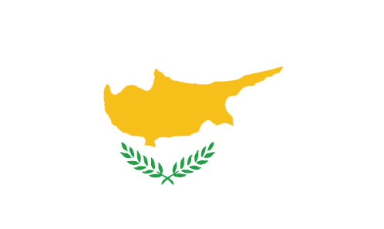
POLICY FRAMEWORK
Cyprus development assistance is guided by the Μedium-Term Strategy for Official Development Assistance 2006-2010. Cypriot assistance is directed to 5 programme countries where Cyprus will undertake to implement more comprehensive schemes of assistance and to 14 project countries where Cypriot aid is delivered in the form of small scale individual projects. Sectoral priorities are infrastructure development, social and services sectors and the environment. Cyprus development activities are labeled CyprusAid. The highest decision making body is the Coordination Body headed by the Minister of Foreign Affairs and membership from the Minister of Finance and the Permanent Secretary of the Planning Bureau. The Planning Bureau has policy preparation, administrative and implementation functions for the decisions.
I. INCREASING FINANCIAL RESOURCES FOR DEVELOPMENT AND GLOBAL CHALLENGES
- IMPROVING DOMESTIC RESOURCE MOBILISATION
- Cyprus does not provide support to reform programmes for capacity development of custom, judiciary and tax administrations in developing countries
- Promotes the principles of good governance in tax matter: No
- New Double Taxation Conventions of 2010:
- State of ratification of/ adherence to international conventions/ initiatives on tax issues:
- IMF Regional Technical Assistance Centres: No
- International Tax Dialogue: No
- International Tax Compact: No
- African Tax Administration Forum (ATAF): No
- Centro Inter-Americano de Administraciones Tributarias (CIAT): No
- IMF Topical Trust Fund on Tax policy and administration: No
- OECD Global Forum on Transparency and Exchange of Information on Tax Purposes: Yes
- International Organization of Tax Administrations (IOTA): Yes
- Commonwealth Association of Tax Administrators (CATA): Yes
- United Nations Convention against Corruption (Merida): Yes
- OECD Convention on Combating Bribery of Foreign Officials in International Business Transactions: No
- Stolen Assets Recovery initiative (STAR): No
- Extractive Industry Transparency Initiative (EITI): No

- SCALING UP ODA
ODA individual commitments/gap to agreed targets
- Cyprus spent EUR 34 million on ODA in 2010 (preliminary), i.e. 20% of its GNI and met the 2010 0.17% ODA/GNI target. This was a nominal increase by 5% compared to 2009. Additional efforts are needed in comparison to other government expenditure projects to reach the 2015 0.33% ODA/GNI target.
- Share of debt relief in ODA during the period 2004 – 2009: N/A
Source: OECD/ DAC data for 1995 – 2010; Commission simulation based on information provided by EU Member States or based on agreed EU commitments for 2010 and 2015. ODA in current prices.

- "Realistic, verifiable actions for meeting your individual ODA commitments until 2015" taken in 2010: None.
- Cyprus is committed to ensure that the majority of Cypriot ODA goes to Africa. Almost 50% of Cypriot programme countries are countries of the African region. Given that increases in the volume of bilateral assistance are distributed evenly between the programme countries, this implies that at least 50% of the aid increases in bilateral assistance will be channelled to Africa.
- Almost 50% of Cypriot bilateral assistance is provided to LDCs.

- SUPPORT FOR/ USE OF INNOVATIVE SOURCES AND MECHANISMS OF FINANCING DEVELOPMENT
- Cyprus supports UNITAD (medical drug financing through innovative sources) with EUR 0.4 million, but has no intention to step up efforts in the area of innovative financing mechanisms.

- LEVERAGING PRIVATE FLOWS FOR DEVELOPMENT
Support to private investment in developing countries:
- Financial tools to support private investment:
- Investment guarantees: No
- Improvement of the overall banking system: No
- Microfinance/ access to financial services: No
- Risk management initiatives: No
- Blending: No
- Private public partnerships: No
- Business and investment climate: Yes
- Investment facilities: No
- Export credits: No
- Scholarship on managerial and financial matters: Yes
- Cyprus does not promote the adoption of internationally agreed principles and standards on Corporate Social and Environmental Responsibility by European companies.
- Cyprus does not support the Kimberley process and the FAO Code of Conduct for Responsible Fisheries.
- New initiatives in relation to including social and environmental clauses in ODA-financed public procurements: None
- Cyprus has no current plans to implement solutions internally or in cooperation with third countries to overcome barriers to migrants and their families' access to financial services. Cyprus’ development and migration policies are currently not interconnected.
- Cyprus does have robust and reliable data concerning the amounts and destination of remittances from the country.
- Cyprus has not implemented the General Principles for International Remittances Services" agreed by the Committee on Payments and Settlements Systems (CPSS)
- AID FOR TRADE
No information available on Cyprus’ commitments for Aid for Trade
- REDUCING THE DEBT BURDEN OF DEVELOPING COUNTRIES
- Cyprus has delivered on its commitments to the HIPC and MDRI initiatives, including commitments towards IDA and the African Development Bank.
- Cyprus sees no need for reform of the international architecture for the restructuring of sovereign debts.
- Cyprus has not planned specific interventions to prevent aggressive litigation against HIPCs.
II. IMPROVED EFFECTIVENESS OF SUPPORT TO DEVELOPING COUNTRIES
- MORE EFFECTIVE EU AID
- On Ownership. Cyprus supported country ownership in 2010 through consultation and coordination with partner countries.
- On Conditionality. Cyprus has carried out the following actions on conditionalities in 2010: harmonisation with other donors.
- On Transparency and Predictability. Cyprus publicly discloses information on aid volume on a website.
- On Alignment. Cyprus has integrated the principles of the Code of Conduct on Complementarity and Division of Labour in strategies, staff guidance and programming processes/guidelines.
- On Harmonisation. Cyprus has arrangements in place for delegated cooperation. In fact, all projects funded by Cyprus Aid are implemented through delegated cooperation. There is a mechanism in place to track cases of delegated cooperation.
- On Mutual Accountability. Cyprus has not established a joint framework for monitoring joint commitments in priority countries.
- On Managing for Development Results. Cyprus does not provide capacity support for Managing for Development Results.
- SUPPORTING BETTER GLOBAL GOVERNANCE
- Cyprus believes that the EU27 should speak with one voice in the IMF, World Bank and the main multilateral development banks' governing bodies. The EU Member-State holding the EU Presidency should communicate the EU position on behalf of all members after an intra EU preparatory meeting.
- Cyprus support stronger Brussels based coordination on issues related to the World Bank and MDB's.
CZECH REPUBLIC

POLICY FRAMEWORK
The Principles for Providing Foreign Aid, the Bill on Foreign Development Cooperation and humanitarian aid and the objectives contained in the Concept of the International Development of the Czech Republic 2008-2012 illustrate the extent to which the Czech Republic recognises development co-operation as a policy area in its own right.
In the past ten years, the Czech Republic introduced a number of major changes in the concept and organisation of development cooperation, aimed at increasing the efficiency of aid provided to partner countries and adapting it to the changing international environment. A turning point was the Czech Republic's accession to the European Union that is the world's leading provider of external assistance. The Czech Development Agency (CzDA) is an implementing body of the Czech Development Cooperation primarily focused on design and execution of bilateral development projects. CzDA has been in operation since January 1, 2008 and was re-established by the Law on Development Cooperation and Humanitarian Assistance on July 1, 2010. Since 2010, the agency reports to the Ministry of Foreign Affairs in charge of coordination of Czech ODA.
I. INCREASING FINANCIAL RESOURCES FOR DEVELOPMENT AND GLOBAL CHALLENGES
- IMPROVING DOMESTIC RESOURCE MOBILISATION
- Support to reform programmes for capacity development of customs, judiciary and tax administrations in developing countries: Czech Republic provides aid in these fields to EU Neighbourhood Policy countries (support to: Tax Administration and Ministry of Finance through projects on administration of customs duties, customs control customs).
- Support to promote good governance in tax matters: Yes
- Bilateral Tax Information Exchange Agreements and Double Taxation Conventions since 2010: (i) Double Taxation Conventions signed with Isle Of Man, Guernsey, British Virgin Islands, Bosnia And Herzegovina; (iia) DTC under negotiation with Jersey, Bermuda, San Marino, China, Hong Kong, Barbados, Denmark, (iib) Protocol to the DTC under negotiation with Serbia, Belgium, Belarus; (iii) planned with Cayman Islands, Seychelles.
- State of ratification of/adherence to international conventions/initiatives on tax issues:
- United Nations Convention against Corruption (Merida): No
- OECD Convention on Combating Bribery of Foreign Officials
- in International Business Transactions: Yes
- Stolen Assets Recovery initiative (STAR): No
- Extractive Industry Transparency Initiative (EITI): No
- IMF Regional Technical Assistance Centres: No
- International Tax Dialogue: No
- International Tax Compact: No
- African Tax Administration Forum (ATAF): No
- Centro Inter-Americano de Administraciones Tributarias (CIAT): No
- IMF Topical Trust Fund on Tax policy and administration: No

- SCALING UP ODA
- In 2010 the Czech Republic spent EUR 169 million (preliminary), i.e.0.12% of its GNI, the same level as in 2009 and short of the 0.17% target.
- Share of debt relief in ODA: N/A
ODA Individual commitments and gap to target
Source: OECD/ DAC data for 1995 – 2010; Commission simulation based on information provided by EU Member States or based on agreed EU commitments for 2010 and 2015. ODA in current prices.

Czech Republic - Share of debt relief in ODA volumes

Source: OECD/DAC data for 2002-2010

- "Realistic, verifiable actions for meeting individual ODA commitments until 2015" taken in 2010: Czech Republic established a multi-annual indicative timetable/minimum aid level commitment, approved by the national government.
- No measures taken nor planned to contribute to the EU27 target to channel at least 50% of EU collective ODA increase to Africa.
- Czech Republic will not reach the target of 0.15%-0.20% ODA/GNI to LDCs by 2010

- SUPPORT FOR/ USE OF INNOVATIVE SOURCES AND MECHANISMS OF FINANCING DEVELOPMENT
- Czech Republic does not intend to step up efforts for innovative financing mechanisms with significant revenue generation potential
- Czech Republic did not use innovative financing mechanisms for development
- LEVERAGING PRIVATE FLOWS FOR DEVELOPMENT
Support to private investment in developing countries:
- Financial tools to support private investment
- Investment guarantees: Yes
- Improvement of the overall banking system: No
- Microfinance/ access to financial services: Yes
- Risk management initiatives: No
- Blending: No
- Private public partnerships: No
- Business and investment climate: No
- Investment facilities: Yes
- Export credits: Yes
- Czech Republic promotes the adoption of internationally agreed principles and standards on Corporate Social and Environmental Responsibility by European companies. Ministry of Foreign Affairs conducts dialogue with some major Czech corporations about global and international cooperation issues. Private sector representatives are also associate members of the Czech Council for Development Cooperation.
- Czech Republic supports the Kimberley process and the FAO Code of Conduct for Responsible Fisheries
- New initiatives in 2010 to include social and environmental clauses in ODA-financed public procurement: Measures according to paragraph 44 of the Public Procurement Law
- Czech Republic did not implement solutions internally or in cooperation with third countries to overcome barriers to migrants and their families' access to financial services. However, the competent authorities of the Czech Republic closely cooperate with the World Bank in the matter of International Remittance Service.

- AID FOR TRADE
Czech Republic, AfT Commitments (in EUR thousands)
Source: OECD CRS Database (latest update)

- REDUCING THE DEBT BURDEN OF DEVELOPING COUNTRIES
- Czech Republic delivered on its HIPC/ MDRI commitments (including vis-à-vis IDA/ AfDB) without delay.
- Actions/steps taken in 2010 to help restore and preserve debt sustainability in low-income countries: Through the application of the OECD Principles and Guidelines to Promote Sustainable Lending Practices in the Provision of Official Export Credits to LICs.
- Czech Republic does not favour reform of the international architecture for restructuring of sovereign debts
- No specific intervention to prevent aggressive litigation against HIPCs (in particular to prevent the actions of "vulture funds").

II. IMPROVED EFFECTIVENESS OF SUPPORT TO DEVELOPING COUNTRIES
- MORE EFFECTIVE EU AID
- On Ownership. In 2010 and beginning 2011, development cooperation programming process with priority (programme) countries is under way.
- On Conditionality. In 2010, Czech Republic progressed by harmonising conditionalities with other donors and by reducing the number of conditionalities.
- On Transparency and Predictability. Czech Republic publicly discloses information on aid volumes through the Czech development Agency (CzDA) web site.
- On Alignment. Czech Republic partially integrated the principles of the Code of Conduct on Complementarity and Division of Labour in its development strategy.
- On Harmonisation. No arrangement in place on delegated cooperation.
- On Mutual Accountability. No joint framework for monitoring joint commitments.
- On Managing for Development Results. Czech Republic does not provide capacity building support for this.

- SUPPORTING BETTER GLOBAL GOVERNANCE
- Position on improving the voice of the EU and its Member States within International Financial Institutions. Czech Republic supports a single EU Chair for the IMF in order for the EU27 to speak with one voice. For instance, to coordinate EU27 positions on key policy issues.
- Czech Republic does not favour stronger Brussels based coordination on issues related to the World Bank and MDBs.

DENMARK 
AT A GLANCE
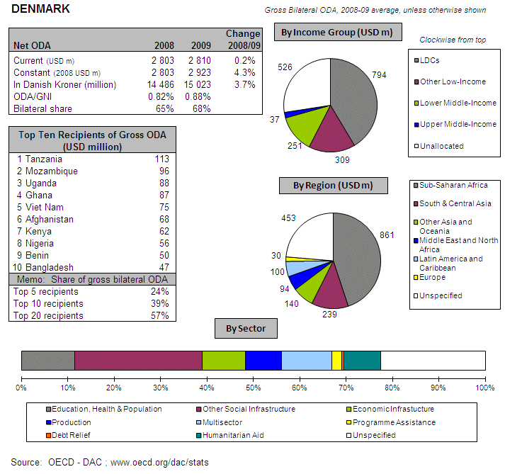
POLICY FRAMEWORK
The Danish parliament adopted a new development policy in June 2010. The Government presents to parliament every year its plan and priorities for Danish development assistance for the coming five year period. The priorities of Denmark's development cooperation for years 2011-2015 are concentration on fewer countries (from 26 to 15 partner countries) and five priority sectors – i) freedom, democracy and human rights, ii) growth and employment, iii) gender equality, iv) stability and fragility, and 5) environment and climate. During 2011-2013 Denmark will maintain the same level of ODA in Danish krone, which implies a decrease of the ODA/GNI ratio when GNI grows. The annual budget for development cooperation is determined by the Government’s Finance Act. Administration of development assistance is the responsibility of the Ministry of Foreign Affairs.
I. INCREASING FINANCIAL RESOURCES FOR DEVELOPMENT AND GLOBAL CHALLENGES
- IMPROVING DOMESTIC RESOURCE MOBILISATION
- Support to reform programmes for capacity development of custom, judiciary and tax administrations in developing countries: Denmark provides support to developing countries' tax policy and administration (semi-autonomous revenue authorities and ministries of finance) in Asia and ACP countries.
- Promotes the principles of good governance in tax matter: Yes
- New Bilateral Tax Information Exchange Agreements and Double Taxation Conventions of 2010: None
- State of ratification of/ adherence to international conventions/ initiatives on tax issues:
- IMF Regional Technical Assistance Centres: No
- International Tax Dialogue: No
- International Tax Compact: No
- African Tax Administration Forum (ATAF): No
- Centro Inter-Americano de Administraciones Tributarias (CIAT): No
- IMF Topical Trust Fund on Tax policy and administration: No
- United Nations Convention against Corruption (Merida): Yes
- OECD Convention on Combating Bribery of Foreign Officials in International Business Transactions: Yes
- Stolen Assets Recovery initiative (STAR): No
- Extractive Industry Transparency Initiative (EITI): Yes
- SCALING UP ODA
ODA individual commitments/gap to agreed targets
- Denmark has since many year exceeded the EU 2015 0.7% ODA/GNI target. The Government will maintain Danish development assistance at the level of DKK 15.2 billion annually over the period 2011-2013. Denmark spent EUR 2164 million on ODA in 2010 (preliminary), i.e. 0.90% in 2010 compared to 0.88% in 2009. This was an increase by 4.3% in real terms compared to 2009.
- Debt relief made up only 3% of Danish ODA during the period 2004 - 2009
Source: OECD/ DAC data for 1995 – 2010; Commission simulation based on information provided by EU Member States or based on agreed EU commitments for 2010 and 2015. ODA in current prices.

Denmark - Share of debt relief in ODA volumes

Source: OECD/DAC data for 2002-2010

- "Realistic, verifiable actions for meeting your individual ODA commitments until 2015" taken in 2010: The Danish government is committed to the 0.7% target. It expects the level of ODA/GNI to be 0.84% in 2011.
- Denmark is committed to ensure that the majority of Danish ODA goes to Africa.
- Denmark will continue to exceed the target of 0.15%-0.20% ODA/GNI to LDCs from 2010 onwards.
- SUPPORT FOR/ USE OF INNOVATIVE SOURCES AND MECHANISMS OF FINANCING DEVELOPMENT
- Denmark has not implemented any innovative financing sources and mechanisms and has no plan to step up efforts in the area.

- LEVERAGING PRIVATE FLOWS FOR DEVELOPMENT
Support to private investment in developing countries: Foreign Direct Investment
Source: OECD/ DAC
- Financial tools to support private investment:
- Investment guarantees: Yes
- Improvement of the overall banking system: No
- Microfinance/ access to financial services: Yes
- Risk management initiatives: No
- Blending: No
- Private public partnerships: Yes
- Business and investment climate: Yes
- Investment facilities: Yes
- Export credits: Yes
- Denmark promotes the adoption of internationally agreed principles and standards on Corporate Social and Environmental Responsibility by European companies. See Box.
Box Innovative Partnerships for Development (IPD) Programme: The IPD Programme offers financial and advisory support to partnerships between Danish companies and companies, organisations or public institutions in developing countries. The programme sets out to promote better working and living conditions for employees, their families, the community and society at large by advancing strategic CSR and socially responsible innovation. Partnerships must be within the framework of the Global Compact and the MDGs and must be long-term sustainable. Partnership proposals are measured against six development impact criteria to ensure adequate development impact. The maximum support provided under the B2B Programme is DKK5 million (approx. EUR 670.000) to each partnership project.

- Denmark is a long-term donor to the UN Global Compact.
- New initiatives in relation to including social and environmental clauses in ODA-financed public procurements: N.A.
- Denmark has current no plans to implement solutions internally or in cooperation with third countries to overcome barriers to migrants and their families' access to financial services. However, Denmark awaits the World Bank’s upcoming study on migration, remittances and diaspora in Africa and EU recommendations which are expected in 2011.

- AID FOR TRADE
Denmark, AfT Commitments (in EUR thousands)
Source: OECD CRS Database (latest update)
- REDUCING THE DEBT BURDEN OF DEVELOPING COUNTRIES
- Denmark has delivered on its commitments to the HIPC and MDRI initiatives, including commitments towards IDA and the African Development Bank
- In addition, Denmark has provided DKK9 million to the cancellation of Haiti´s multilateral debt.
- Denmark sees no need for reform of the international architecture for the restructuring of sovereign debts. However, Denmark believes that non-Paris Club creditors need to be involved in future restructuring and cancellation of LIC debt.
- No specific interventions to prevent aggressive litigation against HIPCs have been taken.

II. IMPROVED EFFECTIVENESS OF SUPPORT TO DEVELOPING COUNTRIES
- MORE EFFECTIVE EU AID
- On Ownership. Denmark supported country ownership in 2010 through consultation and coordination with partner countries and by supporting partner capacity development.
- On Conditionality. Denmark has carried out the following actions on conditionalities in 2010: harmonisation with other donors and making conditionalities public.
- On Transparency and Predictability. Denmark publicly discloses information on aid volume on central and field office websites.
- On Alignment. Denmark has integrated the principles of the Code of Conduct on Complementarity and Division of Labour in strategies, staff guidance and programming processes/guidelines.
- On Harmonisation. Denmark has arrangements in place for delegated cooperation. Denmark was approved to administer EC funds in the indirect centralised management mode, i.e. delegated cooperation in 2010. Denmark subscribes to the Nordic Plus principles for delegated cooperation, where Nordic Plus countries have agreed to mutually approve each other as potential partners for delegated co-operation arrangements. There is no mechanism in place at headquarters level to track cases of delegated cooperation.
- On Mutual Accountability. Denmark has established a joint framework for monitoring joint commitments in priority countries.
- On Managing for Development Results. Denmark provides capacity support for Managing for Development Results.

- SUPPORTING BETTER GLOBAL GOVERNANCE
- Denmark believes that the EU27 should speak with one voice in the IMF, World Bank, the main multilateral development banks' governing bodies and the G20.
ESTONIA

POLICY FRAMEWORK
Estonian Development Cooperation started in 1997, with budget allocation since 1998. Estonian objectives and priorities for development co-operation policy are outlined in the "Principles of Estonian Development Cooperation” approved by the Riigikogu (Parliament) in January 2003 as a successor of the previous policy document "Principles of Development Cooperation for the Years 1999-2000”.
The Ministry of Foreign Affairs is responsible both for programming and for implementation of the development cooperation policy. Other governmental agencies implement specific projects in the scope of their competence. In January 2011, the Estonian Government approved Strategy for Estonian development cooperation and humanitarian aid for 2011-2015 and the implementation plan of the development plan for the years 2011-2012. Detailed information on Estonia's bilateral development cooperation activities is available on the dedicated Ministry of Foreign Affairs website.
I. INCREASING FINANCIAL RESOURCES FOR DEVELOPMENT AND GLOBAL CHALLENGES
- IMPROVING DOMESTIC RESOURCE MOBILISATION
- Support to reform programmes for capacity development of customs, judiciary and tax administrations in developing countries: Estonia provides aid in these fields EU Neighbourhood Policy countries (support to: Tax Administrations and Ministries of Finance).
- Support to promote good governance in tax matters: Yes
- Bilateral Tax Information Exchange Agreements and Double Taxation Conventions since 2010: N/A
- State of ratification of/adherence to international conventions/initiatives on tax issues:
- United Nations Convention against Corruption (Merida): Yes
- OECD Convention on Combating Bribery of Foreign Officials
in International Business Transactions: Yes
- Stolen Assets Recovery initiative (STAR): No
- Extractive Industry Transparency Initiative (EITI): No
- IMF Regional Technical Assistance Centres: No
- International Tax Dialogue: No
- International Tax Compact: No
- African Tax Administration Forum (ATAF): No
- Centro Inter-Americano de Administraciones Tributarias (CIAT): No
- IMF Topical Trust Fund on Tax policy and administration: No
- SCALING UP ODA
- Estonia's ODA/GNI was 0.10% in 2010, the same as in 2009, with a nominal increase of EUR 1 million to EUR 14 million of ODA (preliminary). This falls short of the 2010 target of 0.17%, which the government has set as the minimum target for 2015.
- Share of debt relief in ODA: N/A
ODA Individual commitments and gap to target
Source: OECD/ DAC data for 1995 – 2010; Commission simulation based on information provided by EU Member States or based on agreed EU commitments for 2010 and 2015. ODA in current prices.

- "Realistic, verifiable actions for meeting individual ODA commitments until 2015" taken in 2010: Estonia is striving for the 0,33% margin by having fixed a minimum level contribution in the 2011-2015 Strategy, which will be subject to yearly updates and possible upward corrections depending on the economic situation.
- No direct measures taken or planned to contribute to the EU27 target to channel at least 50% of EU collective ODA increase to Africa. With the increasing EU support to Africa, indirectly the share of Africa in Estonian ODA will increase as well. From 2011 Estonia also will contribute to the 10th EDF (European Development Fund).
- Estonia will not reach the target of 0.15%-0.20% ODA/GNI to LDCs by 2010 and onwards

- SUPPORT FOR/ USE OF INNOVATIVE SOURCES AND MECHANISMS OF FINANCING DEVELOPMENT
- Innovative source of financing: ETS auctioning revenues
- Estonia needs to analyse the merits of innovative financing mechanisms with regard to the volume of Estonian aid.

- LEVERAGING PRIVATE FLOWS FOR DEVELOPMENT
Support to private investment in developing countries:
- Financial tools to support private investment
- Investment guarantees: Yes
- Improvement of the overall banking system: No
- Microfinance/ access to financial services: No
- Risk management initiatives: No
- Blending: Yes
- Private public partnerships: No
- Business and investment climate: Yes
- Investment facilities: No
- Export credits: No
- Estonia does not promote the adoption of internationally agreed principles and standards on Corporate Social and Environmental Responsibility by European companies.
- No new initiatives were started in 2010 to include social and environmental clauses in ODA-financed public procurement.
- Estonia did not implement solutions internally or in cooperation with third countries to overcome barriers to migrants to financial services. The small amount of migrants is the main reason why the flow of funds from migrant workers back to their families in their countries of origin has no dominant role in Estonian remittance market
- Estonia implemented the "General Principles for International Remittances Services" agreed by the Committee on Payments and Settlements Systems (CPSS). No other initiative as Estonia already has a safe and enforceable regulatory environment for the money remittance market (implementation of the PSD in the beginning of 2010 , the Estonian Anti-Money Laundering and Terrorist Financing Prevention Act …)
- Estonia has robust and reliable data concerning the amounts and destination of remittances from Estonia. Furthermore, Estonia adopted the operational definitions, recommendations and best practices on improving the quality and coverage of data on remittances according to the compilation guide drafted by the "Luxembourg Group".

- AID FOR TRADE
Estonia, AfT Commitments (in EUR thousands)

Source: OECD CRS Database (latest update)

- REDUCING THE DEBT BURDEN OF DEVELOPING COUNTRIES
- Estonia delivered on its HIPC/ MDRI commitments (including vis-à-vis IDA/ AfDB) without delay
- Actions/steps taken in 2010 to help restore and preserve debt sustainability in low-income countries: increasing our contribution to the IDA by 41.1%.
- Estonia does not favour reform of the international architecture for restructuring of sovereign debts
- No specific intervention to prevent aggressive litigation against HIPCs (in particular to prevent the actions of "vulture funds").

II. IMPROVED EFFECTIVENESS OF SUPPORT TO DEVELOPING COUNTRIES
- MORE EFFECTIVE EU AID
- On Ownership. In 2010, Estonia supported ownership through consultations and coordination with partner countries, through guidance and incentives for staff in partner countries, and through partner capacity development
- On Conditionality. No Action
- On Transparency and Predictability. Estonia publicly discloses information on aid volumes through the Estonian Development Cooperation web site
- On Alignment. Estonia partially integrated the principles of the Code of Conduct on Complementarity and Division of Labour in its development strategy.
- On Harmonisation. Legal and/or administrative arrangements to ensure delegated cooperation are project based.
- On Mutual Accountability. No joint framework for monitoring joint commitments. Mutual accountability is somewhat covered through the cooperation agreements with the priority target countries since 2011
- On Managing for Development Results. Belgium does not provide capacity building support for this.

- SUPPORTING BETTER GLOBAL GOVERNANCE
- Position on improving the voice of the EU and its Member States within International Financial Institutions. Estonia supports a single EU Chair for the IMF in order for the EU27 to speak with one voice. Shareholders have sometimes different perspectives to certain issues, so "one voice" would probably be going too far and everything does not need to be intra-EU coordinated. In some areas the EU common statements or position papers are of course useful or even necessary. Generally the EU27 has a well-functioning internal coordination of views on main IMF policy issues; similar coordination could be replicated in other IFIs if current coordination is viewed unsatisfactory in producing a coordinated understanding. As European countries belong to different constituencies at the IMF/WB/other MDBs, the strengthened coordination is the best way to increase the cohesiveness of the EU voice in the IFIs.
- Estonia favours stronger Brussels based coordination on issues related to the World Bank and MDBs.
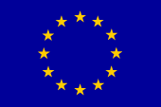
EUROPEAN COMMISSION

AT A GLANCE
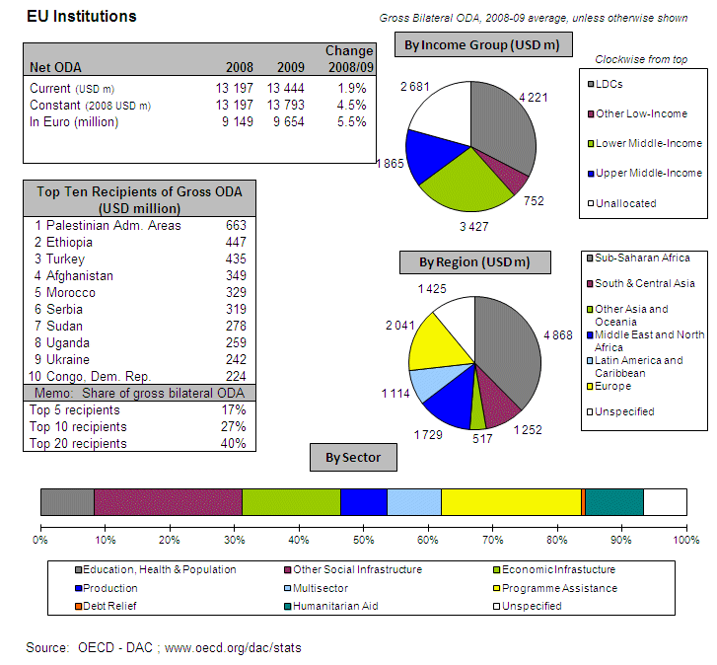
POLICY FRAMEWORK
Since 2006, the "European Consensus on Development" has defined the general framework for the action of the Union and Member States. It highlights the Commission’s dual development role by clarifying its added value in relation to the Member States (its federating role) and by elaborating in its role as a donor. In addition, the Union is particularly committed to honouring the United Nations Millennium Development Goals (MDG), for which the Union has put in place various instruments that will also help reinforce the impact of its action. In January 2011, the European Commission merged EuropeAid and the Directorate-General for Development to create the EuropeAid Development and Cooperation Directorate-General. The goal of the merger is to create a single voice for the EU on development and cooperation issues.
I. INCREASING FINANCIAL RESOURCES FOR DEVELOPMENT AND GLOBAL CHALLENGES
- IMPROVING DOMESTIC RESOURCE MOBILISATION
- Support to reform programmes for capacity development of customs, judiciary and tax administrations in developing countries: European Commission provides aid in these fields to EU candidate countries, EU Neighbourhood Policy countries, Asia, Latin America and ACP Countries (support to administrations and policy of: Customs, Semi-autonomous Revenue Authorities and Ministries of Finance). In March 2011, the European Parliament adopted two resolutions urging the European Union to impose a financial transaction tax and give more tax-related development assistance to developing countries while combating fraudulent practices and tax evasion.
- Support to promote good governance in tax matters: Yes
- Bilateral Tax Information Exchange Agreements and Double Taxation Conventions since 2010: N/A. The specific issue as such is not relevant for the Commission since such bilateral agreements are concluded at Member State level as they fall within Member States' competence. However, it should be noted that the EU does have agreements with five third countries on the taxation of savings income.
- State of ratification of/adherence to international conventions/initiatives on tax issues:
- United Nations Convention against Corruption (Merida): No
- OECD Convention on Combating Bribery of Foreign Officials
in International Business Transactions: No
- Stolen Assets Recovery initiative (STAR): Yes
- Extractive Industry Transparency Initiative (EITI): Yes
- IMF Regional Technical Assistance Centres: Yes
- International Tax Dialogue: Yes
- International Tax Compact: No
- African Tax Administration Forum (ATAF): Yes
- Centro Inter-Americano de Administraciones Tributarias (CIAT): No
- IMF Topical Trust Fund on Tax policy and administration: No

- SCALING UP ODA
ODA Individual commitments and gap to target
- The EU institutions do not have a specific ODA targets, majority of the funds reported as ODA by the Commission are imputed to Member States.
- The EU institutions spent EUR 9804 million of ODA in 2010, a 0.8% increase in real terms on the 2009 figure of EUR 9654 million.

EU institutions' ODA in nominal terms
Source: OECD/DAC data for 2000-2010
- SUPPORT FOR/ USE OF INNOVATIVE SOURCES AND MECHANISMS OF FINANCING DEVELOPMENT

- The European Commission intends to step up efforts for innovative financing mechanisms with significant revenue generation potential, with a view to ensuring predictable financing for sustainable development. At the Foreign Affairs Council (Defence & Development) in December 2010, the Council discussed innovative financing sources and mechanisms for development. The Commission stated that it would continue its work on the technical feasibility of such mechanisms and their potential impact.
- The Commission conducted an impact assessment on new financial sector taxes (notably a Financial Transaction Tax and a Financial Activities Tax) which was published on March 2011. Revenues from such taxes could be used to respond to global and European challenges, such as development and the achievement of the MDGs, as well as efforts to tackle climate change

- LEVERAGING PRIVATE FLOWS FOR DEVELOPMENT
Support to private investment in developing countries:
- Financial tools to support private investment
- Investment guarantees: Yes
- Improvement of the overall banking system: Yes
- Microfinance/ access to financial services: Yes
- Risk management initiatives: Yes
- Blending: Yes
- Private public partnerships: No
- Business and investment climate: Yes
- Investment facilities: Yes
- Export credits: No
- The European Commission promotes the adoption of internationally agreed principles and standards on Corporate Social and Environmental Responsibility by European companies. The Commission intends to continue to promote CSR and other sustainability oriented scheme as a voluntary concept, with an emphasis on dialogue between stakeholders. It promotes international benchmarks for CSR such as the UN MDGs, the ILO tripartite declaration of principles, the OECD guidelines for multinational enterprises, the UN principles for sustainable investment and the UN Global Compact. The EU also aims include sustainable development chapters, with provisions on environment and labour, in all bilateral trade agreements.
- The European Commission supports the Kimberley process and the FAO Code of Conduct for Responsible Fisheries.
- No new initiatives were started in 2010 to include social and environmental clauses in ODA-financed public procurement.
- The European Commission did not implement solutions internally or in cooperation with third countries to overcome barriers to migrants and their families' access to financial services. The Commission is, though, implementing programmes in partner countries with the aim of developing the financial sector (e.g. microfinance, technical assistance on financial sector regulation and supervision) and improving financial literacy in order to familiarise households receiving remittances with banking services.

- AID FOR TRADE
European Commission, AfT Commitments (in EUR thousands)
Source: OECD CRS Database (latest update)
- REDUCING THE DEBT BURDEN OF DEVELOPING COUNTRIES
- The European Commission delivered on its HIPC/ MDRI commitments (including vis-à-vis IDA/ AfDB) without delay.
- Actions/steps taken in 2010 to help restore and preserve debt sustainability in low-income countries: committing EUR 3 Million for the WB DMF and EUR 3 Million to the UNCTAD DMFAS. Financing agreements should be signed early 2011.
- The European Commission favours reform of the international architecture for restructuring of sovereign debts in order to deal with potential future cases of debt distress in low-income countries (through the Paris Club with a role for International Financial Institutions, and through collective action clauses in debt contracts).
- Specific intervention to prevent aggressive litigation against HIPCs (in particular to prevent the actions of "vulture funds"): The European Commission is considering using the "African Legal Support Facility" to provide ad hoc legal advice, on demand, to countries.
II. IMPROVED EFFECTIVENESS OF SUPPORT TO DEVELOPING COUNTRIES
- MORE EFFECTIVE EU AID
- On Ownership. In 2010, the European Commission supported ownership through consultations and coordination with partner countries and through partner capacity development.
- On Conditionality. In 2010, the European Commission progressed by harmonising conditionalities with other donors and by reducing the number of conditionalities.
- On Transparency and Predictability. The European Commission publicly discloses information on aid volumes through its Development Cooperation web site and through the website of field offices. Data are also available in the Annual Report on development policies and external assistance which is widely disseminated (to Delegations, national development agencies, Parliaments and ministers, stakeholders, etc.).
- On Alignment. The European Commission partially integrated the principles of the Code of Conduct on Complementarity and Division of Labour in its development strategy.
- On Harmonisation. Guidelines have been developed in December and templates for Delegation and Transfer Agreements have been approved in and further fine tuned the past years.
- On Mutual Accountability. The European Commission established a joint framework for monitoring joint commitments with some of its priority countries. The European Commission is waiting for the Paris Survey outcome to confirm its position.
- On Managing for Development Results. The European Commission provides capacity building support for this.
- SUPPORTING BETTER GLOBAL GOVERNANCE
- Position on improving the voice of the EU and its Member States within International Financial Institutions. The European Commission is in favour of an EU single seat in the IFIs as a long term ultimate objective to represent the European Union with a single voice. The European Commission have been giving support to this solution for years (as reflected in several official Commission's documents, such as written statements by Commissioners L. Michel and P. Nielson and the Council's conclusions on Monterrey or the report "EMU at 10"). There is work to do to deepen and broaden the coordination between EU Member States, in order to strengthen Europe's voice in the IFIs though a consolidated and less fragmented European representation. However, the Commission warns against rushing into intermediate solutions, and instead favours a package-based approach to such issues.
- The European Commission favours stronger Brussels based coordination on issues related to the World Bank and MDBs.

FINLAND
AT A GLANCE
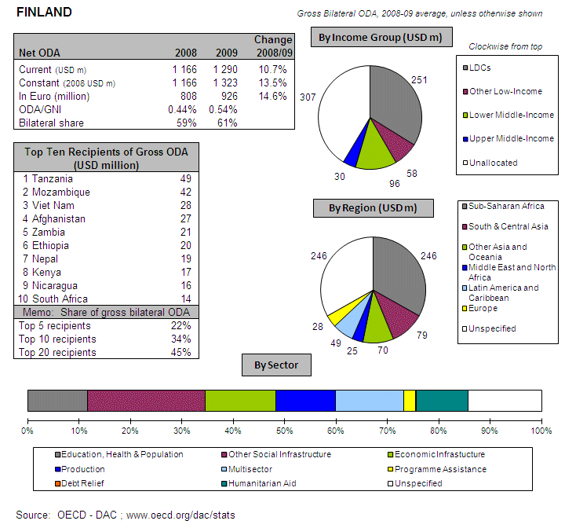
POLICY FRAMEWORK
Finland’s development co-operation is based on annual state budgets and guiding documents rather than being enshrined in law. The current overarching strategic document is a government resolution on development policy from October 2007. In it the government states that it will ensure that Finland’s ODA reaches 0.51% of GNI in 2010 and 0.7% in 2015. Poverty reduction is the overall objective, but there is no particular sectoral focus. Finland has eight long-term partner countries and five partner countries recovering from violent crises. Finland’s development policy is formulated, planned and implemented by the Ministry for Foreign Affairs.
I. INCREASING FINANCIAL RESOURCES FOR DEVELOPMENT AND GLOBAL CHALLENGES
- IMPROVING DOMESTIC RESOURCE MOBILISATION
- Support to reform programmes for capacity development of custom, judiciary and tax administrations in developing countries: Finland provides support to developing countries' tax policy and administration to ministries of finance in ACP countries. In addition, support is provided to national governments, audit institutions and civil society organisations to strengthen public financial management.
- Promotes the principles of good governance in tax matter: Yes, in budget support dialogue.
- New Bilateral Tax Information Exchange Agreements and Double Taxation Conventions of 2010: None
- State of ratification of/ adherence to international conventions/ initiatives on tax issues:
- IMF Regional Technical Assistance Centres: No
- International Tax Dialogue: No
- International Tax Compact: No
- African Tax Administration Forum (ATAF): No
- Centro Inter-Americano de Administraciones Tributarias (CIAT): No
- IMF Topical Trust Fund on Tax policy and administration: No
- United Nations Convention against Corruption (Merida): Yes
- OECD Convention on Combating Bribery of Foreign Officials in International Business Transactions: Yes
- Stolen Assets Recovery initiative (STAR): No
- Extractive Industry Transparency Initiative (EITI): Yes
- SCALING UP ODA
ODA individual commitments/gap to agreed targets
- Finland spent EUR 1008 million on ODA in 2010 (preliminary), a 6.9% increase in real terms compared to 2009,i.e. 0.55% of its GNI, up from 0.54% in 2009.
- Debt relief made up only 3% of Finnish ODA during the period 2004 - 2009

Source: OECD/ DAC data for 1995 – 2010; Commission simulation based on information provided by EU Member States or based on agreed EU commitments for 2010 and 2015. ODA in current prices.

Finland - Share of debt relief in ODA volumes

Source: OECD/DAC data for 2002-2010

- "Realistic, verifiable actions for meeting your individual ODA commitments until 2015" taken in 2010: The Finnish Development Policy Programme, i.e. Government Decision-in-Principle, stated the commitment to ensuring the development cooperation appropriations which will take Finland towards 0.7% GNI set by the UN and that Finland is committed to achieve the target 0.51% in 2010 as established in the European council’s decision. The Ministry for Foreign Affairs has based its forward planning on that commitment. However, the figures indicated above as total ODA are based on the budgetary spending limits for the MFA of Finland exercised development assistance that were set by the Government for the years 2011-2014, adding to it an estimate of the ODA implemented by other ministries. According to the Government decision of the spending limits for 2011-2014 (March 2010) Finland’s ODA will increase up to 0.58% of GNI in 2011. In the Government decision considering the years 2012-2014 a technical assumption is made that the percentage value of 0.58% remains. However, in the Government decision it is stated that Finland is committed to increasing ODA towards the 0.7% target. Finland holds parliamentary elections in April 2011 and the next government will decide on spending limits for 2012-2015. The spending limits will be reviewed during inter-ministerial budget frame negotiations and confirmed through a Government decision in autumn 2011.
- In budgeting at least 50% of Finland’s development aid which is targeted by country or region will be allocated to Africa.
- Finland will meet the target of 0.15%-0.20% ODA/GNI to LDCs by 2010 and onwards.
- SUPPORT FOR/ USE OF INNOVATIVE SOURCES AND MECHANISMS OF FINANCING DEVELOPMENT
- Finland does not support any innovative financing mechanisms and has no plans to do so.
- However, Finland supports the EU proposal to make a comprehensive assessment of the feasibility of a Financial Activity Tax (FAT) and Financial Transactions Tax (FTT). Finland also recognises that it is essential to study further innovative financing mechanisms in the context of reaching its ODA target, since public aid will not be enough. Finland’s Minister for Foreign Trade and Development set up a Working Group on Financing for Development in April 2010. The WG handed over the report to the Minister in December 2010. The WG gave recommendations for the Finnish Government on how to expand the base of development funding and enhance cooperation among various actors in society.

- LEVERAGING PRIVATE FLOWS FOR DEVELOPMENT
Support to private investment in developing countries:
Foreign Direct Investment
Source: OECD/ DAC
- Financial tools to support private investment:
- Investment guarantees: Yes
- Improvement of the overall banking system: Yes
- Microfinance/ access to financial services: Yes
- Risk management initiatives: Yes
- Blending: No
- Private public partnerships: Yes
- Business and investment climate: Yes
- Investment facilities: Yes
- Export credits: Yes
- Finland promotes the adoption of internationally agreed principles and standards on Corporate Social and Environmental Responsibility by European companies. Finland promotes CSER principles in its cooperation with the private sector, most notably as eligibility criteria of Finnpartnership. Finland also supports the UN Global Compact with ODA funds to the amount of EUR 200,000 per year (latest contribution in 2010).
- Finland has ratified the agreement of the Kimberley Process and participates in the Kimberley Process as a Member State of the European Union. Finland supports the EITI Multi-Donor Trust Fund to the amount of EUR 1.3 million during 2009–2011
- New initiatives in relation to including social and environmental clauses in ODA-financed public procurements: Social and environmental aspects are included in development of new case management process software within the Ministry for Foreign Affairs.
- Finland has currently no plans to implement solutions internally or in cooperation with third countries to overcome barriers to migrants and their families' access to financial services. The share of remittance services of the overall payment transmission from Finland is minor, the bulk of payments are transferred via banking channels. Furthermore, there are no indications that the current payment services would not satisfy the needs of migrants. Thus, no further action is considered necessary.
- Finland has not implemented the General Principles for International Remittances Services" agreed by the Committee on Payments and Settlements Systems (CPSS).

- AID FOR TRADE
Finland, AfT Commitments (EUR million)
Source: OECD CRS Database (latest update)
- REDUCING THE DEBT BURDEN OF DEVELOPING COUNTRIES
- Finland has delivered on its commitments to the HIPC and MDRI initiatives, including commitments towards IDA and the African Development Bank.
- Finland sees no need for reform of the international architecture for the restructuring of sovereign debts.
- Finland has planned no specific interventions to prevent aggressive litigation against HIPCs.

II. IMPROVED EFFECTIVENESS OF SUPPORT TO DEVELOPING COUNTRIES
- MORE EFFECTIVE EU AID
- On Ownership. Finland supported country ownership in 2010 through consultation and coordination with partner countries, guidance and incentives for staff in partner countries and by supporting partner capacity development.
- On Conditionality. Finland has carried out the following actions on conditionalities in 2010: harmonisation with other donors and making conditionalities public.
- On Transparency and Predictability. Finland publicly discloses information on aid volume on the internet both at headquarters and at the field level. Disclosure of information at country level depends on the existence of an appropriate common database. When such a mechanism exists, data is provided (e.g. public webpage www.odamoz.org.mz in Mozambique, local Ministry homepages in Kenya). The Ministry for Foreign Affairs launched in December 2010 a publication on Finland’s ODA statistics, which serves to provide information to domestic stakeholders on the use of public ODA.
- On Alignment. Finland has partially integrated the principles of the Code of Conduct on Complementarity and Division of Labour in strategies, staff guidance and programming processes/guidelines. The Ministry for Foreign Affairs is currently revising the cooperation manuals and guidelines.
- On Harmonisation. Within the Nordic Plus group, arrangements are in place to enable delegated cooperation. As regards the EC, Finland’s assessment procedure for indirect centralised management was finalised in June 2010, providing a framework for cooperation between the MFA and the EC in this regard. There is a mechanism in place to track cases of delegated cooperation. The following list covers the delegated cooperation arrangements, whereby other donors’ funds are included into MFA/Finland’s ODA budget for 2010:
- On Mutual Accountability. Finland has established a joint framework for monitoring joint commitments in Kenya, Mozambique, Nicaragua, Tanzania and Zambia.
- On Managing for Development Results. Finland provides capacity support for Managing for Development Results.
- SUPPORTING BETTER GLOBAL GOVERNANCE
- Finland does not share the view that EU27 should speak with one voice in the IMF, World Bank and the main multilateral development banks' governing bodies, since the current governance system based on constituency groups, some of which consist of both EU and non-EU countries, does not favour such an objective.
- Finland supports stronger Brussels based coordination on a regular basis on issues related to the World Bank and MDBs.
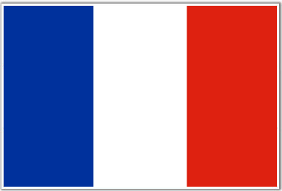
FRANCE

AT A GLANCE
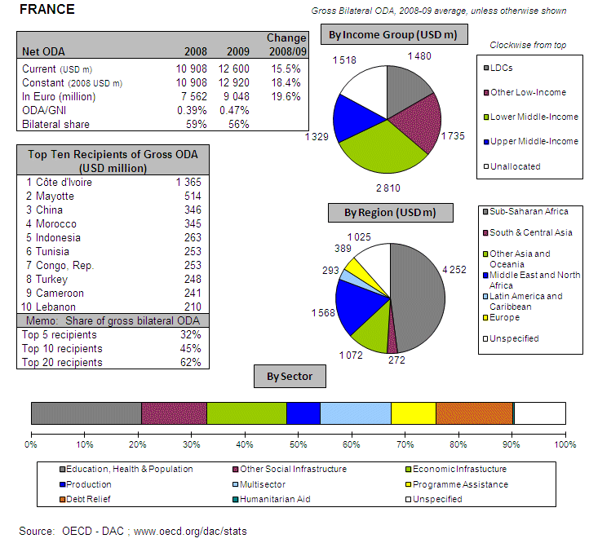
POLICY FRAMEWORK
Responsibilities and tools are shared among the three main players: The Directorate-General for International Co-operation and Development (DGCID) of the Ministry of Foreign and European Affairs (MAEE), the Directorate-General of the Treasury and Economic Policy (DGTPE) which of the Ministry of Economy, Finance and Employment (MINEFE) and the French Development Agency (AFD), a government agency that reports to these two ministries; in addition there are several entities and co-ordination structures to ensure overall coherence. The DGTPE has institutional responsibility for the multilateral development banks and certain thematic funds, while the MAEE manages funds earmarked for United Nations institutions and health sector funds.
AFD Group’s three-year Business Plan for 2011-2013 is in line with France’s new budget framework, which now presents State missions, including official development assistance (ODA), for a three-year period. This ensures greater visibility for France’s aid. This Business Plan is based on the forecasts of the three-year Finance Law for 2011-2013.
The CICID (Comité interministériel de la Coopération internationale et du Développement or French Interministerial Committee for International Cooperation and Development) defines the sector strategic orientations of France’s public economic development assistance policy and geographic priorities. The CICID meeting on June 5th, 2009 voted a set of measures designed to improve French assistance’s effectiveness and targeting in a context marked by the contagion of the global crisis’ effects on countries in development.
I. INCREASING FINANCIAL RESOURCES FOR DEVELOPMENT AND GLOBAL CHALLENGES
- IMPROVING DOMESTIC RESOURCE MOBILISATION
- Support to reform programmes for capacity development of customs, judiciary and tax administrations in developing countries: France provides aid in these fields to EU candidate countries, EU Neighbourhood Policy countries, Asia, Latin America and ACP Countries (support to administrations and policy of: Customs, Semi-autonomous Revenue Authorities and Ministries of Finance).
- Support to promote good governance in tax matters: Yes
- Bilateral Tax Information Exchange Agreements and Double Taxation Conventions since 2010: (i) Double Taxation Conventions signed with Uruguay, Antigua and Barbuda, Grenada, St Kitts et Nevis, St Lucia, Saint-Vincent et Grenadines, Antilles néerlandaises, Cook Islands, Belize, Costa Rica, Dominique, Brunei, Anguilla, Hong Kong ; (ii) under negotiation with Aruba, Liberia, (iii) planned with Philippines, Nauru.
- State of ratification of/adherence to international conventions/initiatives on tax issues:
- United Nations Convention against Corruption (Merida): Yes
- OECD Convention on Combating Bribery of Foreign Officials
in International Business Transactions: Yes
- Stolen Assets Recovery initiative (STAR): Yes
- Extractive Industry Transparency Initiative (EITI): Yes
- IMF Regional Technical Assistance Centres: Yes
- International Tax Dialogue: Yes
- International Tax Compact: Yes
- African Tax Administration Forum (ATAF): Yes
- Centro Inter-Americano de Administraciones Tributarias (CIAT): Yes
- IMF Topical Trust Fund on Tax policy and administration: Yes
- SCALING UP ODA
ODA Individual commitments and gap to target
- France has increased the share of its GNI dedicated to Official Development Assistance (ODA) from 0.47% of GNI in 2009 to EUR 9751 million (preliminary), i.e. 0.50% in 2010, nearly meeting the EU target.
- Debt relief made up 25% of French ODA during the period 2004 – 2009, the largest debt reduction operations being for Nigeria (2005-2006) and Iraq (2005-2008).
Source: OECD/ DAC data for 1995 – 2010; Commission simulation based on information provided by EU Member States or based on agreed EU commitments for 2010 and 2015. ODA in current prices.

France - Share of debt relief in ODA volumes

Source: OECD/DAC data for 2002-2010

- "Realistic, verifiable actions for meeting your individual ODA commitments until 2015" taken in 2010: None.
- In 2009, ODA (bilateral and multilateral) attributed to Africa has increased and represents 55.8% of total net ODA. France has formally reaffirmed its commitment to Africa, during the meeting of the Interministerial Committee for International Cooperation and Development. The 14 priority countries for the geographic concentration of French Aid are all sub-Saharan countries: these countries will receive 50% of grants allocated to helping to achieve the MDGs (not including interventions in countries emerging from crisis and subsidies).
- France will not meet the target of 0.15%-0.20% ODA/GNI to LDCs by 2010 and onwards, though total French ODA (bilateral and multilateral) for LDCs has increased from 0.11% in 2008 to 0.12% of GNI in 2009 and 0.13% in 2010.

- SUPPORT FOR/ USE OF INNOVATIVE SOURCES AND MECHANISMS OF FINANCING DEVELOPMENT

- Innovative source of financing: Airline Ticket Tax/contribution, ETS auctioning revenues, International Financing Facility for Immunisation (IFFIm), Advance Market Commitments (AMCs), Debt2Health
- France intends to step up efforts for innovative financing mechanisms with significant revenue generation potential. Among the avenues explored by the Leading Group on Innovative Financing (63 countries and the European Commission), France supports the idea of taxing financial transactions . Next steps: UN, G20 and Europe.
- Further work on innovative financing mechanism: One of the challenges is to distinguish between technical issues and political opportunity. The Leading Group has entrusted a study on activities that have benefited from globalisation in order to determine how such activities can contribute to Development.
- LEVERAGING PRIVATE FLOWS FOR DEVELOPMENT
Support to private investment in developing countries:
Foreign Direct Investment:
Source: OECD/ DAC

- Financial tools to support private investment
- Investment guarantees: Yes
- Improvement of the overall banking system: Yes
- Microfinance/ access to financial services: Yes
- Risk management initiatives: Yes
- Blending: Yes
- Private public partnerships: Yes
- Business and investment climate: Yes
- Investment facilities: Yes
- Export credits: Yes
- France promotes the adoption of internationally agreed principles and standards on Corporate Social and Environmental Responsibility by European companies. France supports initiatives such as the Global Compact, the recently adopted ISO 26000, or the EITI in the mining industry and mining. France is implementing the OECD guidelines for multinational companies. France promotes the adoption of regional/ sectoral commitments such as the Declaration adopted by African and French companies after the France-Africa Summit of 2010.
- No new initiatives were started in 2010 to include social and environmental clauses in ODA-financed public procurement
- France has implemented solutions internally or in cooperation with third countries to overcome barriers to migrants and their families' access to financial services. Though there are no monitoring indicators for measuring the impact of these solutions on migrants' access to financial services, remittance transfer costs and remittance transfers volumes.
- France implemented the "General Principles for International Remittances Services" agreed by the Committee on Payments and Settlements Systems (CPSS). In the meanwhile, France does not have robust and reliable data concerning the amounts and destination of remittances from France

- AID FOR TRADE
France, AfT Commitments (in EUR thousands)
Source: OECD CRS Database (latest update)
- REDUCING THE DEBT BURDEN OF DEVELOPING COUNTRIES
- France delivered on its HIPC/ MDRI commitments (including vis-à-vis IDA/ AfDB) without delay
- Actions/steps taken in 2010 to help restore and preserve debt sustainability in low-income countries: implementing a lending policy that respects existing international commitments to maintain a sustainable medium-term debt of recipient countries (under the Debt Sustainability IMF and the World Bank, Principles and Guidelines OECD on export credit sustainable). France also supports international efforts to improve debt management by Developing Countries (such as the African Legal Support Facility and the DMFAS Programme, UNCTAD)
- France favours reform of the international architecture for restructuring of sovereign debts in order to deal with potential future cases of debt distress in low-income countries (through the Paris Club with a role for International Financial Institutions, and through collective action clauses in debt contracts)
- Specific interventions to prevent aggressive litigation against HIPCs (in particular to prevent the actions of "vulture funds"): No.

II. IMPROVED EFFECTIVENESS OF SUPPORT TO DEVELOPING COUNTRIES
- MORE EFFECTIVE EU AID
- On Ownership. In 2010, France supported ownership through consultations and coordination with partner countries in particular through the Partnership Framework Document (DCP)
- On Conditionality. In 2010, France progressed by reducing the number of conditionalities.
- On Transparency and Predictability. France publicly discloses information on aid volumes through the site "performance-publique.gouv" providing the citizen all budget documents, including the Policy Document section on French politics for development (inc. ODA forecasts 2011-2013)
- On Alignment. France partially integrated the principles of the Code of Conduct on Complementarity and Division of Labour in its development strategy.
- On Harmonisation. The French Development Agency (AFD) was certified in June 2009 with the European Commission to qualify for management delegations of the European Commission. At the end of November 2010, eleven management delegations were in progress for the benefit of the AFD, for a total of EUR 53,9 million. The funds were disbursed for five of them in a variety of sectors and countries: Mali agriculture, food security in Haiti and Senegal, to support the Economic Partnership Agreements (EPAs) in Senegal…
- On Mutual Accountability. France established a joint framework for monitoring joint commitments.
- On Managing for Development Results. France does not provide capacity building support for this.
- SUPPORTING BETTER GLOBAL GOVERNANCE
- Position on improving the voice of the EU and its Member States within International Financial Institutions. France does not support a single EU Chair for the IMF in order for the EU27 to speak with one voice.
- France favours stronger Brussels based coordination on issues related to the World Bank and MDBs
GERMANY

AT A GLANCE
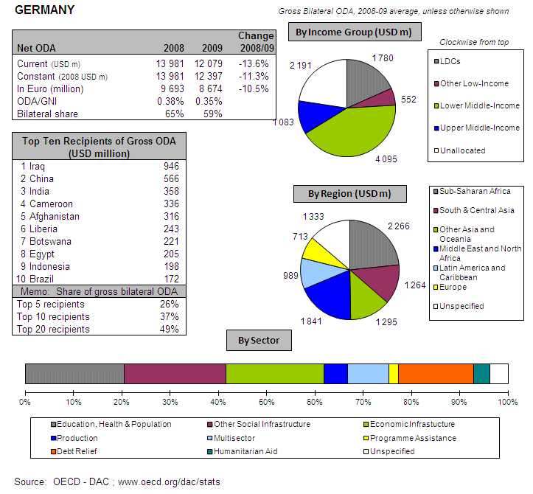
POLICY FRAMEWORK
Germany’s development co-operation policy is underpinned by the budgetary procedure (in particular the budget act passed by the Bundestag each year) and the Coalition Agreement that covers each legislative period. The latest Coalition Agreement (2009) defines the following key sectors for German development cooperation: good governance, education and training, health, rural development, protection of the climate, the environment and natural resources, and economic cooperation. The Agreement expresses a willingness to work towards achieving the 0.7% ODA/GNI target. Policy making and oversight of German development cooperation is vested in the Federal Ministry for Economic Co-operation and Development (BMZ), with implementation carried out by a range of different ministries, federal states (Länder), agencies and organisations. The government intends to carry out organisational and structural reforms of the German aid structure, a first step being the consolidation of German technical cooperation organisations.
I. INCREASING FINANCIAL RESOURCES FOR DEVELOPMENT AND GLOBAL CHALLENGES
- IMPROVING DOMESTIC RESOURCE MOBILISATION
- Support to reform programmes for capacity development of custom, judiciary and tax administrations in developing countries: Germany provides support to developing countries' tax policy and administration, tax consultancy, tax procedures, exchange of information, double taxation agreements, tax harmonisation in EU candidate countries, Asia, Latin America and ACP countries. Supported administrations include customs, revenue authorities, ministries of finance and regional fora including the African Tax Administration Forum (ATAF), EAC, ECOWAS, OLACEFS (Organization of Latin American and Caribbean Supreme Audit Institutions), ECLAC (United Nations Economic Commission for Latin America and the Caribbean). In addition, support is provided to national parliaments, governments, audit institutions, civil society organisations and regional organisations to strengthen public financial management.
- Promotes the principles of good governance in tax matter: Yes
- New Bilateral Tax Information Exchange Agreements and Double Taxation Conventions of 2010: Current information concerning TIEAs and DTCs – not only with developing countries – is regularly published in the official German Federal Law Gazette (Bundesgesetzblatt).
- Support to/ratification of/adherence to international conventions/initiatives on tax issues:
- IMF Regional Technical Assistance Centres: Yes
- International Tax Dialogue: Yes
- International Tax Compact: Yes
- African Tax Administration Forum (ATAF): Yes
- Centro Inter-Americano de Administraciones Tributarias (CIAT): Yes
- IMF Topical Trust Fund on Tax policy and administration: Yes
- South-South Sharing of Successful Tax Practices (S4TP): Yes
- United Nations Convention against Corruption (Merida): Yes
- OECD Convention on Combating Bribery of Foreign Officials in International Business Transactions: Yes
- Stolen Assets Recovery initiative (STAR): No
- Extractive Industry Transparency Initiative (EITI): Yes
- OECD Convention on Combating Bribery of Foreign Officials in International Business Transactions: Yes

- SCALING UP ODA
ODA individual commitments/gap to agreed targets
- Germany is working towards the goal of meeting the 2015 0.7% ODA/GNI target according to the latest Coalition Agreement (2009). spent EUR 9606 million (preliminary), reaching 0.38% in 2010 compared to 0.35% in 2009, a 9.9% increase in real terms compared to 2009.
- Debt relief made up 21% of German ODA during the period 2004 – 2009, fourth highest among Member States.
Source: OECD/ DAC data for 1995 – 2010; Commission simulation based on information provided by EU Member States or based on agreed EU commitments for 2010 and 2015. ODA in current prices.
Germany Share of debt relief in ODA volumes
Source: OECD/DAC data for 2002-2010
- "Realistic, verifiable actions for meeting your individual ODA commitments until 2015" taken in 2010: As part of the budget process for the financial year 2012 and the medium-term financial plan until 2015, the German government will define its intended budgets for development cooperation. Regardless of which the government and parliament will discuss the actual annual budgets 2013-2015 and how to attain the ODA goal in the annual budget processes each year.
- Have you taken or do you plan to take measures to ensure that at least 50% of EU collective aid increases of ODA resources are channelled to Africa? This is a confirmed objective of the German government and is taken into account in the annual allocation of the development cooperation budget.
- It is an objective of the German government to strengthen development cooperation with LDCs, but the ODA share to LDCs depends on the allocation made during the annual budget process.

- SUPPORT FOR/ USE OF INNOVATIVE SOURCES AND MECHANISMS OF FINANCING DEVELOPMENT
- Germany supports the following innovative financing mechanisms:
- ETS auctioning revenues (EUR 230 million in 2009)
- Debt2Health (EUR 20 million in 2010)
- Germany is open to engaging with IFMs in future. Germany is setting up a new special fund under public law (Sondervermögen “Energie- und Klimafonds”) to finance national and international programmes in the fields of energy efficiency, renewable energies and climate change. The fund is in operation since 2011 onwards, with a smaller amount of funding available from contractually agreed payments by energy utilities. From 2013 onwards, additional revenues from auctioning EU emissions allowances (revenues additional to the level of revenues in 2008 = EUR 915 million; excluding emissions trading in the aviation sector) will be channelled to the special fund. It is expected that hundred million Euros of climate and environment related ODA will be committed annually through this fund from 2013 onwards, subject to parliamentary budget approval. In 2011, EUR 31.5 million will be committed as climate and environment related ODA from this fund.
- Germany is currently considering innovative financing mechanisms that use general budget funds to leverage capital market funds (“blending”) as well as private investors for the benefit of sustainable development.

- LEVERAGING PRIVATE FLOWS FOR DEVELOPMENT
Support to private investment in developing countries:
Foreign Direct Investment
Source: OECD/ DAC

- Financial tools to support private investment:
- Investment guarantees: Yes
- Improvement of the overall banking system: Yes
- Microfinance/ access to financial services: Yes
- Risk management initiatives: Yes
- Blending: No
- Private public partnerships: Yes
- Business and investment climate: Yes
- Investment facilities: Yes
- Export credits: No
- Germany promotes the adoption of internationally agreed principles and standards on Corporate Social and Environmental Responsibility by European companies. See Box.
Box: German support to Corporate Social and Environmental Responsibility
- Definition of a government CSR Strategy and a CSR Action Plan
- Application of and support to the OECD Guidelines for Multinational Enterprises
- Support to the UN Special Representative for Business and Human Rights, John Ruggie
- Support to the Global Reporting Initiative
- Support to the Business Anti-Corruption Portal
- Technical Cooperation in partner countries concerning the implementation of the UNCAC and the improvement of the framework for CSR.
- Development Partnerships with business companies (develoPPP.de)
- Signatory of the Kimberley process

- New initiatives in relation to including social and environmental clauses in ODA-financed public procurements: None
- Germany has implemented the "General Principles for International Remittances Services" agreed by the Committee on Payments and Settlements Systems (CPSS). In addition, the German government has set up a remittances price comparison website (www.geldtransfair.de) in cooperation with the Frankfurt School of Finance and Management. The objective is the reduction of transfer costs for formal remittances from migrants living in Germany to their countries of origin.

- AID FOR TRADE
Germany, AfT Commitments (EUR million)
Source: OECD CRS Database (latest update)
- REDUCING THE DEBT BURDEN OF DEVELOPING COUNTRIES
- Germany has delivered on its commitments to the HIPC and MDRI initiatives, including commitments towards IDA and the African Development Bank.
- Germany would like to see a reform of the international architecture for the restructuring of sovereign debts, based on the Paris Club, IFIs and collective action clauses in debt contracts. The German government supports the creation of a debt workout mechanism and wants to promote any relevant discussions.
- Germany has taken no specific measure to prevent aggressive litigation against HIPCs, but welcomes the activities of the African Legal Support Facility (ALSF).

II. IMPROVED EFFECTIVENESS OF SUPPORT TO DEVELOPING COUNTRIES
- MORE EFFECTIVE EU AID
- On Ownership. Germany supported country ownership in 2010 through consultation and coordination with partner countries and support to partner capacity development. German development cooperation is based on partner countries’ demands which are expressed in regular bilateral consultations and negotiations.
- On Conditionality. Germany supported harmonisation with other donors in 2010.
- On Transparency and Predictability. Germany publicly discloses information on aid volume on the internet centrally and through some field offices.
- On Alignment. Germany has integrated the principles of the Code of Conduct on Complementarity and Division of Labour in strategies, staff guidance and programming processes/guidelines.
- On Harmonisation. Germany has arrangements in place for delegated cooperation and there is a mechanism in place at headquarters level to track cases of delegated cooperation. Cases of delegated cooperation agreed to in 2010 in table below.
- On Mutual Accountability. Germany has established a joint framework for monitoring joint commitments in Burkina Faso, Ghana, Mali, Malawi, Mozambique, Peru, Zambia, Tanzania and Uganda.
- On Managing for Development Results. Germany provides capacity support for Managing for Development Results.
- SUPPORTING BETTER GLOBAL GOVERNANCE
- Germany does not share the view that EU27 should speak with one voice in the IMF, World Bank and the main multilateral development banks' governing bodies. Germany believes the EU should speak with one voice according to its responsibilities, such as Art. IV consultations of the EURO AREA; this is ensured through efficient EU coordination within the IMF and the World Bank (regular meetings of all EU Executive Directors (EURIMF meetings)) as well as through close cooperation between the EURIMF and the SCIMF (subcommittee of the EFC) on all relevant EU matters. All other matters outside the responsibility of the EU are represented by each country in its own interest.
- Germany does not support stronger Brussels based coordination on a regular basis on issues related to the World Bank and MDBs.

GREECE

AT A GLANCE
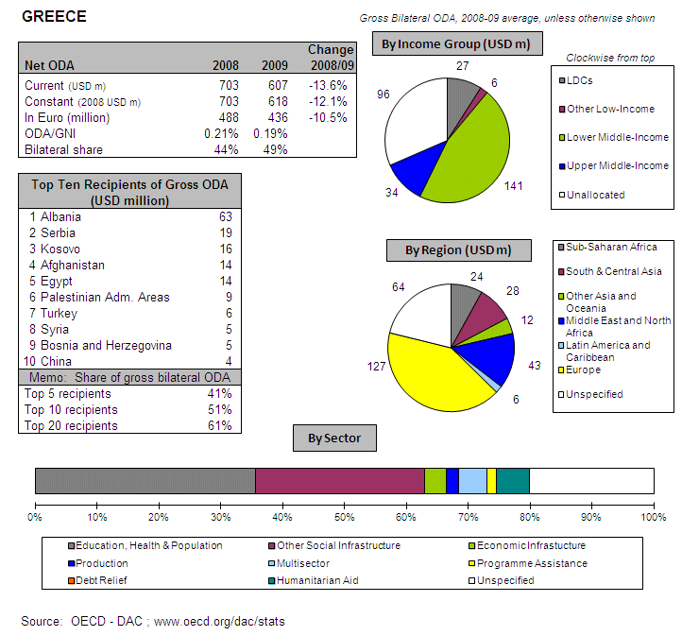
POLICY FRAMEWORK
Greece’s development assistance is guided by five-year Development Cooperation and Assistance Programmes. The financial crisis has caused a fundamental rethink of Greek development activities and a revision of the current five-year programme, which is not yet finalised. The process to achieve international ODA target levels has had to be abandoned. Hellenic Aid, a general directorate within the Ministry of Foreign Affairs, is the coordinating agency of Greek development cooperation. The role of the Ministry of Foreign Affairs in implementation is limited with the bulk of the funds being managed by the Ministry of Economy and Finance for multilateral aid and a larger number of line ministries for bilateral aid.
I. INCREASING FINANCIAL RESOURCES FOR DEVELOPMENT AND GLOBAL CHALLENGES
- IMPROVING DOMESTIC RESOURCE MOBILISATION
- Greece does not provide support to reform programmes for capacity development of custom, judiciary and tax administrations in developing countries.
- Promotes the principles of good governance in tax matters: N/A
- New Bilateral Tax Information Exchange Agreements and Double Taxation Conventions of 2010: N/A
- State of ratification of/ adherence to international conventions/ initiatives on tax issues: N/A
- SCALING UP ODA
ODA individual commitments/gap to agreed targets
- Greece spent EUR 378 million on ODA in 2010 (preliminary), corresponding to 0.17% of GNI in 2010, down from 0.19% in 2009. Consequently Greece is far from reaching the 2010 0.51% target.
- No debt relief was included in Greek ODA during the period 2004 – 2009.
Source: OECD/ DAC data for 1995 – 2010; Commission simulation based on information provided by EU Member States or based on agreed EU commitments for 2010 and 2015. ODA in current prices.

Greece - Share of debt relief in ODA volumes

Source: OECD/DAC data for 2002-2010
- "Realistic, verifiable actions for meeting your individual ODA commitments until 2015" taken in 2010: Projected ODA volumes for the years 2011-2015 are not available for the time being since they are pending the 5-year National Development Plan, which is under review because of the financial crisis and budgetary constraints. Greece undertook its international commitments under the supposition that fiscal circumstances would be favourable and would allow for the anticipated significant increase in ODA. However, despite the relevant efforts, the expected increase of ODA proved not to be feasible, due to fiscal restraints. Furthermore, the current international financial crisis had a negative influence on the economic situation of Greece. Consequently, it is not likely that Greece will fulfil its quantitative commitments as regards ODA grants in the near future.
- Greece will concentrate the allocation of its resources on a core group of partner-countries – including some LDCs.
- Greece has taken measures to ensure that at least 50% of EU collective aid increases are channelled to Africa.
- Greece will not reach the target of 0.15%-0.20% ODA/GNI to LDCs by 2010 and onwards. It would be extremely difficult for Greece to reach the target of 0.15%-0.20% ODA/GNI to LDCs in 2010 or 2011, due to budgetary constraints. There will be targeted actions to LDCs (i.e. climate change adaptation projects) as these countries will constitute part of our geographical priorities in the 5-year National Development Plan.

- SUPPORT FOR/ USE OF INNOVATIVE SOURCES AND MECHANISMS OF FINANCING DEVELOPMENT
- Greece does not support any innovative financing mechanisms and has no plans to do so.

- LEVERAGING PRIVATE FLOWS FOR DEVELOPMENT
Support to private investment in developing countries:
Foreign Direct Investment
Source: OECD/ DAC
- Financial tools to support private investment:
- Investment guarantees: No
- Improvement of the overall banking system: No
- Microfinance/ access to financial services: No
- Risk management initiatives: No
- Blending: No
- Private public partnerships: No
- Business and investment climate: No
- Investment facilities: No
- Export credits: No
- Other: Greece provides subsidies to private productive investments in the framework of implementation of the “Hellenic Plan for the Economic Reconstruction of the Balkans” (HiPERB)
- Greece does not promote the adoption of internationally agreed principles and standards on Corporate Social and Environmental Responsibility by European companies.
- Greece does not provide support to the Kimberley Process and FAO Code of Conduct for Responsible Fisheries.
- New initiatives in relation to including social and environmental clauses in ODA-financed public procurements: None.
- Greece has not implemented solutions internally or in cooperation with third countries to overcome barriers to migrants and their families' access to financial services. However, a plan for improving the impact of remittances on development is under consideration by Greek authorities to improve local growth within the developing country.
- Greece has implemented the General Principles for International Remittances Services" agreed by the Committee on Payments and Settlements Systems (CPSS).

- AID FOR TRADE
Greece, AfT Commitments (EUR million)
Source: OECD CRS Database (latest update)
- REDUCING THE DEBT BURDEN OF DEVELOPING COUNTRIES
- Greece has delivered on its commitments to the HIPC and MDRI initiatives, including commitments towards IDA and the African Development Bank.
- Greece sees a need for reform of the international architecture for the restructuring of sovereign debts, based on the Paris Club and involving International Financial Institutions.
- Greece has planned no specific interventions to prevent aggressive litigation against HIPCs.

II. IMPROVED EFFECTIVENESS OF SUPPORT TO DEVELOPING COUNTRIES
- MORE EFFECTIVE EU AID
- On Ownership. Greece supported country ownership in 2010 through consultation and coordination with partner countries and by supporting partner capacity development.
- On Conditionality. Greece has carried out no actions on conditionalities in 2010.
- On Transparency and Predictability. Greece publicly discloses information on aid volume on the internet and upon request of developing partner or civil society organisations.
- On Alignment. Integration of the principles of the Code of Conduct on Complementarity and Division of Labour in strategies, staff guidance and programming processes/guidelines is subject to the forthcoming 5-year National Development Plan.
- On Harmonisation. Greece has legal and/or administrative arrangements in place for delegated cooperation and there is a mechanism in place to track cases of delegated cooperation. There is ad hoc delegated cooperation (managing Greek funds) with EU Member States for implementing projects in Afghanistan.
- On Mutual Accountability. Greece has not established a joint framework for monitoring joint commitments.
- On Managing for Development Results. Greece does not provide capacity support for Managing for Development Results.
- SUPPORTING BETTER GLOBAL GOVERNANCE
- Greece shares the view that EU27 should speak with one voice in the IMF, World Bank and the main multilateral development banks' governing bodies by reaching a common position within the EU before discussing important issues in these institutions.
- Greece supports stronger Brussels based coordination on a regular basis on issues related to the World Bank and MDBs.


HUNGARY

POLICY FRAMEWORK
The Hungarian Government approved the concept paper of the Hungarian Development Cooperation in 2001. Resolution 1/2008 of the International Development Cooperation (IDC) Governmental Committee, approved by the Government in spring 2008, acknowledges the fact that IDC is identified as one of the important activities in Hungary’s External Relations Strategy. It determines the principles, the goals and the means of Hungary’s international activity.
The Ministry of Foreign Affairs of the Republic of Hungary is responsible for planning and coordinating the Hungarian international development cooperation and humanitarian aid activities via the International Development Cooperation Department. In 2008, a Tendering Unit was formed to deal with the management of all the legal and financial issues related to project implementation.
The main decision-making body related to the development cooperation policy and strategy is the Development Cooperation Governmental Committee, which is an inter-ministerial forum, chaired by the Minister for Foreign Affairs. The work of the Committee is supported by an inter-ministerial Working Group of Experts. The Ministry of Foreign Affairs is also responsible for coordinating the work of the Inter-ministerial Working Group for the Coordination of Humanitarian Aid. The expert-level working group coordinates humanitarian aid issues between the relevant line ministries and the National Directorate for Disaster Management and is chaired by the state secretary of the Ministry of Foreign Affairs.
HUN-IDA, a not-for-profit company contracted by the Ministry of Foreign Affairs is the implementing agency of the Hungarian development cooperation activities. It is mainly responsible for organising and implementing technical assistance programmes with our partner countries and for preparing, monitoring the calls for tender, providing advice and taking part in the capacity building activities.
I. INCREASING FINANCIAL RESOURCES FOR DEVELOPMENT AND GLOBAL CHALLENGES
- IMPROVING DOMESTIC RESOURCE MOBILISATION
- Support to reform programmes for capacity development of customs, judiciary and tax administrations in developing countries: Hungary provides aid in these fields to EU candidate countries, EU Neighbourhood Policy countries, Asia, Latin America and ACP Countries (support to administrations and policy of Semi-autonomous Revenue Authorities and Ministries of Finance).
- Support to promote good governance in tax matters: Yes
- Bilateral Tax Information Exchange Agreements and Double Taxation Conventions since 2010: (i) Signed with Hong Kong, Taiwan, San Marino, USA; (ii) under negotiation with Bahrain, Jordan; (iii) planned with Bermuda, British Virgin Islands, Gibraltar, Guernsey, Jersey, Isle of Man, Liechtenstein.
- State of ratification of/adherence to international conventions/initiatives on tax issues:
- United Nations Convention against Corruption (Merida): No
- OECD Convention on Combating Bribery of Foreign Officials
in International Business Transactions: Yes
- Stolen Assets Recovery initiative (STAR): No
- Extractive Industry Transparency Initiative (EITI): No
- IMF Regional Technical Assistance Centres: No
- International Tax Dialogue: Yes
- International Tax Compact: No
- African Tax Administration Forum (ATAF): No
- Centro Inter-Americano de Administraciones Tributarias (CIAT): No
- IMF Topical Trust Fund on Tax policy and administration: No

- SCALING UP ODA
ODA Individual commitments and gap to target
- Hungary did not reach the ODA target to provide 0.17% of GNI by 2010, spending EUR 85 million (preliminary), i.e. 0.09% of GNI in 2010, down from 0.10% in 2009.

Source: OECD/ DAC data for 1995 – 2010; Commission simulation based on information provided by EU Member States or based on agreed EU commitments for 2010 and 2015. ODA in current prices.

- No realistic, verifiable actions for meeting individual ODA commitments until 2015 taken in 2010: Hungary’s goal is to overcome the difficulties caused by the annual budget planning, where Hungary would strive to give better projections to our partners on funds available for multi-year cooperation.
- No measure taken nor planned to contribute to the EU27 target to channel at least 50% of EU collective ODA increase to Africa. Hungary “takes into account its commitments in the planning process”
- Hungary will not reach the target of 0.15%-0.20% ODA/GNI to LDCs by 2010.

- SUPPORT FOR/ USE OF INNOVATIVE SOURCES AND MECHANISMS OF FINANCING DEVELOPMENT
- Hungary did not use innovative financing mechanisms for development.
- Hungary intends to step up efforts for innovative financing mechanisms with significant revenue generation potential. Hungary would consider supporting innovative financial mechanisms, which are applied globally. Hungary has been working very closely with the Ministry of National Economy to analyse the feasibility of the various IFM initiatives. Apart from this, the annual national budget for 2011 will reallocate the contribution for 2011 (EUR 2,000,000) to the area of climate financing by selling carbon emission quotes.
- No other work on innovative financing mechanisms.
- LEVERAGING PRIVATE FLOWS FOR DEVELOPMENT
Support to private investment in developing countries:
- Financial tools to support private investment
- Investment guarantees: No
- Improvement of the overall banking system: No
- Microfinance/ access to financial services: No
- Risk management initiatives: No
- Blending: No
- Private public partnerships: No
- Business and investment climate: No
- Investment facilities: No
- Export credits: Yes
- Hungary also provides concessional loans through bilateral agreements.
- Hungary does not promote the adoption of internationally agreed principles and standards on Corporate Social and Environmental Responsibility.
- No reported information on Remittances.

- AID FOR TRADE
- No information available

- REDUCING THE DEBT BURDEN OF DEVELOPING COUNTRIES
- Hungary delivered on its HIPC/ MDRI commitments (including vis-à-vis IDA/ AfDB) without delay.
- Hungary favours reform of the international architecture for restructuring of sovereign debts in order to deal with potential future cases of debt distress in low-income countries (involving a role for International Financial Institutions).
- Specific interventions to prevent aggressive litigation against HIPCs (in particular to prevent the actions of "vulture funds"): No
II. IMPROVED EFFECTIVENESS OF SUPPORT TO DEVELOPING COUNTRIES
- MORE EFFECTIVE EU AID
- On Ownership. In 2010, Hungary supported ownership through consultations and coordination with partner countries, through guidance and incentives for staff in partner countries, by supporting partner capacity development.
- On Conditionality. No action.
- On Transparency and Predictability. Hungary publicly discloses information on aid volumes on the Ministry of Foreign website and through a database at country level.
- On Alignment. Hungary partially integrated the principles of the Code of Conduct on Complementarity and Division of Labour in its development strategy.
- On Harmonisation. No legal and/or administrative arrangements in place to manage funds for another Member States or the EU , and/ for another Member States or the EU to manage Hungarian funds (delegated cooperation).
- On Mutual Accountability. No joint framework for monitoring joint commitments.
- On Managing for Development Results. Hungary does not provide capacity building support for this.
- SUPPORTING BETTER GLOBAL GOVERNANCE
- Position on improving the voice of the EU and its Member States within International Financial Institutions. Hungary supports a single EU Chair for the IMF in order for the EU27 to speak with one voice on common positions.
- Hungary favours stronger Brussels based coordination on issues related to the World Bank and MDBs.

IRELAND
AT A GLANCE
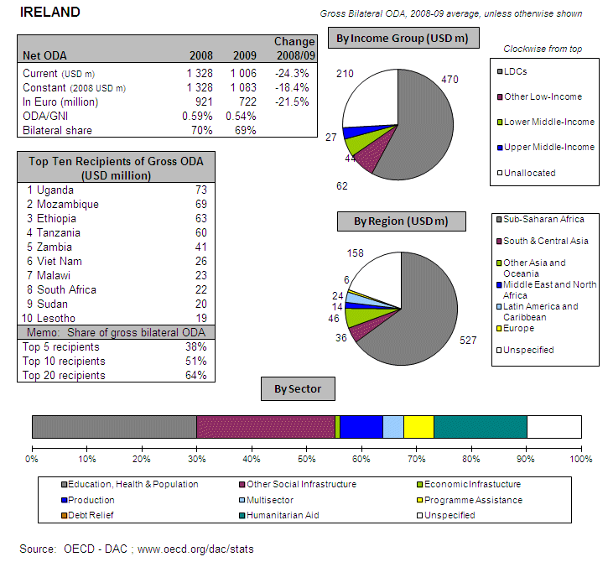
POLICY FRAMEWORK
Irish Aid is the Government of Ireland’s programme of assistance to developing countries. Ireland’s 2006 White Paper on Irish Aid provides the vision and orientation for the development programme. Irish Aid’s Operational Plan 2008-2012 lays out the roadmap for managing and implementing that programme. In 2008 Irish Aid’s headquarters was moved from Dublin to Limerick as part of the government-wide effort to decentralise the public administration. It has proven a major challenge for Irish Aid in particular as a result of loss of expertise and institutional memory, and the need to maintain close linkages with other government departments, embassies and other organisations and NGOs based in Dublin.
Responsibility for Irish foreign policy, including assistance to developing countries (Irish Aid) lies in the first instance with the Minister for Foreign Affairs. However, particular responsibility for policy on Overseas Development Assistance is assigned to the Minister of State for Overseas Development at the Department of Foreign Affairs. The Development Cooperation Directorate, a Division of the Department of Foreign Affairs, is responsible for administering the Irish Aid programme. It also has a coordinating role in relation to Overseas Development Assistance by other Government Departments.
In 2009, the Government established the Irish Aid High Level Steering Group which is chaired by the Secretary General of the Department of Foreign Affairs and includes the Heads of the Corporate Services, Political and Promoting Ireland Abroad Divisions, as well as the Director General and the deputy Director General of the Development Cooperation Directorate .
I. INCREASING FINANCIAL RESOURCES FOR DEVELOPMENT AND GLOBAL CHALLENGES
- IMPROVING DOMESTIC RESOURCE MOBILISATION
- Support to reform programmes for capacity development of customs, judiciary and tax administrations in developing countries: Ireland provides aid in these fields to ACP countries (support to administrations and policy of: Customs, Semi-autonomous Revenue Authorities and Ministries of Finance).
- Support to promote good governance in tax matters: Yes
- Bilateral Tax Information Exchange Agreements and Double Taxation Conventions since 2010: (ia) Double Taxation Conventions signed with Hong Kong, Albania, Kuwait, Montenegro, Morocco, Singapore, United Arab Emirates; (ib) Tax Information Exchange Agreements were concluded with St. Lucia, The Marshall Islands, Belize; (ii) under negotiation with Saudi Arabia, Thailand, Armenia, Azerbaijan, Panama, (iii) planned with Algeria, Jordan, Libya.
- State of ratification of/adherence to international conventions/initiatives on tax issues:
- United Nations Convention against Corruption (Merida): No
- OECD Convention on Combating Bribery of Foreign Officials
in International Business Transactions: Yes
- Stolen Assets Recovery initiative (STAR): No
- Extractive Industry Transparency Initiative (EITI): No
- IMF Regional Technical Assistance Centres: No
- International Tax Dialogue: No
- International Tax Compact: No
- African Tax Administration Forum (ATAF): Yes
- Centro Inter-Americano de Administraciones Tributarias (CIAT): No
- IMF Topical Trust Fund on Tax policy and administration: No

- SCALING UP ODA
ODA Individual commitments and gap to target
- Ireland’s ODA grew steadily over the years to 2008 from modest beginnings. ODA in 2010 was EUR 676 million (preliminary), 0.53% of GNI, a decline from 0.54% in 2009. Ireland still exceeded the minimum ODA target of 0.51% for 2010.
- Ireland did not have any debt relief operations during the period 2004 – 2009
Source: OECD/ DAC data for 1995 – 2010; Commission simulation based on information provided by EU Member States or based on agreed EU commitments for 2010 and 2015. ODA in current prices.

Ireland - Share of debt relief in ODA volumes

Source: OECD/DAC data for 2002-2010

- "Realistic, verifiable actions for meeting individual ODA commitments until 2015" taken in 2010: Ireland’s target for ODA as a percentage of national income is aligned to the EU target of reaching 0.7% by 2015. Annual allocations are negotiated during the annual budget estimates process. The provisional outturn for 2010 (ODA/GNI of 0.53%) means that Ireland has met its 2010 EU interim target.
- Sub-Saharan Africa remains the primary geographic focus for Ireland’s development programme. Seven of Ireland’s nine programme countries are in Africa: Tanzania, Zambia, Lesotho, Mozambique, Uganda, Ethiopia and Malawi, with almost 50% of the bilateral aid programme directed to those countries alone. In total, almost 80% of our bilateral ODA is directed to African countries.
- Ireland has reached the target of 0.15%-0.20% ODA/GNI to LDCs by 2010 and onwards, being already above 0.20%.

- SUPPORT FOR/ USE OF INNOVATIVE SOURCES AND MECHANISMS OF FINANCING DEVELOPMENT
- Ireland did not use innovative financing mechanisms for development.
- Ireland does not intend to step up efforts for innovative financing mechanisms with significant revenue generation potential.
- No other work on innovative financing mechanisms.

- LEVERAGING PRIVATE FLOWS FOR DEVELOPMENT
Support to private investment in developing countries:
- Ireland does not provide financial tools to support private investment.
- Ireland promotes the adoption of internationally agreed principles and standards on Corporate Social and Environmental Responsibility by European companies; including: OECD Guidelines for Multilateral Enterprises, OECD Convention on bribery of foreign public officials, International Labour Organisation (ILO) core conventions on labour standards, UN Global Compact.
- Ireland does not support the Kimberley process and the FAO Code of Conduct for Responsible Fisheries.
- Ireland did not implement the "General Principles for International Remittances Services" agreed by the Committee on Payments and Settlements Systems (CPSS), neither plan to implement solutions to improve the impact of remittances on development. As migrants in Ireland do not originate primarily in less developed countries, relatively little research has been carried out into obstacles to financial inclusion.
- No other initiatives to increase competition and transparency in the remittance market and to reduce remittance transfers costs: At present, the Financial Regulator does not have a mandate to provide information to consumers comparing the costs of using different money transmission businesses. While there is a desire to reduce remittance costs, there is no specific action planned at this stage.

- AID FOR TRADE
Ireland, AfT Commitments (in EUR thousands)

Source: OECD CRS Database (latest update)
- REDUCING THE DEBT BURDEN OF DEVELOPING COUNTRIES
- Ireland delivered on its HIPC/ MDRI commitments (including vis-à-vis IDA/ AfDB) without delay.
- Actions/steps taken in 2010 to help restore and preserve debt sustainability in low-income countries: providing support to the UNCTAD DMFAS programme.
- Ireland favours reform of the international architecture for restructuring of sovereign debts, but such reform will have to be preceded by a period of extensive reflection on the achievements so far and issues remaining before deciding on which mechanism would be the most appropriate.
- Specific interventions to prevent aggressive litigation against HIPCs (in particular to prevent the actions of "vulture funds"): Yes

II. IMPROVED EFFECTIVENESS OF SUPPORT TO DEVELOPING COUNTRIES
- MORE EFFECTIVE EU AID
- On Ownership. In 2010, Ireland supported ownership through consultations and coordination with partner countries, through guidance and incentives for staff in partner countries, and through partner capacity development.
- On Conditionality. In 2010, Ireland progressed by harmonising conditionalities with other donors.
- On Transparency and Predictability. Ireland publicly discloses information on aid volumes through the Irish Aid web site and through a database at country level.
- On Alignment. Ireland partially integrated the principles of the Code of Conduct on Complementarity and Division of Labour in its development strategy.
- On Harmonisation. Irish Aid’s guidance note on division of labour notes: “Before undertaking a delegated cooperation agreement Heads of Missions must seek prior approval from the relevant Head of Programme Countries. It is the responsibility of Programme Countries to get no objections from the Director General, Evaluation and Audit and Legal Division to ensure the proposed memorandum of understanding satisfies Irish Aid management and audit requirements”.
- On Mutual Accountability. Ireland established a joint framework for monitoring joint commitments with some of its priority countries. Though Ireland has not established any ‘new’ mutual accountability mechanisms in 2010, it has fully engaged with mechanisms in-country, where they exist. Mozambique uses a performance assessment framework, Vietnam has a regional peer review and Tanzania in 2010 conducted its independent monitoring group report. Ireland believes this should be a country led process if possible.
- On Managing for Development Results. Ireland provides capacity building support for this.
- SUPPORTING BETTER GLOBAL GOVERNANCE
- Position on improving the voice of the EU and its Member States within International Financial Institutions. Ireland does not support a single EU Chair for the IMF in order for the EU27 to speak with one voice. For some years, Ireland has continuously supported calls by the EU for better coordination of common positions at the IMF, WB and other multilateral development banks governing bodies. Progress has been made on coordination in this area. Ireland believes, however, it would be premature to reach agreement on this issue in advance of further detailed proposals on how it would work in practice and negotiation on individual EU Member State's positions being best protected in the future. For example, Ireland would need to reflect on how their internal processes and mechanisms in the EU can ensure that, in areas like fiscal policy, an individual Member State’s position is best conveyed in an effective manner in any changed external representation arrangements.
- Ireland favours stronger Brussels based coordination on issues related to the World Bank and MDBs

ITALY

AT A GLANCE
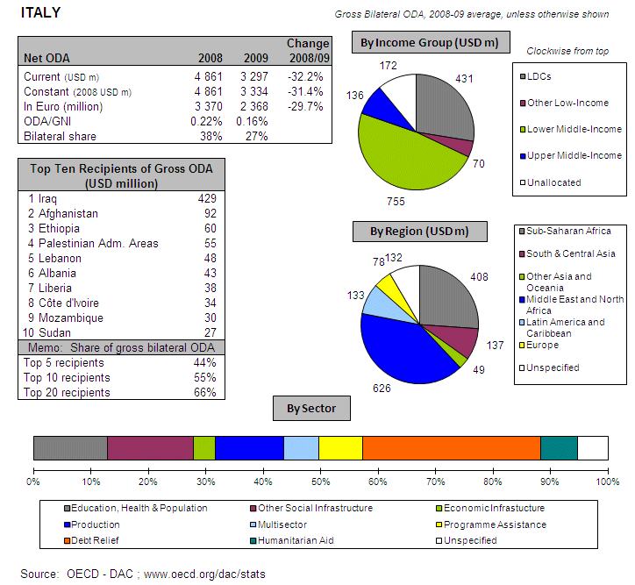
POLICY FRAMEWORK
Law 49/1987 provides the legal and political foundations for Italian Co-operation, establishing development co-operation as an integral part of Italian foreign policy, and giving the Ministry of Foreign Affairs (MFA) responsibility for development co-operation while the Ministry of Foreign Affairs (MFA) and the Ministry of Economy and Finance (MEF) are the main providers of Italian ODA. The 2009 DAC peer review considered the law outdated and constraining for Italian Co-operation.
According to the MFA, the multi-annual Programming Guidelines and Directions (2009-2011) serve this purpose of reform. At the end of June 2010, both the Ministry of Foreign Affairs and the Ministry of Finance (MEF) invited all Italian stakeholders in international development cooperation (NGOs, foundations and all ministries) to a round table to discuss the creation of a regular coordination mechanism.
I. INCREASING FINANCIAL RESOURCES FOR DEVELOPMENT AND GLOBAL CHALLENGES
- IMPROVING DOMESTIC RESOURCE MOBILISATION
- Support to reform programmes for capacity development of customs, judiciary and tax administrations in developing countries: Italy provides aid in these fields to ACP countries administrations (support to: Ministries of Finance).
- Support to promote good governance in tax matters: Yes
- Bilateral Tax Information Exchange Agreements and Double Taxation Conventions since 2010: (i) Double Taxation Conventions signed Cuba, (ii) under negotiation with Bahamas, Barbados, Bosnia-Herzegovina, Chile, Colombia, Costa Rica, Iraq, Kosovo, Philippines, S.A.R. Hong-Kong, Yemen; (iii) planned with The Isle Of Man, Anguilla, The British Virgin Islands, The Cayman Islands, Montserrat, The Turks and Caicos Islands.
- State of ratification of/adherence to international conventions/initiatives on tax issues:
- United Nations Convention against Corruption (Merida): Yes
- OECD Convention on Combating Bribery of Foreign Officials
in International Business Transactions: Yes
- Stolen Assets Recovery initiative (STAR): Yes
- Extractive Industry Transparency Initiative (EITI): Yes
- IMF Regional Technical Assistance Centres: Yes
- International Tax Dialogue: No
- International Tax Compact: No
- African Tax Administration Forum (ATAF): No
- Centro Inter-Americano de Administraciones Tributarias (CIAT): No
- IMF Topical Trust Fund on Tax policy and administration: No

- SCALING UP ODA
ODA Individual commitments and gap to target
- Italy’s ODA of EUR 2349 million (preliminary) corresponded to 0.15% of GNI in 2010, down from 0.16% in 2009, a decrease of 1.5% in real terms compared to 2009. The 2011 Italian Budget proposal from the Government is a further cut to the ODA after the 56% reduction in 2009 (due to a decrease in overall aid and reduced debt relief). The official directorate of Development and Cooperation is currently drafting a mid-term budget plan to ensure required new ODA will be available to maintain ODA/GNI around 0.7% after 2010 .
- Debt relief made up 22% of Italian ODA during the period 2004 - 2009
Source: OECD/ DAC data for 1995 – 2010; Commission simulation based on information provided by EU Member States or based on agreed EU commitments for 2010 and 2015. ODA in current prices.

Italy - Share of debt relief in ODA volumes

Source: OECD/DAC data for 2002-2010

- "Realistic, verifiable actions for meeting individual ODA commitments until 2015" taken in 2010: In 2010, the Italian Government – in the run up to the High Level Event on MDGs, held in New York last September - has been called on by the Parliament to give a renewed attention towards ODA commitments. Nevertheless, the need for Italy to curb its public deficit has delayed so far the process to define the plan for realigning the ODA/GNI in order to reach the international commitments by 2015.
- 50% of the amount available for new bilateral grant aid initiatives in the 2010-2012 budget of the Italian Cooperation will be devoted to Africa, as specified in the guidelines on the Italian Development Cooperation adopted by the Ministry of Foreign Affairs in December 2009. Moreover, Africa remains a priority also as far as finalised contributions to multilateral donors, agencies and development banks are concerned.
- Will you reach the target of 0.15%-0.20% ODA/GNI to LDCs by 2010 and onwards: No, but Italy provides an important share of its ODA to some LDC countries.

- SUPPORT FOR/ USE OF INNOVATIVE SOURCES AND MECHANISMS OF FINANCING DEVELOPMENT
- Innovative sources of financing: International Financing Facility for Immunisation (IFFIm), Advance Market Commitments (AMCs).
- Italy intends to step up efforts for innovative financing mechanisms with significant revenue generation potential.

- LEVERAGING PRIVATE FLOWS FOR DEVELOPMENT
Support to private investment in developing countries:
Foreign Direct Investment
Source: OECD/ DAC

- Financial tools to support private investment
- Investment guarantees: Yes
- Improvement of the overall banking system: Yes
- Microfinance/ access to financial services: Yes
- Risk management initiatives: Yes
- Blending: No
- Private public partnerships: Yes
- Business and investment climate: Yes
- Investment facilities: Yes
- Export credits: Yes
- Italy promotes the adoption of internationally agreed principles and standards on Corporate Social and Environmental Responsibility by European companies. Italy is implementing – among others – the following multilateral initiatives: (i) the UN Global Compact, (ii) the ongoing revision of the “OECD Guidelines for Multinational Enterprises”, through a National Contact Point – PCN and a multi-stakeholder consultation extended to the major enterprises federations; Italian industrial districts; SMEs and agencies specialised on the internationalisation of the Italian economy; (iii) the OECD initiative concerning a “Due Diligence Guidance for Responsible Supply Chains of Minerals from Conflict-Affected and High-Risk Areas”; (iv) the Extractive Industry Transparency Initiative–EITI, (v) the various “CSR Europe” Initiatives; and (vi) Global Reporting Initiative (UNEP).
- Italy supports the Kimberley process and the FAO Code of Conduct for Responsible Fisheries.
- Italy implemented solutions internally or in cooperation with third countries to overcome barriers to migrants and their families' access to financial services; including monitoring indicators for measuring the impact of these solutions on migrants' access to financial services, remittance transfer costs
- Italy implemented the "General Principles for International Remittances Services" agreed by the Committee on Payments and Settlements Systems (CPSS).
- There are other initiatives to increase competition and transparency in the remittance market and to reduce remittance transfers costs: The Bank of Italy has actively collaborated in the elaboration of the General Principles. In 2009 Italy promoted the adoption of a quantified and ambitious objective in the field of remittances and in particular the reduction of the cost of sending remittances. At the L’Aquila Summit G8 leaders set for the first time at international level a significant and quantified commitment: the reduction of the average global cost of sending remittances from the present 10% to 5% in 5 years (the so called “5x5” objective). Italy launched in November 2009 the “Rome Road Map for Remittances” and an International Conference. A dedicated website on the costs of remittances has been elaborated by stakeholders and co-funded by Ministry of Foreign Affairs and is operating since 2009 (www.mandasoldiacasa.it) and has been the first certified by the World Bank as compliant to current applicable standards. Italy together with other partners is providing support to competent organisations such as the World Bank - Global Remittances Working Group. Italy in 2010 has proposed with other partners the enlargement and enhancement of the “5x5” adopted at the G20 Summit in Seoul.
- Meanwhile, Italy has robust and reliable data concerning the amounts and destination of remittances from Italy.
- Finally, Italy adopted the operational definitions, recommendations and best practices on improving the quality and coverage of data on remittances according to the compilation guide drafted by the "Luxembourg Group"

- AID FOR TRADE
Italy, AfT Commitments (in EUR thousands)
Source: OECD CRS Database (latest update)
- REDUCING THE DEBT BURDEN OF DEVELOPING COUNTRIES
- Italy delivered on its HIPC/ MDRI commitments (including vis-à-vis IDA/ AfDB) without delay.
- Actions/steps taken in 2010 to help restore and preserve debt sustainability in low-income countries: (i) Italy has been in the lead, as a co-sponsor, of the “Principles and Guidelines to promote sustainable lending practices in the provision of official export credits to LICs”. By internal regulation Italian Development cooperation decides the concession of loans according to Debt Sustainability Framework /Debt Sustainability Analysis. (ii) In addition, Italy is fully involved in all initiatives aimed at fostering the dialogue with other creditors and helping borrowers, mainly within the OECD/ECG and the Paris Club. In this framework, Italy has supported the decision not to sell on claims on HIPC countries and encourages the provision of IFI’s technical assistance to low-income debtor countries facing litigating creditors or needing assistance to receive comparable treatment by non-PC and commercial creditors. Italy has adhered to the PC publication of data on its debt stock and supports moves by the IFIs to adapt the Debt Sustainability Framework to rapidly evolving debt patterns in LICs. It is financially supporting the World Bank Debt’s Debt Management Facility and also participating in the African Legal Support Facility.
- Italy is open to discuss improvements in the international architecture for the restructuring of sovereign debt, provided that principles followed so far in multilateral fora (i.e. Paris Club) are retained, as they have proven to be effective.
- Specific interventions to prevent aggressive litigation against HIPCs (in particular to prevent the actions of "vulture funds"): Yes, within the Paris Club.

II. IMPROVED EFFECTIVENESS OF SUPPORT TO DEVELOPING COUNTRIES
- MORE EFFECTIVE EU AID
- On Ownership. In 2010, Italy supported ownership through consultations and coordination with partner countries and supporting partner capacity development.
- On Conditionality. In 2010, Italy progressed by harmonising with other donors and by reducing the number of conditionalities.
- On Transparency and Predictability. Italy publicly discloses information on aid volumes through the Italian Development Cooperation web site and through two annual reports (according to Law 49/87 for the Italian Development Cooperation (DGCS).
- On Alignment. Italy partially integrated the principles of the Code of Conduct on Complementarity and Division of Labour in its development strategy. Italy is gradually implementing a more effective concentration of its aid, in consistency with the principles of the EU Code of Conduct and DAC recommendations.
- On Harmonisation. Italy recently adopted the necessary legislative and administrative changes to allow its Development Cooperation to sign transfer and delegation agreements both with the European Commission and EU Member States, in the framework of delegated cooperation. In August 2010 Italy officially expressed its interest to start cooperating with the European Commission in the Indirect Centralised Management mode, and it is waiting for the assessment procedure (so-called “6 pillars audit”) to be confirmed eligible for delegated cooperation.
- On Mutual Accountability. Italy did not establish a joint framework for monitoring joint commitments.
- On Managing for Development Results. Italy does not provide capacity building support for this.
- SUPPORTING BETTER GLOBAL GOVERNANCE
- Position on improving the voice of the EU and its Member States within International Financial Institutions. Italy supports a single EU Chair for the IMF in order for the EU27 to speak with one voice. Though, in the short term, improved coordination mechanisms can be preferred, also considering the different institutional arrangements in the various MDBs.
- Italy favours stronger Brussels based coordination on issues related to the World Bank and MDBs.

LATVIA

POLICY FRAMEWORK
The Development Cooperation Policy Programme of the Republic of Latvia 2006-2010 was prepared taking into account Latvia's growing role in the resolution of global problems. It is in accordance with the foreign policy guidelines of the Republic of Latvia as of 2005 and "The Basic Principles for the Development Cooperation Policy of the Republic of Latvia".
The Ministry of Foreign Affairs is responsible for forming the development cooperation policy and for coordination of the Programme. Individual tasks require the involvement of other governmental institutions as well (pursuant to Cabinet of Ministers Order No. 107 of 19 February 2003 "On the "Basic Principles for the Development Cooperation Policy of the Republic of Latvia").
I. INCREASING FINANCIAL RESOURCES FOR DEVELOPMENT AND GLOBAL CHALLENGES
- IMPROVING DOMESTIC RESOURCE MOBILISATION
- Support to reform programmes for capacity development of customs, judiciary and tax administrations in developing countries: Latvia provides aid in these fields to EU Neighbourhood Policy countries (support to administrations and policy of: Ministries of Finance).
- Support to promote good governance in tax matters: Yes
- Bilateral Tax Information Exchange Agreements and Double Taxation Conventions since 2010: (i) Double Taxation Conventions signed with Egypt (discussion on good governance in tax policy during tax treaty negotiations); (ii) under negotiation with India, Pakistan, (iii) planned with Thailand (DTC), Philippines (DTC), Chile (DTC), Peru (DTC).
- State of ratification of/adherence to international conventions/initiatives on tax issues:
- United Nations Convention against Corruption (Merida): Yes
- OECD Convention on Combating Bribery of Foreign Officials
in International Business Transactions: No
- Stolen Assets Recovery initiative (STAR): Yes
- Extractive Industry Transparency Initiative (EITI): No
- IMF Regional Technical Assistance Centres: No
- International Tax Dialogue: No
- International Tax Compact: No
- African Tax Administration Forum (ATAF): No
- Centro Inter-Americano de Administraciones Tributarias (CIAT): No
- IMF Topical Trust Fund on Tax policy and administration: No

- SCALING UP ODA
Latvia’s ODA/GNI was EUR 12 million (preliminary), i.e.0.06% in 2010, down from 0.07% in 2009. Latvia spent EUR 12 million on ODA in 2010.
Source: OECD/ DAC data for 1995 – 2010; Commission simulation based on information provided by EU Member States or based on agreed EU commitments for 2010 and 2015. ODA in current prices.

- No realistic, verifiable actions for meeting individual ODA commitments until 2015 taken in 2010.
- Latvia has been providing assistance to Africa through multilateral channels. In 2010 and also in 2011 Latvia’s priority partner countries remain the same (Georgia, Moldova, Ukraine and Belarus) and at this stage it is not planned to change the geographical focus of Latvia’s bilateral development cooperation policy.
- Latvia will not reach the target of 0.15%-0.20% ODA/GNI to LDCs by 2010.

- SUPPORT FOR/ USE OF INNOVATIVE SOURCES AND MECHANISMS OF FINANCING DEVELOPMENT
- Latvia did not use innovative financing mechanisms for development.
- Latvia does not intend to step up efforts for innovative financing mechanisms with significant revenue generation potential.
- In the context of the current economic and financial crisis, Latvia is cautious regarding the introduction of new innovative sources of financing.

- LEVERAGING PRIVATE FLOWS FOR DEVELOPMENT
Support to private investment in developing countries:
- Latvia does not provide financial tools to support private investment.
- Latvia promotes the adoption of internationally agreed principles and standards on Corporate Social and Environmental Responsibility by European companies; Signature of “Memorandum of CSR principles of Latvia” in February 2010 with Employers’ Confederation of Latvia (LDDK) together with social partners, NGOs, ministries and governmental institutions.
- Latvia does not support the Kimberley process and the FAO Code of Conduct for Responsible Fisheries.
- No new initiatives in relation to the inclusion of social and environmental clauses in ODA-financed public procurement as already included in the government regulations (updated in 2009).
Remittances
- Latvia did not implement the "General Principles for International Remittances Services" agreed by the Committee on Payments and Settlements Systems (CPSS), neither does it plan to implement solutions to improve the impact of remittances on development. Due to the small number of migrants in Latvia, at this stage it is not planned to implement solutions to improve the impact of remittances on development.
- Other initiatives in order to increase competition and transparency in the remittance market and to reduce remittance transfers costs: Yes. As cross – border remittance flows are not regulated in Latvia, there is no special handling for migrant remittances. All payments, including cross-border credit transfers, are handled according to common standards set out in the Latvian legislation.

- AID FOR TRADE
Latvia, AfT Commitments (in EUR thousands)
Source: OECD CRS Database (latest update)

- REDUCING THE DEBT BURDEN OF DEVELOPING COUNTRIES
- Latvia has not delivered on its HIPC/ MDRI commitments (including vis-à-vis IDA/ AfDB). Outstanding balance for IDA 15 and MDRI for FY 2009-2010 is EUR 0.52 million. Latvian authorities are resolving the issue and negotiating on postponement of payment schedule.
- No actions/steps taken in 2010 to help restore and preserve debt sustainability in low-income countries.
- Latvia does not favour reform of the international architecture for restructuring of sovereign debts.
- No specific interventions to prevent aggressive litigation against HIPCs (in particular to prevent the actions of "vulture funds").

II. IMPROVED EFFECTIVENESS OF SUPPORT TO DEVELOPING COUNTRIES
- MORE EFFECTIVE EU AID
- On Ownership. In 2010, Latvia supported ownership through consultations and coordination with partner countries, through partner capacity development and guidance / incentives for staff in partner countries.
- On Conditionality. No action.
- On Transparency and Predictability. Latvia publicly discloses information on aid volumes through the web site of Ministry of Finance.
- On Alignment. Latvia partially integrated the principles of the Code of Conduct on Complementarity and Division of Labour in its development strategy.
- On Harmonisation. Latvia has special government regulations in place for delegated cooperation.
- On Mutual Accountability. No joint framework for monitoring joint commitments.
- On Managing for Development Results. Latvia provides capacity building support for this.
- SUPPORTING BETTER GLOBAL GOVERNANCE
- Position on improving the voice of the EU and its Member States within International Financial Institutions. Latvia supports a single EU Chair for the IMF in order for the EU27 to speak with one voice. In respect to IMF, main issues are already discussed within SCIMF (Subcommittee on IMF matters), and sometimes also WB (World Bank) issues were discussed within SCIMF, therefore we believe that creation of similar committee for WB issues would be valuable.
- Latvia favours stronger Brussels based coordination on issues related to the World Bank and MDBs.

LITHUANIA

POLICY FRAMEWORK
The first legal framework for Lithuanian development cooperation and humanitarian assistance was set in May 2003 when the government adopted a concept paper on Lithuania’s development cooperation for 2003-2005. Lithuanian development cooperation is based on Government resolution No.561 of 8 June 2006 Decision No. 561 on Policy Guidelines for Development Cooperation in 2006-2010 (Official Journal, 2006, No. 106-3910). This document provides the framework for Lithuania’s current development cooperation policy and outlines its mission, main objectives, principles and priorities as well as coordination, financial commitments and measures for ensuring effectiveness. A concept of a new Law on development cooperation should be worked out by 2012.
Lithuania’s Ministry of Foreign Affairs is the central institution implementing the country’s foreign policy and development cooperation. Within the Ministry, the Department of Development Cooperation and Democracy Promotion administers the country’s bilateral ODA programmes, i.e. Lithuanian Development Cooperation.
I. INCREASING FINANCIAL RESOURCES FOR DEVELOPMENT AND GLOBAL CHALLENGES
- IMPROVING DOMESTIC RESOURCE MOBILISATION
- Lithuania does not promote the principles of good governance in tax matters. But it does assess the level of commitment of the beneficiary to the principles of good governance in tax matters.
- State of ratification of/adherence to international conventions/initiatives on tax issues:
- United Nations Convention against Corruption (Merida): Yes
- OECD Convention on Combating Bribery of Foreign Officials
in International Business Transactions: No
- Stolen Assets Recovery initiative (STAR): No
- Extractive Industry Transparency Initiative (EITI): No
- IMF Regional Technical Assistance Centres: No
- International Tax Dialogue: No
- International Tax Compact: No
- African Tax Administration Forum (ATAF): No
- Centro Inter-Americano de Administraciones Tributarias (CIAT): No
- IMF Topical Trust Fund on Tax policy and administration: No

- SCALING UP ODA
ODA Individual commitments and gap to target
- Lithuania’s ODA was EUR 28 million in 2010 (preliminary), 0.10% of GNI – a small decrease from 0.11% in 2009.
Source: OECD/ DAC data for 1995 – 2010; Commission simulation based on information provided by EU Member States or based on agreed EU commitments for 2010 and 2015. ODA in current prices.

- No realistic, verifiable actions for meeting individual ODA commitments until 2015 taken in 2010.
- No measures taken nor planned to contribute to the EU27 target to channel at least 50% of EU collective ODA increase to Africa.
- Lithuania will not reach the target of 0.15%-0.20% ODA/GNI to LDCs by 2010.

- SUPPORT FOR/ USE OF INNOVATIVE SOURCES AND MECHANISMS OF FINANCING DEVELOPMENT
- Lithuania did not use innovative financing mechanisms for development.
- Lithuania does not intend to step up efforts for innovative financing mechanisms with significant revenue generation potential.
- No other work on innovative financing mechanisms.

- LEVERAGING PRIVATE FLOWS FOR DEVELOPMENT
Support to private investment in developing countries:
- Lithuania does not provide financial tools to support private investment.
- Lithuania does not promote the adoption of internationally agreed principles and standards on Corporate Social and Environmental Responsibility by European companies.
- Lithuania does not support the Kimberley process and the FAO Code of Conduct for Responsible Fisheries. No new initiative taken in 2010 in this field.
- Immigrant communities in Lithuania are very small with no significant remittances.

- AID FOR TRADE
Lithuania, AfT Commitments (in EUR thousands)

Source: OECD CRS Database (latest update)

- REDUCING THE DEBT BURDEN OF DEVELOPING COUNTRIES
- Lithuania did not deliver on its HIPC/ MDRI commitments (including vis-à-vis IDA/ AfDB). After graduation from the IBRD borrower status in 2006, Lithuania is in the process of becoming an IDA member and donor. Although the formal procedures for IDA membership are postponed until 2011, Lithuania will make a decision with regards to MDRI when the membership in IDA is finalised. Lithuania is planning to join the HIPC initiative through IDA.
- Lithuania favours reform of the international architecture for restructuring of sovereign debts based on collective action clauses in debt contracts.
- No specific interventions to prevent aggressive litigation against HIPCs (in particular to prevent the actions of "vulture funds").

II. IMPROVED EFFECTIVENESS OF SUPPORT TO DEVELOPING COUNTRIES
- MORE EFFECTIVE EU AID
- On Ownership. In 2010, Lithuania supported ownership through consultations and coordination with partner countries.
- On Conditionality. No action in 2010.
- On Transparency and Predictability. Lithuania publicly discloses information on aid volumes through the web site of Ministry of Foreign Affairs.
- On Alignment. Lithuania partially integrated the principles of the Code of Conduct on Complementarity and Division of Labour in its development strategy.
- On Harmonisation. According to the Agreement on delegated cooperation between Lithuania’s MFA and Sweden’s SIDA, Lithuanian is leading the programme “Belarus: Delegated cooperation with Lithuania 2008-2011”.
- On Mutual Accountability. No joint framework for monitoring joint commitments.
- On Managing for Development Results. Lithuania does not provide capacity building support for this.
Lithuania - Share of debt relief in ODA volumes

- SUPPORTING BETTER GLOBAL GOVERNANCE
- Position on improving the voice of the EU and its Member States within International Financial Institutions. Lithuania does not support a single EU Chair for the IMF in order for the EU27 to speak with one voice. Lithuania acknowledges the importance of coordination within the EU but that does not mean that the EU should speak with one voice.
- Lithuania favours stronger Brussels based coordination on issues related to the World Bank and MDBs.

LUXEMBOURG
AT A GLANCE
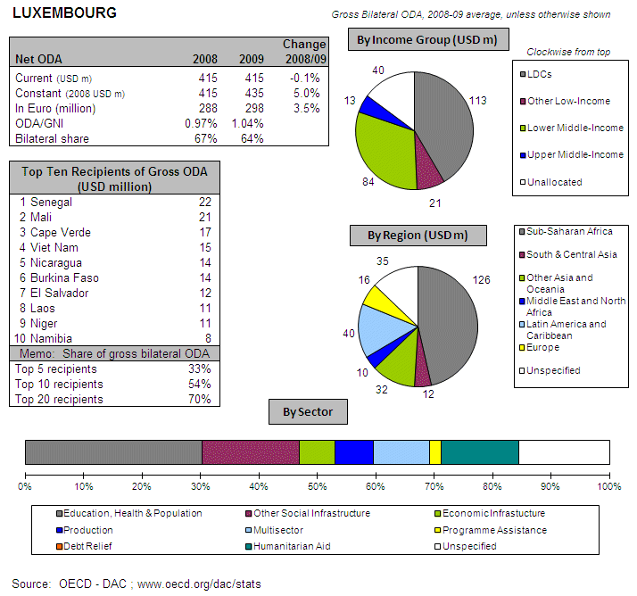
POLICY FRAMEWORK
The legal framework of Luxembourg’s development cooperation activities is the Development Co-operation Act (1996). The key policy document is the one page "strategy and principles" statement on development co-operation from the Ministry of Foreign Affairs. The statement includes commitments to reach 1% ODA/GNI and to concentrate on 10 priority countries in Central America, Western and Southern Africa and South-East Asia. Focus sectors are the social sectors: health, education and local development and water and sanitation in particular). Responsibility for co-operation policy is vested in the Development Cooperation Directorate of the Ministry of Foreign Affairs. The Development Co-operation Directorate is responsible for multilateral ODA (excluding the Bretton Woods institutions) and uses an executing agency, Lux-Development, to design and implement bilateral projects.
I. INCREASING FINANCIAL RESOURCES FOR DEVELOPMENT AND GLOBAL CHALLENGES
- IMPROVING DOMESTIC RESOURCE MOBILISATION
- Support to reform programmes for capacity development of custom, judiciary and tax administrations in developing countries: Luxembourg provides support to developing countries' tax systems in Asia, Latin America and ACP countries. In addition, support is provided to national governments in public financial management.
- Luxembourg promotes the principles of good governance in tax matters.
- New Bilateral Tax Information Exchange Agreements and Double Taxation Conventions of 2010:
- State of support to/ ratification of/ adherence to international conventions/ initiatives on tax issues:
- IMF Regional Technical Assistance Centres: No
- International Tax Dialogue: No
- International Tax Compact: No
- African Tax Administration Forum (ATAF): No
- Centro Inter-Americano de Administraciones Tributarias (CIAT): No
- IMF Topical Trust Fund on Tax policy and administration: No
- United Nations Convention against Corruption (Merida): Yes
- OECD Convention on Combating Bribery of Foreign Officials in International Business Transactions: Yes
- Stolen Assets Recovery initiative (STAR): Yes
- Extractive Industry Transparency Initiative (EITI): No

- SCALING UP ODA
ODA individual commitments/gap to agreed targets
- Luxembourg has since long reached the EU 2015 0.7% ODA/ GNI target. The country’s ODA reached EUR 301 billion (preliminary), i.e.1.09% in of GNI in 2010, up from 1.04% in 2009.
- Luxembourg spent EUR 301 million on ODA in 2010, virtually unchanged compared to 2009.
- There was no debt relief in Luxembourg’s ODA during the period 2004 – 2009.

Source: OECD/ DAC data for 1995 – 2010; Commission simulation based on information provided by EU Member States or based on agreed EU commitments for 2010 and 2015. ODA in current prices.

Luxembourg - Share of debt relief in ODA volumes

Source: OECD/DAC data for 2002-2010

- "Realistic, verifiable actions for meeting your individual ODA commitments until 2015" taken in 2010: Luxembourg reached an ODA/GNI level of 1% in 2009 and intends to maintain this level for the years to come. The government programme for 2009-2014 provides for ODA volume equivalent to 1.0% of GNI during the period.
- More than half of Luxembourg’s assistance is channelled to Africa.
- Luxembourg will continue to exceed the target of 0.15%-0.20% ODA/GNI to LDCs by 2010 and onwards.

- SUPPORT FOR/ USE OF INNOVATIVE SOURCES AND MECHANISMS OF FINANCING DEVELOPMENT
- Luxembourg supports UNITAID’s Airline Ticket Tax/contribution with 500 000 EUR in 2009 and 2010 (not reported as ODA). There are no plans to step up efforts in this area.

- LEVERAGING PRIVATE FLOWS FOR DEVELOPMENT
Support to private investment in developing countries:
- Financial tools to support private investment:
- Investment guarantees: No
- Improvement of the overall banking system: Yes
- Microfinance/ access to financial services: Yes
- Risk management initiatives: No
- Blending: No
- Private public partnerships: No
- Business and investment climate: Yes
- Investment facilities: No
- Export credits: NO
- Luxembourg promotes the adoption of internationally agreed principles and standards on Corporate Social and Environmental Responsibility by European companies. The government set up a coordination committee for corporate social responsibility in 2008. It associates the relevant actors at the state level - including the Directorate of Development Cooperation of the Ministry of Foreign Affairs - and the private sector (companies and associations).
- Luxembourg is not supporting the Kimberley Process and the FAO Code of Conduct for Responsible Fisheries.
- New initiatives in relation to including social and environmental clauses in ODA-financed public procurements: Lux-Development is examining the possibility to include environmental clauses in its calls for tenders in partner countries.
- Luxembourg has implemented solutions internally or in cooperation with third countries to overcome barriers to migrants and their families' access to financial services. There is also a monitoring system in place. Luxembourg launched a 2009-2010 action plan to develop microfinance and remittances from migrants in Cape Verde in collaboration with the NGO Appui au Développement Autonome (ADA) has. This Action Plan contains indicators.
- Luxembourg has not implemented the General Principles for International Remittances Services" agreed by the Committee on Payments and Settlements Systems (CPSS).

- AID FOR TRADE
Luxembourg, AfT Commitments (EUR million)
Source: OECD CRS Database (latest update)
- REDUCING THE DEBT BURDEN OF DEVELOPING COUNTRIES
- Luxembourg has delivered on its commitments to the HIPC and MDRI initiatives, including commitments towards IDA and the African Development Bank.
- Luxembourg believes that questions on the international architecture for the restructuring of sovereign debts do not apply to Luxembourg.

II. IMPROVED EFFECTIVENESS OF SUPPORT TO DEVELOPING COUNTRIES
- MORE EFFECTIVE EU AID
- On Ownership. Luxembourg supported country ownership in 2010 through consultation and coordination with partner countries, guidance and incentives for staff in partner countries and by supporting partner capacity development.
- On Conditionality. Luxembourg has carried out the following actions on conditionalities in 2010: harmonisation with other donors.
- On Transparency and Predictability. Luxembourg publicly discloses information on aid volume on the internet and in an annual report of development cooperation.
- On Alignment. Luxembourg has integrated the principles of the Code of Conduct on Complementarity and Division of Labour in strategies, staff guidance and programming processes/guidelines.
- On Harmonisation. Luxembourg has legal and/or administrative arrangements in place for delegated cooperation and there is a mechanism in place to track cases of delegated cooperation. Lux-Development is allowed to manage community funds under delegated cooperation since June 2009. There is a monitoring system in place to track delegated cooperation. Cases of delegated cooperation agreed to in 2010:
- On Mutual Accountability. Luxembourg has established a joint framework for monitoring joint commitments in all ten priority countries: El Salvador, Nicaragua, Burkina Faso, Cape Verde, Mali, Namibia, Niger, Senegal, Laos, and Vietnam.
- On Managing for Development Results. Luxembourg does not provide capacity support for Managing for Development Results.

- SUPPORTING BETTER GLOBAL GOVERNANCE
- Luxembourg shares the view that EU27 should speak with one voice in the IMF, World Bank and the main multilateral development banks' governing bodies. Luxembourg believes that there is no clear cut answer to this question. Speaking with one voice may definitely enhance the EU’s position in these governing bodies but may at the same further polarise the Boards of these institutions. Whether the latter would be in the interests of the concerned institutions (and their mandates) remains debatable. Now to the question how to bring this about, the straightforward answer would be the establishment of a single European seat. But the answer may differ according to the institution concerned. The IMF, for instance, is first and foremost a financial institution and one EU27 voice might make little sense in this context; a Euro zone representation maybe more sensible in this particular case.
- Luxembourg supports stronger Brussels based coordination on a regular basis on issues related to the World Bank and MDBs. However, Luxembourg believes that it is important to clarify what Brussels based coordination means. If it is meant to be a Commission-run exercise, we would strongly beg to differ. If it means that EU countries would be coordinating along the lines of the Brussels-based IMF coordination (IMF coordination is taking place in the context of the Ecofin) the answer is definitely yes. Of course, since (unlike in the case of IMF coordination) development aid matters are often a shared Ministerial responsibility, coordination is likely to become an institutional challenge.


MALTA

POLICY FRAMEWORK
Significant progress can be seen in the short span of five years (2004–2009) immediately following the country’s accession to the EU and its consequent shift to donor-country status. The Government established a written policy regarding overseas aid and enhanced transparency in showing how the ODA funds are being distributed.
In October 2007 the Government launched its first Overseas Development Policy document, based on the values that underlie Malta’s Foreign Policy ( Strategic Objective 18 of Malta’s Foreign Policy) which states that the Ministry of Foreign Affairs will “Elaborate and action a Policy and Work Programme of humanitarian and development assistance.
I. INCREASING FINANCIAL RESOURCES FOR DEVELOPMENT AND GLOBAL CHALLENGES
- IMPROVING DOMESTIC RESOURCE MOBILISATION
- Malta does not provide concrete development cooperation to support developing countries’ tax systems due to resources constraints.
  - No support to reform programmes for capacity development of customs, judiciary and tax administrations in developing countries.
  - No support to promote good governance in tax matters.
- Bilateral Tax Information Exchange Agreements and Double Taxation Conventions since 2010: (i) Double Taxation Conventions signed with Jersey (ratified by both parties); (ii) under negotiation with Belgium, Bahrain, China, Germany (awaiting ratification).
- State of ratification of/adherence to international conventions/initiatives on tax issues:
- United Nations Convention against Corruption (Merida): Yes
- OECD Convention on Combating Bribery of Foreign Officials
in International Business Transactions: No
- Stolen Assets Recovery initiative (STAR): No
- Extractive Industry Transparency Initiative (EITI): No
- IMF Regional Technical Assistance Centres: No
- International Tax Dialogue: No
- International Tax Compact: No
- African Tax Administration Forum (ATAF): No
- Centro Inter-Americano de Administraciones Tributarias (CIAT): No
- IMF Topical Trust Fund on Tax policy and administration: No

- SCALING UP ODA
ODA Individual commitments and gap to target
- In 2010, Malta spent €7 million as ODA (preliminary), i.e. 0.11% of its GNI, down from EUR 10 million, i.e. 0.18% of GNI in 2009.
Source: OECD/ DAC data for 1995 – 2010; Commission simulation based on information provided by EU Member States or based on agreed EU commitments for 2010 and 2015. ODA in current prices.

- "Realistic, verifiable actions for meeting individual ODA commitments until 2015" taken in 2010: The Government is committed to the objective to reach the ODA targets and is allocating more funds within its budget so as to increase its ODA/GNI ratio to meet its commitments by 2015. Priority is given to public support for the MDG agenda, with a particular focus on areas of public interest where common development goals with development are important like education, health, trade, environment and climate change and migration.
- The Ministry of Foreign Affairs has been co-funding projects implemented by local NGOs in Africa. In its multilateral contributions, Malta will also try to earmark its funds to Africa.
- Malta will not reach the target of 0.15%-0.20% ODA/GNI to LDCs by 2010. Malta supports EU initiatives to this effect.

- SUPPORT FOR/ USE OF INNOVATIVE SOURCES AND MECHANISMS OF FINANCING DEVELOPMENT
- Malta is currently not implementing any innovative source of financing, although this might be considered in the future.

- LEVERAGING PRIVATE FLOWS FOR DEVELOPMENT
Support to private investment in developing countries:
- Malta does not provide financial tools to support private investment.
- Malta does not promote the adoption of internationally agreed principles and standards on Corporate Social and Environmental Responsibility by European companies. As yet, there are no social and environmental clauses included in Malta’s public procurement regulations.
- Malta does not support the Kimberley process and the FAO Code of Conduct for Responsible Fisheries.

Remittances
- Malta did not implement the "General Principles for International Remittances Services" agreed by the Committee on Payments and Settlements Systems (CPSS), neither plan to implement solutions to improve the impact of remittances on development. As local institutions have no data on remittances as these are treated like any other transactions

- AID FOR TRADE
No information available on Malta's commitments for Aid for Trade.

- REDUCING THE DEBT BURDEN OF DEVELOPING COUNTRIES
- Malta has not delivered on its HIPC/ MDRI commitments (including vis-à-vis IDA/ AfDB).
- No actions/steps taken in 2010 to help restore and preserve debt sustainability in low-income countries.
- Malta favours reform of the international architecture for restructuring of sovereign debts in order to deal with potential future cases of debt distress in low-income countries (through the Paris Club with a role for International Financial Institutions).
- No specific interventions to prevent aggressive litigation against HIPCs (in particular to prevent the actions of "vulture funds").

II. IMPROVED EFFECTIVENESS OF SUPPORT TO DEVELOPING COUNTRIES
- MORE EFFECTIVE EU AID
- On Ownership. In 2010, Malta supported ownership through consultations and coordination with partner countries, through Guidance and incentives for staff in partner countries and through partner capacity development.
- On Conditionality. No action.
- On Transparency and Predictability. Malta publicly discloses information on aid volumes through Press release.
- On Alignment. Malta did not integrate the principles of the Code of Conduct on Complementarity and Division of Labour in its development strategy. Still undergoing further internal study.
- On Harmonisation. No legal and/or administrative arrangements in place to manage funds for another Member States or the EU and for another Member States or the EU to manage Malta’s funds (delegated cooperation).
- On Mutual Accountability. No joint framework for monitoring joint commitments.
- On Managing for Development Results. Malta does not provide capacity building support for this.
- SUPPORTING BETTER GLOBAL GOVERNANCE
- Position on improving the voice of the EU and its Member States within International Financial Institutions. Malta supports a single EU Chair for the IMF in order for the EU27 to speak with one voice. One common position on a single EU seat, or failing that, of a single euro zone seat.
- Malta favours stronger Brussels based coordination on issues related to the World Bank and MDBs.
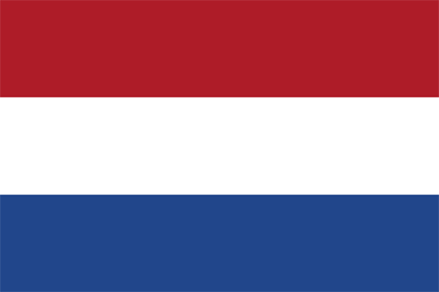
THE NETHERLANDS
AT A GLANCE
POLICY FRAMEWORK
The Government presented a major overhaul of Dutch development policy in a letter to Parliament in November 2010. Aid spending will be reduced permanently from 0.8% to 0.7% of GNI and the number of partner countries will be reduced from 33 to 16. The number of themes will also be reduced in parallel with a shift from social to economic sectors. The administration of Dutch development cooperation is integrated into the Ministry of Foreign Affairs, with the Directorate General for International Cooperation as the leading unit.
I. INCREASING FINANCIAL RESOURCES FOR DEVELOPMENT AND GLOBAL CHALLENGES
- IMPROVING DOMESTIC RESOURCE MOBILISATION
- Support to reform programmes for capacity development of custom, judiciary and tax administrations in developing countries: The Netherlands provides support to developing countries' tax policy and administration (customs, semi-autonomous revenue authorities and ministries of finance) in EU candidate and Neighbourhood Policy countries, Asia and ACP countries.
- Promote the principles of good governance in tax matter: Yes
- New Bilateral Tax Information Exchange Agreements and Double Taxation Conventions of 2010: Agreements concluded with Andorra, Anguilla, Antigua & Barbuda, Bahamas, Belize, Bermuda, British Virgin Islands, Cayman Islands, Cook Islands, Dominica, Gibraltar, Grenada, Guernsey, Isle of Man, Jersey, Liberia, Liechtenstein, Marshall Island, Monaco, Montserrat, Saint Kitts and Nevis, Samoa, San Marino, Seychelles, Singapore, Saint Lucia, Saint Vincent and Grenadines, Turks & Caicos Islands. Agreements under negotiations with Brunei, Costa Rica, Guatemala, Mauritius, Nauru, Niue, Uruguay, Vanuatu.
- State of ratification of/ adherence to international conventions/ initiatives on tax issues:
- IMF Regional Technical Assistance Centres: Yes
- International Tax Dialogue: Yes
- International Tax Compact: Yes
- African Tax Administration Forum (ATAF): Yes
- Centro Inter-Americano de Administraciones Tributarias (CIAT): Yes
- IMF Topical Trust Fund on Tax policy and administration: Yes
- United Nations Convention against Corruption (Merida): Yes
- OECD Convention on Combating Bribery of Foreign Officials in International Business Transactions: Yes
- Stolen Assets Recovery initiative (STAR): Yes
- Extractive Industry Transparency Initiative (EITI): Yes
- SCALING UP ODA
ODA individual commitments/gap to agreed targets
- The ODA levels of the Netherlands have been consistend at or above 0.7% ODA/ GNI since many years.. The new Dutch Government, in its coalition agreement of 2010 ODA, while confirming a spending level of 0.7% of GNI for development aid until 2015, at the same time decided to scale down from the > 0.8% foreseen for 2010 to 0.75% in 2011 and 0.7% from 2012 onwards.
- In 2010 the Netherlands spent EUR 4795 million as ODA (preliminary), 0.81% of its GNI. This was an increase by 2.2% in real terms compared to 2009.
- Debt relief made up only 4% of Dutch ODA during the period 2004 - 2009

Source: OECD/ DAC data for 1995 – 2010; Commission simulation based on information provided by EU Member States or based on agreed EU commitments for 2010 and 2015. ODA in current prices.

The Netherlands - Share of debt relief in ODA volumes
Source: OECD/DAC data for 2002-2010

- "Realistic, verifiable actions for meeting your individual ODA commitments until 2015" taken in 2010: The ODA commitments until 2015 are agreed upon in the coalition agreement and in the government budget for 2011. The current plan is to commit 0.8% in 2010, 0.75% in 2011 and 0.7% from 2012 onwards.
- No specific measures are needed to ensure that at least 50% of EU collective aid increases of ODA resources are channelled to Africa. Overall monitoring ensures that at least 50% of total ODA is spent on Africa. Netherlands’ choice of partner countries is largely focused on Sub Sahara Africa and Netherlands’ bilateral regionally focused ODA has already met the 50% target.
- The Netherlands will continue to exceed the target of 0.15%-0.20% ODA/GNI to LDCs by 2010 and onwards.

- SUPPORT FOR/ USE OF INNOVATIVE SOURCES AND MECHANISMS OF FINANCING DEVELOPMENT

- The Netherlands supports the International Financing Facility for Immunisation (IFFIm). The contribution to IFFIm is EUR 80 million for 8 years (2009-2016), but is expected to continue thereafter.
- The Netherlands plans to step up efforts for innovative financing mechanisms, i.a. by exploring the potential of financial instruments to leverage private investments in sectors that directly relate to development (water, energy, health, financing). In contrast to the currently applied levy type of instruments, these mechanisms are characterised by linking revenue generation directly with utilisation/investment (guarantee type of interventions). The Netherlands are to some extent involved with these types of instruments but in a modest way.
- The Netherlands is also ready to further research into initiatives concerning innovative finance for education, especially at a time when the education sector is hard hit by budget cuts from donor agencies.

- LEVERAGING PRIVATE FLOWS FOR DEVELOPMENT
Support to private investment in developing countries: Foreign Direct Investment
Source: OECD/ DAC

- Financial tools to support private investment:
- Investment guarantees: Yes
- Improvement of the overall banking system: Yes
- Microfinance/ access to financial services: Yes
- Risk management initiatives: Yes
- Blending: No
- Private public partnerships: Yes
- Business and investment climate: Yes
- Investment facilities: Yes
- Export credits: No
- The Netherlands promotes the adoption of internationally agreed principles and standards on Corporate Social and Environmental Responsibility by European companies. The Netherlands has formulated eligibility criteria for companies that apply for grants to invest in developing countries. These criteria prevent child and forced labour (including the first supplier). In assessing the social and environmental aspects of the applications, the Dutch government has formulated criteria which are related to international standards such as the OECD Guidelines, ILO Conventions (Core Labour Standards) and the IFC Performance Standards
- The Netherlands supports the Kimberley process and the FAO Code of Conduct for Responsible Fisheries.
- The Netherlands has taken new initiatives in relation to including social and environmental clauses in ODA-financed public procurements. In 2010 the Netherlands’ started to implement its new policy on sustainable public procurement. Environmental criteria have been applied from January 2010 and social criteria will be applied from 2011. See Box for details.
Box. In the Netherlands, public procurement is used to pursue various policy objectives, including development objectives. The government links its public procurement policy to economic diplomacy, activities of multilateral organisations (e.g. ILO) and supply chain initiatives (e.g. the Dutch Sustainable Trade Initiative and ‘fair trade municipalities’). The government has chosen to apply fundamental labour standards and human rights on a generic basis (i.e. in a uniform manner in all public procurement). The development aim is to realise improvements in the entire supply chain (a process-oriented approach). For a limited number of products, for which community-supported supply chain initiatives exist, supplementary standards apply. These standards relate to living wages/income (or fair trade), working hours, and occupational health and safety. The system is designed to be as simple as possible for both contracting parties and suppliers, and to be consistent with actual practice. It only applies to large contracts (above EUR 133,000 for goods and services). Companies will be held accountable for the way they fulfil their supply chain responsibilities with regard to the product, work or service they deliver.
- The Netherlands have implemented solutions internally or in cooperation with third countries to overcome barriers to migrants and their families' access to financial services. The focus is on reinforcing a positive link between remittances and development. The Netherlands gives support to a remittances comparison website www.geldnaarhuis.nl (evaluated in 2010), which provides information in eight languages on money transfer costs charged by banks and money transfer offices. The Netherlands contributes to financial sector development in countries of origin. The aim is a more sustainable development impact of remittances. Finally, the Netherlands aims to increase the poverty alleviation effect of money transfers through promoting small scale initiatives of migrants.

- AID FOR TRADE
The Netherlands, AfT Commitments (in EUR thousands)
Source: OECD CRS Database (latest update)
- REDUCING THE DEBT BURDEN OF DEVELOPING COUNTRIES
- The Netherlands delivered on its commitments to the HIPC and MDRI initiatives, including commitments towards IDA and the African Development Bank.
- The Netherlands has taken new actions/steps to help restore and preserve debt sustainability in low-income countries by supporting the World Bank's Debt Management Facility (DMF), UNCTAD Debt Management and Financial Analysis System (DMFAS) and the Macroeconomic and Financial Management Institute of Eastern and Southern Africa (MEFMI).
- The Netherlands sees a need for reform of the international architecture for the restructuring of sovereign debts based on the Paris Club and the creation of an International Arbitration Court.
- No specific interventions to prevent aggressive litigation against HIPCs have been taken.
II. IMPROVED EFFECTIVENESS OF SUPPORT TO DEVELOPING COUNTRIES
- MORE EFFECTIVE EU AID
- On Ownership. The Netherlands supported country ownership in 2010 through consultation and coordination with partner countries, guidance and incentives for staff in partner countries and by supporting partner capacity development.
- On Conditionality. The Netherlands have carried out the following actions on conditionalities in 2010: reduction of the number of conditionalities, harmonisation with other donors and making conditionalities public.
- On Transparency and Predictability. The Netherlands publicly discloses information on aid volume on central and field office websites. An important tool to disclose information on aid volume is the biannual Results Report, which reports on aid policy and results. The report is meant to inform parliament, stakeholders and the public and is a coproduction of the Ministry of Foreign Affairs and Dutch CSOs.
- On Alignment. The Netherlands has integrated the principles of the Code of Conduct on Complementarity and Division of Labour in strategies, staff guidance and programming processes/guidelines.
- On Harmonisation. The Netherlands agreed on the following cases of delegation in 2010:
- On Mutual Accountability. The Netherlands has established a joint framework for monitoring joint commitments in Mozambique, Rwanda, Burkina Faso, Tanzania, Uganda and Zambia.
- On Managing for Development Results. The Netherlands provides capacity support for Managing for Development Results (MfDR).
- SUPPORTING BETTER GLOBAL GOVERNANCE
- The Netherlands believes that the EU27 should speak with one voice in the IMF, World Bank and the main multilateral development banks' governing bodies.
- The Netherlands supports stronger Brussels based coordination on issues related to the World Bank and multilateral development banks.

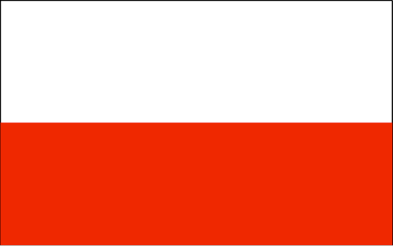
POLAND
AT A GLANCE
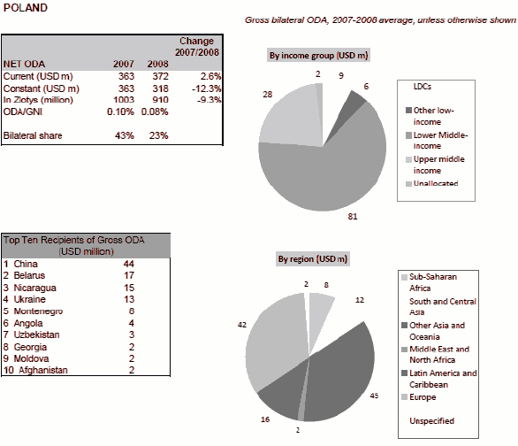
POLICY FRAMEWORK
Poland’s development cooperation is guided by a strategy that was approved by the Council of Ministers in 2003.
The main focal point for development cooperation strategy and policy leadership within the national system is the Development Co-operation Department of the Ministry of Foreign Affairs (DCDMFA). DCDMFA manages only 15% of Poland’s ODA. The delivery of Polish aid is very much a team effort involving other departments of MFA, the Ministry of Finance (EU and multilateral channels), the Ministry of Science and Higher Education (scholarships), the Ministry of Defence (Afghanistan), Ministry of the Interior and Administration (aid to refugees) and a range of other ministries, government agencies and NGOs. MFA is therefore both the policy maker for development co-operation and also the co-ordinator of a host of actors and agencies that are not always under its direct control but which are responsible for delivering Poland’s aid.

Poland plans legislation to strengthen the legal basis for development co-operation and a draft law is being prepared for approval by Parliament. The law, as currently drafted, will create an agency for development co-operation implementation from the existing institutional structures.

The government intends to maximise the opportunity presented by the recent merger of the Office of the Committee for European Integration (UKIE) with MFA which more than doubles the Ministry’s capacity for development cooperation and has put in place a new DCDMFA structure in anticipation of the creation of the agency envisaged in the new legislation
I. INCREASING FINANCIAL RESOURCES FOR DEVELOPMENT AND GLOBAL CHALLENGES
- IMPROVING DOMESTIC RESOURCE MOBILISATION
- Support to reform programmes for capacity development of customs, judiciary and tax administrations in developing countries: Poland does not provide aid in these fields.
- Support to promote good governance in tax matters: Yes
- Bilateral Tax Information Exchange Agreements and Double Taxation Conventions since 2010: (ii) under negotiation with Turkmenistan; (iii) planned with Antigua and Barbuda, Dominica, Grenada, Saint Kitts and Nevis, Saint Lucia, Saint Vincent and the Grenadines, Marshall Islands, Nauru, Samoa, Vanuatu, Seychelles, The Bahamas, Liberia.
- State of ratification of/adherence to international conventions/initiatives on tax issues:
- United Nations Convention against Corruption (Merida): No
- OECD Convention on Combating Bribery of Foreign Officials
in International Business Transactions: Yes
- Stolen Assets Recovery initiative (STAR): No
- Extractive Industry Transparency Initiative (EITI): No
- IMF Regional Technical Assistance Centres: No
- International Tax Dialogue: No
- International Tax Compact: No
- African Tax Administration Forum (ATAF): No
- Centro Inter-Americano de Administraciones Tributarias (CIAT): No
- IMF Topical Trust Fund on Tax policy and administration: No

- SCALING UP ODA
ODA Individual commitments and gap to target
- Poland's ODA spent EUR 285 million as ODA in 2010 (preliminary), i.e. 0.08% of GNI in 2010, down from 0.09% in 2009, falling short of the commitment to reach 0.17% of GNI by 2010.
- A recent DAC Peer review noted Poland’s commitment to reach an ODA/GNI ratio of 0.33% by 2015 is looking increasingly problematic.
Source: OECD/ DAC data for 1995 – 2010; Commission simulation based on information provided by EU Member States or based on agreed EU commitments for 2010 and 2015. ODA in current prices.

- No realistic, verifiable actions for meeting individual ODA commitments until 2015 taken in 2010: Having in mind meeting the accepted EU commitment of 0.33 % GNI of Polish ODA in 2015 when reporting annually to the Parliament on issues of Polish foreign affairs, the Minister of Foreign Affairs recalls the relevant commitment and underlines the importance of scaling up of Polish ODA volumes.
- Poland participates in co-financing of the 10th European Development Fund that is the main instrument of financing cooperation between the European Union and African, Caribbean and Pacific countries. Majority of assistance is directed to Africa. As far as bilateral assistance is concerned, Poland is going to continue to provide ODA to African countries through Polish embassies that are responsible for implementing projects financed from the so-called Small Grant Fund in these countries. Moreover Poland will continue to realise projects in Angola that is the priority country of Polish foreign aid in Africa according to Polish comparative advantages.
- Poland will not reach the target of 0.15%-0.20% ODA/GNI to LDCs by 2010. Poland finances EDF10, provides contributions to the EU ODA budget and continues to assist LDCS bilaterally. All these efforts taken together should contribute to achieving the EU target on LDCs after 2010.

- SUPPORT FOR/ USE OF INNOVATIVE SOURCES AND MECHANISMS OF FINANCING DEVELOPMENT
- Poland did not use innovative financing mechanisms for development.
- Poland does not participate in international cooperation in the field of innovative financing sources and mechanisms. However, Poland considers them very useful in the context of supporting international efforts of scaling up volumes of ODA and achieving Millennium Development Goals. Therefore Poland seriously takes into consideration its future engagement in international cooperation as far as innovative financing sources and mechanisms are concerned.
- No other work on innovative financing mechanisms.
- LEVERAGING PRIVATE FLOWS FOR DEVELOPMENT
Support to private investment in developing countries:
- Financial tools to support private investment
- Investment guarantees: No
- Improvement of the overall banking system: No
- Microfinance/ access to financial services: No
- Risk management initiatives: No
- Blending: No
- Private public partnerships: No
- Business and investment climate: No
- Investment facilities: No
- Export credits: Yes
- Poland does not promote the adoption of internationally agreed principles and standards on Corporate Social and Environmental Responsibility.
- No reported information on Remittances.

- AID FOR TRADE
- No information available on Poland’s commitments for Aid for Trade.

- REDUCING THE DEBT BURDEN OF DEVELOPING COUNTRIES
- Poland delivered on its HIPC/ MDRI commitments (including vis-à-vis IDA/ AfDB) without delay.
- No actions/steps taken in 2010 to help restore and preserve debt sustainability in low-income countries.
- Poland does not favour reform of the international architecture for restructuring of sovereign debts.
- Specific interventions to prevent aggressive litigation against HIPCs (in particular to prevent the actions of "vulture funds"): None

II. IMPROVED EFFECTIVENESS OF SUPPORT TO DEVELOPING COUNTRIES
- MORE EFFECTIVE EU AID
- On Ownership. In 2010, Poland supported ownership through consultations and coordination with partner countries, through guidance and incentives for staff in partner countries, by supporting partner capacity development.
- On Conditionality. No action.
- On Transparency and Predictability. Poland publicly discloses information on aid volumes on Polish aid web site (annual reports enclosing complete information on Polish ODA volumes and covering all activities undertaken in the field of development cooperation). Moreover Poland publishes analyses, booklets and leaflets and cooperates with press and media.
- On Alignment. Poland partially integrated the principles of the Code of Conduct on Complementarity and Division of Labour in its development strategy.
- On Harmonisation. No legal and/or administrative arrangements in place to manage funds for another Member States or the EU , and/ for another Member States or the EU to manage Polish funds (delegated cooperation).
- On Mutual Accountability. No joint framework for monitoring joint commitments.
- On Managing for Development Results. N/A

- SUPPORTING BETTER GLOBAL GOVERNANCE
- Position on improving the voice of the EU and its Member States within International Financial Institutions. Poland does not support a single EU Chair for the IMF in order for the EU27 to speak with one voice. Whereas Poland sees some merit in EU27 speaking with one voice on particular issues raised in the IMF, Poland also believes that the current size of the Executive Board in the Fund reasonably strikes the right balance between legitimacy and an effective functioning of the Fund. Lowering the number of chairs would be unlikely to yield efficiency gains, while reducing notably the variety of views of the Fund’s membership. Poland is therefore not in favour of a reduction of the size of the Board and a single EU chair. Poland believes that the current EU system of coordinating positions and of representation in the IMF works well.
- Poland favours stronger Brussels based coordination on issues related to the World Bank and MBB’s. With regard to the World Bank and other MDBs issues, Poland supports the concept of coordination of the EU Member States’ positions. It might significantly enhance governance process of the aforementioned institutions and make the EU more visible at international fora.

PORTUGAL

AT A GLANCE
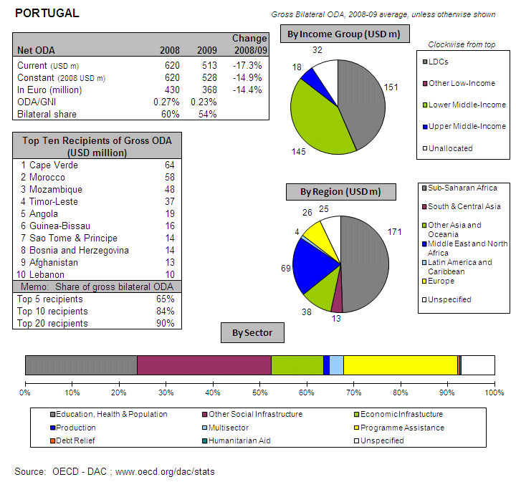
POLICY FRAMEWORK
In 2003, Portugal established IPAD (Instituto Português de Apoio ao Desenvolvimento) with the legal mandate to coordinate development cooperation. Since then, Portugal has made significant progress in building an overall strategic framework for its development co-operation. The “2005 Strategic Vision for Portuguese Development Co-operation” has provided a solid foundation for this change, on which other policies have been built. The Strategic Vision sets out some guiding principles and priorities for Portuguese development co-operation, by drawing on Portugal’s own experiences, foreign policy priorities and international obligations. Thus, it emphasises Portugal’s commitment to the Millennium Development Goals, human security, sustainable economic development, contributing to international development discussions, and also promoting the Portuguese language. It also acknowledges some of the challenges for Portugal, including the fragmentation of the Portuguese development co-operation programme and the importance of co-ordination. As such, it has been a useful tool for IPAD as it seeks to fulfil its co-ordination mandate. While there are still 16 ministries involved in development co-operation, they are now officially obliged to obtain IPAD’s approval for all new ODA-funded activities.
I. INCREASING FINANCIAL RESOURCES FOR DEVELOPMENT AND GLOBAL CHALLENGES
- IMPROVING DOMESTIC RESOURCE MOBILISATION
- Support to reform programmes for capacity development of customs, judiciary and tax administrations in developing countries: Portugal provides aid in these fields to ACP Countries (support to administrations and policy of: Customs and Ministries of Finance).
- Support to promote good governance in tax matters: Yes
- Bilateral Tax Information Exchange Agreements and Double Taxation Conventions since 2010: (i) Bilateral Tax Information Exchange Agreements signed with: Antigua Barbuda, Belize, Andorra, Gibraltar, Bermuda, Cayman Islands, Dominican Republic, Guernsey, Isle of Man, Jersey, Liberia, Santa Lucia, St. Kitts, (iia) under negotiation with: Aruba, Cook Islands, Marshall Islands, Samoa, Vanuatu, Montserrat, Monaco, St. Vincent & Grenadines, (iib) DTAs under negotiation with Botswana, East Timor, Egypt, Kenya, Malaysia, Thailand, Vietnam, Hong Kong (iii) planned with Angola, Bosnia Herzegovina, Cameroon, Ethiopia, Georgia, Mauritius, Peru, Senegal, Serbia, Sao Tomé & Principe, Turkmenistan.
- State of ratification of/adherence to international conventions/initiatives on tax issues:
- United Nations Convention against Corruption (Merida): Yes
- OECD Convention on Combating Bribery of Foreign Officials
in International Business Transactions: Yes
- Stolen Assets Recovery initiative (STAR): No
- Extractive Industry Transparency Initiative (EITI): No
- IMF Regional Technical Assistance Centres: No
- International Tax Dialogue: No
- International Tax Compact: No
- African Tax Administration Forum (ATAF): No
- Centro Inter-Americano de Administraciones Tributarias (CIAT): No
- IMF Topical Trust Fund on Tax policy and administration: No
- SCALING UP ODA
ODA Individual commitments and gap to target
- Portugal missed the ODA target to provide 0.51% of GNI by 2010. Portugal’s ODA reached EUR 489 million, i.e.0.29% of GNI in 2010 (preliminary), up from 0.23% in 2009 – an increase in real terms of 31.5%.
- Portuguese development co-operation is strongly focused on six partner countries with which it has historical connections, a shared language and close relationships: Angola, Cape Verde, Guinea Bissau, Mozambique, Sao Tome and Principe, and Timor-Leste. Five of these countries are least developed countries (LDCs) and four are fragile states.

Source: OECD/ DAC data for 1995 – 2010; Commission simulation based on information provided by EU Member States or based on agreed EU commitments for 2010 and 2015. ODA in current prices.

Portugal - Share of debt relief in ODA volumes
Source: OECD/DAC data for 2002-2010

- "Realistic, verifiable actions for meeting individual ODA commitments until 2015" taken in 2010: Even with a restrictive budget stemming from the international financial crisis, it was possible at a Cabinet level to avoid any restrictions in the cooperation state budget for 2011. Portugal is committed to accelerating progresses towards its aid volume commitments as soon as the economic situation improves.
- Portugal will remain committed to channelling the majority of its aid to Africa, which represents, since 2003, around 64% of bilateral ODA on average.
- Portugal will not reach the target of 0.15%-0.20% ODA/GNI to LDCs by 2010. Due to the effort of fiscal consolidation in Portugal, it is difficult to set out a precise date. Nevertheless, Portugal is firmly committed to maintaining LDCs as the main beneficiaries of Portuguese aid and thereby strives to achieve the 0.15%-0.20% of ODA/ GNI.

- SUPPORT FOR/ USE OF INNOVATIVE SOURCES AND MECHANISMS OF FINANCING DEVELOPMENT
- Portugal does not use innovative sources of financing.
- Portugal intends to step up efforts for innovative financing mechanisms through Political Support to a Transaction Tax.
- No further work on innovative financing mechanisms.

- LEVERAGING PRIVATE FLOWS FOR DEVELOPMENT
Support to private investment in developing countries: Foreign Direct Investment
Source: OECD/ DAC
- Financial tools to support private investment
- Investment guarantees: Yes
- Improvement of the overall banking system: No
- Microfinance/ access to financial services: No
- Risk management initiatives: No
- Blending: Yes
- Private public partnerships: Yes
- Business and investment climate: Yes
- Investment facilities: Yes
- Export credits: Yes
- Portugal promotes the adoption of internationally agreed principles and standards on Corporate Social and Environmental Responsibility by European companies. Legislation and advocacy, namely through the National Strategy for Development Education, the Development Cooperation Forum (joining public and private entities, such as NGOs, Foundations and Private Sector Associations), as well as through policy coherence for development work.
- No new initiatives were started in 2010 to include social and environmental clauses in ODA-financed public procurement.
- On Remittances, Portugal’s Central Bank (Banco de Portugal) has established regulations according to which a list of all fees and charges applied by credit institutions and payment institutions, when selling their products and services, must be easily accessible to customers in all branches and internet sites. This initiative ensures full transparency regarding the cost of products and services, including the remittance costs charged by each institution.
- Portugal has robust and reliable data concerning the amounts and destination of remittances from Portugal. Portugal adopted/ intends to adopt the operational definitions, recommendations and best practices on improving the quality and coverage of data on remittances according to the compilation guide drafted by the "Luxembourg Group".

- AID FOR TRADE
Portugal, AfT Commitments (in EUR thousands)
Source: OECD CRS Database (latest update)

- REDUCING THE DEBT BURDEN OF DEVELOPING COUNTRIES
- Portugal delivered on its HIPC/ MDRI commitments (including vis-à-vis IDA/ AfDB) without delay.
- Actions/steps taken in 2010 to help restore and preserve debt sustainability in low-income countries: Bilateral technical assistance and training to strengthen debt management capacities of low income countries.
- Portugal does not favour reform of the international architecture for restructuring of sovereign debts in order to deal with potential future cases of debt distress in low-income countries.
- Specific interventions to prevent aggressive litigation against HIPCs (in particular to prevent the actions of "vulture funds"): None.
II. IMPROVED EFFECTIVENESS OF SUPPORT TO DEVELOPING COUNTRIES
- MORE EFFECTIVE EU AID
- On Ownership. In 2010, Portugal supported ownership through consultations and coordination with partner countries.
- On Conditionality. In 2010, Portugal progressed by harmonising with other donors.
- On Transparency and Predictability. Portugal publicly discloses information on aid volumes through IPAD website and through a database at country level.
- On Alignment. Portugal partially integrated the principles of the Code of Conduct on Complementarity and Division of Labour in its development strategy.
- On Harmonisation. Portuguese Institute for Development Cooperation was recently certified by the EC to manage EC funds in the external field.
- On Mutual Accountability. Portugal established a joint framework for monitoring joint commitments with two of its priority countries.
- On Managing for Development Results. Portugal provides capacity building support for this.

- SUPPORTING BETTER GLOBAL GOVERNANCE
- Position on improving the voice of the EU and its Member States within International Financial Institutions. Portugal does not support a single EU Chair for the IMF in order for the EU27 to speak with one voice. There are not yet appropriate mechanisms for EU coordination and preparation of EU common positions on IFI issues (apart from IMFWG). Portugal believes the diversity of viewpoints and the representativeness of MDBs concerning their member countries is paramount. There is scope to improve the voice and participation of EU-27 in the BWIs and other MDBs by close and constructive coordination, and dialogue.
- Portugal favours stronger Brussels based coordination on issues related to the World Bank and MDBs.


ROMANIA
POLICY FRAMEWORK
Romania’s development cooperation policy was first defined in the National Strategy on the International Development Cooperation Policy adopted in 2006.
The Romanian Ministry of Foreign Affairs (MFA) is the main institution in charge of managing and implementing the national development cooperation policy. The development assistance, including humanitarian assistance, is financed from the MFA’s budget, through a separate budgetary line, in accordance with the existing legal framework. The Development Assistance Unit (UAsD) that manages development cooperation. UAsD is part of the General Directorate for Economic Diplomacy (DGDE), subordinated to the State Secretary for Global Affairs.
The main framework for inter-institutional dialogue is the Commission for Economic Cooperation and International Development, established through the GD 747/2007. The Commission is a forum for analysis, debate and planning in terms of the implementation process. The Commission’s chairmanship and the secretariat are provided by the MFA.
I. INCREASING FINANCIAL RESOURCES FOR DEVELOPMENT AND GLOBAL CHALLENGES
- IMPROVING DOMESTIC RESOURCE MOBILISATION
- Support to reform programmes for capacity development of customs, judiciary and tax administrations in developing countries: Romania provides aid in these fields through technical consultations on tax administration with the Ministries of Finance from Bosnia-Herzegovina, Uruguay and the Republic of Moldova.
- Support to promote good governance in tax matters: Yes.
- Bilateral Tax Information Exchange Agreements and Double Taxation Conventions since 2010: (i) Double Taxation Conventions signed with Bosnia and Herzegovina (to be signed in 2011, depending of the conclusion of the domestic procedures in both countries for signature), (ii) under negotiation with Uruguay (to be signed in February 2011), (iii) planned with Republic of Moldova (preliminary consultation concerning the conclusion of a TIEA already took place).
- State of ratification of/adherence to international conventions/initiatives on tax issues:
- United Nations Convention against Corruption (Merida): Yes
- OECD Convention on Combating Bribery of Foreign Officials
in International Business Transactions: No
- Stolen Assets Recovery initiative (STAR): No
- Extractive Industry Transparency Initiative (EITI): No
- IMF Regional Technical Assistance Centres: No
- International Tax Dialogue: No
- International Tax Compact: No
- African Tax Administration Forum (ATAF): No
- Centro Inter-Americano de Administraciones Tributarias (CIAT): No
- IMF Topical Trust Fund on Tax policy and administration: No

- SCALING UP ODA
ODA Individual commitments and gap to target
- In 2010, Romania spent EUR86 million as ODA, 0.07% of its GNI (preliminary), down from 0.09% in 2009 missing the interim target of 0.17% ODA/GNI in 2010.
Source: OECD/ DAC data for 1995 – 2010; Commission simulation based on information provided by EU Member States or based on agreed EU commitments for 2010 and 2015. ODA in current prices.

- "Realistic, verifiable actions for meeting individual ODA commitments until 2015" taken in 2010. Romania is making efforts to annually increase its ODA budget. In addition, the government announced the engagement to contribute EUR 100 million to the development of the Republic of Moldova, for the period 2010-2012, that would also add to the total ODA contribution. The debut of payment of Romania’s contribution to the 10th EDF since 2011 (EUR 84 million in total) will also reinforce its commitments.
- No measure taken nor planned to contribute to the EU27 target to channel at least 50% of EU collective ODA increase to Africa.
- Romania did not reach the target of 0.15%-0.20% ODA/GNI to LDCs by 2010.

- SUPPORT FOR/ USE OF INNOVATIVE SOURCES AND MECHANISMS OF FINANCING DEVELOPMENT
- Romania did not use innovative financing mechanisms for development.
- Romania intends to step up efforts for innovative financing mechanisms with significant revenue generation potential. In May 2009, Romania became an observer to the Pilot Group for Innovative Financing. Internal consultations at government level are currently on-going concerning the opportunity of introducing the airline ticket levy (the UNITAID mechanism).
- No other work on innovative financing mechanisms.

- LEVERAGING PRIVATE FLOWS FOR DEVELOPMENT
Support to private investment in developing countries:
- Financial tools to support private investment
- Investment guarantees: No
- Improvement of the overall banking system: No
- Microfinance/ access to financial services: No
- Risk management initiatives: No
- Blending: No
- Private public partnerships: No
- Business and investment climate: Yes
- Investment facilities: No
- Export credits: Yes
- Romania promotes the adoption of internationally agreed principles and standards on Corporate Social and Environmental Responsibility by European companies. During 2010, the Ministry of Environment and Forests of Romania carried out promotion activities (workshops, seminars, participation at the different conferences) in EMAS (Eco-Management and Audit Scheme) field and initiated the legislation establishing measures for the application of EMAS at national level.
- No new initiatives were started in 2010 to include social and environmental clauses in ODA-financed public procurement.
- Romania has not implemented solutions internally or in cooperation with third countries to overcome barriers to migrants and their families' access to financial services. No specific solution has been implemented beside that provided by the relevant acquis i.e. Directive 2007/64 (Payment services Directive) and further action in this field has not yet been considered.
- Romania implemented or plans to implement other initiatives in order to increase competition and transparency in the remittance market and to reduce remittance transfers costs. Romania implemented Directive 2007/64 (Payment Services Directive) which transposed partially CPSS principles.

- AID FOR TRADE
Romania, AfT Commitments (in EUR thousands)
Source: OECD CRS Database (latest update)
- REDUCING THE DEBT BURDEN OF DEVELOPING COUNTRIES
- Romania delivered on its HIPC/ MDRI commitments (including vis-à-vis IDA/ AfDB) without delay.
- No actions/steps taken in 2010 to help restore and preserve debt sustainability in low-income countries.
- Considering its limited experience on the issue of international architecture for restructuring of sovereign debts, Romania is not in the position to make any assessment on it.
- No specific intervention to prevent aggressive litigation against HIPCs (in particular to prevent the actions of "vulture funds").

II. IMPROVED EFFECTIVENESS OF SUPPORT TO DEVELOPING COUNTRIES
- MORE EFFECTIVE EU AID
- On Ownership. In 2010, Romania supported ownership through consultations and coordination with partner countries.
- On Conditionality. No action.
- On Transparency and Predictability. Romania publicly discloses information on aid volumes through the website of Ministry of Foreign Affairs site.
- On Alignment. Romania partially integrated the principles of the Code of Conduct on Complementarity and Division of Labour in its development strategy.
- On Harmonisation. Romania established legal and/or administrative arrangements in place to manage funds for another Member State or the European Commission, and/ for another Member State or the European Commission to manage Romanian funds (delegated cooperation).
- On Mutual Accountability. No joint framework for monitoring joint commitments.
- On Managing for Development Results. Romania does not provide capacity building support for this.
- SUPPORTING BETTER GLOBAL GOVERNANCE
- Position on improving the voice of the EU and its Member States within International Financial Institutions. Romania does not deem it necessary for the EU countries to speak with one voice as long as the positions are well coordinated. The current system of constituencies has proven to work efficiently.
- Romania favours stronger Brussels based coordination on issues related to the World Bank and MDBs.
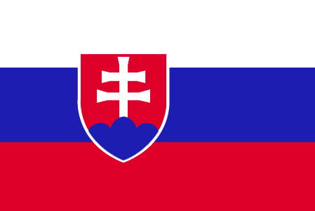
SLOVAK REPUBLIC
POLICY FRAMEWORK
Slovakia’s development aid is regulated by the Official Development Aid Law from 5th December 2007. The overall planning of the assistance is determined by the Midterm Strategy of Development Aid for years 2009 – 2013, which focuses Slovak aid on Afghanistan, Serbia and Kenya, in addition to 16 project countries mainly in the Balkans and Eastern Europe. Each year the Ministry of Foreign Affairs prepares a Yearly National Program on ODA priorities and spending for government authorisation. The 2011 National Programme was adopted in January 2011; it reduces the number of priority countries and narrows the scope of sectors addressed in order to increase the effectiveness of Slovak aid. The Ministry of Foreign Affairs coordinates Slovak aid, while the Slovak Agency for International Development Cooperation is in charge of the implementation of bilateral assistance.
I. INCREASING FINANCIAL RESOURCES FOR DEVELOPMENT AND GLOBAL CHALLENGES
- IMPROVING DOMESTIC RESOURCE MOBILISATION
- Support to reform programmes for capacity development of custom, judiciary and tax administrations in developing countries: Slovakia provides support to developing countries' customs, ministries of finance and tax administration in EU candidate and Neighbourhood Policy countries. In addition, support is provided to national governments to strengthen public financial management.
- Promotes the principles of good governance in tax matter: Yes, by analysing the situation of the country concerned with regard to its commitment and implementation of international standards of transparency and exchange of information.
- New Bilateral Tax Information Exchange Agreements and Double Taxation Conventions of 2010: i) Agreements concluded: Protocol to the DTC with Switzerland, DTC with Oman and DTC with Iran; ii) Agreements under negotiation: TIES with Guernsey and TIES with British Virgin Islands; iii) Agreements planned: TIES with several countries under the South Caribbean Project.
- State of ratification of/ adherence to international conventions/ initiatives on tax issues:
- IMF Regional Technical Assistance Centres: No
- International Tax Dialogue: No
- International Tax Compact: No
- African Tax Administration Forum (ATAF): No
- Centro Inter-Americano de Administraciones Tributarias (CIAT): No
- IMF Topical Trust Fund on Tax policy and administration: No
- OECD Global Forum: Yes
- United Nations Convention against Corruption (Merida): Yes
- OECD Convention on Combating Bribery of Foreign Officials in International Business Transactions: Yes
- Stolen Assets Recovery initiative (STAR): No
- Extractive Industry Transparency Initiative (EITI): No

- SCALING UP ODA
ODA individual commitments/gap to agreed targets
- Slovakia missed the ODA target to provide 0.17% of GNI by 2010. Slovakia’s ODA reached only EUR 56 million 0.09% of GNI in 2010 (preliminary), unchanged since 2009.
- Slovakia spent EUR 56 million on ODA in 2010, a 4% rise in nominal terms.
- Share of debt relief in ODA: N/A.
Source: OECD/ DAC data for 1995 – 2010; Commission simulation based on information provided by EU Member States or based on agreed EU commitments for 2010 and 2015. ODA in current prices.
- "Realistic, verifiable actions for meeting your individual ODA commitments until 2015" taken in 2010: The Ministry of Foreign Affairs is constantly involved in negotiations primarily with the Ministry of Finance with the aim of increasing financing. It has been doing so also in the light of the preliminary observations prepared by the OECD/DAC following the Special Peer Review of the Slovak aid in December 2010 stipulating that the whole of the government approach to financing the development assistance is crucial. Further consultations will follow with the Governmental Office as well as with the Ministry of Finance.
- No measure have been taken or are being taken to ensure that at least 50% of EU collective aid increases of ODA resources are channelled to Africa.
- Slovakia will not reach the target of 0.15%-0.20% ODA/GNI to LDCs by 2010 and onwards. Slovakia’s Medium Term Strategy for ODA includes one least developed country - Afghanistan - as a programme country and Sudan and Ethiopia as project countries. As Serbia, which is currently a programme country, progresses towards joining the EU, Slovakia’s support will decrease and the financial savings will supposedly be redirected to LDCs. This shift will be reflected in the National Programmes for subsequent years.

- SUPPORT FOR/ USE OF INNOVATIVE SOURCES AND MECHANISMS OF FINANCING DEVELOPMENT

- Slovakia does not support any innovative financing mechanisms and has no plans to do so.

- LEVERAGING PRIVATE FLOWS FOR DEVELOPMENT
Support to private investment in developing countries - Financial tools to support private investment:
- Investment guarantees: Yes
- Improvement of the overall banking system: No
- Microfinance/ access to financial services: No
- Risk management initiatives: No
- Blending: No
- Private public partnerships: No
- Business and investment climate: No
- Investment facilities: NO
- Export credits: Yes
- On Corporate Social and Environmental Responsibility: N/A
- On the Kimberley Process and FAO Code of Conduct for Responsible Fisheries: N/A
- New initiatives in relation to including social and environmental clauses in ODA-financed public procurements: N/A
- Slovakia has currently no plans to implement solutions internally or in cooperation with third countries to overcome barriers to migrants and their families' access to financial services.
- Slovakia has not implemented the General Principles for International Remittances Services" agreed by the Committee on Payments and Settlements Systems (CPSS).

- AID FOR TRADE: No information available.

- REDUCING THE DEBT BURDEN OF DEVELOPING COUNTRIES
- Slovakia has delivered on its commitments to the HIPC and MDRI initiatives, including commitments towards IDA and the African Development Bank.
- Slovakia sees no need for reform of the international architecture for the restructuring of sovereign debts.
- Slovakia has planned no specific interventions to prevent aggressive litigation against HIPCs.

II. IMPROVED EFFECTIVENESS OF SUPPORT TO DEVELOPING COUNTRIES
- MORE EFFECTIVE EU AID
- On Ownership. Slovakia supported country ownership in 2010 through consultation and coordination with partner countries.
- On Conditionality. N/A
- On Transparency and Predictability. Slovakia publicly discloses information on aid volume on the internet and through printed documents.
- On Alignment. Slovakia has integrated the principles of the Code of Conduct on Complementarity and Division of Labour in strategies, staff guidance and programming processes/guidelines.
- On Harmonisation. Slovakia has no legal and/or administrative arrangements in place for delegated cooperation.
- On Mutual Accountability. Slovakia has not established any joint frameworks for monitoring joint commitments in priority countries.
- On Managing for Development Results. Slovakia does not provide capacity support for Managing for Development Results.
- SUPPORTING BETTER GLOBAL GOVERNANCE
- Slovakia considers it premature that EU27 should speak with one voice in the IMF, World Bank and the main multilateral development banks' governing bodies.
- Slovakia supports stronger Brussels based coordination on a regular basis on issues related to the World Bank and MDBs.

SLOVENIA
POLICY FRAMEWORK
International development cooperation is regulated by the International Development Cooperation of the Republic of Slovenia Act (Official Gazette of the Republic of Slovenia No. 70/06), adopted in June 2006. The Act defines the objectives and methods of long-term planning, financing and implementation of international development cooperation of Slovenia.
In 2008 the National Assembly adopted the Resolution on international development cooperation for the period until 2015, which defines the geographical and content priorities of Slovenia’s development cooperation and determines the mechanisms for its implementation.
The Ministry of Foreign Affairs is the national coordinator for international development cooperation. In terms of expertise, this field is covered by the Department for International Development Cooperation and Humanitarian Assistance within the Directorate for Economic Diplomacy and Development Cooperation.
At the Government level, an Inter-ministerial Working Body for International Development Cooperation has been set up and tasked with the following:
- Planning, coordinating and monitoring the implementation of international development cooperation;
- Discussing estimated funds to be allocated to international development cooperation;
- Collaborating in the performance assessment of the Resolution's implementation.
In Slovenia, the majority of non-governmental organisations that work in the field of international development co-ordination formed an umbrella platform in 2005 called SLOGA (Slovenian Global Action).
I. INCREASING FINANCIAL RESOURCES FOR DEVELOPMENT AND GLOBAL CHALLENGES
- IMPROVING DOMESTIC RESOURCE MOBILISATION
- Support to reform programmes for capacity development of customs, judiciary and tax administrations in developing countries: Slovenia provides aid in these fields to EU candidate countries, EU Neighbourhood Policy countries (support to administrations and policy of: Customs, Ministries of Finance, Government Supervisory Office, Office of Prevention of money Laundering).
- Support to promote good governance in tax matters: Yes
- Bilateral Tax Information Exchange Agreements and Double Taxation Conventions since 2010: (i) Double Taxation Conventions signed with Armenia, Belarus; (ii) under negotiation with Morocco.
- State of ratification of/adherence to international conventions/initiatives on tax issues:
- United Nations Convention against Corruption (Merida): Yes
- OECD Convention on Combating Bribery of Foreign Officials
in International Business Transactions: Yes
- Stolen Assets Recovery initiative (STAR): No
- Extractive Industry Transparency Initiative (EITI): No
- IMF Regional Technical Assistance Centres: Yes
- International Tax Dialogue: No
- International Tax Compact: No
- African Tax Administration Forum (ATAF): No
- Centro Inter-Americano de Administraciones Tributarias (CIAT): No
- IMF Topical Trust Fund on Tax policy and administration: No

- SCALING UP ODA
ODA Individual commitments and gap to target
- Slovenia's ODA was 0.13% of GNI or EUR 48 million in 2010 (preliminary), down from 0.15% in 2009, missing the ODA target to provide 0.17% of GNI by 2010. This marks a decrease in comparison to the 2009 level for multilateral as well as bilateral contributions.
Source: OECD/ DAC data for 1995 – 2010; Commission simulation based on information provided by EU Member States or based on agreed EU commitments for 2010 and 2015. ODA in current prices.

- "Realistic, verifiable actions for meeting individual ODA commitments until 2015" taken in 2010: The central strategic document on development cooperation (Resolution on International development cooperation of the Republic of Slovenia until 2015), that was adopted by the Parliament only entails a vague commitment on reaching the ODA targets: “Slovenia will endeavour to allocate 0.17 per cent of GNI for ODA by 2010 and 0.33 per cent of GNI by 2015.” So far, those commitments have been maintained. As a reaction to recent budgetary constraints, the MFA has (this year, for the first time) requested the Government to give more exact (budget) indications on ODA expenditure until 2015 in order to secure the predictability of ODA funds and increase overall ODA volumes, as opposed to rather pessimistic projections until 2015. This is to be done as part of negotiating the Stability and Growth Pact (2012-2014(2015)), which is to serve as a reference document for future biannual budget allocations. The Stability and Growth Pact should be finished by 15 April 2011.
- Slovenia will double its disbursements to Africa in 2011 by starting to contribute to the EDF. Slovenia is also actively engaged in establishing a bilateral development programme in Cape Verde.
- Slovenia will not reach the target of 0.15%-0.20% ODA/GNI to LDCs by 2010. Slovenia will endeavour to comply with its commitment of reaching 0.33% of GNI for ODA by 2015, hence increasing its share to the LDCs as part of overall Slovenia’s ODA disbursements. In addition, Slovenia will continue to support the poverty focus of the EDF, as part of its general policy to channel most of its aid to LDCs via multilateral channels.

- SUPPORT FOR/ USE OF INNOVATIVE SOURCES AND MECHANISMS OF FINANCING DEVELOPMENT
- Slovenia does not use innovative sources of financing.
- Slovenia does not intend to step up efforts for innovative financing mechanisms with significant revenue generation potential.
- No further work on innovative financing mechanisms.

- LEVERAGING PRIVATE FLOWS FOR DEVELOPMENT
Support to private investment in developing countries:
- Financial tools to support private investment
- Investment guarantees: No
- Improvement of the overall banking system: No
- Microfinance/ access to financial services: No
- Risk management initiatives: No
- Blending: Yes
- Private public partnerships: No
- Business and investment climate: No
- Investment facilities: Yes
- Export credits: No
- Slovenia promotes the adoption of internationally agreed principles and standards on Corporate Social and Environmental Responsibility by European companies. By voluntary codes.
- Regarding Remittances, Slovenia did not plan to implement solutions to improve the impact of remittances on development as there are very small amounts of remittances transferred from Slovenia.

- AID FOR TRADE
Slovenia, AfT Commitments (in EUR thousands)
Source: OECD CRS Database (latest update)
- REDUCING THE DEBT BURDEN OF DEVELOPING COUNTRIES
- Slovenia delivered on its HIPC/ MDRI commitments (including vis-à-vis IDA/ AfDB) without delay.
- No actions/steps taken in 2010 to help restore and preserve debt sustainability in low-income countries.
- Slovenia favours reform of the international architecture for restructuring of sovereign debts in order to deal with potential future cases of debt distress in low-income countries (involving a role for International Financial Institutions). EU should support discussion regarding a united approach within the IFIs.
- Specific interventions to prevent aggressive litigation against HIPCs (in particular to prevent the actions of "vulture funds"): No.
II. IMPROVED EFFECTIVENESS OF SUPPORT TO DEVELOPING COUNTRIES
- MORE EFFECTIVE EU AID
- On Ownership. In 2010, Slovenia supported ownership through consultations and coordination with partner countries, through Guidance and incentives for staff in partner countries and supporting partner capacity development.
- On Conditionality. In 2010, Slovenia carried out actions on conditionality (reported as unspecified in Slovenia answer to Monterrey Questionnaire).
- On Transparency and Predictability. Slovenia publicly discloses information on aid volumes through the Ministry of Finance website.
- On Alignment. Slovenia did not integrate the principles of the Code of Conduct on Complementarity and Division of Labour in its development strategy.
- On Harmonisation. There are no legal and/or administrative arrangements in place to manage funds for another Member States or the EU, and/ for another Member States or the EU to manage Slovenian funds (delegated cooperation).
- On Mutual Accountability. No joint framework for monitoring joint commitments.
- On Managing for Development Results. Slovenia provides capacity building support for this.
- SUPPORTING BETTER GLOBAL GOVERNANCE
- Position on improving the voice of the EU and its Member States within International Financial Institutions. Slovenia does not support a single EU Chair for the IMF in order for the EU27 to speak with one voice. In the World Bank, Slovenia supports EU27 speaking with common statements (terms of reference) on the basis of good coordination (especially for important issues). However, Slovenia does not support the creation of the single EU Chair in the Board of directors for fear that for important decisions it (like many other small EU member states) would be outvoted by the big EU member states. Even if not outvoted, Slovenia fears that its relative influence on taking EU positions would weaken under a single EU chair. For a small country like Slovenia, representation at the IFIs in a form of a permanent position is crucial.
- Slovenia favours stronger Brussels based coordination on issues related to the World Bank and MDBs.

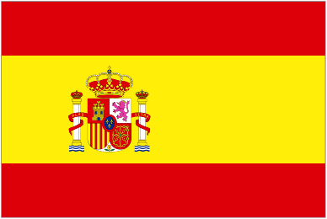
SPAIN
AT A GLANCE
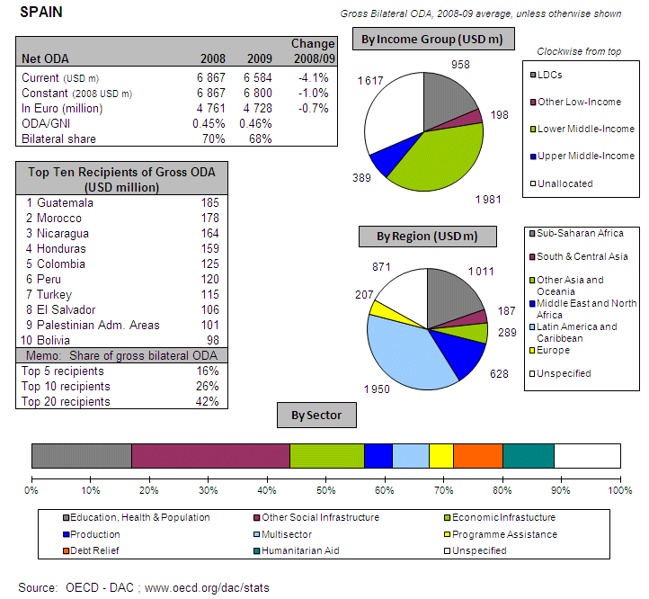
POLICY FRAMEWORK
Spain’s Law 23/1998 on International Development Cooperation provides the main legal framework for Spanish aid. The Master Plan, updated every four years, sets a comprehensive framework for development policy, including strategic objectives, geographic and sectoral priorities, and the roles of various players and instruments. Parliament provides oversight, particularly through the International Cooperation for Development Commission, a permanent body in the Congress and - since the last legislature - also in the Senate.
The Secretariat of State for International Co-operation (SECI) is part of the Ministry of Foreign Affairs and Cooperation (MAEC) – and has the primary responsibility for Spanish aid policy and implementation. In 2011 there is going to be a change in the institutional setup of Spanish cooperation, in response to demands stemming from civil society. A new tool –the Development Promotion Fund- will be managed by the Spanish Agency for International Development Cooperation –AECID-. SECI also houses the Spanish Agency for International Development Cooperation (AECID) that manages Spanish Aid. AECID is the main implementing agency for bilateral assistance; the agency is undergoing a reform since 2009 to increase its capacity for bilateral aid delivery. The Ministry of Economy and Finance (MEH) manages Spanish contributions to international financial institutions and the European Commission.
Spain has set itself ambitious goals for its development cooperation through to 2012 (3rd Master Plan 2009-2012). The previous Master Plan (2005-2008) set out major improvements on past policy and practice, and Spain now faces the challenge of putting the overall vision into practice. Political support and the framework for policy coherence are strong, yet further progress depends on their more strategic and systematic use. Spain is among the few DAC members to include policy coherence for development in its legal and planning framework
I. INCREASING FINANCIAL RESOURCES FOR DEVELOPMENT AND GLOBAL CHALLENGES
- IMPROVING DOMESTIC RESOURCE MOBILISATION
- Support to reform programmes for capacity development of customs, judiciary and tax administrations in developing countries: Spain provides aid in these fields to EU candidate countries, EU Neighbourhood Policy countries, Asia, Latin America and ACP Countries (support to administrations and policy of: Customs, Semi-autonomous Revenue Authorities and Ministries of Finance).
- Spain has been actively involved in the Task Force on Taxes on International Financial Transactions for Development and in the Secretariat of the Experts Committee of Taxes on International Financial Transactions. In his speech at the General Assembly of United Nations (September 2010), the President of the government of Spain announced its support to this mechanism and its coordinated implementation worldwide.
- Support to promote good governance in tax matters: Yes
- Bilateral Tax Information Exchange Agreements and Double Taxation Conventions since 2010: (i) Signed with Andorra (TIEA), The Netherlands Antilles(TIEA), Aruba(TIEA),Bosnia and Herzegovina (DTC),Costa Rica(DTC),Luxembourg (DTC), Serbian (DTC); (ii) under negotiation with Bahamas (TIEA), San Marino (TIEA), Albania(DTC), Barbados (DTC), Georgia (DTC), Pakistan (DTC), Panama (DTC), Uruguay (DTC), Singapore (DTC), Switzerland (DTC)
- State of ratification of/adherence to international conventions/initiatives on tax issues:
- United Nations Convention against Corruption (Merida): Yes
- OECD Convention on Combating Bribery of Foreign Officials
in International Business Transactions: Yes
- Stolen Assets Recovery initiative (STAR): Yes
- Extractive Industry Transparency Initiative (EITI): Yes
- IMF Regional Technical Assistance Centres: Yes
- International Tax Dialogue: Yes
- International Tax Compact: Yes
- African Tax Administration Forum (ATAF): Yes
- Centro Inter-Americano de Administraciones Tributarias (CIAT): Yes
- IMF Topical Trust Fund on Tax policy and administration: No
- OECD’s Centre for Tax Policy and Administration (CTPA) Yes
- Intra European Organisation of Tax Administration (IOATA) Yes
- SCALING UP ODA
ODA Individual commitments and gap to target
- Spain's ODA was 0.43% of GNI or EUR 4467 million in 2010 (preliminary), a decrease by 5.9% in real terms from 0.46% in 2009, thereby missing the ODA target to provide 0.51% of GNI by 2010.
Source: OECD/ DAC data for 1995 – 2010; Commission simulation based on information provided by EU Member States or based on agreed EU commitments for 2010 and 2015. ODA in current prices.
Spain - Share of debt relief in ODA volumes
Source: OECD/DAC data for 2002-2010

- "Realistic, verifiable actions for meeting individual ODA commitments until 2015" taken in 2010: At the beginning of February 2011 the Spanish Parliament adopted a resolution urging the government to develop a multiannual plan by the end of this year, in order to ensure timely accomplishment of the 0.7% target by 2015.
- Due to the fact that EU collective aid increases of ODA towards Africa include all efforts made by individual member states, it should be highlighted that between 2005 and 2009 40% of the whole Spanish geographically specified ODA was channelled to Africa.
- Spain will not reach the target of 0.15%-0.20% ODA/GNI to LDCs by 2010.

- SUPPORT FOR/ USE OF INNOVATIVE SOURCES AND MECHANISMS OF FINANCING DEVELOPMENT
- Innovative source of financing: Airline Ticket Tax/contribution, International Financing Facility for Immunisation (IFFIm). Spain implemented other initiatives: Debt for development projects (Tanzania and Ghana in 2009), and Debt4Education (El Salvador 2005-2010).
- Spain intends to step up efforts for innovative financing mechanisms with significant revenue generation potential. Spain has been actively involved in the Task Force on International Transaction for Development and in the Secretariat of the Experts Committee of Taxes for International Financial Transactions. In his speech at the General Assembly of United Nations (September 2010), the President of the government of Spain announced the support to this mechanism and to its coordinated implementation all over the world.
- Further work on innovative financing mechanism: Spain committed to holding the Presidency for the Leading group on innovative finance for development the second semester of 2011.

- LEVERAGING PRIVATE FLOWS FOR DEVELOPMENT
Support to private investment in developing countries - Foreign Direct Investment
Source: OECD/ DAC

- Financial tools to support private investment
- Investment guarantees: Yes
- Improvement of the overall banking system: No
- Microfinance/ access to financial services: Yes
- Risk management initiatives: Yes
- Blending: Yes
- Private public partnerships: No
- Business and investment climate: Yes
- Investment facilities: Yes
- Export credits: No
- 2010 has been the first year when Spain has conducted financial operations, other than microfinance, in order to contribute to its development goals. Spain is investing in Private Equity Funds which in turn invest in development countries specifically in SMEs, targeting Spain investment (when the capital of the Funds is structured) in the First Loss or the Mezzanine categories. The recently approved FONPRODE act (Development Fund) contemplates the development of fully untied credit and investment operations in order to contribute to achieving goals established in Spain’s 3rd Master Plan
- Spain promotes the adoption of internationally agreed principles and standards on Corporate Social and Environmental Responsibility. Within the 3rd Master Plan of the Spanish Cooperation, the promotion of the adoption by Spanish Companies of the CSR standards is a guideline. A Working Group set up within the Spanish Development Cooperation Council in 2010 was created for better following up the adoption of CSR policies within the private sector and for enhancing complementarity between private and public policies in this regard. Spain is one of the long term supporters of the Global Compact, and Spain’s Local Network of Spanish Companies which are committed with GC principles, is one of the largest in the world
- Spain supports the EITI and the Global Compact and has also developed a tool to work with companies that only meet certain criteria of Corporate Responsibility.
- The Spanish Master Plan includes a guideline to establish CSR conditions for companies that may agree partnerships with other actors to manage ODA resources in a Public Private modality. During 2010 the Ministry for Foreign Affairs and Cooperation worked to define a methodology for the eligibility of private companies as partners of the public development policy which includes CSR and specifically Human Rights, Environment and social conditions. As regards the new financial instruments that the Spanish Cooperation put in place during 2010, the Spanish investment policy will include a specific Environment and Social governance of the financial operations as a necessary prerequisite.

Remittances
- Spain implemented solutions internally and in cooperation with third countries to overcome barriers to migrants and their families' access to financial services
- The Spanish Central Bank developed monitoring indicators in its latest annual report , indicating that the number of registered operators at the end of July had grown from 43 to 47, the number of offices from 130 to 153, and the number of total agents with authorisation for providing remittances sending services from 9760 to 11869 persons. Regarding remittance transfers volume in 2009, it registered a slight increase in relation to 2008, with no significant difference in relation to the main recipient countries
- Spain implemented the "General Principles for International Remittances Services" agreed by the Committee on Payments and Settlements Systems (CPSS).
- Other initiatives to increase competition and transparency in the remittance market and to reduce remittance transfers costs. Yes. The new Spanish regulation for Payment Services, which entered into force on December 4th 2009, following the European Directive on Payment Services, will allow greater liberalisation of markets. According to the new regulation, the amount of capital needed to start operating as MTO has been reduced from EUR 300000 to EUR 20000, which will make it possible for some migrants’ associations to create their own businesses.
- Spain has robust and reliable data concerning the amounts and destination of remittances from Spain. Spain adopted/ intends to adopt the operational definitions, recommendations and best practices on improving the quality and coverage of data on remittances according to the compilation guide drafted by the "Luxembourg Group".

- AID FOR TRADE
Spain, AfT Commitments (in EUR thousands)
Source: OECD CRS Database (latest update)
- REDUCING THE DEBT BURDEN OF DEVELOPING COUNTRIES
- Spain delivered on its HIPC/ MDRI commitments (including vis-à-vis IDA/ AfDB) without delay.
- Actions/steps taken in 2010 to help restore and preserve debt sustainability in low-income countries: The Spanish debt policy with low income countries goes beyond regular Highly Indebted Poor Countries Initiative (HIPC) relief. In particular, Spain provides full relief of debts contracted before 2003 by these countries towards Spain. This debt relief is partially carried out through Debt Swap Agreements, which devote the debt resources to finance development projects in these countries. In 2009 and 2010, Spain has signed Debt Swaps Programmes with LICs and HPCs, including: Mozambique, Ghana and Bolivia.
- Spain favours reform of the international architecture for restructuring of sovereign debts in order to deal with potential future cases of debt distress in low-income countries (through the Paris Club and through collective action clauses in debt contracts)
- Specific interventions to prevent aggressive litigation against HIPCs (in particular to prevent the actions of "vulture funds"): Yes. Spain does not sell debt of these countries. Besides, Spain participates actively in all forums, including the Paris Club, which is working towards a coordinated fight against the implications of the actions of the “vulture funds” for debtor countries
II. IMPROVED EFFECTIVENESS OF SUPPORT TO DEVELOPING COUNTRIES
- MORE EFFECTIVE EU AID
- On Ownership. In 2010, Spain supported ownership through consultations and coordination with partner countries, guidance and incentives for staff in partner countries and by supporting partner capacity development
- On Conditionality. In 2010, Spain progressed by harmonising with other donors and making conditionalities public.
- On Transparency and Predictability. Spain publicly discloses information on aid volumes through website and through a database at country level. The PACI (Annual Plan for International Cooperation) reflects the expenditure plans of all actors of the Spanish Cooperation System per year. The “PACI Follow Up” (also annual) reflects the actual disbursements of every actor in a given year. Both the PACI and the PACI Follow Up for every year are public and available in the following website: www.maec.es. They are also published and distributed among all Spanish cooperation actors
- On Alignment. Spain partially integrated the principles of the Code of Conduct on Complementarity and Division of Labour in its development strategy
- On Harmonisation. Currently Spain is managing funds on delegated cooperation as a leader donor in Cape Verde, Afghanistan and Peru. As silent donor, Spain delegates to other donors in Cambodia (2010) and in Mali (from May, 2009); Spain delegates its responsibilities in Mali to The Netherlands through technical cooperation. Certification by EC is currently under process to allow AECID manage funds from the EU.
- On Mutual Accountability. Spain established a joint framework for monitoring joint commitments with its priorities countries through their Country Partnership Frameworks (CPF)
- On Managing for Development Results. Spain provides capacity building support for this
- SUPPORTING BETTER GLOBAL GOVERNANCE
- Position on improving the voice of the EU and its Member States within International Financial Institutions. Spain does not support a single EU Chair for the IMF in order for the EU27 to speak with one voice. In the short term, given the amount of national resources EU countries contribute to replenishments of IDA and other soft financial windows of the MDBs, EU countries need to maintain a degree of autonomy in building their national position in order to be truly accountable to their constituencies back home regarding such contributions. Since the mandate and contributions to the IFIs are still national (for instance, surveillance is undertook at the national level), one EU 27 voice is not a viable option in the short-run. There should be, however, enhanced coordination and consistency among EU countries positions through ad-hoc coordination by European Board representatives before Board meetings at the MDBs, although not through a Brussels based mechanism. The current coordination system through EFC-SCIMF and EURIMF provides a good ground to channel shared views on the key issues.
- Spain does not favour stronger Brussels based coordination on issues related to the World Bank and MBB’s
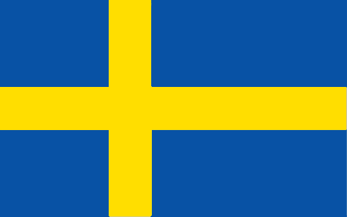
SWEDEN
AT A GLANCE
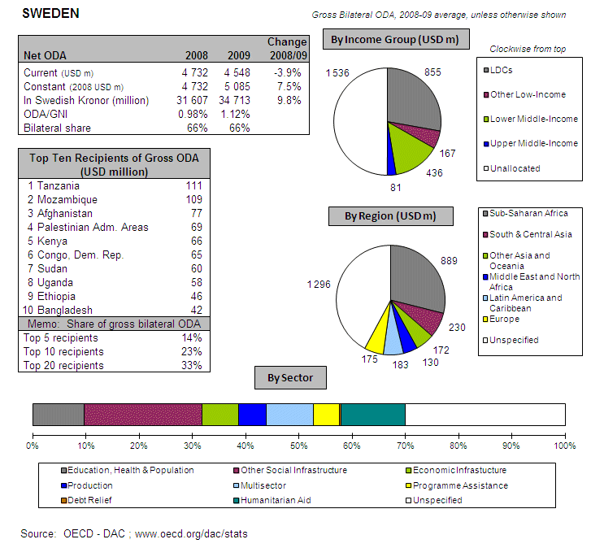
POLICY FRAMEWORK
The foundation of Swedish development policy is the Policy for Global Development that was adopted by Parliament in 2003. It requires all policy areas to cooperate toward the same goal: fair and sustainable global development. Sweden is determined to dedicate 1% of GNI to ODA and the latest annual Budget Bill (autumn 2010) establishes this level for 2011 and as a prognosis for the years 2012-14. In 2007 Sweden reduced the number of partner countries to 33. There has also been a thematic focus, with priority given to democracy and human rights, gender equality and climate and environment. The Ministry of Foreign Affairs manages most of Sweden’s core contributions to multilaterals, while Sida, an independent agency under the Ministry, manages 80% of Sweden’s bilateral aid.
I. INCREASING FINANCIAL RESOURCES FOR DEVELOPMENT AND GLOBAL CHALLENGES
- IMPROVING DOMESTIC RESOURCE MOBILISATION
- Support to reform programmes for capacity development of custom, judiciary and tax administrations in developing countries: Sweden provides support to developing countries' tax administration (semi-autonomous revenue authorities and ministries of finance) in Asia and ACP countries. In addition, support is provided to national parliaments, governments, audit institutions and civil society organisations to strengthen public financial management.
- Promotes the principles of good governance in tax matter: Yes
- New Bilateral Tax Information Exchange Agreements and Double Taxation Conventions of 2010: None
- State of ratification of/ adherence to international conventions/ initiatives on tax issues:
- IMF Regional Technical Assistance Centres: Yes
- International Tax Dialogue: No
- International Tax Compact: No
- African Tax Administration Forum (ATAF): No
- Centro Inter-Americano de Administraciones Tributarias (CIAT): No
- IMF Topical Trust Fund on Tax policy and administration: No
- United Nations Convention against Corruption (Merida): Yes
- OECD Convention on Combating Bribery of Foreign Officials in International Business Transactions: Yes
- Stolen Assets Recovery initiative (STAR): Yes
- Extractive Industry Transparency Initiative (EITI): Yes

- Sweden finances, together with the governments of Denmark, Norway and others, an anti-corruption portal, www.business-anti-corruption.com.

- SCALING UP ODA
ODA individual commitments/gap to agreed targets
- Sweden is already meeting the 2015 0.7% ODA/GNI target. The Government will maintain Swedish development assistance at the level of 1% GNI. ODA/GNI was 0.97% in 2010 compared to 1.12% in 2009.
- Sweden spent EUR 3418 million on ODA in 2010 (preliminary), a decrease of 7.1% in real terms on 2009.
- Debt relief made up only 2% of Swedish ODA during the period 2004 – 2009.

Source: OECD/ DAC data for 1995 – 2010; Commission simulation based on information provided by EU Member States or based on agreed EU commitments for 2010 and 2015. ODA in current prices.

Sweden - Share of debt relief in ODA volumes
Source: OECD/DAC data for 2002-2010
- "Realistic, verifiable actions for meeting your individual ODA commitments until 2015" taken in 2010: Sweden reached its 1% target in 2006.
- The Swedish Government has focused its development cooperation to fewer countries and this has led to a stronger focus on Africa. Over time the Sweden expects this to lead to increased relative allocations to Africa.
- Sweden has exceeded the target of 0.20% ODA/GNI to LDCs since 2000.
- SUPPORT FOR/ USE OF INNOVATIVE SOURCES AND MECHANISMS OF FINANCING DEVELOPMENT
- Sweden supports the International Financing Facility for Immunisation (IFFIm) with SEK17.9 million in 2009 and 2010. Sweden has no intention to step up efforts for innovative financing mechanisms.

- LEVERAGING PRIVATE FLOWS FOR DEVELOPMENT
Support to private investment in developing countries - Foreign Direct Investment:
Source: OECD/ DAC
- Financial tools to support private investment:
- Investment guarantees: Yes
- Improvement of the overall banking system: No
- Microfinance/ access to financial services: Yes
- Risk management initiatives: Yes
- Blending: No
- Private public partnerships: Yes
- Business and investment climate: Yes
- Investment facilities: Yes
- Export credits: Yes
- Sweden promotes the adoption of internationally agreed principles and standards on Corporate Social and Environmental Responsibility by European companies. See Box.
Box. Activities supported by Sweden in the area of Corporate Social and Environmental Responsibility
- the UN Global Compact centrally and various country initiatives).
- the OECD’s Risk Awareness tool for Multinational Enterprises – distribution of the tool to a large number of companies, translations into Chinese, and so on.
- Realising Rights: the Ethical Globalisation Initiative (EGI) spearheaded by Mary Robinson. CSR is one of the core activities of EGI with a focus on a few countries (e.g. Liberia and Ghana) in Sub-Saharan Africa.
- Financial contribution to the UN Secretary-General on the issue of human rights and transnational corporations and other business enterprises, for which John Ruggie is Special Representative. John Ruggie has published draft guiding principles for the implementation of the UN Protect, Respect, Remedy Framework on business and Human Rights, November 2010.
- New initiatives in relation to including social and environmental clauses in ODA-financed public procurements: None
- Sweden has currently no plans to implement solutions internally or in cooperation with third countries to overcome barriers to migrants and their families' access to financial services. The issue of migration is one of the global challenges identified in a restart of Sweden’s Policy for Global Development (2008), but activities so far have been limited. The initiative lies with the Minister of Finance, but at the moment there are no plans to work on the issue.

- AID FOR TRADE
Sweden, AfT Commitments (in EUR million)
Source: OECD CRS Database (latest update)
- REDUCING THE DEBT BURDEN OF DEVELOPING COUNTRIES
- Sweden has delivered on its commitments to the HIPC and MDRI initiatives, including commitments towards IDA and the African Development Bank.
- Sweden sees no need for reform of the international architecture for the restructuring of sovereign debts.
- No specific interventions to prevent aggressive litigation against HIPCs have been taken since there have been no cases under Swedish legislation.

II. IMPROVED EFFECTIVENESS OF SUPPORT TO DEVELOPING COUNTRIES
- MORE EFFECTIVE EU AID
- On Ownership. Sweden supported country ownership in 2010 through consultation and coordination with partner countries, guidance and incentives for staff in partner countries and by supporting partner capacity development.
- On Conditionality. Sweden has carried out the following actions on conditionalities in 2010: harmonisation with other donors and making conditionalities public.
- On Transparency and Predictability. Sweden publicly discloses information on aid volume on the internet. Sweden is currently preparing a public aid database including activity level information in an open format. A website will open shortly. Parallel to this, work is underway to implement the International Aid Transparency Initiative (IATI) standard and to prepare a database to deliver information to the IATI registry.
- On Alignment. Sweden has integrated the principles of the Code of Conduct on Complementarity and Division of Labour in strategies, staff guidance and programming processes/guidelines.
- On Harmonisation. A general legal mandate has been given to Sida from the Swedish government in the annual letter of appropriation to enter into delegated cooperation, but there is no mechanism in place at headquarters level to track cases of delegated cooperation.
- On Mutual Accountability. Sweden has established a joint framework for monitoring joint commitments in Burkina Faso, Mozambique, Rwanda, Tanzania, Uganda and Zambia.
- On Managing for Development Results. Sweden provides capacity support for Managing for Development Results.
- SUPPORTING BETTER GLOBAL GOVERNANCE
- Sweden does not share the view that EU27 should speak with one voice in the IMF, World Bank and the main multilateral development banks' governing bodies. Sweden believes that adequate Board representation is a pre-requisite for EU countries to continue to channel substantial sums of non-earmarked core funding through the IFIs. One EU voice would weaken individual countries’ influence and might affect their ability to continue channelling such substantial amounts through the IFIs.
- Sweden does not support stronger Brussels based coordination on a regular basis on issues related to the World Bank and MDBs. However, Sweden believes that in some cases Brussels based coordination may be both relevant and useful, e.g. as was the case during the voice reform negotiations and the discussions on capital increases for MDBs in 2009-2010.
UNITED KINGDOM

AT A GLANCE
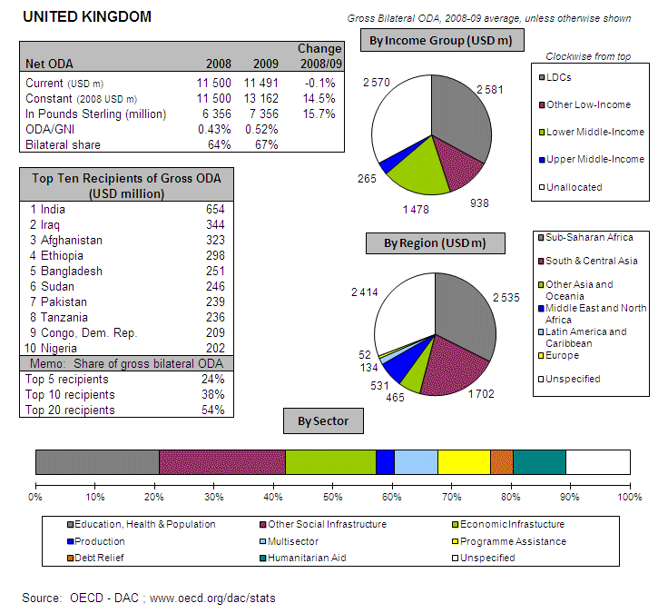
POLICY FRAMEWORK
The legal basis of the UK development co-operation programme is the International Development Act 2002 that stipulates that poverty reduction should be the purpose of development assistance. The most recent white paper on development (2009) sets four key priorities: (i) achieving sustainable growth in the poorest countries; (ii) combating climate change; (iii) supporting conflict prevention and fragile states; and (iv) reinforcing the international aid system’s efficiency and effectiveness. The Department for International Development (DFID) manages 86% of the UK’s ODA.
The UK is committed to reaching a GNI/ODA target of 0.7% by 2013. Reviews of UK aid were published in 2011, and on that basis the UK has decided to reduce the number of partner countries from 43 to 27 and focus its multilateral contributions.
I. INCREASING FINANCIAL RESOURCES FOR DEVELOPMENT AND GLOBAL CHALLENGES
- IMPROVING DOMESTIC RESOURCE MOBILISATION
- Support to reform programmes for capacity development of custom, judiciary and tax administrations in developing countries: The UK provides support to developing countries' tax policy and administration (customs, semi-autonomous revenue authorities and ministries of finance) in EU candidate and EU Neighbourhood Policy countries, Asia, Latin America and ACP countries. In addition, support is provided to national parliaments, governments, audit institutions and civil society organisations to strengthen public financial management.
- Promotes the principles of good governance in tax matter: Yes
- New Bilateral Tax Information Exchange Agreements and Double Taxation Conventions of 2010: i) Agreements concluded: Antigua and Barbuda, Belize, Dominica, Georgia, Grenada, Liberia, St Kitts and Nevis, St Lucia, St Vincent and the Grenadines, South Africa; ii) Agreements under negotiation: Albania, Armenia, Brazil, China, Croatia, Ethiopia, Malawi, Marshall Islands, Mauritius, Peru, Thailand; iii) Agreements planned: Barbados, Belarus, Costa Rica, Panama.
- Support/ratification of/adherence to international conventions/initiatives on tax issues:
- IMF Regional Technical Assistance Centres: Yes
- International Tax Dialogue: Yes
- International Tax Compact: No
- African Tax Administration Forum (ATAF): Yes
- Centro Inter-Americano de Administraciones Tributarias (CIAT): No
- IMF Topical Trust Fund on Tax policy and administration: No
- United Nations Convention against Corruption (Merida): Yes
- OECD Convention on Combating Bribery of Foreign Officials in International Business Transactions: Yes
- Stolen Assets Recovery initiative (STAR): Yes
- Extractive Industry Transparency Initiative (EITI): Yes

- SCALING UP ODA
ODA individual commitments/gap to agreed targets
- The UK is committed to meeting the 2015 0.7% ODA/GNI target. The most recent Spending Review (2010) supports this target, but maintains the level to 0.56 until 2012. This means that the UK aid budget would have to increase some 0.16 percentage points or GBP 3 billion between 2012 and 2013 for the 0.7% target to be achieved. ODA/GNI was 0.56% in 2010 compared to 0.52% in 2009.
- The UK spent EUR 10391 million on ODA in 2010 (preliminary), a 19.4% increase in real terms compared to 2009.
- Debt relief made up 13% of British ODA during the period 2004 – 2009.
Source: OECD/ DAC data for 1995 – 2010; Commission simulation based on information provided by EU Member States or based on agreed EU commitments for 2010 and 2015. ODA in current prices.

UK - Share of debt relief in ODA volumes

Source: OECD/DAC data for 2002-2010

- "Realistic, verifiable actions for meeting your individual ODA commitments until 2015" taken in 2010: The UK Government has set out its commitment to increase Official Development Assistance (ODA) to 0.56 per cent in 2011 and 2012 and 0.7 per cent of Gross National Income (GNI) from 2013 in line with the UK's international commitments to help the very poorest in the world. The Spending Review 2010, published on 20 October 2010 sets out the figures for each year up to 2014 in clear spending plans. The UK's ODA budget will increase every year between now and then. In addition the UK government will enshrine in law during the first session of parliament (before April 2012) its commitment to spend 0.7 per cent of GNI as ODA from 2013.
- Have you taken or do you plan to take measures to ensure that at least 50% of EU collective aid increases of ODA resources are channelled to Africa? The UK’s overall resource allocation process is currently taking place and will be completed by mid-March.
- The UK will reach the target of 0.15%-0.20% ODA/GNI to LDCs by 2010 and onwards.

- SUPPORT FOR/ USE OF INNOVATIVE SOURCES AND MECHANISMS OF FINANCING DEVELOPMENT
- The UK supports the following innovative financing mechanisms:
- International Financing Facility for Immunisation (IFFIm) - GBP 34.5 million in 2010
- Advance Market Commitments (AMCs) - GBP 15.5 million in 2010
- Private Infrastructure Development Group – USD 13.1 million in 2010

- The UK is open to engaging with IFMs in future and supports the exploration of possible routes. The UK engaged in such discussions via a number of international policy fora including EU discussions and the Leading Group on Innovative Financing for Development.

- LEVERAGING PRIVATE FLOWS FOR DEVELOPMENT
Support to private investment in developing countries - Foreign Direct Investment:
Source: OECD/ DAC

- Financial tools to support private investment:
- Investment guarantees: No
- Improvement of the overall banking system: Yes
- Microfinance/ access to financial services: Yes
- Risk management initiatives: No
- Blending: No
- Private public partnerships: Yes
- Business and investment climate: Yes
- Investment facilities: Yes
- Export credits: No
- The UK promotes the adoption of internationally agreed principles and standards on Corporate Social and Environmental Responsibility by European companies through adherence to the OECD Guidelines on Multinational Enterprises and the Kimberley process.
- New initiatives in relation to including social and environmental clauses in ODA-financed public procurements: None
- The UK has implemented the "General Principles for International Remittances Services" agreed by the Committee on Payments and Settlements Systems (CPSS).

- AID FOR TRADE
UK, AfT Commitments (in EUR million)
Source: OECD CRS Database (latest update)
- REDUCING THE DEBT BURDEN OF DEVELOPING COUNTRIES
- The UK has delivered on its commitments to the HIPC and MDRI initiatives, including commitments towards IDA and the African Development Bank.
- The UK sees no need for reform of the international architecture for the restructuring of sovereign debts.
- The UK has taken a specific measure to prevent aggressive litigation against HIPCs through the Debt Relief (developing countries) Act (2010) that prevents litigation against HIPCs in UK courts.
II. IMPROVED EFFECTIVENESS OF SUPPORT TO DEVELOPING COUNTRIES
- MORE EFFECTIVE EU AID
- On Ownership. No additional actions were taken in 2010. Support for country ownership is already integrated into DFID’s policies and procedures.
- On Conditionality. The UK has carried out the following actions on conditionalities in 2010: harmonisation with other donors and making conditionalities public.
- On Transparency and Predictability. The UK publicly discloses information on aid volume on the internet and through databases at country levels. In addition, the UK will start to publish information through the International Aid Transparency Initiative online registry by end January 2011.
- On Alignment. The UK has integrated the principles of the Code of Conduct on Complementarity and Division of Labour in strategies, staff guidance and programming processes/guidelines.
- On Harmonisation. The UK has arrangements in place for delegated cooperation with members of the Nordic+ group and with the European Commission. Cases of delegated cooperation are tracked informally. Some examples:
On Mutual Accountability. The UK works with joint frameworks for monitoring joint commitments together with other development partners and partner countries. In 2010 mutual accountability frameworks were established and reviewed in a number of countries including Bangladesh (joint cooperation strategy), Ghana (through aid policy and joint donor Performance Assessment Framework), Nepal (through the joint transparency and accountability initiative with the UN and a number of bilateral donors), Uganda (supporting development of an aid policy and joint MOU), and Zambia (development of a new Joint Assistance Strategy).
- On Managing for Development Results. The UK provides capacity support for Managing for Development Results.
- SUPPORTING BETTER GLOBAL GOVERNANCE
- The UK does not share the view that EU27 should speak with one voice in the IMF, World Bank and the main multilateral development banks' governing bodies. The UK believes there are significant advantages to our current informal coordination on strategic policy issues, and sees no need for changes: the EU subcommittee on IMF matters (SCIMF) and the EU coordination in relation to the Executive Board meetings of the IMF (EURIMF) are effective ways of coordinating EU positions on IMF issues and work well. The best way to strengthen this coordination is to build on existing arrangements, by strengthening the accountability of EU Executive Directors to their capitals.
- The UK does not support stronger Brussels based coordination on a regular basis on issues related to the World Bank and MDBs.

http://english.bmf.gv.at/EconomicPolicy/EconomicpolicyinAustria/Stabilityprogram/STAPRO_2009_bis_2013_ENfinal.pdf
Three Year Programme on Austrian Development Policy 2009-2011 (revised in November 2009). Update in March 2011: reports, programs and policy statements of the Austrian Development Cooperation. Please note that more recent publications are only available in German at the moment (Dreijahresprogramm 2010 – 2012, Bericht 2009): http://www.entwicklung.at/services/publications/reports/en/, http://www.entwicklung.at/services/publications/programmes/en/ http://www.entwicklung.at/services/publications/policy_documents_focus_documents/en/ http://www.entwicklung.at/entwicklungspolitik/oesterreich/de/
http://www.fiscus.fgov.be/interfafznl/fr/international/conventions/sign.htm
http://www.fiscus.fgov.be/interfafznl/fr/international/conventions/index.htm
An inventory of existing mechanisms to comply with Aid Commitments by Member States, Standard Briefing, Policy Department DG External Policies, December 2010.
http://diplomatie.belgium.be/en/policy/development_cooperation/
http://www.euroresources.org/guide/donor_profiles/bg_bulgaria.html
http://www.acp-eucourier.info/Bulgaria-s-developme.1038.0.html
http://www.planning.gov.cy/planning/planning.nsf/dmlcystrategy_en/dmlcystrategy_en?OpenDocument
http://www.planning.gov.cy/planning/planning.nsf/All/2D4926C033E44160C225753F0036FE75?OpenDocument
Special DAC review 2007
Czech development Agency (CzDA) http://www.czda.cz/?lang=en
Peacebuilding within Czech Official Development, Assistance Initiative for Peacebuilding (IfP), a consortium led by International Alert and funded by the European Commission http://www.initiativeforpeacebuilding.eu/pdf/Peacebuilding_within_Czech_Official_development_assistance.pdf
http://www.um.dk/en/menu/DevelopmentPolicy/DanishDevelopmentPolicy/
http://www.um.dk/en/menu/DevelopmentPolicy/DanishDevelopmentPolicy/PrioritiesOfTheDanishGovernmentForDanishDevelopmentAssistance/
DAC peer review Denmark 2007
http://www.um.dk/en/menu/DevelopmentPolicy/DanishDevelopmentPolicy/PrioritiesOfTheDanishGovernmentForDanishDevelopmentAssistance/
http://www.vm.ee/?q=en/taxonomy/term/55
http://www.vm.ee/sites/default/files/arengukoostoo-humanitaarabi_arengukava_2011-2015.pdf
https://rakendused.vm.ee/akta/index.php?language=eng
Via the webpage www.mfa.ee and more detailed Aid Database: https://rakendused.vm.ee/akta/index.php?language=eng
Official Journal C 46 of 24.2.2006
http://europa.eu/legislation_summaries/development/general_development_framework/index_en.htm
http://www.europarl.europa.eu/en/pressroom/content/20110308IPR15028/html/Tax-reform-to-boost-revenue-for-EU-and-developing-countries
http://ec.europa.eu/europeaid/how/delivering-aid/monterrey_en.htm
OECD DAC Peer Review Finland 2007
http://formin.finland.fi/public/default.aspx?contentid=107497
http://formin.finland.fi/public/default.aspx?nodeid=15359&contentlan=2&culture=en-US
http://formin.finland.fi/public/default.aspx?contentid=107497
Le Budget Pluriannuel De L’Etat 2011-2013, www.budget.gouv.fr/themes/finances_publiques/document_dofip2010.pdf and Plan d’Affaires 2009-2011 ,http://www.afd.fr/jahia/Jahia/lang/en/home/publications/Publications-institutionnelles/programme-d-activite
http://www.diplomatie.gouv.fr/en/france-priorities_1/development-and-humanitarian-action_2108/institutions-and-issues-of-development-economic-assistance_7404/index.html
Groupe pilote sur les financements innovants pour le développement, http://www.leadinggroup.org/rubrique1.html
http://www.performance-publique.gouv.fr/
OECD DAC Peer Reviews Germany 2010
http://www.bmz.de/en/what_we_do/principles/koalitionsvertrag/index.html
OECD DAC Peer Reviews Germany 2010
OECD DAC Peer Review Greece 2006
Reply to the questionnaire for the 2011 Accountability Report
http://www.hellenicaid.gr/appdata/documents/report-2009-eng-final.pdf
OECD DAC Peer Review Greece 2006
http://www.mfa.gov.hu/kum/en/bal/foreign_policy/international_development/
http://www.mfa.gov.hu/NR/rdonlyres/09524B2E-76D7-4DCC-ADF6-67D3E1A14FA7/0/InspiredByExperience.pdf
http://www.mfa.gov.hu/kum/en/bal/foreign_policy/international_development/
http://www.irishaid.gov.ie/about.asp
http://www.irishaid.gov.ie/publications_report.asp
DAC Peer Review 2009
http://actionaiditaly.blogspot.com/
http://actionaiditaly.blogspot.com/
Quote from this year survey : EU Development Accountability and Monitoring, Questionnaire for the 2011 Report.
http://www.cooperazioneallosviluppo.esteri.it/pdgcs/inglese/intro.html
http://www.mfa.gov.lv/en/DevelopmentCo-operation/BasicDocuments/Programme/
http://www.mfa.gov.lv/en/DevelopmentCo-operation/BasicDocuments/Programme/
http://www.lrv.lt/main_en.php
Development Cooperation in LITHUANIA, Country Study, Annika Kool, on behalf of TRIALOG, December 2007
http://www.urm.lt/index.php?-450921326
OECD DAC Peer Review Luxembourg 2008
http://www.gouvernement.lu/gouvernement/programme-2009/programme-2009/programme-gouvernemental-2009.pdf
http://www.foreign.gov.mt/Library/PDF/Malta%27s%20Overseas%20Development%20Policy%20eng.pdf
http://www.foreign.gov.mt/default.aspx?MDIS=21&NWID=664
http://www.minbuza.nl/en/Key_Topics/Development_Cooperation/Dutch_development_policy/Less_fragmentation_means_more_effective_aid
DAC Peer Review 2006
Poland DAC Special Review 2010: http://www.oecd.org/dataoecd/58/43/45362587.pdf http://www.oecd.org/document/56/0,3343,en_2649_34603_45367800_1_1_1_37413,00.html
Poland DAC Special Review 2010: http://www.oecd.org/dataoecd/58/43/45362587.pdf http://www.oecd.org/document/56/0,3343,en_2649_34603_45367800_1_1_1_37413,00.html
Poland DAC Special Review 2010: http://www.oecd.org/dataoecd/58/43/45362587.pdf http://www.oecd.org/document/56/0,3343,en_2649_34603_45367800_1_1_1_37413,00.html
http://www.polishaid.gov.pl/Assistance,in,figures,184.html
Portugal Development Assistance Committee (DAC) Peer Review 2010 http://www.oecd.org/dataoecd/33/19/46552896.pdf
http://www.ipad.mne.gov.pt/index.php?option=com_content&task=view&id=200&Itemid=220
http://www.mae.ro/en/node/2062
http://www.mae.ro/sites/default/files/file/2010/brosura_(4).pdf
'General principles for international remittance services', published by the Committee on Payment and Settlement Systems (CPSS)
http://www.mae.ro/en/node/2062
http://www.mvro.sk/en/development-aid/development-aid-slovakia?start=1
http://www.mzv.sk/App/WCM/main.nsf?Open
http://www.mvro.sk/en/development-aid/development-aid-slovakia?start=1
http://www.slovenia.si/en/slovenia/state/slovenia-in-the-world/slovenias-international-development-co-operation-and-humanitarian-aid/
Sloven'Aid: http://www.mzz.gov.si/en/foreign_policy/international_development_cooperation_and_humanitarian_assistance/slovenaid/
www.sloga-platform.org
Annex 2 Monterrey Survey 2011: Slovenia Development cooperation, Background note. Submitted in March 2011
http://www.mf.gov.si/en/areas_of_work/state_aid_monitoring/
http://www.maec.es/es/Home/Documents/PLANAFRICA09_12EN.pdf
http://www.bde.es/webbde/es/Secciones/Publicaciones/InformesBoletinesRevistas/BoletinEconomico/10/Jul/Fich/art8.pdf)
http://www.sweden.gov.se/sb/d/2798
http://www.sweden.gov.se/sb/d/11962
OECD DAC Peer review Sweden 2009
OECD DAC Peer Review UK 2010
http://www.dfid.gov.uk/Media-Room/Speeches-and-articles/2011/BAR-MAR-oral-statement/
http://cdn.hm-treasury.gov.uk/sr2010_chapter2.pdf

